Insert to one:


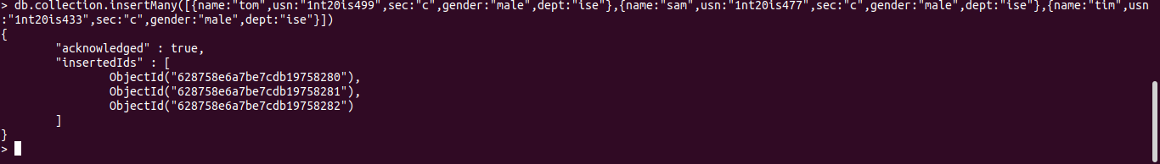
Insert to many:



Or operation:


