BUGS/DEFECTS

1.

Title:
Application stays on registration form and doesn’t redirect to home page when a newly registered user logs into the application

Description:
When a new user is registered and then logged in, the application stays on registration page instead of redirecting to home page after login.

Reproduction steps:
- go to the link https://buggy.justtestit.org/
- click on “register” button
- fill in the details of registration form and submit
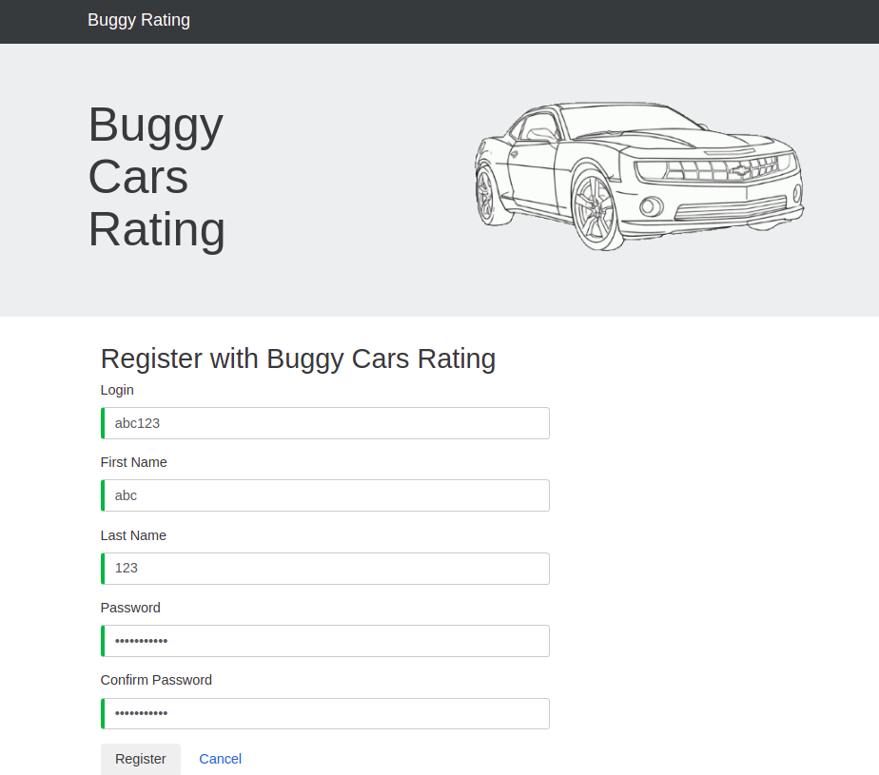 | 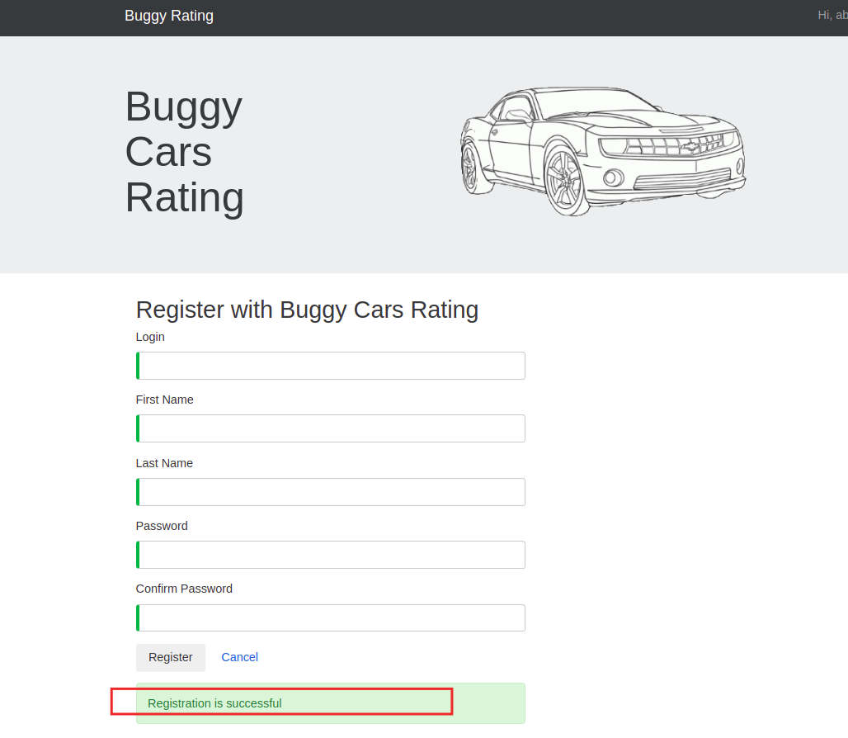
- once the registration is successful, try logging in with the same credentials used for registering
- after clicking “login” button, observe that it remains on the old registration screen instead of welcome/home screen

Actual result:
The registration form screen remains when the new user is logged in for the first time in the application and doesn’t redirect to home page after login.
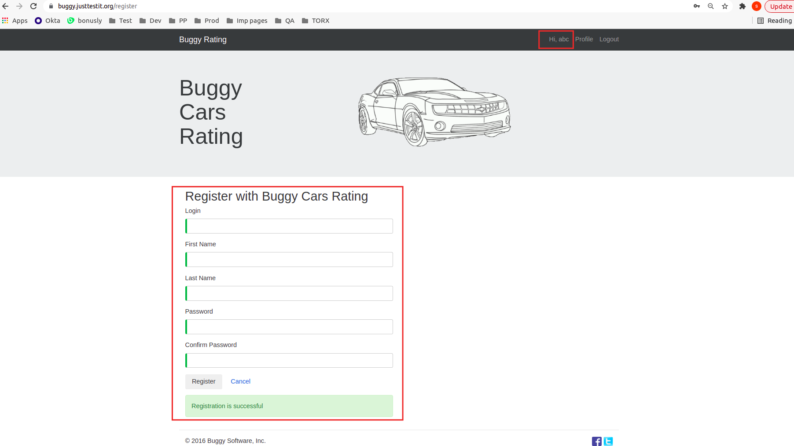

Expected result:
The app should redirect to home screen after logging in and should not still show the registration form with success registration msg.

2.

Title:
The logout doesn’t redirect to default application page and remains on the last page where user was before logging out.

Description:
The application remains on the last page (“profile” page in this case) even when the user logs out of the application, exposing all the user details.

Reproduction steps:
- go to the link https://buggy.justtestit.org/
- login (username: abc123, password: Password!23)
- go to “profile”
- fill in the additional info and save it
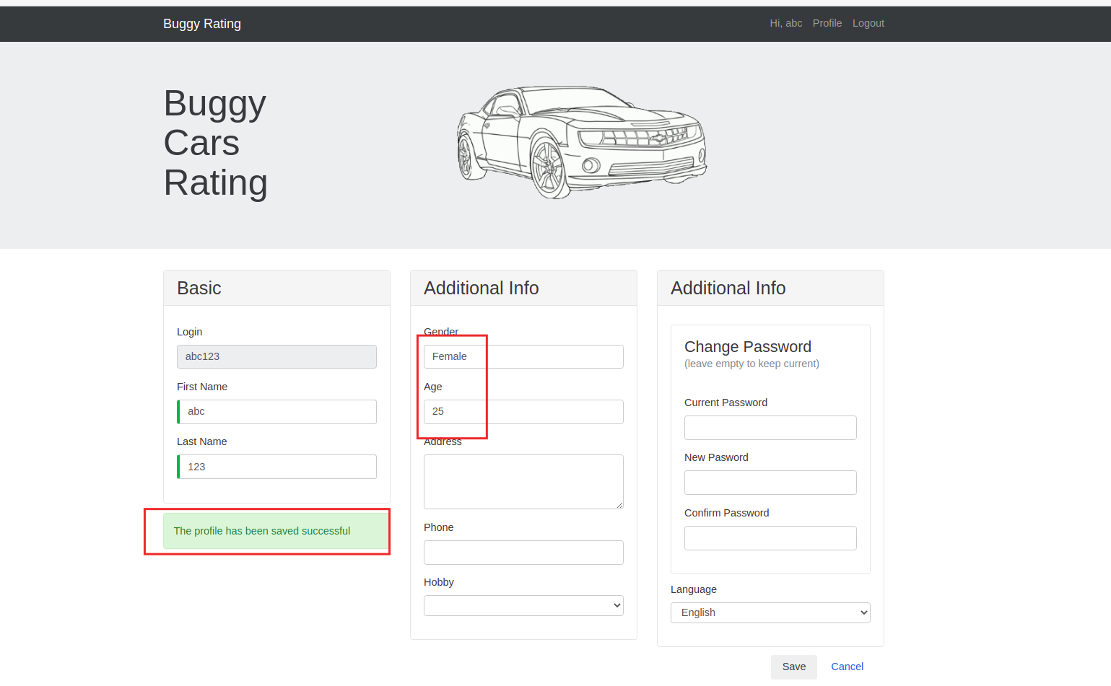
- be on this page and click logout
- observe that this edit profile page remains there even when the user is logged out
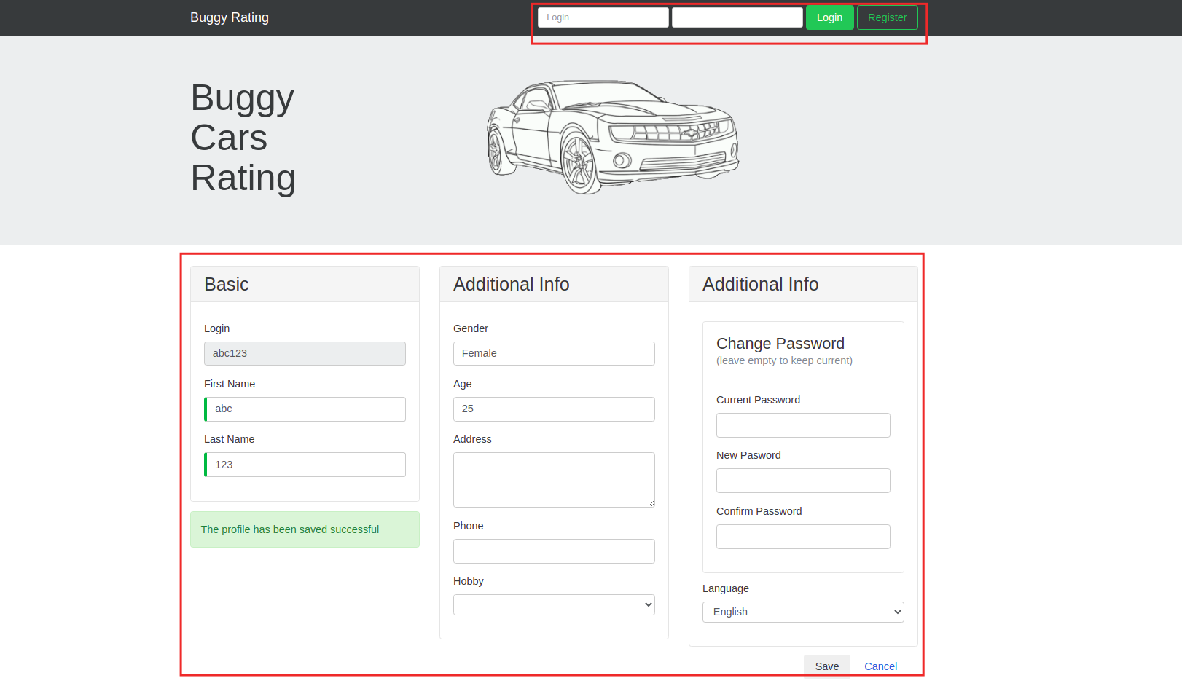

Actual result:
Logout did not redirect to default screen and application remains on the profile page showing all the details.

Expected result:
It should redirect to default application page and should not show the profile screen with user information after logging out.

3.

Title:
Author name is missing from the vote table of Make = “Lamborghini” and Model = “Diable”

Description:
The vote table of the model “Diable” of make Lamborghini has the Author information missing. Column title is there but the names are missing.

Reproduction steps:
- go to the link https://buggy.justtestit.org/
- login (username: abc123, password: Password!23)
- click on “Overall rating” image button
- click on the hyperlink of model “Diablo”
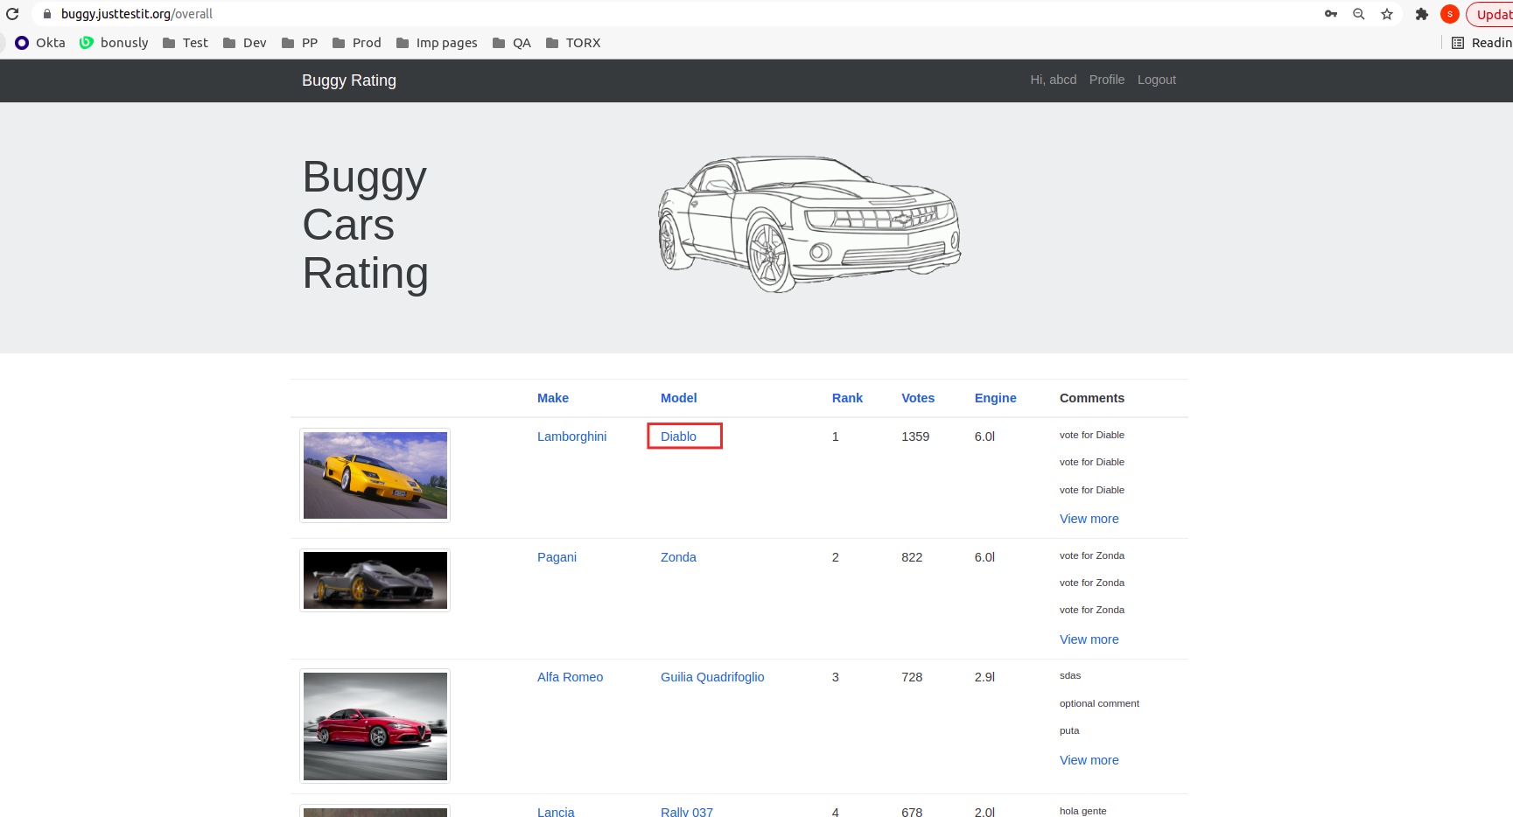
- observe that the Author column has author names missing
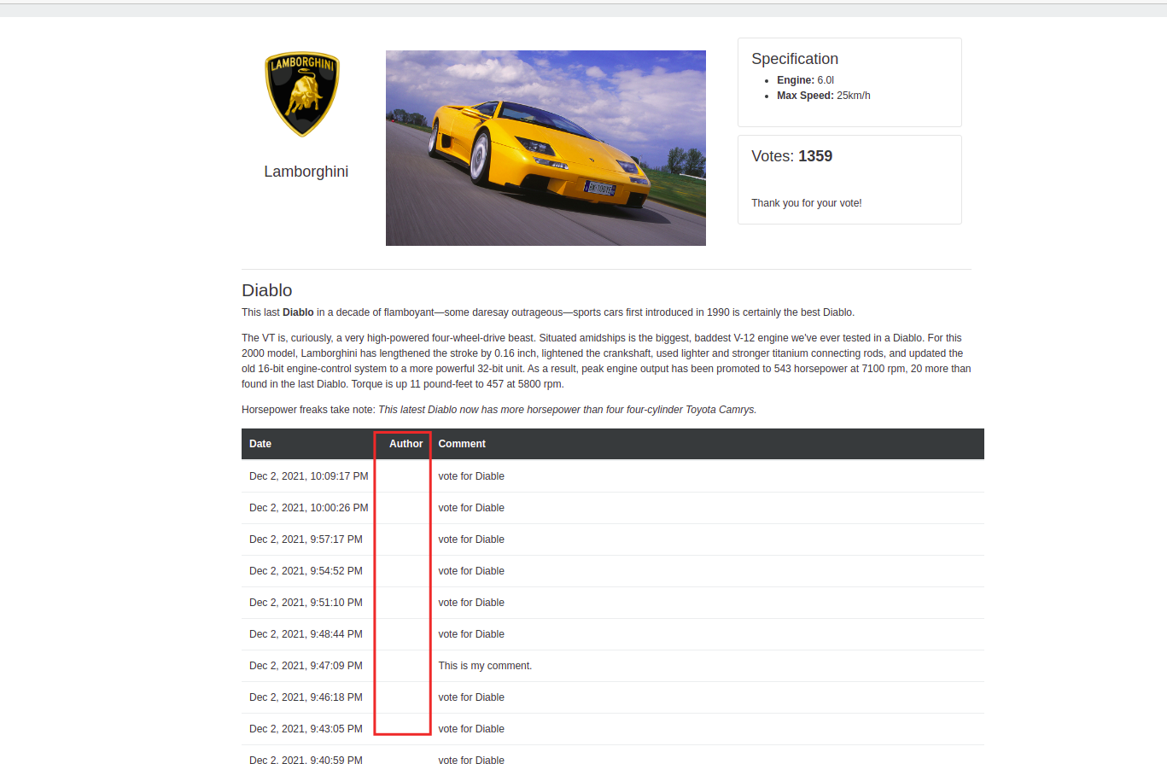

Actual result:
The author names are missing from the vote table under “author” column

Expected result:
The author name should be there in the vote table under the column “author”, as it is there for t=rest of the models.

4.

Title:
Unable to logout from the application when on “Overall rating” page

Description:
The logout button doesn’t work when the user is on “Overall rating” page, with this url: https://buggy.justtestit.org/overall.

Reproduction steps:
- go to the link https://buggy.justtestit.org/
- login (username: abc123, password: Password!23)
- click on “Overall rating” image button
- click on logout button and observe that it doesn’t do anything
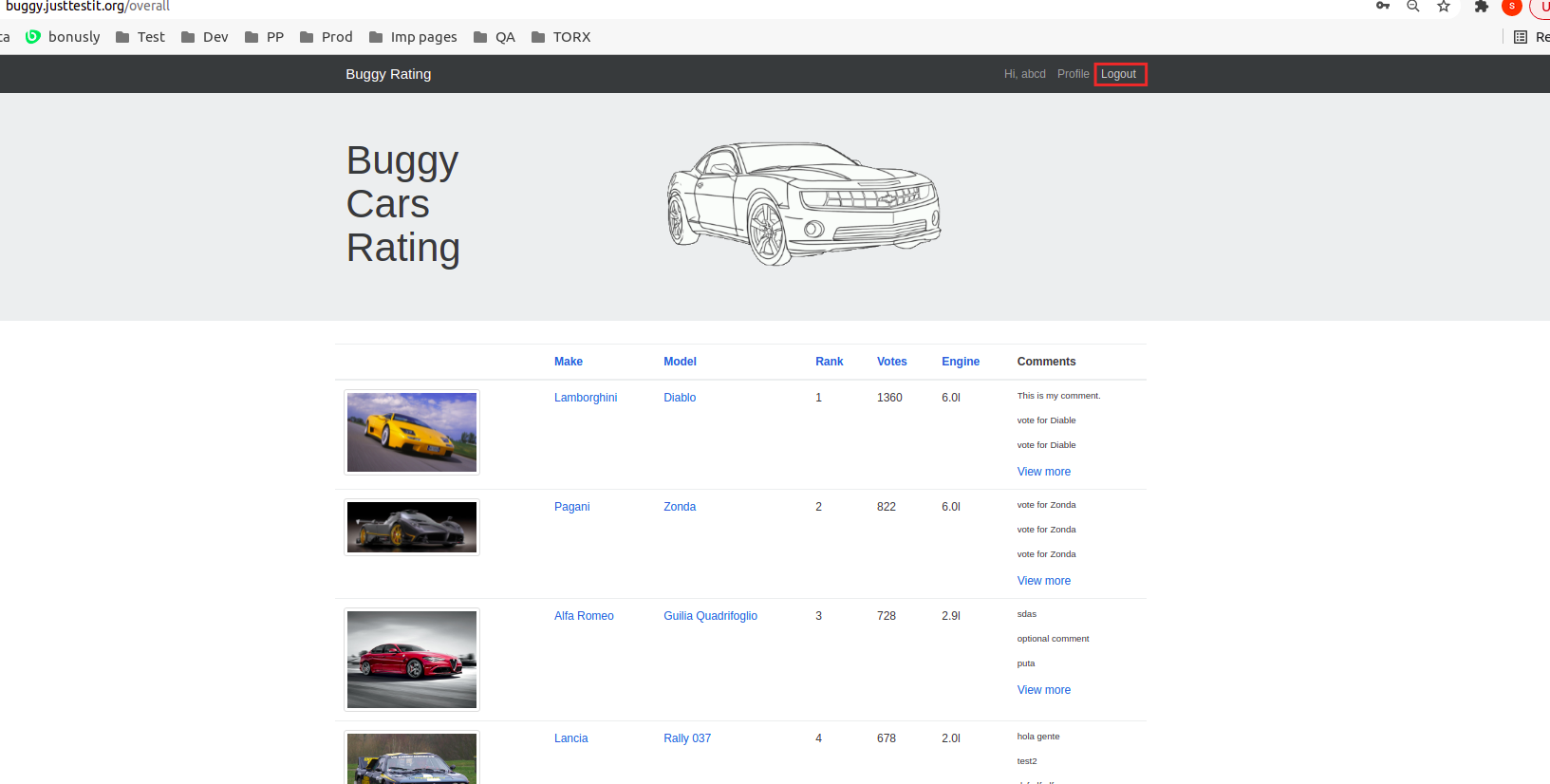

Actual result:
Can’t logout of the application when on overall rating page.

Expected result:
It should allow user to logout from any page of the application.

5.

Title:
Cannot navigate to main page from “Popular make” page

Description:
Trying to navigate to the main page by clicking “Buggy rating” logo on top when user is on “popular make” page, doesn’t redirect to main application page.
Navigating somewhere else (like “Profile”) and then trying to click again on “buggy rating” logo, will redirect to the main page.

Reproduction steps:
- go to the link https://buggy.justtestit.org/
- login (username: abc123, password: Password!23)
- click on “Popular Make” image button
- click on “buggy rating” on top left to go to main page and observe that nothing happens and application fails to redirect on the main page
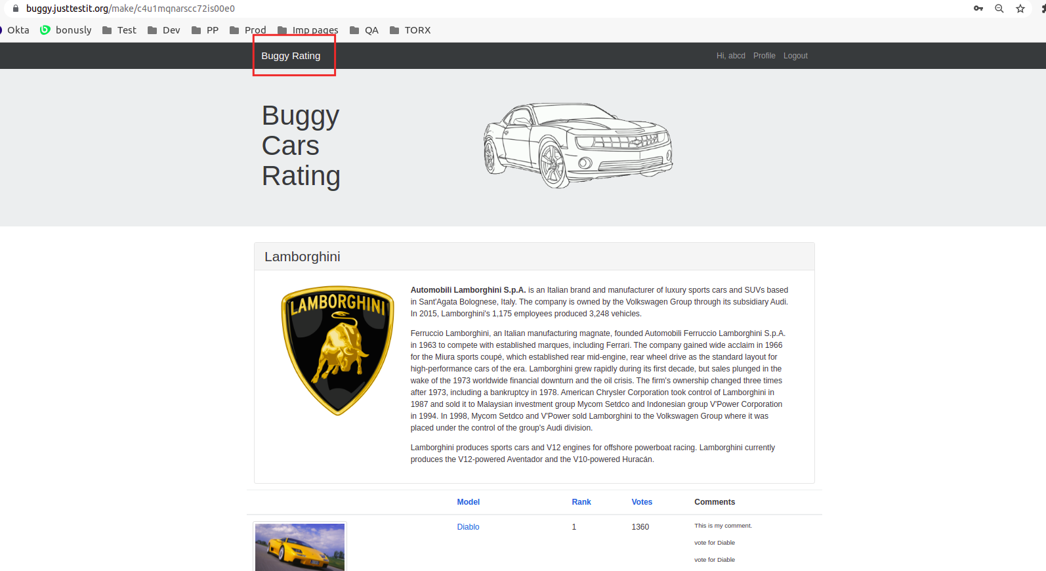

Actual result:
Application doesn’t redirect to main page when “buggy rating” logo is clicked.

Expected result:
Application should redirect to the main page when “buggy rating” is clicked.

6.

Title:
Voting without any comment doesn’t log the record in the vote table

Description:
If a vote is submitted without any comment, the action doesn’t reflect on the vote table.

Reproduction steps:
- go to the link https://buggy.justtestit.org/
- login (username: abc123, password: Password!23)
- click on “overall rating” image button
- search for a model which is not yet voted
- submit the vote without writing any comment
- the successful vote msg would display but no record on vote table
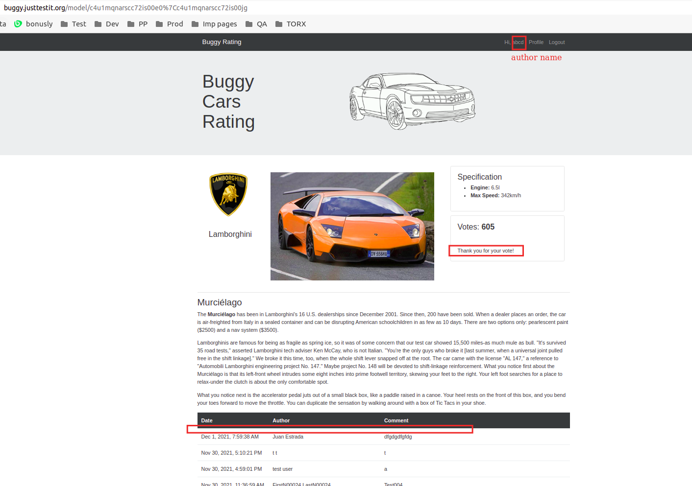
Actual result:
The vote record doesn’t get recorded when a vote is submitted without comment.

Expected result:
The vote table should get updated with the date/time and author name.

