MERIDIAN · MBTI EXECUTIVE DECISION-SUPPORT SYSTEM

Data Model & ER Diagram
Every entity the system needs to run Flow 1 (individual assessment) and Flow 2 (HR / executive oversight) end to end — from department routing through the scored MBTI attempt to the decision-maker archetype and the follow-up email log.
9 entities · 2 self-referencing scopes · localStorage prototype → relational-ready

1. Entities at a glance
Entity | Purpose | Primary key
DEPARTMENT | The 9 org units; decides Flow 1 vs Flow 2 routing at login/register. | department_name
DEPARTMENT_SCOPE | Which business departments each Flow 2 role may view in the Company Overview (self-referencing). | viewer_department + viewable_department
USER | Every account in the system — Flow 1 employees and Flow 2 HR/executives. | user_id
QUESTION | The fixed 32-item MBTI question bank, split 9/7/9/7 across the four dichotomies. | question_id
TEST_RESULT | One completed assessment attempt: final scores plus the resolved 4-letter type. | result_id
ANSWER | Each individual answer inside an attempt — the Layer-1 scoring audit trail. | answer_id
MBTI_GROUP | The 4 temperament groups: Analyst, Diplomat, Sentinel, Explorer. | group_name
ARCHETYPE | Knowledge base — maps an MBTI code to a decision-maker archetype. | mbti_code
EMAIL_LOG | Outbound follow-up / reminder emails an HR user sends to an employee. | email_id

2. ER diagram
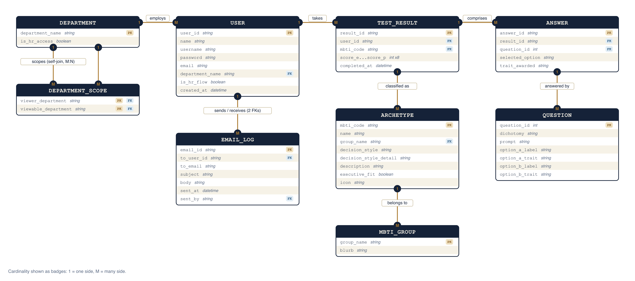
Crow's-foot cardinality shown as badges — 1 = one side, M = many side. Full attribute detail for every entity is in §4.

3. Relationships in plain language
- DEPARTMENT employs USER — a department employs many users; a user belongs to exactly one department, which also decides Flow 1 vs Flow 2 routing.
- DEPARTMENT scopes (self-join, M:N) DEPARTMENT_SCOPE — a department can appear many times in DEPARTMENT_SCOPE, both as the viewing role and as a viewable business unit — this encodes the CTO / Engineering-Manager visibility limits.
- USER takes TEST_RESULT — a user takes many test attempts over time (retakes); each attempt belongs to one user.
- TEST_RESULT comprises ANSWER — a test result comprises many answer rows, one per question in that attempt — the raw data behind the aggregated scores.
- QUESTION answered by ANSWER — a question is reused across many answer rows from different attempts; each answer references exactly one question.
- TEST_RESULT classified as ARCHETYPE — every test result's resolved 4-letter type maps to exactly one archetype in the knowledge base (Layer-2 IF-THEN rules).
- ARCHETYPE belongs to MBTI_GROUP — each archetype belongs to one of the 4 MBTI groups (Analyst / Diplomat / Sentinel / Explorer).
- USER sends / receives EMAIL_LOG — a user (HR/executive) sends many email log entries, and a user (employee) receives many — two distinct foreign keys onto the same USER table.

4. Full attribute reference
USER — every account in the system
Attribute | Type | Key | Notes
user_id | string | PK
name | string |  | Display name
username | string |  | Unique login handle
password | string |  | Mock plaintext in the prototype — hash in production
email | string |  | Used for Flow 2 follow-up emails
department_name | string | FK | → DEPARTMENT
is_hr_flow | boolean |  | Derived from department at registration
created_at | datetime
DEPARTMENT — org unit + routing rule
Attribute | Type | Key | Notes
department_name | string | PK | One of 9 fixed values
is_hr_access | boolean |  | True → routes to Flow 2 (HR, Eng. Manager, CTO, CEO)
DEPARTMENT_SCOPE — Flow 2 visibility rules (self-referencing)
Attribute | Type | Key | Notes
viewer_department | string | PK | FK → DEPARTMENT
viewable_department | string | PK | FK → DEPARTMENT
TEST_RESULT — one completed assessment attempt
Attribute | Type | Key | Notes
result_id | string | PK
user_id | string | FK | → USER
mbti_code | string | FK | → ARCHETYPE — resolved 4-letter type
score_e … score_p | int × 8 |  | Raw dichotomy tallies from Layer-1 scoring
completed_at | datetime
ANSWER — one question's answer inside an attempt
Attribute | Type | Key | Notes
answer_id | string | PK
result_id | string | FK | → TEST_RESULT
question_id | int | FK | → QUESTION
selected_option | string |  | "A" or "B"
trait_awarded | string |  | One of E / I / S / N / T / F / J / P
QUESTION — the fixed 32-item bank
Attribute | Type | Key | Notes
question_id | int | PK
dichotomy | string |  | EI / SN / TF / JP
prompt | string
option_a_label / option_a_trait | string
option_b_label / option_b_trait | string
ARCHETYPE — MBTI code → decision-maker style (knowledge base)
Attribute | Type | Key | Notes
mbti_code | string | PK | One of 16 codes
name | string |  | e.g. "The Commander"
group_name | string | FK | → MBTI_GROUP
decision_style / decision_style_detail | string |  | Dashboard label + elaboration
description | string
executive_fit | boolean |  | Flags the 4 core upper-management archetypes
icon | string |  | Path to SVG icon
MBTI_GROUP — the 4 temperament groups
Attribute | Type | Key | Notes
group_name | string | PK | Analyst / Diplomat / Sentinel / Explorer
blurb | string |  | One-line description of the group's decision tendency
EMAIL_LOG — outbound HR follow-up / reminder emails
Attribute | Type | Key | Notes
email_id | string | PK
to_user_id | string | FK | → USER (recipient)
to_email | string
subject / body | string
sent_at | datetime
sent_by | string | FK | → USER (HR sender)
Mirrors README.md §5 (ER diagram) for the Meridian prototype. The current localStorage layer (lib/store.ts) only persists USER (with its result embedded) and EMAIL_LOG; QUESTION, ANSWER, ARCHETYPE, MBTI_GROUP and DEPARTMENT_SCOPE are static or derived in code today (lib/questions.ts, lib/mbti.ts, lib/groups.ts, lib/types.ts) but are included because a production, regulator-auditable build would move them into real tables — and start persisting individual ANSWER rows, which the prototype currently discards once scored.

