**Lab 14**

Q1:

Run the transaction in Q1, select all data in BankAccount, and explain the results.

The result contains all 3 inserted data from the transaction “AddAccounts” with select all data from BankAccount table.

Run the transaction in Q1 again, select all data, and explain the results.

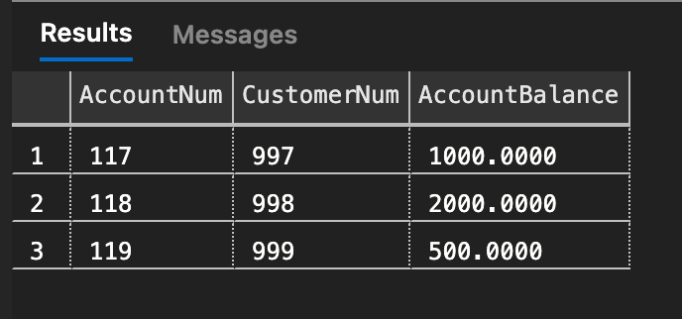

The result has the same as first time selected. But when we run the transaction again, it is failed to insert data because it contained already. So, its rollback for the second transaction.

Q2:

Run the transaction Q 2 twice, see the results, and explain what happends.

1st round is transferred successfully, and the result is represent as above picture.

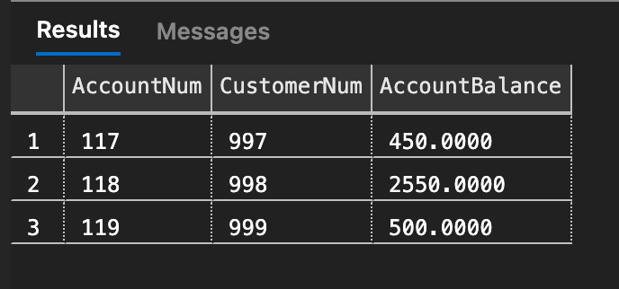

2nd round is insufficient balanced to transfer, so it will be the same amount and represented as the picture above.