Sports injury and illness recording application (SIRA)

แอปพลิเคชันบันทึกอาการบาดเจ็บและการเจ็บป่วยทางการกีฬา

BY

Mr. Krissanapong Palakham 6288102

Mr. Pongsakorn Piboonpongpun 6288107

Mr. Rathakit sriprachayanun 6288134

ADVISOR

asst. prof. Dr. charnyote pluempitiwiriyawej

A Senior Project Submitted in Partial Fulfillment of

the Requirements for

THE DEGREE OF BACHELOR OF SCIENCE

(INFORMATION AND COMMUNICATION TECHNOLOGY)

Faculty of Information and Communication Technology

Mahidol University

2022

**COPYRIGHT OF MAHIDOL UNIVERSITY**

ACKNOWLEDGEMENTS

We really would like to thank everyone who has taken part in our initiative and was relevant. This project could not be completed without the participation of all of the participants, including Mr. Krissanapong (Pun), Mr. Pongsakorn (Mark), and Mr. Rathakit Sriprachayanun (Art). We were also grateful to Asst. Prof. Dr. Charnyote Pluempitiwiriyawej, who served as our principal advisor for his invaluable assistance, and to all of the advisors from the Faculty of Information and Communication Technology and the Faculty of Sports Sciences for their support. We could learn a lot from this endeavor and put what we have learned into practice as we completed the final report. Finally, we expected that our project would be entirely useful, and grateful as well as thanks to our parents encouraged us with their special support.

Mr. Krissanapong Palakham

Mr. Pongsakorn Piboonpongpun

Mr. Rathakit Sriprachayanun

Sports injury and illness recording application

Mr. Krissanapong Palakham 6288102 ITCS/B

Mr. Pongsakorn Piboonpongpun 6288107 ITCS/B

mr. rathakit sriphachayanun 6288134 ITCS/B

B.Sc. (INFORMATION AND COMMUNICATION TECHNOLOGY)

PROJECT ADVISOR: asst. prof. dr. charnyote pluempitiwiriyawej

ABSTRACT

<Abstract content as sentence case here>

KEYWORDS: injury/illness/psychology/athlete/staff/

application/recording

P.

แอปพลิเคชันบันทึกอาการบาดเจ็บและการเจ็บป่วยทางการกีฬา

กฤษณพงศ์ ปาลคำ 6288102 ITCS/B

พงศกร พิบูลพงศ์พันธ์ 6288107 ITCS/B

รัฐกฤษฏิ์ ศรีปรัชญานันท์ 6288134 ITCS/B

วท.บ. (เทคโนโลยีสารสนเทศและการสื่อสาร)

อาจารย์ที่ปรึกษาโครงการ: ผศ. ดร. ชาญยศ ปลื้มปิติวิริยะเวช

บทคัดย่อ

หน้า

**CONTENTS**

Page

ACKNOWLEDGEMENTS ii

ABSTRACT iii

LIST OF TABLES vii

LIST OF FIGURES ix

1. Introduction 1

1.1 Motivation 1

1.2 Problem Statement 1

1.2.1 Recording with Paper 2

1.2.2 Recording with Google Form 2

1.3 Objectives of the Project 2

1.4 Scope of the Project 2

1.5 Expected Benefits 2

1.6 Organization of the Document 3

1. Background 4

2.1 Literature Review 4

2.1.1 The health problems survey from the Oslo Sports Trauma Research Center 4

2.1.2 Better reporting of sports-related overuse injuries and health issues 5

2.1.3 Development of an overuse injury questionnaire 5

1. Analysis and Design 6

3.1 System Architecture Overview 6

3.2 System Structure Chart 9

3.3 Process Analysis and Design 13

3.3.1 Data Flow Diagram 13

3.3.2 Data Dictionary 16

3.4 Database Analysis and Design 25

3.4.1 ER-Diagram 26

3.4.2 Relational Schema 27

3.4.3 File Structure 31

3.5 I/O Design 46

3.5.1 Interface Design 46

1. Implementation 53

4.1 Hardware and System Environment 53

4.2 Implementation Guide and Techniques 54

4.2.1 <Guide/Technique/Know-how> 54

4.2.2 < Guide/Technique/Know-how> 54

1. Testing and Evaluation 55

5.1 Unit Tests 55

5.1.1 Test Performed on <Process Number> <Process Name> 55

5.1.2 Test Performed on <Process Number> <Process Name> 55

5.2 System Integration Test 56

5.2.1 Test Scenario 56

1. Conclusions 58

6.1 Benefits 58

6.1.1 Benefits to Project Developers 58

6.1.2 Benefits to Users 58

6.2 Problems and Limitations 58

6.3 Future Work 59

REFERENCES 60

1. <INSERT YOUR TOPIC> 61

BIOGRAPHIES 62

LIST OF TABLES

Page

Table 2.1: Thai and English in OSTRC Health questionnaires 6

Table 2.2: Thai and English in OSTRC Overuse questionnaires 11

Table 2.3 Thai and English in Sport psychology questionnaires 15

Table 3.1: List of all Processes 34

Table 3.2: Process Description of Log on to the application authentication 35

Table 3.3: Process Description of Complete the questionnaire 35

Table 3.4: Process Description of Notify cases 36

Table 3.5: Process Description of Complete the medical record 36

Table 3.6: Process Description of Notify status and advice messages 36

Table 3.7: Process Description of Retrieve result questionnaire history 37

Table 3.8: Process Description of Retrieve result records and cases 37

Table 3.9: List of all Data Stores 38

Table 3.10: Data Store Description of Users database 38

Table 3.11: Data Store Description of Questionnaire database 39

Table 3.12: Data Store Description of Medical record database 39

Table 3.13: Data Store Description of Medical record database 39

Table 3.14: List of All Data Elements 40

Table 3.15: List of all Tables in Our System Database 45

Table 3.16: File Structure of Athlete 50

Table 3.17: File Structure of Staff 52

Table 3.18: File Structure of Health questionnaire 53

Table 3.19: File Structure of Physical questionnaire 55

Table 3.20: File Structure of Illness record 57

Table 3.21: File Structure of Injury record 59

Table 3.22: File Structure of Illness record 61

Table 3.23: File Structure of Message 63

Table 5.1: <Test Name> 73

Table 5.2: <Test Name> 73

LIST OF FIGURES

Page

Figure 3.1: SIRA Systems architecture 14

Figure 3.2: SIRA systems workflow 16

Figure 3.3: Structure chart of SIRA system 18

Figure 3.4: SIRA Data Flow Diagram Level 0 22

Figure 3.5: SIRA Data Flow Diagram Level 1 23

Figure 3.6: Conceptual ER-Diagram of SIRA 34

Figure 3.7: Register and Login 54

Figure 3.8 Staff/Athlete Homepage 55

Figure 3.9: Questionnaire page 56

Figure 3.10: Recording page 57

Figure 3.11: Notification page 58

Figure 3.12: History page 59

Figure 3.13: Staff’s case page 60

CHAPTER 1

# Introduction

In this chapter, there are six parts of introduction which are Motivation, Problem Statement, Objectives of the Project, Scope of the Project, Expected Benefits of the Project, and Organization of the Document. Their focus will be on how the application was developed, why there is a need for the application, and what were the benefits of the application.

## Motivation

Nowadays, injuries usually happen whether physical, mental or health, especially for athletes. Injury problems can affect athletes with their training, practice, as well as a competition. Athletes' performance would be decreased, resulting in their winning success in a competition or evenly lacking training. In addition, staff or medical teams (e.g., coaches, doctors, physical therapists, psychologists) would also be affected by athletes’ injuries. Due to athlete’s injury problems, staffs have to create or change a plan to suit the athlete's problem. Thus, it would be difficult to adjust if the athlete’s problem information is sent late. In order to prevent those problems, keeping records of the athlete’s problems as well as medical recordings from diagnostics are important. Collecting the record from both athletes and staff will assist the athletes’ injury problems in order to decrease treatment time, so athletes can heal themselves with the correct method and also understand their injury status and what they need to do. Moreover, staff can plan whether healing, training, or competition for injured athletes. Therefore, building a platform for keeping those records will extremely be useful for both athletes and staff.

## Problem Statement

Recording the athlete’s problems actually happened in Thailand. However, there are two main problems with recording systems:

### Recording with Paper

The paper-based recording has a number of drawbacks, including being hard to find, easily lost, difficult to retrieve, and requiring a large amount of labor. At the moment, we switch to different methods to avoid these issues.

### Recording with Google Form

Google Form recordings are changed methodology from the paper-based. However, this method of recording injuries and illness has also had some problems whether scattered information, data integration, and difficult processing. Thus, this method has to be changed to a new one in order to improve the recording system.

## Objectives of the Project

* Develop an SIRA system capable of managing data on physical injuries, health illnesses, and mental illnesses
* Make athletes know their injury status in order to heal themselves with the correct methodology
* Enable coaches and the medical staff to utilize athlete data to be useful and provide coaching and treatment input to specific athletes

## Scope of the Project

* A mobile platform that can record both athlete’s questionnaires and complaints as well as medical recordings from staff
* The operating systems provide both IOS and Android in order to collect for all athletes and staff data from all user devices
* Applied the Oslo Sports Trauma Research Center (OSTRC) questionnaires to the systems
* Sending weekly notifications for athletes in order to answer questionnaires every week

## Expected Benefits

In order to build the application, we expected our solution would be assisted to any kind of users that were classified into two groups including users and developers. Furthermore, users were classified into three groups including athletes, medical team, and organization agents. The description is as follows:

* Athlete
  + Receiving a recommendation from medical team for healing themselves
  + Regularly receiving health checks with professional medical team
  + Filling out the health questionnaire forms as simple with clearly user interfaces
* Staff
  + Filling out the medical record form as simple with clearly user interfaces
  + Planning for healing, training, competition for injured athletes
* Organization Agent
  + Making a decision in order to send athletes to compete in each event
  + Athletes’ and Medical Teams’ data in order to archive and analysis
* Developers
  + Practicing mobile programming both coding and framework
  + Creating an assistant program for athletes and medical staff
  + Developing an application for both IOS and android operating systems with Dart language and Google Firebase Services
  + Evolving problem-solving, time management, prioritizing tasks, programming, database management, UX/UI, and presentation skill.

## Organization of the Document

This document consists of 6 chapters including:

1. Introduction – The motivation, problem statements, project objectives, project scopes, expected benefits for both users and developers, and document organization are all contained in the introduction's first chapter, which also introduces the project.
2. Background – Background knowledge, including a literature review, is included in the second chapter.
3. Analysis and Design – The project's analysis and design are presented in the third chapter. It includes details on the project's design, such as a system architecture overview, a system structure diagram, and a design for the web-based service.
4. Implementation – The fourth chapter discusses the implementation and includes information on hardware, system environment, implementation techniques, and implementation guide.
5. Testing and Evaluation – The testing and evaluation process, spread pattern results, and discussion are all found in the fifth chapter.
6. Conclusion – Conclusion, benefits, issues and limitations, and future work are all included in the sixth chapter.

CHAPTER 2

# Background

This chapter includes examples of earlier projects completed by other scholars. We give a summary of the project's content while highlighting its advantages and disadvantages in relation to other projects. In addition, we had the project reviewed so that we could improve it and change it to fit our preferences so that it would be a fantastic app.

## Background Knowledge

There will be questionnaires from the OSTRC that are separated into three parts including health, overuse, and sport psychology. The health questionnaire is about the illness of the athletes, for instance, fatigue, fever, and so on. The overuse questionnaire is about the physical injury from any part of the body. The sport psychology questionnaire is about the athletes’ mental illness, for instance, readiness to compete, training, and sleep quality.

Table 2.1: Thai and English in OSTRC Health questionnaires

|  |  |
| --- | --- |
| **Thai version** | **English version** |
| คุณมีปัญหาด้านอาการเจ็บป่วยหรือไม่   * ใช่ * ไม่มี | Do you have an illness problem?   * Yes * No |
| 1. ใน 7 วันที่ผ่านมาปัญหาการบาดเจ็บการเจ็บป่วย หรือปัญหาสุขภาพอื่น ๆ ของท่านทำให้การฝึกซ้อมหรือการ  แข่งขันกีฬามีปัญหาหรือไม่   * เข้าร่วมการฝึกซ้อมหรือแข่งขันกีฬาได้เต็มที่โดยไม่มีปัญหาการบาดเจ็บ,เจ็บป่วย หรือปัญหาสุขภาพ * เข้าร่วมการฝึกซ้อมหรือแข่งขันกีฬาได้เต็มที่แต่มีปัญหาการบาดเจ็บ,เจ็บป่วย หรือปัญหาสุขภาพ * เข้าร่วมการฝึกซ้อมหรือแข่งขันกีฬาได้ไม่เต็มที่เพราะมีปัญหาการบาดเจ็บ,เจ็บป่วย หรือปัญหาสุขภาพ * ไม่สามารถเข้า ร่วมการฝึกซ้อมหรือแข่งขนกีฬาได้ เพราะมีปัญหาการบาดเจ็บ,เจ็บป่วย หรือปัญหาสุขภาพ | Have you had any difficulties participating in normal training and competition due to injury, illness, or other health problems during the past week?   * Full participation without health problems. * Full participation, but with injury/illness. * Reduced participation due to injury/illness. * Cannot participate due to injury/illness. |

|  |  |
| --- | --- |
| **Thai version** | **English version** |
| 2. ใน 7 วันที่ผ่านมา ปัญหาการบาดเจ็บการเจ็บป่วย หรือปัญหาสุขภาพ ของท่านส่งผลกระทบต่อปริมาณการฝึกซ้อมหรือแข่งขันมากน้อยเท่าไหร่   * ไม่ลดลง * ลดลงเล็กน้อย * ลดลงปานกลาง * ลดลงอย่างมาก * ไม่สามารถเข้าร่วมได้เลย | To what extent have you reduced you training volume due to injury, illness, or other health problems during the past week?   * No reduction * To a minor extent * To a moderate extent * To a major extent * Cannot participate at all |
| 3. ใน 7 วันที่ผ่านมา ปัญหาการบาดเจ็บการเจ็บป่วย หรือปัญหาสุขภาพ ของท่านส่งผลกระทบต่อความสามารถ ในการเล่นกีฬามากน้อยเท่าไหร่   * ไม่ลดลง * ลดลงเล็กน้อย * ลดลงปานกลาง * ลดลงอย่างมาก * ไม่สามารถเข้าร่วมได้เลย | To what extent has injury, illness or other health problems affected your performance during the past week?   * No effect * To a minor extent * To a moderate extent * To a major extent * Cannot participate at all |
| 4. ใน 7 วันที่ผ่านมา ท่านมีปัญหาการบาดเจ็บ การเจ็บป่วยหรือปัญหาสุขภาพมากน้อยเพียงใด   * ไม่สามารถเข้าร่วมได้เลย * มีอาการหรือปัญหาสุขภาพเล็กน้อย * มีอาการหรือปัญหาสุขภาพพอประมาณ * มีอาการหรือปัญหาสุขภาพอย่างมาก | To what extent have you experienced symptoms/health complaints during the past week?   * No symptoms/health complaints * To a mild extent * To a moderate extent * To a severe extent * Cannot participate at all |
| **Thai version** | **English version** |
| 5.อาการป่วย   * ไข้ * อ่อนล้า * ต่อมอักเสบ * เจ็บคอ * คัดจมูก/น้า มูกไหล/จาม * ไอ * หายใจลำบาก * ปวดหัว * คลื่นไส้ * อาเจียน * ท้องเสีย * ท้องผูก * เป็นลม * ผื่นคัน * หัวใจเต้นผิดปกติ * เจ็บหน้าอก * ปวดเมื่อยกล้ามเนื้อเนื้อส่วนท้อง * ความเจ็บปวดอื่น ๆ * ชา * ความวิตกกังวล * หดหู่/เศร้า * หงุดหงิดง่าย * อาการบริเวณตา * อาการบริเวณหู * อาการที่ทางเดินปัสสาวะและอวัยวะเพศ | Illness part   * Fever * Fatigue/malaise * Swollen gland * Sore throat * Blocked nose, running nose, sneezing * Cough * Difficulty breathing * Headache * Nausea * Vomiting * Diarrhea * Constipation * Fainting * Rash/itchiness * Irregular pulse/arrhythmia * Chest pain/angina * Abdomen pain * Other pain * Numbness/pins and needles * Anxiety * Depression * Irritability * Eye symptoms * Ear symptoms * Symptoms form urinary tract and genitals |

|  |  |
| --- | --- |
| **Thai version** | **English version** |
| ใน 1 สัปดาห์ที่ผ่านมากรุณาระบุจำนวนวันที่คุณพลาดการฝึกซ้อมหรือแข่งขันเนื่องจากปัญหาที่ได้กล่าวมานี้   * 0 1 2 3 4 5 6 7 | Please state the number of days over the past 7-day period that you have had to completely miss training or competition due to this problem.   * 0 1 2 3 4 5 6 7 |
| ครั้งนี้คือครั้งแรกที่ท่านได้ลงทะเบียนปัญหาในประเด็นนี้ในระบบนี้ใช้หรือไม่   * ใช้ เป็นครั้งแรก * ไม่ใช้ข้าพเจ้าได้รายงานปัญหาเรื่องนี้มาแล้วในช่วงหนึ่งเดือนที่ผ่านมา * ไม่ใช้ข้าพเจ้าได้รายงานปัญหาเรื่องนี้มาแล้ว นานมากกว่าในช่วงหนึ่งเดือนที่ผ่านมา | Is this the first time you have registered this problem through this monitoring system?   * Yes, this is the first time * No, I have reported the same problem in one of the previous four weeks * No, I have reported the same problem previously, but it was more than four weeks ago |
| ข้าพเจ้าได้รายงานปัญหานี้กับบุคลากรดังกล่าวนี้กับ   * แพทย์เวชศาสตร์การกีฬาประจำทีม/สโมสร * นักกายภาพบำบัดการกีฬาประจำทีม/สโมสร * แพทย์เวชศาสตร์การกีฬาที่อื่น * นักกายภาพบำบัดการกีฬาที่อื่น | I have reported this problem to ...   * Olympic team doctor * Olympic team physiotherapist * Other Olympiatoppen doctor * Other Olympiatoppen physiotherapist |

|  |  |
| --- | --- |
| **Thai version** | **English version** |
| กรุณาใช้พื้นที่นี้ในการให้ข้อมูลเพิ่มเติมเกี่ยวกับ ปัญหากับทีมทางการแพทย์ของคุณ   * เติมลงในช่องว่าง | Please use this field to send additional information about this problem to your Olympic medical team   * Fill the blank |
| 9. คุณมีปัญหาด้านอาการบาดเจ็บอื่น ๆ หรือไม่   * มี * ไม่มี | Do you have another Injury problem?   * Yes * No |

Table 2.2: Thai and English in OSTRC Overuse questionnaires

|  |  |
| --- | --- |
| **Thai version** | **English version** |
| ท่านมีอาการบาดเจ็บหรือไม่   * มี * ไม่มี | Do you have an injury problem?   * Yes * No |
| บริเวณที่บาดเจ็บ   * หัวและหน้า * คอ * หัวไหล่/ไหปลาร้า * ต้นแขน * ข้อศอก * แขนท่อนล่าง * ข้อมือ * มือและนิ้ว * หน้าอก/ซี่โครง * หน้าท้อง * กระดูกันหลังทรวงอก * กระดูกสันหลังส่วนล่าง * เชิงกราน/ก้น * สะโพก/ขาหนีบ * ต้นขา * เข่า * ขาท่อนล่าง * ข้อเท้า * เท้าและนิ้วเท้า | Injury part   * Head * Neck * Shoulder * Upper arm * Elbow * Lower arm * Wrist * Hand and finger * Chest and ribs * Abdomen * Thoracic spine * Lower spine * Pelvis and buttocks * Hip and groin * Thigh * Knee * Lower leg * Ankle * Feet and toes |
| เลือกระดับความเจ็บปวดของร่างกาย   * 1 ถึง 10 | Select the body part pain level   * 1 to 10 |

|  |  |
| --- | --- |
| **Thai version** | **English version** |
| 1.ใน 7 วันที่ผ่านมา ปัญหา (Location) ของท่านทำให้การเข้าร่วมฝึกซ้อมหรือการแข่งขันกีฬามีปัญหาหรือไม่   * เข้าร่วมการฝึกซ้อมหรือการแข่งขันได้เต็มที่โดยไม่มีปัญหา (Location) * เข้าร่วมการฝึกซ้อมหรือการแข่งขันกีฬาได้เต็มที่แต่มีปัญหา (Location) * เข้าร่วมการฝึกซ้อมหรือแข่งขันกีฬาได้ไม่เต็มที่เพราะมีปัญหา (location) * ไม่สามารถเข้าร่วมการฝึกซ้อมหรือแข่งขันกีฬาได้เลยเพราะมีปัญหา (location) | Have you had any difficulties participating in training and competition due to (Location) problems during the past 7 days?   * Full participation without (Location) problems. * Full participation, but with (Location) problems * Reduced participation due to (Location) problems * Could not participate due to (Location) problems. |
| 2. ใน 7 วันที่ผ่านมา ปัญหา (Location) ของท่านส่งผลกระทบต่อการฝึกซ้อมหรือแข่งขันมากน้อยเพียงใด   * + ไม่ส่งผลกระทบต่อการฝึกซ้อมหรือแข่งขันเลย   + การฝึกซ้อมหรือแข่งขันลดลงเล็กน้อย   + การฝึกซ้อมหรือแข่งขันลดลงปานกลาง   + การฝึกซ้อมหรือแข่งขันลดลงอย่างมาก   + ไม่สามารถเข้าร่วมการฝึกซ้อมหรือแข่งขันได้เลย | To what extent have you modified your training or competition due to (Location) problems during the past 7 days?   * No modification * To a minor extent * To a moderate extent * To a major extent * Cannot participate at all |

|  |  |
| --- | --- |
| **Thai version** | **English version** |
| 3.ใน 7 วันที่ผ่านมา ปัญหา (Location) ของคุณส่งผลกระทบต่อความสามารถในการเล่นกีฬามากน้อยเพียงใด   * + ไม่ส่งผลกระทบต่อความสามารถในการเล่นกีฬาเลย   + ความสามารถในการเล่นกีฬาลดลงเล็กน้อย   + ความสามารถในการเล่นกีฬาลดลงปานกลาง   + ความสามารถในการเล่นกีฬาลดลง อย่างมาก | To what extent have (Location) problems affected your performance during the past 7days?   * No effect * To a minor extent * To a moderate extent * To a major extent * Cannot participate at all |
| 4. ใน 7 วันที่ผ่านมา อาการเจ็บปวดของ (Location) ของท่านซึ่งเป็นผลมาจากการเข้าร่วมการแข่งขัน/ฝึกซ้อมกีฬาอยู่ในระดับใด   * + ไม่เจ็บเลย   + เจ็บเล็กน้อย   + เจ็บพอประมาณ   + เจ็บมาก | To what extent have you experienced Head pain related to your sport during the past 7 days?   * No pain * Mild pain * Moderate pain * Severe pain |
| 5. ใน 1 สัปดาห์ที่ผ่านมา กรุณาระบุจำนวนที่คุณพลาดการฝึกซ้อมหรือแข่งขันเนื่องจากปัญหาที่ได้กล่าวมานี้   * 0 1 2 3 4 5 6 7 | Please state the number of days over the past 7-day period that you have had to completely miss training or competition due to this problem.   * 0 1 2 3 4 5 6 7 |

|  |  |
| --- | --- |
| **Thai version** | **English version** |
| 6. ครั้งนี้คือครั้งแรกที่ท่านได้ลงทะเบียนปัญหาในประเด็นนี้ ในระบบนี้ใช่หรือไม่   * ใช่เป็นครั้งแรก * ไม่ใช่ ข้าพเจ้าได้รายงานปัญหาเรื่องนี้มาแล้วในช่วงหนึ่งเดือนที่ผ่ามา * ไม่ใช่ ข้าพเจ้าได้รายงานปัญหาเรื่องนี้มาแล้ว นานมากกว่าในช่วงหนึ่งเดือนที่ผ่านมา | Is this the first time you have registered this problem through this monitoring system?   * Yes, this is the first time * No, I have reported the same problem in one of the previous four weeks * No, I have reported the same problem previously, but it was more than four weeks ago |
| 7. ข้าพเจ้าได้รายงานปัญหานี้กับบุคลากรดังกล่าวนี้กับ   * แพทยเวชศาสตร์การกีฬาประจำทีม/สโมสร * นักกายภาพบำบัดการกีฬาประจำทีม/สโมสร * แพทยศาสตร์การกีฬาที่อื่น * นักกายภาพบำบัดการกีฬาที่อื่น | I have reported this problem to ...   * Olympic team doctor * Olympic team physiotherapist * Other Olympiatoppen doctor * Other Olympiatoppen physiotherapist |
| 8. กรุณาใช้พื้นที่นี้ในการให้ข้อมูลเพิ่มเติมเกี่ยวกับปัญหากับทีมทางการแพทย์ของคุณ   * เติมลงในช่องว่าง | Please use this field to send additional information about this problem to your Olympic medical team   * Fill the blank |

Table 2.3 Thai and English in Sport psychology questionnaires

|  |  |
| --- | --- |
| **Thai version** | **English version** |
| ในช่วงระยะเวลา 1 เดือนที่ผ่านมาส่วนใหญ่ ท่านมักเข้านอนเวลากี่โมง   * 1 ถึง 24 | During the past month, when have you usually gone to bed at night?   * 1 to 24 |
| ในช่วงระยะเวลา 1 เดือนที่ผ่านมา โดยปกติคุณใช้เวลานานเท่าใด (เป็นนาที) ในการนอนหลับในแต่ละคืน   * ป้อนช่วงเวลาเป็นนาที | During the past month, how long (in minutes) has it usually takes you to fall asleep each night?   * Enter time interval in minutes |
| ในช่วงระยะเวลา 1 เดือนที่ผ่านมาส่วนใหญ่ท่านตื่นนอนตอนเช้าเป็นเวลากี่โมง   * 1 ถึง 24 | During the past month, when have you usually gotten up in the morning?   * 1 to 24 |
| ในช่วงระยะเวลา 1 เดือนที่ผ่านมา ท่านานหลับได้จริงเป็นเวลากี่ชั่วโมงต่อคืน   * ป้อนช่วงเวลาเป็นนาที | During the past month, how many hours of actual sleep did you get at night?   * Enter time interval in minutes |
| นอนไม่หลับหลังจากเข้านอนไปแล้วนานกว่า 30 นาที   * ไม่เคยเลยในช่วงระยะเวลา 1 เดือนที่ผ่านมา * น้อยกว่า 1 ครั้งต่อสัปดาห์ * 1 หรือ 2 ครั้งต่อสัปดาห์ * 3 ครั้งต่อสัปดาห์ | Cannot get sleep within 30 minutes   * Not during the past month * Less than once a week * Once or twice a week * Three or more times a week |
| รู้สึกตัว ตื่นขึ้นระหว่างนอนหลับกลางดึกหรือตื่นเช้ากว่าเวลาที่ตั้งใจไว้   * ไม่เคยเลยในช่วงระยะเวลา 1 เดือนที่ผ่านมา * น้อยกว่า 1 ครั้งต่อสัปดาห์ * 1 หรือ 2 ครั้งต่อสัปดาห์ * 3 ครั้งต่อสัปดาห์ขึ้นไป | Wake up in the middle of the night or early morning   * Not during the past month * Less than once a week * Once or twice a week * Three or more times a week |
| **Thai version** | **English version** |
| ตื่นเพื่อไปเข้าห้องน้ำ   * ไม่เคยเลยในช่วงระยะเวลา 1 เดือนที่ผ่านมา * น้อยกว่า 1 ครั้งต่อสัปดาห์ * 1 หรือ 2 ครั้งต่อสัปดาห์ * 3 ครั้งต่อสัปดาห์ขึ้นไป | Have to get up to use the bathroom   * Not during the past month * Less than once a week * Once or twice a week * Three or more times a week |
| หายใจไม่สะดวก   * ไม่เคยเลยในช่วงระยะเวลา 1 เดือนที่ผ่านมา * น้อยกว่า 1 ครั้งต่อสัปดาห์ * 1 หรือ 2 ครั้งต่อสัปดาห์ * 3 ครั้งต่อสัปดาห์ขึ้นไป | Cannot breathe comfortably   * Not during the past month * Less than once a week * Once or twice a week * Three or more times a week |
| ไอกรนเสียงดัง   * ไม่เคยเลยในช่วงระยะเวลา 1 เดือนที่ผ่านมา * น้อยกว่า 1 ครั้งต่อสัปดาห์ * 1 หรือ 2 ครั้งต่อสัปดาห์ * 3 ครั้งต่อสัปดาห์ขึ้นไป | Cough or snore loudly   * Not during the past month * Less than once a week * Once or twice a week * Three or more times a week |
| รู้สึกหนาวเกินไป   * ไม่เคยเลยในช่วงระยะเวลา 1 เดือนที่ผ่านมา * น้อยกว่า 1 ครั้งต่อสัปดาห์ * 1 หรือ 2 ครั้งต่อสัปดาห์ * 3 ครั้งต่อสัปดาห์ขึ้นไป | Feel too cold   * Not during the past month * Less than once a week * Once or twice a week * Three or more times a week |

|  |  |
| --- | --- |
| **Thai version** | **English version** |
| รู้สึกร้อนเกินไป   * ไม่เคยเลยในช่วงระยะเวลา 1 เดือนที่ผ่านมา * น้อยกว่า 1 ครั้งต่อสัปดาห์ * 1 หรือ 2 ครั้งต่อสัปดาห์ * 3 ครั้งต่อสัปดาห์ขึ้นไป | Feel too hot   * Not during the past month * Less than once a week * Once or twice a week * Three or more times a week |
| ฝันร้าย   * ไม่เคยเลยในช่วงระยะเวลา 1 เดือนที่ผ่านมา * น้อยกว่า 1 ครั้งต่อสัปดาห์ * 1 หรือ 2 ครั้งต่อสัปดาห์ * 3 ครั้งต่อสัปดาห์ขึ้นไป | Had bad dream   * Not during the past month * Less than once a week * Once or twice a week * Three or more times a week |
| รู้สึกปวด   * ไม่เคยเลยในช่วงระยะเวลา 1 เดือนที่ผ่านมา * น้อยกว่า 1 ครั้งต่อสัปดาห์ * 1 หรือ 2 ครั้งต่อสัปดาห์ * 3 ครั้งต่อสัปดาห์ขึ้นไป | Have pain   * Not during the past month * Less than once a week * Once or twice a week * Three or more times a week |
| เหตุผลอื่นๆ   * เติมลงในช่องว่าง | Other reason(s), please describe   * Fill the blank |
| ในช่วงระยะเวลา 1 เดือนที่ผ่านมา ท่านคิดว่าคุณภาพการนอนหลับโดยรวมของท่านเป็นอย่างไร   * ดีมาก * ค่อนข้างดี * ค่อนข้างแย่ * แย่มาก | During the past month, how would you rate your sleep quality overall?   * Very good * Fairly good * Fairly bad * Very bad |

|  |  |
| --- | --- |
| **Thai version** | **English version** |
| ในช่วงระยะเวลา 1 เดือนที่ผ่านมา ท่านใช้ยาเพื่อช่วยในการนอนหลับบ่อยเพียงใด (ไม่ว่าจะตามใบสั่งแพทย์หรือซื้อมาเอง)   * ไม่เคยเลยในช่วงระยะเวลา 1 เดือนที่ผ่านมา * น้อยกว่า 1 ครั้งต่อสัปดาห์ * 1 หรือ 2 ครั้งต่อสัปดาห์ * 3 ครั้งต่อสัปดาห์ขึ้นไป | During the past month, how often have you take medicine (prescribe or "over the counter") to help you sleep?   * Not during the past month * Less than once a week * Once or twice a week * Three or more times a week |
| ในช่วงระยะเวลา 1 เดือนที่ผ่านมา ท่านมีปัญหาง่วงนอนหรือเผลอหลับขณะขับขี่ยานพาหนะ, ขณะรับประทานอาหารหรือขณะเข้าร่วมกิจกรรมทางสังคมต่างๆ บ่อยเพียงใด   * ไม่เคยเลยในช่วงระยะเวลา 1 เดือนที่ผ่านมา * น้อยกว่า 1 ครั้งต่อสัปดาห์ * 1 หรือ 2 ครั้งต่อสัปดาห์ * 3 ครั้งต่อสัปดาห์ขึ้นไป | During the past month, how often have you had trouble staying awake while driving, eating meals, or engaging in social activity?   * Not during the past month * Less than once a week * Once or twice a week * Three or more times a week |
| ในช่วงระยะเวลา 1 เดือนที่ผ่านมา ท่านมีปัญหาเกี่ยวกับความกระตือรือร้นในการทำงานให้สำเร็จมากน้อยเพียงใด   * ไม่มีปัญหา * มีปัญหาเพียงเล็กน้อย * มีปัญหา * มีปัญหาอย่างมาก | During the past month, how much of a problem has it been for you to keep up enough enthusiasm to get things done?   * No problem at all * Only a very slight problem * Somewhat of a problem * A very big problem |
| ท่านมีคู่นอน, เพื่อนร่วมห้องหรือผู้อาศัยอยู่ในบ้านหลังเดียวกันหรือไม่   * มี * ไม่มี | Do you have roommate?   * Yes * No |

|  |  |
| --- | --- |
| **Thai version** | **English version** |
| หากคุณมีเพื่อนร่วมห้องหรือคู่นอนให้ถามเขา/เธอว่าคุณมีอาการกรนเสียงดังบ่อยแค่ไหนในเดือนที่ผ่านมา   * ไม่เคยเลยในช่วงระยะเวลา 1 เดือนที่ผ่านมา * น้อยกว่า 1 ครั้งต่อสัปดาห์ * 1 หรือ 2 ครั้งต่อสัปดาห์ * 3 ครั้งต่อสัปดาห์ขึ้นไป | If you have roommate or bed partner, ask him/her how often in the past month you have had Loud snoring   * Not during the past month * Less than once a week * Once or twice a week * Three or more times a week |
| หากคุณมีเพื่อนร่วมห้องหรือคู่นอนให้ถามเขา/เธอว่าคุณมีช่วงหยุดหายใจเป็นระยะหนึ่งขณะหลับบ่อยแค่ไหนในเดือนที่ผ่านมา   * ไม่เคยเลยในช่วงระยะเวลา 1 เดือนที่ผ่านมา * น้อยกว่า 1 ครั้งต่อสัปดาห์ * 1 หรือ 2 ครั้งต่อสัปดาห์ * 3 ครั้งต่อสัปดาห์ขึ้นไป | If you have roommate or bed partner, ask him/her how often in the past month you have had long pauses between breaths while asleep   * Not during the past month * Less than once a week * Once or twice a week * Three or more times a week |
| หากคุณมีเพื่อนร่วมห้องหรือคู่นอนให้ถามเขา/เธอว่าคุณมีอาการกล้ามเนื้อขากระตุกขณะหลับบ่อยแค่ไหนในเดือนที่ผ่านมา   * ไม่เคยเลยในช่วงระยะเวลา 1 เดือนที่ผ่านมา * น้อยกว่า 1 ครั้งต่อสัปดาห์ * 1 หรือ 2 ครั้งต่อสัปดาห์ * 3 ครั้งต่อสัปดาห์ขึ้นไป | If you have roommate or bed partner, ask him/her how often in the past month you have had legs twitching or jerking while you sleep   * Not during the past month * Less than once a week * Once or twice a week * Three or more times a week |

|  |  |
| --- | --- |
| **Thai version** | **English version** |
| หากคุณมีเพื่อนร่วมห้องหรือคู่นอนให้ถามเขา/เธอว่าคุณมีอาการมึนงงหรือตกใจตื่นขณะนอนหลับบ่อยแค่ไหนในเดือนที่ผ่านมา   * ไม่เคยเลยในช่วงระยะเวลา 1 เดือนที่ผ่านมา * น้อยกว่า 1 ครั้งต่อสัปดาห์ * 1 หรือ 2 ครั้งต่อสัปดาห์ * 3 ครั้งต่อสัปดาห์ขึ้นไป | If you have roommate or bed partner, ask him/her how often in the past month you have had episodes of disorientation or confusion during sleep   * Not during the past month * Less than once a week * Once or twice a week * Three or more times a week |
| อาการอื่นๆ ที่รบกวนขณะนอนหลับ โปรดระบุ   * เติมลงในช่องว่าง | Other restlessness while you sleep   * Fill the blank |
| ความมั่นใจโดยรวมในการหลับมาเล่นกีฬา   * 0 1 2 3 4 5 6 7 8 9 10 | My overall confidence to play is:   * 0 1 2 3 4 5 6 7 8 9 10 |
| ความมั่นใจในการกลับมาเล่นโดยไม่เจ็บ   * 0 1 2 3 4 5 6 7 8 9 10 | My confidence to play without pain is:   * 0 1 2 3 4 5 6 7 8 9 10 |
| ความมั่นใจที่จะทุ่มเท 100%   * 0 1 2 3 4 5 6 7 8 9 10 | My confidence to give 100% effort is:   * 0 1 2 3 4 5 6 7 8 9 10 |
| ความมั่นใจที่จะไม่กังวลกับส่วนที่เคยบาดเจ็บ   * 0 1 2 3 4 5 6 7 8 9 10 | My confidence to not concentrate on the injury is:   * 0 1 2 3 4 5 6 7 8 9 10 |
| ความมั่นใจว่าส่วนที่เคยบาดเจ็บจะกลับมาเล่นได้ไหว   * 0 1 2 3 4 5 6 7 8 9 10 | My confidence in the injured body part to handle demands of the situation is:   * 0 1 2 3 4 5 6 7 8 9 10 |
| ความมั่นใจในความสามารถของฉัน   * 0 1 2 3 4 5 6 7 8 9 10 | My confidence in my skill level/ability is:   * 0 1 2 3 4 5 6 7 8 9 10 |

## Literature Review

### The health problems survey from the Oslo Sports Trauma Research Center

Prior to recently, the majority of research on sports injury prevention consisted of observational studies that outlined injury risk in various activities as well as their incidence, pattern, and severity. Few studies, however, had been created to offer comprehensive data on injury processes and risk factors—data that was necessary in order to suggest appropriate preventative strategies. Based on this foundation, Oslo University Hospital and the Norwegian School of Sport Sciences collaborated to establish the Oslo Sports Trauma Research Center in May 2000. As a FIFA Medical Center of Excellence, the Oslo Sports Trauma Research Center was officially opened in 2009. The facility was also chosen to be one of the first four IOC Research Centers for Injury Prevention that year.

### Better reporting of sports-related overuse injuries and health issues

The OSTRC believed that these improvements would improve the respondents' experience and, as a result, maximized their adherence, and this paper offered updates to the OSTRC surveys. These impressions were influenced by environmental factors, including athlete experience, sport level, sports kind, and season. This implied that data gathered from various athletic cohorts would not necessarily be comparable. We supported additional studies on the psychometric characteristics of the OSTRC questionnaires in various contexts and groups.

### Development of an overuse injury questionnaire

According to the research, a new overuse injury questionnaire was developed during a series of group meetings at the facility involving sports physiotherapists, physicians, sports injury epidemiologists, athletes, and questionnaire design experts. The intention was to create a questionnaire that could be applied to the problem of overuse injuries on any area of ​​the body. However, for the purposes of this study, we chose to focus on the athlete's three common areas of overuse injury: his knees, hips, and shoulders. At the first meeting, a draft list of questions was developed that included items on the symptoms of the injury, the impact of undue injury on sport participation and performance, and the degree to which the injury affects physical functions such as jumping, lifting, and throwing.

### Material and Method for OSTRC Questionnaire on health problem

The OSTRC questionnaire on overuse injury and health problem developed by Clarsen Etal was translated and adapted to the Thai culture. These questionnaires are tools for injury and illness registration with four essential questions used to assess the severity. Scores in each symptom range from 0 to 100. The range of values in each question is from 0 to 25, with 0 representing no problem and 25 representing the maximum problem level in each question. Therefore, questions 1 and 4 are scored 0-8-17-25, and questions 2 and 3 are scored 0-6-13-19-25.

### Translation and adaptation of OSTRC into Thai

The translation and adaptation of the questionnaire was conducted based on the guidelines for the process of cross-cultural adaptation of self-report measures. This process consists of five stages,

**Stage 1 – Forward translation:** Two independent translators (T1 and T2) with Thai as their native language translated the OSTRC English questionnaire into Thai. T1 was a knowledge-based translator whereas T2 was a general translator.

**Stage 2 – Synthesis of the forward translation:** The two translations (T1 and T2) and the researcher combined the results of both translations.

**Stage 3 – Back translation:** Thai translated version (T12) was translated back into English by two other translators whose primary language was English and fluent in Thai. (BT1 and BT2)

**Stage 4 – Expert committee:** The expert committee consisted of the researcher, health professionals, athletes, and the translators. (Forward and backward translators)

**Stage 5 – Test of the pre-final version:** In this stage, 15 athletes who had the same characteristics of the participants of the study were included to test the pre-final version of injury surveillance.

CHAPTER 3

# Analysis and Design

This chapter has included the analysis and design of our system which is contained the system architecture and structure chart that explained the structure and process that happened in the system. Moreover, the system has included the database analysis consisting of ER diagram, Relational Schema, and File Structure which are explained the database on our system what data have to be kept in our system.

## System Architecture Overview

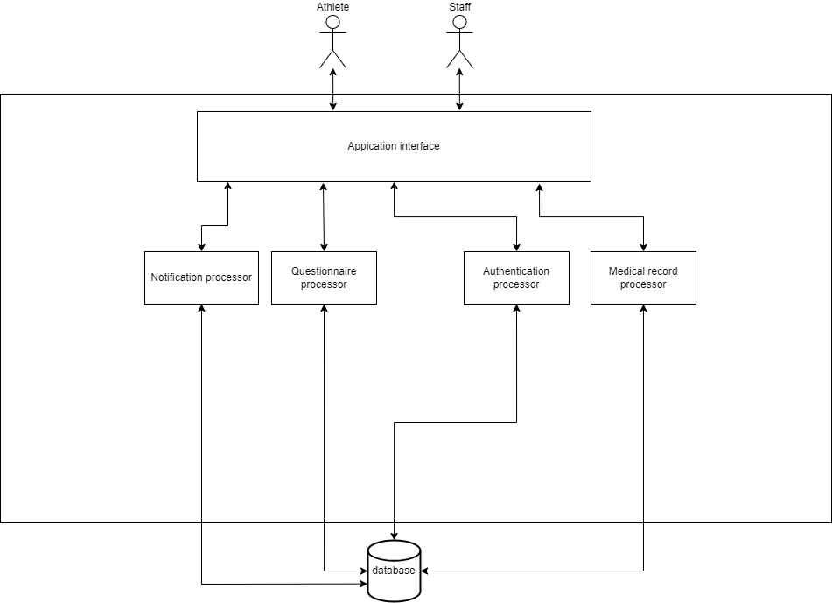

Figure 3.1: SIRA Systems architecture

Figure 3.1 shows the overviews of our system architecture (Sport Injury and Illness Recording Application). There are two types of the users, they are athlete and staff (medical team). The athletes can fill out a weekly injury or illness check questionnaire and submit data to firebase for storage and send to the medical team to track and view illnesses or injuries outside of athletes from training or competition. The staff can not only track and view athlete symptoms, but also create a record to save diagnoses of athlete symptoms in the firebase for decision-making by the organization. The system includes application interface, questionnaire processor, authentication processor, medical record processor, and notification processor. The application interface can only be used in phones with IOS operating system at this time. Authentication is to manage user accounts which can be separated into two categories, athletes and staff that athletes are allowed to save and read their data. The staff has the same rights as athletes but can be able to view illnesses and injuries data or weekly questionnaires of athletes taking. Doing questionnaire is accessible by athlete, which can be chosen from the application interface and the scores are calculated according to the Oslo Sports Trauma Research Center (OSTRC) and sent to firebase. Tracking will have access from medical team coming through the application interface to access athlete information. Forgot password can set the new password from the user send the email in the application interface. In order to connect to the database, the database manager serves as a controller. All statistical data can be stored in a database.

Figure 3.2: SIRA systems workflow

Figure 3.2 represents the workflow of all processes that specify whether athletes, staffs as well as the SIRA systems. The process starts from completion of questionnaire from athletes in order to save a result into the database (Firebase Firestore). After saved into the database, the system will send a notification of which questionnaire contains a total score over 25 points to staffs as a case. Then, staff will see the notification and receive whatever they want. Next, staffs have to complete a medical record regard to the received cases. After they finished the medical record, the system will notify the questionnaire status and advice messages for athlete from the staff who received. Then, athlete will receive the notification and they need to check the questionnaire status and react to advice messages for healing themselves. In addition, staffs can view the case and medical record history. Also, athletes can view the questionnaire history and advice messages.

## System Structure Chart

We produced the system structure chart, which illustrated the process all users would urge in terms of a diagram, in order to demonstrate how the SIRA system would be processed. The essential procedures for the recording system were analyzed and organized in the system structure chart. Additionally, a graphic and description have been used to explain the data that was needed to carry out the process.

|  |  |
| --- | --- |
|  | |
| Project : Sport Injury and Illness Recording Application  System : Recording system | Major Advisor : Asst. Prof. Dr. Charnyote Pluempitiwiriyawej |
| Description : This diagram represents the structure chart of main processes that both athlete and staff have to work as a procedure. | |

Figure .: Structure chart of SIRA system

The detailed description of each subsystem is shown below:

1. **Authentication process** – Users have to authenticate to our system both registration and log in in order to access the interactive interfaces
   1. Register to the system – Fill in the personal information, username, and updated password to register to the system
   2. Log on to the authentication – Fill in the email and password in order to verify the authentication part and access to the interfaces
2. **Complete the questionnaire** – Athletes choose the questionnaire type, then complete whether questionnaire and complain
   1. Choosing the questionnaire type – Athletes choose the questionnaire type including health questionnaire, physical complain, or mental questionnaire
   2. Fill in the chosen questionnaire – Fill in or choose an answer in order to complete the questionnaire
3. **Notify cases** – Notification for staff in order to notify the case from athlete’s questionnaire after it is finished
   1. Receiving cases – Staff receive the notification from the system
4. **Complete the medical record** – Staffs have to fill in the medical record from case diagnostic
   1. Diagnostic the cases from athlete – Diagnostic whether health, body injury, and mental problem from athletes’ cases
   2. Choosing the medical record type – Staffs choose the appropriately medical record type to received cases
   3. Fill in the chosen medical record – Staffs complete the chosen medical record from the diagnostic result
5. **Notify status and advice messages** – The system will send the notification of status and advice message from staff who received their case
   1. Receiving status and advice messages – Athletes will receive the notification from staff in order to verify their questionnaire status and know how to react to their injury or illness
6. **Retrieve result questionnaire history** – Athletes can view their questionnaire history to check the past cases
   1. Query the result questionnaire history – Athletes query the desired questionnaire by given options or default settings
7. **Retrieve result records and cases** – Staffs can view their medical record history as well as the cases they received
   1. Query the result records and cases – Staffs query the desired record or cases by given options or default settings

## Process Analysis and Design

### Data Flow Diagram

Our data flow diagram represents the structure and analysis of the processes that can take place in our system and describes the system's flow. The graphic illustrates the processes that our users can carry out and how they create a process in order to produce an output, such as registration, login, completing a questionnaire, and other procedures. The diagram also shows the users who might be the main users, the data that is collected into the database, and the database that is needed for our systems.

|  |  |
| --- | --- |
|  | |
| Project : Sport Injury and Illness Recording Application  System : Recording system | Major Advisor : Asst. Prof. Dr. Charnyote Pluempitiwiriyawej |
| Description : This diagram represents how athletes and medical team are interacted with the SIRA application. | |

Figure .: SIRA Data Flow Diagram Level 0

|  |  |
| --- | --- |
|  | |
| Project : Sport Injury and Illness Recording Application  System : Recording system | Major Advisor : Asst. Prof. Dr. Charnyote Pluempitiwiriyawej |
| Description : This diagram deep dives into level 1 of the data flow diagram which makes more clearly in each process through the SIRA application. | |

Figure .: SIRA Data Flow Diagram Level 1

### Data Dictionary

A data dictionary is a way to document and describe Processes, Data Stores, and Data Elements (Data Flow) that occur in a Data Flow Diagram (DFD). It is composed of 3 parts as shown below.

* Process Descriptions
* Data Stores
* Data Elements

#### Process Description

This section will provide the detailed description of each process that exists in this system. It includes Inbound Data, Outbound Data, and Logic Summary.

Table .: List of all Processes

| No. | Process | Name | Description |
| --- | --- | --- | --- |
| 1 | P1 | Authentication process | The process of authentication both register and log in to the system |
| 2 | P2 | Complete the questionnaire | Fill in the questionnaire in the system |
| 3 | P3 | Notify cases | Notification for medical team to examine the cases |
| 4 | P4 | Complete the medical record | Fill in the medical record from a diagnostic result |
| 5 | P5 | Notify status and advice messages | Notification for athlete to receive the questionnaire status and advice messages |
| 6 | P6 | Retrieve result questionnaire history | Query for retrieving the questionnaire result history description |
| 7 | P7 | Retrieve result records and cases | Query for retrieving the medical result history description and cases history description |

Table 3.2: Process Description of Log on to the application authentication

|  |  |
| --- | --- |
| Process Name | P1 – Authentication process |
| Description | The process of authentication both register and log in to the system |
| Inbound data | * Athlete’s username and password * Staff’s username and password * Athlete’s data * Staff’s data |
| Outbound Data | * User’s username and password * Athlete’s data * Staff’s data |
| Logic Summary | No subsystem |

Table 3.3: Process Description of Complete the questionnaire

|  |  |
| --- | --- |
| Process Name | P2- Complete the questionnaire |
| Description | Fill in the questionnaire in the system |
| Inbound data | * Answer & Score |
| Outbound Data | * Answer result * Total score * Preliminary advice message |
| Logic Summary | No subsystem |

Table 3.4: Process Description of Notify cases

|  |  |
| --- | --- |
| Process Name | P3- Notify cases |
| Description | Notification for medical team to examine the cases |
| Inbound data | * Total score over 25 * Questionnaire case description |
| Outbound Data | * Questionnaire case description and total score |
| Logic Summary | No subsystem |

Table 3.5: Process Description of Complete the medical record

|  |  |
| --- | --- |
| Process Name | P4- Complete the medical record |
| Description | Fill in the medical record from a diagnostic result |
| Inbound data | * Diagnostic result for athlete * Advice messages |
| Outbound Data | * Questionnaire status * Diagnostic results for athlete * Advice messages |
| Logic Summary | No subsystem |

Table 3.6: Process Description of Notify status and advice messages

|  |  |
| --- | --- |
| Process Name | P5- Notify status and advice messages |
| Description | Notification for athlete to receive the questionnaire status and advice messages |
| Inbound data | * Questionnaire status * Advice messages |
| Outbound Data | * Questionnaire status * Advice messages |
| Logic Summary | No subsystem |

Table 3.7: Process Description of Retrieve result questionnaire history

|  |  |
| --- | --- |
| Process Name | P6- Retrieve result questionnaire history |
| Description | Query for retrieving the questionnaire result history description |
| Inbound data | * Questionnaire history * Query for questionnaire history description |
| Outbound Data | * Questionnaire history description * Query for questionnaire history description |
| Logic Summary | No subsystem |

Table 3.8: Process Description of Retrieve result records and cases

|  |  |
| --- | --- |
| Process Name | P7- Retrieve result records and cases |
| Description | Query for retrieving the medical result history description and cases history description |
| Inbound data | * Query for case history * Query for medical record * Case history * Diagnostic record |
| Outbound Data | * Medical record description * Case history description * Query for case history * Query for medical record |
| Logic Summary | No subsystem |

#### Data Stores

This section describes the data stores that exist in the data flow diagram and consists of the Data Store Name, Description, Inbound Data, and Outbound Data.

Table 3.9: List of all Data Stores

| No. | Data Store | Name | Description |
| --- | --- | --- | --- |
| 1 | D1 | Users database | Keeping the staff and athlete data |
| 2 | D2 | Questionnaire database | Keeping the result of questionnaire from athletes |
| 3 | D3 | Medical record database | Keeping the result of diagnostic from medical team |
| 4 | D4 | Message database | Keeping the messages between athletes and staffs |

Table 3.10: Data Store Description of Users database

|  |  |
| --- | --- |
| Data Store Name | D1- Users database |
| Description | Keeping the staff and athlete data |
| Inbound data | * Athlete’s data * Staff’s data * User’s username and password |
| Outbound Data | * User verification |

Table 3.11: Data Store Description of Questionnaire database

|  |  |
| --- | --- |
| Data Store Name | D2- Questionnaire database |
| Description | Keeping the result of questionnaire from athletes |
| Inbound data | * Answer result * Total score * Questionnaire status * Query for questionnaire history description |
| Outbound Data | * Total score over 25 * Questionnaire case description * Questionnaire history * Questionnaire status |

Table 3.12: Data Store Description of Medical record database

|  |  |
| --- | --- |
| Data Store Name | D3- Medical record database |
| Description | Keeping the result of diagnostic from medical team |
| Inbound data | * Diagnostic results for athlete * Query for case history * Query for diagnostic record |
| Outbound Data | * Medical record * Case history |

Table 3.13: Data Store Description of Medical record database

|  |  |
| --- | --- |
| Data Store Name | D4- Message database |
| Description | Keeping the messages between athletes and staffs |
| Inbound data | * Advice messages |
| Outbound Data | * Advice messages |

#### Data Element

This section describes the data elements or data flows that exist in this system. The table below contains the list of all data elements belonging to their data element name, starting process/source/data store, and ending process/source/data store.

Table 3.14: List of All Data Elements

| SEQ | Data Element Name | From Process/Source/Data Store | To Process/Source/Data Store |
| --- | --- | --- | --- |
| 1 | Athlete’s data | Athlete | P1 |
| 2 | Athlete’s data | P1 | D1 |
| 3 | Staff’s data | Medical Team | P1 |
| 4 | Staff’s data | P1 | D1 |
| 5 | Athlete’s username & password | Athlete | P1 |
| 6 | Staff’s username & password | Medical Team | P1 |
| 7 | User’s username & password | P1 | D1 |
| 8 | User verification | D1 | P1 |
| 9 | Answer & Score | Athlete | P2 |
| 10 | Preliminary advice message | P2 | Athlete |
| 11 | Answer result | P2 | D2 |
| 12 | Total score | P2 | D2 |
| 13 | Total score over 25 | D2 | P3 |
| 14 | Questionnaire case description | D2 | P3 |
| 15 | Questionnaire case description & Total score | P3 | Medical Team |
| 16 | Diagnostic results for athlete | Medical Team | P4 |
| 17 | Advice messages | Medical Team | P4 |
| 18 | Questionnaire status | P4 | D2 |
| 19 | Advice messages | P4 | D4 |
| 20 | Diagnostic results for athlete | P4 | D3 |
| 21 | Questionnaire status | D2 | P5 |
| 22 | Advice messages | D4 | P5 |
| 23 | Questionnaire status | P5 | Athlete |
| 24 | Advice messages | P5 | Athlete |
| 25 | Query for questionnaire history description | Athlete | P6 |
| 26 | Query for questionnaire history description | P6 | D2 |
| 27 | Questionnaire history | D2 | P6 |
| 28 | Questionnaire history description | P6 | Athlete |
| 29 | Query for case history | Medical Team | P7 |
| 30 | Query for diagnostic record | Medical Team | P7 |
| 31 | Query for case history | P7 | D3 |
| 32 | Query for diagnostic record | P7 | D3 |
| 33 | Case history | D3 | P7 |
| 34 | Diagnostic record | D3 | P7 |
| 35 | Case history description | P7 | Medical Team |
| 36 | Diagnostic record description | P7 | Medical Team |

## Database Analysis and Design

The systems are created with interactive together which contain the entities, relationships, and attributes. Each entity will contain its data as attributes that represent the needed data as well as primary key and foreign key which can be used in SQL. The attribute contains the data that is relevant to them which some data can be null, and some data must fill in. However, this design and analysis are simply examples but cover all main users and data in our game system.

### ER-Diagram

|  |  |
| --- | --- |
|  | |
| Project: Sport Injury and Illness Recording Application  System: Recording system | Major Advisor: Asst. Prof. Dr. Charnyote Pluempitiwiriyawej |
| Description: This is ER-Diagram of SIRA including four entities that are superclass. User class has two subclasses including “Athlete” and “Staff”. Questionnaire class has two subclasses including “HealthQuestionnaire” and “PhysicalQuestionnaire”. MedicalRecord class has two subclasses including “IllnessRecord” and “InjuryRecord”. Message is weak entity from Medical Record. | |

Figure .: Conceptual ER-Diagram of SIRA Database

### Relational Schema

This section describes the attributes of the tables in the database. The attribute notation is shown below.

* **Attributes** – which are bold and underlined are the Primary Keys
* *Attributes* – which are Italic are the Foreign Keys
* ***Attributes*** – which are bold, italic and underlined are both Primary Keys and Foreign Keys

Tables in this system can be divided into 3 groups as follows:

* Master File Table
* Base File Table
* Transaction File Table

Table .: List of all Tables in Our System Database

| Table# | Table Name | Table Type | Description |
| --- | --- | --- | --- |
| 1 | Athlete | Master | It is the subclass that collects the information of athlete. |
| 2 | Staff | Master | It is the subclass that collects the information of staff. |
| 3 | HealthQuestionnaire | Base | It is the subclass that collects all of health questionnaires that athletes do. |
| 4 | PhysicalQuestionnaire | Base | It is the subclass that collects all of physical questionnaires that athletes do. |
| 5 | IllnessRecord | Base | It is the subclass that collects all of illness records that staffs do. |
| 6 | InjuryRecord | Base | It is the subclass that collects all of injury records that staffs do. |
| 7 | Message | Base | This table is the weak entity that collects the messages that occur when the staff makes a record for the athlete. |

1. Relational Schema of Master File Tables

**Athlete**

|  |  |  |  |  |  |  |  |
| --- | --- | --- | --- | --- | --- | --- | --- |
| **uid** | **athlete_no** | username | password | firstname | lastname | sportType | birthdate |

|  |  |  |  |  |  |
| --- | --- | --- | --- | --- | --- |
| department | weight | height | email | age | gender |

**Staff**

|  |  |  |  |  |  |  |  |
| --- | --- | --- | --- | --- | --- | --- | --- |
| **uid** | **staff_no** | username | password | firstname | lastname | stafftType | birthdate |

|  |  |
| --- | --- |
| department | email |

1. Relational Schema of Base File Tables

**HealthQuestionnaire**

|  |  |  |  |  |
| --- | --- | --- | --- | --- |
| **questionnaireNo** | ***athleteNo*** | questionnaireType | totalPoint | caseFinished |

|  |  |  |  |  |  |  |  |
| --- | --- | --- | --- | --- | --- | --- | --- |
| caseRecieved | healthSymptom | doDate | ***staff_no_received*** | Q1 | Q2 | Q3 | Q4 |

**PhysicalQuestionnaire**

|  |  |  |  |  |
| --- | --- | --- | --- | --- |
| **questionnaireNo** | *athleteNo* | questionnaireType | totalPoint | caseFinished |

|  |  |  |  |  |  |  |  |
| --- | --- | --- | --- | --- | --- | --- | --- |
| caseRecieved | bodypart | doDate | *staff_no_received* | Q1 | Q2 | Q3 | Q4 |

**IllnessRecord**

|  |  |  |  |  |  |  |
| --- | --- | --- | --- | --- | --- | --- |
| **report_id** | *staff_uid* | *athlete_no* | report_type | sport_event | DoingDate | affected_system_code |

|  |  |  |  |  |  |
| --- | --- | --- | --- | --- | --- |
| affected_system | diagnosis | illness_cause | mainSymtoms | mainSymptomsCode | illness_cause_code |

|  |  |
| --- | --- |
| occurred_date | no_day |

**InjuryRecord**

|  |  |  |  |  |  |  |
| --- | --- | --- | --- | --- | --- | --- |
| **report_id** | *staff_uid* | *athlete_no* | report_type | sport_event | DoingDate | round_heat_training |

|  |  |  |  |  |  |
| --- | --- | --- | --- | --- | --- |
| injuryBody | injuryBodyCode | injuryCause | injuryCauseCode | injuryDateTime | injuryTypeCode |

|  |  |
| --- | --- |
| injuryType | no_day |

**Message**

|  |  |  |  |  |
| --- | --- | --- | --- | --- |
| **messageNo** | messageDescription | messageDateTime | *athleteNo* | *staffUID* |

### File Structure

This section shows the details of each file component including field name, field description, field data type, field length, null value, primary key and foreign key.

Table 3.16: File Structure of Athlete

|  |  |  |  |  |  |  |  |  |
| --- | --- | --- | --- | --- | --- | --- | --- | --- |
| Table Name : | Athlete | | | | | | Table#**1** | |
| Table Type : | Master | | | | | | | |
| Description : | Storing the information of athletes. | | | | | | | |
| Field Name | | Type | Length | Description | Key | Reference | | Null |
| uid | | varchar | 28 | User’s ID | PK |  | | NOT |
| athleteNo | | varchar | 11 | Athlete’s ID | PK |  | | NOT |
| username | | varchar | 500 | Athlete’s username |  |  | | NOT |
| password | | varchar | 500 | Athlete’s password |  |  | | NOT |
| firstname | | varchar | 500 | Athlete’s firstname |  |  | | NOT |
| lastname | | varchar | 500 | Athlete’s lastname |  |  | | NOT |
| sportType | | varchar | 500 | Athlete’s sport type |  |  | | NOT |
| birthdate | | DATE | 100 | Athlete’s birth date |  |  | | NOT |
| department | | varchar | 500 | User’s department |  |  | | NOT |
| weight | | double | 11 | Athlete’s weight |  |  | | NOT |
| height | | double | 11 | Athlete’s height |  |  | | NOT |
| age | | int | 2 | Athlete’s age |  |  | | NOT |
| gender | | varchar | 6 | Athlete’s gender |  |  | | NOT |
| email | | varchar | 500 | Athlete’s email |  |  | | NOT |
|  | | Total | 3669 | Bytes |  |  | |  |

|  |  |  |  |  |  |  |  |  |
| --- | --- | --- | --- | --- | --- | --- | --- | --- |
| Table Name : | Staff | | | | | | Table#**2** | |
| Table Type : | Master | | | | | | | |
| Description : | Storing the information of staffs. | | | | | | | |
| Field Name | | Type | Length | Description | Key | Reference | | Null |
| uid | | varchar | 28 | User’s ID | PK |  | | NOT |
| staffNo | | varchar | 11 | Staff’s ID | PK |  | | NOT |
| username | | varchar | 500 | Staff’s username |  |  | | NOT |
| password | | varchar | 500 | Staff’s password |  |  | | NOT |
| firstname | | varchar | 500 | Staff’s firstname |  |  | | NOT |
| lastname | | varchar | 500 | Staff’s lastname |  |  | | NOT |
| staffType | | varchar | 500 | Staff’s type |  |  | | NOT |
| birthdate | | DATE | 100 | Staff’s birth date |  |  | | NOT |
| department | | varchar | 500 | User’s department |  |  | | NOT |
| email | | varchar | 500 | Staff’s email |  |  | | NOT |
|  | | Total | 3639 | Bytes |  |  | |  |

Table 3.17: File Structure of Staff

Table 3.18: File Structure of Health questionnaire

|  |  |  |  |  |  |  |  |  |
| --- | --- | --- | --- | --- | --- | --- | --- | --- |
| Table Name : | HealthQuestionnaire | | | | | | Table#**3** | |
| Table Type : | Base | | | | | | | |
| Description : | Storing the athlete’s health questionnaire answers and calculate the score | | | | | | | |
| Field Name | | Type | Length | Description | Key | Reference | | Null |
| questionnaireNo | | varchar | 12 | Questionnaire’s ID | PK |  | | NOT |
| athleteNo | | varchar | 28 | Athlete’s user ID | FK | Athlete | | NOT |
| questionnaireType | | varchar | 500 | Questionnaire’s type |  |  | | NOT |
| totalPoint | | int | 3 | Total of points |  |  | | NOT |
| caseFinished | | varchar | 500 | Check this case finish or not |  |  | | NOT |
| caseReceived | | varchar | 500 | Check this case receive or not |  |  | | NOT |
| healthSymptom | | varchar | 500 | Athlete’s health symptom |  |  | | NOT |
| doDate | | DATETIME | 100 | Questionnaire’s do date and time |  |  | | NOT |
| staff_no_received | | varchar | 500 | Staff’s user ID who receives the athlete’s case | FK | Staff | | NOT |
| Q1 | | int | 11 | Question 1 point |  |  | | NOT |
| Q2 | | int | 11 | Question 2 point |  |  | | NOT |
| Q3 | | int | 11 | Question 3 point |  |  | | NOT |
| Q4 | | int | 11 | Question 4 point |  |  | | NOT |
|  | | Total | 2687 | Bytes |  |  | |  |

Table 3.19: File Structure of Physical questionnaire

|  |  |  |  |  |  |  |  |  |
| --- | --- | --- | --- | --- | --- | --- | --- | --- |
| Table Name : | PhysicalQuestionnaire | | | | | | Table#**4** | |
| Table Type : | Base | | | | | | | |
| Description : | Storing the athlete’s physical questionnaire answers and calculate the score | | | | | | | |
| Field Name | | Type | Length | Description | Key | Reference | | Null |
| questionnaireNo | | varchar | 12 | Questionnaire’s ID | PK |  | | NOT |
| athleteNo | | varchar | 28 | Athlete’s user ID | FK | Athlete | | NOT |
| questionnaireType | | varchar | 500 | Questionnaire’s type |  |  | | NOT |
| totalPoint | | int | 3 | Total of points |  |  | | NOT |
| caseFinished | | varchar | 500 | Check this case finish or not |  |  | | NOT |
| caseReceived | | varchar | 500 | Check this case receive or not |  |  | | NOT |
| bodyPart | | varchar | 500 | Athlete’s body part |  |  | | NOT |
| doDate | | DATETIME | 100 | Questionnaire’s do date and time |  |  | | NOT |
| staff_no_received | | varchar | 500 | Staff’s user ID who receives the athlete’s case | FK | Staff | | NOT |
| Q1 | | int | 11 | Question 1 point |  |  | | NOT |
| Q2 | | int | 11 | Question 2 point |  |  | | NOT |
| Q3 | | int | 11 | Question 3 point |  |  | | NOT |
| Q4 | | int | 11 | Question 4 point |  |  | | NOT |
|  | | Total | 2687 | Bytes |  |  | |  |

Table 3.20: File Structure of Illness record

|  |  |  |  |  |  |  |  |  |
| --- | --- | --- | --- | --- | --- | --- | --- | --- |
| Table Name : | IllnessRecord | | | | | | Table#**5** | |
| Table Type : | Base | | | | | | | |
| Description : | Storing the illness record that staff do. | | | | | | | |
| Field Name | | Type | Length | Description | Key | Reference | | Null |
| report_id | | varchar | 12 | Report’s ID | PK |  | | NOT |
| staff_uid | | varchar | 28 | Staff’s user ID | FK | Staff | | NOT |
| athlete_no | | varchar | 11 | Athlete’s ID |  |  | | NOT |
| report_type | | varchar | 500 | Report’s type |  |  | | NOT |
| sport_event | | varchar | 500 | Sport that causes illness in the event |  |  | | NOT |
| DoingDate | | varchar | 500 | Staff’s do date |  |  | | NOT |
| affected_system | | varchar | 500 | Affected system that happen to athlete |  |  | | NOT |
| affected_system_code | | int | 2 | Affected system code |  |  | | NOT |
| diagnosis | | varchar | 500 | The identification of the nature of an illness or other problem by examination |  |  | | NOT |
| illness_cause | | varchar | 500 | The cause of illness |  |  | | NOT |
| illness_cause_code | | int | 2 | Illness’s cause code |  |  | | NOT |
| mainSymptoms | | varchar | 500 | Main Symptoms diagnosed |  |  | | NOT |
| mainSymptomsCode | | int | 2 | Main Symptoms code |  |  | | NOT |
| occurred_date | | DATETIME | 100 | The date and time that occur illness |  |  | | NOT |
| no_day | | varchar | 100 | The day to rest or stop training |  |  | | NOT |
|  | | Total | 3757 | Bytes |  |  | |  |

Table 3.21: File Structure of Injury record

|  |  |  |  |  |  |  |  |  |
| --- | --- | --- | --- | --- | --- | --- | --- | --- |
| Table Name : | InjuryRecord | | | | | | Table#**6** | |
| Table Type : | Base | | | | | | | |
| Description : | Storing the injury record that staff do. | | | | | | | |
| Field Name | | Type | Length | Description | Key | Reference | | Null |
| report_id | | varchar | 12 | Report’s ID | PK |  | | NOT |
| staff_uid | | varchar | 28 | Staff’s user ID | FK | Staff | | NOT |
| athlete_no | | varchar | 11 | Athlete’s ID |  |  | | NOT |
| report_type | | varchar | 500 | Report’s type |  |  | | NOT |
| sport_event | | varchar | 500 | Sport that causes injury in the event |  |  | | NOT |
| DoingDate | | varchar | 500 | Staff’s do date |  |  | | NOT |
| injuryBody | | varchar | 500 | The athlete’s body part that injuries |  |  | | NOT |
| injuryBodyCode | | int | 2 | Injury Body code |  |  | | NOT |
| round_heat_training | | varchar | 500 | Round, heat or training during an injury |  |  | | NOT |
| injuryCause | | varchar | 500 | The cause of injury |  |  | | NOT |
| injuryCauseCode | | int | 2 | Injury’s cause code |  |  | | NOT |
| injuryDateTime | | DATETIME | 100 | Injury’s date and time |  |  | | NOT |
| injuryType | | varchar | 500 | Injury’s type |  |  | | NOT |
| injuryTypeCode | | int | 2 | Injury’s type code |  |  | | NOT |
| no_day | | varchar | 100 | The day to rest or stop training |  |  | | NOT |
|  | | Total | 3757 | Bytes |  |  | |  |

Table 3.22: File Structure of Illness record

|  |  |  |  |  |  |  |  |  |
| --- | --- | --- | --- | --- | --- | --- | --- | --- |
| Table Name : | IllnessRecord | | | | | | Table#**5** | |
| Table Type : | Base | | | | | | | |
| Description : | Storing the illness record that staff do. | | | | | | | |
| Field Name | | Type | Length | Description | Key | Reference | | Null |
| report_id | | varchar | 12 | Report’s ID | PK |  | | NOT |
| staff_uid | | varchar | 28 | Staff’s user ID | FK | Staff | | NOT |
| athlete_no | | varchar | 11 | Athlete’s ID |  |  | | NOT |
| report_type | | varchar | 500 | Report’s type |  |  | | NOT |
| sport_event | | varchar | 500 | Sport that causes illness in the event |  |  | | NOT |
| DoingDate | | varchar | 500 | Staff’s do date |  |  | | NOT |
| affected_system | | varchar | 500 | Affected system that happen to athlete |  |  | | NOT |
| affected_system_code | | int | 2 | Affected system code |  |  | | NOT |
| diagnosis | | varchar | 500 | The identification of the nature of an illness or other problem by examination |  |  | | NOT |
| illness_cause | | varchar | 500 | The cause of illness |  |  | | NOT |
| illness_cause_code | | int | 2 | Illness’s cause code |  |  | | NOT |
| mainSymptoms | | varchar | 500 | Main Symptoms diagnosed |  |  | | NOT |
| mainSymptomsCode | | int | 2 | Main Symptoms code |  |  | | NOT |
| occurred_date | | DATETIME | 100 | The date and time that occur illness |  |  | | NOT |
| no_day | | varchar | 100 | The day to rest or stop training |  |  | | NOT |
|  | | Total | 3757 | Bytes |  |  | |  |

Table 3.23: File Structure of Message

|  |  |  |  |  |  |  |  |  |
| --- | --- | --- | --- | --- | --- | --- | --- | --- |
| Table Name : | Message | | | | | | Table#**7** | |
| Table Type : | Base | | | | | | | |
| Description : | Storing the message when staff do the record and want to give message to athlete. | | | | | | | |
| Field Name | | Type | Length | Description | Key | Reference | | Null |
| messageNo | | varchar | 11 | Message’s ID | PK |  | | NOT |
| messageDescription | | varchar | 500 | Message description |  |  | | NOT |
| messageDateTime | | DATETIME | 100 | Message’s date and time |  |  | | NOT |
| athleteNo | | varchar | 11 | Athlete’s ID | FK | Athlete | | NOT |
| staffUID | | varchar | 28 | Sport that causes illness in the event | FK | Staff | | NOT |
|  | | Total | 650 | Bytes |  |  | |  |

## I/O Design

This section explains the design of the Input and Output User Interface. The section consists of two parts, the interface design and the transition diagram showing transition through the system.

### Interface Design

Figure 3.7: Register and Login

According to Figure 3.7, users must sign in in login page and sign up in register page to create an account.

Figure 3.8 Staff/Athlete Homepage

According to Figure 3.8, both interfaces contain staff homepage (left picture) and athlete homepage (right picture). When user’s login successfully, user can go to homepage first. If you are athlete, your homepage has the green bottom bar that has home, search, and history button. If you are staff, your homepage has the blue bottom bar that has home, history, and cases button

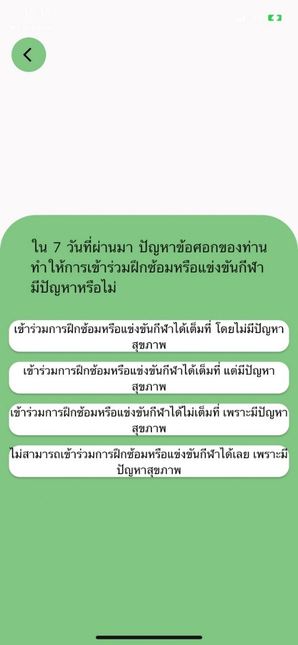

Figure 3.9: Questionnaire page

According to Figure 3.9, athletes have the three questionnaire buttons in their homepage that are health questionnaire, physical complain, and mental questionnaire.

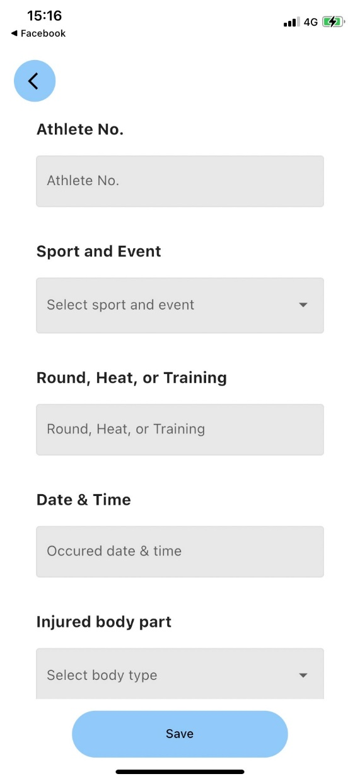

Figure 3.10: Recording page

According to Figure 3.10, athletes have the two recording buttons in their homepage that are illness and injury record.

Figure 3.11: Notification page

According to Figure 3.11, both interfaces represent the athlete notification page (left picture) and the staff notification page (right page). For notification page, Athletes and staffs can see the top right button in homepage that have bell button, it is notification button. The alarm button properties of both parties are different as follows:

* **Athlete’s notification (Left picture)**

It notifies the message that the staff or medical team sent to that athlete.

* **Staff’s notification (Right picture)**

It notifies the cases that the athlete has completed the questionnaire and the points are due to be recorded by the medical team which the medical team can accept cases by pressing the plus button and reading the description above the button.

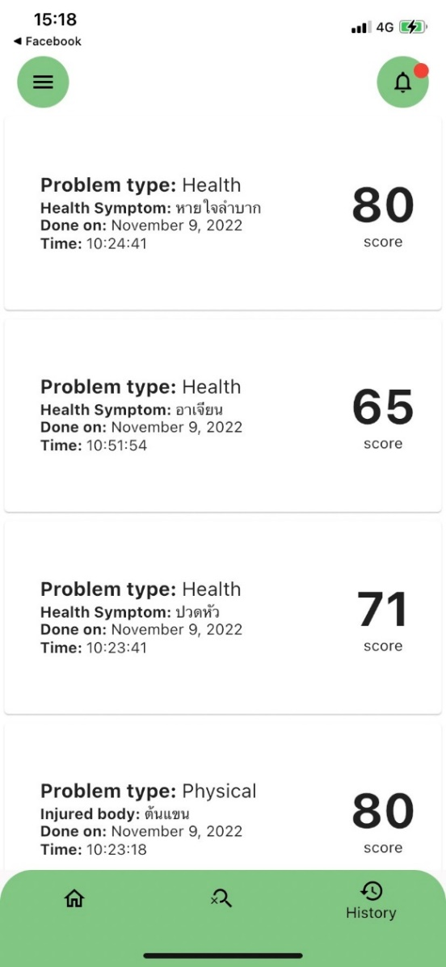 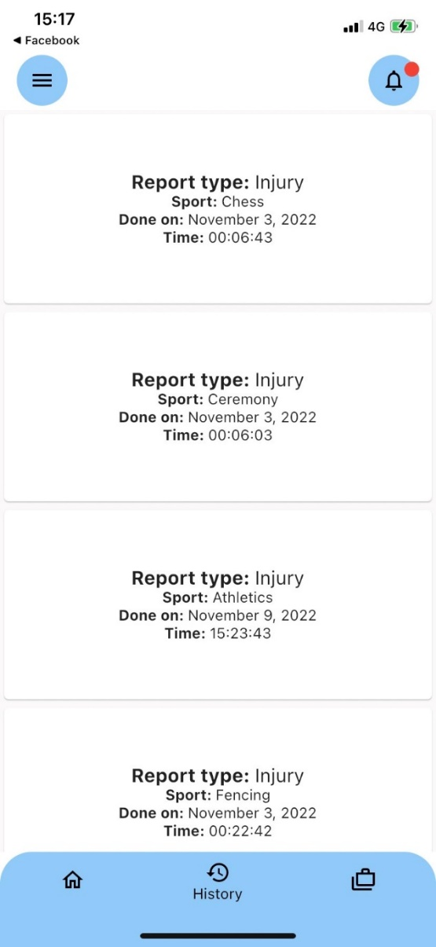

Figure 3.12: History page

According to Figure 3.12, both interfaces represent the athlete history page (left picture) and the staff history page (right picture). Athlete and staff have the history button that each position when pressing the history data button is different as follows:

* **Athlete’s history (Left picture)**

It shows the history of the questionnaires that athletes do it. It shows the questionnaire score, questionnaire type, health symptom or injured body, and date and time of the questionnaire.

* **Staff’s history (Right picture)**

It shows report completed by staff which shows data card with report type, sport, and date and time of the finished report.

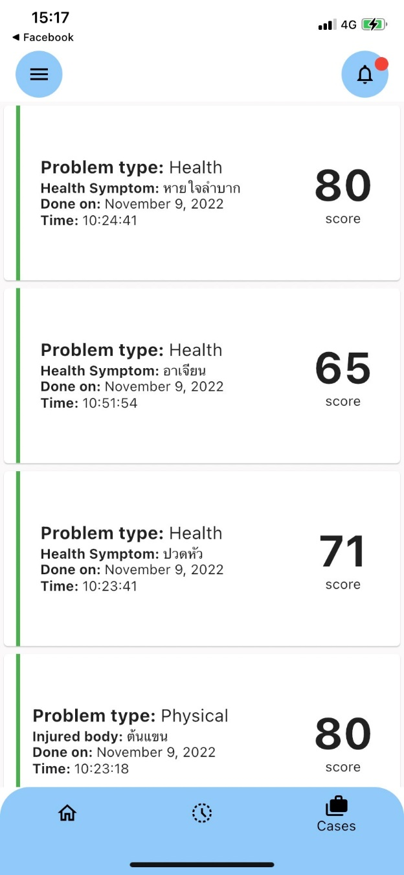

Figure 3.13: Staff’s case page

Figure 3.13 shows the cases that staff receive in the notification. When staff click plus button in notification, the received case will show in the case page with red line tag. If staffs finish the received case, the case will change the red line tag to green line tag. Cards in the case page show several information, for instance, the received case history, case’s score, problem type, and others.

CHAPTER 4

# Implementation

## Hardware and System Environment

* Operating System and Utilities Applications
* Web Server Software
* Editor
* Database Management System (DBMS)
* Programming and Scripting Tools
* Components

## Implementation Guide and Techniques

### <Guide/Technique/Know-how>

### < Guide/Technique/Know-how>

CHAPTER 5

# Testing and Evaluation

## Unit Tests

For the unit tests, we selected some important and critical processes for formal unit testing. The selected processes include:



### Test Performed on <Process Number> <Process Name>

Table 5.1: <Test Name>

|  |  |  |
| --- | --- | --- |
| Operation Performed | Condition Tested | Actual Result |
|  |  |  |
|  |  |  |
|  |  |  |
|  |  |  |
|  |  |  |

### Test Performed on <Process Number> <Process Name>

Table 5.2: <Test Name>

|  |  |  |
| --- | --- | --- |
| Operation Performed | Condition Tested | Actual Result |
|  |  |  |
|  |  |  |
|  |  |  |
|  |  |  |

## System Integration Test

This activity is performed after the system is completely integrated. The purpose of this testing is to check whether the system can operate correctly according to the required functions or not.

### Test Scenario

In order to test all functional aspects of the system thoroughly, we had set up a test scenario which consisted of phases as shown below.

Moreover, the test scenario can be used as a user guideline because it covers all the steps necessary in order to use our system. The details of each phase are shown in the next section.

#### 

#### 

#### 

#### 

#### 

CHAPTER 6

# Conclusions

## Benefits

### Benefits to Project Developers

### Benefits to Users

## Problems and Limitations

## Future Work

REFERENCES

1. Author. *Title*. Series Title [Type of Medium] Year Last Update Date [cited Access Year Access Date]; Edition:[Description]. Available from: URL

2. Author, B., *Title*. Editon ed. Series Title, ed. S. Editor. Vol. Volume. Year, City: Publisher. Number of Pagers.

APPENDIX A

# <INSERT YOUR TOPIC>

BIOGRAPHIES

|  |  |
| --- | --- |
| NAME | Mr. Krissanapong Palakham |
| INSTITUTIONS ATTENDED | Assumption College Thonburi, 2019:  High School Diploma  Mahidol University, 2023:  Bachelor of Science (ICT) |
|  |  |
| NAME | Mr. Pongsakorn Piboonpongpun |
| INSTITUTIONS ATTENDED | Assumption College Thonburi, 2019:  High School Diploma  Mahidol University, 2023:  Bachelor of Science (ICT) |
|  |  |
| NAME | Mr. Rathakit Sriprachayanun |
| INSTITUTIONS ATTENDED | , :  High School Diploma  Mahidol University, 2023:  Bachelor of Science (ICT) |