**CERTIFICATE**

This is to certify that the work titled “Navigation and Obstacle Avoidance for Autonomous Vehicles” submitted by “**SHUBHANKAR KAUSHIK (21102031)**” in partial fulfilment for the award of degree of Bachelors of Technology of Jaypee Institute of Information Technology, Noida has been conducted under my supervision. This work has not been submitted partially or completely to any other University or Institute for the award of this or any other degree or diploma.

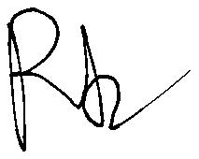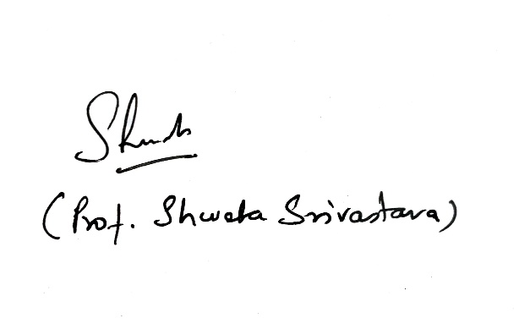

**(Mr. Ritesh Kumar Sharma) (Prof. Shweta Sristava)**

Associate Professor HOD - ECE

**Date:** 10/5/2025

**CERTIFICATE**

This is to certify that the work titled “Navigation and Obstacle Avoidance for Autonomous Vehicles” submitted by “**SAKSHAM SAHA (21102033)**” in partial fulfilment for the award of degree of Bachelors of Technology of Jaypee Institute of Information Technology, Noida has been conducted under my supervision. This work has not been submitted partially or completely to any other University or Institute for the award of this or any other degree or diploma.



**(Mr. Ritesh Kumar Sharma) (Prof. Shweta Sristava)**

Associate Professor HOD - ECE

**Date:** 10/5/2025