Team 2
Software Requirements Specification

Release 1

REVISION HISTORY

VERSION | DATE | DESCRIPTION | AUTHOR
1.0 | 18.02 | A C++ speed typing trainer that helps developers and students improve their typing speed and accuracy | Dumitru Ciobanu, Andreas Müller, Andres Alexander Jürgenson

CONTENTS

1 SW System Overview 4
1.1 Purpose 4
1.2 Scope 4
1.3 Use-Case Diagram 4
1.4 General Constraints 4
1.5 Assumptions and Dependencies 4
1.6 Acronyms and Abbreviations 4
2 SW Functional Requirements 5
2.1 Features / Functions to be Implemented 5
2.1 Acceptance Criteria 5
2.2 Implementation Requirements 5
3 SW Non-Functional Requirements 6
3.1 Resource Consumption 6
3.2 License Issues 6
3.3 Coding Standard 6
3.4 Modular Design 6
3.5 Reliability 6
3.6 Portability 6
3.7 General Operational Guidelines 6
4 SW Design Artifacts 7
4.1 CRC Cards (Class–Responsibility–Collaboration) 7
4.2 Conceptual UML Diagram (entities & relationships) 7

SW System Overview
Specify the purpose and the overview of the SRS.

Purpose
Describe the purpose of the system. What problem does it solve? Who are the intended users? Why is it being developed?

The purpose of a Speed Typing Trainer built in C++ is for users to measure and improve their tactile data-entry skills.

Solves: Input inefficiency and web-based trainers have slight input lag

Intended users: Students, Software developers, Hobbyists, Academics

Development reason: Demonstrates the ability to handle real-time user input, minimalist efficiency for people who enjoy “zen-mode”

Scope
Define the scope of the system. What functionality is included? What is explicitly excluded? Mention benefits and key features.

Functionality: Display a source text that changes color, capture every keystroke to calculate WPM (Words Per Minute) using high-resolution clocks, post-test summary showing the percentage of error, difficulty tiers

Excluded: cloud synchronization, AI-generated text

Benefits: Directly translates to faster email drafting or coding, no data sent to third-party servers, asynchronous handling

Key features: zero-latency engine, sudden death mode ( forcing a focus on 100% accuracy )

Use-Case Diagram
Provide a high-level UML use-case diagram showing main actors and their interactions with the system.

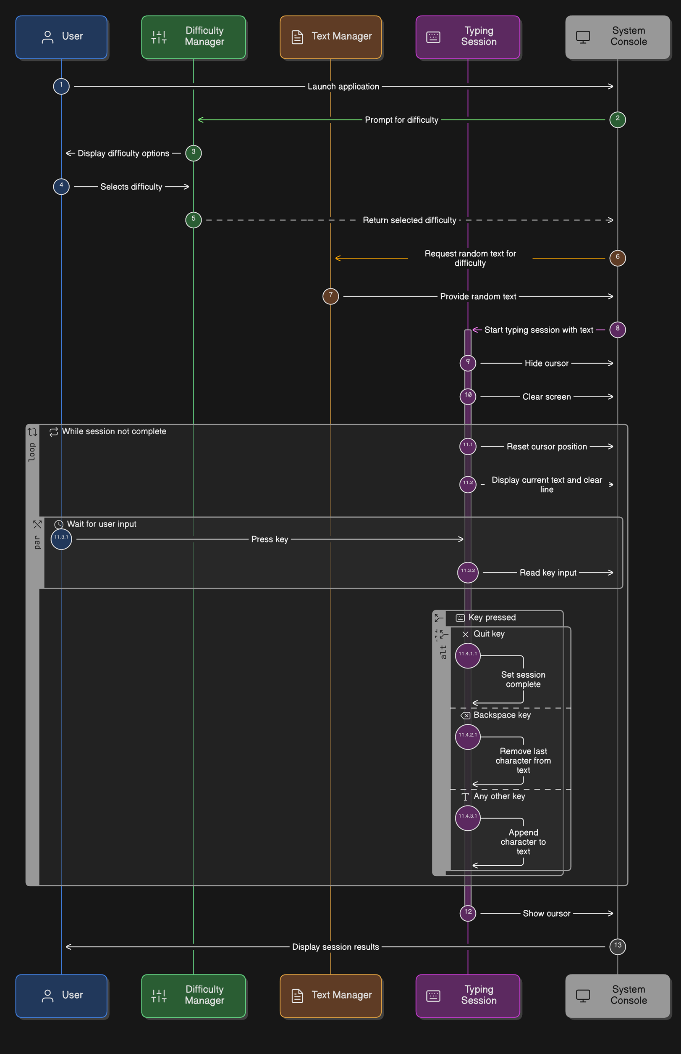

General Constraints
List technical and business constraints such as programming language, operating system, performance limitations, and standards.

Programming language: C++
Operating system: Windows 11 & NixOS
Performance limitations: >= 10ms
Standards: UTF-8 encoding for characters, GDPR

Assumptions and Dependencies
State assumptions (e.g., availability of internet, supported devices) and dependencies (e.g., external APIs, hardware).

Assumptions: use of standard QWERTY keyboard, availability of terminal, user literacy, local storage permissions

Dependencies: Physical keyboard, standard library, compiler (MinGW, Clang)

Acronyms and Abbreviations
List all acronyms and abbreviations used in the document along with their explanations.
Terms Used | Description of terms
GDPR | General Data Protection Regulation
WPM | Words Per Minute
CPM | Characters Per Minute

SW Functional Requirements

2.1 Features / Functions to be Implemented
All functional requirements should be derived from User Stories or Use Cases.
This means that instead of listing abstract features, you first describe how users interact with the system and what goals they achieve.
User Stories – short, simple descriptions of a feature told from the perspective of the user (e.g., “As a registered user, I want to reset my password so that I can regain access to my account.”).
Use Cases – structured scenarios that describe interactions between actors and the system, including preconditions, steps, and outcomes.
From these stories/cases, you can then identify:
- User interactions (e.g., authentication, profile management).
- Business processes (e.g., order processing, reporting).
- Integrations (e.g., with external APIs or third-party systems).
- System logic (e.g., validation, workflows, automation).
- Algorithms (if required, e.g., recommendation or prediction).
Each function must be traceable back to a User Story or Use Case, ensuring that the system is built strictly according to user and business needs.
User stories:
As a user, I want to practice typing C++ code so that I can improve my programming speed. -> System must read .cpp files to present typing prompts, preserving indentation and special characters
As a user, I want my typing speed calculated so that I can track improvement. -> System must implement a timer that triggers on the first keystroke and stops on the last calculating WPM
As a user, I want errors highlighted so that I know what to correct. -> UI must compare the user’s char against the buffer char
As a user, I want different difficulty levels so that I can progress gradually -> System must categorize text sources by complexity
As a user, I want a simple program that works and it isn’t on the web browser, so that I can accurately predict my progression
- One main program
  - TextProvider, TypingEngine, TerminalUI, InputHandler (4 layers)
Input validation is handled in separate functions, e.g., validNumber().
Menu loops are implemented with while loops for stability instead of recursion.

Acceptance Criteria
Define how each requirement will be validated: test cases, acceptance tests, or quality metrics.

AC 1: C++ Code Practice Mode
Requirement: As a user, I want to practice typing C++ code.
Validation Method: Functional Testing.
Acceptance Criteria:
The system must correctly render \t (tabs) as 4 spaces or a tab-jump.
Special characters common in C++ ({, }, (, ), ;, #, <) must be registered and validated correctly.
The system must not crash when loading a .cpp file larger than 10KB.
AC 2: Speed Calculation Accuracy
Requirement: As a user, I want my typing speed calculated.
Validation Method: Quality Metrics & Unit Testing.
Acceptance Criteria:
Test Case: If a user types 200 correct characters in exactly 60 seconds, the displayed $WPM$ must be exactly $40.0$.
The timer must start exactly on the first char input and stop exactly on the final char of the buffer.
AC 3: Real-time Error Highlighting
Requirement: As a user, I want errors highlighted.
Validation Method: Visual Acceptance Test.
Acceptance Criteria:
Correct characters must turn Green.
Incorrect characters must turn Red.
If a user hits Backspace, the highlighting must revert to the default "untyped" color (Grey/White).
AC 4: Difficulty Progression
Requirement: As a user, I want different difficulty levels.
Validation Method: System Integration Test.
Acceptance Criteria:
Easy: Uses a dictionary of the 500 most common English words.
Hard: Uses randomly generated strings or complex C++ syntax with nested logic.
The user must be able to navigate the difficulty menu using arrow keys or numeric input.

Implementation Requirements
Provide details of specific implementation requirements if applicable. For example, integration with existing systems, supported platforms, or algorithms.

Specific implementation:

- The system must display C++ code for users to type.
- The system must measure typing speed.
- The system must calculate accuracy
- The system must highlight mistakes.
- The system should store user performance.
- The system should allow difficulty selection.

Integration system: <termios.h> - POSIX (Linux/macOS), <conio.h> - Windows
Supported platforms: Linux, Windows, macOS

Algorithms:

Input validation

Step-by-Step:
- Wait for a single character input(c) using non-blocking I/O (like _getch() or termios).
- If c == target_string[i], mark as Correct and increment index.
- If c = BACKSPACE, decrement index (if > 0) and clear the error state for that position.
- Otherwise, mark as Incorrect, increment index, and trigger a visual/audio error cue.

WPM & Accuracy Formula

WPM = (Characters / 5) / Minutes

SW Non-Functional Requirements

Input Validation
Define requirements for input validation and protection against invalid or unexpected data.

Requirements:

Only characters within the standard ASCII range (32 to 126) should be treated as text input.

User cannot load an empty .txt

Architectural Constraints
Specify architectural requirements that ensure separation of responsibilities and clean system structure.

Data Layer (TextProvider): This module manages all File I/O operations and string sanitization. It focuses exclusively on extracting raw text from local directories or C++ source files, ensuring the engine receives a clean data stream.
Logic Layer (TypingEngine): Maintains the internal state of the session by tracking the input index and managing high-precision std::chrono timers.
View Layer (TerminalUI): This component is responsible for the visual representation of the session through ANSI escape sequences.
Controller Layer (InputHandler): This module handles direct hardware interaction and platform-specific constraints. It utilizes non-blocking polling to capture raw bytes from the keyboard buffer and provides a unified input stream to the engine, allowing the rest of the application to remain hardware-agnostic.

Reliability
Define requirements that ensure stable and predictable system behavior.

File I/O Failures, Input sanitization, exception neutrality, Memory bound checks
Requirements: Input should be rate limited, File I/O Error handling, Unit testable logic

Maintainability
Specify requirements that support clean code structure and future system extension.

Future extensions: clear boundary between Engine (Logic) and View (Terminal), better GUI

Clean code structure: Header-implementation, self-documented code, configurable difficulties

SW Design Artifacts

CRC Cards (Class–Responsibility–Collaboration)
List the main classes with their responsibilities (action verbs) and collaborators (related classes); keep items concise and implementation-agnostic.
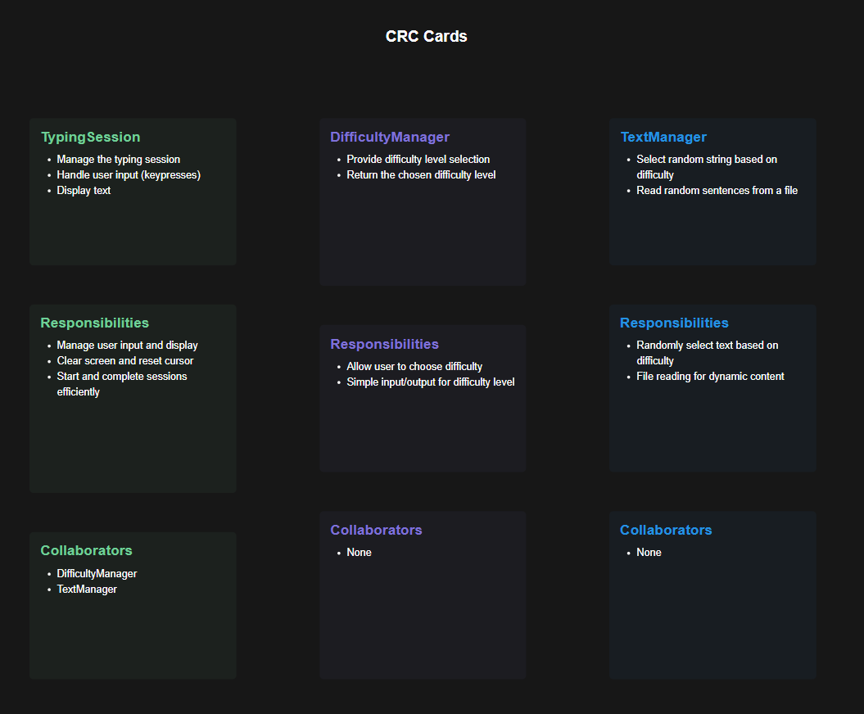

Conceptual UML Diagram (entities & relationships)
Draw a conceptual class diagram with key entities and their relationships; focus on nouns from User Stories/Use Cases, omit methods and low-level details.
