GIT COMMANDS:
All commands are in small letters

GIT MAIN VIEW:
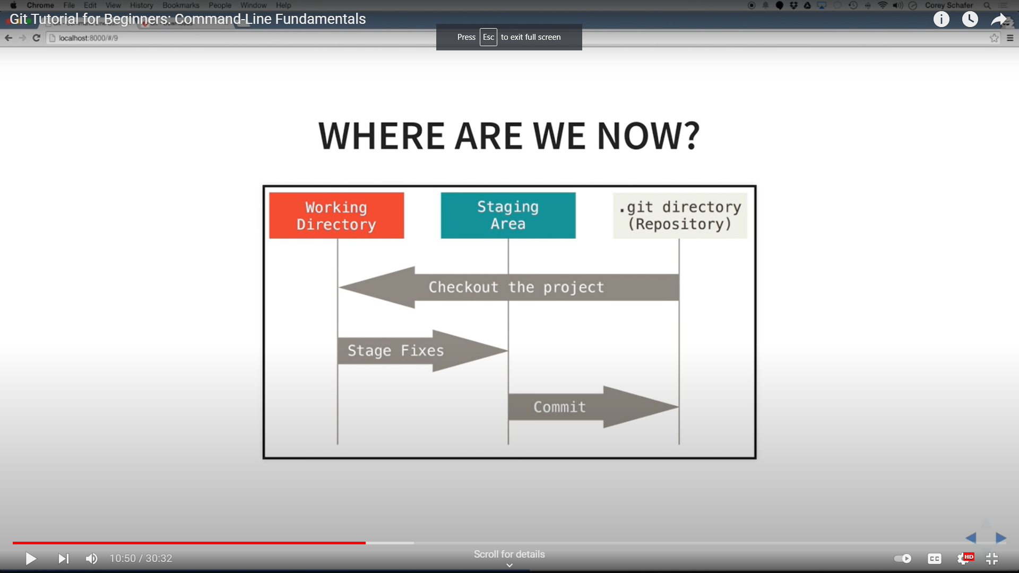

- GIT VERSION:

- git –version
- GIT config

- Git config –global user.name “vidyasgar”
- Git config – global user.email vidyasagar@gmail.com

- GIT CONFIG HELP

- Git help config

- GIT INIT (for initializing git in local directory)
- Git init

- REMOVE INIT (to remove git tracking in local directory)
Using command line
- rm -rf .git

- GIT STATUS [ to know the status of tracking folder]

- Git status

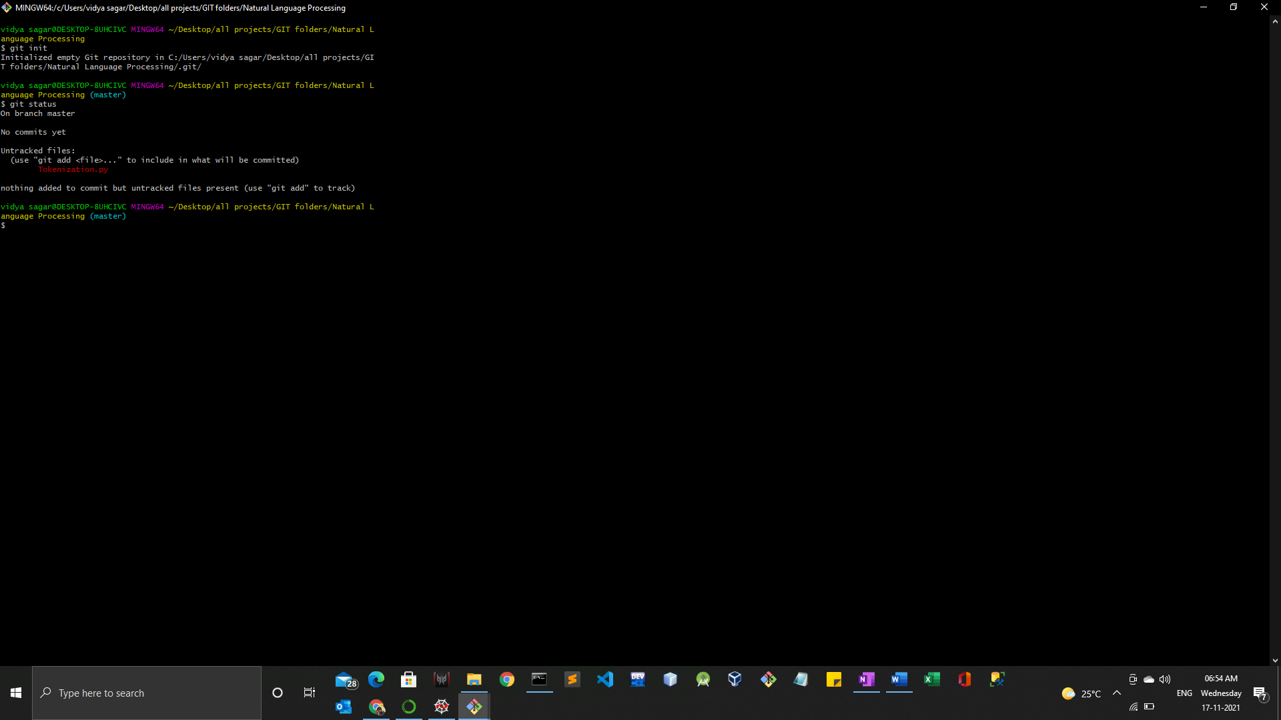

- GIT ADD
- Git add -A for adding all the files to staging area;
- Git add filename for adding specific file to staging are;

- For Revert adds
- Git reset filename [will be moved to unstaged area]
- Git reset [ for everything to moved to unstaged area]

- GIT LOG

- 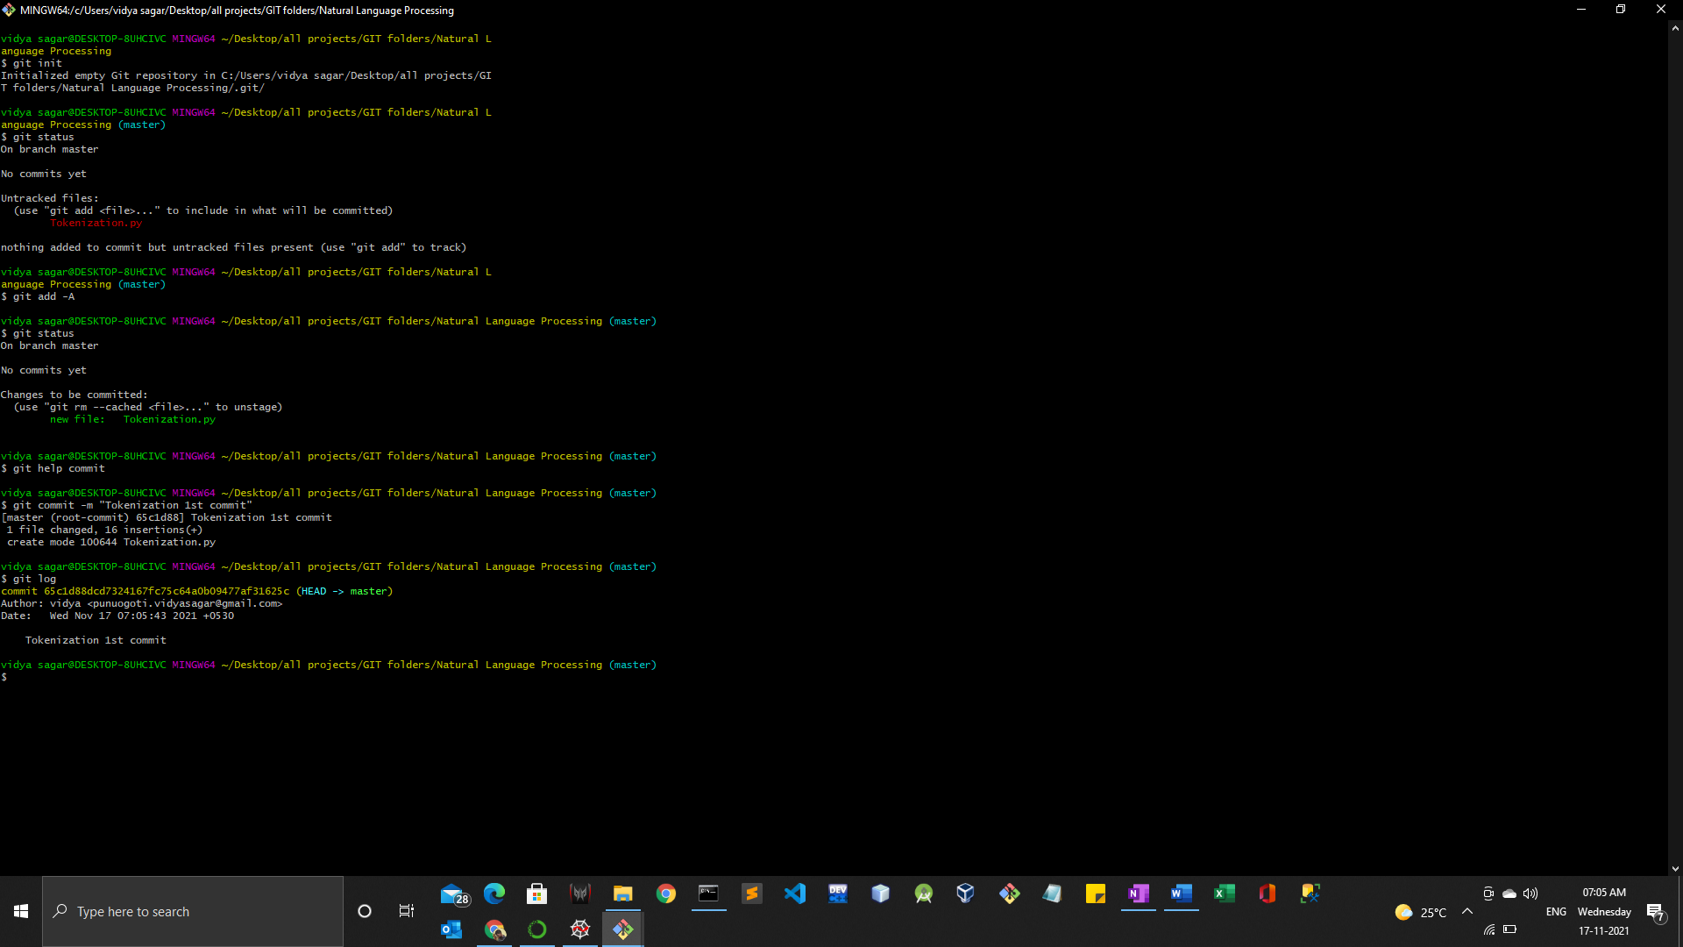

Connecting git with remote repository.
Git remote add origin link_of_the_repository_in_Github

