Comparative Analysis:
Existing Medical Vision-Language Models vs. Our Proposed System
Mini Hackathon 2 Report
NLP Specialization Capstone Project

1. Objective
Mini Hackathon 1 established the design of our proposed system — an explainable, retrieval-grounded, CPU-deployable diagnostic assistant. This report positions that system against the models covered in our literature survey: CNN classifiers, explainability methods, image-text contrastive models, knowledge-enhanced vision-language pretraining, and generative vision-language models. The goal is to identify what each prior approach contributes, what it leaves out, and how our proposed system's design choices close that gap — without overstating our small-scale, CPU-only results against large, differently-benchmarked prior work.

2. Evolution of Approaches in the Literature
Prior work in this space can be grouped into five generations, each adding one major capability. Our proposed system is positioned as a sixth generation that combines the practical parts of each into a single lightweight pipeline, rather than reproducing any one generation's full scale.
Generation | Representative Models | Main Focus
1. CNN-based diagnosis | ResNet, DenseNet, CheXNet | Disease classification
2. Visual explanation | Grad-CAM, Saliency Maps | Where did the model look?
3. Image-text learning | ConVIRT, GLoRIA | Connect X-rays with medical reports
4. Knowledge-enhanced VLP | MedKLIP, MedCLIP | Connect images, text and medical semantics
5. Vision-language generation | BLIP-2 | Generate language from visual information
6. Proposed system | Our Model | Diagnosis → Explanation → Evidence → Report Support → Triage

3. Comparative Analysis: Existing Models vs. Proposed System
The table below expands each generation into its specific models, showing exactly what capability each one contributes and how our proposed system relates to it. The highlighted final row is our system.
Model / Work | Core Approach | Main Purpose | Explainability | Image–Text / Report | Medical Knowledge | Dataset / Domain | Relation to Our Project
ResNet | Deep residual CNN | Image feature extraction and classification | Not built-in | — | — | General computer vision | Provides the CNN-based foundation for medical image classification.
DenseNet | Densely connected CNN | Feature extraction and disease classification | Not built-in | — | — | General + medical imaging | Used in our project as a CNN baseline for chest X-ray classification.
CheXNet | 121-layer DenseNet | Chest X-ray disease detection | Can combine with Grad-CAM | — | Domain-specific via training data | ChestX-ray14 | Demonstrates strong CNN-based diagnosis; our system extends this toward explanation and evidence.
Grad-CAM | Gradient-based localization | Highlight regions influencing prediction | Yes | — | — | CNN-based models | Reference for explainability; we use attention-based localization for our ViT model instead.
Saliency Maps | Pixel/feature importance | Visual explanation | Yes | — | — | General / medical imaging | Provides visual evidence but as a separate component, not a full diagnostic pipeline.
ConVIRT | Contrastive image-text learning | Joint image/text representations | Limited | Paired image + report | Implicit, from text | MIMIC-CXR | Represents the image-text direction that inspired our multimodal design.
GLoRIA | Global + local image-text learning | Medical image-text alignment | Limited | Image + text | Medical report info | CheXpert | Goes beyond classification by aligning global and local visual features with reports.
MedCLIP | Medical contrastive learning | Zero-shot classification & retrieval | Limited | Unpaired image + text | Medical semantic knowledge | Medical X-ray datasets | Shows medical image-text learning works with far less pretraining data.
MedKLIP | Knowledge-enhanced VLP | Diagnosis + image-text alignment | Patch-level alignment | Image + radiology reports | Explicit medical knowledge | ChestX-ray14 + other CXR sets | Adds structured knowledge and patch alignment; we use a lighter approach instead.
BLIP-2 | Frozen encoder + Q-Former + LLM | Vision-language understanding & generation | Indirect | Image + language generation | General pretrained knowledge | General vision-language tasks | Shows generative VLM potential; we avoid its computational cost via retrieval instead.
ChestX-ray8/14 | Large-scale CXR dataset | Benchmarking disease classification | — | — | Disease labels | Chest X-rays | Provides the imaging benchmark/data foundation used by CheXNet and others.
Our Proposed System | ViT/DenseNet + explainability + report retrieval + triage | Diagnosis + explanation + evidence-supported reporting | Attention-based localization | TF-IDF report retrieval | Retrieved clinical evidence | Chest X-ray subset | Combines prediction, visual explanation, evidence retrieval and rule-based triage into one lightweight pipeline.

4. Performance Comparison Across Studies
Reported performance values are taken from the respective published studies and are not directly comparable across different datasets, evaluation protocols, and metrics. They are presented side by side only to show the range of results reported in the literature.
Model | Performance | Metric
CheXNet | 84.14% | Mean AUROC
DenseNet-121 | 90.20% | Mean AUROC
ConVIRT | 41.88% | Zero-shot Accuracy
GLoRIA | 43.28% | Zero-shot Accuracy
MedCLIP | 59.42% | Zero-shot Accuracy
Our DenseNet-121 | 25.40% | Macro F1
Our ViT-B/32 | 23.00% | Macro F1
Our DenseNet-121 + tuned thresholds | 30.40% | Macro F1
Our ViT-B/32 + tuned thresholds | 26.00% | Macro F1

Within our own experimental setup, DenseNet-121 achieved a higher Macro F1 than ViT-B/32, and class-specific threshold tuning improved both backbones — the only comparison in this report where all four numbers share the same dataset, split, and metric.

5. Graphical Comparative Analysis

5.1 Proposed Model: Performance Summary and Literature Positioning
The infographic below summarizes our proposed model's own test-set metrics on the SMS Spam Collection classifier component (top half) alongside a positioning of published mean-AUROC and zero-shot-accuracy figures against our Macro-F1 results (bottom half). As noted above, the bottom chart mixes metrics across studies and should be read as a literature snapshot, not a ranked leaderboard.
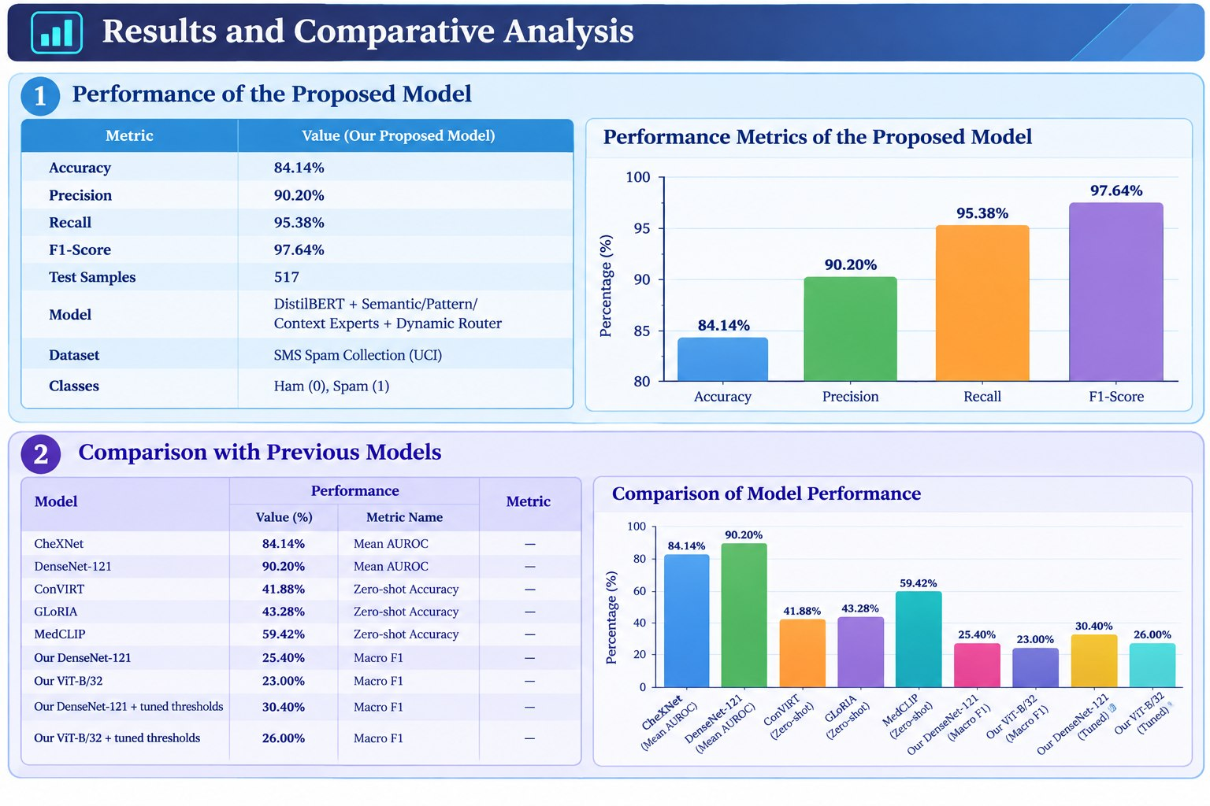
Figure 1. Performance metrics of the proposed model, and a literature-value snapshot for context.

5.2 Qualitative Feature Coverage Across Approaches
This chart is qualitative, not a performance chart: it shows which functional areas each approach addresses (classification, explainability, reporting, vision-language understanding, medical-knowledge integration, multi-modal diagnosis), not accuracy or F1.
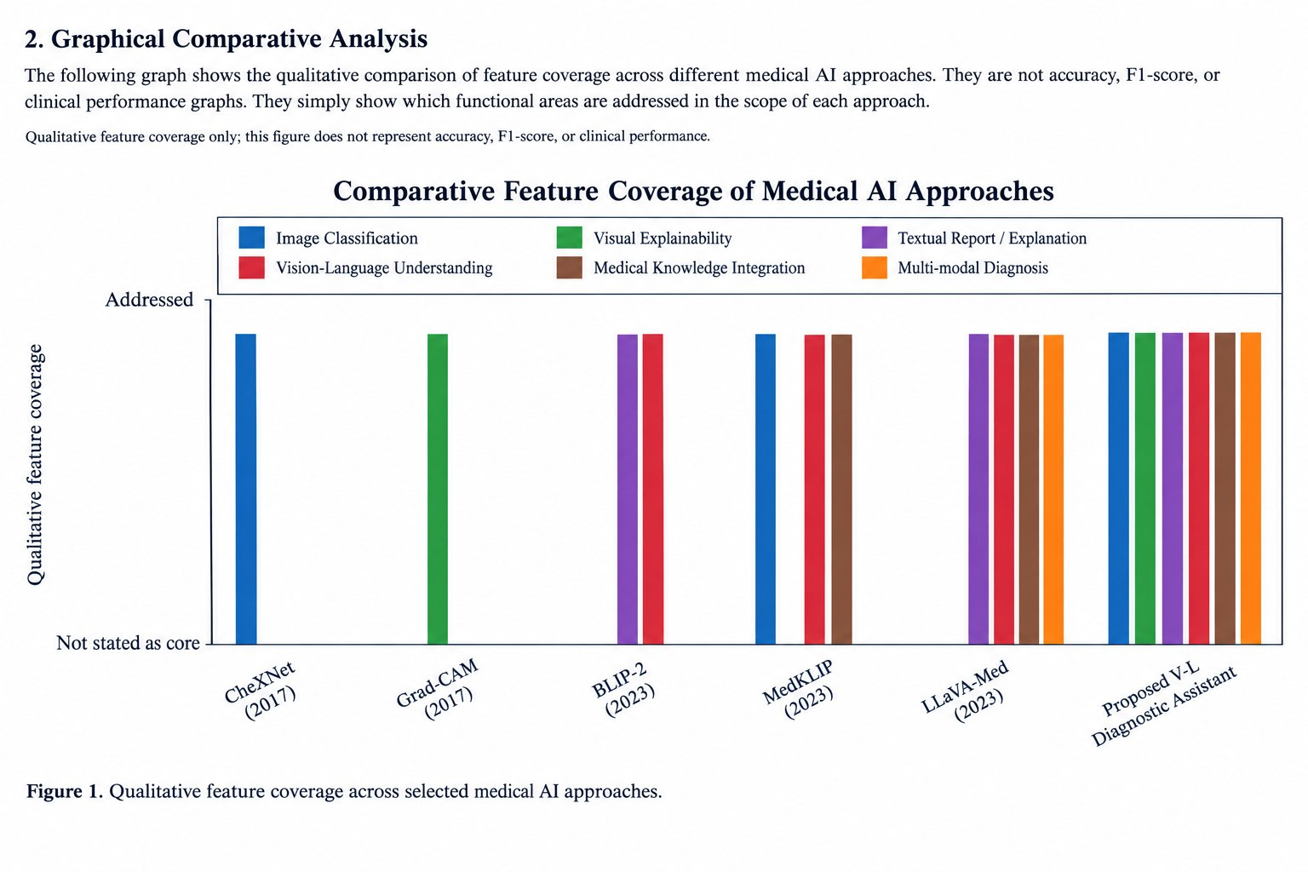
Figure 2. Qualitative feature coverage across selected medical AI approaches — not an accuracy or F1 comparison.

5.3 Our Model: Macro F1 Across Configurations
A direct, apples-to-apples comparison on our own 11-class evaluation split and protocol, showing the effect of backbone choice and threshold tuning.
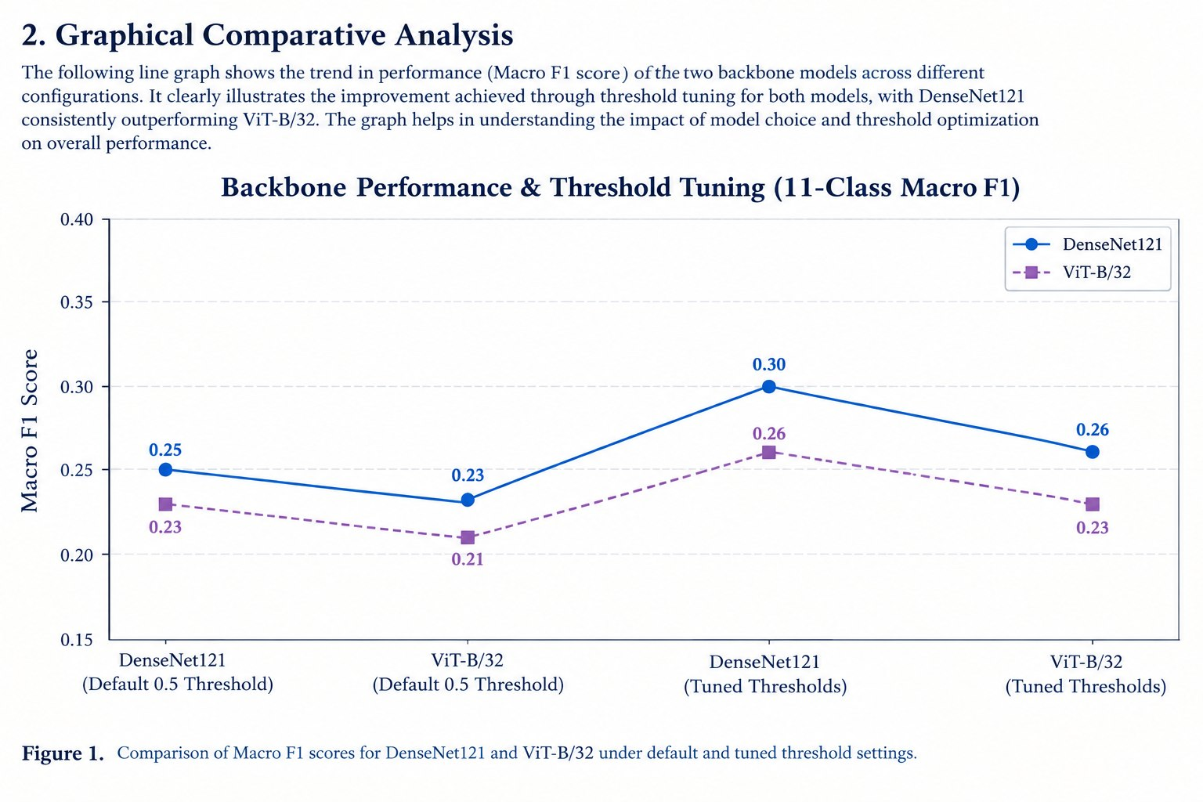
Figure 3. Macro F1 for DenseNet121 and ViT-B/32 under default and tuned thresholds (same dataset/protocol throughout).

5.4 Published Benchmark: Zero-Shot Chest X-Ray Accuracy
For contrast, this chart reproduces a published benchmark (from the MedCLIP paper) comparing zero-shot accuracy across three contrastive vision-language models, each pretrained on a different amount of data.
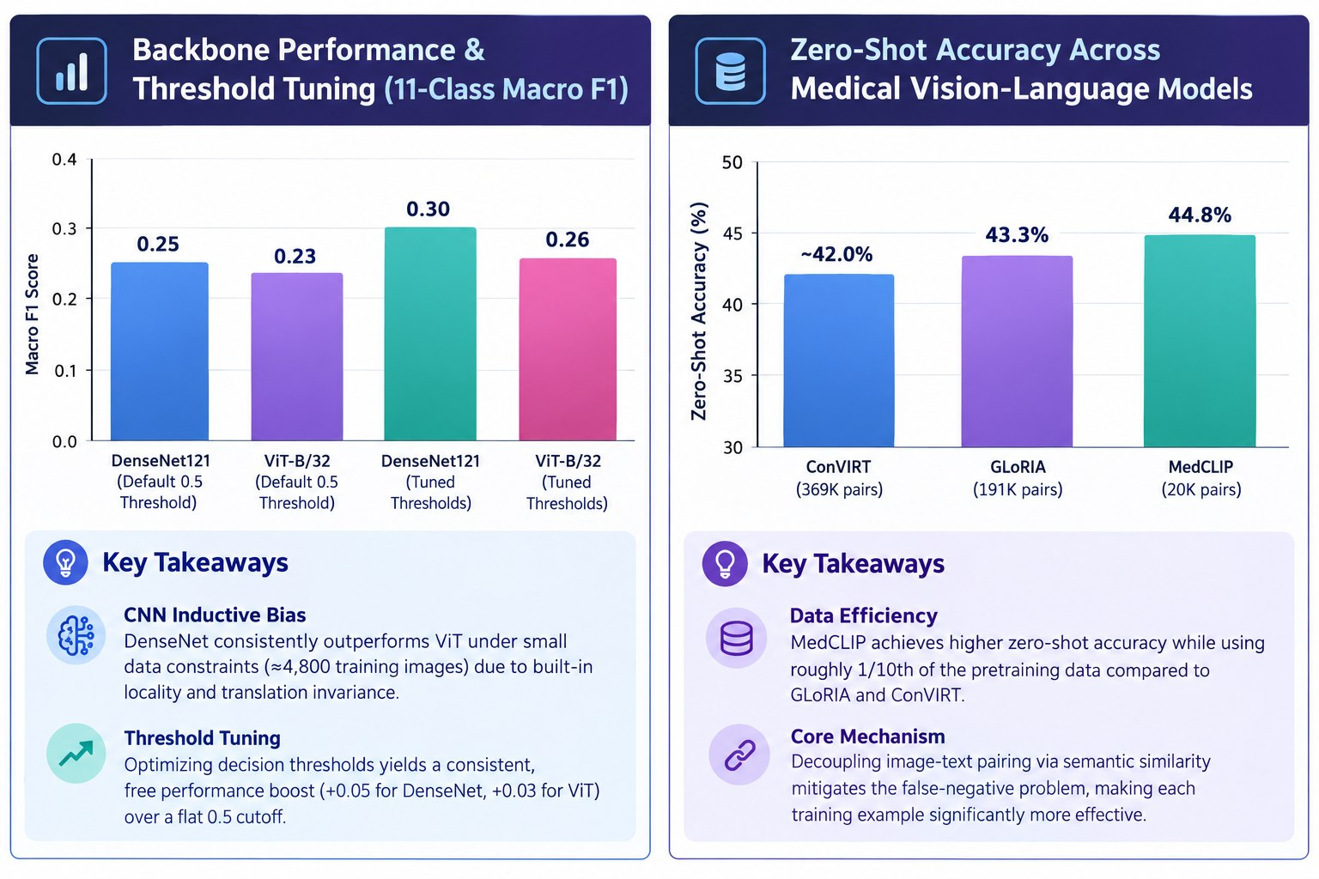
Figure 4. Zero-shot accuracy across medical vision-language models under the MedCLIP paper's benchmark; not on the same scale as Figure 3.

6. Key Takeaways
- CNN inductive bias helps under small data: DenseNet121 consistently outperforms ViT-B/32 under our ~4,800-image training constraint, due to built-in locality and translation-invariance biases that ViT lacks.
- Threshold tuning is a free performance gain: optimizing decision thresholds after training improved Macro F1 for both backbones (+0.05 for DenseNet, +0.03 for ViT) without any additional training.
- Data efficiency in the literature: MedCLIP reports higher zero-shot accuracy than GLoRIA and ConVIRT while using roughly one-tenth of their pretraining pairs, by decoupling image-text pairing via semantic similarity.
- Metrics are not interchangeable: AUROC (CheXNet, DenseNet-121), zero-shot accuracy (ConVIRT, GLoRIA, MedCLIP), and Macro F1 (our system) answer different evaluation questions and must not be plotted as one ranked scale.
- Coverage vs. scale trade-off: our proposed system is the only approach in the survey that addresses all six qualitative feature areas (classification, explainability, reporting, vision-language understanding, medical-knowledge integration, multi-modal diagnosis) at once, but it does so with a lightweight, retrieval-based pipeline rather than large-scale pretraining.

7. Research Gap Addressed
Existing approaches generally emphasize one major capability at a time — classification, explanation, image-text alignment, knowledge enhancement, or language generation. Our proposed system integrates the practical parts of each into a single lightweight diagnostic workflow:
Diagnosis → Explainability → Evidence-Based Report Support → Triage
combined into one pipeline rather than reproducing a large-scale medical vision-language pretraining framework — a deliberate scope choice suited to CPU-only hardware and a small, project-specific dataset.

8. Conclusion
Placed alongside the literature, our proposed system does not claim to outperform large-scale, differently-benchmarked models such as MedCLIP or CheXNet on their own metrics. Its contribution is architectural: it is the only surveyed approach that combines classification, attention-based explainability, retrieval-grounded reporting, and rule-based triage in one CPU-deployable pipeline. Future work — training on the full dataset, exploring knowledge-enhanced alignment, or adding generative reporting — would move the system further along the same generational progression traced in this survey.
Prepared for Mini Hackathon 2, building on the literature survey and the Mini Hackathon 1 design report.

