Outline the principle of quantum parallelism and give details its significance in quantum computation.
Quantum parallelism is the ability of a quantum computer to evaluate a function for all possible inputs simultaneously using a superposition of states.
Significance:
It provides massive parallel computation, forming the foundation of algorithms like Deutsch–Jozsa and Grover’s search, leading to significant quantum speedup over classical computation.

Illustrate how the stabilizer formalism is used to detect and correct quantum errors in a quantum system.
The stabilizer formalism detects and corrects quantum errors by defining a set of commuting operators (stabilizers) whose +1 eigenspace represents valid code states.
When an error occurs, it flips the sign (–1) of certain stabilizer measurements, producing a syndrome that identifies the error.
By applying the corresponding correction operator, the system restores the original logical qubit without measuring or disturbing its quantum state.

Illustrate how the quantum phase estimation algorithm can be used to extract eigenvalues of a unitary operator.
Quantum Phase Estimation (QPE) extracts the eigenvalue (phase) of a unitary operator from using controlled- operations and the inverse QFT. It is fundamental in algorithms like Shor’s and HHL for finding eigenvalues and periodicities efficiently.

Interpret how the HHL algorithm solves systems of linear equations using quantum computing principles.
The HHL algorithm (Harrow–Hassidim–Lloyd) solves a system of linear equations Ax=b using quantum computing by encoding the vectors b and x as quantum states.
It performs three main steps:
- Quantum Phase Estimation (QPE): Finds the eigenvalues of matrix A.
- Controlled Rotation: Applies rotations proportional to 1/λi​, effectively computing A⁻¹.
- Uncomputation: Reverses QPE to remove ancillary data, leaving a quantum state proportional to the solution ∣x⟩=A⁻¹∣b⟩.

Summarize the role of Grover’s algorithm in enhancing the efficiency of unstructured search problems.
Grover’s algorithm provides a quadratic speedup for searching an unsorted database of items.
Classically, finding a marked item requires searches, while Grover’s algorithm finds it in only steps.
It works by repeatedly applying two operations:
- Oracle: Marks the correct solution by inverting its phase.
- Diffusion Operator: Amplifies the probability of the marked state through interference.
Significance:
This makes Grover’s algorithm a key tool for speeding up unstructured search problems, optimization, and pattern matching in quantum computing.

Infer the significance of quantum walk algorithms in efficiently solving graph-based problems.
Quantum walk algorithms are significant because they use the principles of quantum superposition and interference to explore multiple paths on a graph simultaneously.
This parallel exploration enables faster propagation across the graph compared to classical random walks.
As a result, quantum walk algorithms provide speedups in graph-based problems such as search, element distinctness, and network connectivity, and form the foundation for efficient algorithms like Grover’s search and spatial search, often achieving quadratic or exponential improvements over classical counterparts.

Compare QNNs with classical neural networks in terms of their learning capabilities.
Aspect | Quantum Neural Networks (QNNs) | Classical Neural Networks (NNs)
Information Representation | Use qubits and superposition, enabling parallel processing of multiple states. | Use classical bits with one deterministic state at a time.
Learning Capability | Can capture complex, high-dimensional patterns more efficiently due to quantum state space and interference. | Effective for many problems but limited by classical feature space and exponential cost for some high-dimensional data.

Contrast Quantum PCA with classical PCA in terms of dimensionality reduction and scalability.
Classical PCA performs dimensionality reduction by computing the covariance matrix of data and finding its eigenvectors and eigenvalues — a process that scales polynomially with data size (O(n³)), making it slow for large datasets.
In contrast, Quantum PCA (qPCA) encodes the covariance matrix as a quantum density matrix and uses quantum phase estimation to extract principal components directly from the quantum state.
This allows exponential speedup in processing high-dimensional data, as qPCA can operate in O(log n) time under ideal conditions, offering superior scalability for large, quantum-representable datasets.

Demonstrate how the QAOA can be applied to solve combinatorial optimization problems.
The Quantum Approximate Optimization Algorithm (QAOA) solves combinatorial optimization problems by encoding the cost function into a cost Hamiltonian and using a mixer Hamiltonian to explore the solution space.
Steps:
- Start from an equal superposition of all possible bitstrings.
- Alternately apply (to imprint problem costs) and (to mix states).
- Measure the final state to get a bitstring that approximately minimizes (or maximizes) the cost function

Outline the use of QML techniques are applied in drug discovery and financial modeling.
In Drug Discovery: QML models simulate molecular interactions at the quantum level to predict binding affinities and drug efficacy faster and more accurately.
In Financial Modelling: QML aids in portfolio optimisation, risk analysis, and market prediction by processing complex financial data efficiently, offering faster insights than classical ML.

Part - B
Construct a quantum circuit diagram illustrating the universality of a quantum gate set composed of H, CNOT, and phase (S, T) gates.
Answer:
Principle:
The gate set {H, CNOT, S, T} (also called Clifford + T) is universal, meaning any quantum computation can be built from these gates.
Explanation:
- H (Hadamard): Creates superposition and converts between Z- and X-bases.
- S (phase) & T (π/8) gates: Generate rotations about the Z-axis.
- Combining H with S/T produces arbitrary single-qubit rotations.
- CNOT: Provides entanglement between qubits.
Together, arbitrary 1-qubit operations + CNOT ⇒ universal quantum computation.
Circuit illustration:
Example of universal block:
q0: ──H──T──H──■──
│
q1: ────────────X──
(HTH ≈ single-qubit rotation, CNOT = entangler)
Construct a quantum circuit that employs quantum parallelism to evaluate a 2-bit Boolean function for all possible input combinations simultaneously.
Answer:
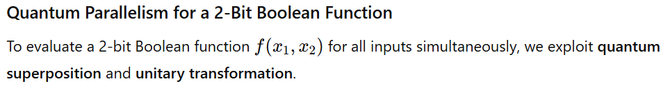
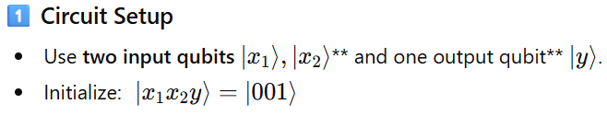
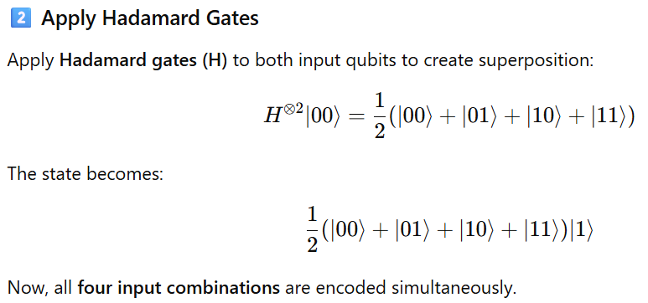
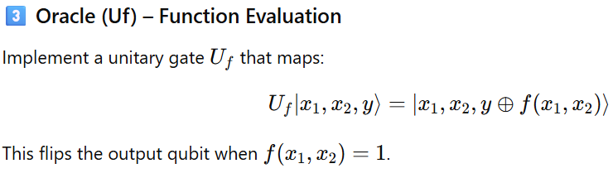
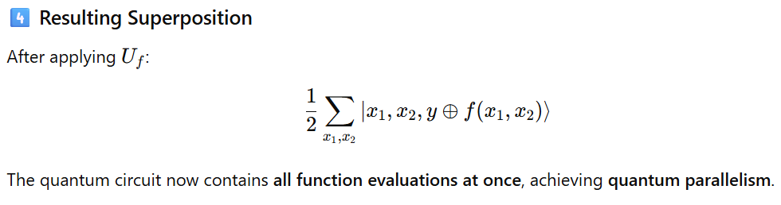
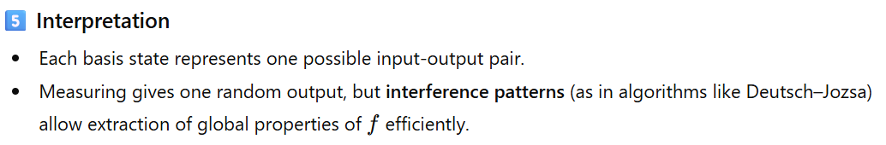

Build a quantum circuit for the Bernstein–Vazirani algorithm, and demonstrate how it identifies a hidden binary string with a single oracle query.
Answer:
Principle:
The Bernstein–Vazirani algorithm finds a hidden binary string using only one oracle query, exploiting superposition and quantum interference.

Steps:
- Initialization:
Prepare input qubits in and one ancilla in :
- Hadamard Gates:
Apply on all qubits to create superposition:
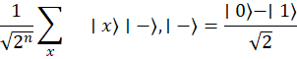
- Oracle :
The oracle flips the phase based on :
This encodes the hidden string as phase information.
- Final Hadamard:
Apply again to the input qubits, converting phase into the bit pattern of .
- Measurement:
Measuring the input qubits gives the hidden string directly.

Simple Example (n = 3, s = 101):
- Start:
- After Hadamard: all 8 input combinations in superposition.
- Oracle applies phases where (for inputs with bits matching 101).
- After final Hadamard: input register becomes .
- Measurement → Output = 101, the hidden string.

Circuit Sketch:
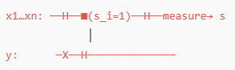
Design a quantum circuit for phase estimation using the QFT. Explain how this circuit estimates the eigenvalues of a given unitary operator, and describe the function of each component in the process.
Answer:
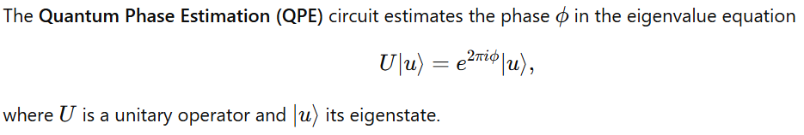
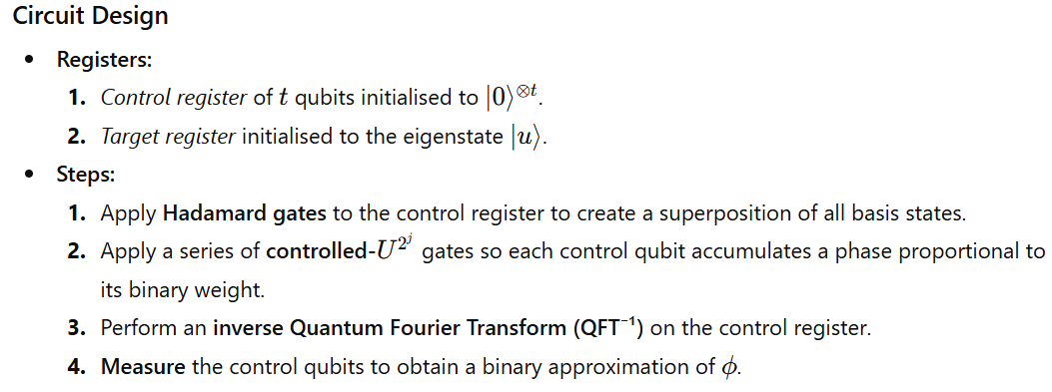
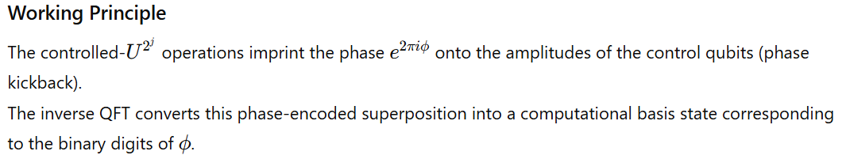
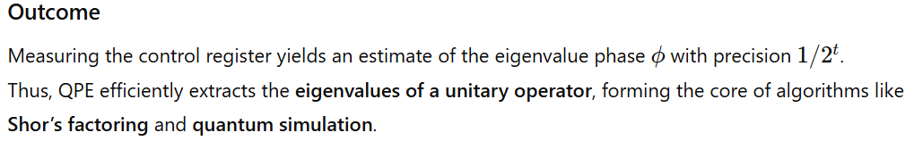

Model the Grover search algorithm for a database of 4 items (N = 4). Specify the marked element. Plan the sequence of operations, including the oracle and diffusion operator, for a single iteration, and calculate the final probability amplitude of the marked state, showing the amplification effect.
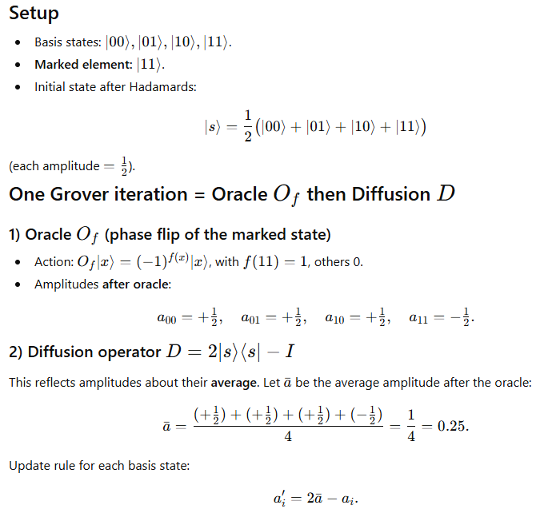
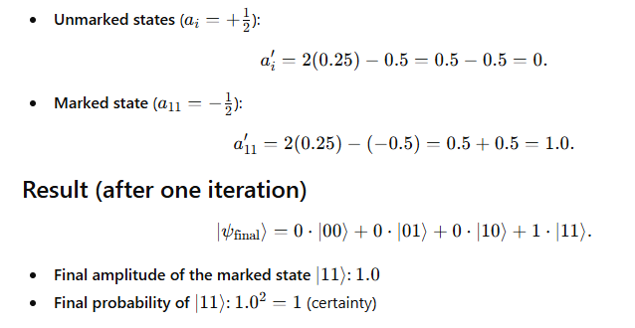
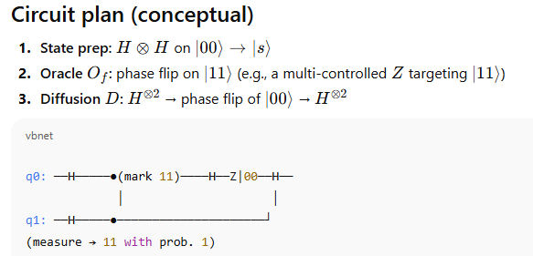
For , one Grover iteration amplifies the marked state to probability 1, perfectly illustrating amplitude amplification.

A quantum computing team is implementing a QSVM for financial fraud detection using a ZFeatureMap with 2 qubits. Given the statevectors for two transaction feature vectors,
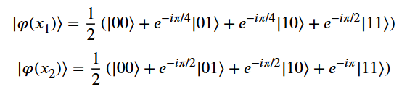
Apply the quantum kernel computation formula to calculate K(x₁, x₂). Demonstrate each step of the inner product calculation, compute the final kernel value, and verify that the result satisfies the kernel matrix symmetry property.
Answer:
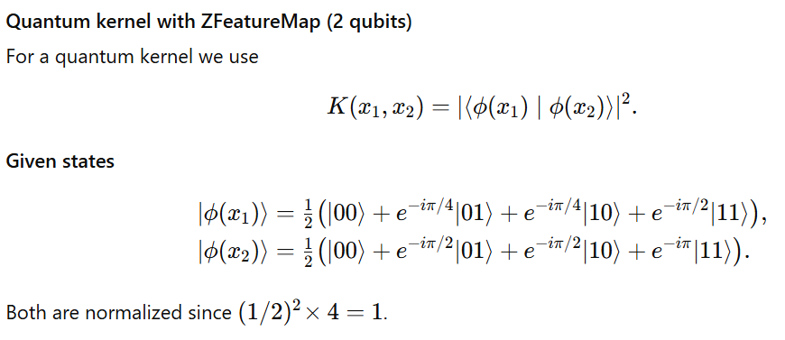
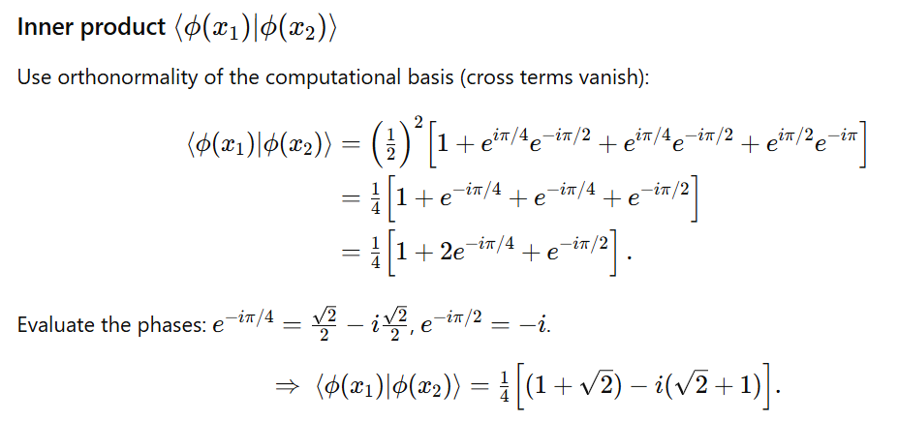
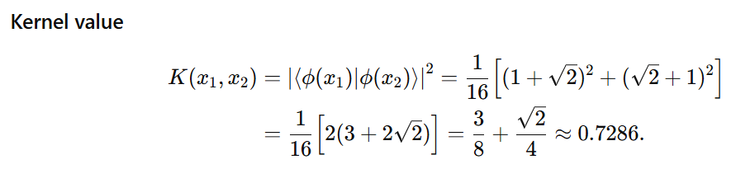
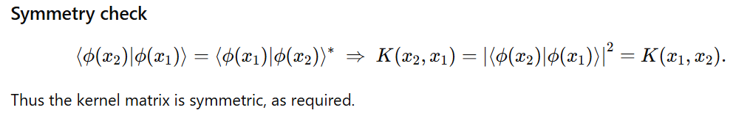

A biomedical research team is using a QSVM to classify medical images as “healthy” or “diseased.” Given the quantum kernel matrix for four patient samples:
K = [[1.00, 0.85, 0.15, 0.10],
[0.85, 1.00, 0.12, 0.08],
[0.15, 0.12, 1.00, 0.75],
[0.10, 0.08, 0.75, 1.00]]
With labels: y = [0, 0, 1, 1] (0=healthy, 1=diseased) and optimal α = [0.6, 0.4, 0.7, 0.5], apply the QSVM decision function to classify a new test sample z with kernel values: K(x₁,z)=0.80, K(x₂,z)=0.75, K(x₃,z)=0.20, K(x₄,z)=0.18. Calculate the decision function value step by step, and determine the final classification.
Answer:
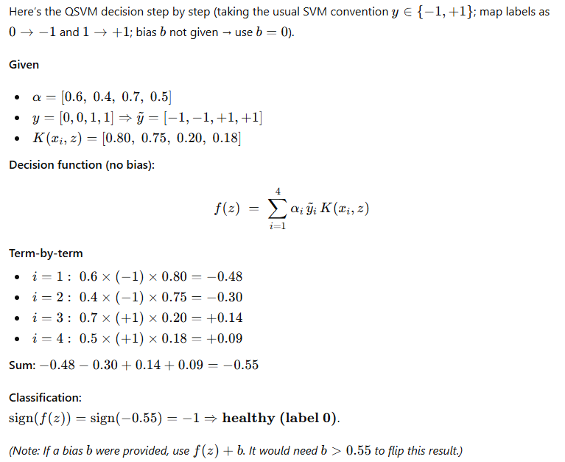

Model the QAOA to solve a combinatorial optimization problem, such as the traveling salesman problem. Outline the circuit, parameter initialization, and how the algorithm iteratively improves the solution.
Answer:
