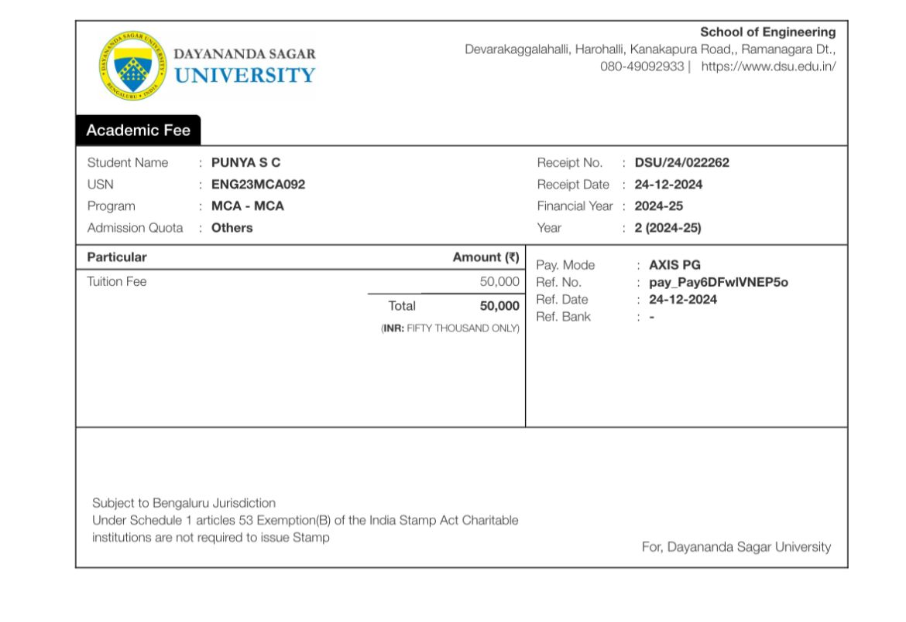

2,000

5((**INR**: TWO THOUSAND ONLY)

**2,000**