**Question 3 (25 points)**

**For this question, we will use Austres dataset that is available in the package. Using R, plot the time series in the following ways**

1. **Plot the time series**

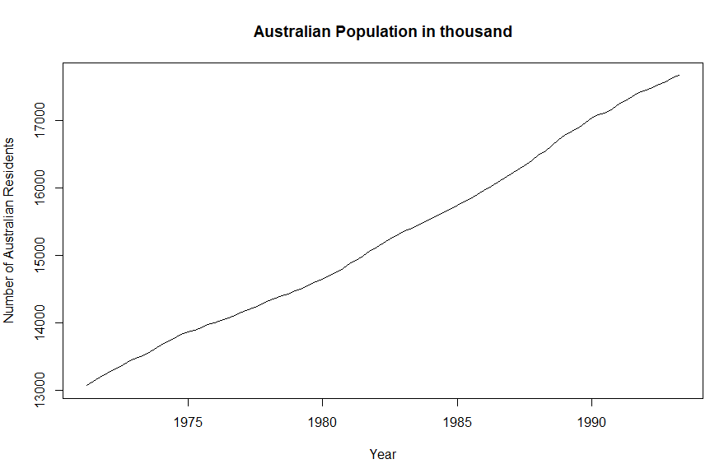

The Austres dataset plotted in a graph. The Austres dataset depicts the Australian Population over a period of time 1971 – 1993. According to the graph we can see that the population (represented by y-axis) has an average increasing value over the period of time. There’re a little bumps in between which means that the population did not increase linearly – meaning, the increase was not a constant function of time.

1. **Decompose the series into its seasonal, trend and irregular components and plot the result in one graph.**

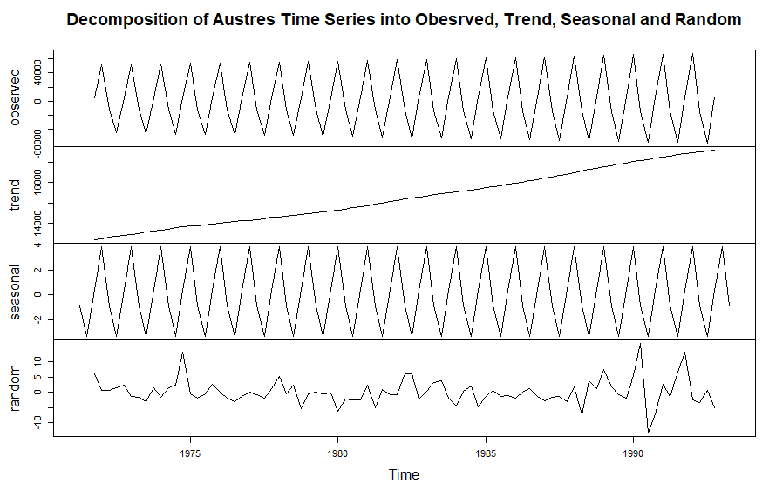

This graph is the decomposition of the Austres dataset. The decomposition type is additive, that means that the time series split into 3 parts is additive in nature.

*Time series = Trend + Seasonal + Random*

Additive type was used because the seasonal variation is constant throughout the time period and it does not increase when the time increases.

1. **Determine whether the data is autocorrelated and justify your answer**

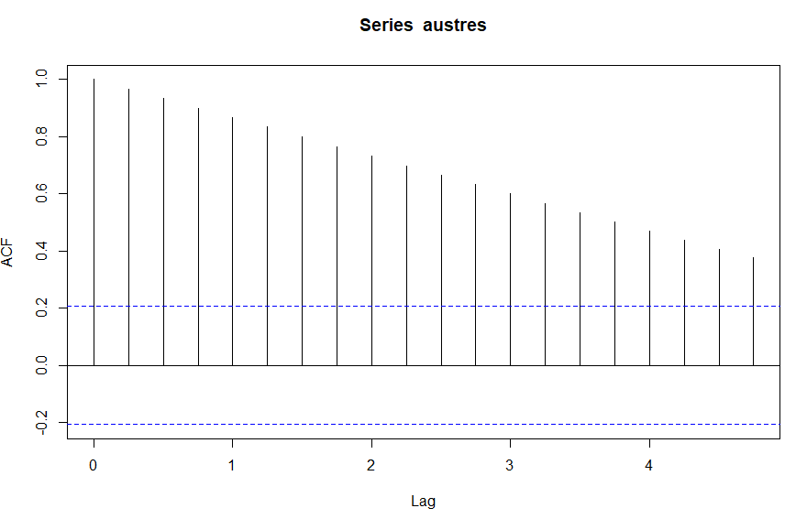

Autocorrelation suggests that the values in a time series dataset (like Austres dataset) are co-related with each other as a function of time. Each autocorrelated time series may have a different function of time that they are related in.

Austres is a time series dataset that contains the estimates of Australian resident population size for the time 1971 – 1993. The series has an increasing trend with time as we can see in the plot graph. I used the ACF function in R to build an autocorrelation plot. This plot helps us tell whether the elements of the time series are positively correlated, negatively correlated or independent of each other. The y-axis depicts the ACF values – autocorrelation function – this has a range of -1 to 1. The x-axis depicts the lag between he elements of the time series – this means that if the lag is 1 (like in our graph), it means that the values were observed one time period earlier.

In the graph, each vertical line (called spike) parallels to one lag and the height depicts the ACF value. As long as the spike is above or below the blue dotted line, it means there is some ACF value, hence some autocorrelation. The spike at lag 0 is always equal to 1 because it is the first value and is being compared to itself. As we move forward the x-axis (that is as we look over time/lag), we see the spikes are decreasing. This means, that the values are related to the previous values but by less percentage – hence the low ACF value. However, since they do not reach the blue dotted line, *this concludes that the Austres dataset is autocorrelated.*

1. **Plot the differences between successive data values**

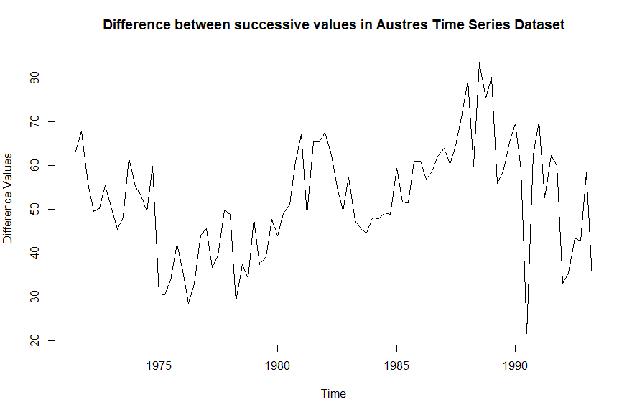

This is the plot of the values of difference between the successive values in the Austres Time series Dataset. The plot also helps supporting the claim that Austres is a autocorrelated graph. As we can see, when the value difference decreases, it keeps decreasing, and similarly when it is increasing, it is increasing. Which means the values are correlated and there is no sudden changes.

**R source code**

austres

summary(austres)

##A3 Q3 part a

plot.ts(austres, xlab="Year",ylab="Number of Australian Residents", main="Australian Population in thousand")

##A3 Q3 part b

##source : https://www.rdocumentation.org/packages/stats/versions/3.6.2/topics/decompose

##https://grokbase.com/p/r/r-help/072v6r3n1c/r-ts-decompose-plot-and-title

z<-decompose(austres, type = "additive", filter = NULL)

plot(cbind(observed = z$random +

z$trend * z$seasonal, trend = z$trend, seasonal = z$seasonal,

random = z$random), main = "Decomposition of Austres Time Series into Obesrved, Trend, Seasonal and Random")

## get ACF - A3 Q3 psrt c

##source : https://www.rpubs.com/dougtharp/542457

line.acf <- acf(austres, plot = TRUE)

## A3 Q3 part d

## source : https://statisticsglobe.com/diff-function-in-r

plot(diff(austres),ylab="Difference Values", main="Difference between successive values in Austres Time Series Dataset")