**Question 4 (25 points)**

1. **Design a system that allows a user to review a collection of videos**

I designed a system that will allow a user to review a collection of videos. This is the interface of the main page when the user opens the system. I have names it “Watch it”. An interface should be easy to navigate and understand, while not being too crowded. Also, one might realise that Miller’s number 7 should be kept in mind. Having more than 7 stuff can confuse the user and give a bad user experience.

The main page interface includes the menu button (the infamous three lines symbol) with the brand name on its right. In the header itself there is the About, Login and Signup buttons. The about button will take the user to the page with a little description about this system. The login and signup buttons will allow user to create an account with the system. Creating account will be free and have benefits for the users. These are discussed ahead in the answer.

On the main page, there is a Search engine for user to enter any keywords about a video they wish to watch. I tried to give the “Search” text a little jazz to make it look good.

For user to login if account already exists

User can read about the system here

Brand Name

Menu

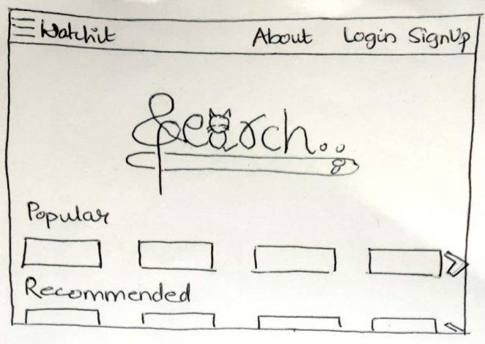

More videos can be found towards right. It is like a scroll right button

This is also the main page interface, but when scrolled down. A few videos will always be available on the main page, so the user does not always have to search something. The *popular* videos will include all the videos that have had the most views and comments. These are the ‘trending’ videos. The *recommended* videos will include all the videos related to the videos watched by the user in the past. This section may also include some important and serious trending news and topics that user is recommended to watch. The *latest* videos include the videos that have been recently posted by any famous user.

All the trending videos under this section. There will be at least 10 videos in this section

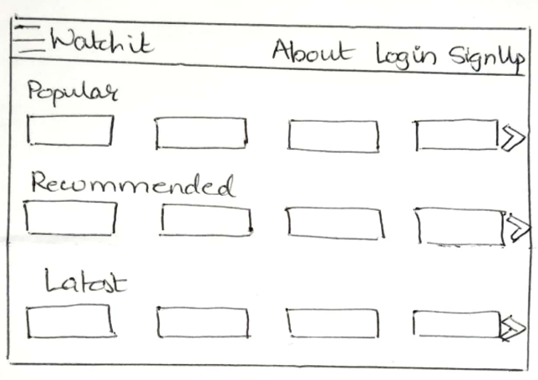

The recommended section may include related to the user’s search history. Or it may also include videos about hot and important topics which may be political or related to human rights.

The latest section as the name suggests includes videos posted within past week.

This interface picture shows what the menu section will include. The menu section includes various criteria for a user to search videos. Some popular search criteria for searching a video are Genre, Artist, Location and Language.

The Genre section as the name suggests will have many videos in the same format as the videos are depicted under the popular, recommended, and latest sections. Only, the topics instead of the popular, recommended, and latest will be Genre types like funny, sad, news, surprising, scary, entertaining, trailer, happy, music and many more.

The Artist section will include videos of the famous artists only. For example, a user “vine_energy” started posting videos and their videos gained a lot of popularity, then vine_energy will be on of the artists in the artists section. The user will get an option to search an artist inside the artist section or directly in the search engine at the main page.

The location as the name suggests will allow user to find a video specific to a certain location. For example, if the user clicks on location>Canada, then the user will only be listed with all the videos by the artists/users of Canada. The videos may also include videos about Canada but posted by a user from some other location.

The Language section allows user to choose videos of a specific language. The languages will not include all the languages in the world but only the languages that have entered the system’s database as the videos got posted.

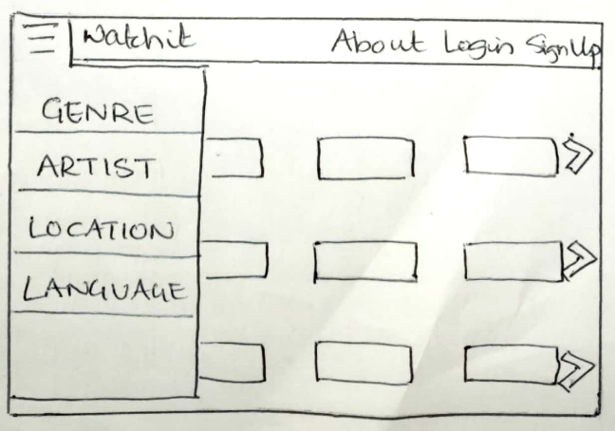

Over to account creation by user. Why should a user create an account in a system that only lets them review some videos? Since, the system database has thousands or perhaps millions of videos, sometimes user likes a video or wishes to see it again. A user might also want to watch a video offline that is, they might want to download a video. Creating an account will allow the user to download a video (watch offline), upload a video and have all their liked video stored in one place where they can be accessed again anytime. Account creatin would be free with no charge.

A user can create an account by clicking on the *Signup* button in the header. The user will ask to enter a username which should be unique. A username should be unique because it will allow the videos posted by a certain username be only linked to that person. The user will then ask for an email for contact reasons. And a strong password.

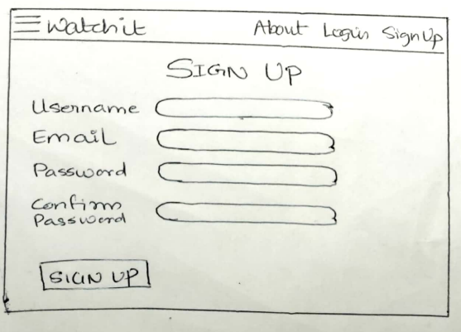

After account creation, the user can login anytime by clicking the login button in the header. The login page will let user enter their username and password. There is also an option of forgot password in case the user forgets their password and wish to change it. An email will be sent to the user on their email with the link to reset password. There will also be a “remember me” check box button, which f checked, then the user will not have to enter the username and password every time they come to the login page on that specific device.

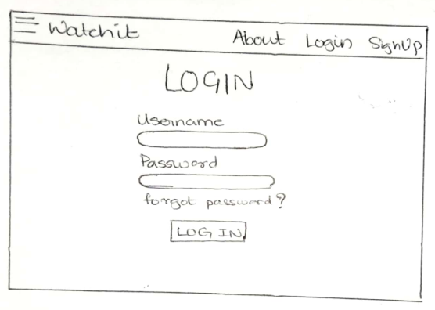

Forgot password will send an email to the registered email by the user with a link to reset password

Remember me checkbox

Remember me

Once the user is logged in, the header will change to the header as seen in the below image. The profile icon button and a log out button. Everything else would be same as the main page of when the user was not logged in – with a search engine, videos under sections popular, recommended, and latest.

When clicked on the profile icon, this is what the user will see. A section *profile* with their username, email and password. The user is allowed to change their username and password if they wish to. The link for reset password or username will be sent to their email once the change button is clicked.

The videos downloaded by the user will be seen under the *downloads* section.

The next section is the *liked* section that will contain the videos liked by the user.

The last section is the *uploaded* section where all the uploaded videos by the user will be seen. Beside the uploaded section title will be a upload button which when clicked allows the user to upload a new video

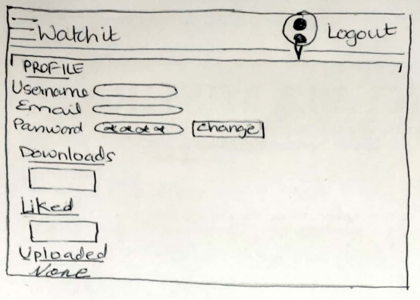

**upload**



This is the design of the system that allows the user to review videos. I tried including the interface of every page possible! Thank you.