**Technical Report for Café Database System**

JSOM, University of Texas at Dallas

Punya Ira Anand

COMPREHENSIVE DATABASE IMPLEMENTATION FOR CAFE MANAGEMENT

In-Scope Work

• Project requirements documentation – Introduction, Overview, Literature review, Assumptions, Constraints

• Entity-relationship model - Design and Requirements

• DDL Scripts

• DML Scripts

• SQL Scripts

• Comprehensive Report

**Introduction**

This report is about the systematic approach that we took to develop, design and implement a relational database management system (DBMS) for a cafe chain’s operations. This report includes the complete scope of the project which is tailored for managing and optimizing the operations of this cafe. This system is focused on managing and streamlining the operations pertaining to orders, product inventory, and customer interactions and therefore increasing the efficiency and reliability of the data overall across all the branches of the cafe.

**Overview**

The cafe DBMS project addresses the need for a data management system that handles and manages extensive operational data throughout multiple locations of cafe efficiently. By collaborating data with functions – spreading from stock management to order process and customer management system. The DBMS is efficiently designed to fetch and provide comprehensive insights and analytics, enhance customer service, and improve operational decisions. At the end of this, we anticipate a robust database that will support day-day operations while providing strategic data insights through advanced data analytics

**Literature Review**

In the exploratory phase, research was conducted to understand existing DB solutions in other retail and hospitality environments. Studies such as "Efficient Data Management in Retail Operations" and "Database Solutions for Multi-location Restaurant Chains" provided analytics into the challenges and effective strategies in the hospitality industry. The literature emphasized the importance of a scalable and flexible database architecture that can adapt to the varying demands of a growing business, such as a café chain. Additionally, recent advancements in relational database technology and their application in real-time data processing were reviewed to ensure the proposed system could handle high transaction volumes and complex query requirements effectively.

**Assumptions and Constraints**

**Assumptions:**

- The database system will handle up to 10,000 transactions daily without performance degradation.

- The system will be used continuously during business hours with minimal downtime.

- All locations will have uniform product offerings and pricing to ensure consistency and integrity in reporting and inventory management.

**Constraints**

- Real-time synchronization of data across all locations is mandatory to ensure inventory and orders are up to date.

- The system must comply with all applicable data protection regulations to safeguard customer and business data.

- Scalability must be maintained, allowing for the addition of new café locations without significant system reconfigurations.

**Project Step #1: Initial Design and Requirements**

This initial phase involved gathering detailed requirements from various stakeholders, including café managers, inventory specialists, and marketing personnel, to ensure the database would meet the diverse needs of the business. Key requirements identified included:

- Robust order management capabilities to track orders from placement through fulfillment.

- Detailed inventory management to monitor stock levels, track shipments, and predict inventory needs based on sales trends.

- Customer management features to maintain customer profiles, preferences, and transaction histories to enhance customer service and marketing efforts.

Based on these requirements, an initial entity-relationship (ER) diagram was created to visualize the database structure, which included entities such as Products, Orders, Inventory, and Customers, along with their relationships.

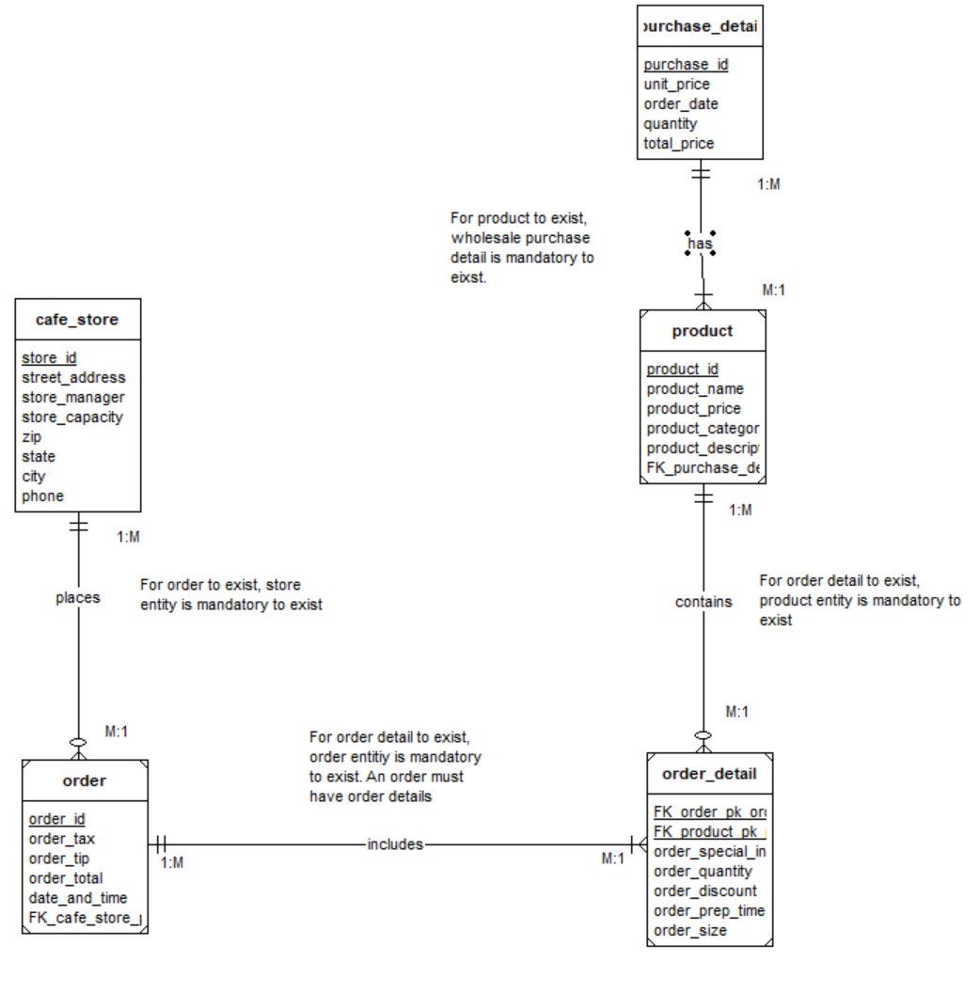

1. **Entity and Attribute Description**

**Cafe_Store**

**Description**: Represents a physical location where customers can purchase food and beverages.

**Attributes**:

* + **store_id** (PK): A unique identifier for each cafe store.
  + **street_address:** The street address of café store.
  + **store_manager**: The name of the individual managing the store.
  + **store_capacity**: The maximum number of people the store can accommodate at one time.
  + **zip**: The zip code for the café_store.
  + **state:** The US state in which the store is located.
  + **city:** TheUScity in which the store is located.
  + **phone:** The phone number of the café store.

**Order**

**Description**: A record of a transaction initiated by a customer to purchase products from a cafe store.

**Attributes**:

* + **order_id** (PK): A unique identifier for each order.
  + **order_total**: The total cost of the order.
  + **order_tax**: The total tax placed on the order.
  + **order_tip**: The total amount tipped by the customer.
  + **date_and_time**: The exact date and time at which the order was placed.
  + **FK_cafe_store_pk_store_id** (FK): A foreign key linking the order to the specific cafe store where it was made.

**Order_Detail**

**Description**: Details of individual items within an order.

**Attributes**:

* + **FK_order_pk_order_id** (FK, PK): A foreign key to the Order entity, part of the composite primary key that uniquely identifies each order detail.
  + **FK_product_pk_product_id** (FK, PK): A foreign key to the Product entity, identifying what product the detail refers to.
  + **order_special_info**: Contains special information provided by customer e.g.   
    regarding their dietary restrictions.
  + **order_prep_time**: The average time it takes to process this item.
  + **order_quantity**: The number of items purchased.
  + **order_size**: The size of the item purchased.
  + **order_discount**: The total discount on that item.   
      
    **Product**
  + **Description**: Goods available for purchase at the cafe.
  + **Attributes**:
  + **product_id** (PK): A unique identifier for each product.
  + **product_name**: The name of the product.
  + **product_description**: A brief description of the product.
  + **product_price**: The standard price of the product.
  + **product_category**: The category in which the product lies.
  + **FK_purchase_detail_pk_purchase_id**: A foreign key to Purchase detail entity, identifying what wholesale purchase it refers to.

**Purchase_Detail**

**Description**: Represents the wholesale purchases made by the cafe for stocking products.

**Attributes**:

* + **purchase_id** (PK): A unique identifier for each purchase detail record.
  + **order_date:** The date when the wholesale purchase was made.
  + **quantity**: The amount of the products ordered in this purchase transaction.
  + **unit_price**: The cost per unit of the product at the time of purchase.
  + **total_price**: The overall cost of the purchase transaction.

1. **Relationship and Cardinality Description**

**Relationship**: “places” between entities cafe_store and order.

**Cardinality**: 1:M between cafe_store and order.

**Business rule:** A cafe_store can make zero or many orders; an order must only be associated with one cafe_store.

**Relationship**: “includes” between order and order_detail.

**Cardinality**: 1:M between order and order_detail.

**Business rule**: An order must contain one or many order_details; an order_detail must be from only one order.

**Relationship**: “contains” between product and order_detail.

**Cardinality**: 1:M between product and order_detail.

**Business rule**: A product can be in zero or many order_details; an order_detail must contain only one product.

**Relationship**: “has” between purchase_detail and product.

**Cardinality**: 1:M between purchase_detail and product.

**Business rule**: A purchase_details may include zero or many products. A product must have only one purchase_detail.

**3. Assumptions and Special Considerations**

**Assumptions**:

1. Uniform Pricing: It's assumed that within a single purchase order (as captured in the Purchase_Detail entity), the unit price of a product is uniform across the quantity ordered. This simplifies the calculation of the total price but assumes no tiered pricing for bulk orders.
2. Inventory Updates: The system is presumed to automatically update inventory levels based on the Quantity attribute in the Purchase_Detail entity. This assumes a direct integration between the purchasing system and inventory management functionalities.
3. Product Availability: For the Order_Detail entity, it's assumed that all products listed as part of an order are available at the time of the order. This overlooks backorders or inventory shortages, simplifying order processing.

**Special Consideration:** Order_Detail is treated as a weak entity due to its dependence on Order and Product for uniqueness and existence, necessitating an identifying relationship.

**Data Definition Language (DDL)**

The DDL part of this project involves the creation of SQL scripts to define the database schema. This includes the creation of tables, constraints, indices, and relationships. Detailed SQL statements were crafted to ensure all aspects of the café's operations were adequately modeled in the database. For instance, tables for storing product details, order information, inventory records, and customer data were created with relationships that enforce data integrity and facilitate complex queries.

set search_path to 'cafe';

/*

Project BAUN 6320 - UTD

*/

/* DROP statements to clean up objects from previous run */

-- Triggers

DROP TRIGGER IF EXISTS TRG_cafe_store_store_id ON cafe_store;

DROP TRIGGER IF EXISTS TRG_orders_order_id ON orders;

DROP TRIGGER IF EXISTS TRG_purchase_detail_purchase_id ON purchase_detail;

DROP TRIGGER IF EXISTS TRG_product_product_id ON product;

-- Trigger Functions

DROP FUNCTION IF EXISTS TRG_cafe_store_store_id_function();

DROP FUNCTION IF EXISTS TRG_orders_order_id_function();

DROP FUNCTION IF EXISTS TRG_purchase_detail_purchase_id_function();

DROP FUNCTION IF EXISTS TRG_product_product_id_function();

-- Sequences

DROP SEQUENCE IF EXISTS SEQ_cafe_store_store_id;

DROP SEQUENCE IF EXISTS SEQ_orders_order_id;

DROP SEQUENCE IF EXISTS SEQ_purchase_detail_purchase_id;

DROP SEQUENCE IF EXISTS SEQ_product_product_id;

-- Indices

DROP INDEX IF EXISTS IDX_cafe_store_store_id;

DROP INDEX IF EXISTS IDX_orders_order_id;

DROP INDEX IF EXISTS IDX_orders_FK_cafe_store_pk_store_id;

DROP INDEX IF EXISTS IDX_purchase_detail_purchase_id;

DROP INDEX IF EXISTS IDX_product_product_id;

DROP INDEX IF EXISTS IDX_product_FK_purchase_detail_pk_purchase_id;

DROP INDEX IF EXISTS IDX_order_detail_FK_order_pk_order_id;

DROP INDEX IF EXISTS IDX_order_detail_FK_product_pk_product_id;

-- Tables

DROP TABLE IF EXISTS order_detail;

DROP TABLE IF EXISTS product;

DROP TABLE IF EXISTS orders;

DROP TABLE IF EXISTS purchase_detail;

DROP TABLE IF EXISTS cafe_store;

/* Create Sequences */

CREATE SEQUENCE SEQ_cafe_store_store_id

START 100

INCREMENT 100;

CREATE SEQUENCE SEQ_orders_order_id

START 1

INCREMENT 1;

CREATE SEQUENCE SEQ_purchase_detail_purchase_id

START 10

INCREMENT 5;

CREATE SEQUENCE SEQ_product_product_id

START 10

INCREMENT 10;

/* Create tables based on entities */

CREATE TABLE cafe_store(

store_id INTEGER NOT NULL,

store_manager VARCHAR(30) NOT NULL,

store_capacity INTEGER NOT NULL,

phone NUMERIC(10,0) NOT NULL,

street_address VARCHAR(50) NOT NULL,

city VARCHAR(30) NOT NULL,

state VARCHAR(2) NOT NULL,

zip VARCHAR(5) NOT NULL,

CONSTRAINT PK_cafe_store PRIMARY KEY (store_id)

);

CREATE TABLE orders(

order_id INTEGER NOT NULL,

order_tax NUMERIC(10, 2) NOT NULL,

order_tip NUMERIC(10, 2) NOT NULL,

order_total NUMERIC(10, 2) NOT NULL,

date_and_time DATE NOT NULL,

FK_cafe_store_pk_store_id INTEGER NOT NULL,

CONSTRAINT PK_order_id PRIMARY KEY (order_id),

CONSTRAINT FK_cafe_store FOREIGN KEY (FK_cafe_store_pk_store_id) REFERENCES cafe_store(store_id)

);

CREATE TABLE purchase_detail(

purchase_id INTEGER NOT NULL,

unit_price NUMERIC(10, 2) NOT NULL,

order_date DATE NOT NULL,

quantity NUMERIC(10, 2) NOT NULL,

total_price NUMERIC(15, 2) NOT NULL,

CONSTRAINT PK_purchase_detail PRIMARY KEY (purchase_id)

);

CREATE TABLE product(

product_id INTEGER NOT NULL,

product_name VARCHAR(25) NOT NULL,

product_price NUMERIC(10, 2) NOT NULL,

product_category VARCHAR(30) NOT NULL,

product_description VARCHAR(255) NOT NULL,

FK_purchase_detail_pk_purchase_id INTEGER NOT NULL,

CONSTRAINT PK_product_id PRIMARY KEY (product_id),

CONSTRAINT FK_purchase_detail FOREIGN KEY (FK_purchase_detail_pk_purchase_id) REFERENCES purchase_detail(purchase_id)

);

CREATE TABLE order_detail(

FK_order_pk_order_id INTEGER NOT NULL,

FK_product_pk_product_id INTEGER NOT NULL,

order_special_info VARCHAR(100),

order_quantity INTEGER NOT NULL,

order_discount DECIMAL(4, 2),

order_prep_time INTERVAL NOT NULL,

order_size VARCHAR(10) NOT NULL,

CONSTRAINT PK_order_detail PRIMARY KEY (FK_order_pk_order_id, FK_product_pk_product_id),

CONSTRAINT FK_orders FOREIGN KEY (FK_order_pk_order_id) REFERENCES orders(order_id),

CONSTRAINT FK_products FOREIGN KEY (FK_product_pk_product_id) REFERENCES product(product_id)

);

/* Create Trigger Functions */

CREATE OR REPLACE FUNCTION TRG_cafe_store_store_id_function()

RETURNS TRIGGER AS $$

BEGIN

IF TG_OP = 'INSERT' OR TG_OP = 'UPDATE' THEN

IF NEW.store_id IS NULL THEN

NEW.store_id := NEXTVAL('SEQ_cafe_store_store_id');

END IF;

END IF;

RETURN NEW;

END;

$$ LANGUAGE plpgsql;

CREATE OR REPLACE FUNCTION TRG_orders_order_id_function()

RETURNS TRIGGER AS $$

BEGIN

IF TG_OP = 'INSERT' OR TG_OP = 'UPDATE' THEN

IF NEW.order_id IS NULL THEN

NEW.order_id := NEXTVAL('SEQ_orders_order_id');

END IF;

END IF;

RETURN NEW;

END;

$$ LANGUAGE plpgsql;

CREATE OR REPLACE FUNCTION TRG_purchase_detail_purchase_id_function()

RETURNS TRIGGER AS $$

BEGIN

IF TG_OP = 'INSERT' OR TG_OP = 'UPDATE' THEN

IF NEW.purchase_id IS NULL THEN

NEW.purchase_id := NEXTVAL('SEQ_purchase_detail_purchase_id');

END IF;

END IF;

RETURN NEW;

END;

$$ LANGUAGE plpgsql;

CREATE OR REPLACE FUNCTION TRG_product_product_id_function()

RETURNS TRIGGER AS $$

BEGIN

IF TG_OP = 'INSERT' OR TG_OP = 'UPDATE' THEN

IF NEW.product_id IS NULL THEN

NEW.product_id := NEXTVAL('SEQ_product_product_id');

END IF;

END IF;

RETURN NEW;

END;

$$ LANGUAGE plpgsql;

/* Create Triggers */

CREATE TRIGGER TRG_cafe_store_store_id

BEFORE INSERT OR UPDATE OF store_id ON cafe_store

FOR EACH ROW

EXECUTE FUNCTION TRG_cafe_store_store_id_function();

CREATE TRIGGER TRG_orders_order_id

BEFORE INSERT OR UPDATE OF order_id ON orders

FOR EACH ROW

EXECUTE FUNCTION TRG_orders_order_id_function();

CREATE TRIGGER TRG_purchase_detail_purchase_id

BEFORE INSERT OR UPDATE OF purchase_id ON purchase_detail

FOR EACH ROW

EXECUTE FUNCTION TRG_purchase_detail_purchase_id_function();

CREATE TRIGGER TRG_product_product_id

BEFORE INSERT OR UPDATE OF product_id ON product

FOR EACH ROW

EXECUTE FUNCTION TRG_product_product_id_function();

/* Create indices for natural keys, foreign keys, and frequently-queried columns */

-- cafe_store

-- Primary Key

CREATE INDEX IDX_cafe_store_store_id ON cafe_store(store_id);

-- orders

-- Primary Key

CREATE INDEX IDX_orders_order_id ON orders(order_id);

-- Foreign Key

CREATE INDEX IDX_orders_FK_cafe_store_pk_store_id ON orders(FK_cafe_store_pk_store_id);

-- purchase_detail

-- Primary Key

CREATE INDEX IDX_purchase_detail_purchase_id ON purchase_detail(purchase_id);

-- product

-- Primary Key

CREATE INDEX IDX_product_product_id ON product(product_id);

-- Foreign Key

CREATE INDEX IDX_product_FK_purchase_detail_pk_purchase_id ON product(FK_purchase_detail_pk_purchase_id);

-- order_detail

-- Primary Key / Foreign Key

CREATE INDEX IDX_order_detail_FK_order_pk_order_id ON order_detail(FK_order_pk_order_id);

CREATE INDEX IDX_order_detail_FK_product_pk_product_id ON order_detail(FK_product_pk_product_id);

**Data Manipulation Language (DML)**

Following the creation of the database schema, DML scripts were developed to populate the database with initial data sets, including sample products, customer records, and preliminary orders. These scripts are crucial for testing the database's performance and ensuring that the data flows correctly through the various components of the database system.

set search_path to 'cafe';

/*

Project BAUN 6320 - UTD

*/

-- cafe_store table

INSERT INTO

cafe_store (store_manager, store_capacity, phone, street_address, city, state, zip)

VALUES

('Nisha Shah', 80, 4693853946, '1235 Main Street', 'Richardson', 'TX', 75080),

('William Wilson', 70, 2125439674, '261 Boradway', 'New York', 'NY', 10001),

('Ava Miller', 100, 3055552468, '2468 Oak Lane', 'Miami', 'FL', 33125),

('Nathan Shaw', 50, 5035455678, '5678 Pine Avenue', 'Portland', 'OR', 97201),

('Sofia Brown', 90, 3038649100, '910 Maple Drive', 'Denver', 'CO', 80202),

('Abigail Jones', 110, 4159451357, '1357 Cedar Road', 'San Francisco', 'CA', 94110),

('Dev Patel', 120, 2147427859, '7859 Willow Avenue', 'Dallas', 'TX', 75201),

('Ehan Smith', 40, 4699376925, '123 Frisco Avenue', 'Frisco', 'TX', 75034),

('Mateo Flores', 80, 3129376543, '6543 Walnut Boulevard', 'Chicago', 'IL', 60601),

('Santiago Lopez', 90, 3050583980, '456 Ocean Drive', 'Miami', 'FL', 33139);

-- orders table

INSERT INTO

orders (order_tax, order_tip, order_total, date_and_time, FK_cafe_store_pk_store_id)

VALUES

(2.01, 3, 24.49,'2023-04-20',800),

(1.38, 4, 16.78,'2023-06-23',100),

(0.8, 1, 9.75,'2023-07-11',900),

(5.36, 7, 65,'2023-07-14',300),

(0.91, 0, 11,'2023-08-03',200),

(2.90, 6, 35.18,'2023-11-27',700),

(4.34, 8, 52.87,'2024-01-04',600),

(1.11, 2, 13.5,'2024-02-13',400),

(2.26, 3, 27.45,'2024-03-19',100),

(1.45, 4, 17.56,'2024-03-22',500);

-- purchase_detail table

INSERT INTO

purchase_detail (unit_price, order_date, quantity, total_price)

VALUES

(10, '2023-08-20', 8, 80),

(1.49, '2023-09-13', 30, 44.7),

(6, '2023-10-18', 20, 120),

(17.99, '2023-12-20', 7, 125.93),

(3.49, '2024-01-10', 25, 87.25),

(7.99, '2024-02-16', 13, 103.87),

(0.99, '2024-03-17', 40, 39.6),

(9.99, '2024-03-19', 14, 139.86),

(9.49, '2024-03-23', 8, 75.92),

(15, '2024-03-28', 12, 180);

-- product table

INSERT INTO

product (product_name, product_price, product_category, product_description, FK_purchase_detail_pk_purchase_id)

VALUES

('Espresso Beans', 19.99, 'Coffee', 'High-quality espresso beans for brewing rich and flavorful shots.', 55),

('Vanilla Syrup', 12.99, 'Syrups', 'A sweet and aromatic syrup for adding flavor to coffee and tea.', 10),

('Croissant', 2.49, 'Pastries', 'A buttery and flaky pastry perfect for breakfast or a snack.', 40),

('Green Tea', 4.99, 'Tea', 'A refreshing and healthy green tea known for its antioxidants.', 35),

('Chocolate Muffin', 3.99, 'Pastries', 'A moist and chocolaty muffin that pairs well with coffee.', 25),

('Caramel Macchiato', 5.49, 'Coffee Drinks', 'A popular espresso-based drink with caramel and steamed milk.', 50),

('Iced Tea', 3.99, 'Tea', 'A cool and refreshing iced tea available in various flavors.', 20),

('Ham and Cheese Sandwich', 13.99, 'Sandwiches', 'A classic sandwich with ham, cheese, lettuce, and tomato.', 45),

('Almond Milk', 5.49, 'Milk Alternatives', 'A dairy-free alternative made from almonds, perfect for lattes.', 30),

('Blueberry Scone', 2.99, 'Pastries', 'A delicious scone filled with blueberries and topped with glaze.', 15);

-- order_detail table

INSERT INTO

order_detail (FK_order_pk_order_id, FK_product_pk_product_id, order_special_info, order_quantity, order_discount, order_prep_time, order_size)

VALUES

(1, 10, 'Double shot', 2, 0.1, INTERVAL '15 minutes', 'Large'),

(2, 60, 'Extra foam', 1, 0.0, INTERVAL '9 minutes', 'Medium'),

(3, 30, 'None', 2, 0.15, INTERVAL '13 minutes', 'Medium'),

(4, 20, 'None', 1, 0.05, INTERVAL '6 minutes', 'Large'),

(5, 70, 'Extra ice', 2, 0.0, INTERVAL '8 minutes', 'Small'),

(6, 90, 'None', 2, 0.0, INTERVAL '11 minutes', 'Large'),

(7, 40, 'No sugar', 1, 0.10, INTERVAL '10 minutes', 'Medium'),

(8, 80, 'Extra cheese', 2, 0.0, INTERVAL '15 minutes', 'Medium'),

(9, 100, 'None', 1, 0.10, INTERVAL '10 minutes', 'Small'),

(10, 50, 'Extra chocolate', 2, 0.0, INTERVAL '9 minutes', 'Medium');

**SQL Queries**

The SQL queries developed for this project range from simple data retrieval to complex analytical queries that provide insights into business operations. These queries are vital for daily operations, such as generating sales reports, tracking inventory levels, and understanding customer buying patterns.

**Query 1:** Select all columns and all rows from one table (5 points)

select * from cafe_store

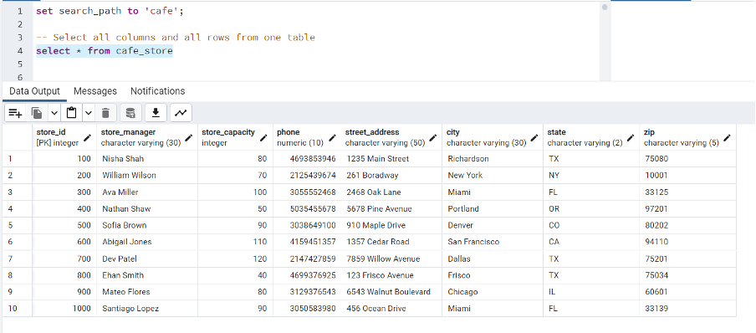

**Query 2:** Select five columns and all rows from one table (5 points)

select order_special_info, order_quantity, order_discount,

order_prep_time, order_size from order_detail

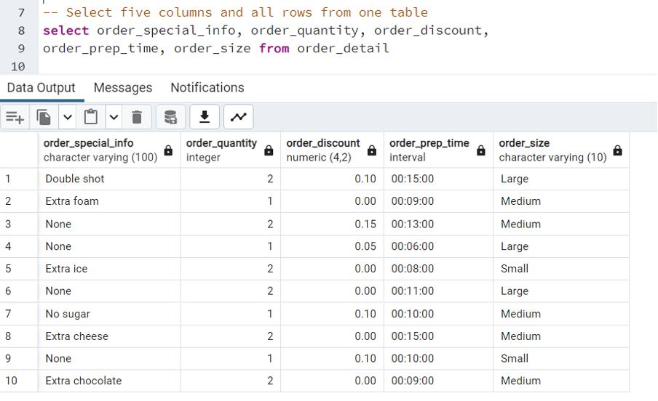

**Query 3:** Select all columns from all rows from one view (5 points)

CREATE VIEW main_order_details AS

SELECT order_special_info, order_quantity, order_discount,

order_prep_time, order_size

FROM order_detail;

SELECT * FROM main_order_details;

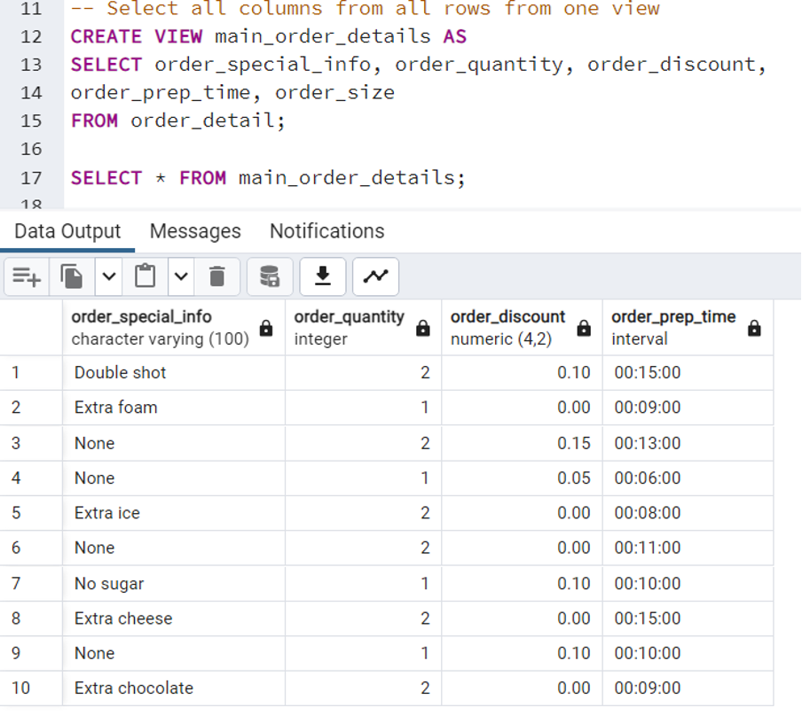

**Query 4:** Using a join on 2 tables, select all columns and all rows from the tables without the use of a Cartesian product (5 points)

SELECT *

FROM orders o

JOIN order_detail od ON o.order_id = od.fk_order_pk_order_id;

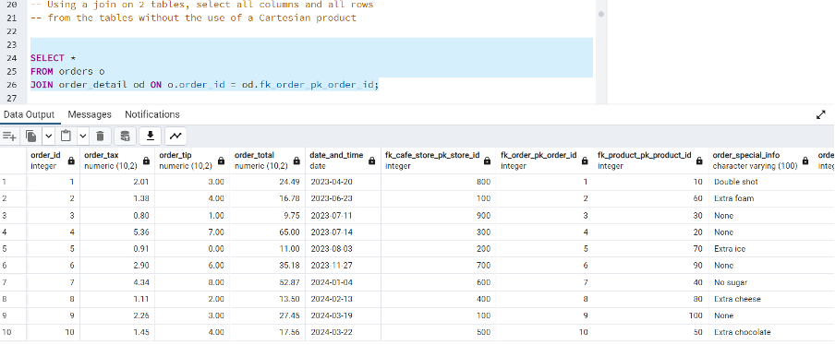

**Query 5:** Select and order data retrieved from one table (5 points)

select * from orders  
ORDER BY order_total DESC

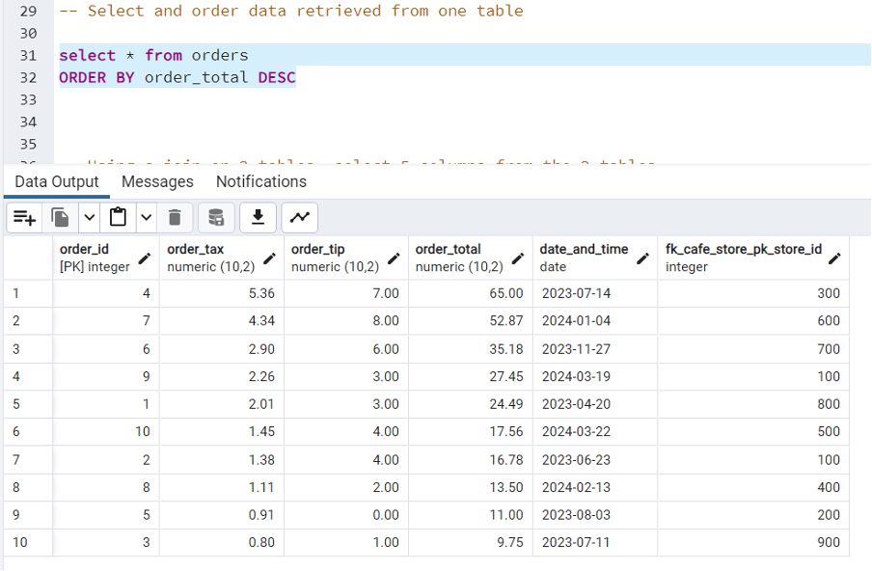

**Query 6:** Using a join on 3 tables, select 5 columns from the 3 tables. Use syntax that would limit the output to 3 rows (5 points)

SELECT od.fk_order_pk_order_id, od.order_size, o.order_tax, o.date_and_time, pd.product_name

FROM order_detail od

JOIN orders o ON od.fk_order_pk_order_id = o.order_id

JOIN product pd ON od.fk_product_pk_product_id = pd.product_id

LIMIT 3

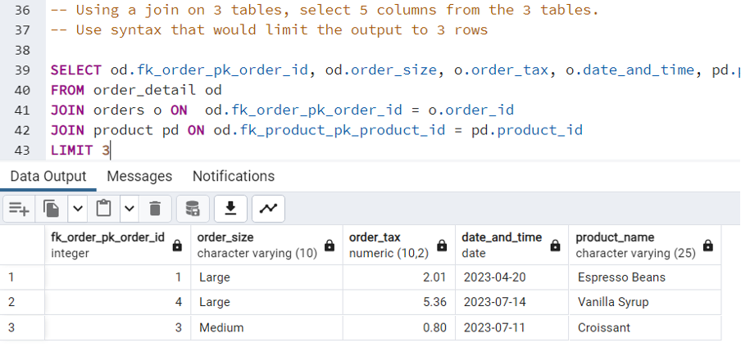

**Query 7:** Select distinct rows using joins on 3 tables (5 points)

SELECT DISTINCT od.order_quantity, od.order_size, o.order_tax, o.date_and_time, pd.product_name

FROM order_detail od

JOIN orders o ON od.fk_order_pk_order_id = o.order_id

JOIN product pd ON od.fk_product_pk_product_id = pd.product_id

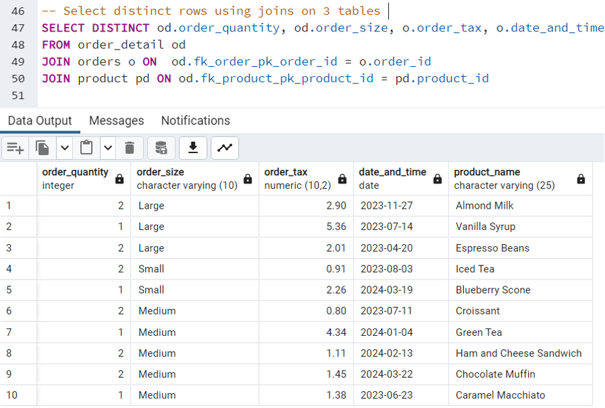

**Query 8:** Use GROUP BY and HAVING in a select statement using one or more tables (5 points)

SELECT o.order_id, Avg(o.order_total), od.order_quantity

FROM orders o

JOIN order_detail od ON o.order_id = od.fk_order_pk_order_id

GROUP BY o.order_id, od.order_quantity

Having Avg(o.order_total) > 25

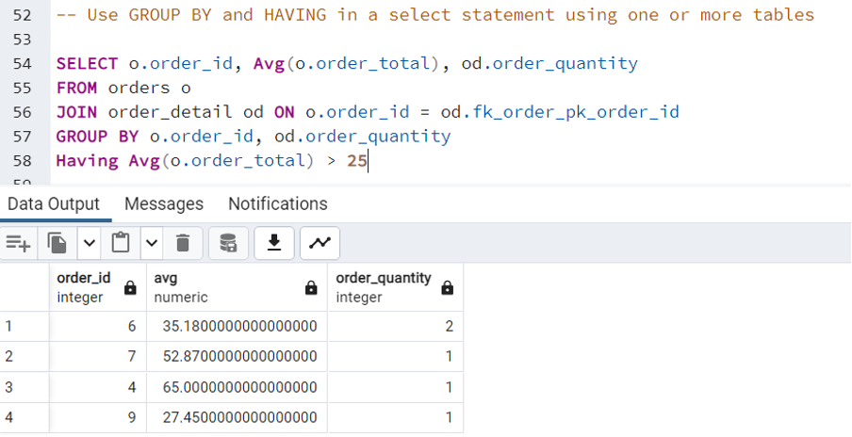

**Query 9**: Use IN clause to select data from one or more tables (5 points)

SELECT *

FROM orders  
WHERE order_id IN (1,4,7)

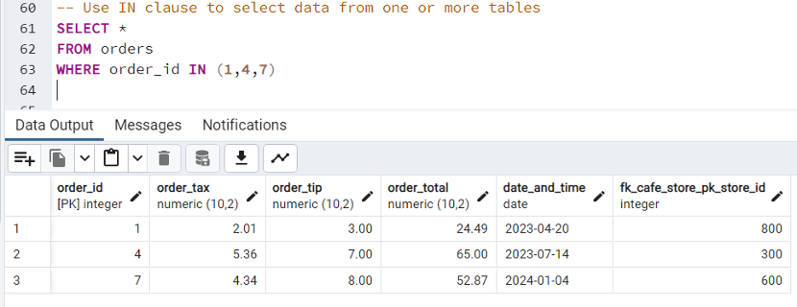

**Query 10:** Select length of one column from one table (use LENGTH function) (5 points)

SELECT LENGTH(product_name) AS name_length

FROM product;

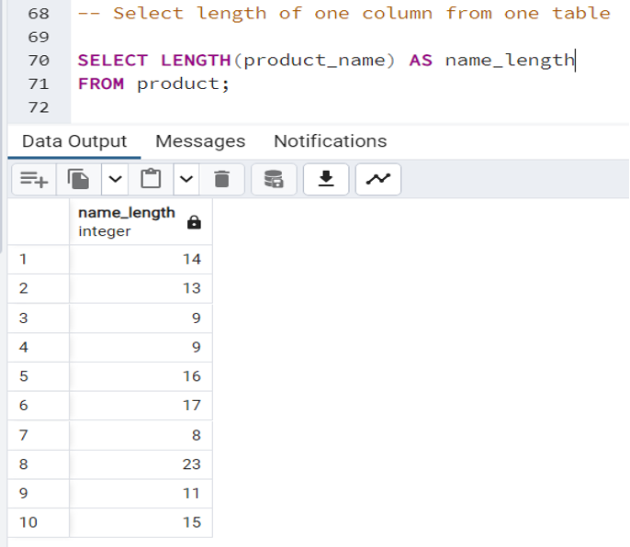

**Query 11:** Delete one record from one table. Use select statements to demonstrate the table contents before and after the DELETE statement. Make sure you use ROLLBACK afterwards so that the data will not be physically removed (5 points)

BEGIN;

select * from order_detail;

DELETE FROM order_detail WHERE order_quantity = 2;

select * from order_detail;

ROLLBACK;

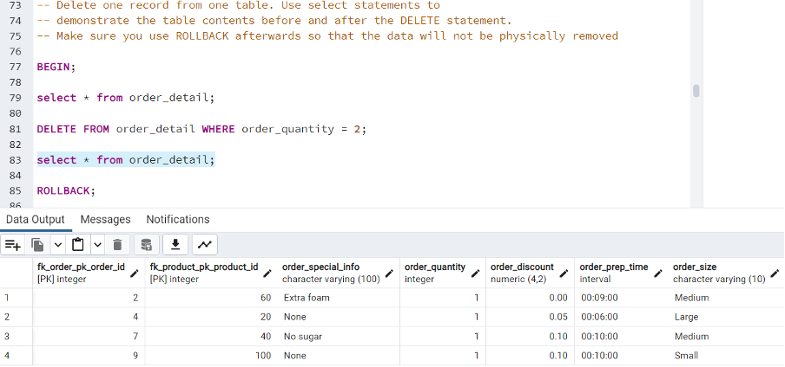

**Query 12:** Update one record from one table. Use select statements to demonstrate the table contents before and after the UPDATE statement. Make sure you use ROLLBACK afterward so that the data will not be physically removed (5 points)

BEGIN;

select * from orders;

UPDATE orders SET order_total = 10 WHERE order_id = 3;

select * from orders;

ROLLBACK;

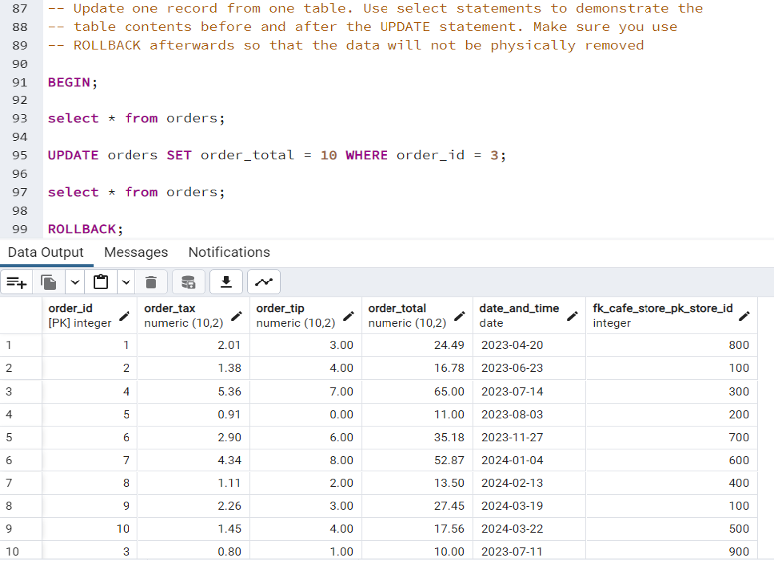

**Performing 2 Additional Advanced Queries**

Advance Query 1. Revenue Analysis by Store and Product Category

SELECT

cs.store_id,

cs.store_manager,

p.product_category AS category,

SUM(od.order_quantity * p.product_price) AS total_revenue

FROM

cafe_store cs

JOIN

orders o ON cs.store_id = o.FK_cafe_store_pk_store_id

JOIN

order_detail od ON o.order_id = od.FK_order_pk_order_id

JOIN

product p ON od.FK_product_pk_product_id = p.product_id

GROUP BY

cs.store_id, cs.store_manager, p.product_category

ORDER BY

cs.store_id, total_revenue DESC;

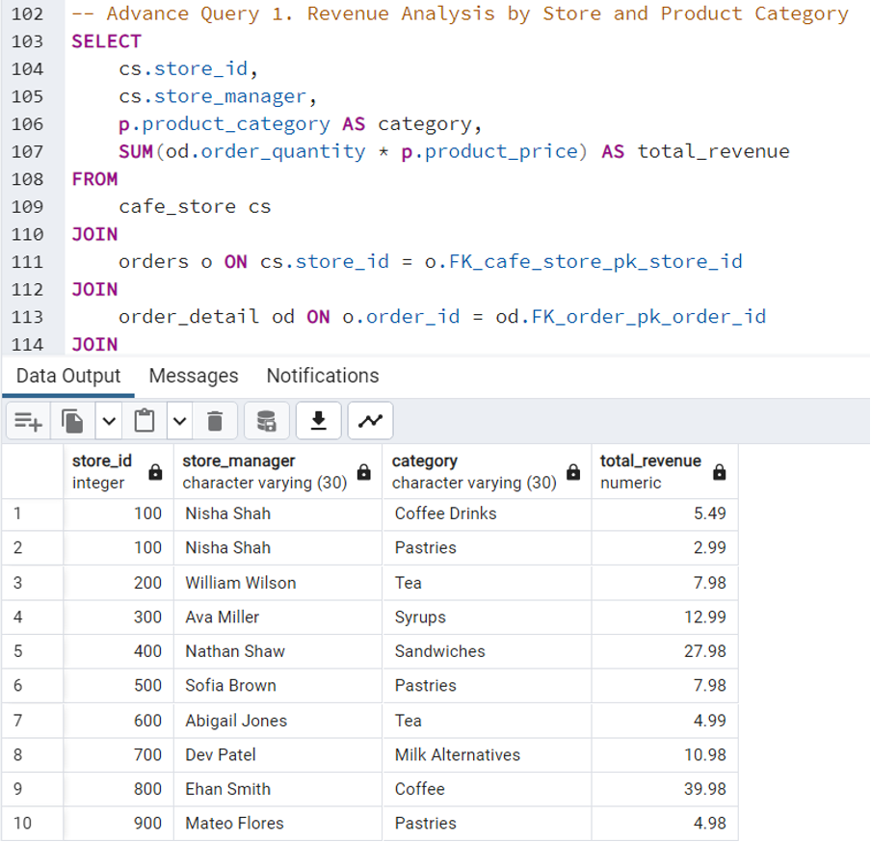

Advance Query 2.Store-wise Sales Composition by Product Category

WITH StoreSales AS (  
 SELECT  
 cs.store_id,  
 cs.city,  
 SUM(o.order_total) AS total_sales  
 FROM  
 orders o  
 JOIN  
 cafe_store cs ON o.FK_cafe_store_pk_store_id = cs.store_id  
 GROUP BY  
 cs.store_id, cs.city  
),  
CategorySales AS (  
 SELECT  
 cs.store_id,  
 p.product_category,  
 SUM(od.order_quantity * p.product_price) AS category_sales  
 FROM  
 order_detail od  
 JOIN  
 orders o ON od.FK_order_pk_order_id = o.order_id  
 JOIN  
 product p ON od.FK_product_pk_product_id = p.product_id  
 JOIN  
 cafe_store cs ON o.FK_cafe_store_pk_store_id = cs.store_id  
 GROUP BY  
 cs.store_id, p.product_category  
)  
SELECT  
 ss.store_id,  
 ss.city,  
 cs.product_category,  
 cs.category_sales,  
 (cs.category_sales / ss.total_sales * 100) AS percentage_of_total_sales  
FROM  
 StoreSales ss  
JOIN  
 CategorySales cs ON ss.store_id = cs.store_id  
ORDER BY  
 ss.store_id, cs.category_sales DESC;

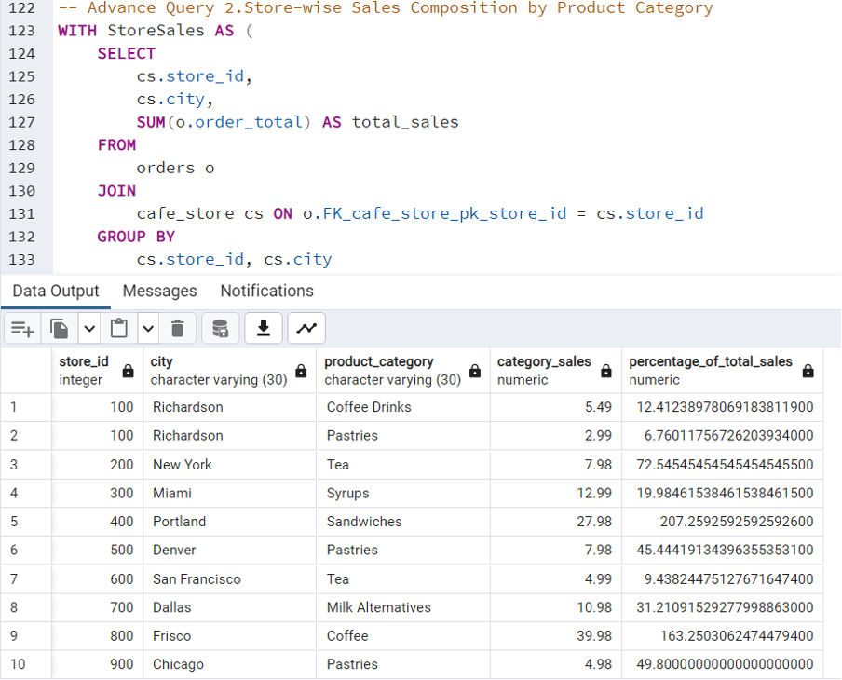

**Conclusion**

The database system designed for the café chain is a comprehensive solution that integrates various aspects of the business operations into a unified data management framework. Through the careful design and implementation of the database schema, DML scripts, and SQL queries, the system is equipped to handle the current and future data management needs of the café chain. This project not only supports operational efficiency but also provides a foundation for strategic decision-making based on reliable data.

This long-form technical report provides a thorough overview of the database project from concept to implementation, ensuring it aligns with the detailed example provided earlier. This structure ensures that every phase of the project is well-documented, providing a comprehensive reference for the design, development, and operational strategy of the database system.