**CIS 241 Competency Project**  
This project is web sites which has 5 web pages. The content is differently for each page.

The purpose is let visitors come to see information about myself, such as my background history, resume, and etc.

My web site has 5 pages, so each pages have different feature.  
  
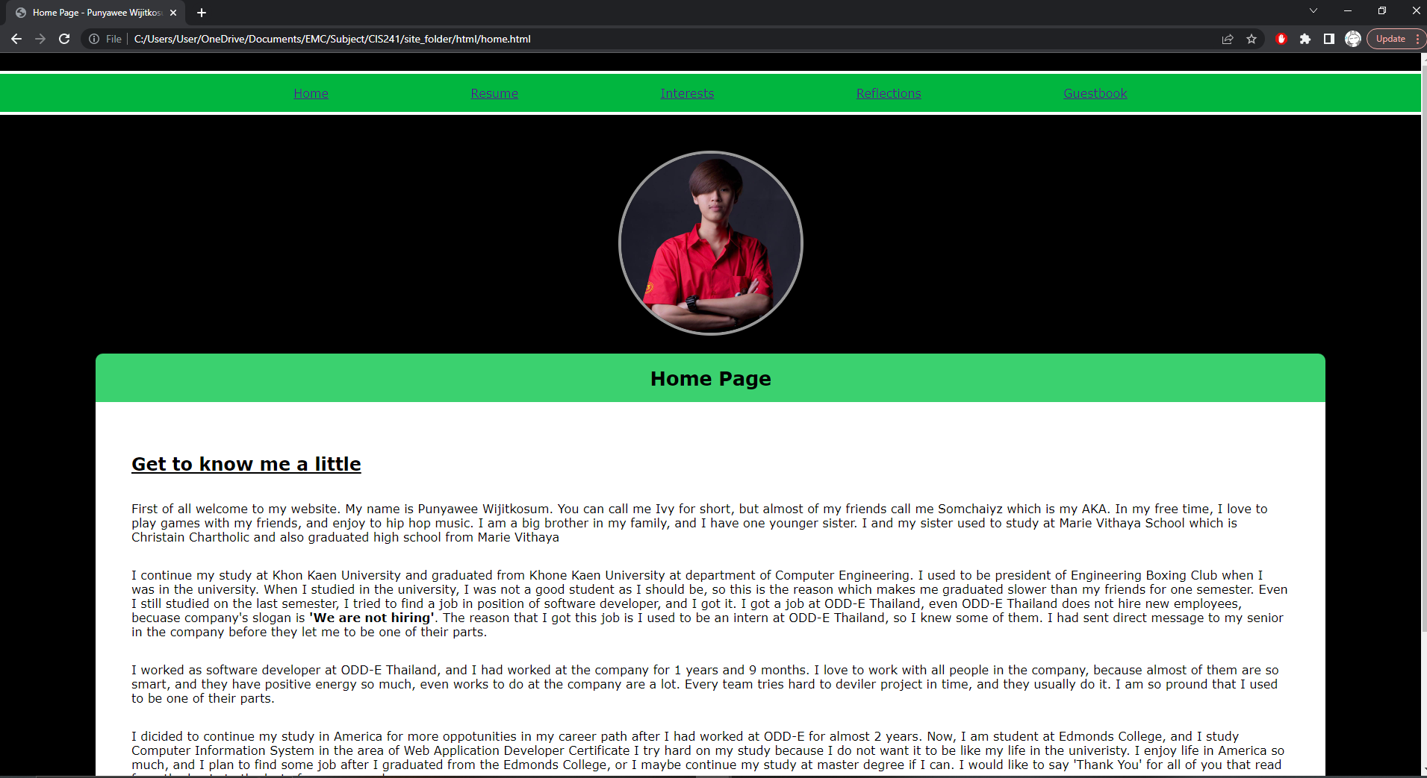

Home Page

The home page has only my back ground history, so the feature just displays my history.

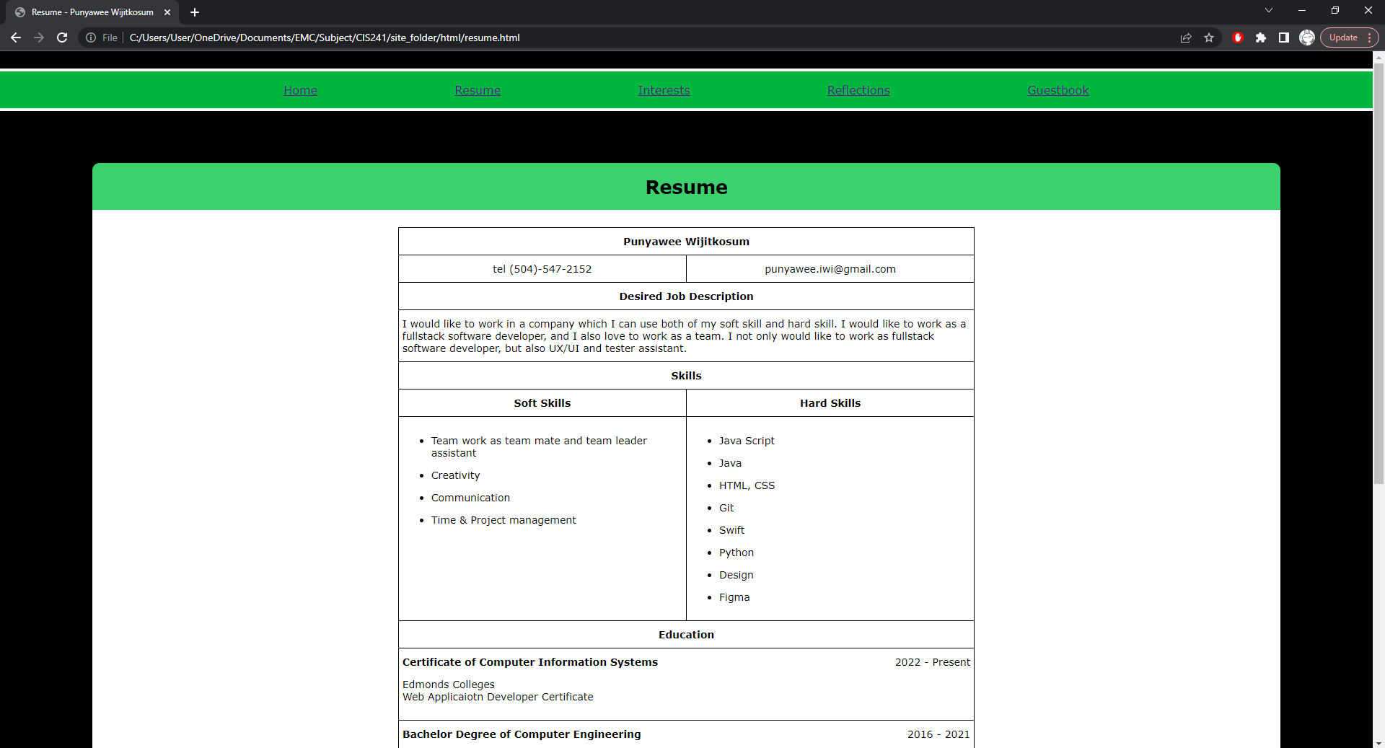

Resume Page

The resume page displays my resume, such as my skills, desired job, my education, and work experiences with built-in table.

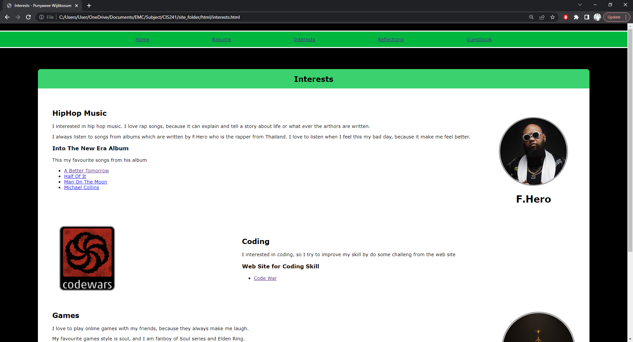

Interests Page

Interests Page displays 3 subjects that I interested, and this page also has 7 different links in term of list to navigate the visitors to the web sites which contain information about the subjects that I interested.

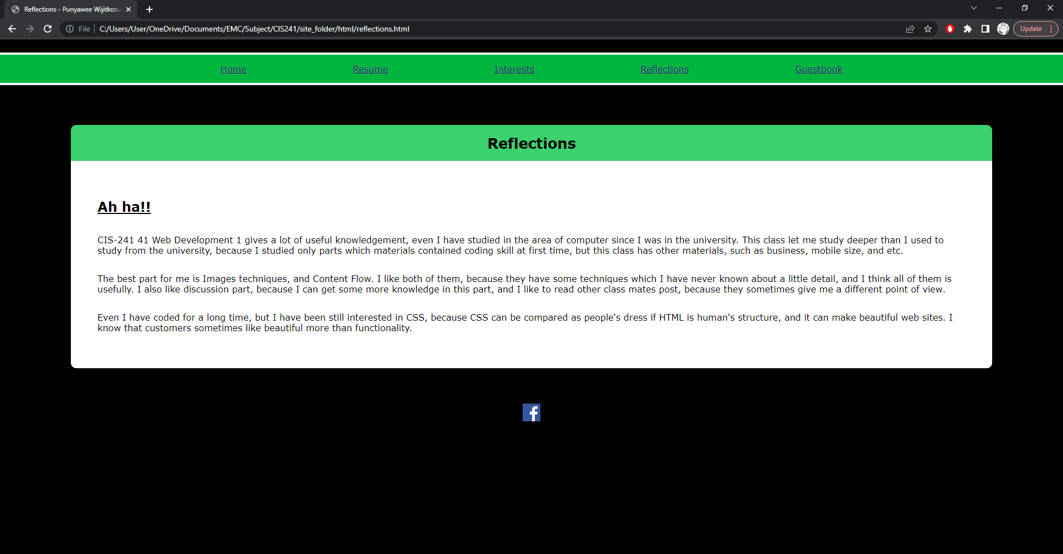

Reflection Page

Reflection page is displays about what a good moment from what I have learned from CIS-241, such as ‘Ah-ha’ moments.

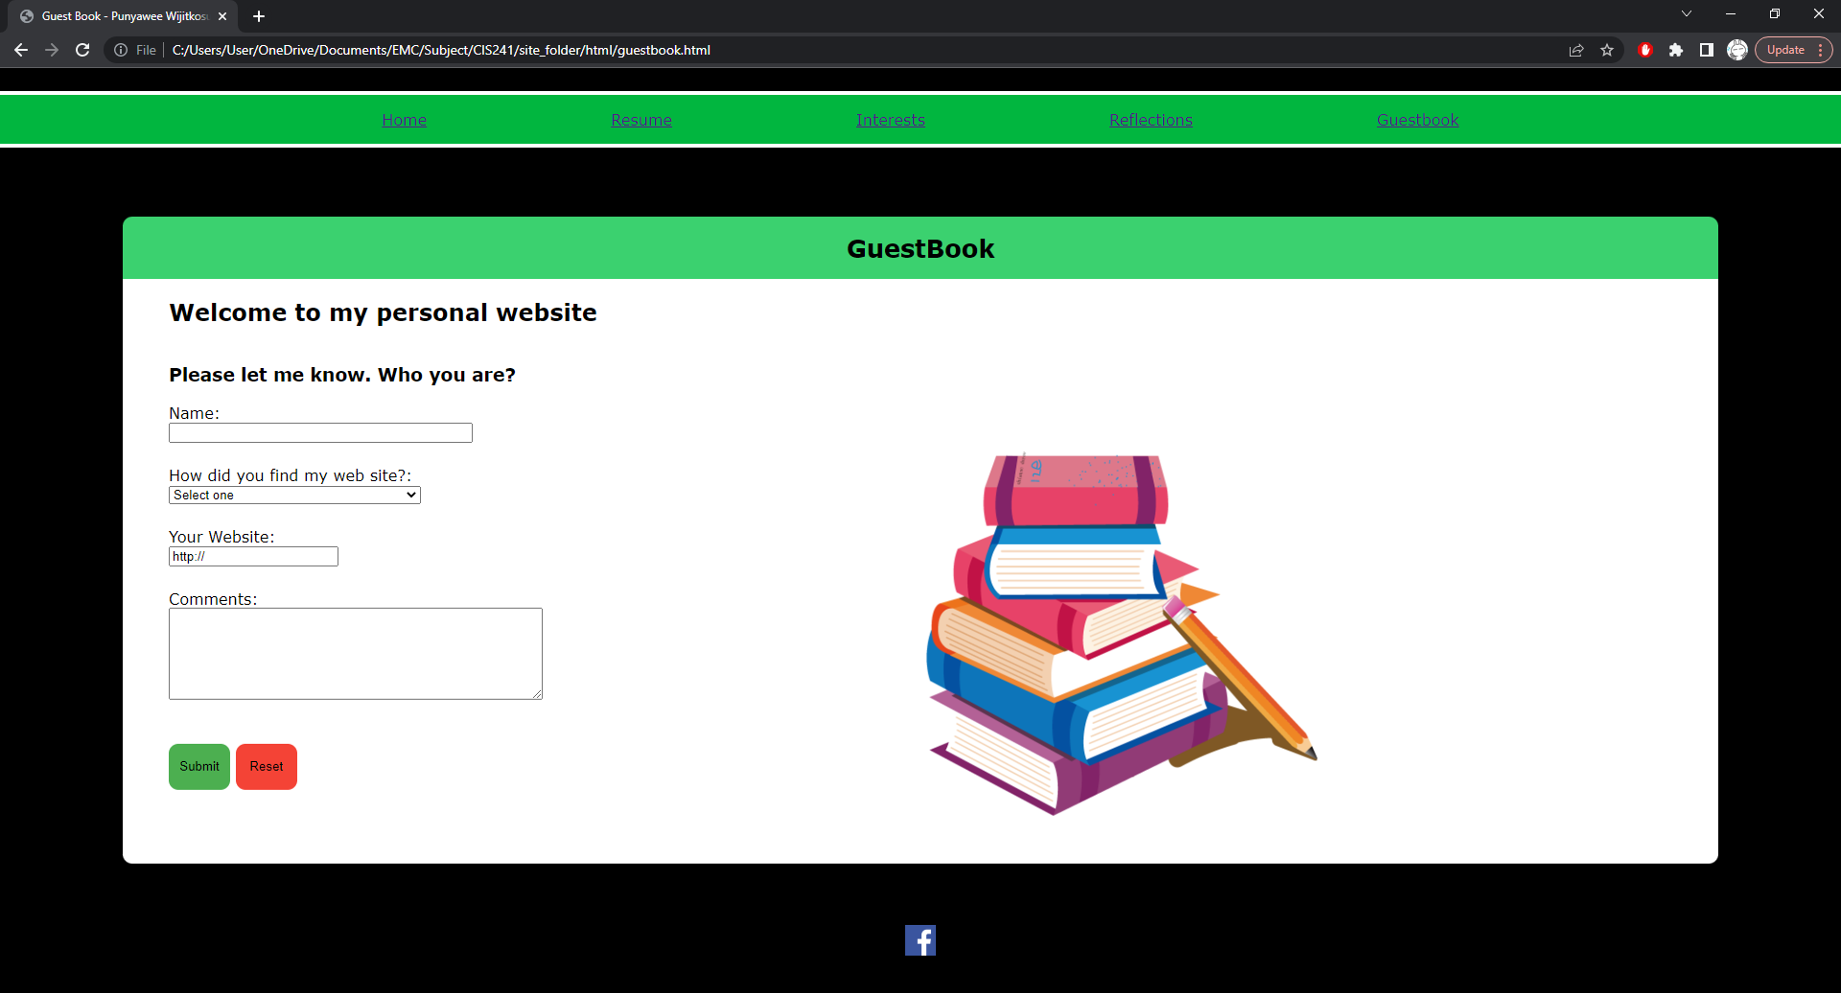

Guest Book Page  
Guest Book page let the visitors come and fill that form which uses ‘mailto’, so when the visitors finished the form and click on submit button, it will open visitors’ email, and draft an email to me with the data from form that visitors filled at my web page.