Version 0.0

12/13/20

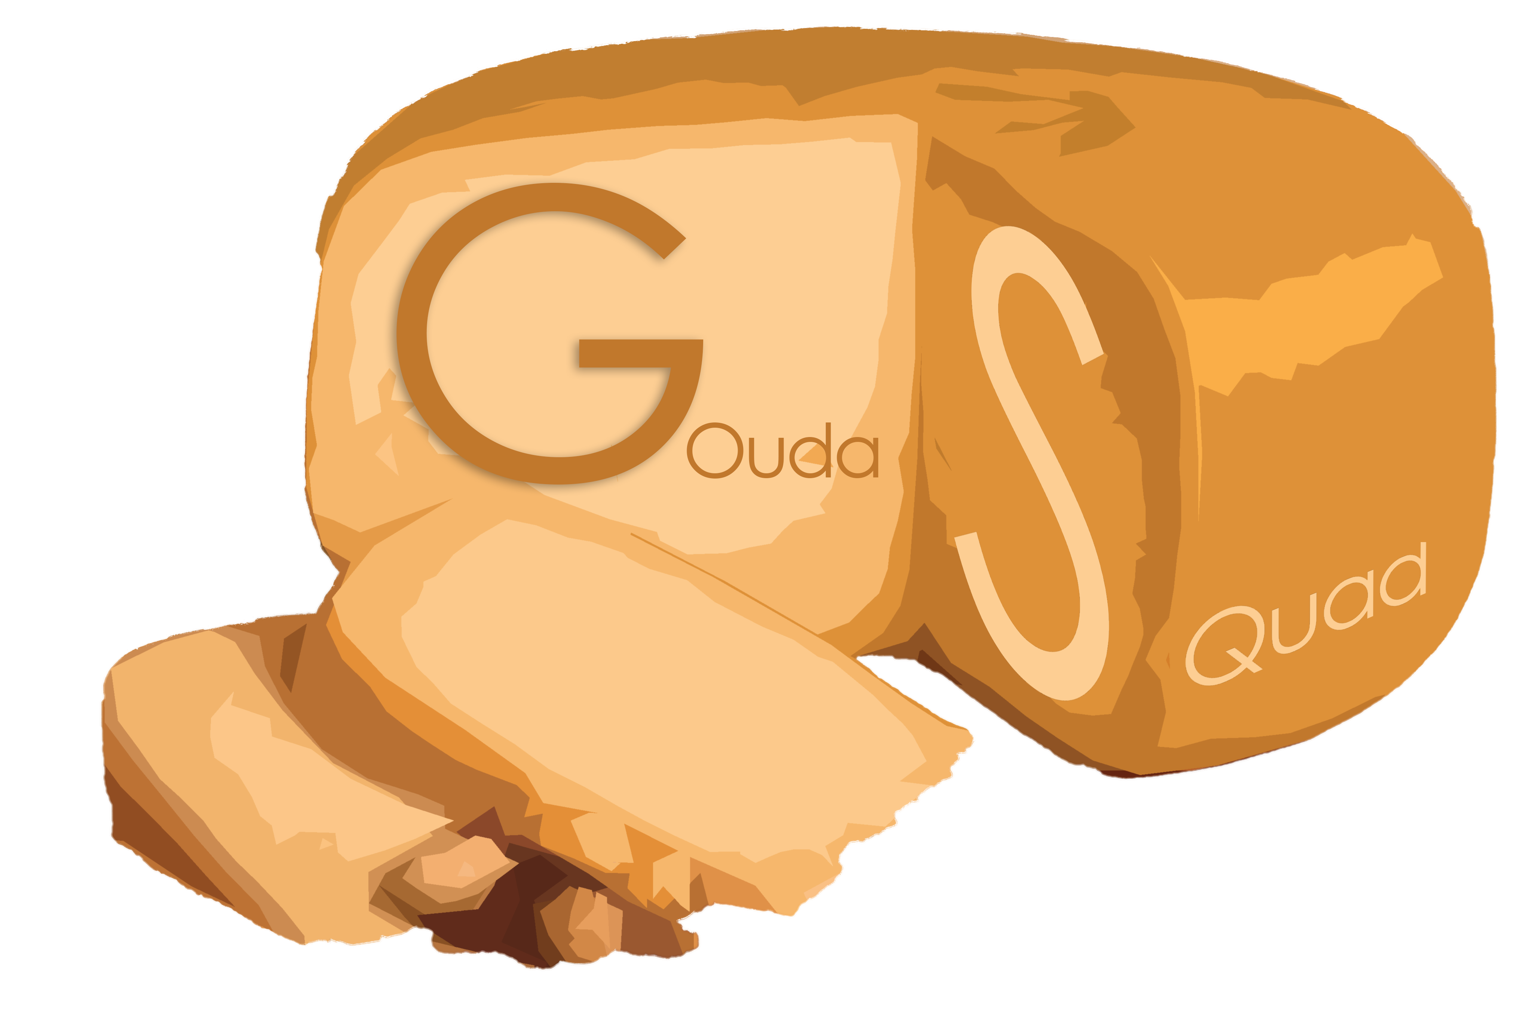

Presented by: Michael Pacheco

Gouda Squad

# Project Communication Plan

## Project communication documents

### Project communication table

| Document | Recipients | Responsibilities | Update frequency |
| --- | --- | --- | --- |
| Game Design Document | Whole Team | Design Team | As Needed |
| Style Guide | Art Team | Art Team | As Needed |
| Trello | Whole Team | Whole Team | As Needed |
| Project schedule | Whole team | Michael | As Needed |

## Team structure

**Pupcheco (Michael)** - Producer; Creative Director; Artist

**Cody** - Artist; Designer

**Neswest (West)** - Technical Artist; Programmer

**Cwook (Christian)** - Programmer

**Raeth (Ryan)**- programmer

**Brendan** - jr Programmer

**Jamesmello (James)** - Sound Designer

**Marcy** - composer

**El** - Writer; Designer

### Team goals

Create a **short**, game experience that **challenges** players to **make connections**, and come **to their own conclusions**

### Team assignments

Use the following table to outline the project's marketing teams, team goals, team leads, and team roles.

**Project Name project team**

| Name of team | Team goals | Team leads | Team roles |
| --- | --- | --- | --- |
| Art Team | Create art that drives the mood, and that helps the player focus on what’s important, | Michael | Modeling Artist, Material Artist, lighting artist |
| Programming Team | Create core game mechanics, create necessary shaders | Lead name | Tech Art, gameplay programmer, Build Master |
| Audio Team | Create sounds and music that help create the tone and atmosphere for the game | Lead name | Audio Designer, Composer |
| Writing Team | Create puzzle solution, write narrative for solution, turn narrative into case files, create other case files to hide key pieces amongst | El | Narrative Designer |
| Design Team | Design core game loop, create mvp plan, write short GDD, playtest | Cody | Level Design, mechanic design |

## Team roles and responsibilities

Asset Artist: responsible for creating in game assets

Lighting artist: Handles game lighting and post processing

Gameplay programmer: responsible for programming core gameplay mechanics

Audio Programmer (**not** **full role**): responsible for making sure Audio team can implement audio into the engine

Build Master (**not full role**): responsible for helping people with git issues and catching merge conflicts.

Audio Designer: responsible for gameplay related audio (footsteps, opening drawers, dialogue recording)

Composer: creates the games soundtrack and musical score

Writer: Writes the core narrative and designs the core narrative puzzle the players have to put together

designer: creates the layout for the room the players are in; designs the core game loop, and how the mechanics work; responsible for testing gameplay elements and tweaking them.

## Risks and issues management

### Potential exceptions and problems

* **Problem 1:** Can’t get time loop working
  + **Symptoms:** Gameplay elements dependent on time resetting wont work
  + **Consequences:** time will be wasted if core game mechanics aren’t carefully managed
  + **Solutions:** all core gameplay must be containable to a single playthrough
* **Problem 2**: movement and interaction mechanics aren’t fun by themselves
  + **Symptoms**: game will feel like its missing something
  + **Consequences**: game is not fun
  + **Solutions**: Come up with backup ideas for the core game loop
* **Problem 3:** Not enough time to write convincing side story documents
  + **Symptoms**: if core narrative is not well hidden, it will be too easy
  + **Consequences**: Game is not fun
  + **Solutions**: Use randomly generated stories/situations to assist with writing

### Tracking risks and issues

In the following table, track the risks and issues that you identified.

| Date recorded | Risk description | Probability | Impact | Mitigation plan |
| --- | --- | --- | --- | --- |
| 12/13/20 | No Time-loop | Medium | Medium | Core game loop contained to one loop |
| 12/13/20 | Mechanics are not fun | High | High | Plan additional ways to improve the core game loop ahead of time |
| 12/133/20 | No time for side stories | High | High | Use online generators for assistance |

Change management process

### Change management process steps

* Any changes are **not official** until they are posted in **announcements channel** on discord and Trello
* Changes need to be run by **all team leads** prior to posting in announcements page
* All changes that week should be **discussed at team meetings** even if they are already on discord and Trello

### Change control board (CCB)

Discipline Leads have the final say in deciding if something within the discipline is in scope or not, IE:

Someone proposes change to art style 🡪 art lead has final say for if its in scope or not

Someone proposes new mechanic 🡪 design lead will have final say if it fits our games design pillars, programming lead has final say for if making it is in scope