Raspberry Pi Final Project Title

Project Team Members
Name of team member 1 Matthew Tucker
Name of team member 2 Zakkary Hucksby
Name of team member 3 Johnathan Terry

Project Summary
Briefly summarize your what your project is about:
Make a mobile platform to play an original Zombie game. The game is home survival that can go on indefinitely and as time goes on will get harder. Will protect a house from waves at night and scavenge in the morning. Can you survive the Zombie Apocalypse?
Goals and Objectives
Briefly identify your project's main goals and objectives:
Main goal is to make a simple/complex game and a mobile platform to play the game in python. Objectives are making a mobile platform to play game, make a game, and make it 3D/ look 3D.

How will it be used?
Briefly describe how someone would go about using your project i.e. a general use case:
A way to play a game on the move and be able to entertain themselves/others with a game in a time of social distancing, with the mobile raspberry pi and or the game.

GPIO
Briefly discuss how you plan to incorporate GPIO, an external circuit, and any other external components:
Will be making controller with buttons and joysticks. There will be speakers, and battery pack as of now.

How do you think it will work?
Briefly describe how you anticipate your project working i.e. Which sensors interact in which way to achieve the targets you specified above? Or which buttons activate what functionality of your system?
Will hopefully work with the joysticks controlling player movement and elevation, a button for jumping, a button for interacting, and button for inventory, pause/settings, use item, reload, and switch item. Other buttons can be added to do other functions, and such as needed.

GUI
Briefly discuss how you plan to integrate an intuitive GUI that will be rendered on the LCD touchscreen. Feel free to provide a mock-up.
The GUI will draw and area of the map that the player is in with a fog of war for farther places, hoping to make 3D in a home made or provided 3D engine in python or fake 3D.

THE PICTURE IS JUST A QUICK SKETCH AND DOES NOT REPRESENT THE EXACT OUTCOME BUT IS USED TO SEE THE BEST OUTCOME/POSIBILITY. IS MISSING SOME HOUSES.
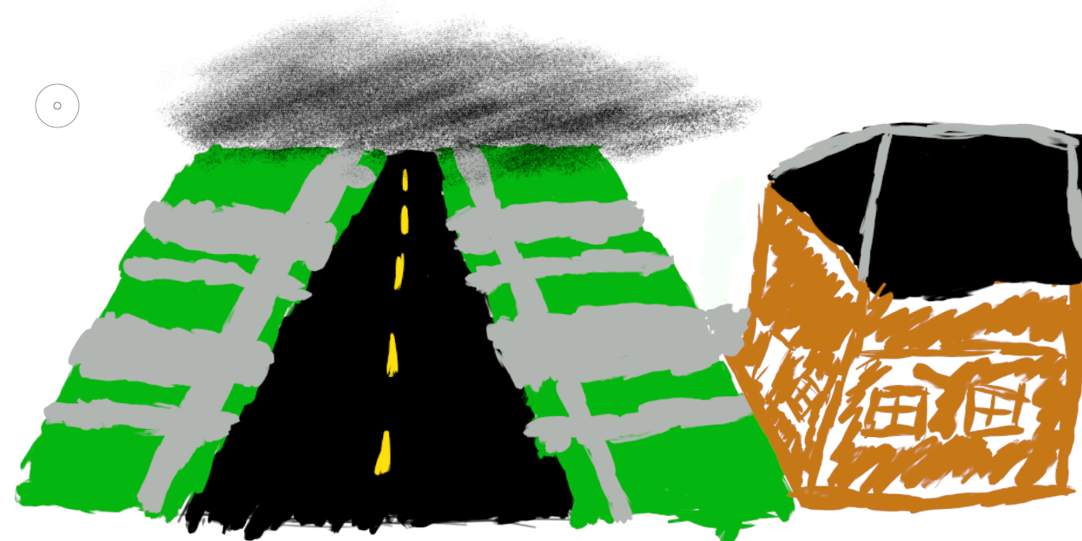

Github Repository
This project's Github repository is located at: https://github.com/Pupp3tt/2020CompSci.git

Gantt Chart
Insert your project's Gantt chart here. Make sure to modify the spreadsheet provided. An easy way to insert the spreadsheet is to highlight the relevant cells in the spreadsheet, copy it to the clipboard via Ctrl+C, and paste it as a Bitmap (centered and using no wrap) via Shift+Ctrl+V. Feel free to briefly discuss the schedule.

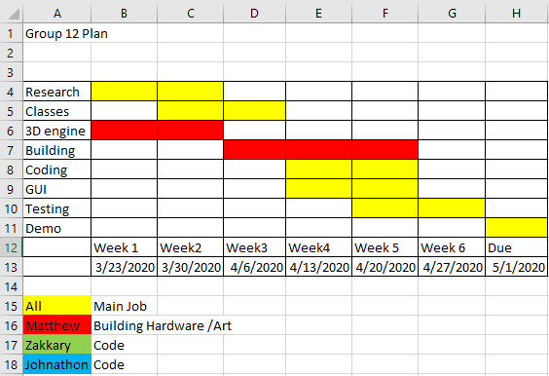

Research – find out anything that may stop or hurt project
Classes – make the classes for evything in game
3D Engine – looking at one for python, or make one
Coding – using the classes and Engine to make game
GUI – make the would
Testing - make sure it all works together
Demo – the Demo is due this day (May be wrong if so please inform us)

