

Cloud Security Alliance
Certificate of Completion Awarded to

Joshua Battung

Date: August 19, 2026
C
A
T
I
O
D
E
D
U
Location: Online
N
C
N
U
E

AI Security Summit 2026: CxO Trust
R
U
C
E
S
D
U
R
O
E
L
C
D
I
T
S
C
O
E
N
C
T
I
N
A
I
L
L
A
Y
T
I

Instructional Delivery Method: Virtual

Continued Education Credits are awarded per 50-minutes of educational content.
CSA confirms that the certificate recipient has completed the number of awarded hours.

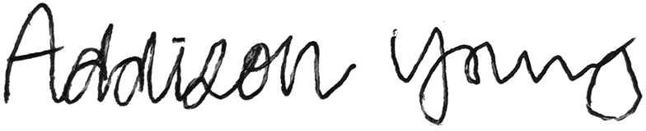
3.5
Addison Young, Event Manager Total Credits

Version 20250925

