**GUIDE TO TEST YOUR PROJECT WITH THE REAL RPI BOARD**

1. **Prepare the SD card**

Use the **Raspberry Pi imager** tool to flash a Raspberry Pi OS (32-bit) on your SD card.

1. **Build Image**

Build your project to get the file **kernel8.img.**

**Note**:

* For testing, in your code, you should **display an** **image** at the beginning of the main function (e.g. after WelcomeMessage, so that you can see it on the **screen** later).
* If you are using **RPI4**, go to the header file **gpio.h** and comment out the line

**#define** RPI3 (keep other content unchanged). Then type “make” in the terminal to compile the project again for RPI4.

// -----------------------------------gpio.h -------------------------------------

**//#define** RPI3 //enable when using RPI3 (QEMU emulation/ real RPI3 board). Disable for RPI4

**#ifdef** RPI3 //RPI3

**#define** MMIO_BASE 0x3F000000

**#else** //RPI4

**#define** MMIO_BASE 0xFE000000

**#endif**

…………………………………………………

1. **Copy to SD card**

Copy **kernel8.img** file to the microSD card and remove all other **\*.img** files inside. Of course, the microSD card needs to be formatted properly before.

In order to use the mini UART, we also need to configure the Raspberry Pi to use a fixed VPU core clock frequency. This is because the mini UART clock is linked to the VPU core clock, so that when the core clock frequency changes, the UART baud rate will also change.

To do so, the **enable_uart** and **core_freq** settings can be added to **config.txt** file inside the microSD card to change the behaviour of the mini UART as below:

Note: recommend to use **UART1** in your project for easier connection

*File: config.txt*

*Add two additional settings at the end of the file*

**enable_uart=1**

**core_freq=250**

1. **UART connection between the board and your computer**

* In addition, we will need an **USB to COM** **adapter cable** so that we can connect the serial port of raspberry pi board our computer through its USB port. There are two types of USB to COM adapters that you can use:
* [**USB TO COM PL2303 V2**](https://thegioichip.com.vn/products/cap-chuyen-usb-sang-ttl)(blue cable)

If your computer does not recognize that device automatically, you may need to install its driver from the seller’s page or from the official website: <http://www.prolific.com.tw/US/ShowProduct.aspx?p_id=225&pcid=41>

For Windows 10, there could be an error with the driver. If so, you can reinstall it with this [guide](https://translate.google.com/translate?sl=vi&tl=en&u=https://hocarm.org/huong-dan-cai-driver-pl2303-voi-win10/).

* [**USB SERIAL CONVERTER FT232**](https://linhkienthanhcong.com/cap-chuyen-usb-uart-ft232)(black cable)

After driver installation, you will see the port in Windows “**Device Manager**” (search and run from search bar). For example, it is currently running as **COM5** port in the figure below:

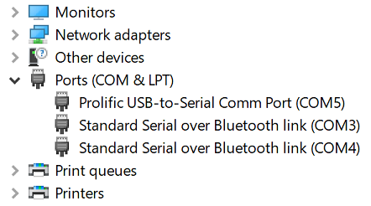

* **Connecting the cable**

In the adapter cable, BLACK, WHITE and GREEN are respectively Ground, RXD and TXD pins of the cable. It is the same for PL2303 (blue) or FT232 (black) cables.

To connect two UART devices, we need to connect RX pin of a device to TX pin of the other and vice versa. Therefore, you should connect the **BLACK wire to Ground** (Pin 6), the **WHITE wire to TXD** (GPIO 14) and the **GREEN wire to RXD** (GPIO 15) of the Raspberry as below. Refer to pinout diagram provided at the beginning of the lab guide for details.

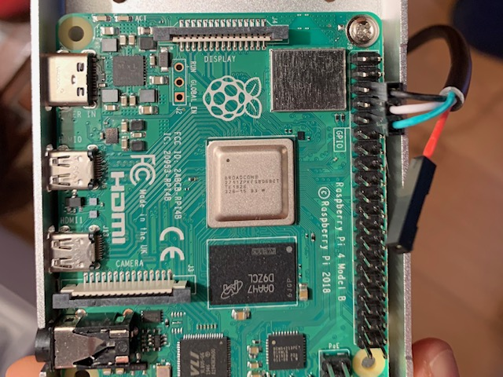

* **Use a terminal tool to communicate with the serial port**
  + For Windows, install **TeraTerm** tool at this link: [TeraTerm](https://rmiteduau-my.sharepoint.com/:u:/g/personal/linh_tranduc_rmit_edu_vn1/EX0-on1BEB5BhRSg0ZXZ05wBWeLNpDnKQPK2-l4yJ_63iA?e=j1vkc4). Then use TeraTerm for serial connection as below:

*Select* ***Setup*** *>* ***Serial port.***

*Select the COM port which is connected to the cable in* ***Port*** *option.*

*Select the values for UART connection as configured in our code:*

**Speed**: 115200(baud rate).

**Data**: 8 bit

**Parity**: none

**Stop bits**: 1

**Flow control**: None

Finally, select **New Open** to start the connection.

* + For **MacOS**, you can do it as follow:
    - Open an OS X terminal session
    - Find the right TTY device by typing: ls /dev/cu.*

With the USB-Serial adapter plugged in, you'll get a list, including something like this:

$ **ls /dev/cu.\***  
/dev/cu.Bluetooth-Modem       /dev/cu.iPhone-WirelessiAP  
/dev/cu.Bluetooth-PDA-Sync    /dev/cu.usbserial

* Then type: screen /dev/cu.usbserial 115200 to connect to the serial port
* Reference for more details:[https://pbxbook.com/other/mac-tty.html](https://aus01.safelinks.protection.outlook.com/?url=https%3A%2F%2Fpbxbook.com%2Fother%2Fmac-tty.html&data=05%7C01%7Clinh.tranduc%40rmit.edu.vn%7Ca028cbb3fff6438b6f4008da80d8e6fc%7Cd1323671cdbe4417b4d4bdb24b51316b%7C0%7C0%7C637963966378609075%7CUnknown%7CTWFpbGZsb3d8eyJWIjoiMC4wLjAwMDAiLCJQIjoiV2luMzIiLCJBTiI6Ik1haWwiLCJXVCI6Mn0%3D%7C3000%7C%7C%7C&sdata=7JSYP8ivbvDw7LfopsddETcJjq8mjmVwNbcP9fEkRVM%3D&reserved=0)

1. **Screen Connection**

**RPI3**: use HDMI-HDMI cable to connect to a TV/LCD screen.

**RPI4**: use miniHDMI-HDMI cable to connect to a TV/LCD screen.

For the RPI4, there are two HDMI ports, thus, please use **HDMI1** for connection (enabled by default) with your screen.

Note: If you use a TV instead of a monitor for screen display and you don’t see anything on the screen, you may try doing extra setting through config.txt file:

#### **hdmi_safe**

Setting hdmi_safe to 1 will lead to "safe mode" settings being used to try to boot with maximum HDMI compatibility

#### **hdmi_group** & **hdmi_mode** for correct resolution

Search here with keyword “hdmi_group”, “hdmi_mode”for corresponding setting:

<https://www.raspberrypi.com/documentation/computers/config_txt.html>

For example, do following setting for 1080p (1920x1080) resolution.

hdmi_group**=**1

hdmi_mode**=**16

1. Check Result

Now, turn ON power for the board.

On the screen, you should see an image.

On the TeraTerm terminal in your computer, you should see

|  |  |
| --- | --- |
|  |  |

If it does not work as above, there could be issues with the connection cable, the board, or your code (less likely), and some troubleshooting is needed.