1. Install JDK20
   1. Check your java version: java -version:



* 1. If the version of java is less than 20, download the JDK20 (choose your own product):

<https://www.oracle.com/java/technologies/downloads/>

* 1. After install, check the version again

1. Install Mysql 8
   1. Download the Mysql 8 (choose your own system):

<https://dev.mysql.com/downloads/mysql/>

* 1. install mysql 8:

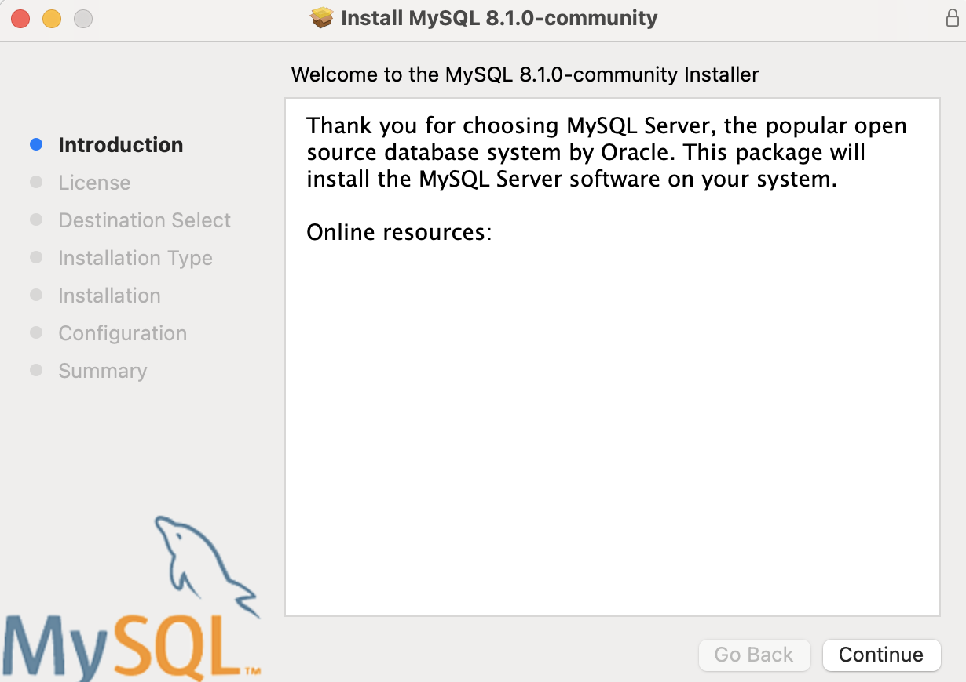

click Continue

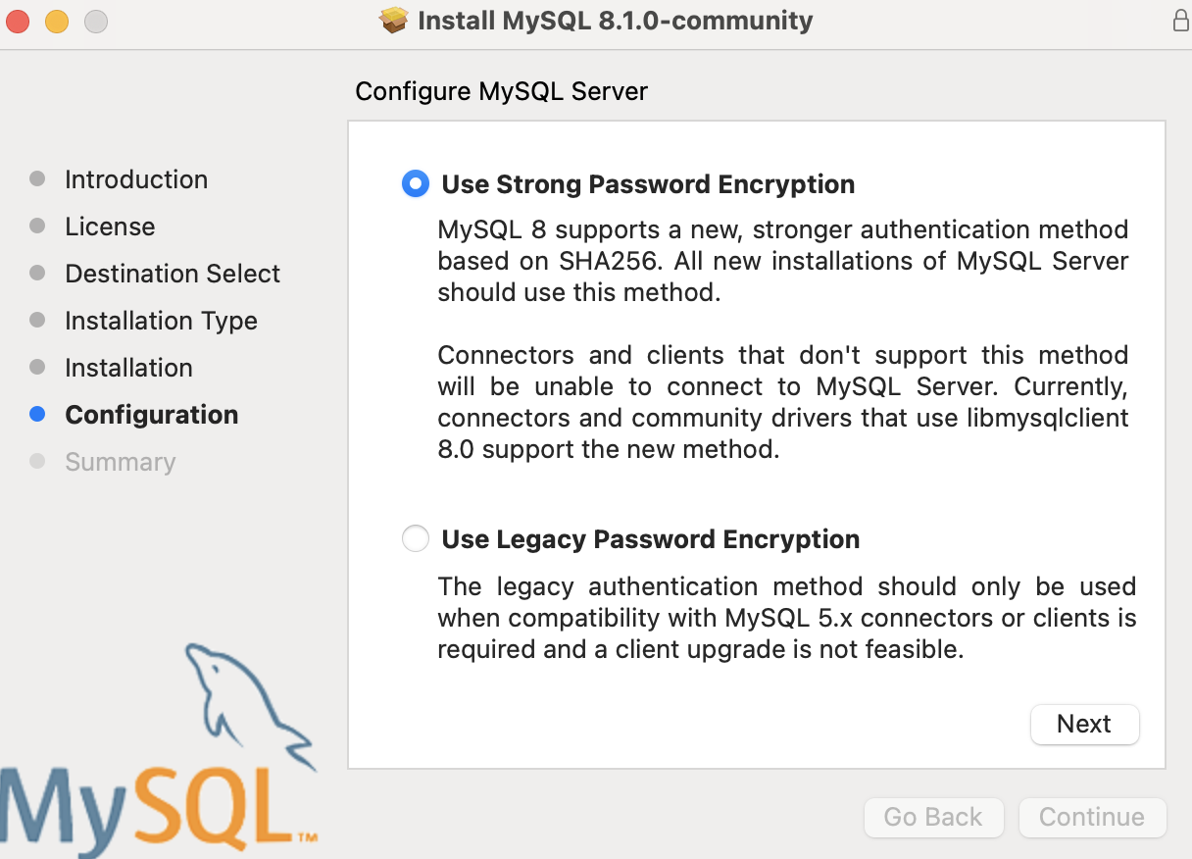

click Next

* 1. **Set the password to be ‘rootroot’**

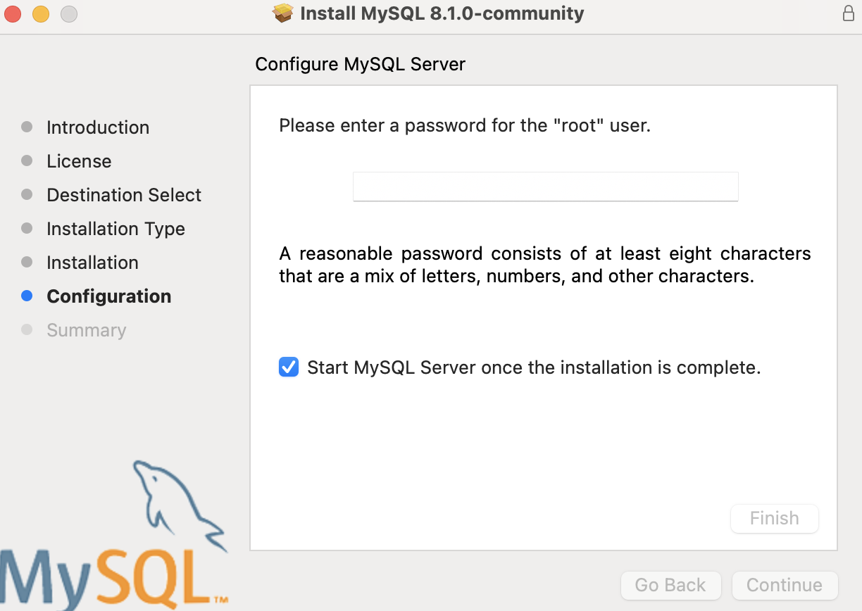

enter **rootroot** as the password

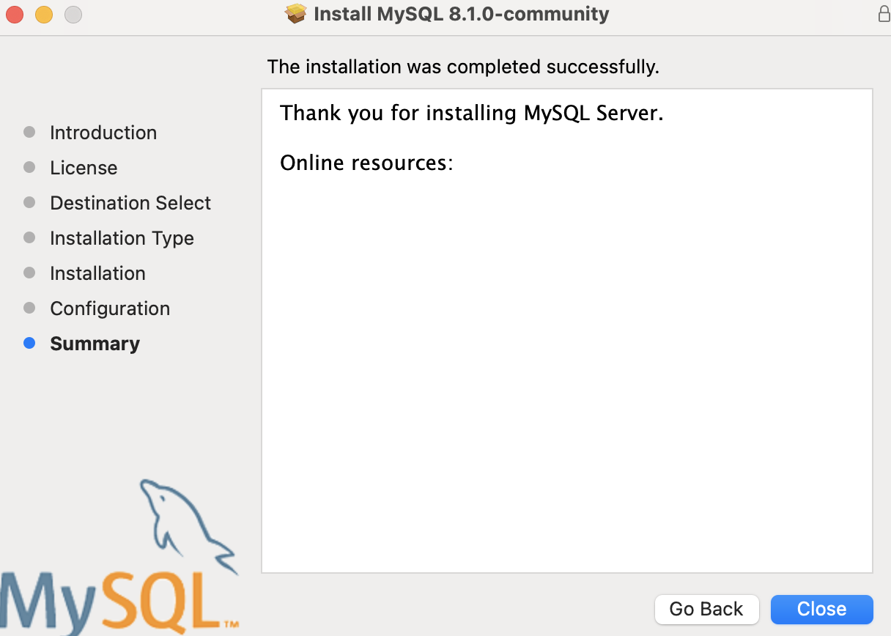

finish installing

1. Download the 9900.sql file
   1. Download the 9900.sql file from Github (in the Database file):

<https://github.com/unsw-cse-comp3900-9900-23T2/capstone-project-9900w18bgogogo/tree/main/Database>

1. Run the 9900.sql file
   1. Login mysql (before you do that, you could need to Add the mysql binary to your system's path <https://www.tutorialspoint.com/adding-mysql-to-windows-path> ):

**mysql -u root -p**

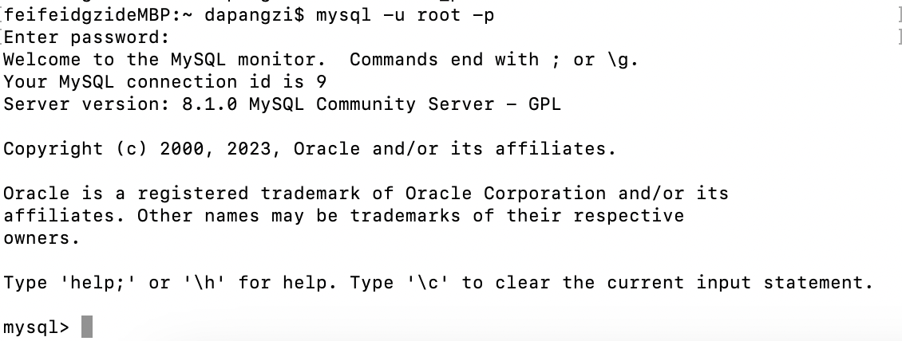

* 1. Create database waitsys:

**create database waitsys;**



* 1. Using the waitsys:

**use waitsys;**

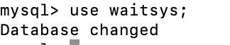

* 1. import the source file 9900.sql:

**source {the path of 9900.sql}**

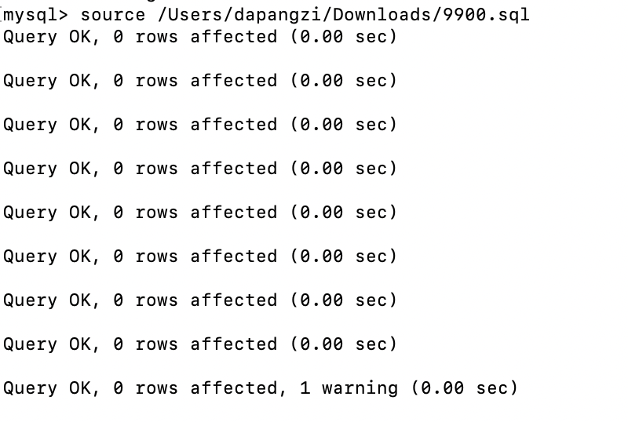

1. Download the waitSys.jar

Download the waitSys.jar from github <https://github.com/unsw-cse-comp3900-9900-23T2/capstone-project-9900w18bgogogo/tree/main>

1. Run the waitSys.jar file
   1. open the terminal at the path of the waitSys.jar
   2. run the waitSys.jar

**java -jar waitSys.jar**

