VIVEKANAND EDUCATION SOCIETY’S INSTITUTE OF TECHNOLOGY
An Autonomous Institute Affiliated to University of Mumbai
Department of Computer Engineering

CAPSTONE PROJECT–II
PROJECT REPORT

GRASP: Greenwashing Risk Assessment in Structured Business Responsibility and Sustainability Reporting in India
Submitted in partial fulfilment of the requirements for the
Bachelor of Engineering (B.E.) Degree in Computer Engineering
Semester VII | Academic Year 2026–27
Submitted by
Purab Keshwani – D17B 26
Khushi Dayaramani – D17B 14
Ronit Chugwani – D17B 13
Karan Sarani – D17B 45
Project Mentor
Mrs. Yugchhaya Galphat
A. Y. 2026–27
CERTIFICATE
VIVEKANAND EDUCATION SOCIETY’S INSTITUTE OF TECHNOLOGY
An Autonomous Institute Affiliated to University of Mumbai
Department of Computer Engineering

This is to certify that the Capstone Project–II report entitled “GRASP: Greenwashing Risk Assessment in Structured Business Responsibility and Sustainability Reporting in India” has been submitted by Group No. 44, comprising the students listed below, in partial fulfilment of the requirements for the Bachelor of Engineering in Computer Engineering for Semester VII, Academic Year 2026‑27.
Group No. 44 | Domain: Application Design & Product Development
Student | Class / roll number
Purab Keshwani | D17B 26
Khushi Dayaramani | D17B 14
Ronit Chugwani | D17B 13
Karan Sarani | D17B 45

The report is submitted under the guidance of Mrs. Yugchhaya Galphat. Approval, assessment and signatures are to be completed by the authorised faculty and examiners.

Mentor signature: ____________________________
Mrs. Yugchhaya Galphat
Date: ____________________
Place: Mumbai
Programme / course outcomes | Grade
PO1–PO11; PSO1–PSO2; CO1–CO6

PROJECT REPORT APPROVAL
For B.E. (Computer Engineering)
The Capstone Project–II report entitled “GRASP: Greenwashing Risk Assessment in Structured Business Responsibility and Sustainability Reporting in India”, submitted by Group No. 44 for the Bachelor of Engineering in Computer Engineering, is placed for examination and approval.

Internal Examiner: ____________________________________
External Examiner: ____________________________________
Head of Department: __________________________________
Principal: ____________________________________________
Date: ____________________
Place: ____________________
DECLARATION
The undersigned students declare that this report presents the work carried out for the Capstone Project–II submission entitled “GRASP: Greenwashing Risk Assessment in Structured Business Responsibility and Sustainability Reporting in India”. Sources of ideas, methods, data and results are acknowledged in the report and references. Any external certificates, approvals and supporting reports must be supplied in their original authorised form.
The report records the implementation and available audit evidence. Model evaluations, AI annotations, historical human ratings and application outputs are identified according to the respective source. This declaration is to be signed by the students after final review.

Student / class and roll number | Signature
Purab Keshwani — D17B 26
Khushi Dayaramani — D17B 14
Ronit Chugwani — D17B 13
Karan Sarani — D17B 45

Date: ____________________
Place: Mumbai
ACKNOWLEDGEMENT
Sincere gratitude is expressed to Mrs. Yugchhaya Galphat for guidance, review and support throughout the development of GRASP. The mentor’s feedback helped shape the reporting workflow, research presentation and interpretation of the results.
Acknowledgement is extended to the Department of Computer Engineering at Vivekanand Education Society’s Institute of Technology for the academic support and learning environment provided during the Capstone Project–II work. The opportunity to connect software engineering with sustainability disclosure analysis contributed to the development of both technical and research skills.
The work also draws on public BRSR filings, openly available research, pretrained language models and open-source software. These resources made it possible to study filing-based analysis and build a connected application. The corresponding methods and sources are acknowledged in the references.
Appreciation is expressed to all contributors who supported discussion, implementation and document review. Responsibility for checking the final submission, attaching required evidence and obtaining approvals remains with Group No. 44.

Purab Keshwani
Khushi Dayaramani
Ronit Chugwani
Karan Sarani
COURSE OUTCOMES AND MAPPING
Course Outcome | Description
CO1 | Implement and integrate all modules of the proposed system effectively.
CO2 | Perform testing, debugging, validation, and performance optimization of the developed solution.
CO3 | Analyze project outcomes using appropriate engineering tools and metrics.
CO4 | Demonstrate deployment readiness, usability, security, scalability, and sustainability considerations.
CO5 | Analyze, interpret, and present research outcomes effectively using appropriate research methodologies, analytical tools, and presentation techniques.
CO6 | Present and defend the complete project professionally through demonstrations, presentations, and comprehensive technical documentation.

CO–PO–PSO Mapping
CO | PO1 | PO2 | PO3 | PO4 | PO5 | PO6 | PO7 | PO8 | PO9 | PO10 | PO11 | PSO1 | PSO2
CO1 | 2 | 3 | 3 | – | 3 | – | – | – | 3 | – | 2 | 3 | 3
CO2 | 2 | 3 | 2 | 3 | 3 | – | – | – | 2 | – | 2 | 3 | 2
CO3 | 2 | 3 | 2 | 3 | 3 | – | – | – | – | 2 | 2 | 3 | 2
CO4 | 2 | 2 | 3 | 2 | 3 | 2 | 3 | 2 | – | – | 3 | 3 | 3
CO5 | 2 | 3 | – | 3 | 3 | – | – | 2 | – | 3 | 2 | 2 | 2
CO6 | – | – | – | – | 2 | – | – | 2 | 3 | 3 | 2 | 2 | 2

Mapping scale: 3 = high correlation; 2 = moderate correlation; 1 = low correlation; – = no direct correlation. The mapping is reproduced from the college template; it is not an awarded grade.
Implementation evidence for CO1–CO6 is provided by the integrated modules, testing records, quantitative analysis, service design, research comparison and technical documentation.
TABLE OF CONTENTS
ABSTRACT xii
CHAPTER 1: INTRODUCTION 1
1.1 Introduction 1
1.2 Motivation 1
1.3 Problem Definition 2
1.4 Existing Systems 2
1.5 Lacunae in Existing Systems 3
1.6 Relevance of the Project 3
1.7 Alignment with the United Nations Sustainable Development Goals 4
CHAPTER 2: LITERATURE SURVEY 5
2.1 Brief Overview 5
2.2 Related Works and Research Papers Referred 5
2.3 Patent Search 8
2.4 Inference Drawn 9
2.5 Comparison with Existing Systems 10
2.6 Feasibility Analysis 10
2.7 Expected Outcomes 11
CHAPTER 3: REQUIREMENT GATHERING 12
3.1 Requirements Scope and Sources 12
3.2 Functional Requirements 12
3.3 Non-Functional Requirements 13
3.4 Hardware, Software, Technologies and Tools 14
3.5 Constraints 15
CHAPTER 4: PROPOSED DESIGN 16
4.1 Block Diagram of the System 16
4.2 Modular Design of the System 17
4.3 Detailed Design 17
4.4 Scheduling and Tracking 19
4.5 Sustainability Design Decisions 20
CHAPTER 5: IMPLEMENTATION OF THE PROPOSED SYSTEM 21
5.1 Development Methodology 21
5.2 Algorithms and Internal Working 21
5.3 Dataset Sources and Utilisation 28
CHAPTER 6: TESTING OF THE PROPOSED SYSTEM 29
6.1 Testing Objectives and Scope 29
6.2 Types of Tests Considered 29
6.3 Test Case Scenarios and Recorded Results 30
6.4 Inferences Drawn from Test Cases 31
CHAPTER 7: RESULTS AND DISCUSSION 32
7.1 User Interface Screens 32
7.2 Performance Evaluation Measures 35
7.3 Dataset and Feature Inputs 37
7.4 Model Results and Generalisation Diagnostics 37
7.5 Comparison of Results with Existing Methods 40
7.6 Application Results and Inferences 41
7.7 Sustainability Impact Assessment and Rubric Justification 45
CHAPTER 8: CONCLUSION 48
8.1 Limitations 48
8.2 Future Scope 49
REFERENCES 50
APPENDIX I: EVIDENCE AND SUPPORTING DOCUMENTS 52
A. User Guide and Reproduction Notes 52
B. Complete Recorded Sector Summary 52
C. Publication or Acceptance Proof 56
D. Publication or Presentation Certificate 57
E. Plagiarism Similarity Report 58
F. AI-Content Report 59
G. Competition or Award Evidence 60
H. Progress Review Sheet 1 61
I. Progress Review Sheet 2 62
J. Demonstration Video Reference 63

LIST OF FIGURES
Figure 4.1. GRASP architecture from public filing data to company and sector outputs. 16
Figure 4.2. Core database relationships. A company has multiple filings, and each filing has multiple context-bearing facts. 18
Figure 4.3. Read-only company analysis request from browser selection to a source-linked response. 18
Figure 5.1. Single-label dataset construction from narrative facts, recorded label sources and company-based splitting. 23
Figure 7.1. Live company search locates matching names and CINs before opening a filing report. 32
Figure 7.2. Live filing report for Triveni Turbine Limited, showing company identity, reporting year and filed numerical trends. 33
Figure 7.3. Peer-comparison selection with two financial companies. The interface supports a group of two to five companies. 34
Figure 7.4. Structured filing upload screen. The implemented route accepts XML/XBRL files; no file was uploaded for this documentation capture. 35
Figure 7.5. Validation macro-F1 over five completed epochs. The highest recorded value occurs at epoch 4, which supplies the selected checkpoint. 38
Figure 7.6. Top-1 agreement by label source with reported company-bootstrap confidence intervals. 39
Figure 7.7. Mean Transparency Scores for selected eligible sectors. Group sizes are shown with the names; bars describe saved company scores rather than environmental performance. 43

LIST OF TABLES
Table 1.1. SDG alignment and available evidence 4
Table 2.1. Research methods and design inferences 7
Table 2.2. Patent publications reviewed 9
Table 2.3. Practical comparison of disclosure-analysis approaches 10
Table 3.1. Functional requirements and corresponding outputs 12
Table 3.2. Quality requirements and evidence status 13
Table 3.3. Implementation tools and roles 14
Table 4.1. Modules, inputs and outputs 17
Table 4.2. Main service endpoints 19
Table 4.3. Work packages and completion evidence 20
Table 5.1. Frozen language-detector decision rules 24
Table 5.2. Fixed principle-to-SDG map 27
Table 5.3. Final labelled corpus by source 28
Table 5.4. Company-disjoint supervised split 28
Table 6.1. Recorded verification cases and evidence status 30
Table 7.1. Approved results and evaluation populations 36
Table 7.2. Text segments by BRSR principle 37
Table 7.3. Per-principle classification on the company-disjoint test set 38
Table 7.4. Source-wise agreement for the recovered classifier 39
Table 7.5. Triveni worked score from the saved application snapshot 41
Table 7.6. Selected financial-company results from the saved snapshot 42
Table 7.7. Financial-sector score bands 42
Table 7.8. Largest recorded sector groups 44
Table 7.9. Paired-year company scores 45
Table 7.10. Material topics and implementation evidence 46
Table 7.11. Template rubric mapped to available evidence 47
Table A.1. Complete recorded sector score summary 52

ABBREVIATIONS
Abbreviation | Meaning
API | Application Programming Interface
BERT | Bidirectional Encoder Representations from Transformers
BRSR | Business Responsibility and Sustainability Reporting
CI | Confidence Interval
CIN | Corporate Identity Number
CO / PO / PSO | Course / Programme / Programme-Specific Outcome
ESG | Environmental, Social and Governance
GRASP | Greenwashing Risk Assessment in Structured Business Responsibility and Sustainability Reporting
MLM | Masked Language Modelling
MPNet | Masked and Permuted Pre-training Network
NIC | National Industrial Classification
NLP | Natural Language Processing
SDG | Sustainable Development Goal
SEBI | Securities and Exchange Board of India
TS | Transparency Score
XBRL | eXtensible Business Reporting Language

ABSTRACT
India’s Business Responsibility and Sustainability Reporting (BRSR) framework produces a large collection of company disclosures containing text and numerical information. Reviewing this collection manually requires analysts to locate relevant statements, identify supporting figures and compare reporting across companies. Existing language tools can recognise topics, retrieve answers or detect persuasive wording, but disclosure review also needs a clear connection to filed evidence. GRASP provides a connected workflow for this purpose. Public filings are collected and stored with company identity, reporting period and context. Narrative text segments receive filing-derived principle labels and support a domain-adapted BERT classifier. Word lists and MPNet sentence similarity identify potentially vague language, while numerical and assurance rules create linked review records. A fixed Transparency Score combines Completeness, Specificity, Clarity and mapped Sustainable Development Goal coverage, and the service layer presents company and sector comparisons. The labelled corpus contains 42,409 text segments. On 6,201 test text segments from 175 companies excluded from supervised training, the recovered classifier reaches 93.00% Top-1 agreement and macro-F1 of 0.9158 against the taxonomy-derived labels. The Transparency Score has a Pearson correlation of 0.6314 with historical ratings for 20 companies. Application results cover 1,164 company scores and demonstrate review at company, financial-sector and wider sector levels. The outcome is an inspectable disclosure-analysis workflow that brings source records, principle assignments and visible score calculations together for consistent review.
Keywords: BRSR; disclosure analysis; weak supervision; BERT; vagueness detection; Transparency Score.

CHAPTER 1: INTRODUCTION

1.1 Introduction
Business Responsibility and Sustainability Reporting (BRSR) gives Indian listed companies a common structure for reporting environmental, social and governance information. A filing contains descriptive answers as well as numerical items about subjects such as energy, emissions, water, employment and business conduct. The Securities and Exchange Board of India (SEBI) introduced the reporting requirement through its 2021 circular [1]. The reporting structure creates an opportunity to study disclosure quality across companies using a common set of questions.
A common reporting format does not make a large collection easy to review. A data analyst still needs to locate relevant text, identify the reporting principle, check supporting figures and compare the result with suitable companies. Manual review becomes difficult when hundreds of reports contain similar wording, repeated answers and different reporting periods. A clear statement can also describe an intention without providing evidence of progress.
GRASP, the Greenwashing Risk Assessment in Structured Business Responsibility and Sustainability Reporting framework, connects filing collection, text analysis, numerical review and company comparison. The application organises public filing data and produces records that a reviewer can inspect. The system assigns BRSR principles to text segments, flags potentially vague language, links selected claims with filed figures and calculates a Transparency Score with a visible component breakdown.
Three terms have fixed meanings in this report. A report or filing is one company submission for a reporting year. A fact is one stored reporting item together with its concept, value and context. A text segment is the narrative content extracted from a fact and used for language analysis. Dataset counts refer to text segments unless a table explicitly states companies, filings or grouped examples. These units are kept separate because one filing can supply many facts and text segments.

1.2 Motivation
The practical need is to make supporting evidence easier to find. Consider a company statement that emissions have reduced. A phrase detector may recognise a reduction claim, but a reviewer also needs the relevant emissions value, comparison period and unit. Showing the sentence beside the reported numbers creates a more useful review record than a language label alone.
A second motivation is consistency. Analysts may interpret the same disclosure differently when the principle assignment and score calculation are not visible. Filing-derived labels provide a repeatable starting point for model training. Recording the label source makes it possible to assess whether the classifier behaves differently on explicitly tagged answers and concept-mapped answers.
The third motivation is comparison at scale. A company score is easier to interpret when the calculation and peer group are available. A financial company and a manufacturer can have different reporting patterns. Sector comparisons therefore accompany the score, while the original component values remain available for review. The intended use is evidence-supported disclosure screening rather than an automatic finding of misconduct.

1.3 Problem Definition
The problem is to turn a large collection of public BRSR filings into a consistent and inspectable disclosure-review workflow. The workflow must preserve filing context, classify narrative content under nine principles, identify language requiring closer review, expose relevant numerical evidence and summarise company disclosures using a reproducible score.
The input is a structured BRSR filing containing company identity, reporting dates, narrative answers and numerical facts. The outputs are stored filing records, principle probabilities, vagueness and filing-consistency review records, four Transparency Score components and company or sector comparisons. The core engineering requirement is traceability: a reported output should be linked to its source filing and calculation.
Success is assessed using separate evidence for separate functions. Principle classification is compared with taxonomy-derived labels on companies excluded from supervised training. The text-vagueness detector is compared with the available development and AI annotation sets. The score is compared with the historical human-rating cohort. Application records demonstrate coverage and examples of operation; those records are not model-accuracy measurements.

1.4 Existing Systems
Existing approaches include keyword dictionaries, supervised text classifiers, sentence-embedding methods and large language model assistants. Dictionaries can identify phrases such as commitments or targets, but a word match alone provides little information about the quality of supporting evidence. Sentence embeddings compare meaning and can group related disclosures without requiring a labelled training set.
Domain-specific transformer models, including ClimateBERT, improve the representation of climate-related language through additional pretraining [2]. Retrieval and language model systems such as ChatReport and ESGReveal support question answering and information extraction from sustainability reports [3], [4]. These methods are useful building blocks, but the task addressed in this report also requires filing context, numerical records and transparent company-level aggregation.
Manual spreadsheets and dashboards can compare disclosed values after extraction. The main difficulty is the effort required to connect extracted values with narrative claims and to keep the same calculation across a national collection. GRASP combines these functions in one data and service architecture.

1.5 Lacunae in Existing Systems
The first gap concerns the link between a statement and supporting evidence. Identifying an environmental topic does not establish whether a numerical item supports the statement. A useful screening system should keep the sentence, figure and filing context available for inspection.
The second gap concerns the source of training labels. A reported classification score is difficult to interpret if the label creation process is unclear. BRSR offers explicit principle tags and question concepts, but these sources differ. The dataset therefore records whether a label came from a PrincipleAxis tag, a concept map or a principle-specific note.
The third gap concerns the meaning of an aggregate score. A single value can hide whether the result comes from broad reporting coverage, specific evidence or clear language. GRASP displays the four component values and provides comparisons within recorded sector groups. This design connects the score with the underlying reporting behaviour.

1.6 Relevance of the Project
For an analyst, the workflow brings text, figures and review signals into one interface. For a researcher, the saved dataset and evaluation artifacts make the label source and test population explicit. For a company preparing a report, the component breakdown can identify which parts of disclosure need more supporting information. These uses support review and comparison without replacing professional judgement.
The saved application dataset contains 1,164 company scores and 1,172 filings. The score collection covers 72 recorded sector groups; 47 groups contain at least five companies and are used for the eligible peer analysis. These are descriptive counts from the saved application artifacts. The model evaluation uses a different unit: 6,201 test text segments from 175 companies.

1.7 Alignment with the United Nations Sustainable Development Goals
The closest alignment is Sustainable Development Goal (SDG) 12, Responsible Consumption and Production. Target 12.6 concerns the inclusion of sustainability information in company reporting [20], [23]. GRASP supports the review of that information by organising filings and showing how disclosure scores are calculated. The contribution is an information and review capability; the implementation does not measure a direct reduction in emissions or resource use.
Table 1.1. SDG alignment and available evidence
SDG / target | Relevant function | Evidence and boundary
SDG 12 / 12.6 | Organise corporate sustainability reporting for review | Stored filings, score components and sector comparisons; no claim of changing the official SDG indicator.
SDG 13 / climate information | Expose emissions statements and reported figures | Linked review records help inspect climate-related claims; operational emissions reductions are not measured.
SDG 16 / accountable information | Retain source records and visible calculations | Filing identifiers, raw values, label sources and runtime model path support inspection; no legal compliance certification.

CHAPTER 2: LITERATURE SURVEY

2.1 Brief Overview
Research on sustainability disclosure analysis spans language representation, topic classification, evidence retrieval, greenwashing screening and company-level reporting. The review focuses on how each approach supplies a useful part of the GRASP workflow. A model that recognises climate-related language solves a different task from a system that retrieves an answer or calculates a company score. Published results are therefore interpreted in the context of the original task and dataset.
The selected literature includes foundational transformer methods, climate-specific language models, weak supervision, disclosure assistants and an Indian BRSR study. This combination explains both the language-processing choices and the need for a filing-centred application. Table 2.1 summarises the main technical connections.

2.2 Related Works and Research Papers Referred

2.2.1 General language models and domain adaptation
BERT uses bidirectional transformer representations learned through pretraining and then adapts those representations to a supervised task [7]. In a classification setting, a task-specific head converts the encoded text into class scores. This architecture supports the nine-principle classifier because one text segment can be represented and assigned a probability for each principle.
Gururangan et al. studied continued pretraining on domain and task text [8]. The central idea is that general pretraining can be followed by adaptation to the vocabulary and writing style of a specific corpus. GRASP follows that model-development pattern before principle fine-tuning. The available experiments do not isolate a causal percentage-point gain from adaptation alone. A controlled plain-BERT versus adapted-BERT experiment would require otherwise identical data and training settings.
MPNet combines masked and permuted pretraining objectives [19]. Sentence-transformer models provide sentence-level vectors that can be compared using cosine similarity [9]. In GRASP, MPNet supplies semantic comparisons for vagueness analysis and a zero-shot principle comparator. The supervised BERT classifier and zero-shot comparator use different learning conditions and are described accordingly.

2.2.2 Climate-related language and greenwashing analysis
ClimateBERT applies additional pretraining to climate-related text [2]. ClimaText provides a dataset for identifying climate-change topics [12]. These contributions demonstrate the value of specialist language data, while also showing that topic recognition and evidence verification remain separate questions. A sentence can clearly concern climate change without proving that a stated action has occurred.
Bingler et al. investigated the characteristics of corporate climate disclosures, including general language and selective disclosure [13], [14]. The later study connects disclosure language with climate initiatives, emissions and reputation-related information. This line of research motivates the distinction between a statement that sounds convincing and a statement supported by concrete evidence.
ClimateBERT-NetZero focuses on identifying and assessing net-zero and reduction targets [15]. Vinella et al. study language models for greenwashing detection [16]. These tasks contribute ideas about commitments, specificity and classification, but no published metric is transferred into the GRASP results table. Each model has a different evaluation population and label definition.
The survey by Calamai et al. brings together text-based greenwashing methods and helps distinguish linguistic signals from stronger evidence about company conduct [5]. The GRASP detector is therefore presented as a set of review signals. The audited numerical results concern its text-vagueness subdetector, rather than an independently validated determination of greenwashing across all signals.

2.2.3 Disclosure assistants and information extraction
ChatReport uses large language model tools to support sustainability disclosure analysis [3]. ESGReveal extracts structured information from ESG reports [4]. These systems show how language models can reduce the effort of finding and organising relevant information. GRASP instead begins with structured filing facts and keeps the relationship between narrative text and numerical items in a relational database.
The distinction is practical. Answer generation is useful for a question asked by a reviewer, while a structured pipeline can repeatedly apply the same calculation to a complete filing collection. GRASP retains a supervised classifier for principle assignment and explicit rules for inspectable review records. This choice makes the source and calculation visible without requiring generated explanations for every stored item.

2.2.4 Indian reporting, weak labels and evaluation
The Indian Institute of Management Ahmedabad study analyses BRSR disclosures submitted by 1,012 Indian businesses [6]. It provides relevant national reporting context and demonstrates the value of studying disclosure patterns across a large collection. Shankar and Xu examine automated greenwashing detection in Indian corporate sustainability reports [17]. These studies place the application in the Indian reporting setting.
Snorkel describes the use of programmatic weak supervision to create training labels [10]. GRASP does not implement a Snorkel generative label model; the relevant idea is the explicit treatment of automatically derived labels as weak supervision. PrincipleAxis tags, concept maps and principle-specific notes supply three recorded label sources.
Kapoor and Narayanan explain how leakage can distort scientific machine-learning evaluation [11]. GRASP therefore separates companies during supervised training and reports source-wise and concept-exclusion diagnostics. Repeated text across different companies and earlier encoder adaptation are separate considerations from supervised company overlap. Recording these distinctions makes the reported result easier to interpret.
Table 2.1. Research methods and design inferences
Year / reference | Objective and method | Main finding or scope | Inference for GRASP
2017 [10] | Programmatic weak supervision; Snorkel | Labels can be created from rules and other weak sources. | Record the source of each filing-derived label.
2019 [7] | Bidirectional transformer pretraining; BERT | One pretrained encoder can be fine-tuned for classification. | Use a nine-class supervised head.
2019 [9] | Sentence vectors; Sentence-BERT | Vector similarity supports semantic comparison. | Compare text with clear and vague reference statements.
2020 [8] | Continued domain/task pretraining | Adaptation is a distinct training step. | Describe adaptation separately from architecture and evaluation.
2020 [12], [19] | Climate topic data and MPNet representations | Topic detection and vector encoding serve different tasks. | Separate topic similarity from principle classification.
2021–22 [2], [13] | Climate-specific language and disclosure study | Climate language can be analysed beyond word counts. | Use domain-aware models and explicit evidence checks.
2023 [3], [15] | Disclosure assistant and target detection | Retrieval and target recognition support specialist review. | Keep claim text available beside source information.
2023 [11] | Leakage and reproducibility analysis | Test independence depends on the whole data workflow. | Separate companies and document evaluation populations.
2024 [14], [16] | Disclosure language and greenwashing screening | Language signals require a clearly defined reference task. | Report detector scope with each metric.
2025 [4]–[6], [17] | ESG extraction, survey and Indian reporting studies | Structured information and local reporting context are central. | Combine filing storage, labels, review records and comparisons.

2.3 Patent Search
A focused prior-art search was conducted on 1 November 2026 using the phrases “ESG report processing”, “automated ESG disclosure evaluation” and “sustainability disclosure scoring”. Two published applications closely related to document analysis and disclosure assessment were reviewed. The publication text is used as technical prior art; publication is not treated as proof of a granted right or product validation. No freedom-to-operate conclusion is drawn from this limited search.
Table 2.2. Patent publications reviewed
Publication / date | Disclosed mechanism | Connection and distinction
US20250111126A1; 3 April 2025 [21] | Question answering from ESG reports with page-wise text, transformer answer snippets and highlighted source locations. | Supports the importance of evidence location. GRASP organises structured filing facts and exposes component-based scores.
WO2026069379A1; 2 April 2026 [22] | ESG document processing with retrieval, semantic analysis, benchmark-based evaluation and scoring. | Shows closely related disclosure-analysis prior art. GRASP is described by its implemented BRSR data flow and audited evaluation rather than a claim of exclusive ownership of the broad idea.

The US publication identifies VelocityEHS Holdings Inc. as applicant. The international publication identifies the Indian Institute of Forest Management, the Indian Institute of Technology Madras and the University of Kerala. Application and legal status should be checked in the relevant official register before any intellectual-property decision. The Blackbook contains no claim that GRASP has a patent, an acceptance or a publication certificate.

2.4 Inference Drawn
The literature supports a combined approach. A trained classifier can organise text, sentence embeddings can compare meaning, and explicit numerical rules can produce inspectable records. A database is needed to keep company, filing period, context and value together. An aggregate score should expose its components so that a high result has a clear interpretation.
The main contribution is the connected workflow and the evidence supporting its reported operation. The classification dataset is derived from the reporting structure, the model is evaluated on separate companies, and company-level outputs are presented from one worked example to sector-wide summaries. This is more precise than claiming that one model independently solves all aspects of greenwashing.

2.5 Comparison with Existing Systems
Table 2.3. Practical comparison of disclosure-analysis approaches
Approach | Useful capability | GRASP design choice
Manual spreadsheet review | Flexible expert interpretation and context checking | Store repeatable calculations and source records to support review.
Keyword / phrase detector | Simple and inspectable phrase matching | Combine lexicon checks with semantic similarity and evidence markers.
Zero-shot sentence embeddings | Meaning comparison without the labelled BRSR training set | Retain MPNet as a comparator on the same test text segments.
Supervised text classification | Learn recurring label-related patterns from examples | Use domain-adapted BERT and report results by label source.
LLM disclosure assistant | Retrieve, summarise or answer report questions | Use stored facts and explicit calculations as the core workflow.

2.6 Feasibility Analysis
Technical feasibility is supported by the implemented Python analysis service, relational database and browser interface. The trained model can be reused for inference, while stored analysis tables support repeated comparisons. The saved application collection demonstrates processing across 1,164 companies. The implementation uses local data and model assets; the corresponding files are required when reproducing the service on another machine.
Economic feasibility depends mainly on existing computing access, storage, training time and maintenance. The system does not require a paid language-model API for the reported classifier or rule-based detector. Hardware, electricity, staff time and hosting still have costs. No verified purchase ledger or energy measurement was supplied, so a zero-cost budget or measured financial saving is not claimed.
Operational feasibility comes from a simple sequence: select a company, inspect its filing, view score components and compare a small peer group. Public reports are the data source. Access controls, upload validation, source licensing, storage policies and review responsibility should be established before wider deployment. A flag should be interpreted as a request for evidence review, especially before public communication about a named company.
Sustainability feasibility is considered through model reuse, stored results and bounded peer comparisons. Retraining is separated from normal dashboard use. These choices can reduce repeated work, but no numerical energy saving is asserted without measurement.

2.7 Expected Outcomes
The expected operational outcome is a consistent path from public filing to review output. The completed implementation provides company records, text principle assignments, language flags, selected numerical review records and a four-part Transparency Score. The evaluation outcome is a clearly stated result for each task, including the data unit and reference source. The application outcome is easier navigation from a company summary to the information behind the score.

CHAPTER 3: REQUIREMENT GATHERING

3.1 Requirements Scope and Sources
Requirements were derived from the reporting structure, the research problem, the implemented services and the available evaluation artifacts. No interview study or survey of end users is claimed. The principal user is a disclosure analyst who needs to search a company, inspect the relevant filing and compare score components. A researcher needs reproducible data selection and clearly identified labels. A maintainer needs predictable storage, model loading and error handling.
The system boundary begins with a public BRSR filing and ends with an inspectable company or sector output. Company selection, source collection, parsing, analysis and presentation are included. Independent verification of actual company operations, legal certification, investment recommendations and a fully automated judgement of misconduct are outside this boundary.

3.2 Functional Requirements
Table 3.1. Functional requirements and corresponding outputs
ID | Requirement | Output / acceptance evidence
FR-01 | Identify companies by name and Corporate Identity Number (CIN). | Company directory and persistent company record.
FR-02 | Store each filing with reporting dates and source information. | Filing linked to one company; company-year uniqueness.
FR-03 | Preserve raw values, units, dates and dimensions during ingestion. | Fact records retain the reporting context.
FR-04 | Create principle-labelled text segments with source provenance. | Dataset records identify Section B, Section C or NotesPrinciple.
FR-05 | Assign probabilities for the nine reporting principles. | Recovered classifier output and runtime model path.
FR-06 | Flag potentially vague text and expose related review information. | Text flag and associated evidence markers.
FR-07 | Present selected claim–figure, assurance and omission review records. | Linked narrative and filed-item information.
FR-08 | Calculate four Transparency Score components with fixed weights. | Completeness, Specificity, Clarity, SDG coverage and total.
FR-09 | Compare company results within eligible recorded sectors. | Peer summary and percentile for groups with at least five companies.
FR-10 | Expose stored analysis through an API and browser interface. | Company, comparison and filing-analysis views.
FR-11 | Preserve a traceable classifier method and checkpoint identity. | No silent substitution when the required checkpoint is unavailable.

3.3 Non-Functional Requirements
The main quality requirements are reproducibility, traceability, understandable presentation and predictable failure handling. A model result should identify the evaluated population and the reference labels. A company output should identify the filing period. A score should retain the four component values rather than only the total.
Performance targets should be measured separately from correctness. The available audit does not include a controlled response-time, concurrency or load-test study. Claims such as “real time for all companies” or “production ready under any load” are therefore avoided. The dashboard demonstrates operation on a local service, while broader deployment requires an explicit capacity and security assessment.
Table 3.2. Quality requirements and evidence status
Quality | Required behaviour | Current evidence / further verification
Reproducibility | Record dataset split, model identity and fixed scoring settings. | Saved split assertions, checkpoint recovery and frozen detector manifest.
Traceability | Keep source facts and output calculations inspectable. | Company–filing–fact schema, raw strings and score breakdown.
Usability | Use clear labels, reporting years and component descriptions. | Browser interface and live screenshots; no formal usability study.
Reliability | Report missing assets and avoid unannounced model substitution. | Compliance-mapping route fails closed for a missing classifier.
Security | Validate uploads and review access before public deployment. | XML/XBRL upload path is implemented; full penetration testing is not recorded.
Scalability | Reuse stored data and model instances where supported. | National collection demonstrated; load limits require measurement.
Maintainability | Separate ingestion, analysis, scoring and service concerns. | Python modules, API schemas and frontend components.

3.4 Hardware, Software, Technologies and Tools
The implementation uses a Python analysis backend and a TypeScript browser frontend. The local machine used the .venv-ml environment for machine-learning commands. The versions below were read from the available environment and package metadata. No specific processor, RAM capacity or GPU device is asserted because that hardware inventory was not supplied. A CUDA-enabled PyTorch package does not by itself identify the physical GPU.
Table 3.3. Implementation tools and roles
Layer | Technology | Role
Backend | Python 3.13.14; FastAPI 0.141.1; Uvicorn 0.52.3 | Serve structured company and analysis endpoints.
Data | SQLAlchemy; SQLite database; pandas 3.0.5 | Store filing facts and produce dataset/result tables.
Models | PyTorch 2.13.0+cu126; Transformers 5.15.0 | BERT model training, checkpoint recovery and inference.
Semantic analysis | Sentence-Transformers 5.7.0; MPNet | Sentence similarity and zero-shot comparison.
Frontend | Next.js 16.3.1; React 19.2.8; TypeScript 5 | Company search, reports, comparison and upload views.
Presentation | Tailwind CSS 4; Recharts 3.10 | Interface styling and numerical visualisations.
Environment | Node.js 20.9 or later; .venv-ml | Frontend runtime requirement and isolated Python dependencies.
Documentation | LaTeX research paper; saved JSON/CSV/Markdown audits | Recorded methods, results and evidence references.

3.5 Constraints
The labelled corpus reflects the available filing text and the programmatic labelling procedure. Section C supplies most text segments, and Principle 7 has fewer examples than the other classes. Evaluation should therefore include source-wise and per-principle results rather than only an overall accuracy.
The company-disjoint split prevents a company from appearing in more than one supervised split. It does not remove all identical wording reused by different companies. The legacy domain-adaptation corpus also requires a separate exposure statement. These conditions are retained in the evaluation interpretation instead of being treated as additional independent test cohorts.
Operational constraints include access to the database, trained checkpoints, tokenizer files and saved sector benchmarks. The frontend and backend must use consistent service addresses. The current upload service handles structured XML/XBRL filings; an interface label that mentions PDF should not be interpreted as an implemented general PDF extraction capability.

CHAPTER 4: PROPOSED DESIGN

4.1 Block Diagram of the System
GRASP uses a shared filing store to connect language analysis with reported data. Collection and parsing supply the stored facts. Dataset construction and training produce the principle classifier. The analysis branches provide principle assignments, review records and company scores to the service layer. The Clarity calculation reuses the vagueness detector, so language screening also contributes to the final Transparency Score.
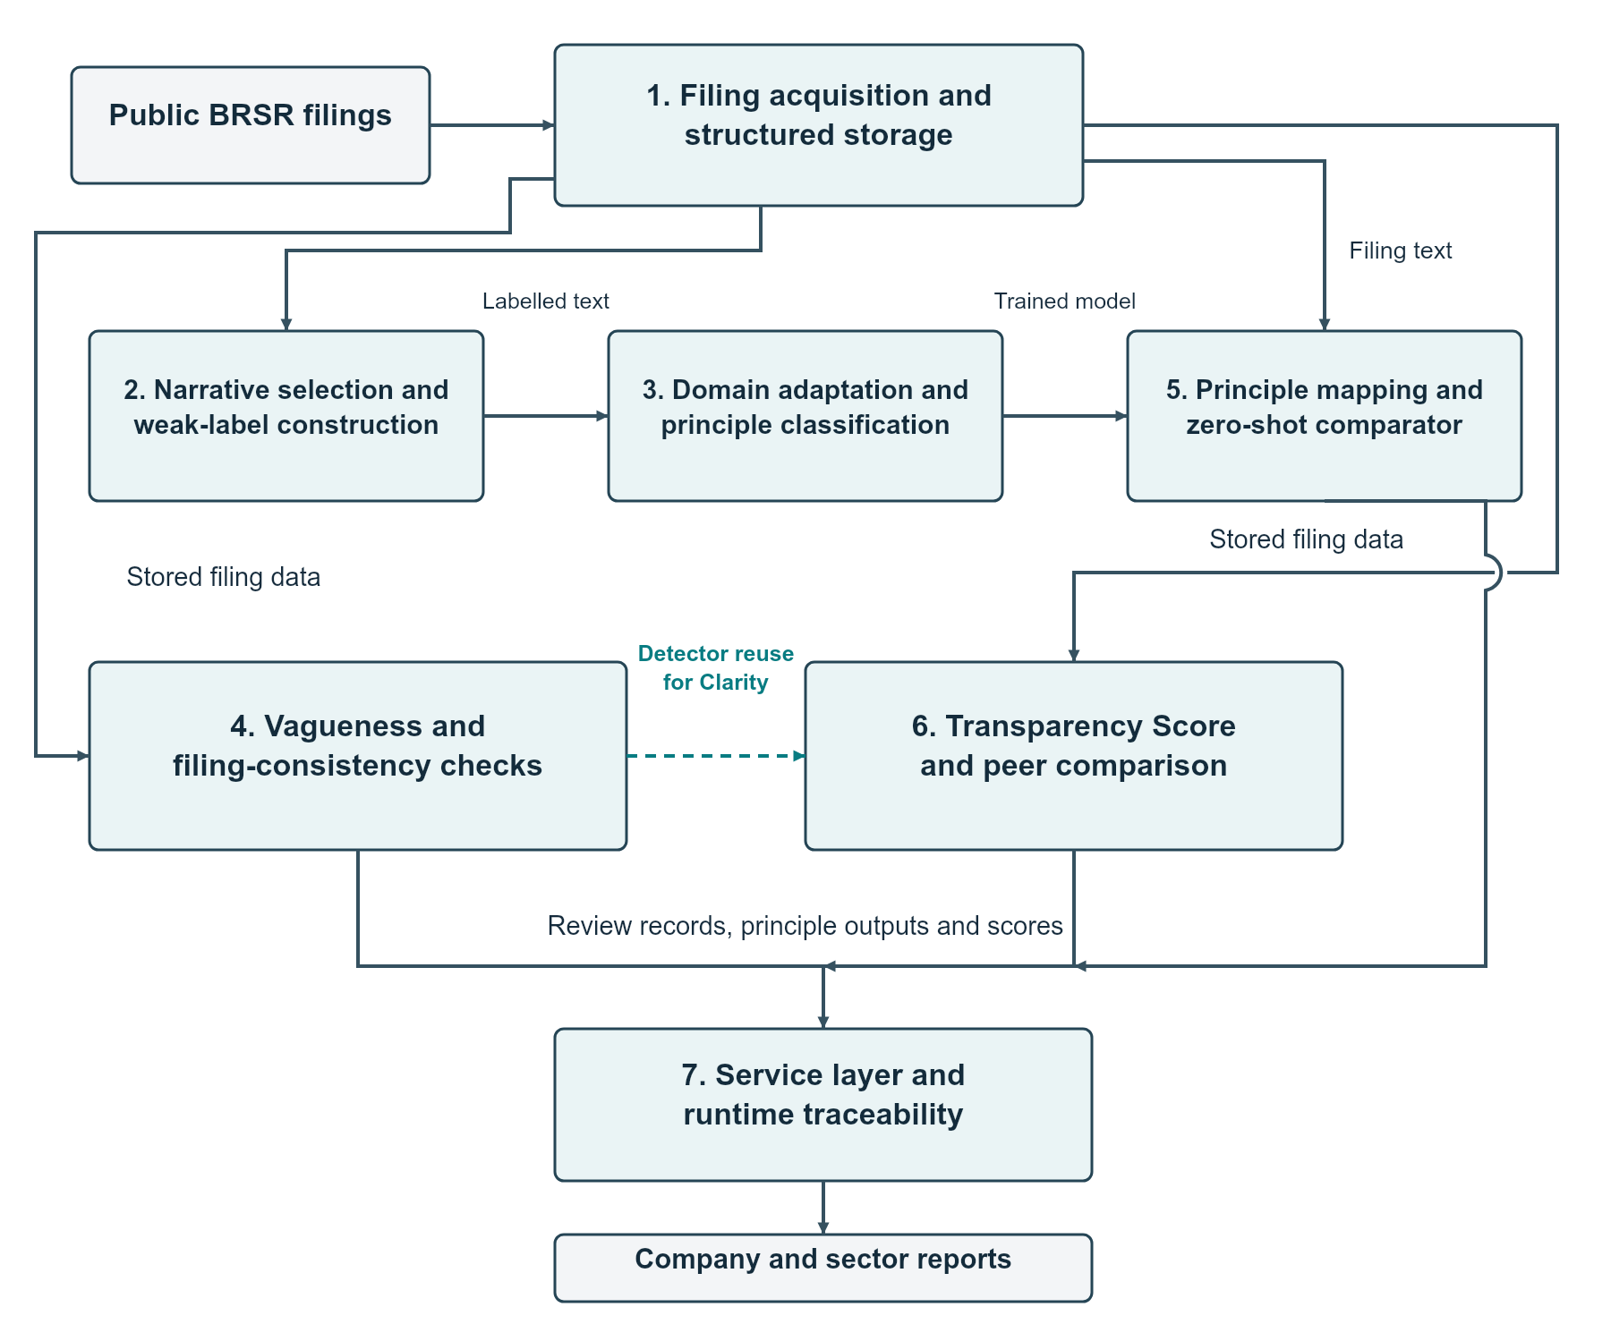
Figure 4.1. GRASP architecture from public filing data to company and sector outputs.
The architecture separates model development from routine use. Training consumes the labelled dataset and produces a checkpoint. During application use, the saved model can be loaded for principle assignment without repeating training. Score calculations use filing facts and detector outputs, while the API returns structured results to the browser.

4.2 Modular Design of the System
Table 4.1. Modules, inputs and outputs
Module | Input and main operation | Output
1. Filing acquisition and structured storage | Download or accept a filing; preserve identity, context and raw values. | Company, filing and fact records.
2. Narrative selection and weak-label construction | Clean text; apply explicit principle tags, concept maps and note labels. | Text segments with principle and source.
3. Domain adaptation and principle classification | Adapt BERT and fine-tune the nine-principle head. | Recovered supervised checkpoint.
4. Vagueness and filing-consistency checks | Inspect language, markers, selected figures, assurance and omissions. | Review flags with linked source records.
5. Principle mapping and zero-shot comparator | Apply the classifier; compare MPNet definition and anchor similarities. | Principle probabilities and comparison predictions.
6. Transparency Score and peer comparison | Aggregate completeness, specificity, clarity and SDG coverage. | Four components, weighted total and peer context.
7. Service layer and runtime traceability | Expose company records and analysis through typed API responses. | Browser reports and identifiable model outputs.

4.3 Detailed Design

4.3.1 Data model and source preservation
The database has three central entities. A Company has a unique CIN and can have several Filings. Each Filing records its reporting period, source URL and raw fact count. Each Fact belongs to one filing and stores its concept, original value, unit, decimals, dates and dimensions. A dimension describes context such as employee category or gender. Keeping dimensions with the value prevents unrelated reporting items from being combined accidentally.
A unique company-year constraint distinguishes repeated submissions from different reporting years. Re-ingestion replaces the facts for that filing within the ingestion workflow. Raw value strings are retained rather than rounded or converted at extraction time. Numerical interpretation belongs to the analysis layer, where assumptions can be inspected separately.
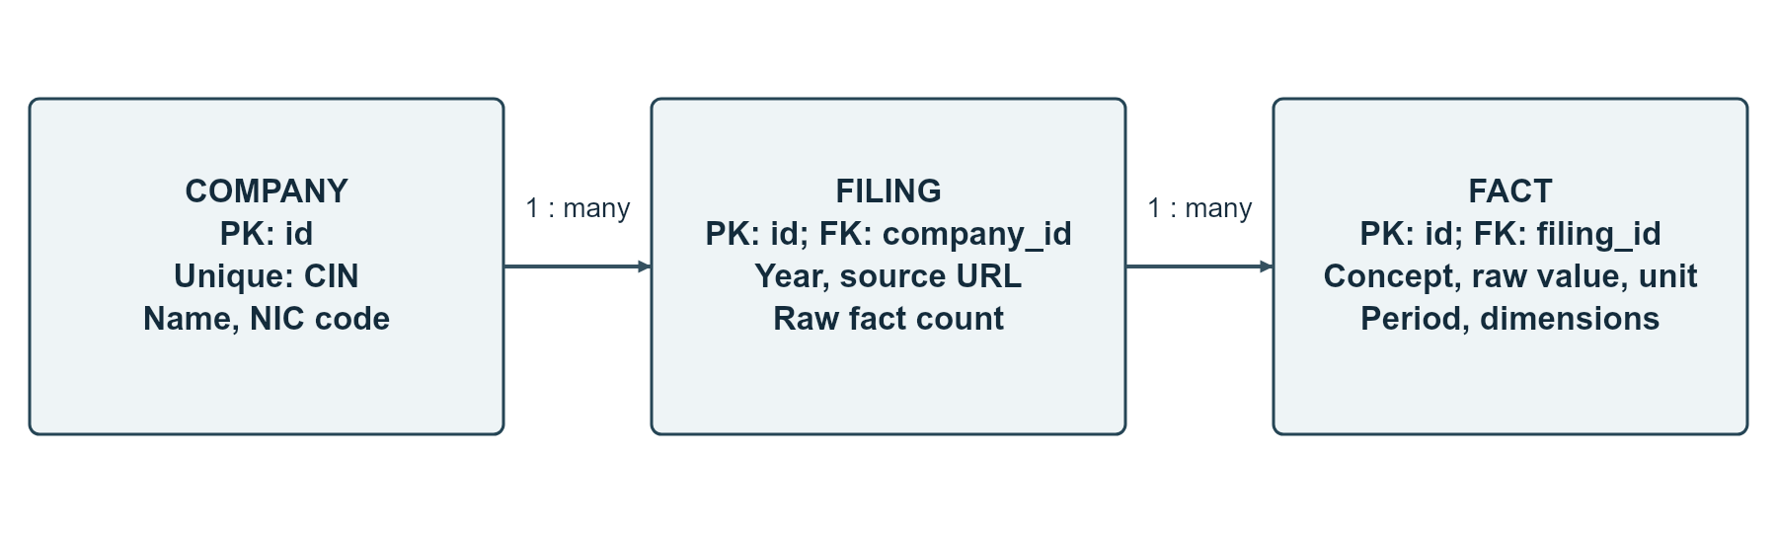
Figure 4.2. Core database relationships. A company has multiple filings, and each filing has multiple context-bearing facts.

4.3.2 Data flow and request sequence
A company report request starts with a selected company name. The service resolves the company, chooses the relevant filing and gathers the requested analysis. The browser presents the filing year, trends, review signals and score components. A peer-comparison request gathers the corresponding outputs for a small group of companies and places comparable fields beside each other.
The compliance-mapping route is a separate model-dependent operation. It reports the method and checkpoint path along with principle probabilities. A successful request verifies runtime integration for that route; it does not establish model accuracy. A missing required checkpoint produces an error rather than silently changing the method to a zero-shot calculation.
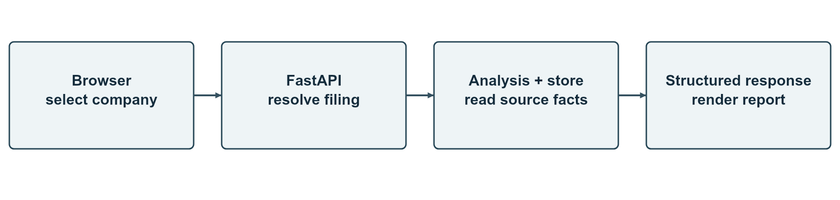
Figure 4.3. Read-only company analysis request from browser selection to a source-linked response.

4.3.3 Interface and API contracts
Table 4.2. Main service endpoints
Endpoint | Purpose and response
GET /health | Check whether the service is reachable.
GET /companies | List stored company names and identifiers.
GET /companies/{name}/filings | List a company’s reporting periods.
GET /companies/{name}/report | Return filing metadata, trends and review summaries.
GET /companies/{name}/transparency-score | Return the score and four components.
GET /companies/{name}/sector-benchmark | Return recorded sector and eligible peer context.
GET /companies/{name}/truth-audit | Return claim–evidence and related review signals.
GET /companies/{name}/compliance-mapping | Return recovered-classifier principle mapping with method and model path.
GET /companies/compare?names=… | Compare two to five selected companies.
POST /companies/upload-and-analyze | Accept a structured XML/XBRL filing for ingestion and analysis.

Company names must be URL-encoded before use in a path. The company list must also be interpreted using its actual response shape; selecting a missing name property can create an empty URL segment. The recorded API debugging sequence confirmed that a route can exist in the OpenAPI specification while an incorrectly formed request still returns “Not Found”.

4.4 Scheduling and Tracking
Development followed an iterative sequence of ingestion, dataset construction, model training, analysis integration and audit correction. The available audit trail records completed work and result verification. It does not provide a signed week-by-week attendance or meeting history, so the plan below shows work packages and dependencies rather than invented calendar completion dates.
Table 4.3. Work packages and completion evidence
Package | Dependency | Recorded deliverable
Data foundation | Public company and filing sources | Structured company–filing–fact database.
Label construction | Stored narrative facts | 42,409 text segments with source provenance.
Supervised model | Labelled data and company split | Recovered seed-99 checkpoint and 6,201-row evaluation.
Review signals | Narratives and selected numerical concepts | Frozen detector settings and saved comparison results.
Scoring and peers | Stored facts and detector flags | Company components, scores and eligible sector summaries.
Service integration | Database and required model assets | API method/path verification and browser views.
Documentation and submission | Approved paper and audit artifacts | Blackbook, evidence spaces and mentor review.

4.5 Sustainability Design Decisions
The design reuses trained models and stores filing facts so that routine analysis does not require repeated downloads or training. Local rule calculations handle transparent checks, while the language models serve tasks that benefit from learned representations. Keeping those responsibilities separate makes maintenance and interpretation easier.
The application presents component scores and peer-group sizes to reduce misleading comparisons. Small groups are identified separately from eligible groups. Public filing data is used for the reported analysis, but upload handling and wider deployment still require appropriate retention and access policies. Energy use and carbon savings were not measured, so sustainability claims are restricted to these documented design choices.

CHAPTER 5: IMPLEMENTATION OF THE PROPOSED SYSTEM

5.1 Development Methodology
Implementation began with the filing data layer, followed by dataset construction, model development, analysis functions and service integration. The audit then checked whether the reported results matched the saved data and selected checkpoint. Corrections were recorded as new result artifacts rather than silently replacing the interpretation of older experiments.
The final classifier remains based on bert-base-uncased. Additional masked-language-model training changes the encoder weights, and supervised fine-tuning adds the nine-principle classification task. MPNet serves sentence similarity and the zero-shot comparison. Historical ClimateBERT, ensemble, selective-prediction and sliding-window experiments are not the approved final classifier.
The repository separates concerns under src: ingestion reads filings, database models preserve facts, analysis modules calculate outputs, and API routes expose results. The frontend consumes structured responses. This separation allows a parsing correction to be distinguished from a scoring or model change.

5.2 Algorithms and Internal Working

5.2.1 Filing collection and ingestion
Collection starts with a company identifier and a filing source. The structured document is downloaded or supplied through the upload route. The parser reads concepts, contexts and units before storing fact values. A context contains the reporting entity, period and dimensions. For example, employee counts can be distinguished by employment type and gender instead of being merged into one total.
The ingestion layer retains raw values exactly as filed. Converting a string to a number is delayed until an analysis requires arithmetic. This prevents extraction from silently changing precision or converting a non-answer to zero. The filing record retains its source URL and reporting dates, and all related facts point to that filing.
The saved company-year constraint prevents multiple filing records for the same company and financial-year end. Re-ingestion replaces that filing’s fact collection through the ingestion workflow. A collection log supports resuming completed and failed downloads. These controls support repeatable data collection; the application count is not a measured extraction-accuracy score.

5.2.2 Narrative selection and weak-label construction
The classifier dataset starts with narrative concepts containing ExplanatoryTextBlock. URLs are removed before the minimum-word check. At least 15 useful words must remain. Short fragments, bare links and listed non-answers are filtered out. This produces classifier text segments; the score uses a different text-selection rule described later.
Labels are assigned in order. An explicit PrincipleAxis tag gives the Section B label. If the tag is not available, the configured Section C concept-to-principle map is checked. A NotesPrincipleX concept supplies the principle-specific note label. The extension contains 29 AI-assisted assignments, while existing configured mappings take priority. These labels are taxonomy-derived weak labels; no independent expert verification of the additional mappings is claimed.
Candidates are grouped by company, concept and cleaned text. Repeated candidates with the same label produce one dataset row. A group containing several labels is removed from the single-label dataset. Such a group can reflect cross-cutting content or generic wording reused under several questions. Removing the group avoids imposing one arbitrary label, but also changes which Section B examples remain.
The measured Section B funnel contains 41,898 explanatory facts, 25,214 clean candidates and 2,479 final dataset rows. Across the full build, 36,491 noisy candidates and 2,640 conflicting-label groups were removed. Candidate rows and groups are different units; subtracting a count of groups from a count of rows does not reconstruct the final total. The historical Section B value of 17,219 is not used as a current measured count.
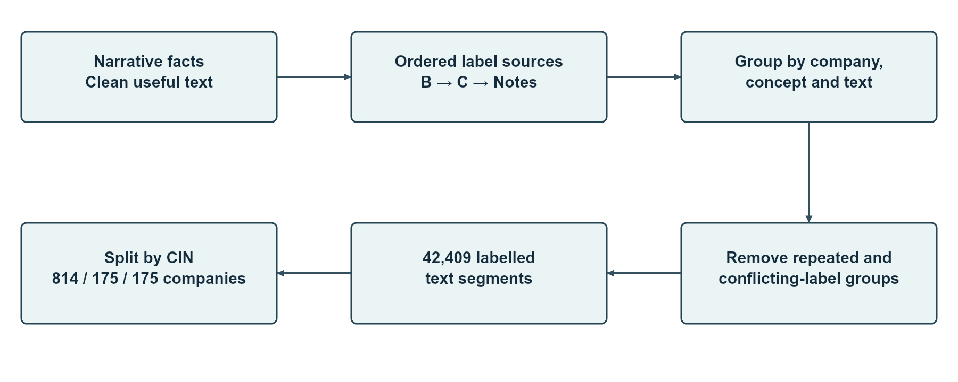
Figure 5.1. Single-label dataset construction from narrative facts, recorded label sources and company-based splitting.

5.2.3 Company split and BERT fine-tuning
The complete corpus contains 42,409 text segments from 1,164 companies. The final supervised split groups rows by CIN: 814 training companies, 175 validation companies and 175 test companies. No company appears in more than one split. Exact wording can still be shared by different companies; 50 test text segments, or 0.81% of the 6,201-row test set, overlap training wording under the recorded check.
BERT represents each text segment as tokens, which are word pieces produced by the tokenizer. At most 512 tokens are accepted. Dynamic padding fills only the unused positions required within a batch. Four text segments form a microbatch, and gradients from four microbatches are accumulated before a parameter update. The effective update batch therefore contains 16 text segments under this configuration.
Fine-tuning runs for five epochs. An epoch is one complete pass through the training set. The learning rate is 0.00002, weight decay is 0.01 and warmup lasts 300 steps, followed by cosine decay. Cross-entropy trains the model to assign probability to the reference principle. Square-root inverse-frequency class weights give less frequent principles more influence without applying the full inverse-frequency ratio.
Five random seeds—42, 1, 7, 99 and 2024—were compared using validation macro-F1. Seed 99 and checkpoint 7,460 were selected for the audited final evaluation. The checkpoint contained 50 LayerNorm parameters with older gamma/beta aliases. Recovery renamed these to weight/bias, required every expected parameter to load and verified tensor equality after save and reload. Recovery changed parameter names, not the learned numerical values.
The legacy masked-language-model corpus builder reads company narratives across the database. Company separation in the approved evaluation therefore applies to labelled fine-tuning. Later train-company-only experiments are separate work and are not substituted for the approved final results in this report.

5.2.4 Vagueness detector
The language detector combines a hedging word list with semantic similarity. Hedging patterns include promises, uncertain timing and progress statements without a measure. Evidence patterns look for percentages, currency amounts, physical units, counts, reporting years, standards and selected governance systems. The code calls the evidence marker has_kpi, but the pattern set is broader than a numerical key performance indicator.
The lexicon rule flags hedging without an evidence marker. Text segments longer than 80 words must also meet a hedging density of 0.005, calculated as matched hedging expressions divided by word count. A separate priority rule handles bare URLs and listed website redirects. The corrected patterns require digits for currency matches, include MW/GW units and recognise formal statutory terms.
The MPNet branch divides a text segment into sentences and compares each sentence with fixed vague and specific reference statements. Cosine similarity measures the closeness of the sentence vectors. The sentence with the largest specific-minus-vague similarity is selected as the most specific sentence in the segment. The decision combines that sentence’s similarities with the evidence-marker status.
Table 5.1. Frozen language-detector decision rules
Condition | Rule
No evidence marker | Semantic flag when vague similarity ≥0.42 and exceeds specific similarity; the lexicon rule can also flag the segment.
Evidence marker present | Flag when vague similarity ≥0.58 and vague-minus-specific similarity ≥0.15.
Bare URL / listed redirect | Apply the redirect rule with priority.
Evaluation version | stage4-rule-detector-2026-10-18; thresholds verified against the freeze manifest.

The frozen engine was evaluated on the 80-example development set and compared with one AI annotation set containing 70 examples. These are different reference groups. The AI annotations are explicitly identified as AI-generated, and no two-rater agreement statistic is reported. The detector’s measured results apply to text vagueness, not to the entire four-signal audit.

5.2.5 Numerical, assurance and omission records
For selected emissions, water, waste and non-renewable-energy topics, the numerical branch looks for a sentence containing both improvement wording and a phrase linked to the measure. A review record is created if a linked filed value rises despite reduction-style wording. The record keeps the sentence, reporting concept, previous value, current value and related assurance information.
A numerical increase does not automatically contradict every improvement statement. A sentence may concern intensity rather than an absolute quantity, or a different boundary or reporting period. The linked record allows these distinctions to be checked. The assurance and omission rules also produce review records rather than independently validated misconduct labels. Period, unit, dimension and zero-value handling require attention when interpreting those outputs.

5.2.6 Principle mapping and zero-shot comparison
The mapping service reuses the recovered classifier. The nine output scores are converted to probabilities through softmax. For text segments filed under a principle, the service averages the model probability for that principle and retains a low-support example for inspection. The company summary averages the available principle means. This is model support for the recorded assignment, not the probability that a company complies with regulation.
The zero-shot MPNet comparator ranks the same nine principles without fitting to the principle-labelled training set. Each principle has a definition and a set of anchor examples. Half of the ranking score comes from definition similarity. The other half combines the maximum anchor similarity with the mean anchor similarity, weighted 0.70 and 0.30.
$$z_{k}(x) = 0.50 d_{k}(x) + 0.50 [0.70 {\text{max}}_{a}s_{ka}(x) + 0.30 {\text{mean}}_{a}s_{ka}(x)]$$
Here d is similarity to the definition and s is similarity to an anchor. The supervised and zero-shot methods are evaluated on the same test rows, which supports a paired comparison. The comparison does not isolate the effect of domain adaptation because labelled training and model representations differ.

5.2.7 Transparency Score calculation
The Transparency Score is a weighted sum of four percentages. The implementation fixes the weights at 40% Completeness, 30% Specificity, 20% Clarity and 10% mapped SDG coverage. These are implementation choices, not SEBI-mandated weights. Each component and the final weighted sum are rounded to two decimal places.
$$\text{TS} = 0.40 C + 0.30 \text{Sp} + 0.20 \text{Cl} + 0.10 G$$
Completeness measures the share of the saved concept universe with an accepted response. The denominator is the 1,057 distinct concept names observed in the saved database. The numerator counts concepts with at least one accepted response in the filing. A concept appearing under several dimensions counts once. Blank values and listed placeholders are rejected. Structured zeros count as valid responses. Narrative blocks and address fields use their own text rules.
$$C = 100 × \frac{\text{accepted concepts}}{1,057}$$
Specificity uses text-block facts containing at least 30 characters. Duplicate concept–text pairs are removed after whitespace cleaning. The same wording under two different concepts may still form two scoring text segments. The numerator counts segments containing at least one configured evidence marker. A segment with five numbers counts once, just like a segment with one recognised standard.
$$\text{Sp} = 100 × \frac{\text{segments with an evidence marker}}{\text{scoring text segments}}$$
Clarity reuses the same combined vagueness detector described above. It is the percentage of scoring text segments without a flag. A separate second vagueness model is not trained for scoring. For example, one flagged segment among 52 gives a Clarity value of 98.08%. If no scoring text segments are available, Specificity and Clarity return zero.
$$\text{Cl} = 100 × \left(1 - \frac{\text{flagged scoring text segments}}{\text{scoring text segments}}\right)$$
Mapped SDG coverage counts distinct goals linked to qualifying explicitly tagged narratives. A narrative must contain at least 20 characters and an evidence marker. The fixed principle-to-goal map supplies the goal numbers. Repeated goals count once. The union is divided by the 17 SDGs. The configured map covers 14 goals, so its maximum is 82.35%. This component measures mapped goal breadth and does not evaluate all 169 SDG targets.
$$G = 100 × \frac{\text{distinct mapped goals}}{17}$$
Table 5.2. Fixed principle-to-SDG map
Principle | Mapped goal numbers | Principle | Mapped goal numbers
P1 | 16 | P6 | 6, 7, 12, 13, 15
P2 | 9, 12 | P7 | 16, 17
P3 | 3, 5, 8 | P8 | 1, 8, 10, 11
P4 | 10, 17 | P9 | 9, 12
P5 | 8, 10, 16 | — | —

The overall score summarises disclosure characteristics under these definitions. It is not a measure of actual environmental performance. A clear statement reporting poor performance may still contribute to Clarity because the component measures language flags rather than the desirability of the reported outcome. The component breakdown is therefore essential to interpretation.

5.2.8 Peer comparison and service integration
Companies are assigned to recorded sector groups using the stored industry code and a local mapping. The main peer analysis includes groups with at least five companies. A company percentile is the percentage of sector scores strictly below its score. Ties receive the same percentile, and the largest score need not reach the 100th percentile.
$$\text{Peer percentile} = 100 × \frac{\text{companies with a strictly lower score}}{\text{sector company count}}$$
The backend exposes analysis using FastAPI, and the frontend presents company search, reports, comparison and filing upload. The recovered classifier route identifies the method and checkpoint path. A missing model asset returns a service error rather than silently substituting a different method. This supports runtime traceability without confusing the service check with model evaluation.

5.3 Dataset Sources and Utilisation
Table 5.3. Final labelled corpus by source
Label source | Text segments | Share
Section B: explicit PrincipleAxis | 2,479 | 5.85%
Section C: configured concept map with AI-assisted extension | 36,513 | 86.10%
NotesPrincipleX | 3,417 | 8.06%
Total | 42,409 | 100% (rounded shares)

Table 5.4. Company-disjoint supervised split
Split | Companies | Text segments
Training | 814 | 29,834
Validation | 175 | 6,374
Test | 175 | 6,201
Total | 1,164 | 42,409

The earlier segment-level split of 29,683/6,358/6,368 is historical dataset-build output. The company-disjoint split above is used for the approved supervised evaluation. The distinction matters because a random text-level split can place writing from the same company in both training and test.
Application scoring uses filing facts and its own narrative selection rules rather than the classifier dataset alone. Company counts, filing counts, classifier text segments and scoring text segments should therefore not be added together or treated as interchangeable sample sizes.

CHAPTER 6: TESTING OF THE PROPOSED SYSTEM

6.1 Testing Objectives and Scope
Testing checks data separation, model integrity, detector reproducibility, score interpretation and service integration. The chapter distinguishes saved execution evidence from code inspection and unexecuted deployment checks. No new training or benchmark evaluation was run while preparing this Blackbook. Approved audit artifacts supply the numerical results.
A test can answer only the question covered by its input and reference. A zero-company-overlap assertion checks split membership. A strict checkpoint load checks parameter restoration. A successful API response checks one integration path. None of these checks alone measures the semantic correctness of every disclosure output.

6.2 Types of Tests Considered
Data-integrity checks verify dataset totals, label sources and company separation. Model-integrity checks verify parameter aliases, strict loading and save/reload equality. Evaluation checks calculate classification metrics on the recorded test population and compare methods on identical rows. Rule-version checks verify the frozen detector manifest before producing results.
Integration checks inspect the actual route, returned method and checkpoint path. Interface captures demonstrate navigation and report presentation in the local application. Repository test files cover ingestion, analysis and synthetic rule cases, but a fresh full-suite execution was not requested or performed during document creation. The Blackbook therefore does not assign a new pass status to those files.

6.3 Test Case Scenarios and Recorded Results
Table 6.1. Recorded verification cases and evidence status
ID | Input / expected behaviour | Recorded result | Evidence / status
TC-01 | Build the company split; no CIN shared across train, validation and test. | 814 / 175 / 175 companies; all pairwise intersections zero. | Saved split assertions: PASS.
TC-02 | Evaluate the approved full test population without a row-count mismatch. | 6,201 text segments and 175 CINs. | Recovered full-evaluation audit: PASS.
TC-03 | Restore all selected classifier parameters without missing weights. | 50 LayerNorm aliases remapped; strict loading and exact save/reload equality verified. | Checkpoint recovery audit: PASS.
TC-04 | Check frozen detector identity before development evaluation. | Freeze verified; N=80 and confusion counts total 80. | Frozen detector audit: PASS.
TC-05 | Keep AI annotation provenance explicit for batch 3. | N=70; one AI annotation set; no human-rater or kappa claim. | AI comparison artifact: RECORDED.
TC-06 | Compare supervised and zero-shot outputs on the same test rows. | Paired comparison on N=6,201 with CIN-bootstrap intervals. | Recovered Stage 5 audit: PASS.
TC-07 | Retain all historical human ratings in the headline correlation. | N=20; Pearson r=0.6314 with reported interval. | Stage 6 audit: RECORDED.
TC-08 | Identify the loaded classifier in a successful service request. | 360 ONE WAM LIMITED returned recovered method and checkpoint path. | User-run API verification, 19 October 2026: PASS for that request.
TC-09 | Show actual company search and filing-report views. | Live local screens captured on 1 November 2026. | Interface observation: CAPTURED; not an accuracy test.
TC-10 | Exercise upload validation, concurrency, security and recovery under controlled tests. | No new full test run recorded for this documentation task. | NOT EXECUTED in this task.

The service verification returned method recovered_seed99_supervised_classifier and the recovered checkpoint path. The returned company summary of 89.17% was a model-probability output for that filing. It is not an additional validation accuracy and is not added to the classifier results table.
The current live interface was used for screenshots only. Approved result tables use the saved paper and audit snapshots. Interface counters, current runtime outputs and saved publication metrics are not interchangeable. A snapshot difference should be reconciled before a future release rather than replaced silently in the research record.

6.4 Inferences Drawn from Test Cases
The checks establish three useful properties of the reported workflow. First, the supervised company split is reproducible and contains no shared CINs. Second, the selected classifier parameters can be restored exactly after alias recovery. Third, the model-dependent API route can identify the checkpoint used for an actual company request.
The detector results also show why reference provenance matters. The 80-example result is a development comparison, while the 70-example result uses AI-generated annotations. The two results are reported separately. Similarly, the Transparency Score correlation uses the complete historical 20-company human-rating cohort, without choosing exclusions after seeing residuals.
Further deployment testing should measure endpoint latency, upload limits, malformed-input handling, model-asset failures, concurrency and access policies under a fixed environment. These are defined engineering tasks rather than completed results in the present evidence set.

CHAPTER 7: RESULTS AND DISCUSSION

7.1 User Interface Screens
The following screens were captured from the local application on 1 November 2026. The browser currently displays the interface name BeyondPDF, while GRASP identifies the research pipeline documented in this report. Screens show company search, a filing report, peer selection and structured-file upload. No simulated dashboard image is used.
The screenshots illustrate application navigation. The numerical research tables that follow use the approved saved audit and paper snapshots. A current interface value is not substituted for an approved benchmark result, and a screen capture is not treated as an additional model test.
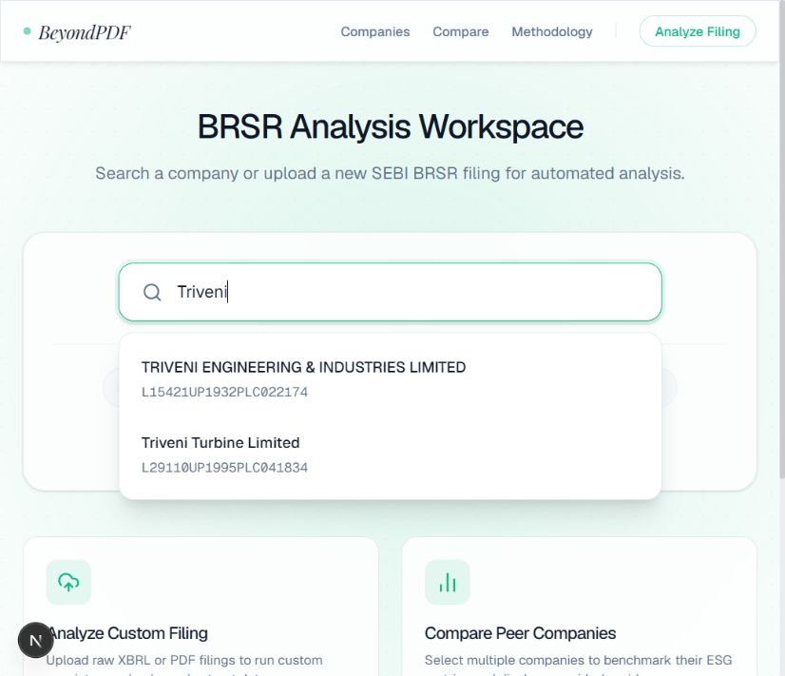
Figure 7.1. Live company search locates matching names and CINs before opening a filing report.
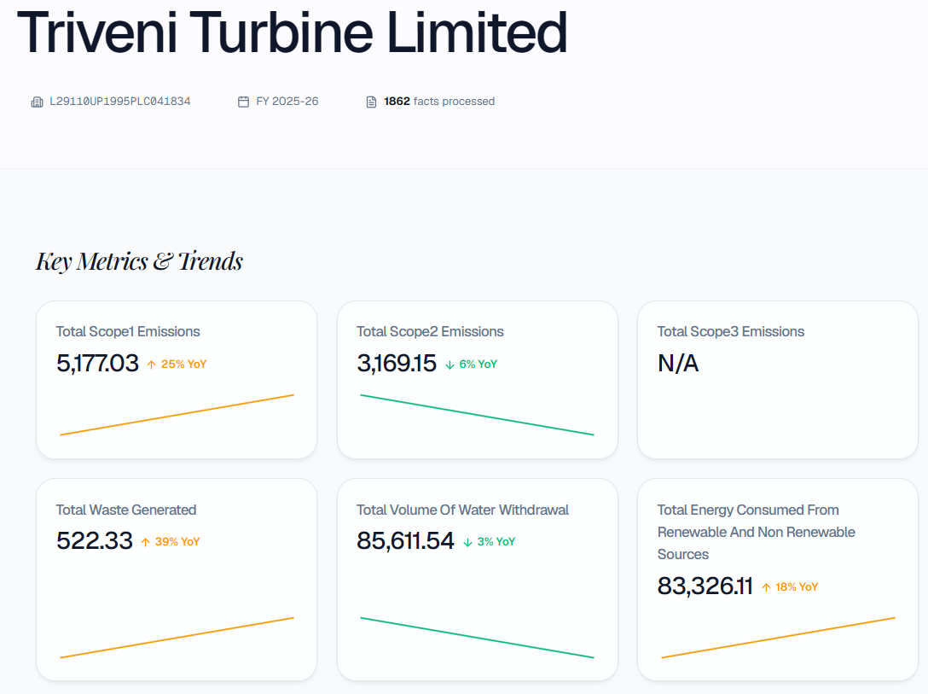
Figure 7.2. Live filing report for Triveni Turbine Limited, showing company identity, reporting year and filed numerical trends.
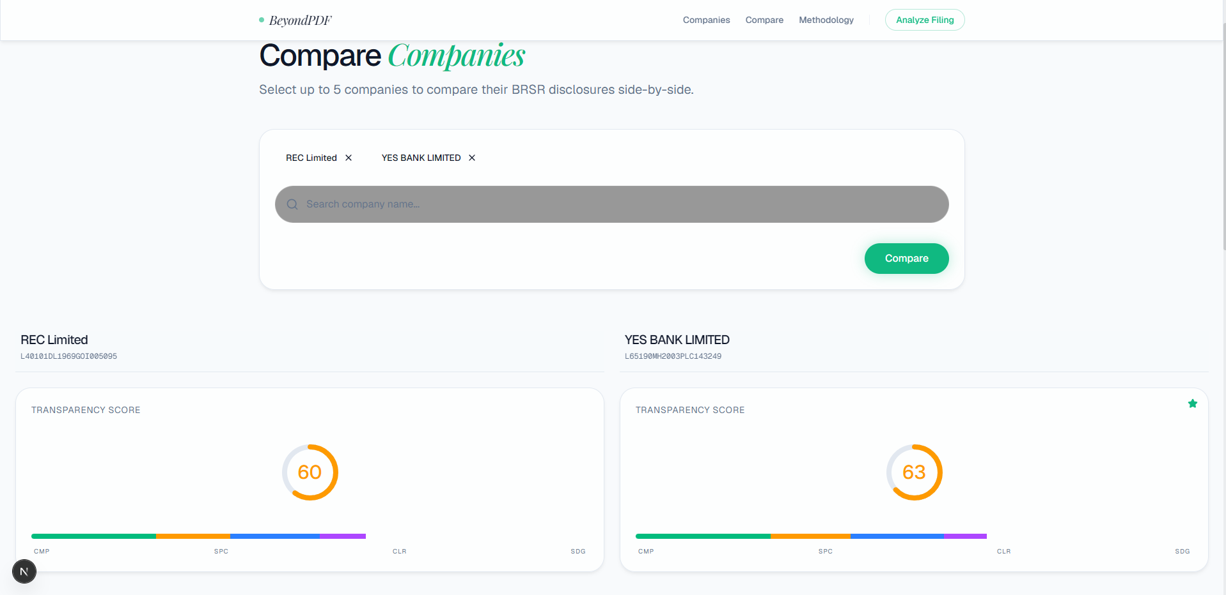
Figure 7.3. Peer-comparison selection with two financial companies. The interface supports a group of two to five companies.
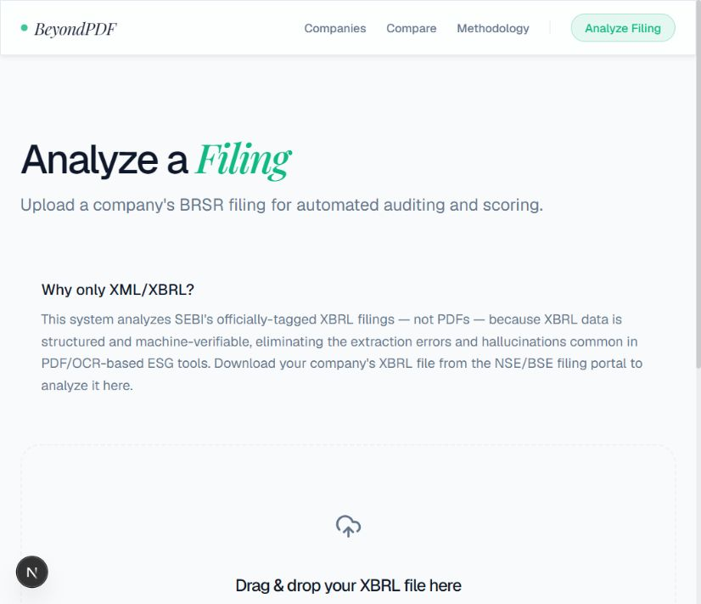
Figure 7.4. Structured filing upload screen. The implemented route accepts XML/XBRL files; no file was uploaded for this documentation capture.

7.2 Performance Evaluation Measures
Top-1 agreement is the percentage of text segments for which the highest-ranked principle matches the reference label. Top-2 agreement counts a segment when the reference appears among the first two predictions. Precision answers: when a principle is predicted, how often is that assignment correct? Recall answers: among the reference examples of a principle, how many are found? F1 balances these two quantities. Macro-F1 gives each principle equal importance before averaging, so a small class still affects the result.
For the vagueness detector, precision is the share of flagged examples that the reference also labels vague. Recall is the share of reference-vague examples detected by the system. Accuracy is the share of all examples with a matching decision. These meanings can be understood without treating a flag as a proven case of greenwashing.
A 95% confidence interval describes uncertainty under the stated resampling or estimation procedure. The classifier and paired-comparison intervals resample companies by CIN, keeping each selected company’s text segments together. Variation across three concept holdouts is reported as sample standard deviation, which is a different quantity from a confidence interval.
Table 7.1. Approved results and evaluation populations
Component / population | Approved result | 95% interval / interpretation
Principle classifier; 6,201 text segments, 175 companies | Top-1 93.00%; Top-2 97.68%; macro-F1 0.9158 | Top-1 92.04–93.89%; Top-2 97.10–98.21%; F1 0.9036–0.9277.
Vagueness; development N=80 | Accuracy 75.00%; precision 0.7073; recall 0.7838; F1 0.7436 | CI not calculated; development reference with unconfirmed blinding.
Vagueness; AI comparison N=70 | Accuracy 72.86%; precision 0.6000; recall 0.8077; F1 0.6885 | CI not calculated; one AI annotation set.
Zero-shot MPNet; same 6,201 test rows | Top-1 67.63%; Top-2 83.34% | Top-1 66.45–68.93%; Top-2 82.31–84.38%.
Supervised minus zero-shot; paired rows | Top-1 difference +25.37 percentage points | 24.02–26.71 percentage points; different learning conditions.
Transparency Score; 20 historical human ratings | Pearson r=0.6314; Spearman rho=0.6285 | Pearson 0.2683–0.8519; Spearman 0.2321–0.8540.
Service integration; one company request | Recovered method and checkpoint path returned | Integration evidence; no accuracy or confidence interval.

7.3 Dataset and Feature Inputs
Table 7.2. Text segments by BRSR principle
Principle | Full corpus total | Share
P1: ethical conduct | 5,015 | 11.83%
P2: sustainable products / services | 5,566 | 13.12%
P3: employee and worker well-being | 11,835 | 27.91%
P4: stakeholder interests | 3,128 | 7.38%
P5: human rights | 3,095 | 7.30%
P6: environment | 5,749 | 13.56%
P7: responsible public policy | 543 | 1.28%
P8: inclusive growth | 2,475 | 5.84%
P9: consumer value | 5,003 | 11.80%

The table describes the entire labelled corpus, not just the training split. Text content alone enters the classifier. Source labels and concept names remain dataset metadata used for construction and diagnostics. The model can still learn recurring wording associated with reporting questions even when concept names are not supplied as input.

7.4 Model Results and Generalization Diagnostics

7.4.1 Recovered company-disjoint classifier
The recovered seed-99 classifier assigns the reference principle as its first choice for 5,767 of 6,201 test text segments. The reference appears among the first two choices for 6,057 segments. These results correspond to 93.00% Top-1 and 97.68% Top-2 agreement. Macro-F1 is 0.9158. The evaluation repeats the existing test cohort after checkpoint recovery; it is not a fresh external test.
Table 7.3. Per-principle classification on the company-disjoint test set
Principle | Precision | Recall | F1 | Text segments
P1 | 0.9592 | 0.9431 | 0.9511 | 773
P2 | 0.9154 | 0.8837 | 0.8992 | 808
P3 | 0.9533 | 0.9644 | 0.9588 | 1,715
P4 | 0.9611 | 0.9488 | 0.9549 | 469
P5 | 0.9009 | 0.8508 | 0.8751 | 449
P6 | 0.8943 | 0.9356 | 0.9145 | 823
P7 | 0.8551 | 0.8551 | 0.8551 | 69
P8 | 0.8921 | 0.9212 | 0.9064 | 368
P9 | 0.9259 | 0.9285 | 0.9272 | 727
Macro average | 0.9175 | 0.9146 | 0.9158 | 6,201 total

The per-principle results show why the overall value is not sufficient by itself. Principle 7 contributes only 69 test text segments, while Principle 3 contributes 1,715. Macro-F1 gives both principles equal weight. The class table makes this imbalance visible without confusing the corpus count of 543 Principle 7 examples with the test support of 69.
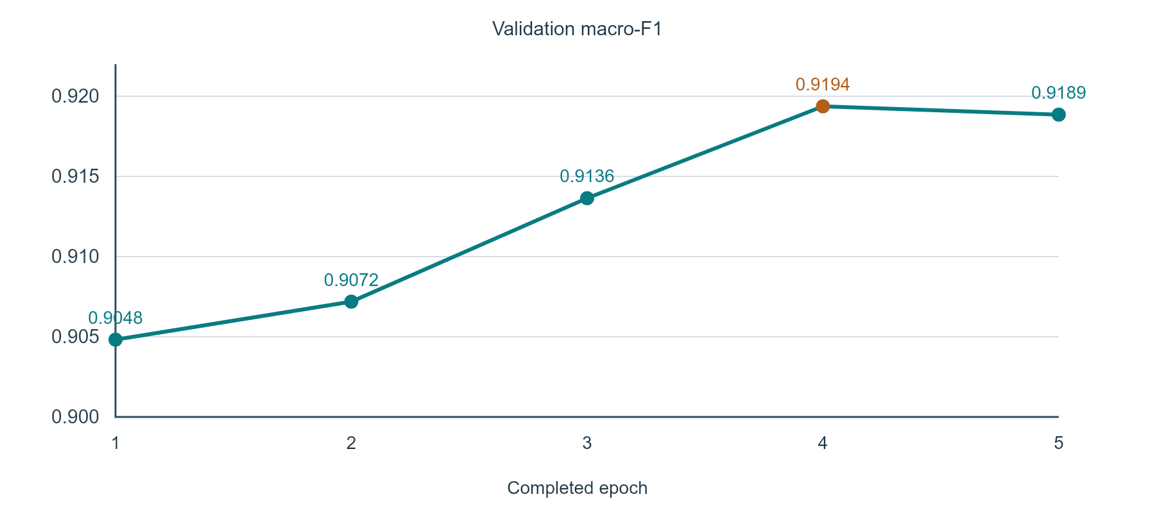
Figure 7.5. Validation macro-F1 over five completed epochs. The highest recorded value occurs at epoch 4, which supplies the selected checkpoint.

7.4.2 Results by label source
Table 7.4. Source-wise agreement for the recovered classifier
Source | N / companies | Top-1 | Top-2 | Top-1 95% CI
Section B | 352 / 71 | 63.35% | 80.40% | 56.55–69.67%
Section C | 5,364 / 174 | 95.15% | 99.01% | 94.41–95.92%
NotesPrinciple | 485 / 103 | 90.72% | 95.46% | 86.55–94.09%

The large source gap is an important interpretation of the overall result. Section C supplies 86.10% of the corpus and uses concept-derived labels. Its wording is often related to a recurring question template. Section B has explicitly tagged principle labels but also contains cross-cutting or reused content, much of which is removed by the conflicting-label filter. Source-wise results indicate that the aggregate score should be described as agreement with taxonomy-derived labels rather than independent proof of principle understanding.
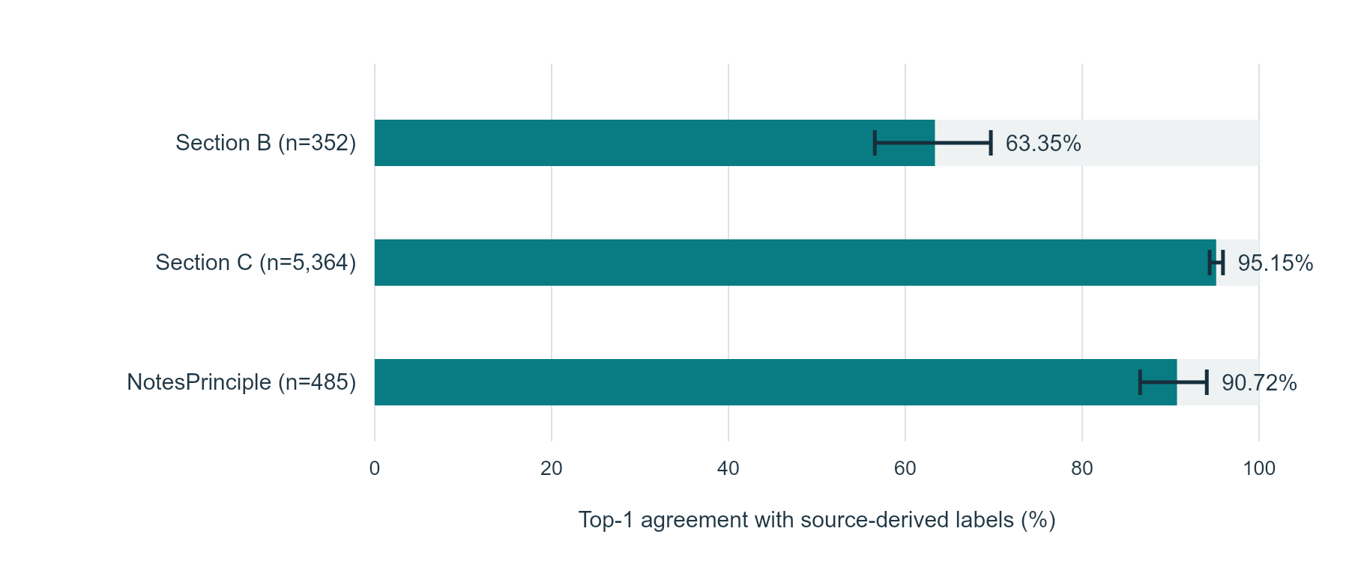
Figure 7.6. Top-1 agreement by label source with reported company-bootstrap confidence intervals.

7.4.3 Concept exclusion and multi-label diagnostics
The concept-exclusion diagnostic asks whether a model can classify text from question concepts removed from its training data. On the same 1,190 evaluation rows, the full-concept baseline reaches 97.98% Top-1, while the concept-disjoint model reaches 87.31%. The paired difference is −10.67 percentage points, with interval −12.36 to −8.96. The baseline and excluded-concept experiments differ in training examples and seeds, so the comparison is a generalisation diagnostic rather than a pure single-component ablation.
Across three concept holdouts, mean Top-1 is 81.64% with a sample standard deviation of 4.92 percentage points. Mean Top-2 is 95.34% ±1.31 percentage points, and macro-F1 is 0.6752 ±0.0170. These figures describe variation across three runs on a reused test population, not a new independent test or a 95% interval.
An exploratory multi-label redesign groups company–text examples and combines available principle labels. On 5,934 grouped test examples, Hit@1 is 93.36%, micro-F1 is 0.8898 and macro-F1 is 0.8782 at threshold 0.5. The baseline Hit@1 on that grouped target is 93.55%. The redesign changes the target definition and is not presented as an across-the-board improvement.

7.4.4 Frozen vagueness detector and score correlation
The frozen development comparison identifies 29 of the 37 reference-vague examples, while 12 of its 41 flags are not marked vague by that reference. The 80 decisions include 31 matching clear examples and eight missed reference-vague examples. This produces F1 0.7436. The separate AI comparison contains 21 matching vague decisions, 14 additional flags, five missed reference-vague decisions and 30 matching clear decisions, producing F1 0.6885.
These counts describe the text-vagueness subdetector. A binary-prediction area statistic is not reported as continuous-score ROC AUC. The experimental XGBoost target and earlier tuned small-sample metrics are not final validation results.
For the Transparency Score, all 20 historical human-rated companies remain in the headline cohort. Pearson correlation is 0.6314, with 95% interval 0.2683–0.8519 and p=0.0028. Spearman rank correlation is 0.6285. Mean absolute error is 12.16 score points and root mean squared error is 15.19. The reported squared correlation is 0.3986. The historical rating source and unrecorded blinding condition are retained when interpreting this small comparison.

7.5 Comparison of Results with Existing Methods
The zero-shot MPNet hybrid reaches 67.63% Top-1 and 83.34% Top-2 on the same 6,201 text segments. The recovered supervised classifier reaches 93.00% and 97.68%. The paired Top-1 difference is +25.37 percentage points. This is a comparison of supervised transfer with a zero-shot ranking method; it is not a causal measurement of alignment scoring or domain adaptation alone.
The Section C dominance and concept-exclusion results explain part of the interpretation. A supervised model can learn recurring label-related patterns from the dataset. A zero-shot comparator is not fitted to those labels. Results from earlier ClimateBERT or ensemble experiments used different data or evaluation settings and are not inserted as directly comparable rows.

7.6 Application Results and Inferences

7.6.1 Level 1: one company from filing to outcome
Triveni Turbine Limited provides a complete worked example. The saved filing ends on 31 March 2026 and contains 1,862 raw facts. The score calculation accepts 613 of the 1,057 distinct database concepts, giving Completeness 57.99%. The scoring text contains 52 unique concept–text pairs. Of these, 33 contain an evidence marker, giving Specificity 63.46%; one is flagged vague, giving Clarity 98.08%. Twelve distinct goals are mapped, giving SDG coverage 70.59%.
Table 7.5. Triveni worked score from the saved application snapshot
Component | Value | Weight | Contribution
Completeness | 57.99 | 0.40 | 23.196
Specificity | 63.46 | 0.30 | 19.038
Clarity | 98.08 | 0.20 | 19.616
Mapped SDG coverage | 70.59 | 0.10 | 7.059
Transparency Score | — | Total | 68.91 after rounding

The Machinery and Equipment group contains 36 companies with a mean score of 49.46. Triveni’s saved percentile is 94.4. The underlying filing also reports Scope 1 emissions rising from 4,142.84 to 5,177.03 tonnes CO2e, Scope 2 falling from 3,353.61 to 3,169.15, and water withdrawal falling from 88,662.28 to 85,611.54 kilolitres. These values demonstrate why a disclosure score and an operational trend are different outputs.

7.6.2 Level 2: selected financial companies
Table 7.6. Selected financial-company results from the saved snapshot
Company | FY end | C | Sp | Cl | G | TS
REC Limited | 2026 | 56.01 | 57.69 | 98.08 | 82.35 | 67.56
Mahindra Finance | 2026 | 67.83 | 49.15 | 98.31 | 29.41 | 64.48
YES BANK | 2026 | 60.45 | 46.67 | 92.00 | 70.59 | 63.64
Kotak Mahindra Bank | 2026 | 61.21 | 59.42 | 95.65 | 17.65 | 63.21

The comparison shows several routes to a similar total. Mahindra Finance has higher Completeness than REC but lower mapped SDG coverage. Kotak has stronger Specificity than YES BANK, while YES BANK has broader mapped SDG coverage. Showing components prevents the total from being treated as a single unexplained rank. The year is the financial-year-end year reconstructed from the latest saved filing linked by CIN.

7.6.3 Level 3: complete financial-sector group
The recorded Financial Services group, excluding Insurance, contains 94 companies. Mean Transparency Score is 48.17, median 49.79 and standard deviation 9.88. Scores range from 29.83 to 67.56. The saved year linkage includes 77 filings ending in 2026 and 17 ending in 2025. This is a mixed-year descriptive snapshot, not a controlled comparison of all companies in one financial year.
Table 7.7. Financial-sector score bands
Score band | Companies | Mean score
60 or above | 11 | 62.39
50 to below 60 | 35 | 54.77
40 to below 50 | 26 | 45.22
Below 40 | 22 | 34.05
Total | 94 | 48.17 overall

Average components are Completeness 49.77, Specificity 28.35, Clarity 90.67 and mapped SDG coverage 16.27. Clear language is therefore common under the detector definition, while evidence-marker coverage and mapped goal breadth vary more. A clear text segment can still omit quantitative detail, which is why Clarity and Specificity are separate.

7.6.4 Level 4: all recorded sectors
Across 1,164 company scores, the mean is 48.73 and the median is 47.25. Scores range from 26.88 to 75.58, with standard deviation 9.98. There are 72 recorded sectors. Of these, 47 groups contain at least five companies and cover 1,109 scores. The remaining 25 groups contain 55 scores and are retained separately from the eligible peer summary.
Among eligible groups, Warehousing and Transport Support has the highest mean, 54.55 across six companies. Wearing Apparel has the lowest mean, 42.33 across six companies, followed by Education at 42.43. These are descriptive group averages under the implemented score; the results do not establish the causes of sector differences.
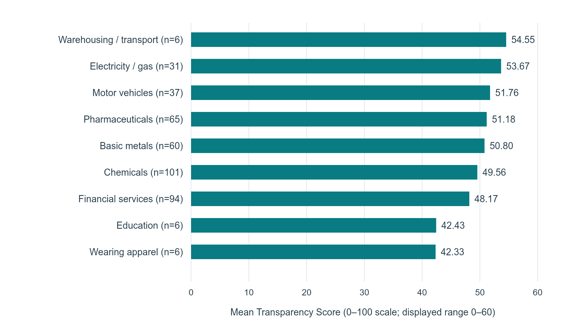
Figure 7.7. Mean Transparency Scores for selected eligible sectors. Group sizes are shown with the names; bars describe saved company scores rather than environmental performance.
Table 7.8. Largest recorded sector groups
Sector | Companies | Mean | Minimum | Maximum
Chemicals Manufacturing | 101 | 49.56 | 32.18 | 75.34
Financial Services (excl. Insurance) | 94 | 48.17 | 29.83 | 67.56
Pharmaceuticals | 65 | 51.18 | 32.38 | 73.72
Basic Metals | 60 | 50.80 | 34.61 | 75.58
Electrical Equipment | 51 | 48.80 | 26.88 | 67.03
Computer Programming and IT Services | 49 | 50.24 | 32.89 | 73.98
Non-Metallic Mineral Products | 40 | 50.36 | 35.66 | 69.20
Food Products Manufacturing | 38 | 47.57 | 30.04 | 69.86
Motor Vehicles | 37 | 51.76 | 33.29 | 70.12
Machinery and Equipment | 36 | 49.46 | 35.61 | 69.67

The pharmaceutical group illustrates within-sector variation. Its 65 companies have a mean of 51.18 and range from 32.38 to 73.72. Dabur is at the upper end and Kopran at the lower end in the saved table. Clarity exceeds 85 for 58 of the 65 companies, so differences in evidence detail and coverage remain important even when language is usually not flagged vague. The complete 72-sector table is provided in the supporting appendix.

7.6.5 Paired reporting years
Eight companies have a paired-year score comparison in the saved analysis. Mean score rises from 45.17 to 50.40, a descriptive increase of 5.23 points. Six scores rise and two fall. The component changes differ across companies: some gains come mainly from Completeness, while others come from Specificity or mapped SDG coverage. The eight-company subset is not presented as a market-wide trend.
Table 7.9. Paired-year company scores
Company | Earlier | Later | Change
Praj Industries | 38.55 | 50.30 | +11.75
ESAF Small Finance Bank | 42.59 | 54.10 | +11.51
Sudarshan Colorants | 49.74 | 58.78 | +9.04
Gopal Snacks | 41.30 | 47.29 | +5.99
G R Infraprojects | 35.94 | 38.87 | +2.93
Sudarshan Chemical | 62.95 | 65.32 | +2.37
VIP Industries | 45.91 | 45.56 | −0.35
SML Mahindra | 44.38 | 42.98 | −1.40
Mean | 45.17 | 50.40 | +5.23

7.7 Sustainability Impact Assessment and Rubric Justification

7.7.1 Scope, boundary and evidence
The assessment covers filing collection, model development, local analysis, storage and presentation. The environmental footprint of company operations is outside the system boundary. Relevant evidence includes the database design, saved models, audit artifacts, source tables and actual interface captures. Operational electricity and embodied hardware impacts were not measured.

7.7.2 Material sustainability topics
Table 7.10. Material topics and implementation evidence
Topic | Why relevant | Evidence / boundary
Computing and storage | Training, model loading and repeated analysis consume resources. | Saved checkpoints and reusable stored facts; no measured kWh or carbon inventory.
Information quality | Misinterpreted flags can affect review decisions. | Separate output types, component definitions and reference provenance.
Sector comparison | Peer size and sector assignment affect interpretation. | Recorded sector labels and at-least-five-company eligibility rule.
Public data and governance | Reports can include contact information and public-company statements. | Public-source filing context; wider deployment needs retention and access policies.
Access and usability | Reviewers need understandable evidence and calculations. | Search, company report, comparison and upload views; no formal accessibility audit.

7.7.3 Sustainability targets and progress
The immediate design targets are to reuse existing data and model artifacts, make score calculations visible and avoid presenting a review flag as a confirmed adverse finding. The implementation provides stored facts, fixed component weights and source-linked records. These are verifiable design features. Future energy and usability targets require a measured baseline before numerical progress can be reported.

7.7.4 SDG alignment and evidence
The strongest direct connection remains SDG Target 12.6 on company sustainability reporting [23]. The system supports the organisation and review of reporting information. Climate-related records also support the inspection of emissions statements, and runtime traceability supports accountable information use. These connections describe the function of the tool, not a measured contribution to national SDG indicators.

7.7.5 Sustainability assessment rubric
Table 7.11. Template rubric mapped to available evidence
Criterion | Weight | Evidence supplied for mentor assessment
A. Scope, boundary, materiality and baseline | 15% | System boundary, data collection and material topics stated.
B. Environmental resources and impact | 20% | Model/data reuse described; energy measurements remain unrecorded.
C. Social value, inclusion and ethics | 20% | Review-oriented outputs, clear label provenance and component explanation.
D. Governance, privacy, compliance and security | 20% | Source links and model traceability; public deployment controls require further testing.
E. SDG linkage and measurable targets | 10% | Target 12.6 linkage; distinction between tool function and SDG outcomes.
F. Measurement, monitoring, transparency and improvement | 15% | Saved result artifacts, confidence intervals and a future measurement plan.

The rubric weights are reproduced from the college template. The official criterion grades and final score are left for mentor assessment; no self-awarded performance grade is fabricated.

7.7.6 Evidence and limitations statement
The report documents a working disclosure-review pipeline and the available audited comparisons. Energy savings, analyst time savings, regulatory acceptance and production-scale service reliability have not been quantified. A future assessment can add power measurements, a timed analyst task, accessibility checks and controlled service load tests. The present sustainability account remains tied to available implementation evidence.

CHAPTER 8: CONCLUSION
GRASP connects public BRSR filings with a structured disclosure-review workflow. The implementation preserves company, period and context information, builds filing-derived principle labels, applies a recovered BERT classifier, generates language and filing-consistency review records, and calculates a Transparency Score with four visible components. The service layer makes these outputs available for company inspection and peer comparison.
The approved company-disjoint evaluation contains 6,201 text segments from 175 companies. The classifier reaches 93.00% Top-1 agreement and macro-F1 0.9158 against taxonomy-derived labels. Source-wise evaluation shows 63.35% on Section B, 95.15% on Section C and 90.72% on principle-specific notes. These distinctions are central to the interpretation of the overall result. The fixed vagueness detector reaches F1 0.7436 on the development set and 0.6885 in the AI-label comparison. The Transparency Score has Pearson correlation 0.6314 with the historical 20-company human-rating cohort.
Application results connect these model evaluations with use at four levels: one worked company, selected financial companies, the complete financial-sector group and all recorded sectors. The saved score collection covers 1,164 companies. The component breakdown shows how coverage, evidence markers, language flags and mapped goal breadth contribute to each result. This combination provides a practical basis for consistent disclosure screening and evidence review.

8.1 Limitations
Training labels are taxonomy-derived weak labels, including AI-assisted concept assignments. High agreement on recurring Section C content does not by itself establish broad semantic understanding. The concept-exclusion results and lower Section B agreement make this distinction visible. Company separation is verified for supervised fine-tuning; the legacy adaptation corpus has a separate exposure concern.
The measured detector results concern text vagueness, and the newer annotation set is AI-generated. The human-score comparison is small and comes from one historical source with unrecorded blinding. The score uses a fixed database concept universe and a fixed principle-to-SDG map. Sector assignment, mixed-year snapshots and the limited paired-year subset should be considered when interpreting application comparisons.
Current application screens and approved research snapshots can differ as code or data changes. Publication tables remain tied to the saved audit artifacts. Broader deployment requires controlled upload, security, concurrency, accessibility and response-time testing.

8.2 Future Scope
This work can be extended using multiple levels. At the data level, ingestion can include unstructured annexures and charts while retaining source locations and reporting context. At the model level, a train-company-only adaptation corpus and controlled plain-BERT comparison can isolate representation effects. Larger concept-disjoint evaluations and independently annotated cross-cutting text can improve understanding of generalisation.
At the validation level, new blinded annotations can be collected for the complete review workflow and for company scores, with reference instructions and agreement documented before evaluation. Score calibration should use separate data from the final evaluation. At the operational level, timed analyst tasks, accessibility checks, load tests and measured computing energy can support stronger deployment and sustainability claims.
At the longitudinal level, additional annual cycles can extend the eight-company paired analysis into a wider panel with consistent reporting definitions. At the policy level, the filing-centred approach can be studied under other structured sustainability standards, including international frameworks. Such extensions should preserve the distinction between disclosure quality, model support and independently verified company performance.

REFERENCES
[1] Securities and Exchange Board of India, "Business responsibility and sustainability reporting by listed entities," Circular SEBI/HO/CFD/CMD-2/P/CIR/2021/562, 10 May 2021. https://www.sebi.gov.in/legal/circulars/may-2021/business-responsibility-and-sustainability-reporting-by-listed-entities_50096.html.
[2] N. Webersinke, M. Kraus, J. A. Bingler, and M. Leippold, "ClimateBERT: A pretrained language model for climate-related text," arXiv:2110.12010, 2021. https://arxiv.org/abs/2110.12010.
[3] J. Ni et al., "CHATREPORT: Democratizing sustainability disclosure analysis through LLM-based tools," in Proceedings of EMNLP: System Demonstrations, 2023, pp. 21–51. https://doi.org/10.18653/v1/2023.emnlp-demo.3.
[4] Y. Zou et al., "ESGReveal: An LLM-based approach for extracting structured data from ESG reports," Journal of Cleaner Production, vol. 489, article 144572, 2025. https://doi.org/10.1016/j.jclepro.2024.144572.
[5] T. Calamai, O. Balalau, T. Le Guenedal, and F. M. Suchanek, "Corporate greenwashing detection in text—a survey," arXiv:2502.07541, 2025. https://arxiv.org/abs/2502.07541.
[6] A. Garg, K. Upadhyay, D. Arora, V. Avashia, J. Shah, and V. Gupta, Analysis and Insights from ESG Disclosures Submitted by 1012 Indian Businesses under BRSR Guidelines (2022–23). Indian Institute of Management Ahmedabad, NIIF Chair in ESG, 2025. https://www.iima.ac.in/sites/default/files/2025-02/BRSR%20Report_2-12-2024.pdf.
[7] J. Devlin, M.-W. Chang, K. Lee, and K. Toutanova, "BERT: Pre-training of deep bidirectional transformers for language understanding," in Proceedings of NAACL-HLT, 2019, pp. 4171–4186. https://doi.org/10.18653/v1/N19-1423.
[8] S. Gururangan et al., "Don't stop pretraining: Adapt language models to domains and tasks," in Proceedings of ACL, 2020, pp. 8342–8360. https://doi.org/10.18653/v1/2020.acl-main.740.
[9] Nils Reimers and Iryna Gurevych, "Sentence-BERT: Sentence embeddings using Siamese BERT-networks," in Proceedings of EMNLP-IJCNLP, 2019, pp. 3982–3992. https://doi.org/10.18653/v1/D19-1410.
[10] A. Ratner, S. H. Bach, H. Ehrenberg, J. Fries, S. Wu, and C. Ré, "Snorkel: Rapid training data creation with weak supervision," Proceedings of the VLDB Endowment, vol. 11, no. 3, pp. 269–282, 2017. https://doi.org/10.14778/3157794.3157797.
[11] S. Kapoor and A. Narayanan, "Leakage and the reproducibility crisis in machine-learning-based science," Patterns, vol. 4, no. 9, article 100804, 2023. https://doi.org/10.1016/j.patter.2023.100804.
[12] F. S. Varini, J. Boyd-Graber, M. Ciaramita, and M. Leippold, "ClimaText: A dataset for climate change topic detection," arXiv:2012.00483, 2020. https://arxiv.org/abs/2012.00483.
[13] J. A. Bingler et al., "Cheap talk and cherry-picking: What ClimateBERT has to say on corporate climate risk disclosures," Finance Research Letters, vol. 47, article 102776, 2022. https://doi.org/10.1016/j.frl.2022.102776.
[14] J. A. Bingler, M. Kraus, M. Leippold, and N. Webersinke, "How cheap talk in climate disclosures relates to climate initiatives, corporate emissions, and reputation risk," Journal of Banking & Finance, vol. 164, article 107191, 2024. https://doi.org/10.1016/j.jbankfin.2024.107191.
[15] T. Schimanski, J. Bingler, M. Kraus, C. Hyslop, and M. Leippold, "ClimateBERT-NetZero: Detecting and assessing net zero and reduction targets," in Proceedings of EMNLP, 2023, pp. 15745–15756. https://doi.org/10.18653/v1/2023.emnlp-main.975.
[16] A. Vinella, M. Capetz, R. Pattichis, C. Chance, R. Ghosh, and K.-W. Chang, "Leveraging language models to detect greenwashing," arXiv:2311.01469, revised 2024. https://arxiv.org/abs/2311.01469.
[17] R. Shankar and Q. Xu, "Automated detection of greenwashing in Indian corporate sustainability reports using natural language processing," SSRN working paper 5294480, posted 2025; manuscript dated 30 June 2024. https://doi.org/10.2139/ssrn.5294480.
[18] XBRL International, "Extensible Business Reporting Language (XBRL) 2.1," Recommendation, corrected errata, 20 February 2013. https://specifications.xbrl.org/work-product-index-group-base-spec-base-spec.html.
[19] K. Song, X. Tan, T. Qin, J. Lu, and T.-Y. Liu, "MPNet: Masked and permuted pre-training for language understanding," in Advances in Neural Information Processing Systems, vol. 33, 2020, pp. 16857–16867. https://arxiv.org/abs/2004.09297.
[20] United Nations, "The 17 goals," Sustainable Development Goals, 2030 Agenda, 2015. https://sdgs.un.org/goals.
[21] J. Penfield and P. T. Parikh, “System and method for processing environmental, social, and governance reports,” US patent application publication US20250111126A1, 3 April 2025. https://patents.google.com/patent/US20250111126A1/en (accessed 1 November 2026).
[22] B. A. V. Nair et al., “A method and system for automated processing of environmental, social and governance disclosure documents,” international application publication WO2026069379A1, 2 April 2026. https://patents.google.com/patent/WO2026069379A1/en (accessed 1 November 2026).
[23] United Nations Department of Economic and Social Affairs, “Goal 12: Responsible consumption and production,” Target 12.6. https://sdgs.un.org/goals/goal12 (accessed 1 November 2026).
Implementation evidence: GRASP_Journal.pdf; results/audit/stage1_7_final_master_table.md; stage3_seed99_recovered_full_results.json; stage5_company_disjoint_recovered_results.json; stage4_dev80_frozen_results.json; stage4_batch3_ai_comparison.json; task5_stage6_results.json; paper/supplementary tables S1–S4; source files under src and frontend. These are local implementation artifacts, not additional published studies.

APPENDIX I: EVIDENCE AND SUPPORTING DOCUMENTS

A. User Guide and Reproduction Notes
To inspect a company, open the local browser workspace, search the company name and choose the intended CIN. The company report displays the filing year, reported trends and available analysis. Use the component breakdown to interpret the Transparency Score. Review a flag alongside its original sentence, concept, value and context.
For a peer comparison, open Compare, select between two and five companies and submit the selection. Prefer companies in the same recorded sector and check reporting years. To analyse a new structured filing, use the upload page with an XML or XBRL file. The screenshot task did not upload or change filing data.
The backend entry point is api.main:app under src. The frontend is the Next.js application under frontend. The .venv-ml environment is used for machine-learning dependencies. The database, tokenizer, recovered checkpoint and sector benchmark assets must be supplied separately when cloning a repository that excludes data assets. Missing model files should be diagnosed through the route error rather than replaced silently.
Reproduction of reported metrics should use the saved split files and the specific recovered checkpoint identified in the audit. New experiments should have a separate ledger and result paths. Existing test-set re-evaluations must remain labelled as reused evaluations.

B. Complete Recorded Sector Summary
The table includes all 72 recorded groups. “Eligible” means the group contains at least five company scores; it does not indicate an independent quality certification. Source: saved sector_summary.csv and paper supplementary table S2.
Table A.1. Complete recorded sector score summary
Sector | N | Mean | Min | Max | Peer group
Chemicals Manufacturing | 101 | 49.56 | 32.18 | 75.34 | Eligible
Financial Services (excl. Insurance) | 94 | 48.17 | 29.83 | 67.56 | Eligible
Pharmaceuticals | 65 | 51.18 | 32.38 | 73.72 | Eligible
Basic Metals | 60 | 50.80 | 34.61 | 75.58 | Eligible
Electrical Equipment | 51 | 48.80 | 26.88 | 67.03 | Eligible
Computer Programming and IT Services | 49 | 50.24 | 32.89 | 73.98 | Eligible
Non-Metallic Mineral Products | 40 | 50.36 | 35.66 | 69.20 | Eligible
Food Products Manufacturing | 38 | 47.57 | 30.04 | 69.86 | Eligible
Motor Vehicles | 37 | 51.76 | 33.29 | 70.12 | Eligible
Machinery and Equipment | 36 | 49.46 | 35.61 | 69.67 | Eligible
Rubber and Plastics | 36 | 49.22 | 35.44 | 73.87 | Eligible
Auxiliary Financial Services | 31 | 47.26 | 27.67 | 61.39 | Eligible
Electricity, Gas, Steam and AC Supply | 31 | 53.67 | 31.95 | 74.23 | Eligible
Fabricated Metal Products | 27 | 50.29 | 35.03 | 65.72 | Eligible
Textiles | 26 | 47.44 | 31.77 | 67.65 | Eligible
Wholesale Trade | 24 | 45.46 | 28.05 | 64.86 | Eligible
Civil Engineering | 23 | 48.31 | 31.99 | 66.15 | Eligible
Retail Trade | 21 | 43.06 | 34.22 | 56.45 | Eligible
Construction | 20 | 48.73 | 36.58 | 63.25 | Eligible
Insurance and Pension Funding | 20 | 51.52 | 29.92 | 64.17 | Eligible
Real Estate Activities | 19 | 47.90 | 35.17 | 63.42 | Eligible
Human Health Activities | 18 | 46.37 | 33.92 | 62.86 | Eligible
Information Service Activities | 18 | 47.39 | 33.97 | 64.19 | Eligible
Computer, Electronic and Optical Products | 17 | 47.46 | 32.93 | 65.45 | Eligible
Other Transport Equipment | 17 | 50.83 | 37.67 | 66.89 | Eligible
Other Manufacturing | 16 | 46.11 | 30.59 | 63.81 | Eligible
Telecommunications | 15 | 50.63 | 36.57 | 69.19 | Eligible
Accommodation | 14 | 48.67 | 31.28 | 67.57 | Eligible
Mining and Quarrying | 13 | 47.40 | 29.01 | 73.16 | Eligible
Beverages Manufacturing | 10 | 47.30 | 34.70 | 67.71 | Eligible
Other (Division 99) | 10 | 48.39 | 34.80 | 73.44 | Eligible
Wholesale/Retail Trade - Motor Vehicles | 10 | 49.25 | 37.40 | 67.92 | Eligible
Architecture and Engineering | 9 | 48.50 | 37.49 | 64.86 | Eligible
Coke and Refined Petroleum | 9 | 52.32 | 38.20 | 69.63 | Eligible
Paper Products | 9 | 43.27 | 33.42 | 48.93 | Eligible
Broadcasting | 8 | 43.65 | 31.66 | 52.74 | Eligible
Land Transport | 7 | 47.42 | 34.72 | 63.63 | Eligible
Water Supply and Waste Management | 7 | 43.33 | 36.73 | 56.76 | Eligible
Wood Products | 7 | 46.18 | 36.16 | 64.51 | Eligible
Education | 6 | 42.43 | 33.28 | 55.70 | Eligible
Furniture | 6 | 51.28 | 36.17 | 65.29 | Eligible
Other Professional/Technical Activities | 6 | 48.43 | 38.73 | 57.90 | Eligible
Scientific R&D | 6 | 44.90 | 38.95 | 52.11 | Eligible
Warehousing and Transport Support | 6 | 54.55 | 37.82 | 67.03 | Eligible
Wearing Apparel | 6 | 42.33 | 37.17 | 48.78 | Eligible
Leather Products | 5 | 50.00 | 42.14 | 58.86 | Eligible
Water Transport | 5 | 48.37 | 38.70 | 61.22 | Eligible
Food and Beverage Service | 4 | 49.10 | 36.77 | 58.03 | Small
Motion Picture and Sound Production | 4 | 37.26 | 31.12 | 43.36 | Small
Other (Division 34) | 4 | 46.46 | 42.37 | 52.22 | Small
Publishing Activities | 4 | 45.19 | 39.22 | 53.56 | Small
Tobacco Products | 4 | 59.47 | 51.04 | 67.36 | Small
Travel Agency Activities | 4 | 41.41 | 37.59 | 45.64 | Small
Employment Activities | 3 | 42.67 | 33.77 | 55.52 | Small
Office Administrative Support | 3 | 40.11 | 37.37 | 44.35 | Small
Printing | 3 | 41.54 | 38.83 | 46.95 | Small
Agriculture, Forestry and Fishing | 2 | 36.50 | 34.33 | 38.67 | Small
Air Transport | 2 | 48.24 | 43.74 | 52.74 | Small
Rental and Leasing | 2 | 37.52 | 34.21 | 40.82 | Small
Repair and Installation of Machinery | 2 | 38.88 | 37.94 | 39.82 | Small
Specialized Construction | 2 | 49.71 | 39.59 | 59.83 | Small
Sports and Recreation | 2 | 44.44 | 43.24 | 45.63 | Small
Advertising and Market Research | 1 | 41.36 | 41.36 | 41.36 | Small
Head Office and Management Consultancy | 1 | 39.29 | 39.29 | 39.29 | Small
Other (Division 00) | 1 | 31.58 | 31.58 | 31.58 | Small
Other (Division 02) | 1 | 70.97 | 70.97 | 70.97 | Small
Other (Division 40) | 1 | 37.80 | 37.80 | 37.80 | Small
Other (Division 67) | 1 | 27.56 | 27.56 | 27.56 | Small
Other (Division 89) | 1 | 45.77 | 45.77 | 45.77 | Small
Public Administration | 1 | 42.42 | 42.42 | 42.42 | Small
Security and Investigation | 1 | 47.25 | 47.25 | 47.25 | Small
Unclassified | 1 | 41.54 | 41.54 | 41.54 | Small

C. Publication or Acceptance Proof
Insert the accepted/published paper, acceptance letter or applicable IPR document here. This space is intentionally blank; no publication or acceptance status is asserted.

RESERVED FOR THE ORIGINAL SUPPORTING DOCUMENT
Document reference: __________________________________________
Date / authority: _____________________________________________

D. Publication or Presentation Certificate
Insert the official publication/presentation certificate here when available. This space is intentionally blank.

RESERVED FOR THE ORIGINAL SUPPORTING DOCUMENT
Document reference: __________________________________________
Date / authority: _____________________________________________

E. Plagiarism Similarity Report
Insert the complete institution-approved plagiarism report here. No similarity percentage has been entered.

RESERVED FOR THE ORIGINAL SUPPORTING DOCUMENT
Document reference: __________________________________________
Date / authority: _____________________________________________

F. AI-Content Report
Insert the AI-content report required by the department here. No AI-detection score or certificate has been fabricated.

RESERVED FOR THE ORIGINAL SUPPORTING DOCUMENT
Document reference: __________________________________________
Date / authority: _____________________________________________

G. Competition or Award Evidence
Insert certificates or participation/award proof only if applicable. Otherwise retain an approved not-applicable statement.

RESERVED FOR THE ORIGINAL SUPPORTING DOCUMENT
Document reference: __________________________________________
Date / authority: _____________________________________________

H. Progress Review Sheet 1
Insert the signed Progress Review Sheet 1 supplied by the department here. No attendance, marks or signatures have been entered.

RESERVED FOR THE ORIGINAL SUPPORTING DOCUMENT
Document reference: __________________________________________
Date / authority: _____________________________________________

I. Progress Review Sheet 2
Insert the signed Progress Review Sheet 2 supplied by the department here. No attendance, marks or signatures have been entered.

RESERVED FOR THE ORIGINAL SUPPORTING DOCUMENT
Document reference: __________________________________________
Date / authority: _____________________________________________

J. Demonstration Video Reference
Add the GitHub path or approved video reference here. The implementation video must not exceed three minutes. Video preparation and upload are separate from this Blackbook.

RESERVED FOR THE ORIGINAL SUPPORTING DOCUMENT
Document reference: __________________________________________
Date / authority: _____________________________________________

