**EXPERIMENT – 8**

**Aim:** Demonstration of Source Code & Configuration Management using Git, Gitbash & GitHub.

**Demo Task:**

For demo project, commands and steps to perform various source code and config management activities using Git, Git bash and Github.

**Task to be performed by Students:**

Follow the below workflow for your project using SCM tools.

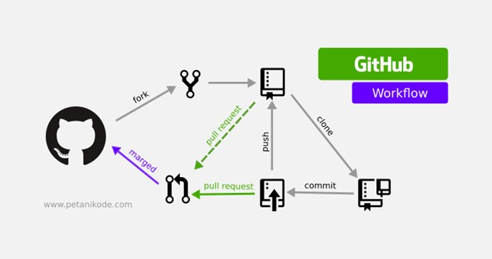

Make sure to add and get awareness for the following below tasks for your project/system assigned to you.

1. Managing your organization’s GitHub account , Install Git

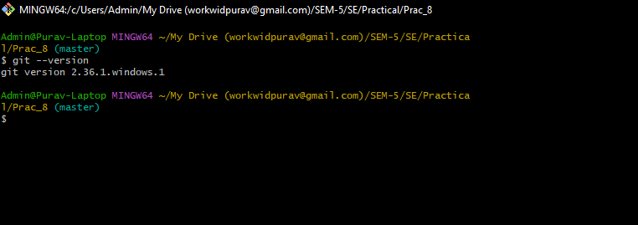

1. Create and adding new files to local git repository

1. Demonstrate the staging environment and various commits

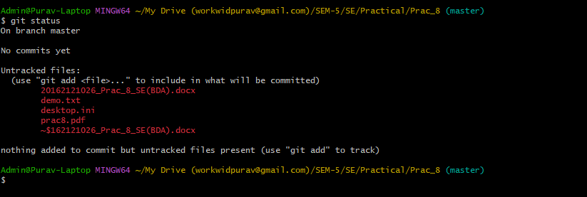

1. Add a file in to the staging environment

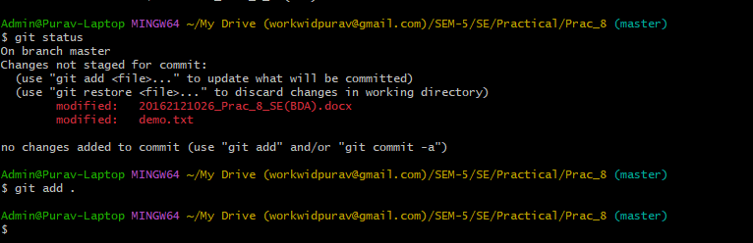

1. Create commit and new branches

1. Create a new repository on Github.

1. Pushing a branch to Github

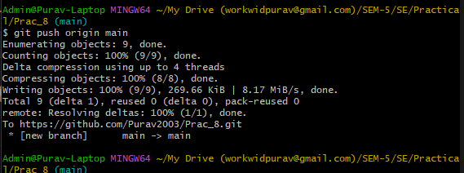

1. Managing Pull Request for your projects (PRs)
2. Managing changes back to your Local PC from Github

[Hint: https://product.hubspot.com/blog/git-and-github-tutorial-for-beginners]