Game Design Document

Fill up the Following document

1. Write the title of your project.

= Unlimited Dog Running Game.

1. What is the goal of the game?

= To get the highest Score.

1. Write a brief story of your game?

= There was once a dog, who got lost. He wanted to gat home back as

soon as possible, so, he started to run back the way he came in hopes to

get back to his home.

1. Which are the playing characters of this game?

* Playing characters are the ones which respond to the user based on the input from the user
* Cars, monkeys, dinos, wizards etc, are the playing characters in the game.

|  |  |  |
| --- | --- | --- |
| Number | Character Name | What can this character do? |
| 1 | Dog. | Try to beat the previous score. |

1. Which are the Non Playing Characters of this game?

* Non Playing characters are the ones which don't have an action or a behavior when the user interacts with the game.
* Hurdles, stones, bananas, coins, etc are non-playing characters in the game.

|  |  |  |
| --- | --- | --- |
| Number | Character Name | What can this character do? |
| 1 | Log. | To act as an obstacle. |
| 2 | Bush. | To act as an obstacle. |
| 3 | Cloud. | To act as an obstacle. |

Draw your imagination of this game. What does this game look like?

* Draw the game either on your computer or on paper,
* Add images of scenes of the game to show each of the playing and non-playing characters at least once.

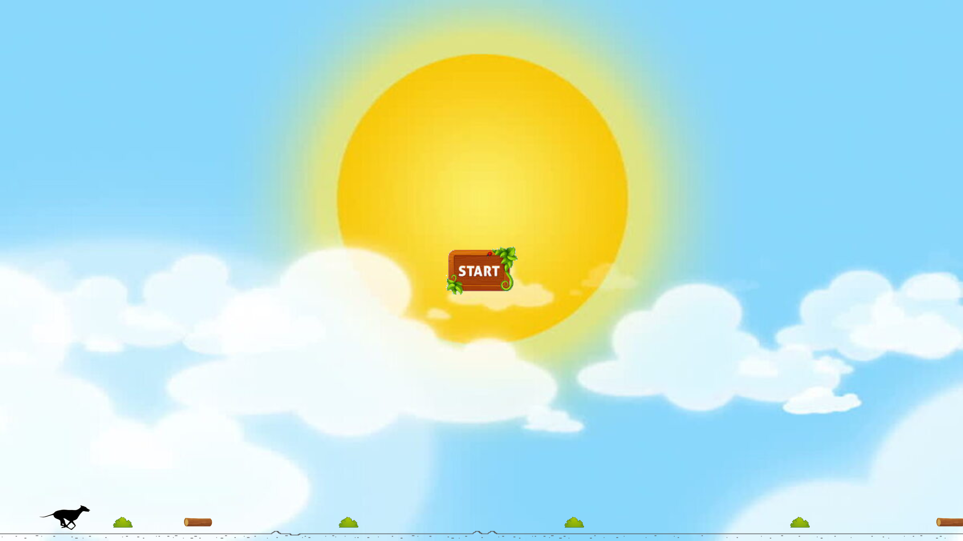

How do you plan to make your game engaging?

I plan to make my game engaging by adding lots of obstacles, background images and instructions on how to play the game.