A Project Report
On

AI Resume Analyser

By
Purav Desai (ET23BTIT077)
Parth Patel (ET23BTIT110)
Deep Shah (ET23BTIT125)
Khushi Shah (ET23BTIT126)
Mit Shah (ET23BTIT127)

under the mentorship of

Dr. Mita Parikh
Head, Department of Information Technology



December 2026
Department of Information Technology
Sarvajanik College of Engineering and Technology
Sarvajanik University
Dr. R K Desai Marg, Opp. Mission Hospital, Athwalines, Athwa, Surat, Gujarat 395001

Index
Index II
UNDERTAKING IV
CERTIFICATE V
Acknowledgements VI
Abstract VII
List of Tables VIII
List of Figures IX
List of Symbols, Abbreviations and Nomenclature X
1 Introduction 1
1.1 Project Background 1
1.2 Problem Statement 1
1.3 Objectives 2
1.4 Related Work and Technical Foundations 2
1.5 Proposed System 3
1.6 Scope and Boundaries 4
1.7 Feasibility and Requirements 4
1.8 Organization of the Report 5
2 Design 6
2.1 Functional Requirements and Use Cases 6
2.2 System Architecture 7
2.3 Data Model and Persistence 7
2.4 Placement Ranking Algorithm 9
2.5 Taxonomy Grounding and Skill Comparison 10
2.6 Deterministic Skill Score 11
2.7 Report Scoped Retrieval and Chat 12
2.8 Cache and Session Isolation 13
2.9 Reliability Privacy and Failure Behavior 14
3 Implementation 15
3.1 Technology Stack and Module Organization 15
3.2 Document Parsing and Job Ingestion 16
3.3 Placement Screens and Candidate Identity 16
3.4 Detailed Analysis Service 17
3.5 Assistant and Citation Validation 17
3.6 Demonstration Data and Location Features 17
3.7 Verification Strategy and Results 18
3.8 Performance Observations 19
3.9 Deployment and Operational Procedure 21
4 Conclusion 22
4.1 Project Outcomes 22
4.2 Limitations 22
4.3 Future Work 23
References 24
Appendix 25
A Installation and Verification 25
B Principal API Contracts 25
C Core Algorithms 26
D Illustrative Result and Reproducibility Notes 27

UNDERTAKING

The work presented in the project report entitled AI Resume Analyser during the academic year 2026-27 is the outcome of the students' independent efforts. The findings and conclusions presented are based on the research and development undertaken by the students during the project.

Name(s) of student(s) | Enrollment Number(s) | Signature
Purav Desai | ET23BTIT077
Parth Patel | ET23BTIT110
Deep Shah | ET23BTIT125
Khushi Shah | ET23BTIT126
Mit Shah | ET23BTIT127

Date: ____________________
Place: Surat

CERTIFICATE

This is to state that the Project Report entitled AI Resume Analyser submitted by Purav Desai (Enrolment No: ET23BTIT077); Parth Patel (Enrolment No: ET23BTIT110); Deep Shah (Enrolment No: ET23BTIT125); Khushi Shah (Enrolment No: ET23BTIT126); Mit Shah (Enrolment No: ET23BTIT127) during the academic year 2026-27 is approved for the award of the degree of Bachelor of Technology in Information Technology.

Date: ____________________
Place: Surat

Dr. Mita Parikh  Head, Department of IT | Prof. (Dr.) Mita Parikh  Head, Department of IT

Examiner's Signature

____________________________________

Acknowledgements
We acknowledge the academic guidance of Dr. Mita Parikh and the Department of Information Technology at Sarvajanik College of Engineering and Technology, Sarvajanik University. We are grateful for the opportunity to develop AI Resume Analyser as a practical application of document processing, information retrieval, and software engineering.

We acknowledge the researchers, documentation authors, and open-source contributors whose work supports the project. ESCO provides a skill vocabulary, GeoNames provides geographical reference data, and the Python and web software ecosystem supplies the components used for parsing, storage, validation, and the interface. The adapted RAG source and the project repository are credited in the references.

We thank our fellow students and families for their encouragement. The project brought together the team's work on the application workflow, technical integration, testing, and documentation. Responsibility for the submitted report remains with the student team.

Purav Desai ET23BTIT077
Parth Patel ET23BTIT110
Deep Shah ET23BTIT125
Khushi Shah ET23BTIT126
Mit Shah ET23BTIT127

Abstract
AI Resume Analyser is a local placement-preparation application that compares a selected resume with saved job descriptions and explains individual matches. The system accepts readable PDF, DOCX, and UTF-8 TXT documents, ranks jobs through semantic similarity and explicit preferences, and produces a detailed report for a chosen resume and job pair.

Extracted skill names are normalized against ESCO and a custom technical taxonomy. Python performs set comparison and computes a weighted skill-coverage score using 80 percent essential and 20 percent preferred requirements. Qualitative model observations remain separate from this deterministic score. Optional Mercury assessment reviews at most 25 baseline matches and preserves similarity ordering when complete validated decisions are unavailable.

The report-scoped assistant combines dense and lexical retrieval, rank fusion, and structured generation. Session and context filters preserve document ownership, while citation validation builds source cards from stored metadata and real PDF page references. Bounded caches and content-aware invalidation reuse unchanged work without mixing candidates or embedding spaces.

The current implementation passed 124 isolated Python regression checks and seven HTML integration scripts. These results verify functional contracts with mocked providers and do not establish real-world ranking accuracy or live AI latency. The project provides explainable support for career preparation while leaving final judgments with the user.

Keywords: resume analysis, ESCO, skill coverage, semantic ranking, retrieval augmented generation, source citations.

List of Tables
Table 1. Comparison of document analysis approaches 3
Table 2. Software and operational requirements 4
Table 3. Functional requirements 6
Table 4. Principal data structures and storage 8
Table 5. Location preference hierarchy 9
Table 6. Meaning of the displayed scores 10
Table 7. Illustrative deterministic skill comparison 11
Table 8. Cache layers and invalidation 13
Table 9. Implementation modules 15
Table 10. Demonstration and verification data 18
Table 11. Selected regression scenarios 18
Table 12. Historical local UI benchmark 19
Table 13. Principal API routes 25

List of Figures
Figure 1. Candidate workflow from document upload to source cited explanation 4
Figure 2. Module architecture and storage boundaries of AI Resume Analyser 7
Figure 3. Conceptual relationships between documents analyses and chat contexts 8
Figure 4. Detailed analysis pipeline with a deterministic scoring boundary 11
Figure 5. Hybrid retrieval and validated answer generation for the selected match 12
Figure 6. Historical repeated Streamlit workflow timing with mocked providers 20

List of Symbols, Abbreviations and Nomenclature
Symbol | Abbreviation or meaning
AI | Artificial Intelligence
API | Application Programming Interface
BM25 | Best Matching 25 lexical retrieval model
CSV | Comma-Separated Values
DOCX | Office Open XML document format
ESCO | European Skills, Competences, Qualifications and Occupations
HTTP | Hypertext Transfer Protocol
JD | Job Description
JSON | JavaScript Object Notation
LLM | Large Language Model
NLP | Natural Language Processing
OCR | Optical Character Recognition
PDF | Portable Document Format
RAG | Retrieval Augmented Generation
RRF | Reciprocal Rank Fusion
SDK | Software Development Kit
TTL | Time To Live
UI | User Interface
UUID | Universally Unique Identifier
E and P | Essential and preferred grounded requirement sets
M_E and M_P | Numbers of matched essential and preferred skills
k | Rank-fusion smoothing constant; 60 in this implementation

Introduction

Project Background
AI Resume Analyser helps a candidate compare a resume with saved job descriptions, understand the requirements that are evidenced in the resume, and ask questions about a selected match. The project combines semantic document retrieval, taxonomy-based skill normalization, a reproducible skill-coverage calculation, and a conversational explanation layer. Its primary interface is a browser application served by a FastAPI backend. An older Streamlit dashboard remains available for local testing.
A resume and a job description describe related information in different forms. A candidate may list a framework in a skills section, describe its use in a project, or use an alternative name. A vacancy may separate mandatory requirements from desirable qualifications and include experience, education, location, and work arrangement constraints. Comparing these documents by manually counting shared words does not explain which requirements are supported or how a result was calculated.
The project addresses this problem through two separate outputs. Placement ranking identifies relevant jobs among the saved descriptions. Detailed analysis then explains one resume and job pair through matched skills, missing essential and preferred skills, additional candidate skills, and narrative observations. The assistant uses the completed report and supporting document passages to answer follow-up questions. These outputs support career preparation and document review; the system does not issue hiring decisions.

Problem Statement
The central problem is to produce useful resume-to-job comparisons without allowing a language model to invent the candidate's qualifications or the numeric skill score. The system must handle different document formats, normalize skill aliases, retain the identity of the selected resume, distinguish job preferences from skill coverage, and show the evidence behind a conversational answer. It must also remain usable when an optional provider is unavailable or a document contains too little readable text.
A second problem is state consistency. Uploading another resume, switching jobs, refreshing the browser, and repeating an analysis should not cause a previous candidate's result to appear under the new selection. The report, ranking, chat context, and stored vectors must therefore carry document identity and content information through the complete workflow.

Objectives
The project aims to provide a transparent local workflow for placement preparation. The objectives are to accept PDF, DOCX, and UTF-8 TXT documents; rank saved jobs by semantic similarity and explicit preferences; normalize extracted skills against ESCO and a custom technical taxonomy; calculate skill coverage in Python; explain selected matches through source-cited chat; and reuse unchanged work through bounded, context-aware caching.
The implementation also aims to make failure states visible. Empty uploads, insufficient context, unavailable providers, malformed answers, invalid citations, and unresolved location names should produce clear outcomes. A failed AI request must not be replaced by an apparently successful fabricated assessment.

Related Work and Technical Foundations

Taxonomies and Semantic Retrieval
ESCO is a multilingual classification of skills, competences, qualifications, and occupations maintained by the European Commission [1]. In this project, its preferred labels and alternative labels provide a reference vocabulary for skill normalization. A custom taxonomy supplements technical tools that need project-specific coverage. Taxonomy lookup standardizes names; it does not prove that a candidate actually possesses a skill beyond the evidence stated in the resume.
Embeddings represent text as vectors that can be compared for semantic relevance. Google's embedding interface supports retrieval-oriented tasks, including separate document and query task types for the text embedding model used by the project [2]. Placement ranking uses vector similarity, while the chat pipeline also uses lexical retrieval so that exact technology names remain searchable.

Retrieval Augmented Generation
Lewis et al. describe retrieval-augmented generation as a combination of generation and an external retrieval mechanism [3]. This project applies the same general principle to a much smaller, user-selected document context. It retrieves resume, job, and analysis passages and provides them to the answer generator. It does not train the original research architecture or claim the benchmark results reported in that paper.
Cormack, Clarke, and Buettcher introduce Reciprocal Rank Fusion as a method for combining ranked result lists [4]. The chat implementation uses this principle to merge dense and BM25 results without comparing their incompatible raw score scales. Source identity is retained by chunk ID rather than by the text alone.
Table 1. Comparison of document analysis approaches
Approach | Strength | Limitation | Project response
Manual review | Uses context and human judgment | Time-consuming across many jobs | Produces a shortlist and an evidence-based report
Keyword overlap | Finds exact technical terms | Misses aliases and related wording | Adds embeddings and taxonomy normalization
Unconstrained generation | Produces fluent explanations | May invent facts or scores | Separates extraction from deterministic scoring
Semantic similarity | Finds related document meanings | Does not show requirement coverage | Keeps similarity separate from the gap report
Grounded document chat | Explains retrieved evidence | Depends on retrieval and source quality | Validates citations and preserves document scope

Proposed System
The proposed system first accepts and validates documents. Job descriptions are stored with metadata and vectors. The user selects a resume and preferences, runs placement ranking, and opens the gap report for an individual job. The report contains a deterministic skill score and separately labelled AI observations. The assistant becomes available for a successful selected match and answers questions with supporting source cards.
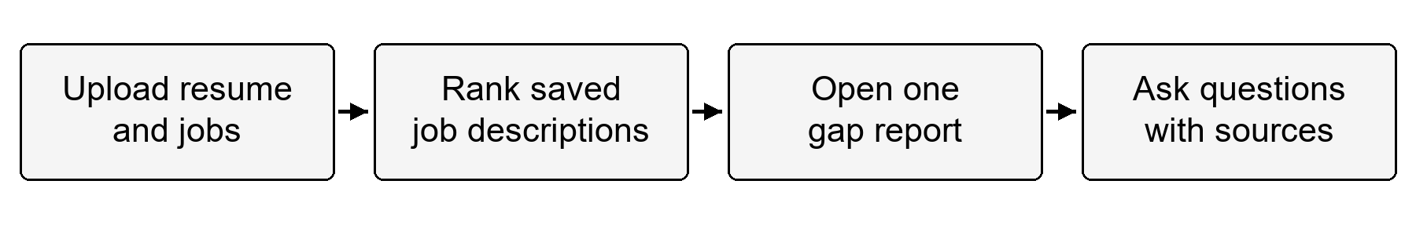
Figure 1. Candidate workflow from document upload to source cited explanation
The optional Mercury stage reranks a bounded shortlist through OpenRouter. It does not replace the embedding stage or change the mathematical skill-coverage score. If this optional stage cannot produce a complete validated result, the application retains the baseline similarity order and explains the fallback.

Scope and Boundaries
The present scope is a local, single-user career guidance application. It includes document parsing, job management, ranking, gap analysis, comparisons, Markdown report downloads, provider settings, and report-scoped chat. It includes a five-example fixture set and a larger fictional India demonstration dataset.
The scope does not include recruitment automation, a verified prediction of employment outcomes, production user authentication, or a complete OCR service for scanned resumes. The demo dataset is not an accuracy benchmark. Provider-dependent operations require valid access and may be affected by service availability, quotas, and model support.

Feasibility and Requirements
The application can run locally because document metadata, vectors, taxonomies, and city information have local representations. Remote generation is requested only where the workflow needs a qualitative assessment or answer. Batching, a bounded decision shortlist, and reuse of unchanged vectors reduce repeated processing. Python 3.12 is the documented project runtime; the Windows regression checks were also executed in the existing Python 3.14 environment with UTF-8 mode.
Table 2. Software and operational requirements
Component | Requirement or role | Qualification
Runtime | Python 3.12 documented and Node.js for HTML checks | Use an isolated virtual environment
Backend | FastAPI and Uvicorn | Runs locally on port 8010 by default
Document support | PyMuPDF and python-docx | Readable PDF DOCX and UTF-8 TXT text
Storage | Chroma persistent directory | Writable local storage for vectors and metadata
Taxonomy | ESCO CSV and custom skills JSON | Required for new detailed skill analyses
Providers | Gemini and optional Groq OpenRouter keys | Availability and quotas are external dependencies
Browser | Current browser with local storage | Resume text and selection persist per browser origin
Resources | Memory and disk for dependencies and optional models | No measured minimum hardware guarantee is claimed

Organization of the Report
Chapter 2 presents requirements, architecture, data structures, algorithms, and state isolation. Chapter 3 explains the implementation, verification results, performance observations, and deployment procedure. Chapter 4 records conclusions, limitations, and future work. References identify the technical foundations and source repositories. The appendix provides installation steps, API contracts, pseudocode, and an illustrative example.

Design

Functional Requirements and Use Cases
The main actor is the candidate using the browser application. The actor adds personal documents, manages saved jobs, chooses a resume, reviews matching jobs, inspects a gap report, and asks follow-up questions. External AI providers are supporting services, not owners of the application's state. The backend validates each request before using stored or remote resources.
Table 3. Functional requirements
ID | Requirement | Expected behavior
FR1 | Upload readable documents | Validate format size and non-empty extracted text
FR2 | Manage saved jobs | Add list delete and recover stored job records
FR3 | Rank placement matches | Compare the selected resume with saved job vectors
FR4 | Apply preferences | Show location and work-arrangement bonuses separately
FR5 | Explain one match | Return grounded skills and a reproducible skill score
FR6 | Answer follow-up questions | Use the selected documents and completed analysis
FR7 | Display sources | Return validated chunk references and real PDF pages
FR8 | Maintain state consistency | Reject mismatched contexts and late stale responses
FR9 | Configure providers | Keep saved keys local and display masked status
FR10 | Load demo data | Preserve personal records and reuse existing demo jobs

System Architecture
The browser interface in ai_ui.html communicates with the FastAPI service in server.py. The backend delegates document parsing, job storage, placement ranking, detailed analysis, chat, and report generation to separate modules. Chroma holds job vectors and scoped chat chunks. ESCO and custom JSON files provide skill labels, while GeoNames-derived city data supports local location resolution.
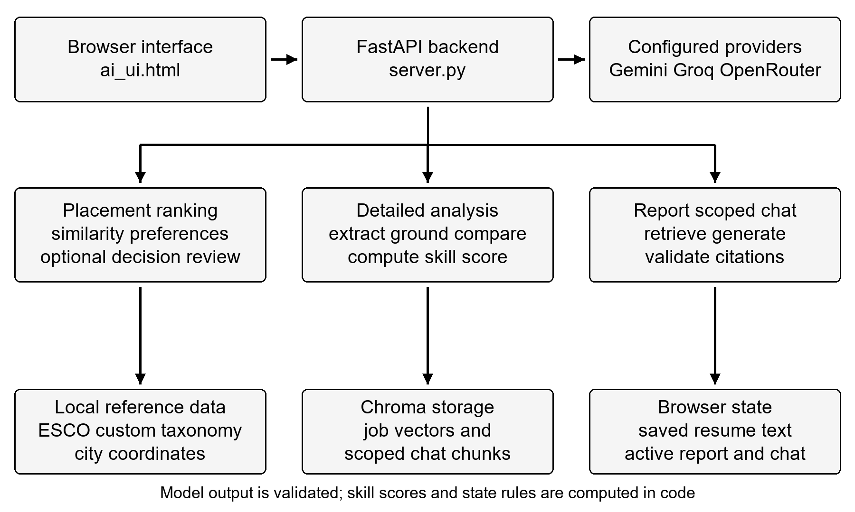
Figure 2. Module architecture and storage boundaries of AI Resume Analyser
The architecture separates deterministic computation from model output. Models can extract candidate skill names and produce narrative fields. Python performs taxonomy grounding, set comparison, score calculation, preference arithmetic, citation checks, and response validation. Pydantic models define the contracts exchanged by these modules. FastAPI provides the request and response layer and its documented API interface [5].

Data Model and Persistence
The project uses document records and vector collections rather than a relational database schema. A JDRecord contains a job ID, title, company, location, snippet, and full text. Its vector is associated with the same ID. A DetailAnalysis records the selected resume ID and job ID, sufficient-context state, skill score, skill gap, narrative observations, requirement estimates, and recommendations.
Table 4. Principal data structures and storage
Entity | Important fields | Storage or lifetime
Resume record | ID name text and page references | Browser local storage and page state
JDRecord | Job ID metadata full text and vector | Persistent Chroma job collection
RankingResult | Resume ID ranked cards method and decision status | Current browser or dashboard state
DetailAnalysis | Resume ID job ID score and grounded gap lists | Per-page analysis cache
Chat context | Session ID content hash document IDs and analysis | Scoped persistent chunk collection
ChatCitation | Validated chunk ID source type page and excerpt | Returned with an answer
Provider configuration | Keys models and optional reranking settings | Ignored local environment file

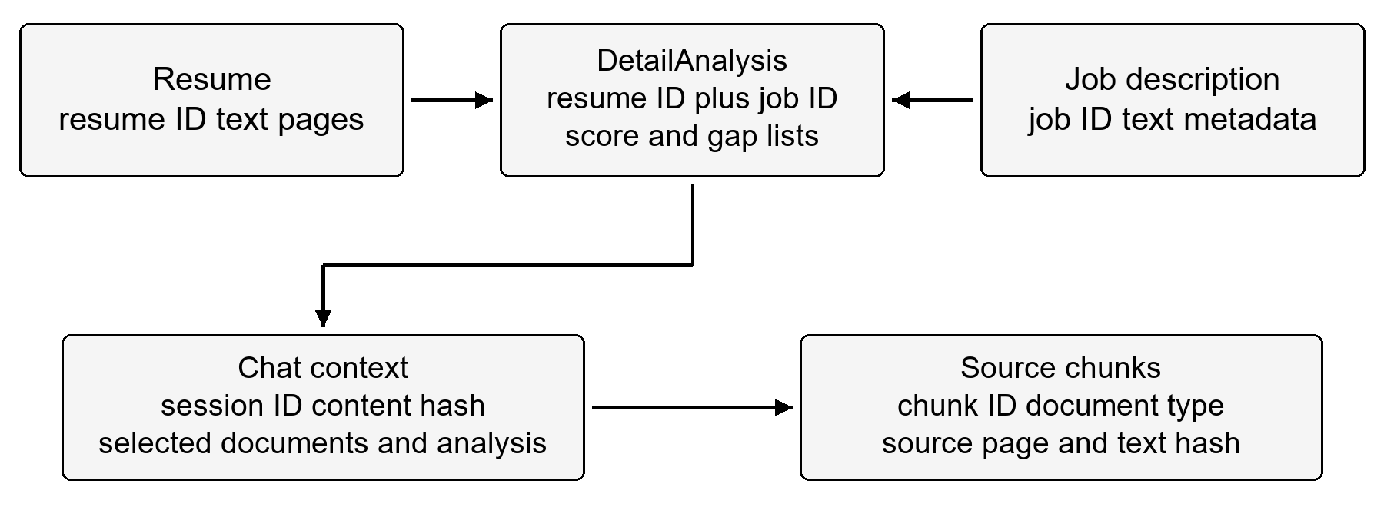
Figure 3. Conceptual relationships between documents analyses and chat contexts
Resume persistence is different from server-side conversation persistence. The browser restores saved resume text and selected resume after a refresh. Jobs persist in the backend. A completed analysis and its conversation are page-session objects and are rebuilt when required. Original PDF page numbers remain available as source metadata, but the report does not assume that original uploaded file bytes are retained as a permanent archive.

Placement Ranking Algorithm
The first stage embeds the selected resume and computes cosine similarity against the stored job vectors. A matrix operation evaluates the jobs together. Zero vectors are handled safely and the baseline ordering has a deterministic job-ID tie breaker. Preference bonuses are computed in code and are kept separately from the base similarity value. In the formula below, r and j are the resume and job vectors.
$$cosine similarity = \frac{r · j}{‖r‖ ‖j‖}$$
Location resolution uses normalized city names, aliases, and explicit country or state qualifiers. Distance is a straight-line geographical estimate between city coordinates. Same-city matches receive five points; different cities within 100, 200, and 300 kilometres receive four, three, and two points respectively. Beyond 300 kilometres the location bonus is zero. Ambiguous or unknown places receive no guessed bonus. GeoNames supplies the underlying geographical reference data [6].
Table 5. Location preference hierarchy
Resolved relationship | Location points | Interpretation
Same city | 5 | Exact resolved preferred city
Different city at most 100 km | 4 | Nearby city within the first band
Over 100 km at most 200 km | 3 | City within the second band
Over 200 km at most 300 km | 2 | City within the third band
Over 300 km | 0 | Outside the configured nearby range
Unresolved ambiguous or remote-only | 0 | No city coordinate is guessed

Bounded Mercury Reranking
At most the top 25 baseline jobs enter the optional typed decision stage. Requests contain complete resume/job pairs and are divided into batches of at most ten questions, with a 60 KB request limit. The model returns an ordered Weak, Moderate, or Strong assessment and a confidence value. Validated probabilities produce a normalized role-fit index. The implementation's default confidence threshold is 0.5.
$$role fit = 50 × (0 × P_{Weak} + 1 × P_{Moderate} + 2 × P_{Strong})$$
The final ordering combines this role-fit index with separate location and arrangement points, using the baseline similarity as a tie breaker. A result outside the 25-job shortlist remains in similarity order and is marked as not AI reviewed. A missing key, disabled stage, provider error, oversized pair, invalid response, or low-confidence shortlist retains the complete baseline order. This design prevents partial assessments from silently replacing unreviewed results.
Table 6. Meaning of the displayed scores
Value | Source | Meaning
Embedding similarity | Document vectors | Semantic relatedness of resume and job text
Role fit index | Validated Mercury assessment | Normalized ordered model rating from 0 to 100
Preference points | Local Python rules | Location plus arrangement bonuses up to eight points
Ranking total | Base score plus preference points | Ordering value that can exceed 100
Skill coverage score | Grounded skill set comparison | 80 percent essential and 20 percent preferred coverage
Dimension estimates | Analysis generation | Separate AI observations on experience education and responsibilities

Taxonomy Grounding and Skill Comparison
The generation response separates resume skills, essential job skills, and preferred job skills. Each extracted name passes through an exact normalized taxonomy lookup and then, when needed, a fuzzy lookup. Unmatched candidates are discarded from the grounded comparison. Accepted skills retain their standardized name, source, taxonomy ID, and exact or close match type.
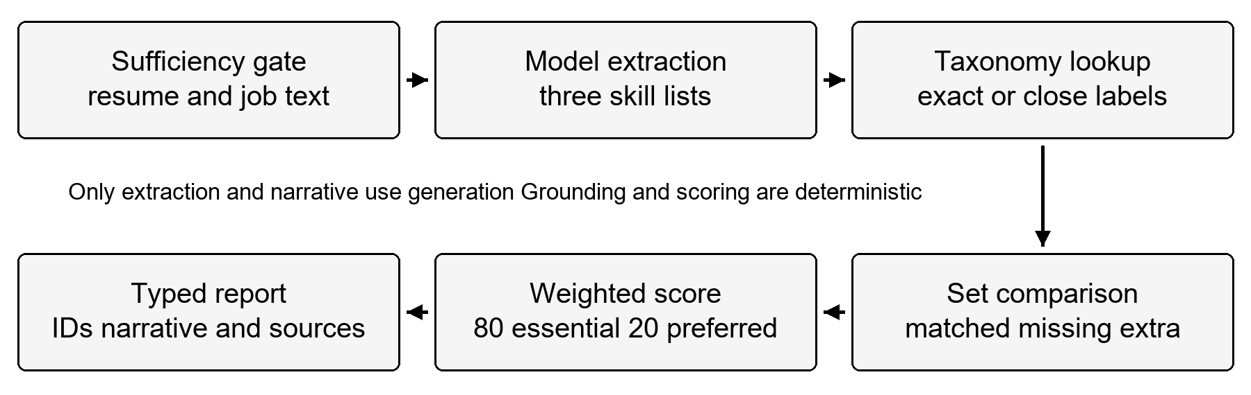
Figure 4. Detailed analysis pipeline with a deterministic scoring boundary
Comparison deduplicates standardized names and gives essential requirements precedence over preferred duplicates. It separates matched, missing essential, missing preferred, and additional resume skills. If either side relies on a close taxonomy match, the result is labelled close. Exact resume duplicates take precedence over weaker duplicate evidence.

Deterministic Skill Score
Let E be the set of essential grounded requirements and P the preferred set after removing any skills already in E. Let M_E and M_P be the numbers of those requirements matched by the resume. The score uses fixed weights and is rounded to an integer between zero and 100.
$$skill score = round[100 × (0.8 × \frac{M_{E}}{|E|} + 0.2 × \frac{M_{P}}{|P|})]$$
A category with no listed requirements uses a ratio of one in the implemented formula. When both categories are empty, the comparison returns zero; the analysis pipeline also returns an insufficient-context result when no job requirement skills can be verified. This handling avoids a false perfect score caused by empty extracted requirements.
Table 7. Illustrative deterministic skill comparison
Category | Required skills | Resume evidence | Coverage
Essential | Python Docker | Python | 1 of 2
Preferred | FastAPI Kubernetes | FastAPI | 1 of 2
Additional resume skill | Not a job requirement | Redis | Reported as extra
Final skill score | 80% essential and 20% preferred | 0.8 x 0.5 + 0.2 x 0.5 | 50 of 100

The Skills entry in the requirement-match response is replaced by this computed score. Experience, education, and responsibility estimates are displayed separately and do not enter the mathematical skill calculation. No score is a hiring probability, and a skill absent from a resume is described as not evidenced rather than proof of inability.

Report Scoped Retrieval and Chat
The chat context includes the selected resume, job description, and matching completed analysis. It is divided into token-measured chunks of 300 tokens with a 50-token overlap. Each chunk carries session and context IDs, document type, source, page metadata, and a text hash. Chroma metadata filters restrict both dense retrieval and the lexical corpus to that selected scope [7].
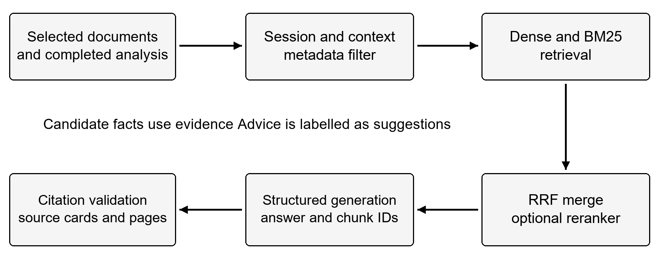
Figure 5. Hybrid retrieval and validated answer generation for the selected match
Dense and BM25 rankings are merged by Reciprocal Rank Fusion. With a one-based rank r, a chunk receives the sum of 1 divided by 60 plus r across its retrieval lists. Optional CrossEncoder reranking can refine the selected passages. Short document contexts receive broad coverage; larger contexts include relevant resume and job evidence and the existing analysis.
The generator returns structured JSON containing an answer, a context-sufficiency flag, and cited chunk IDs. The backend verifies those IDs against the supplied evidence and builds source cards from stored metadata. It does not accept model-invented filenames or page numbers. Suggestions may use general career or technical knowledge, but they must be labelled as suggestions and cite the document basis for their relevance.

Cache and Session Isolation
Caching is used where a stored result has a stable identity. It is not used as a substitute for checking which documents are active. Resume embeddings are keyed by the embedder and resume content. Analysis reuse is tied to the resume and job pair. Mercury assessments include content, job identity, model, credential fingerprint, and rubric version in their cache keys.
Table 8. Cache layers and invalidation
Layer | Identity | Bound or lifetime | Invalidation
Resume embedding | Embedder and resume text | 32 entries | Changed content or client refresh
Job record/vector | Stored job ID | Tracks the current job collection | Added removed or replaced IDs
Mercury assessment | Document pair model key fingerprint and rubric | 128 entries for 30 minutes | Changed content configuration or restart
Chat snapshot | Session context content and actual embedding space | Until scoped cleanup | Changed documents analysis or model
Browser analysis | Resume ID and job ID | Current page session | Document or active report changes

Chat collections are separated by the actual embedding space. Once stored Gemini vectors are bound to retrieval, a temporary failure cannot silently substitute local query vectors. A local fallback selected during initial indexing uses its own collection. Session and document deletion clear the corresponding contexts across the relevant collections. Random session IDs provide context separation but are not production authentication.

Reliability Privacy and Failure Behavior
The design validates upload size, readable text, bounded chat requests, analysis ownership, and generated answer structure. The sufficiency gate requires at least 30 words in each document before a detailed generation request. Generation failures produce an explicit unsuccessful response. The browser blocks stale asynchronous results from appearing after a resume or report switch.
Provider keys are stored in the ignored local environment file, and the settings interface displays masked configuration status. Remote operations send the selected document content to the configured providers. A shared or public deployment would need authenticated user ownership, authorization checks, tighter origin controls, secure secret handling, and retention policies in addition to the present local design.

Implementation

Technology Stack and Module Organization
The project is implemented in Python with a browser interface in HTML, CSS, and JavaScript. FastAPI routes connect the interface to separate services. NumPy supports vector operations, RapidFuzz supports label matching, PyMuPDF and python-docx support parsing, and Pydantic validates contracts. The RAG engine reuses adapted chunking, retrieval, and generation modules from the documented source repository [8].
Table 9. Implementation modules
Module | Primary responsibility | Main output
server.py | API routing settings fixtures and UI serving | Validated HTTP responses
ai_ui.html | Upload ranking report and assistant screens | Browser interaction and local state
document_parsing.py | PDF DOCX and TXT extraction | Text and page references
jd_index.py | Persistent job storage and batched ingestion | Job records and vectors
ranking.py | Similarity preferences and shortlist orchestration | Ranked cards and method metadata
decision_ranking.py | Typed Mercury calls and bounded pair cache | Validated role-fit assessments
location_preferences.py | Offline city resolution and distance bands | Preference points and explanations
analysis_pipeline.py | Detailed extraction grounding and response assembly | DetailAnalysis
esco_loader.py | ESCO and custom taxonomy indexing | Exact and fuzzy label lookup
skill_comparison.py | Deterministic skill set operations | SkillGap and skill score
chat_service.py | Scoped indexing retrieval and citation validation | ChatResponse and source cards
rag_engine | Chunking embeddings retrieval and generation | Reusable RAG operations
report_generator.py | Structured result conversion | Downloadable Markdown report

Document Parsing and Job Ingestion
PDF extraction preserves the real one-based page references for readable pages. DOCX extraction reads paragraphs and table cells without inventing page numbers. TXT extraction accepts UTF-8 and handles a byte-order mark. Empty text, unsupported formats, and uploads above the configured five-megabyte limit are rejected with visible feedback.
New job records are normalized before storage. Equivalent title, company, location, and full text reuse an existing record. Bulk demo ingestion embeds new jobs in batches of 20 and preserves already completed batches after a later provider failure. A retry reuses the stored portion. The current backend has no artificial job-count cap; resource usage still grows with the stored dataset.
The store synchronizes its in-memory view with persistent job IDs. A failed read is not treated as successful initialization. Locking protects local concurrent operations, and failed deletion does not first discard the in-memory cache. These measures address stale-record and partially completed update conditions.

Placement Screens and Candidate Identity
Placement fit has separate setup, matching-results, and gap-report views. Setup selects the candidate and preferences. The results view offers result-count choices, filtering, ordering, comparison, and access to an individual report. Returning from a report keeps the ranking, while changing the candidate invalidates the previous match context.
The current frontend binds results and chat to document identity. Late network answers are ignored when their request no longer belongs to the active report. The older dashboard also identifies the resume used for the ranking rather than relabelling existing results with the newly selected list index. Upload and removal operations invalidate stale displayed results, and analyses remain isolated by candidate/job pair.

Detailed Analysis Service
The service fetches the selected stored job and checks input sufficiency before generation. Its configured Gemini client and model cascade can retry a transient error or try another configured client or model. A successful normal analysis has one successful generation response; failures and retries can involve more than one attempted call. The report therefore does not describe this as an unconditional single-call guarantee.
The response schema provides skill lists and qualitative fields rather than an authoritative numeric skill score. The backend parses the JSON, grounds the lists, computes the gap and score, replaces the Skills estimate, and assembles the typed response. Missing job IDs, unreadable context, invalid JSON, unverified requirements, and provider errors have distinct visible failure outcomes.

Assistant and Citation Validation
The assistant includes at most six previous messages for follow-up interpretation. History is reference context rather than evidence of candidate facts. The selected report is treated as authoritative for its computed score and gap lists. The prompt distinguishes factual answers, document comparison, project suggestions, interview advice, and estimated learning plans.
Gemini generation can use a configured Groq fallback, with the same local JSON validation applied to both. A factual answer with insufficient evidence receives a consistent fallback. A sufficient answer without valid citations is rejected. Citation numbers are assigned by the backend, and excerpts and page references are taken from the indexed chunks. The model cannot make a proposed project appear as work the candidate already completed.

Demonstration Data and Location Features
The original fixture set contains five resumes and five jobs. The India dataset adds 100 fictional jobs and 100 fictional resumes across 20 role families and five profile variants. It demonstrates partial skill evidence, experienced profiles, career-transition profiles, explicit preferred requirements, alternative requirements, and different Indian cities. Neither the profile pair links nor the generated examples provide numerical ground-truth fit labels.
Table 10. Demonstration and verification data
Item | Size | Use
Original fixtures | 5 resumes and 5 jobs | Small end-to-end demonstrations
India dataset | 100 resumes and 100 jobs | Bulk loading and varied document exploration
Role families | 20 | Breadth of technical examples
Profile variants | 5 per role family | Different experience and skill evidence
Python verification | 124 tests | Storage API analysis retrieval and ranking contracts
HTML verification | 7 scripts | Browser flow state and integration contracts

For a Mumbai preference, the bundled examples illustrate Mumbai, Navi Mumbai, Pune, Ratnagiri, and Ahmedabad across the configured bands. Approximate distances and the explanation for each location bonus are shown separately from role fit. Unknown or ambiguous locations are not resolved by guessing the nearest popular city.

Verification Strategy and Results
Verification uses unit, API, storage-integration, and browser-state checks. Provider calls are mocked, while Chroma filtering and many storage operations use real isolated collections. The runner directs persistent test writes into separate scratch storage and avoids resetting application records. Node checks exercise the JavaScript interface with a controlled browser harness.
On 14 October 2026, the current Python suite completed 124 tests successfully in 27.130 seconds using UTF-8 mode. All seven HTML integration scripts also passed. This is a functional regression result, not a live provider-availability test or a measurement of ranking accuracy. The source snapshot used for this report is ff0dc25.
Table 11. Selected regression scenarios
Scenario | Verification target | Result
Failed initial database read | Initialization is retried without a false empty cache | Pass
External job replacement | New persistent IDs replace stale records even at the same count | Pass
Repeated ranking | Unchanged resume vectors and stored jobs are reused | Pass
Candidate switch | Previous ranking or late chat is not relabelled as the new candidate | Pass
Missing grounded requirements | No false perfect score is returned | Pass
Invalid chat citations | Invented or missing source IDs are rejected | Pass
Embedding provider change | Incompatible query and document vector spaces are not mixed | Pass
Demo reload and partial failure | Personal records remain and saved batches are reused | Pass
Mercury failure or uncertainty | The complete similarity baseline is retained | Pass
Location aliases and boundaries | City resolution and fixed distance cutoffs are checked | Pass

The Windows dataset test also demonstrates why explicit text encoding matters. Default cp1252 decoding altered an em dash in the UTF-8 JSON fixture, while Python UTF-8 mode produced the expected content. The verified command is included in the appendix so the result can be reproduced without changing the dataset.

Performance Observations
An earlier controlled benchmark compared the original and optimized Streamlit placement workflow using five resumes and five jobs. Both paths used warmed setup and zero-latency mocked HTTP/provider work. Six repeated identical runs were recorded per version. The median local orchestration and rendering time decreased from 1.2669 seconds to 0.1425 seconds, an 88.75 percent elapsed-time reduction and an 8.89-fold local speedup.
Table 12. Historical local UI benchmark
Metric | Before | After
Median local workflow time | 1.2669 seconds | 0.1425 seconds
JD ingestion calls per repeated run | 5 | 0
Detailed analysis calls per repeated run | 1 | 0
Job reset calls per repeated run | 1 | 0
Placement ranking calls per repeated run | 1 | 1
Timed runs | 6 | 6

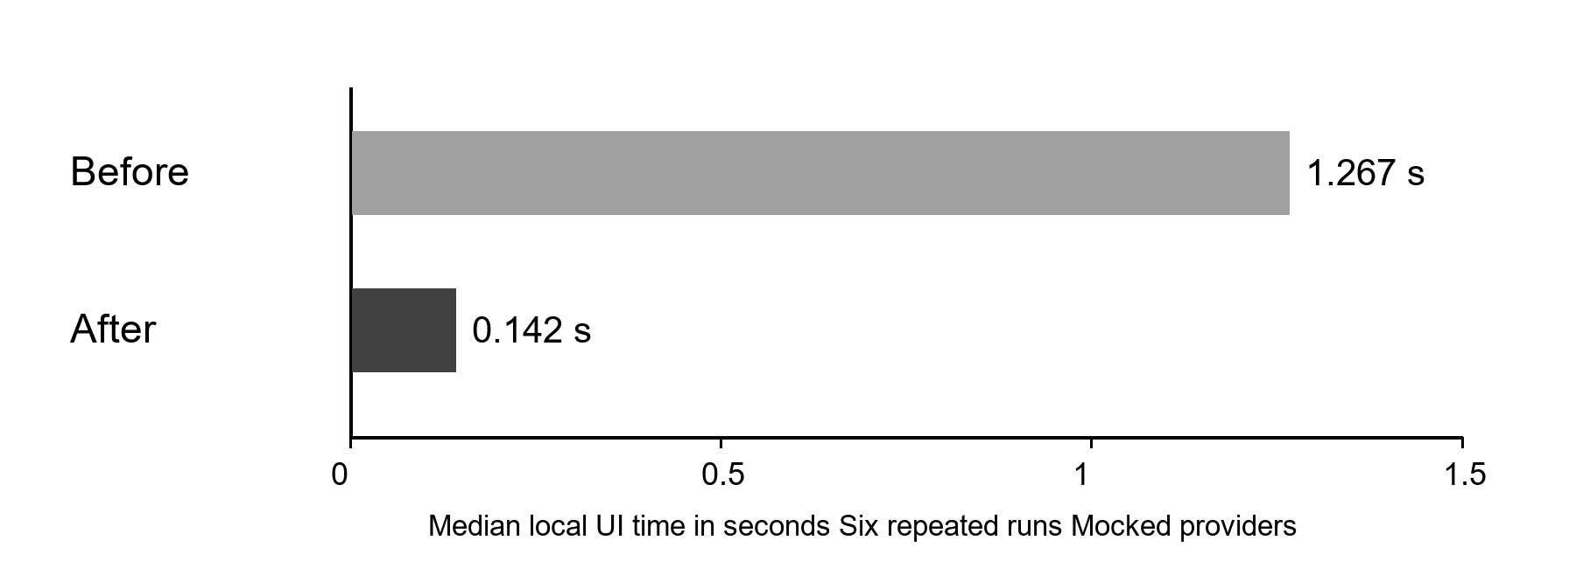
Figure 6. Historical repeated Streamlit workflow timing with mocked providers
The reduction includes removal of 1.1 seconds of artificial waiting and reuse of unchanged work. It excludes live AI response time, network time, real provider cost, and current HTML-interface timing. The result must not be presented as an 88.75 percent speedup of the entire current application. A separate live benchmark would be needed to measure end-to-end latency under realistic provider and document conditions.
The present architecture also limits optional reranking to 25 jobs, batches demo embeddings, bounds resume and decision caches, and makes optional resources lazy. These measures control repeated work. They do not establish a throughput guarantee for large multi-user deployments or eliminate the need to profile larger job collections.

Deployment and Operational Procedure
The documented installation uses a virtual environment and the declared requirements. Gemini is the primary configured provider; Groq and OpenRouter enable optional fallback and decision features. The backend serves the main HTML interface at the local base URL, and its API documentation is available through the docs endpoint. The older Streamlit dashboard runs as a separate optional process.
Before a demonstration, confirm readable documents, taxonomy files, provider configuration, and the intended selected resume. Display the ranking method and score meaning, then open a report and inspect its supporting evidence. After source updates, restart the backend. For shared use, operational controls and authentication must be designed before exposing the local service to other users.

Conclusion

Project Outcomes
AI Resume Analyser combines job discovery, document comparison, skill-gap explanation, and conversational support in one local workflow. Its principal contribution is the separation of model-generated extraction and narrative from deterministic skill normalization, set comparison, score calculation, and source validation. The candidate can inspect why a requirement is matched or not evidenced, rather than relying on an unexplained aggregate number.
The updated implementation also strengthens state consistency. Document identity follows placement results, cached analyses, and chat contexts. Persistent job changes refresh the local view, bulk ingestion reuses completed work, and incompatible embedding spaces remain separate. The verified regression suite and HTML checks cover these behaviors with controlled inputs and isolated storage.

Limitations
The system's results depend on readable source text, taxonomy coverage, extraction quality, and retrieval relevance. A missing resume mention cannot establish that a candidate lacks a skill. A high skill score does not establish suitable experience, truthful qualifications, or a likely hiring outcome. Narrative dimension estimates and optional role-fit assessments remain model outputs requiring human interpretation.
The current test dataset is synthetic, and the functional tests use mocked providers. Ranking quality, explanation quality, and live latency therefore remain separate evaluation questions. Remote service access, rate limits, model support, and response variation can affect practical operation. Local browser storage and random session IDs provide useful scope management but do not replace authenticated ownership in a production deployment.
The job store has no artificial count limit, but the similarity matrix and persistent data still consume memory and processing time. Only the first 25 embedding matches receive optional decision review. Scanned documents need a supported OCR process before their content can be reliably used. These limitations define the current implementation rather than hidden guarantees.

Future Work
Future work should add authenticated ownership and explicit data-retention controls for shared deployments. Evaluation should use consented, independently labelled resume/job pairs, assess retrieval recall and citation support, and measure ranking quality separately from skill extraction and score correctness. Human review of uncertain and close taxonomy matches would improve transparency.
Other improvements include an OCR workflow with page-quality checks, broader multilingual taxonomy handling, richer treatment of alternative and equivalent requirements, and a larger-scale indexing strategy. A live latency study should separate parsing, embeddings, storage, reranking, generation, and browser rendering. Accessibility and usability studies should verify that candidates understand the difference between similarity, role fit, preference points, and skill coverage.

References
[1] European Commission. What is ESCO. European Skills Competences Qualifications and Occupations. https://esco.ec.europa.eu/en/about-esco/what-esco. Accessed 14 October 2026.
[2] Google AI for Developers. Embeddings. Gemini API documentation. https://ai.google.dev/gemini-api/docs/embeddings. Accessed 14 October 2026.
[3] P. Lewis et al. Retrieval-Augmented Generation for Knowledge-Intensive NLP Tasks. Advances in Neural Information Processing Systems 33, 2020. arXiv 2005.11401. https://arxiv.org/abs/2005.11401.
[4] G. V. Cormack, C. L. A. Clarke and S. Buettcher. Reciprocal Rank Fusion outperforms Condorcet and individual Rank Learning Methods. SIGIR 2009, pp. 758-759. https://cormack.uwaterloo.ca/cormacksigir09-rrf.pdf.
[5] FastAPI. Official documentation. https://fastapi.tiangolo.com/. Accessed 14 October 2026.
[6] GeoNames. About GeoNames. https://www.geonames.org/about.html. Accessed 14 October 2026.
[7] Chroma. Metadata Filtering. Official documentation. https://docs.trychroma.com/docs/querying-collections/metadata-filtering. Accessed 14 October 2026.
[8] S. Shah. RAG source repository. https://github.com/shahmit107/RAG. Adaptation provenance is recorded in rag_engine/README.md and RAG_IMPLEMENTATION.md.
[9] P. Desai and project contributors. AI Resume Analyser source repository. https://github.com/PuravDesai004/AI_Resume_Analyser. Local source snapshot ff0dc25 used in this report.
[10] Project verification artifacts. tests/run_review_checks.py, seven tests/test_html_*.cjs scripts, project_validation.log dated 14 October 2026, and historical placement_ui_benchmark.json. Local engineering evidence; not an external accuracy dataset.

Appendix

A Installation and Verification
Create the virtual environment from the repository directory, install the declared dependencies, and create the local configuration from the example file. Provider keys must be filled locally and kept out of version control.
py -3.12 -m venv .venv
.\.venv\Scripts\python.exe -m pip install -r requirements.txt
Copy-Item .env.example .env
.\.venv\Scripts\python.exe -m uvicorn server:app `
--host 127.0.0.1 --port 8010

Open the interface at http://127.0.0.1:8010 and API documentation at http://127.0.0.1:8010/docs. In this workspace, the existing environment is named venv, so the verification command below uses that name and explicitly enables UTF-8 mode.
.\venv\Scripts\python.exe -X utf8 tests/run_review_checks.py
node tests/test_html_chat_context.cjs
node tests/test_html_chat_gaps.cjs
node tests/test_html_features.cjs
node tests/test_html_placement_flow.cjs
node tests/test_html_chat_suggestions.cjs
node tests/test_html_mercury.cjs
node tests/test_html_india_dataset.cjs

Relevant environment names are GEMINI_API_KEY, GEMINI_FALLBACK_API_KEY, GROQ_API_KEY, OPENROUTER_API_KEY, RAG_GENERATION_MODEL, RAG_EMBEDDING_MODEL, RAG_RERANK, OPENROUTER_DECISION_MODEL, and RANK_DECISION_ENABLED. Model access is configured and checked at runtime; no live model-availability claim is made by the offline tests.

B Principal API Contracts
Table 13. Principal API routes
Method | Path | Purpose
GET HEAD | /health | Check startup and configured provider status
GET | / | Serve the main HTML interface
POST | /api/upload-document | Validate and extract an uploaded document
POST | /jds | Add or reuse one stored job
GET | /jds | List jobs with full details
GET | /jds/ids | Read stored IDs for synchronization
GET | /jds/count | Read current count with null artificial cap
DELETE | /jds/{jd_id} | Remove one job
DELETE | /jds | Clear the stored job collection
POST | /rank | Return ranked cards and score-source metadata
POST | /analyze | Analyze one resume and job pair
POST | /chat/documents | Prepare a scoped document context
POST | /chat | Ask within the specified context
DELETE | /chat/sessions/{session_id} | Remove the session's indexed contexts
POST | /api/load-fixtures/india | Load or recover the 100-profile demo
GET | /api/loaded-demo-resumes | Recover recognized loaded demo profiles
POST | /api/report/markdown | Download the structured gap report
GET POST | /api/config | Read masked status or update local settings

C Core Algorithms
The following pseudocode summarizes the implemented responsibilities. It describes the normal successful flow and its guards, rather than reproducing every library call or retry branch.
PLACEMENT RANKING
read a synchronized snapshot of stored jobs and vectors
reuse or compute the selected resume vector
calculate vector similarity and local preference points
sort baseline jobs with a stable job-ID tie breaker
assess at most 25 jobs through the optional typed decision stage
if every required assessment is valid and sufficiently confident:
order the shortlist by role fit plus preference points
else:
retain the complete baseline order and explain the fallback
return the requested display count with score-source metadata

DETAILED ANALYSIS
fetch the selected job; reject a missing job ID
check readable resume and job text against the word-count gate
request structured extraction and narrative from a configured model
ground the three skill lists against the taxonomy
reject a job with no verified requirement skills
compare standardized sets and compute weighted skill coverage
replace the Skills requirement estimate with the computed score
return the analysis with its resume ID and job ID

REPORT SCOPED CHAT
validate selected document and completed-analysis ownership
reuse or create a context hash and compatible embeddings
retrieve dense and lexical passages under session/context filters
merge by chunk ID and optionally rerank
generate structured factual answers or clearly labelled suggestions
validate cited IDs against the supplied passages
return source cards using stored source and page metadata

D Illustrative Result and Reproducibility Notes
Consider a fictional resume evidencing Python, FastAPI, and Redis, and a job requiring Python and Docker with FastAPI and Kubernetes preferred. The grounded comparison in Table 7 reports Python and FastAPI as matched, Docker as missing essential, Kubernetes as missing preferred, and Redis as additional. The deterministic score is 50. This illustration explains the algorithm and does not claim a measured provider response or a real candidate assessment.
The report describes the source snapshot ff0dc25 reviewed on 14 October 2026. The verified Python suite used isolated scratch storage and fake AI calls. The seven HTML scripts used controlled interface harnesses. The historical UI benchmark used baseline commit 49d97fb and an earlier optimized Streamlit workflow; it is included with its scope restrictions rather than used as evidence of current end-to-end performance.
Formal student, mentor, and examiner signatures and issue dates are to be completed through the college's sign-off process. The project source credits and technical references remain part of the report's reproducibility record.

