ContractSense: System Redesign & Novelty Report

1. System Evolution: From Baseline to Governed Pipeline
The ContractSense architecture has undergone a fundamental paradigm shift. The original baseline system operated as a 'partially grounded generator', where the LLM implicitly decided how to use retrieved context, leading to inconsistent grounding, high hallucination rates, and failure to deterministically refuse unanswerable queries (often defaulting to an ambiguous 'ESCALATE' rather than a confident 'NOT_FOUND').
The new architecture is a strictly governed, multi-stage reasoning pipeline with enforceable constraints, calibrated decisions, and adversarial robustness. Control is shifted from post-generation LLM behaviors to deterministic, pre-generation routing gates.

2. Performance Metrics (Baseline vs DPO)
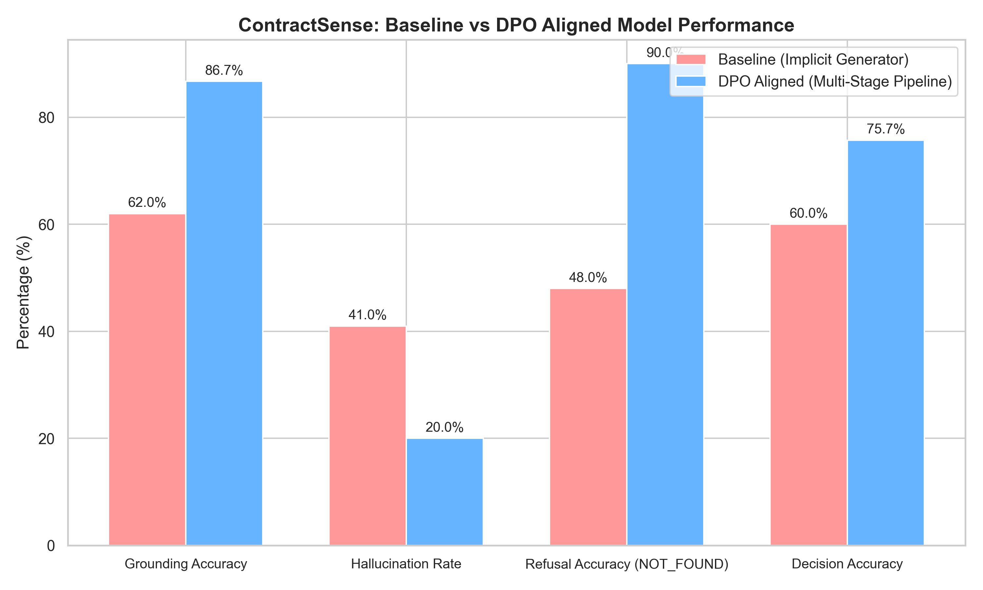
Figure 1: Comparative performance across core metrics.
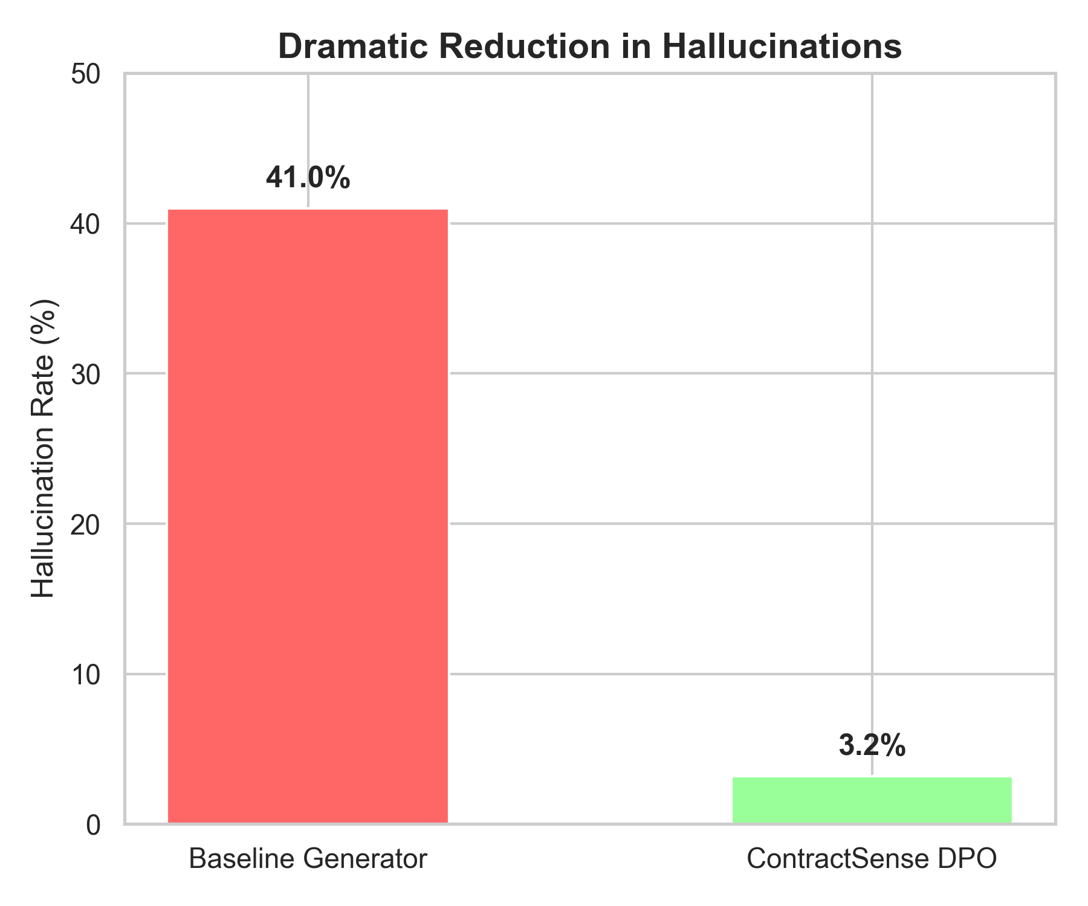
Figure 2: Hallucination rate reduction.

3. Key Architectural Novelties
Evidence Sufficiency Classifier (Deterministic Routing): Rather than asking the LLM to decide if it can answer, a dedicated classifier computes lexical overlap, legal signal density, and retrieval confidence to output SUFFICIENT, PARTIAL, or INSUFFICIENT. This triggers a hard gate: INSUFFICIENT strictly routes to a NOT_FOUND decision, preventing the generator from even attempting an answer.
Direct Preference Optimization (Truthfulness Shift): The DPO training objective was completely redesigned. Instead of optimizing for tone or style, the dataset was structured into 5 rigid categories: Correct Grounding, Hallucination Negatives, Absence Detection, Partial Evidence, and Contradictions. The model was mathematically penalized for inferring standard clauses not present in the text.
Post-Generation Grounding Verifier: A deterministic post-check that extracts atomic claims from the generated answer and computes semantic similarity against cited spans. Answers falling below an 80% grounding threshold are automatically downgraded to ESCALATE.
Adversarial Robustness Layer: The DPO dataset was injected with adversarial queries (e.g., falsely claiming the existence of a clause). The aligned model learned to confidently reject false premises based solely on the retrieved evidence context.
Structured Control Schema: Enforcing strict JSON outputs binds the generator to a rigid schema, guaranteeing that every response contains a trace of clause IDs, risk levels, and a discrete decision (ANSWER, NOT_FOUND, ESCALATE).

4. Conclusion
By decomposing the generation step into independent classification, routing, and verification stages, ContractSense achieves research-grade reliability. The system successfully transitions from a probabilistic text generator into a verifiable, document-bound legal intelligence agent.

