**CLASSROOM MANAGEMENT SYSTEM**

**S. E. Information Technology**

By

**Himanshu Chaurasiya 17**

**Vikas Chaurasiya 18**

**Parth Dali 19**

**Pranav Dalvi 20**

Mentor:

Name of the Mentor

**Mrs. Grinal Tuscano**



Department of Information Technology

St. Francis Institute of Technology

(Engineering College)

University of Mumbai

2020-2021

# Institute Vision, Mission, Quality Policy

## Institute Vision

To be a chrysalis where bright youngsters are transformed into technological entrepreneurs and innovative leaders of tomorrow’s world, consistent with the Franciscan vision of integrity, peace and love

## Institute Mission

To churn highly competent engineering graduates with a commitment to result oriented work, a perennial zest for learning, a quest for excellence, an open mind and the universal values of honesty, dignity and mutual care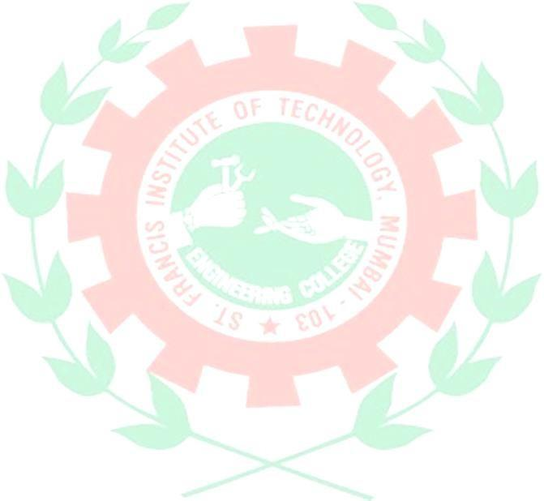

## Institute Quality Policy

To be the most preferred Institute of Engineering and Technology equipped with state-of-art facilities, to develop technically qualified techno-entrepreneurial class of value based global industry leaders, imparting comprehensive technical education, through highly competent and dedicated staff, ensuring continual improvement of QMS processes, meeting ISO 9001-2015 statutory and regulatory requirements

# Department Vision, Mission and Quality Policy

**Department Vision**

To create a conducive instrument for transforming the enrolled potential freshers into competent Information Technology professional or entrepreneur with integrity and ethical value

**Department Mission**

1. To become unit of excellence in teaching, training, research, innovative applications and extension work in IT in co-operation with various departments
2. To make knowledge and expertise accessible with various dissemination strategies, including networking with research unit, colleges, government and industry along with the motivation for self-learning
3. To integrate teaching, research and practice along with higher education for generation and application of knowledge in line with emerging needs of industry, technical quality with market driven professional pursuits, programs, courses, collaboration.
4. To develop entrepreneur skills along with ethical and professional values among students

**Department Program Educational Objectives (PEOs)**

1. To provide an environment and to make knowledge & expertise accessible for students to work in multi- disciplinary projects, to solve the real life problems with the help of modern tools and techniques and to lead towards a successful professional career.
2. To develop effective soft skills, inculcate team building capabilities such as leadership skills, managerial skills, and entrepreneurial skills and simultaneously nurture professional and ethical attitude in broad social context for sustainable development through lifelong learning.
3. To develop effective soft skills, inculcate team building capabilities such as leadership skills, managerial skills, and entrepreneurial skills and simultaneously nurture professional and ethical attitude in broad social context for sustainable development through lifelong learning.

**Department Program Specific Outcomes (PSOs)**

**PSO1:** Students will be able to acquire the basic knowledge of analysis and design, based on the comprehensive principles of Software Engineering, Project Management, Software Testing and Quality Assurance.

**PSO2:** Students will be able to apply research based approach using innovative tools and techniques in the field of Communication & Networks, Computer graphics & Image Processing and Information Security & Data Management.

**PSO3:** Students will be able to use the knowledge of Information Technology to develop end to end solutions in the field of SCAM (Social, Cloud, Analytics and Mobile).

**PSO4:** Students will be able to fuel entrepreneurship or to serve niche employment while portraying competencies like teamwork, efficient soft skills and a zeal for lifelong learning in order to contribute to society with moral and ethical values.

## Program Objectives (POs)

1. **Engineering knowledge (PO1)**

Apply the knowledge of mathematics, science, engineering fundamentals, and an engineering specialization for the solution of complex engineering problems.

1. **Problem Analysis (PO2)**

Identify, formulate, research literature, and analyse complex engineering problems reaching substantiated conclusions using first principles of mathematics, natural sciences, and engineering sciences.

1. **Design/development of solutions (PO3)**

Design solutions for complex engineering problems and design system components or processes that meet the specified needs with appropriate consideration for public health and safety, and cultural, societal, and environmental considerations.

1. **Conduct investigations of complex problems (PO4)**

Use research-based knowledge and research methods including design of experiments, analysis and interpretation of data, and synthesis of the information to provide valid conclusions.

1. **Modern tool usage (PO5)**

Create, select, and apply appropriate techniques, resources, and modern engineering and IT tools, including prediction and modelling to complex engineering activities, with an understanding of the limitations.

1. **The engineer and society (PO6)**

Apply reasoning informed by the contextual knowledge to assess societal, health, safety, legal and cultural issues and the consequent responsibilities relevant to the professional engineering practice.

1. **Environment and sustainability (PO7)**

Understand the impact of the professional engineering solutions in societal and environmental contexts, and demonstrate the knowledge of, and need for sustainable development.

1. **Ethics (PO8)**

Apply ethical principles and commit to professional ethics and responsibilities and norms of the engineering practice.

1. **Individual and team work (PO9)**

Function effectively as an individual, and as a member or leader in diverse teams, and in multi-disciplinary settings.

1. **Communication (PO10)**

Communicate effectively on complex engineering activities with the engineering community and with t h e society at large, such as, being able to comprehend and write effective reports and design documentation, make effective presentations, and give and receive clear instructions.

1. **Project management and finance (PO11)**

Demonstrate knowledge and understanding of the engineering and management principles and apply these to one’s own work, as a member and leader in a team, to manage projects and in multidisciplinary environments.

1. **Life- long learning (PO12)**

Recognize the need for, and have the preparation and ability to engage in independent and life-long learning in the broadest context of technological change.

Graduates will be able to secure employment or be an entrepreneur with ability to apply professional knowledge with ethical responsibility.

**Mini-project Objectives**

|  |  |
| --- | --- |
| 1 | To identify the real-world problems |
| 2 | To find a feasible, technology-based solution to the identified problem |
| 3 | To apply basic engineering fundamentals to solve the problem |
| 4 | To inculcate self-learning and research skills. |

**Mini-project Outcomes**

|  |  |
| --- | --- |
| ITM401.1 | Students shall be able to **identify** real-world problems. |
| ITM401.2 | Students shall be able to **apply** basic engineering knowledge to find a feasible solution for the problem identified. |
| ITM401.3 | Students shall be able to **develop** interpersonal as well as written and oral communication skills. |
| ITM401.4 | Students shall be able to **infer** from available results through theoretical/ experimental/simulations. |
| ITM401.5 | Students shall be able to **analyse** the impact of solutions in societal and environmental context for sustainable development. |
| ITM401.6 | Students shall be able to **demonstrate** project management principles during project work. |

Amrita Mathur, Grinal Tuscano, Purnima Kubde, Prachi Raut Dr. Joanne Gomes

Faculty In-Charge HoD INFT

**Mapping Course Outcomes (COs) to Program Outcomes (POs)**

|  |  |  |  |  |  |  |  |  |  |  |  |  |
| --- | --- | --- | --- | --- | --- | --- | --- | --- | --- | --- | --- | --- |
| **Lab Outcomes** | **Program Outcomes** | | | | | | | | | | | |
|  | **PO1** | **PO2** | **PO3** | **PO4** | **PO5** | **PO6** | **PO7** | **PO8** | **PO9** | **PO10** | **PO11** | **PO12** |
| ITM401.1 Students shall be able to **identify** real-world problems. |  | **3** |  |  |  |  |  |  |  |  |  |  |
| ITM401.2 Students shall be able to **apply** basic engineering knowledge to find a feasible solution for the problem identified. | **3** |  |  |  |  |  |  |  |  |  |  |  |
| ITM401.3 Students shall be able to **develop** interpersonal as well as written and oral communication skills. |  |  | **3** |  |  |  |  |  |  |  |  |  |
| ITM401.4 Students shall be able to **infer** from available results through theoretical/ experimental/simulations. |  |  | **3** |  |  |  |  |  |  |  |  |  |
| ITM401.5 Students shall be able to **analyse** the impact of solutions in societal and environmental context for sustainable development. |  |  |  |  |  |  | 3 |  |  |  |  |  |
| ITM401.6 Students shall be able to **demonstrate** project management principles during project work. |  |  |  |  |  |  |  |  |  |  | **3** |  |

**Examination Scheme**



|  |  |  |  |  |  |  |  |  |
| --- | --- | --- | --- | --- | --- | --- | --- | --- |
| **Course Code** | **Course Name** | Examination Scheme  Total | | | | | | |
| Theory Marks  Term Work | | | | Term Work | Pract. /Oral | Total |
| Internal assessment | | | End Sem.  Exam |
| Test1 | Test 2 | Avg. |
| ITM401 | Mini Project – 1 B for Python based automation  projects | -- | -- | -- | -- | 25 | 25 | 50 |

**Term Work Assessment**

1. The review/ progress monitoring committee shall be constituted by head of departments of each institute. The progress of mini project to be evaluated on continuous basis, minimum two reviews in each semester.
2. In continuous assessment focus shall also be on each individual student, assessment based on individual’s contribution in group activity, their understanding and response to questions.
3. Distribution of Term work marks for both semesters shall be as below:

* Marks awarded by guide/supervisor based on log book: 10
* Marks awarded by review committee: 10
* Quality of Project report: 05

**Mini-Project Log**

|  |  |  |  |
| --- | --- | --- | --- |
| **Sr. No.** | **Week Number (From – To)** | **Work Planned** | **Work Completed** |
| 1 | 8/03/2021 – 23/03/2021 | Discussion about topic assigned and learning about the technologies. | We learned the basic level of the technologies that we are going to used. |
| 2 | 23/03/2021 – 25/03/2021 | Discussion with the members on the design and functionality. | Layout of the Website and it’s designing. |
| 3 | 26/03/2021 – 12/04/2021 | Started working on our project. | 40% work done. |
| 4 | 13/04/2021 – 18/04/2021 | Mid – term Evaluation. | Completed with the presentation. |
| 5 | 19/04/2021 – 30/04/2021 | Started designing the GUI and database connectivity. | 60% work done. |
| 6 | 1/05/2021 – 13/05/2021 | Addition of extra functionalities and Debugging. | Almost completed our project. |
| 7 | 14/05/2021 – 17/05/2021 | Final Evaluation with the implementation. | Completion of our project, report and logbook. |

**Remarks by mentor:**

Name and signature:

Date: