**CLASSROOM MANAGEMENT SYSTEM**

**S. E. Information Technology**

By

**Himanshu Chaurasiya 17**

**Vikas Chaurasiya 18**

**Parth Dali 19**

**Pranav Dalvi 20**

Mentor:

**Name of the Mentor**

Mrs. Grinal Tuscano



Department of Information Technology

St. Francis Institute of Technology

(Engineering College)

University of Mumbai

2020-2021

**DECLARATION**

We declare that this written submission represents our ideas in our own words and where others' ideas or words have been included, we have adequately cited and referenced the original sources.

We also declare that we have adhered to all principles of academic honesty and integrity and have not misrepresented or fabricated or falsified any idea/data/fact/source in this submission.

We understand that any violation of the above will be cause for disciplinary action by the Institute and can also evoke penal action from the sources which have thus not been properly cited or from whom proper permission has not been taken when needed.

1.-----------------------------------------

Himanshu Chaurasiya (17)

2.-----------------------------------------

Vikas Chaurasiya (18)

3.-----------------------------------------

Parth Dali (19)

4.-----------------------------------------

Pranav Dalvi (20)

Date:

**CERTIFICATE**

This Python Mini-project “ClassRoom Management System” by Himanshu Chaurasiya(17), Vikas Chaurasiya(18), Parth Dali(19), Pranav Dalvi(20) is complete in all respects and was successfully demonstrated on {Final external presentation date}.

Name: ---------------------------------------------

Signature:------------------------------------------

(Internal examiner)

Name: ---------------------------------------------

Signature:------------------------------------------

(External examiner)

Date:

Place:

**CONTENTS**

|  |  |  |
| --- | --- | --- |
| **Chapter No.** | **Chapter Name** | **Page Number** |
| 1 | Introduction | 5 |
| 2 | Literature Review | 6 |
| 3 | Problem Statement | 7 |
| 4 | System Design and Requirements | 8-10 |
| 5 | Results | 11-14 |
| 6 | Conclusion and Future Scope | 15 |
|  | References | 16 |
|  | Papers published/ Participations/ Awards | 17 |

**Chapter 1**

**Introduction**

Classroom Management System deals with the maintenance of student and teachers information with in the institute. It is an automation system, which is used to store the student’s information, course-track, assignment, notice-updates. It is a Student-Teacher Portal where teachers and student can sign up and teachers can add students in the class. Teachers can analyze classroom tasks in precise detail determined the procedures and expectations required for students to be successful. The project overcomes all the manual approach of maintaining class information on paper by automating. As the system is fully automated, it does not require human efforts in calculating student’s grade. Thus, considering above functionalities, this system is useful in managing the class more efficiently.

**Chapter 2**

**Literature Review**

Classroom management is one of the most important aspects of a teacher’s daily responsibilities.  It is also one of the areas in which teachers are given the most freedom.  Teachers can choose from a variety of classroom management strategies based on their personalities and values as well as the personality of the class.  Classroom rules are often a teacher’s first step in classroom management.  Teachers must decide who will make the rules and how they will be taught to the students while also considering how the rules will be perceived by students (Anderson & Spaulding, 2007).  Once rules have been established, teachers need to monitor student behavior to ensure rules are being followed.  Many teachers struggle to find a way to monitor student behavior while still having time to devote to instruction of content.  Strategies such as self-monitoring (Rafferty, 2010; Vanderbilt, 2005) and daily behavior report cards (Chafouleas, Riley-Tillman, & McDougal, 2002) are often utilized to reach this balance.  Many teachers also use a token economy reward system to help manage the class.  With this strategy, students earn tokens for good behavior and accumulated tokens can be exchanged for a reward (Anderson & Spaulding, 2007).  Good classroom management is essential to a productive classroom and it is up to each teacher to discover which strategies work best for the current students in the class.

**Chapter 3**

**Problem Statement**

To create a Classroom Management System using Python and Django. It is an integrated web application that handles various academic and non-academic activities of a College/ Academic Institute which can be accessed by student/teacher through internet connected devices. Various functionalities are provided based on the user category either student/teacher. It will have a friendly user interface and would help maintain records of each students.

**Chapter 4**

**System Design and Requirements**

**4.1 Architectural Diagram/ Block diagram**

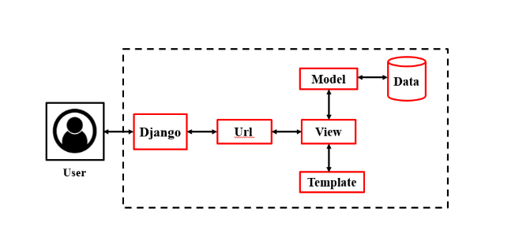

Fig 4.1 Architectural Design

**4.2 Flow Chart**

Login

Teacher

Student

Upload Assignment

View Marks

Enter Marks

View Assignments

Notice

View Notice

View Student List

Teacher List

View Submissions

Message

Inbox

**4.3 System Requirements**

**Hardware requirements**:

* Processor: Dual Core or higher
* Hard Drive: 500 GB or higher
* RAM: 2GB or higher
* Internet Connection: Preferred 1Mbps or higher

**Software requirements**:

* Front­End Design: HTML, CSS, JavaScript
* Back­End, Database: Python, Django, PostgreSQL
* Operating System: Windows 7 or higher
* Editor Tools: Pycharm
* Web Browser: Google Chrome

**Chapter 5**

**Results**

**Home Page:** It gives a general Information regarding to the website and users have to login or Signup to access the Website.

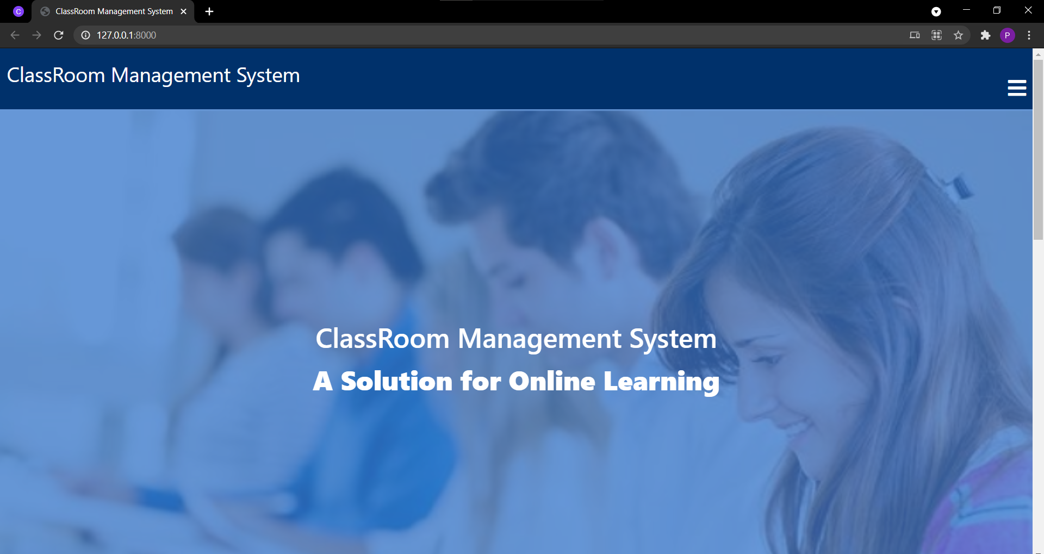

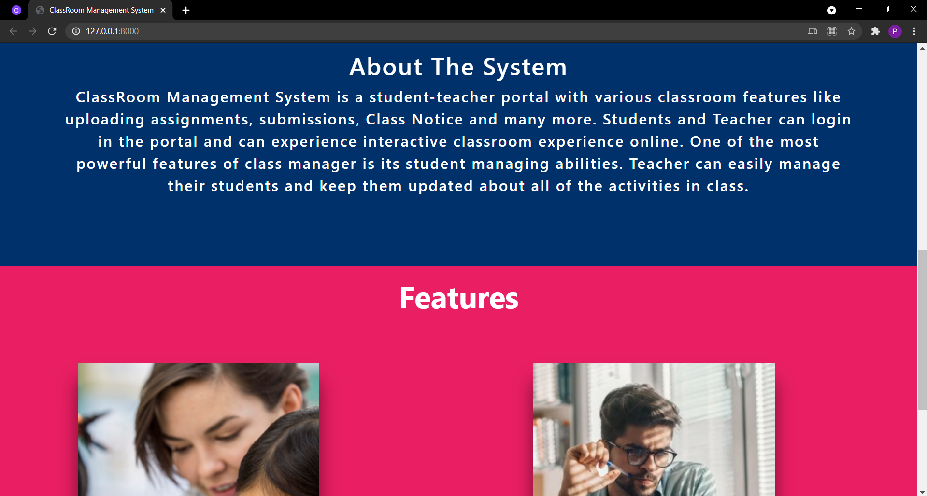

**Sign Up page:** There are two user’s option while signing up. One is for Student’s and one is for Teacher’s.

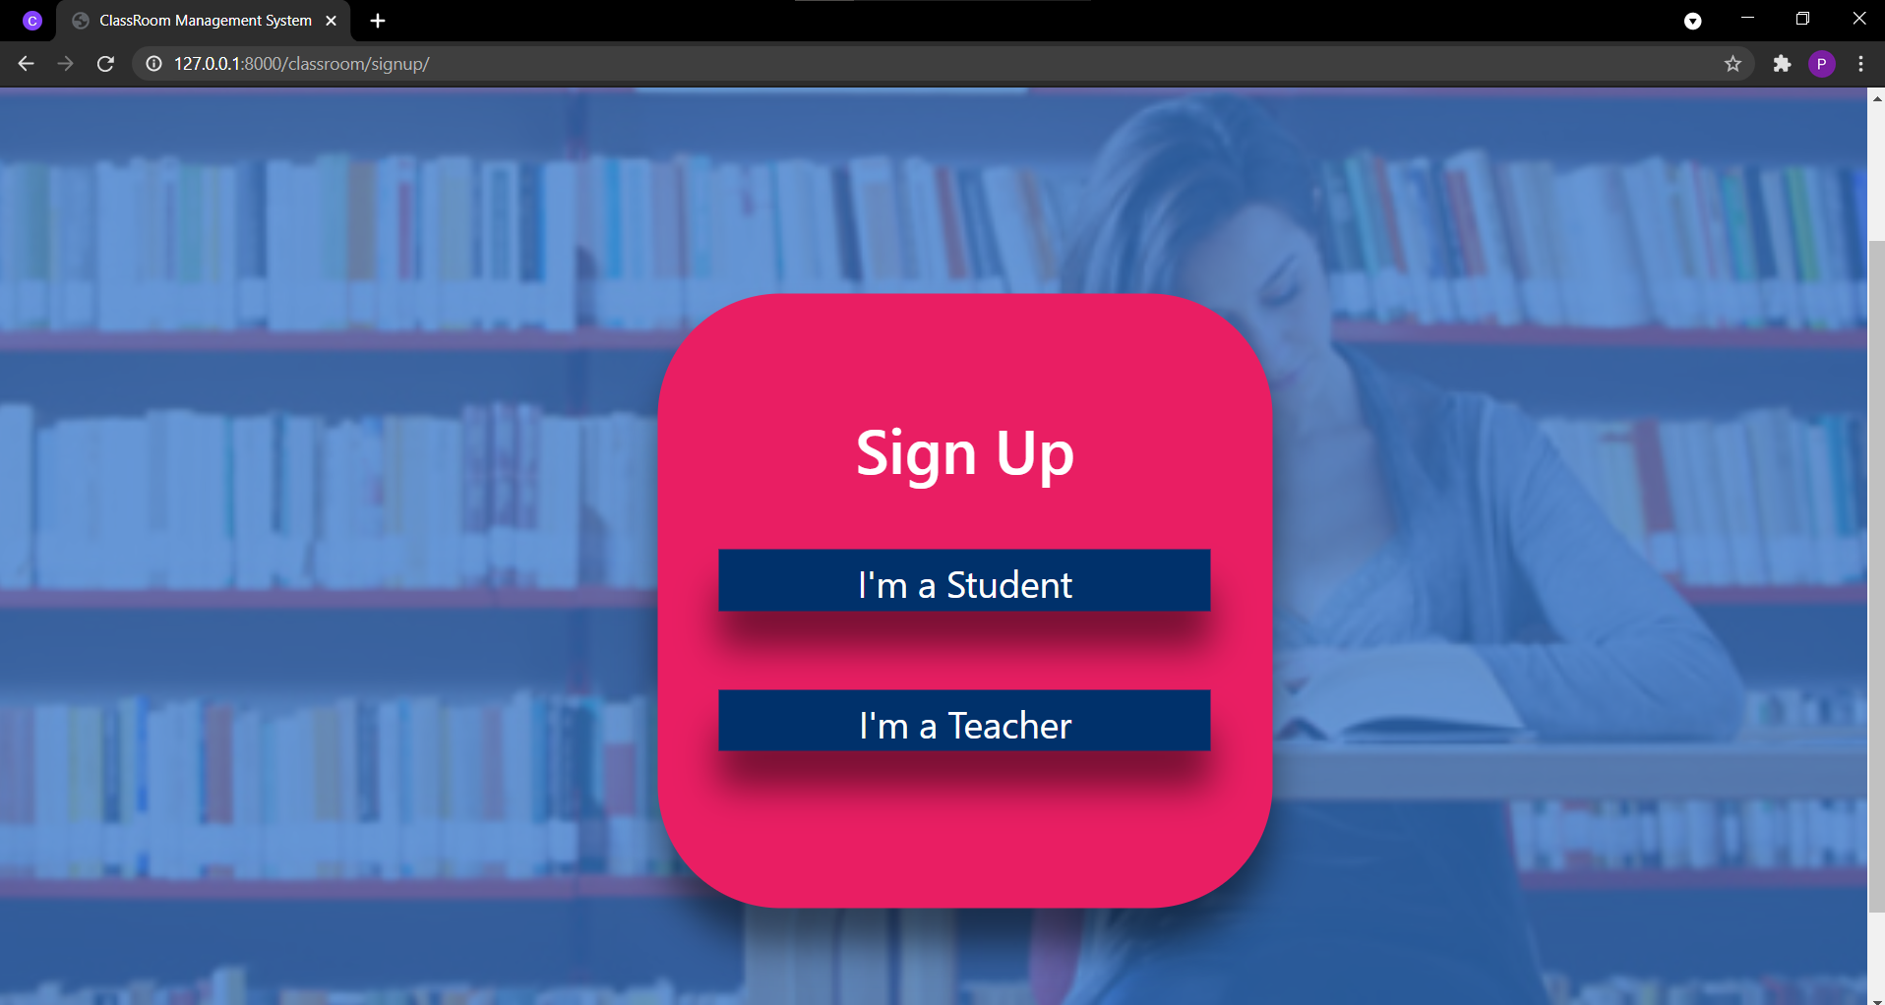

Both the user’s have to fill a form based on their category. User can register by giving their Name, Username, Email, and Password. All this data will be stored in the database.

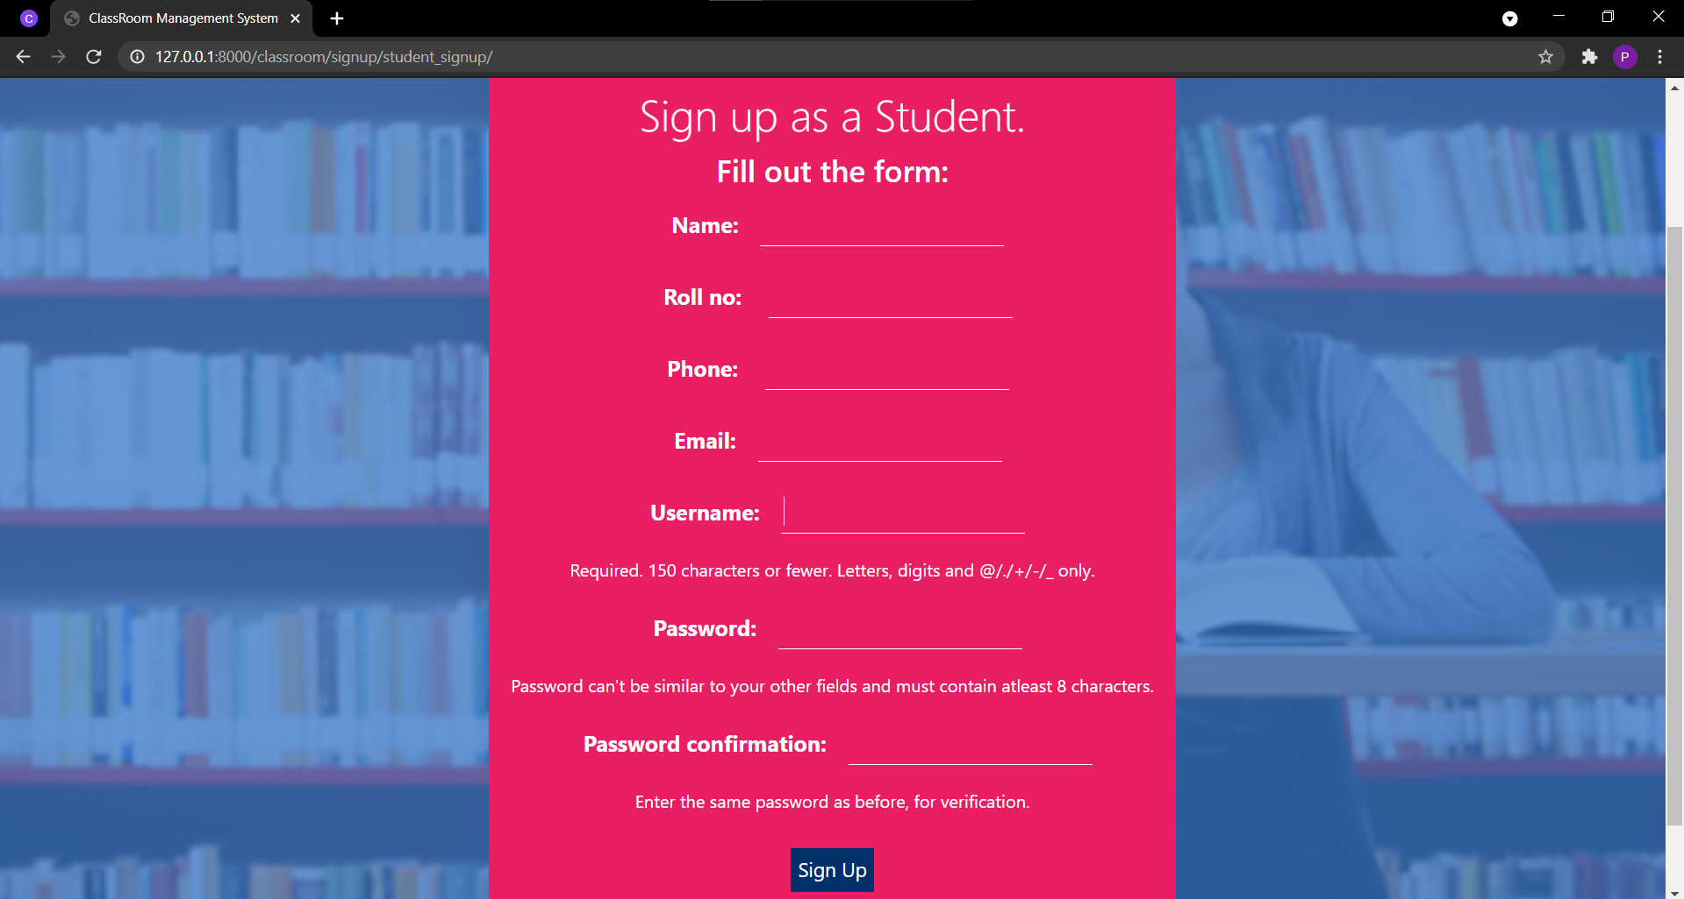

**Login page:** Already registered users can login directly with their username and password to access the website.

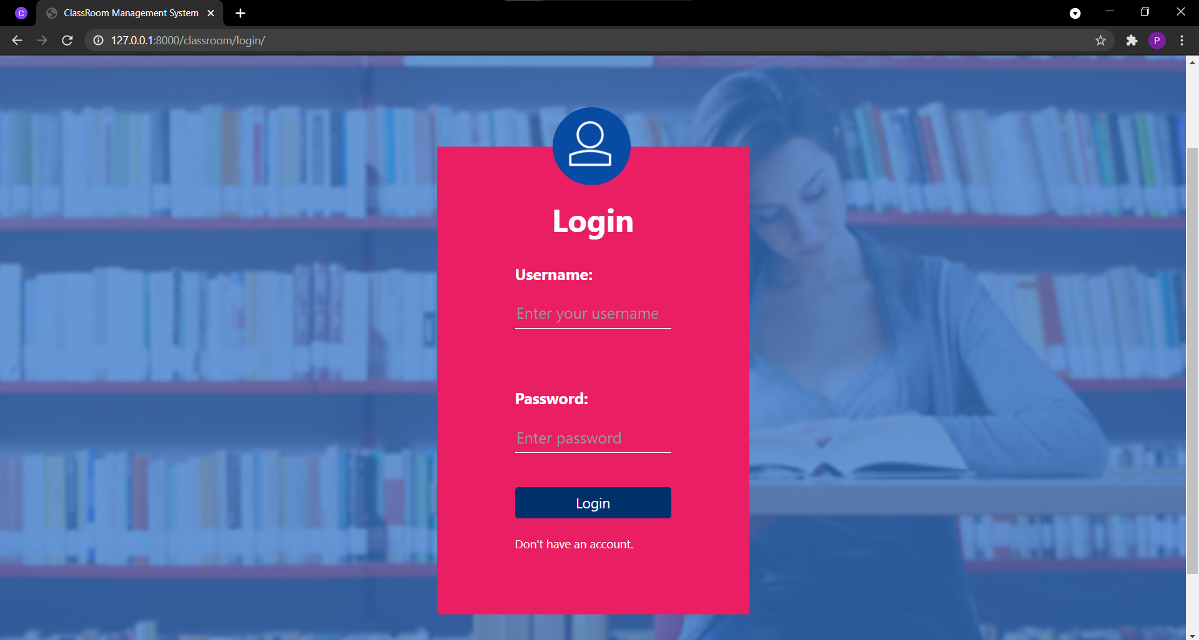

**Student Page:** For a login through a student’s account the following are the different functions/options provided. A student can access them based on their requirements.

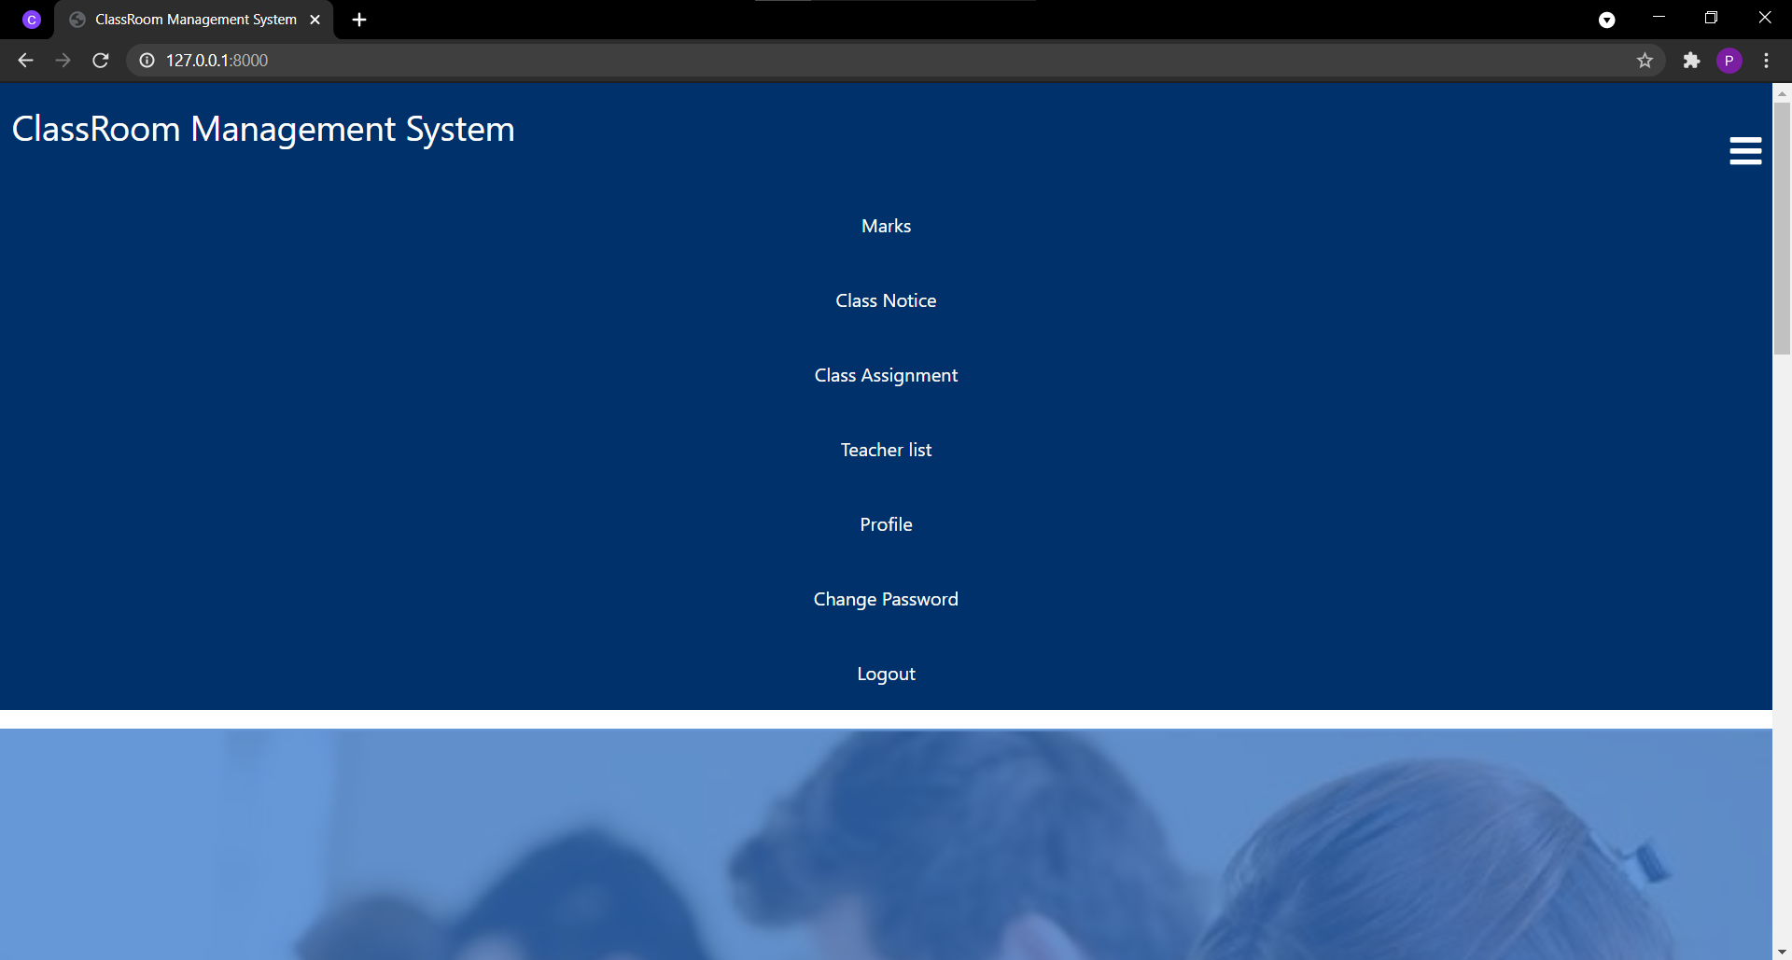

**Teacher Page:** For a login through a Teacher’s account the following are the different functions/options provided. A Teacher can access them based on their requirements.

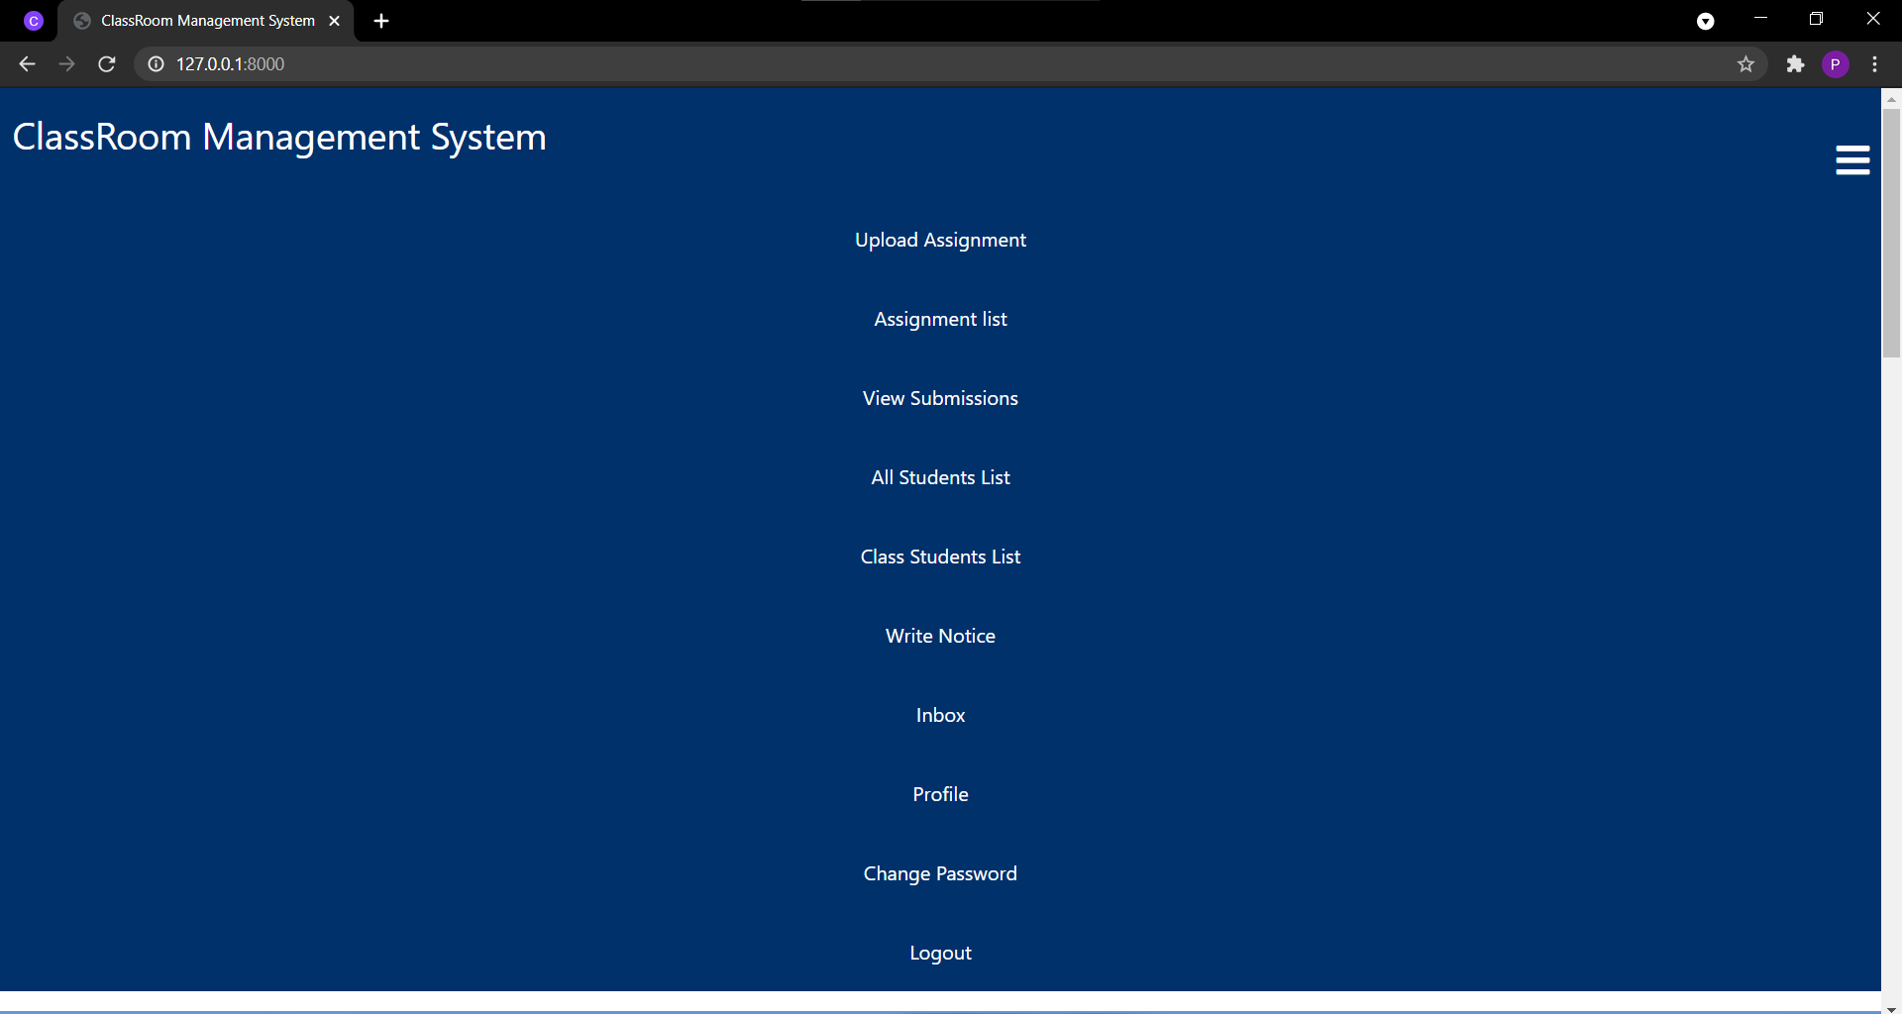

**Chapter 6**

**Conclusion and Future Scope**

**Conclusion:**

The goal of the project is to create a user friendly website and help

E -learning/ virtual learning by making it easy and efficient for students and teachers. Throughout this semester the team has decided and finalized the project topic and worked on its plan, design and how it has to be implemented while following the project guidelines. Approval and evaluation of the project was done online.

**Future Scope:**

In future we can expand this project by adding services like

* We can upgrade the system from web based to cloud based.
* We can group classes for one subject under one category.
* We can add a feature to grade marks automatically based on some experiments.
* Users can create separate rooms/groups for discussion on a particular topic.
* It will show every updated notice given by University authorities

**References**

**•**https://www.upgrad.com/blog/python­projects­ideas­topics­beginners/

• [www.w3schools.com](http://www.w3schools.com)

• https://django-sis.readthedocs.io/en/latest/

• <https://realpython.com/django­setup/>

• https://code-projects.org/school-management-system-using-django-framework/

**Papers Published/ Participations/ Awards**

1. <https://apps.aima.in/ejournal_new/articlesPDF/Arvind-Mahajan.pdf>
2. <https://files.eric.ed.gov/fulltext/EJ1066313.pdf>
3. https://www.ijrte.org/wp-content/uploads/papers/v7i6/F2613037619.pdf