Linear Data and Regression – Data Centers Report

Student Information
Author: < student name >
Email: login@purdue.edu
Section Number: ENGR 131 - ###

Part A: Power Used for Data Cooling Centers
< paste formatted chart here >

- What do SSE, SST and R2 tell you about the data for the two cooling technologies?
< type your response here>

- A colleague on your team suggests forcing both linear regression lines through the origin by checking Excel's "Set Intercept = 0.0" option. The chart is shown below.
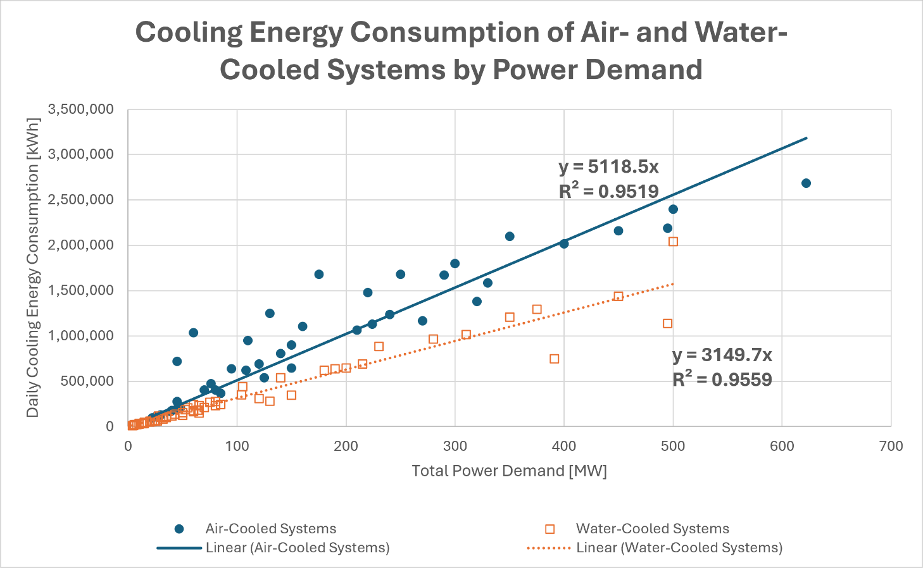
Review your original, unconstrained equations. Why does having a negative y-intercept make no physical sense for a data center?
< type your response here>

- In a water-scarce location, which cooling technology is more feasible? Explain your recommendation by outlining the specific environmental, energy, and resource trade-offs involved.
< type your response here>

Part B: Water Consumption in Cooling Data Centers
- Look at the slope of your Traditional cooling equation and your Direct-to-Chip cooling equation. What do these numbers physically tell us about how much water a data center consumes?
< type your response here>

- One of your teammates subtracted the Direct-to-Chip model from the Traditional model to create a single "Net Water Savings" equation:
$$∆Water Consumed \left[\frac{m^{3}}{d}\right]=9.95 [\frac{m^{3}}{d*MW}]*Power Demand [PW]$$
Explain how your teammate simplified the math to get that savings rate. Why is having a single, combined equation like this highly useful for an environmental engineer pitching an upgrade to a city council rather than showing them two separate equations?
< type your response here>

- Imagine a tech company is planning a new data center.
  - Using the combined net savings equation from Question 5, estimate how many cubic meters of water they will save every single day if they choose Direct-to-Chip cooling instead of Traditional cooling for the following total operating capacities:
    - 350 MW: <value>
    - 650 MW: <value>
  - Discuss why predicting water consumption [m³/d] using the linear model is highly risky based on the datasets and models that were provided.
< type your response here>

