Maritime Sensing and Perception Pipeline
  - Current implementation report for Samuel Yoon and the Maritime team
This report explains the processing pipeline that exists today, the purpose of each part, how data moves through it, and what its outputs mean. It describes the source at commit 999f1ac on feature/cv-raycast, reviewed on 4 November 2026. The working implementation begins with timestamped pixels and vehicle states. Live Arducam capture and raw sensor fusion are not yet connected.
The main result is a reproducible, source-independent pixel-to-GPS path with uncertainty and physical-instance identities. Its numerical core is synthetically tested. Completing the drone system requires measured sensor contracts, calibrated real observations, live adapters and deployment validation. The companion completion plan separates those additions from questions you can answer and experiments the team must run.

1 Current capabilities
Area | Current state
Processing core | Implemented and tested without ROS, GPU or camera hardware
Synthetic survey and replay | Implemented with seeded forward projection and withheld truth
Object motion model | Static position with optional random-walk process uncertainty
Real detector | Optional local-weights adapter exists; actual inference and trained accuracy unverified
ROS and Docker | Conversions, recorded replay node, launch and build candidates exist; runtime unexecuted
Physical mapping and GCS delivery | Camera and FCU acquisition, physical accuracy, GCS import and radio delivery remain open

Ordinary GNSS without RTK is the confirmed positioning direction. The camera remains a fixed Arducam IMX519, planned compute is a Jetson Orin Nano 8GB, and YOLO26n remains the detector baseline. Exact lens, focus, capture mode, FCU/firmware and target Jetson software combination are not verified in this implementation.
Three products stay distinct: an observation is one image-derived location measurement; a track estimates one physical object across observations; a survey map or report groups tracks for a consumer. An object location is not a boat waypoint. Existing boat and GCS runtime behavior was preserved.

2 Visual walkthrough
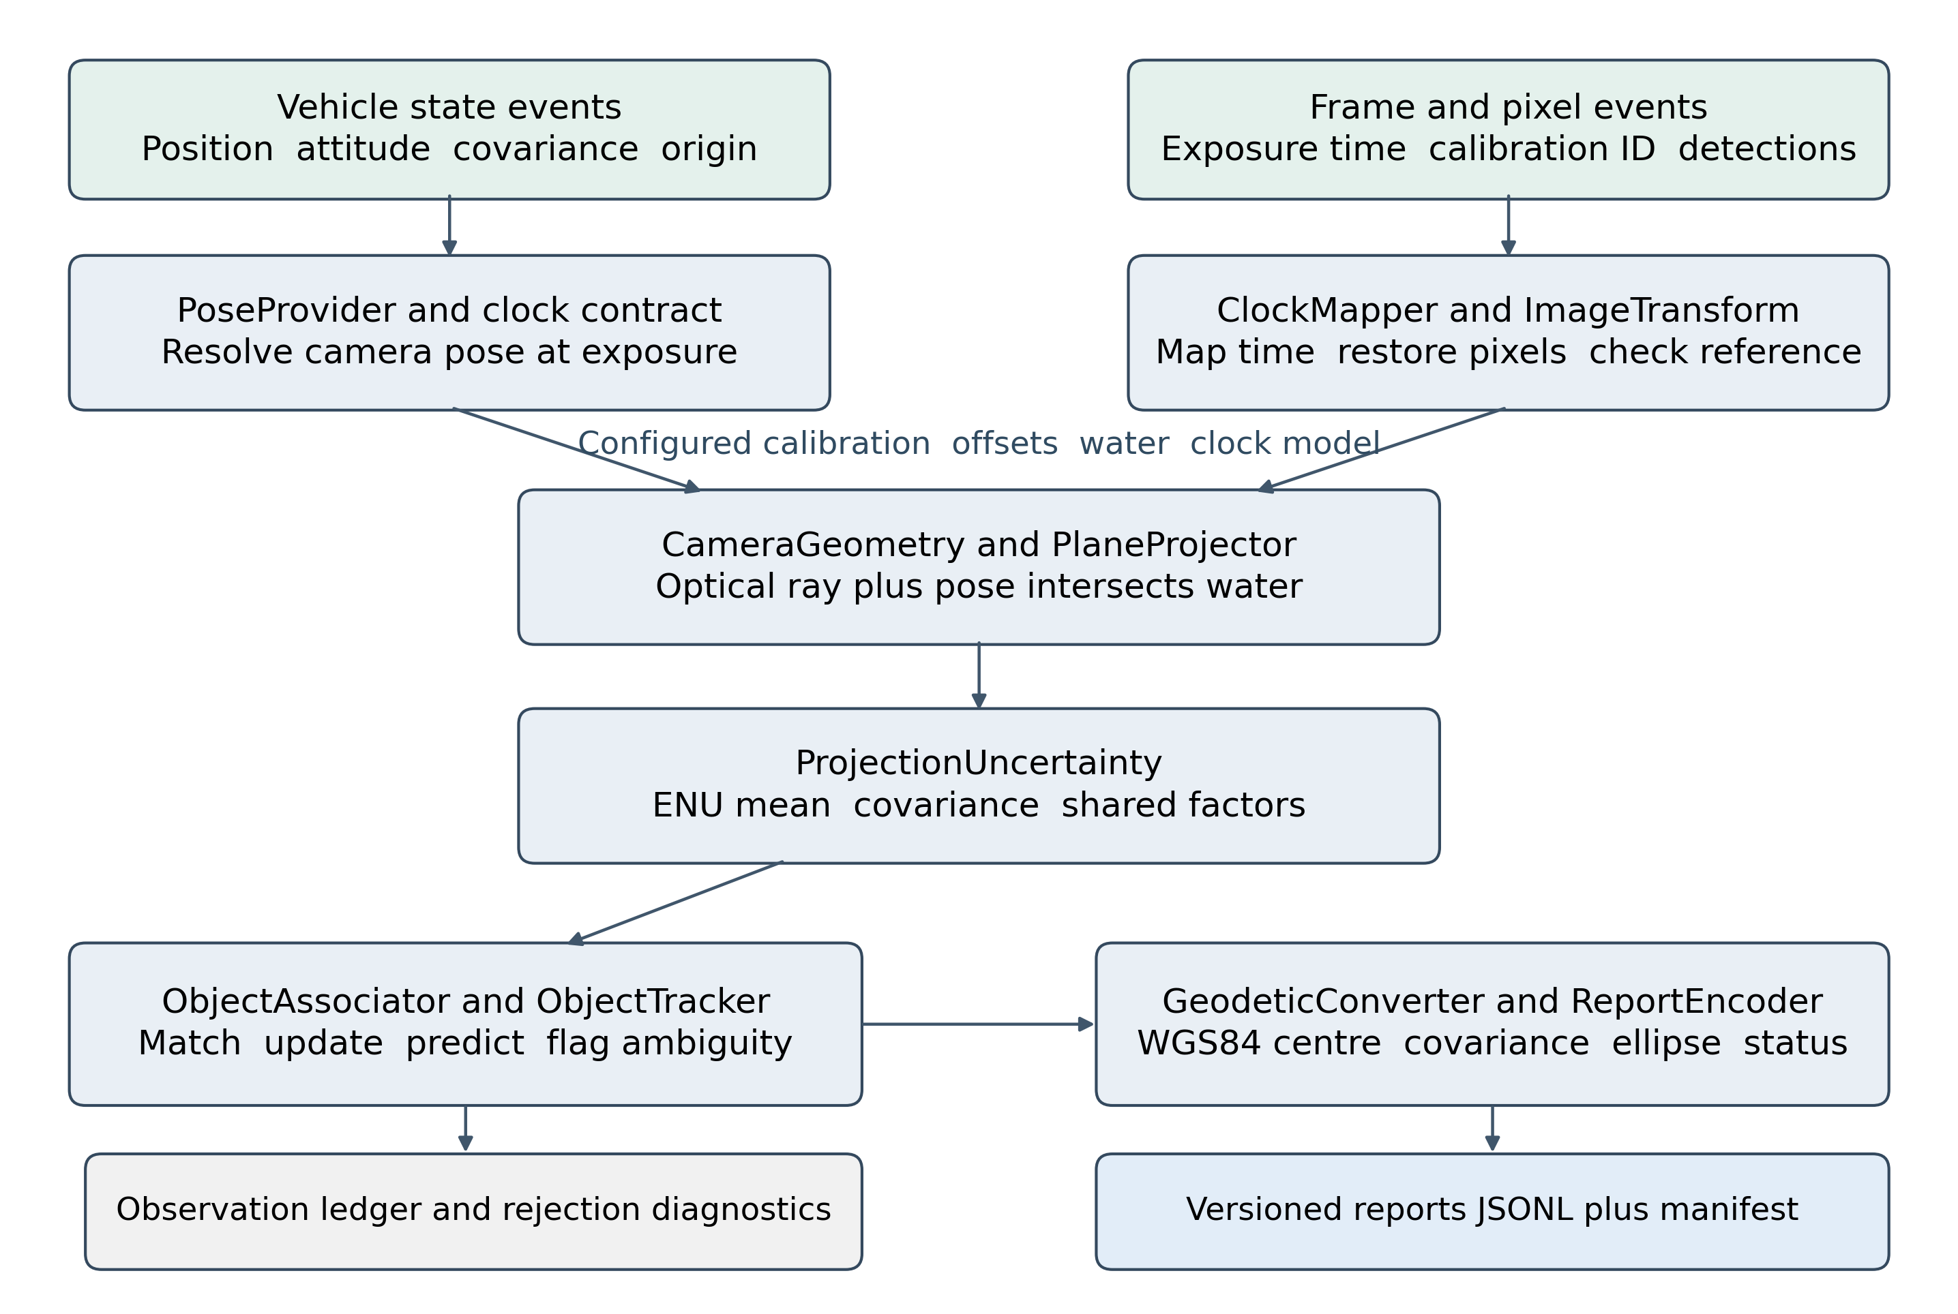
Figure 1 The current numerical path. Green inputs are source-neutral event contracts. Configuration supplies calibration, water and clock assumptions. Each class has a narrow role; these boxes are not separate ROS nodes.
The left branch establishes where the camera was and how it was oriented. The right branch establishes which calibrated pixel is being located and when its exposure occurred. Projection combines them. Uncertainty describes the observation before association decides which physical object it belongs to. Tracking then consolidates evidence, and geographic conversion happens at export.
Validity checks run throughout the path. An invalid observation contributes no new position. Previously established tracks can still appear as predictions or become stale; their status and last observation time distinguish those estimates from fresh observations. Errors whose timestamps cannot be interpreted are recorded separately instead of being given a substitute epoch.

3 Sources and truth isolation
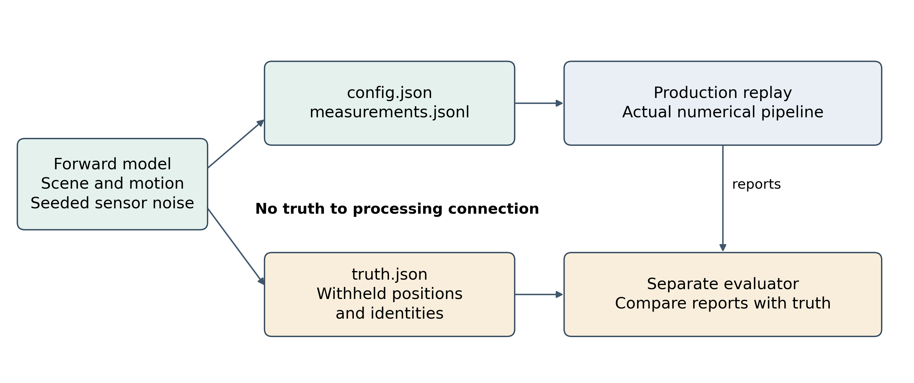
Figure 2 Synthetic generation and evaluation surround the production core. Known target coordinates are used to create pixels, then withheld. Only the separate evaluator compares reports with truth.
perception_synthetic.generator generates camera motion, noisy antenna states and image pixels through a forward camera model. It writes config.json and measurements.jsonl for processing, plus a separate truth.json for evaluation. The actual PerceptionPipeline consumes the first two files through replay_session. It never reads the scene targets or truth file. The evaluator runs after replay and uses detection correspondences to measure identity and position error.
This separation is important: the inverse path really reconstructs coordinates from measurements. It does not return the known target coordinates. Independent analytical projection and geodetic reference tests supplement forward/inverse tests, so matching bugs in a generator and inverse cannot be the only evidence of correctness.

4 Input and coordinate contracts
Record | Required meaning
VehicleState | Nanosecond measurement time; fixed origin and estimator epoch; ENU position; FLU body attitude; quaternion xyzw; ENU velocity and angular velocity; covariance decomposition; position, heading and height quality
Frame and detections | Exposure midpoint and publish times; source clock; frame and calibration IDs; raw or rectified image domain; image sizes; affine source-from-input map; pixel coordinates, covariance, class, ID and reference method
CameraCalibration | Resolution; fx, fy, cx, cy; five plumb_bob distortion terms; optical-to-body rotation; camera and antenna offsets; intrinsic and mount covariance; synthetic provenance
Water and clock configuration | Horizontal water elevation in the same ENU frame; uncertainty/model ID; explicit clock offset, drift, reference epoch and timing uncertainties

The local frame is survey_enu, measured in metres: East, North, Up. The body frame is forward, left, up. Optical coordinates are image right, image down and lens forward. Rotations have named directions. ENU yaw zero is East and increases toward North. A raw NED/FRD source requires a verified adaptation; a MAVROS-converted source must not be converted twice.
An input position explicitly refers to the body origin or GNSS antenna. The code uses that declaration to apply the camera and antenna lever arms once. A GNSS antenna position is not automatically the lens position. The origin is fixed for a session; subtracting a noisy launch fix does not make the map absolutely accurate.

5 Time and pose resolution

ClockMapper
ClockMapper maps a frame timestamp using a configured offset and drift relative to a reference timestamp. It carries declared independent and common clock uncertainty into projection. Unmapped clocks and invalid times are unavailable. The current vehicle-state contract already requires mapped survey_utc times; a live source adapter must establish that mapping rather than relabel FCU time.

VehicleState and PoseProvider
VehicleState.from_dict checks frames, position reference, quaternion, finite values, covariance and the required position/heading/height quality flags. PoseProvider stores a bounded state history, rejects unordered input, and requires an explicit new session when the estimator epoch changes. Origin inconsistencies and incompatible references cannot be silently interpolated.
For an exposure between two valid samples, position is interpolated and attitude is interpolated using SciPy SLERP. The provider requires both bracketing samples and a configured maximum gap. It does not fall back to the latest pose. Exact matching samples can be used directly. Numerical endpoint derivatives propagate pose uncertainty through interpolation; sample IDs preserve correlation when several observations reuse the same samples.
The stationary scenario uses a 0.21 s maximum pose gap and a 30 s history. These are synthetic settings, not flight acceptance values. The core does not create new reports continuously during complete input silence; prediction occurs when another frame epoch is processed. A live adapter needs scheduling, buffering and bounded waiting appropriate to actual detector latency.

6 Calibrated geometry

ImageTransform and target reference
ImageTransform restores detector coordinates to the calibrated source image using an explicit affine transform. It propagates pixel covariance through that transform and rejects mismatched calibration IDs, resolutions, singular transforms and out-of-bounds coordinates. This is where crop, resize, tile and letterbox conventions must be made consistent.
The current core accepts the declared reference_method water_centre. It does not independently find a waterline or infer buoy freeboard. That label is an input assertion requiring validation on real data. A box centre can move because of reflections, height, occlusion or shape. For overhead views, the bottom of a box is not generally the desired water-centre.

CameraGeometry and PlaneProjector
CameraGeometry uses OpenCV inverse distortion for raw plumb_bob pixels. For rectified pixels it uses the effective rectified intrinsics and does not undistort a second time. The optical ray is normalized before it is rotated into the world frame.
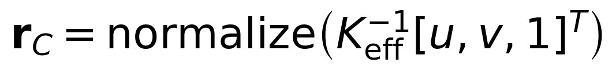
The camera pose combines the vehicle attitude and calibrated mount. With an antenna-referenced input, the camera origin follows the expression below. For a body-referenced input, only the camera lever arm is added.
PlaneProjector intersects the ray with the horizontal water plane. It returns the two horizontal ENU coordinates. The report later supplies the configured plane height as the third coordinate.
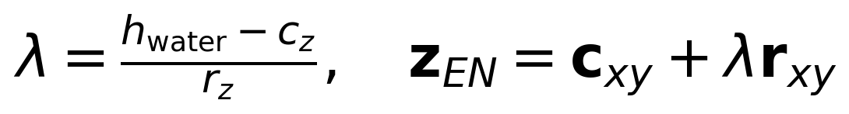
The analytic scenario gives a simple independent check. A level camera 4 m above water, with focal length 600 pixels and principal point (640,480), locates the centre pixel at ENU (0,0). For the stated downward mount, pixel (640,330) is 1 m East and pixel (790,480) is 1 m South. A 90 degree heading rotates those directions predictably. Separate tests also cover roll, pitch, mount rotation and antenna/camera offsets.
Projection rejects a camera below the surface, backward rays, near-horizon rays, nonfinite results and excessive range. The noisy scenario uses a minimum downward cosine of 0.25 and maximum range of 30 m. These are demonstration limits. Only horizontal water is implemented; arbitrary planes, waves and object-height corrections remain extensions to justify by measurements.

7 What uncertainty means
The output is a mean horizontal location plus a 2 by 2 East/North covariance in square metres. It is not YOLO class confidence, pixel scatter alone, or a guaranteed maximum error. The off-diagonal term describes correlated East/North error and determines ellipse orientation.

ProjectionUncertainty
ProjectionUncertainty numerically differentiates the actual projection function over 20 parameters: two pixel coordinates, six pose errors, four intrinsic parameters, six mount errors, water elevation and time offset. The timing derivative uses vehicle velocity and angular velocity. Covariance and shared factors are propagated through these derivatives at the current geometry.
The implementation distinguishes independent pixel/reference and timing residuals from named common errors. Pose-sample factors are shared whenever observations reuse a sample. Navigation, calibration, water and clock factors persist under their declared model IDs. Each named source is represented as a common unit-normal vector; different groups are assumed independent.
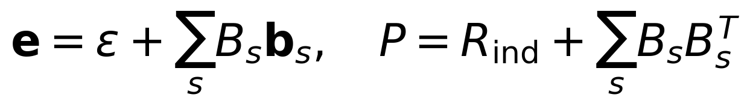
A factor is a sensitivity matrix, not an estimated bias. The code does not claim to discover the actual GNSS offset. Its covariance is a first-order approximation based on supplied priors. Full pose covariance can include position/attitude cross terms. Intrinsic/mount/water/clock group independence and the constancy of each model ID must be established by the input adapter.

Why repeated frames do not remove common GPS error
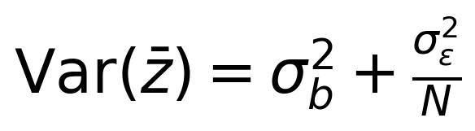
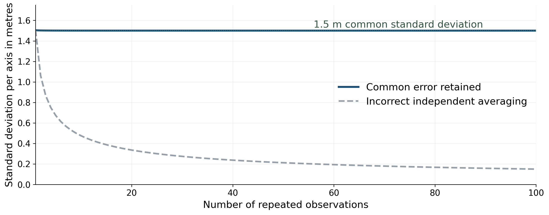
Figure 3 An illustrative repeated-view calculation with 1.5 m common standard deviation and 0.1 m independent noise per axis. The common component remains. This curve illustrates the model; it is not measured receiver performance or a reproduction of every tracker term.
Track updates carry the common factors forward instead of treating the total observation covariance as fresh independent noise on every frame. If a translation factor is identical in the track and the new observation, it remains identical after the update. Diverse viewing geometry can change other factor sensitivities; that does not make an unknown absolute translation observable by itself.
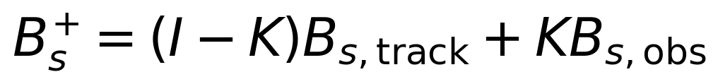

Probability ellipse
The 95 percent ellipse uses the two-dimensional chi-square quantile, approximately 5.99146. The covariance eigenvalues determine the semi-axis lengths; the major eigenvector determines orientation. Angles are radians counterclockwise from East, modulo pi. An isotropic covariance has no unique orientation, so the angle is null.
The report always sets coverage_validated to false. Current uncertainties omit uncalibrated distortion-coefficient error, freeboard/reference bias and rolling-shutter structure. Near-horizon nonlinear effects are rejected conservatively rather than explained away by a very long ellipse. Real coverage needs independent held-out reference observations and a measured correlation model.

8 Association and persistent identities

ObjectAssociator
Association asks whether a new observation belongs to an existing physical object of the same class. It uses a covariance-aware innovation and a Gaussian cost including squared Mahalanobis distance and a log determinant term. Matching compares the difference between track and observation factors. Shared errors that cancel in that difference do not unnecessarily inflate the gate between nearby objects.
The stationary configuration uses a 99.9 percent two-dimensional gate, corresponding to squared distance about 13.8155. The ObjectAssociator constructor default is 99 percent; the scenario overrides it. Neither gate probability is the probability that an identity is correct. Both require calibrated uncertainties and suitable clutter/missed-detection policies.
SciPy solves the assignment with explicit unmatched alternatives. When competing costs are too close under the configured ambiguity margin, observations are marked ambiguous and are not forced into a track or immediately turned into a duplicate identity. Unmatched observations can initiate tentative tracks. The current miss cost and ambiguity rule are simple baselines, not a fully calibrated detection/clutter likelihood model.

Track and ObjectTracker
Each track stores a two-dimensional mean, independent covariance, named factors, first/last observation times and observation count. The mean is static between measurements; optional random-walk uncertainty grows with elapsed time. The update uses the correlation-aware gain and a Joseph covariance expression while propagating every named factor.
The current scenario confirms an object after two observations, marks a track stale after 1.5 s without an observation, and permits at most 32 tracks. Staleness is distinct from association status. A stale track remains stored and can be considered for later association. There is no implemented deletion, retirement, automatic merge/split lineage, or cross-flight reidentification policy. Capacity exhaustion produces a rejection rather than silently reusing an ID.
These choices fit the stationary demonstration. Whether they fit moored buoys, a floating case or repeated surveys must be measured. Constant velocity, bounded mooring motion and multi-hypothesis tracking are possible future choices, not implemented capabilities.

9 Geographic reports and replay

GeodeticConverter
The converter uses PROJ WGS84 geodetic/ECEF/topocentric operations, with a fixed origin and explicitly ellipsoidal height. It converts the estimated centre at export rather than tracking latitude and longitude directly. Independent tests use an equatorial reference and a published PROJ example, supplemented by course-scale round trips.
The existing shared.geometry projection was preserved. At the documented synthetic comparison origin, the two methods differ by about 0.253 m over a 100 m North displacement. That is a projection-formula difference, not measured GNSS error. A deliberate GCS boundary must reconcile it before surveyed maps drive existing planning geometry.

ReportEncoder
ReportEncoder creates the maritime.track_report version 1 envelope. It validates JSON Schema, finite values, covariance symmetry/PSD and component consistency, ellipse derivation, unique IDs, timestamp ordering/age and ENU/WGS84 consistency. Required unknown covariance causes measurement rejection; it is not represented as zero uncertainty.
Field group | Purpose
Survey revision and source | Identify the survey snapshot and preserve explicit synthetic/recorded/hardware provenance
Frame and origin | Specify ENU axes, metres, covariance units and WGS84 origin
State and observation times | Separate state epoch, last supporting observation and publication time
Track state and status | Physical instance ID, class, centre, observation count, motion model and observed/predicted/stale status
Uncertainty | Independent/shared/total EN covariance, named factors, 95 percent ellipse and unvalidated coverage flag
Diagnostics and processing | Rejections, ambiguity/association decisions and calibration/software/backend identifiers

age_s is state_at minus last_observed_at. Publication lag is a different quantity. The current replay reports a state at the processed exposure epoch; it does not relabel that historical state as a current-time prediction. Consumers should inspect both state age and report lag.

Recording and replay
File | Role
config.json | Source mode, calibration, clocks, water, origin, uncertainty and processing limits; no target truth
measurements.jsonl | Timestamped source-neutral vehicle-state and frame/pixel events
truth.json | Separate forward-model/evaluator data; not needed by processing
reports.jsonl and observations.jsonl | Validated track snapshots and pre-tracking projected observations
replay_errors.jsonl | Rejected events that cannot produce a valid report epoch
manifest.json and evaluation.json | Checksums/runtime provenance and separately computed error/identity/freshness metrics

Replay refuses to overwrite a nonempty output directory. Checksums cover processing inputs, outputs and source files, and the manifest records package versions. This is sufficient to reproduce the current annotated-pixel path. It is not yet a live asynchronous recorder for raw camera images, raw IMU and full FCU transport data.

10 Demonstrated behavior
The following results were recorded during implementation of this exact source snapshot and are retained in README and local ignored run evidence. This report rechecked source and outputs; it does not claim additional physical experiments.
Measurement | Recorded result
Core and conversion tests | 74 drone tests passed
Existing GCS regression checks | 11 workspace tests passed
Analytic case | Three known horizontal positions recovered exactly
Noisy stationary survey | 61 reports; three confirmed identities; zero switches, fragmentations or mixed-identity tracks
Position error under configured GPS offset | Median 0.807757 m; p95 0.817358 m; maximum 0.821363 m
Shared horizontal uncertainty | Minimum final shared covariance eigenvalues remained above 2.25 m²
Invalid and ambiguous inputs | Three invalid-input cases rejected; two observations marked ambiguous
Freshness behavior | Predicted and stale states occurred; all final tracks stale after deliberately missing bracketing pose
Reproducibility and packaging | Byte-identical replay in a separate process/hash seed, truth-free replay test, non-editable package build/install and packaged analytic demo passed

The synthetic source contains a fixed +0.7 m East and −0.4 m North GNSS offset, 1.5 m common horizontal standard deviation, noisy pose samples, raw pixel noise, changing camera heading, temporary misses and injected invalid data. Pixel and sensor assumptions are explicitly synthetic. Error statistics use pure confirmed tracks. Single-run region containment is not an independent statistical coverage result.
The configured published timestamps are 150 ms after exposure. That is simulated metadata, not a measured inference or end-to-end performance benchmark. The known horizontal offset remaining in estimates is expected behavior: the pipeline retains uncertainty rather than pretending to correct an unobservable offset.
The following is a selected, rounded excerpt from report revision 60, before the final stale-input case. The GPS coordinates are fixture outputs, not measured buoy locations.
{
"id": "object_0001",
"state_at": "2026-11-04T15:00:23.650000000Z",
"position_wgs84": {
"latitude_deg": 39.99999634315492,
"longitude_deg": -85.9999987936392
},
"uncertainty": {
"covariance_en_m2": [
[
2.250153,
1e-05
],
[
1e-05,
2.250138
]
],
"ellipse_en": {
"probability": 0.95,
"semi_major_m": 3.671749,
"semi_minor_m": 3.671729,
"angle_ccw_from_east_rad": 0.460154
},
"coverage_validated": false
},
"estimate_status": "observed",
"association_status": "confirmed"
}
This is a partial, rounded track record, not a complete report envelope or validation fixture. The full report also contains factors, frame/origin, publication time, quality and processing metadata.

11 Runtime and replacement boundaries
The tested runtime is Linux x86_64 with Python 3.12.14, NumPy 2.2.6, SciPy 1.17.0, OpenCV headless 4.12.0.88, pyproj 3.7.2 and jsonschema 4.25.1. Pinned SciPy and pyproj require Python 3.11 or later. This does not select a supported Jetson/JetPack/ROS stack.
The core uses OpenCV plus a narrow analytic horizontal-plane intersection because ROS/IPM/image_geometry/tf2 were unavailable. SciPy supplies rotations/SLERP, statistical scaling, linear solves and assignment. PROJ supplies geodesy. Full IPM/tf2 evaluation remains open; the existing fallback is not evidence that a ROS projector was tested.
The optional ROS node replays recorded events through the same pipeline and publishes JSON on /drone/perception/report using std_msgs/String. It is not a live FCU/camera subscriber or a radio protocol. Structural Odometry/Detection2D conversion helpers are tested without ROS. The Odometry helper requires verified ENU/FLU conventions and a verified residual/shared covariance decomposition so common GNSS error is not added twice.
The optional UltralyticsDetector accepts existing local weights, preserves frame metadata and emits source-image box centres. No weights download or synthetic fallback occurs. Its default reference is unvalidated and the geolocator rejects it. Successful deployment requires an empirically justified reference estimator/policy, not simply changing that string. Actual inference and water-object training were not exercised.
CPU and desktop ROS Jazzy Dockerfiles and a launch path are provided, but Docker, colcon, DDS, ROS launch, GPU/Jetson behavior and physical sensors did not run. The GCS importer still expects its existing object-map format and does not consume this report schema. File delivery is the first intended boundary; radio transport and mission updates remain separate work.
The current prototype retains track factors and frame IDs across a survey, has no track retirement policy, and writes replay outputs synchronously. Pose history is bounded but the full long-session state is not yet production-bounded. A live implementation needs memory/queue limits, overload behavior, delayed-measurement policy, storage handling and restart semantics.

12 Run and inspect
Run from the repository root using uv, a new Python 3.12 environment and empty output directories. Commands follow the user’s uv-only workflow. See README for Docker and ROS candidates.
uv venv --python 3.12 .venv
uv pip install --python .venv/bin/python -r drone/requirements-test.txt ./drone
uv run --no-project --python .venv/bin/python python -m perception_synthetic.demo \
--adapter synthetic --scenario stationary \
--output simulation/logs/perception/stationary-demo
uv run --no-project --python .venv/bin/python python -m perception_synthetic.demo \
--adapter synthetic --scenario analytic \
--output simulation/logs/perception/analytic-demo
uv run --no-project --python .venv/bin/python python -m maritime_perception.replay \
--session simulation/logs/perception/stationary-demo/session \
--output simulation/logs/perception/stationary-replay
uv run --no-project --python .venv/bin/python python -m pytest drone/tests -q
uv run --no-project --python .venv/bin/python python -m unittest discover -s gcs/tests \
-p test_workspace.py -v
Inspect evaluation.json and result/reports.jsonl together. Check the survey/source flags, shared covariance, last-observation time, state epoch, diagnostic reasons and identity count. A small local scatter or many repeated observations should never be taken as proof of small absolute GPS error.

13 Source references
Source links remain pinned to reviewed implementation commit 999f1ac. Commands were updated for uv; the companion completion plan retains the same implementation and validation boundaries.
Snapshot and commit
README commands and recorded validation
Pipeline orchestration
Camera and plane geometry
Clock and pose resolution
Uncertainty propagation
Association and static tracking
Report encoder and validation
Report JSON Schema
Synthetic forward source
Withheld evaluator
Tasks and remaining acceptance
Maintained working context

