Extension DCR Web Service

A web service has been made available to access read-only information for use on Extension web sites. The web service provides methods to access Files, Images, Item Details, Static Item Details, Expanded Item details, a Site Menu, and the Home ID for a given URL.

# Retrieve Item Details

A web service method is available at  [https://ag.purdue.edu/api/DepotWS /Item.ashx](https://site/Item.ashx) that enables users to retrieve details on an Item in the system. In order to retrieve these details, the user needs to submit a request to the web service with the following parameters:

|  |  |  |  |
| --- | --- | --- | --- |
| Parameter | Data Type | Required | Description |
| t | String | Yes | This should be set to “d”. |
| i | Integer | Yes | Item ID |
| callback | String | No | The callback JavaScript method for Cross-Domain AJAX requests, if overriding jQuery defaults |

The web service will attempt to find an Item with the ID provided (“i”) that is ready for display. If the Item is set to be published at the time of the request, it will be returned to the user as a JSON object with the following properties:

|  |  |  |
| --- | --- | --- |
| Property Name | Data Type | Description |
| strAuthorAlias | String | The username for the Author |
| strAuthorName | String | The Full Name of the Author |
| strTitle | String | The Title of the Item |
| datCreated | Date/Time | The date the Item was created |
| blnANR | Boolean |  |
| blnECD | Boolean |  |
| bln4H | Boolean | A flag indicating if the Item is a 4-H Item |
| blnHHS | Boolean |  |

If the Item with the ID provided in is not set to be published at the time of the request, or no such item exists, then an empty JSON object will be returned instead.

## JSON Returned

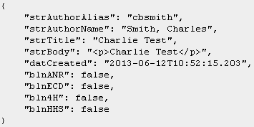

If JSONP is used to create a cross-domain AJAX request, then the JSON object will be surrounded with a JavaScript method with the name passed in the “callback” parameter. Normally, jQuery should handle stripping this extra information and returning just the JSON object.

## Example Call

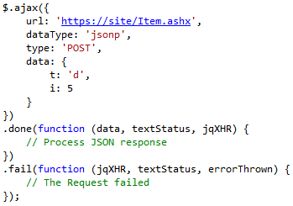

# Retrieve Expanded Item Details

A web service method is available at  [https://ag.purdue.edu/api/DepotWS /Item.ashx](https://site/Item.ashx) that enables users to retrieve the expanded details on an item in the system. In order to retrieve these expanded details, the user needs to submit a request to the web service with the following parameters:

|  |  |  |  |
| --- | --- | --- | --- |
| Parameter | Data Type | Required | Description |
| t | String | Yes | This should be set to “e”. |
| i | Integer | Yes | Item ID |
| callback | String | No | The callback JavaScript method for Cross-Domain AJAX requests, if overriding jQuery defaults |

The web service will attempt to find an Item with the ID provided (“i”) that is ready for display. If the Item is set to be published at the time of the request, it will be returned to the user as a JSON object with the following properties:

|  |  |  |
| --- | --- | --- |
| Property Name | Data Type | Description |
| Files | List<ItemFile> | List of Files |
| Videos | List<ItemVideo> | List of Videos |
| Images | List<ItemImage> | List of Images |
| Links | List<ItemRelatedLink> | List of Links |

Each ItemFile object will have the following structure:

|  |  |  |
| --- | --- | --- |
| Property Name | Data Type | Description |
| intItemID | Integer | The ID of the item |
| intFileID | Integer | The ID of the file |
| strLinkText | String | The text of the link |

Each ItemVideo object will have the following structure:

|  |  |  |
| --- | --- | --- |
| Property Name | Data Type | Description |
| intItemID | Integer | The ID of the item |
| intVideoID | Integer | The ID of the video |
| strLinkText | String | The text of the link |
| strVideoTitle | String | The title of the video |

Each ItemImage object will have the following structure:

|  |  |  |
| --- | --- | --- |
| Property Name | Data Type | Description |
| intItemID | Integer | The ID of the item |
| intImageID | Integer | The ID of the image |
| strCaption | String | The caption of the image |
| strAltText | String | The alternate text of the image |
| strPosition | String | The position of the image |

Each ItemRelatedLink object will have the following structure:

|  |  |  |
| --- | --- | --- |
| Property Name | Data Type | Description |
| intRelatedLinkID | Integer | The ID of the related link |
| intOrder | Integer | The order of the link |
| strLinkURL | String | The URL link |
| strLinkText | String | The text of the URL link |
| blnNewWindow | Boolean | True/False if the link should open up in a new window |
| intItemID | Integer | The ID of the item |

If the Item with the ID provided does not exist, then an empty JSON object will be returned instead.

## JSON Returned

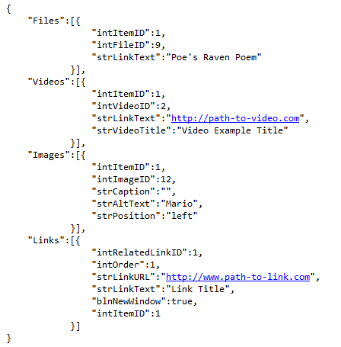

If JSONP is used to create a cross-domain AJAX request, then the JSON object will be surrounded with a JavaScript method with the name passed in the “callback” parameter. Normally, jQuery should handle stripping this extra information and returning just the JSON object.

## Example Call

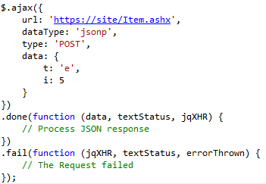

# Retrieve Static Item Details

A web service method is available at  [https://ag.purdue.edu/api/DepotWS /Item.ashx](https://site/Item.ashx) that enables users to retrieve details on Static Content in the system. In order to retrieve these details, the user needs to submit a request to the web service with the following parameters:

|  |  |  |  |
| --- | --- | --- | --- |
| Parameter | Data Type | Required | Description |
| t | String | Yes | This should be set to “s”. |
| i | Integer | Yes | Static Content ID |
| callback | String | No | The callback JavaScript method for Cross-Domain AJAX requests, if overriding jQuery defaults |

The web service will attempt to find Static Content with the ID provided (“i”). If the Static Content exists, it will be returned to the user as a JSON object with the following properties:

|  |  |  |
| --- | --- | --- |
| Property Name | Data Type | Description |
| strTitle | String | The Title of the Static Content |
| strBody | String | The Body text of the Static Content |

If Static Content with the ID provided does not exist, then an empty JSON object will be returned instead.

## JSON Returned

## 

If JSONP is used to create a cross-domain AJAX request, then the JSON object will be surrounded with a JavaScript method with the name passed in the “callback” parameter. Normally, jQuery should handle stripping this extra information and returning just the JSON object.

## Example Call

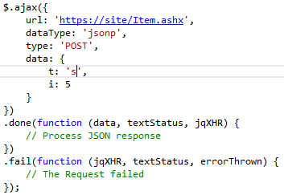

# Retrieve Expanded Static Item Details

A web service method is available at  [https://ag.purdue.edu/api/DepotWS /Item.ashx](https://site/Item.ashx) that enables users to retrieve expanded details on Static Content in the system. In order to retrieve these details, the user needs to submit a request to the web service with the following parameters:

|  |  |  |  |
| --- | --- | --- | --- |
| Parameter | Data Type | Required | Description |
| t | String | Yes | This should be set to “c”. |
| i | Integer | Yes | Static Content ID |
| callback | String | No | The callback JavaScript method for Cross-Domain AJAX requests, if overriding jQuery defaults |

The web service will attempt to find Static Content with the ID provided (“i”). If the Static Content exists, it will be returned to the user as a JSON object with the following properties:

|  |  |  |
| --- | --- | --- |
| Property Name | Data Type | Description |
| Files | List<StaticFile> | List of Files |
| Videos | List<StaticVideo> | List of Videos |
| Images | List<StaticImage> | List of Images |

Each StaticFile object will have the following structure:

|  |  |  |
| --- | --- | --- |
| Property Name | Data Type | Description |
| intStaticContentID | Integer | The ID of the static content |
| intFileID | Integer | The ID of the file |
| strLinkText | String | The text of the link |

Each StaticVideo object will have the following structure:

|  |  |  |
| --- | --- | --- |
| Property Name | Data Type | Description |
| intStaticContentID | Integer | The ID of the static content |
| intVideoID | Integer | The ID of the video |
| strLinkText | String | The text of the link |
| strTitle | String | The title of the video |

Each StaticImage object will have the following structure:

|  |  |  |
| --- | --- | --- |
| Property Name | Data Type | Description |
| intStaticContentID | Integer | The ID of the static content |
| intImageID | Integer | The ID of the image |
| strCaption | String | The caption of the image |
| strAltText | String | The alternate text of the image |
| strPosition | String | The position of the image |

If the Item with the ID provided does not exist, then an empty JSON object will be returned instead.

## JSON Returned

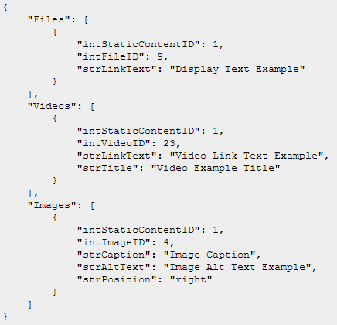

If JSONP is used to create a cross-domain AJAX request, then the JSON object will be surrounded with a JavaScript method with the name passed in the “callback” parameter. Normally, jQuery should handle stripping this extra information and returning just the JSON object.

## Example Call

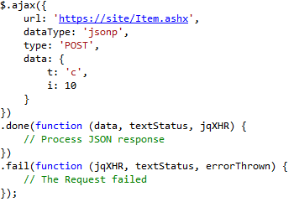

# Retrieve Item Blurb List

A web service method is available at  [https://ag.purdue.edu/api/DepotWS /Item.ashx](https://site/Item.ashx) that enables users to retrieve the item blurb list by the current home. In order to retrieve these details, the user needs to submit a request to the web service with the following parameters:

|  |  |  |  |
| --- | --- | --- | --- |
| Parameter | Data Type | Required | Description |
| t | String | Yes | This should be set to “b”. |
| i | Integer | Yes | The ID of the Current Home |
| callback | String | No | The callback JavaScript method for Cross-Domain AJAX requests, if overriding jQuery defaults |

The web service will attempt to find an Item with the ID provided (“i”) that is ready for display. If the Item is set to be published at the time of the request, it will be returned to the user as a JSON array object with the following properties:

|  |  |  |
| --- | --- | --- |
| Property Name | Data Type | Description |
| intItemID | Integer | Item ID |
| strTitle | String | Title of Item |
| strShortBody | String | Short Body text of Item |

If the Item with the ID provided does not exist, then an empty JSON object will be returned instead.

## JSON Returned

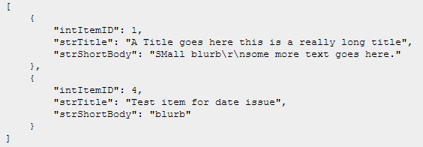

## Example Call

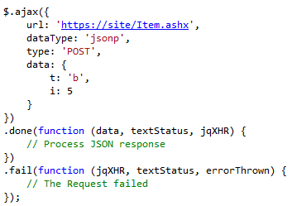

# Retrieve Item Blurb Expanded

A web service method is available at  [https://ag.purdue.edu/api/DepotWS /Item.ashx](https://site/Item.ashx) that enables users to retrieve the expanded item blurb details list for the current home and a category/subcategory. In order to retrieve these details, the user needs to submit a request to the web service with the following parameters:

|  |  |  |  |
| --- | --- | --- | --- |
| Parameter | Data Type | Required | Description |
| t | String | Yes | This should be set to “x”. |
| i | Integer | Yes | The ID of the current home |
| c | Integer | Yes | The ID of the category. -1 for subcategory |
| s | Integer | Yes | The ID of the subcategory. -1 for category |
| callback | String | No | The callback JavaScript method for Cross-Domain AJAX requests, if overriding jQuery defaults |

The web service will attempt to find a list of Items with the ID of the current home provided (“i”) that is ready for display. If the Items are set to be published at the time of the request, it will be returned to the user as a JSON array object with the following properties:

|  |  |  |
| --- | --- | --- |
| Property Name | Data Type | Description |
| intItemID | Integer | Item ID |
| blnANR | Boolean |  |
| blnECD | Boolean |  |
| bln4H | Boolean | A flag indicating if the Item is a 4-H Item |
| blnHHS | Boolean |  |
| blnHasVideos | Boolean | Boolean stating if Item has videos |
| blnHasFiles | Boolean | Boolean stating if Item has files |

If the Item with the ID provided does not exist, then an empty JSON object will be returned instead.

## JSON Returned

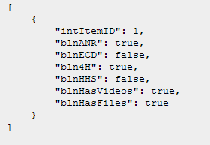

## Example Call

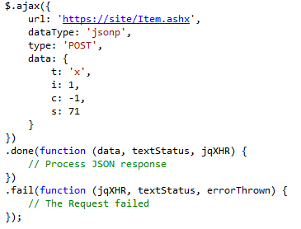

# Retrieve Home ID

A web service method is available at  [https://ag.purdue.edu/api/DepotWS /Home.ashx](https://site/Home.ashx) that enables users to retrieve details of a Home object with a given URL. In order to retrieve these details, the user needs to submit a request to the web service with the following parameters:

|  |  |  |  |
| --- | --- | --- | --- |
| Parameter | Data Type | Required | Description |
| t | String | Yes | This should be set to “h”. |
| u | String | Yes | Request URL |
| callback | String | No | The callback JavaScript method for Cross-Domain AJAX requests, if overriding jQuery defaults |

The web service will attempt to find a Home object with the URL provided (“u”). If the Home object exists, it will be returned to the user as a JSON object with the following properties:

|  |  |  |
| --- | --- | --- |
| Property Name | Data Type | Description |
| intHomeID | Int | The ID of the Home Object |
| strHomeName | String | The Name of the Home Object |
| strPublicURLRoot | String | The Public URL Root of the Home Object |
| strGoogleSearchID | String | The Google Search ID of the Home Object |
| strGoogleSearchResultsURL | String | The Google Search Results URL of the Home Object |

If a Home object with the URL provided does not exist, then an empty JSON object will be returned instead.

## JSON Returned

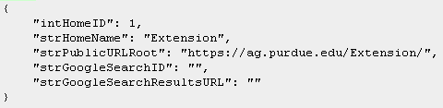

## Example Call

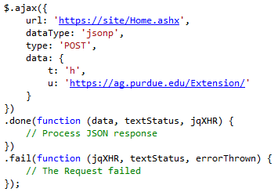

# Retrieve Social Media Links

A web service method is available at  [https://ag.purdue.edu/api/DepotWS /Home.ashx](https://site/Home.ashx) that enables users to retrieve the social media links for a home object. In order to retrieve these links, the user needs to submit a request to the web service with the following parameters:

|  |  |  |  |
| --- | --- | --- | --- |
| Parameter | Data Type | Required | Description |
| t | String | Yes | This should be set to “s”. |
| i | Integer | Yes | The ID of the Home object to search for |
| callback | String | No | The callback JavaScript method for Cross-Domain AJAX requests, if overriding jQuery defaults |

The web service will attempt to find a Home object with the ID provided (“i”). If the Home object exists, all of its social media links will be returned to the user as a list of JSON objects with the following properties:

|  |  |  |
| --- | --- | --- |
| Property Name | Data Type | Description |
| intSocialMediaID | Integer | The ID of the social media link |
| strSocialMediaName | String | The name of the social media link |
| strSocialMediaURL | String | The URL of the social media link |

If an object with the home ID provided does not exist, then an empty JSON object will be returned instead.

## JSON Returned

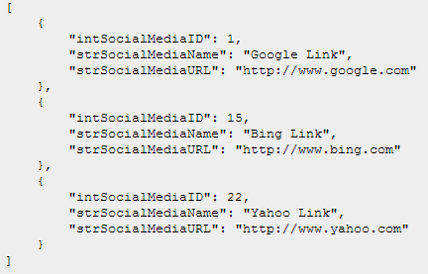

## Example Call

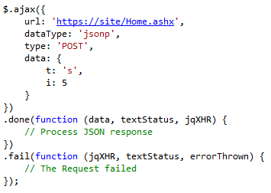

# Retrieve Relevant Links

A web service method is available at  [https://ag.purdue.edu/api/DepotWS /Home.ashx](https://site/Home.ashx) that enables users to retrieve the relevant links for a home object. In order to retrieve these links, the user needs to submit a request to the web service with the following parameters:

|  |  |  |  |
| --- | --- | --- | --- |
| Parameter | Data Type | Required | Description |
| t | String | Yes | This should be set to “r”. |
| i | Integer | Yes | The ID of the Home object to search for |
| c | Integer | Yes | The ID of the category. -1 for subcategory |
| s | Integer | Yes | The ID of the subcategory. -1 for category |
| callback | String | No | The callback JavaScript method for Cross-Domain AJAX requests, if overriding jQuery defaults |

The web service will attempt to find a list of relevant links with the ID of the current home provided (“i”) that is ready for display. If the Items are set to be published at the time of the request, it will be returned to the user as a JSON array object with the following properties:

|  |  |  |
| --- | --- | --- |
| Property Name | Data Type | Description |
| intLinkID | Integer | ID of the Link |
| strLinkURL | String | URL of the Link |
| strLinkText | String | Display text of the Link |
| blnNewWindow | Boolean | A flag indicating if the link opens in new window |
| intHomeID | Integer | ID of the related Home |

If an object with the home ID provided does not exist, then an empty JSON object will be returned instead.

## JSON Returned

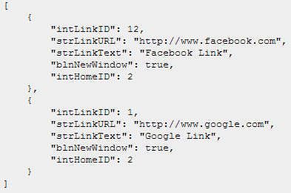

## Example Call

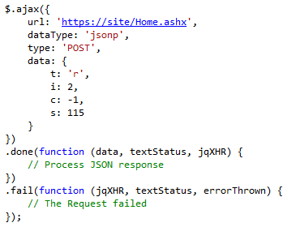

# Retrieve Menu

A web service method is available at  [https://ag.purdue.edu/api/DepotWS /Menu.ashx](https://site/Menu.ashx) that enables users to retrieve details of the Menu for a Home object. In order to retrieve these details, the user needs to submit a request to the web service with the following parameters:

|  |  |  |  |
| --- | --- | --- | --- |
| Parameter | Data Type | Required | Description |
| t | String | Yes | This should be set to “m”. |
| i | Integer | Yes | The ID of the Home object to search for |
| callback | String | No | The callback JavaScript method for Cross-Domain AJAX requests, if overriding jQuery defaults |

The web service will attempt to find a Home object with the ID provided (“i”). If the Home object exists, its menu will be returned to the user as a JSON object with the following properties:

|  |  |  |
| --- | --- | --- |
| Property Name | Data Type | Description |
| currentHome | Home | The Home object for the passed in ID |
| listMenuCategories | List<MenuCategory> | The list of Menu Categories |

Each Home object will have the following structure:

|  |  |  |
| --- | --- | --- |
| Property Name | Data Type | Description |
| intHomeID | Integer | The ID of the Home object |
| intHomeTypeID | Integer | The ID of the Home Type |
| strHomeName | String | The Name of the Home object |
| intOrgID | Integer | The Organization ID associated with the Home object |
| strPublicURLRoot | String | The Public URL Root associated with the Home object |
| strGoogleSearchID | String | The Google Search ID associated with the Home object |
| strGoogleSearchResultsURL | String | The Google Search Results URL associated with the Home object |

Each MenuCategory object will have the following structure:

|  |  |  |
| --- | --- | --- |
| Property Name | Data Type | Description |
| intCategoryID | Integer | The ID of the Category |
| strCategoryText | String | The descriptive text of the Category |
| strCategoryURL | String | The URL of the Category |
| listMenuLinks | MenuLinkList | The Links associated with the Category |
| listMenuSubCategories | MenuSubCategoryList | The Sub-Categories associated with the Category |

Each MenuLinkList object will have the following structure:

|  |  |  |
| --- | --- | --- |
| Property Name | Data Type | Description |
| intNodeID | Integer | The ID of the Link |
| strNodeText | String | The descriptive text of the Link |
| strNodeURL | String | The URL of the Link |
| blnNewWindow | Boolean | A flag indicating if the Link should be opened in a new browser window |

Each MenuSubCategoryList object will have the following structure:

|  |  |  |
| --- | --- | --- |
| Property Name | Data Type | Description |
| intSubCatID | Integer | The ID of the Sub-Category |
| strSubCatText | String | The descriptive text of the Sub-Category |
| strSubCatURL | String | The URL of the Sub-Category |
| listMenuLinks | MenuLinkList | The Links associated with the Sub-Category |

If a Home object with the URL provided does not exist, then an empty JSON object will be returned instead.

## JSON Returned

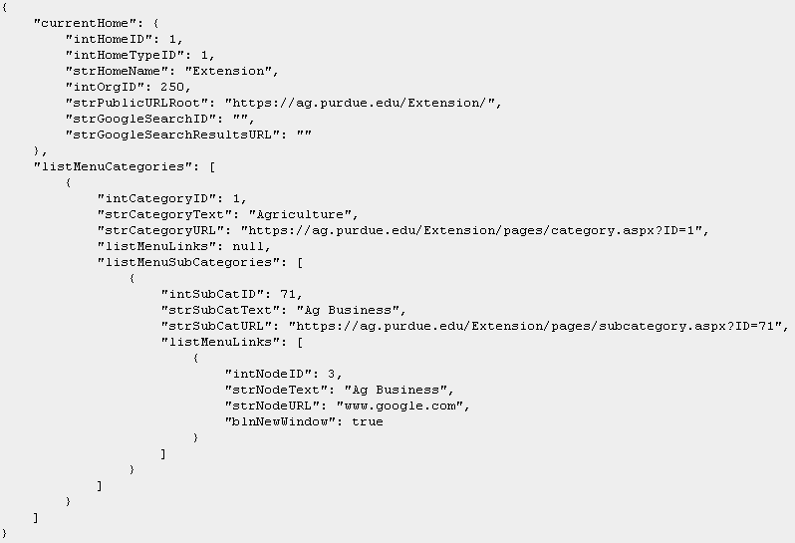

## Example Call

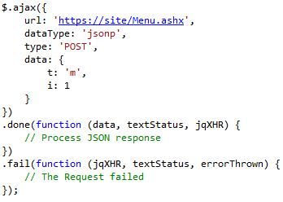

# Retrieve Menu Expanded

A web service method is available at  [https://ag.purdue.edu/api/DepotWS /Menu.ashx](https://site/Menu.ashx) that enables users to retrieve the expanded details of the Menu for a Home object. In order to retrieve these details, the user needs to submit a request to the web service with the following parameters:

|  |  |  |  |
| --- | --- | --- | --- |
| Parameter | Data Type | Required | Description |
| t | String | Yes | This should be set to “e”. |
| i | Integer | Yes | The ID of the Home object to search for |
| callback | String | No | The callback JavaScript method for Cross-Domain AJAX requests, if overriding jQuery defaults |

If a menu object with the home ID provided does not exist, then an empty JSON object will be returned instead.

## JSON Returned

## Example Call

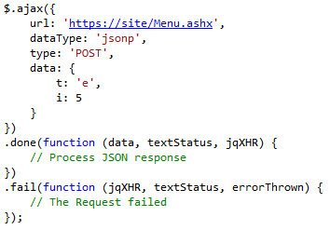

# Download File

A web service method is available at  [https://ag.purdue.edu/api/DepotWS /File.ashx](https://site/File.ashx) that enables users to download a file by the specified file ID. In order to download a file, the user needs to submit a request to the web service with the following parameters:

|  |  |  |  |
| --- | --- | --- | --- |
| Parameter | Data Type | Required | Description |
| t | String | Yes | This should be set to “f”. |
| i | Integer | Yes | File ID |

## Example Call



# Open Image

A web service method is available at  [https://ag.purdue.edu/api/DepotWS /File.ashx](https://site/File.ashx) that enables users to open an image by the specified image ID. In order to open an image, the user needs to submit a request to the web service with the following parameters:

|  |  |  |  |
| --- | --- | --- | --- |
| Parameter | Data Type | Required | Description |
| t | String | Yes | This should be set to “i”. |
| i | Integer | Yes | Image ID |

## Example Call



Event Labels

A web service has been made available to access read-only information for use on Extension web sites. The web service provides methods to access Files, Images, Item Details, Static Item Details, Expanded Item details, a Site Menu, and the Home ID for a given URL.

Retrieve Event Label Details

A web service method is available at [https://ag.purdue.edu/api/DepotWS/event.ashx](https://ag.purdue.edu/api/DepotWS/event.ashx%20) that enables users to retrieve details on an event in the system. In order to retrieve these details, the user needs to submit a request to the web service with the following parameters:

|  |  |  |  |
| --- | --- | --- | --- |
| Parameter | Data Type | Required | Description |
| t | String | Yes | Always set it to “el” |
| i | Integer | Yes | Pass -1 for all county or CountyID to get specific county results |
| tids | Integer | No | TypeID |
| ba | Boolean | No | FALSE for OR. TRUE for AND. Defaults to FALSE |
| ps | Integer | No | Page Size |
| pn | Integer | No | Page Number |
| sd | DateTime | No | Start Date |
| ed | DateTime | No | End Date |
| lids | Integer | No | Label ID |

The web service will attempt to find an event with the ID provided (“i”) that is ready for display. If the event is set to be published at the time of the request, it will be returned to the user as a JSON object with the following properties.

|  |  |  |
| --- | --- | --- |
| Property Name | Data Type | Description |
| datStartDate | DateTime | Start Date of the event |
| strTitle | String | The title of the event |
| intAuthorPUID | Integer | Purdue ID of the author |
| intHomeID | Integer | The Home ID |
| strContactName | String | Contact’s name |
| strContactEmail | String | Contact’s email |
| strContactPhone | String | Contact’s Phone |
| strDescription | String | Description of the event |
| strCost | String | Cost for the registration of the event |
| strRegister | String | The registration URL for the event |
| blnANR | Boolen | A flag indication if the event is ANR |
| blnECD | Boolean | A flag indication if the event is ECD |
| bln4H | Boolean | A flag indication if the event is ANR |
| blnHHS | Boolean | A flag indication if the event is HHS |
| datCreated | DateTime | The date the event was created |
| datModified | DateTime | The date the event was last modified |
| blnArchive | Boolean | A flag indicating if the event has been archived |
| intEventID | Integer | The Event ID |
| intEventAddressID | Integer | The Event Address ID |
| datEndDate | DateTime | The last date of the event |
| datStartTime | DateTime | The start time of the event |
| datEndTime | DateTime | The end time of the event |
| chrTimeZone | Character | The time zone |
| blnCancelEvent | Boolean | A flag indicating whether the event has been canceled |
| strBuilding | String | The building name of the location where the event is held |
| strRoom | String | The room name/number of the location where the event is held |
| strAddress1 | String | Address1 of the location where the event is held |
| strAddress2 | String | Address2 of the location where the event is held |
| strCity | String | The city name in which the event is held |
| strState | String | The state in which the event is held |
| strZip | String | The zip code of the address in which the event is held |
| decLongitude | Decimal | The longitude of the event address |
| decLatitude | Decimal | The latitude of the event address |
| intItemTotalCount | Integer | Total Count |

## JSON Returned

|  |
| --- |
| [{"datStartDate":"2016-09-10T00:00:00",  "eventList":[{"intEventID":9964,  "strTitle":"SIPAC Ag Field Day",  "intAuthorPUID":-1,  "intHomeID":1,  "strContactName":"Jason Tower",  "strContactEmail":"towerj@purdue.edu",  "strContactPhone":"812.482.1782",  "strDescription":"<p>Small Scale Tilapia Production Utilizing Farm Ponds<br />Presenter: Bob Rode, Purdue Aquaculture Unit Manager</p>\r\n<p>Cattle Handling Systems Demonstrations<br />Demonstrations by Cow Co. Inc., For-Most, Sioux Steel Co., Priefert</p>\r\n<p>2:00 PM&mdash;4:00 PM Tilapia Production<br />4:30 PM&mdash;6:45 PM Cattle Handling Equipment Demonstration<br />7:00 PM&mdash;7:45 PM Meal provided by our sponsors<br />7:45 PM Cattle Handling Tips, Jason Tower, SIPAC</p>\r\n<p>To register contact Jason Tower, <a href=\"mailto:towerj@purdue.edu,\">[towerj@purdue.edu,</a>&nbsp;812.678.4427</p](mailto:towerj@purdue.edu,%3c/a%3e&nbsp;812.678.4427%3c/p)>",  "strCost":"FREE",  "strRegister":"",  "blnANR":true,  "blnECD":false,  "bln4H":false,  "blnHHS":false,  "datCreated":"2016-08-12T09:30:52.353",  "datModified":"2016-08-12T09:30:52.353",  "blnArchive":false,  "DateList":{"intEventDateID":16775,  "intEventID":-1,  "intEventAddressID":17074,  "datStartDate":"2016-09-10T00:00:00",  "datEndDate":"0001-01-01T00:00:00",  "datStartTime":"14:00:00",  "datEndTime":"20:00:00",  "chrTimeZone":"E",  "blnCancelEvent":false,  "strBuilding":"",  "strRoom":"",  "strAddress1":"11371 East Purdue Farm Road",  "strAddress2":"",  "strCity":"Dubois",  "strState":"IN",  "strZip":"47527",  "decLongitude":-86.6935800,  "decLatitude":38.4552920},  "intItemTotalCount":2}]}] |

Retrieve Event Details

A web service method is available at [https://ag.purdue.edu/api/DepotWS/event.ashx](https://ag.purdue.edu/api/DepotWS/event.ashx%20) that enables users to retrieve details on an event in the system. In order to retrieve these details, the user needs to submit a request to the web service with the following parameters:

|  |  |  |  |
| --- | --- | --- | --- |
| Parameter | Data Type | Required | Description |
| i | Integer | Yes | Pass -1 for all county or CountyID to get specific county results |
| t | String | Yes | Always set it to “d” |

The web service will attempt to find a Home object with the ID provided (“i”). If the Home object exists, all of its social media links will be returned to the user as a list of JSON objects with the following properties:

|  |  |  |  |  |  |  |  |  |  |  |  |  |  |  |  |  |  |  |  |  |  |  |  |  |  |  |  |  |  |  |  |  |  |  |  |  |  |  |  |  |  |  |  |  |  |  |  |  |  |  |  |  |  |  |  |  |  |  |  |  |  |  |  |  |  |  |  |  |  |  |  |  |  |  |
| --- | --- | --- | --- | --- | --- | --- | --- | --- | --- | --- | --- | --- | --- | --- | --- | --- | --- | --- | --- | --- | --- | --- | --- | --- | --- | --- | --- | --- | --- | --- | --- | --- | --- | --- | --- | --- | --- | --- | --- | --- | --- | --- | --- | --- | --- | --- | --- | --- | --- | --- | --- | --- | --- | --- | --- | --- | --- | --- | --- | --- | --- | --- | --- | --- | --- | --- | --- | --- | --- | --- | --- | --- | --- | --- |
| |  |  |  | | --- | --- | --- | | Property Name | Data Type | Description | | intEventID | Integer | The Event ID | | strTitle | String | Title of the Event | | intAuthorPUID | Integer | Purdue ID of the author | | intHomeID | Integer | Home ID of the Event | | strContactName | String | Name of the contact for the Event | | strContactEmail | String | Email of the contact for the Event | | strContactPhone | String | Contact phone number for the Event | | strDescription | String | Event Description | | strCost | String | Registration Cost for the Event | | strRegister | String | Event registration URL | | blnANR | Boolean | Specifies whether the event is an ANR event | | blnECD | Boolean | Specifies whether the event is an ECD event | | bln4H | Boolean | Specifies whether the event is an 4H event | | blnHHS | Boolean | Specifies whether the event is and HHS event | | datCreated | Date | The date when Event was created | | datModified | Date | The latest modification date of the event | | blnArchive | Boolean | Specifies whether the event has been archived | | intEventDateID | Integer | Event Date ID | | intEventID | Integer | Event ID | | intEventAddressID | Integer | Event Address ID | | datStartDate | Date | Start Date of the Event | | datEndDate | Date | End Date of the Event | | datStartTime | Date | Start Time of the event | |  |  |

If an object with the home ID provided does not exist, then an empty JSON object will be returned instead.

## Example Call

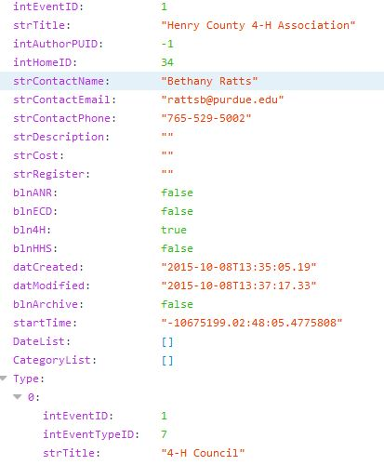

## JSON Returned



Retrieve Events Based on Home

A web service method is available at [https://ag.purdue.edu/api/DepotWS/event.ashx](https://ag.purdue.edu/api/DepotWS/event.ashx%20) that enables users to retrieve the list of events based on the home selected. In order to retrieve these details, the user needs to submit a request to the web service with the following parameters:

|  |  |  |  |
| --- | --- | --- | --- |
| Parameter | Data Type | Required | Description |
| i | Integer | Yes | Pass -1 for all county or CountyID to get specific county results |
| ps | Integer | No | Page Size |
| t | String | Yes | Always set it to “eh” |

The web service will attempt to find a Home object with the ID provided (“i”). If the Home object exists, all of its social media links will be returned to the user as a list of JSON objects with the following properties:

|  |  |  |  |  |  |  |  |  |  |  |  |  |  |  |  |  |  |  |  |  |  |  |  |  |  |  |  |  |  |  |  |  |  |  |  |  |  |  |  |  |  |  |  |  |
| --- | --- | --- | --- | --- | --- | --- | --- | --- | --- | --- | --- | --- | --- | --- | --- | --- | --- | --- | --- | --- | --- | --- | --- | --- | --- | --- | --- | --- | --- | --- | --- | --- | --- | --- | --- | --- | --- | --- | --- | --- | --- | --- | --- | --- |
| |  |  |  | | --- | --- | --- | | Property Name | Data Type | Description | | intEventID | Integer | The Event ID | | intHomeID | Integer | The Home ID of the Event | | intEventDateID | Integer | The Event Date ID of the event | | intHomeID | Integer | Home ID of the Event | | datStartDate | Date | Start Date of the Event | | datStartTime | Date | Start Time of the event | | datEndTime | Date | End Time of the Event | | chrTimeZone | Character | Time Zone of the Event | | blnCancelEvent | Boolean | Specifies if the Event has been canceled | | strTitle | String | Title of the Event | | strCity | String | City where the Event is going to take place | | intOrderID | Integer | The order ID | | intEventDateCount | Integer | The number of the Events on a particular day | |  |  |

If an object with the home ID provided does not exist, then an empty JSON object will be returned instead.

## Example Call

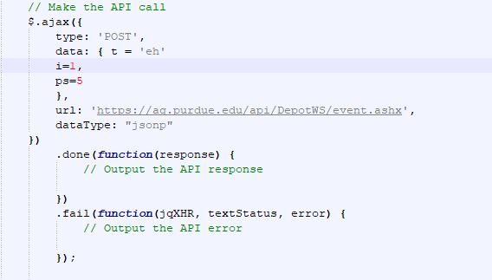

## JSON Returned

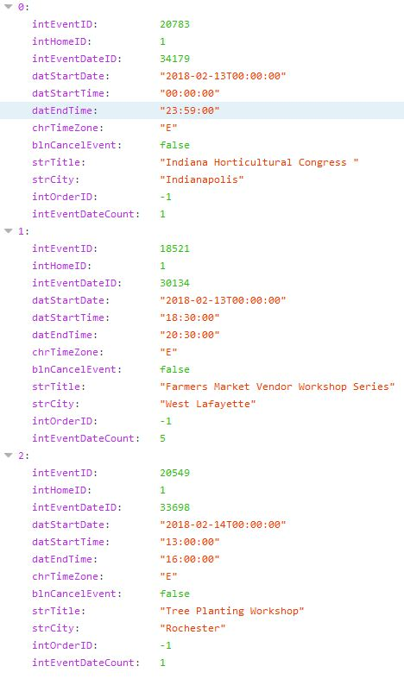

Retrieve Event Type

A web service method is available at [https://ag.purdue.edu/api/DepotWS/event.ashx](https://ag.purdue.edu/api/DepotWS/event.ashx%20) that enables users to retrieve the list of event’s type. This web service call doesn’t require any parameters.

|  |  |  |  |
| --- | --- | --- | --- |
| Parameter | Data Type | Required | Description |
| t | String | Yes | Always set it to “et” |

The web service will attempt to find a Home object with the ID provided (“i”). If the Home object exists, all of its social media links will be returned to the user as a list of JSON objects with the following properties:

|  |  |  |
| --- | --- | --- |
| Property Name | Data Type | Description |
| intEventID | Integer | The ID of the Event |
| intEventTypeID | Integer | The ID of the Event Type |
| strTitle | String | The Event Type Title |

If an object with the home ID provided does not exist, then an empty JSON object will be returned instead.

## Example Call

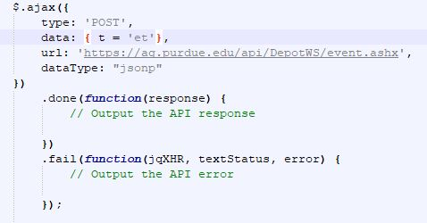

## JSON Returned

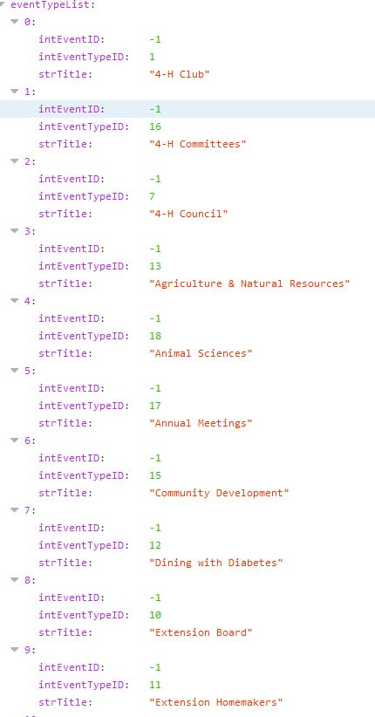

Retrieve Event Location

A web service method is available at [https://ag.purdue.edu/api/DepotWS/event.ashx](https://ag.purdue.edu/api/DepotWS/event.ashx%20) that enables users to retrieve the list of event’s location. This web service call doesn’t require any parameters.

|  |  |  |  |
| --- | --- | --- | --- |
| Parameter | Data Type | Required | Description |
| t | String | Yes | Always set it to “l” |

The web service will attempt to find a Home object with the ID provided (“i”). If the Home object exists, all of its social media links will be returned to the user as a list of JSON objects with the following properties:

|  |  |  |
| --- | --- | --- |
| Property Name | Data Type | Description |
| intHomeID | Integer | The ID of the social media link |
| intHomeTypeID | Integer | The name of the social media link |
| strHomeName | String | The URL of the social media link |
| intOrgID | Integer | Organization ID |
| strPublicURLRoot | String | Public URL Root |
| strGoogleSearchID | String | Google search ID of the Home object |
| strGoogleSearchResult | String | Google search results URL of the home object |

If an object with the home ID provided does not exist, then an empty JSON object will be returned instead.

## Example Call

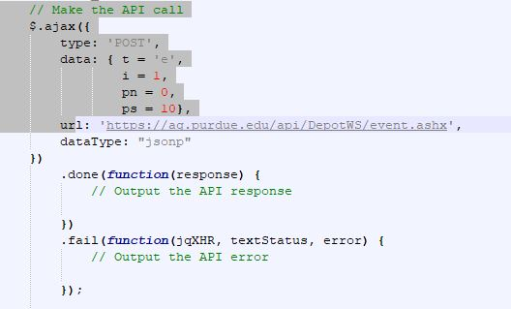

JSON Returned

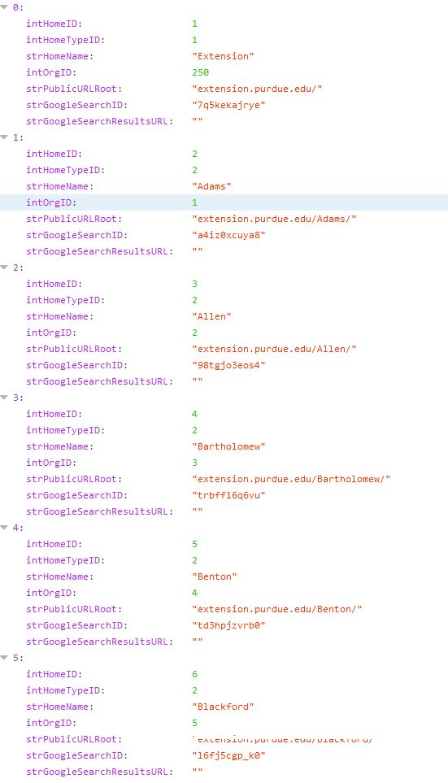

Retrieve Events based on the Filter Criteria

A web service method is available at [https://ag.purdue.edu/api/DepotWS/event.ashx](https://ag.purdue.edu/api/DepotWS/event.ashx%20) that enables users to retrieve the list of events based on the filters selected. In order to retrieve these details, the user needs to submit a request to the web service with the following parameters

|  |  |  |  |
| --- | --- | --- | --- |
| Parameter | Data Type | Required | Description |
| t | String | Yes | Always set it to “ef” |
| l | Integer | Yes | Pass -1 for all county or CountyID to get specific county results |
| tids | Integer | No | TypeID |
| cids | Integer | No | CategoryID |
| ps | Integer | No | Page Size |
| pn | Integer | No | Page Number |
| sd | DateTime | No | Start Date |
| ed | DateTime | No | End Date |
| scids |  |  | SubCategoryID |
| sar | Boolean |  | Set it to “False” |
| bc | Boolean |  | Set it to “True” |

The web service will attempt to find a Home object with the ID provided (“i”). If the Home object exists, all of its social media links will be returned to the user as a list of JSON objects with the following properties:

|  |  |  |
| --- | --- | --- |
| Property Name | Data Type | Description |
| datStartDate | Date | The start date of the Event |
| intEventID | Integer | The Event ID |
| strTitle | String | Title of the Event |
| intAuthorPUID | Integer | Purdue ID of the author |
| intHomeID | Integer | Home ID of the Event |
| strContactName | String | Name of the contact for the Event |
| strContactEmail | String | Email of the contact for the Event |
| strContactPhone | String | Contact phone number for the Event |
| strDescription | String | Event Description |
| strCost | String | Registration Cost for the Event |
| strRegister | String | Event registration URL |
| blnANR | Boolean | Specifies whether the event is an ANR event |
| blnECD | Boolean | Specifies whether the event is an ECD event |
| bln4H | Boolean | Specifies whether the event is an 4H event |
| blnHHS | Boolean | Specifies whether the event is and HHS event |
| datCreated | Date | The date when Event was created |
| datModified | Date | The latest modification date of the event |
| blnArchive | Boolean | Specifies whether the event has been archived |
| intEventDateID | Integer | Event Date ID |
| intEventID | Integer | Event ID |
| intEventAddressID | Integer | Event Address ID |
| datStartDate | Date | Start Date of the Event |
| datEndDate | Date | End Date of the Event |
| datStartTime | Date | Start Time of the event |
| datEndTime | Date | End Time of the Event |
| chrTimeZone | Character | Time Zone of the Event |
| blnCancelEvent | Boolean | Specifies if the Event has been canceled |
| strBuilding | String | The building where the Event is going to take place |
| strRoom | String | Room number where the Event is going to take place |
| strAddress1 | String | Address 1 of the Event Location |
| strAddress2 | String | Address 2 of the Event Location |
| strCity | String | City where the Event is going to take place |
| strState | String | State where the Event is going to take place |
| strZip | String | Zip of the Event location |
| decLongitude | Decimal | Longitude of the Event Location |
| decLatitude | Decimal | Latitude of the Event Location |
| intItemTotalCount | Integer | Total number of Events |

If an object with the home ID provided does not exist, then an empty JSON object will be returned instead.

## Example Call

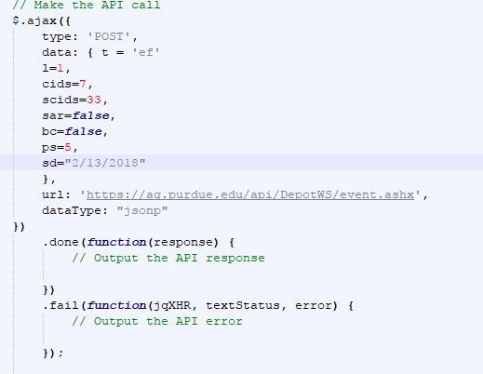

## JSON Returned

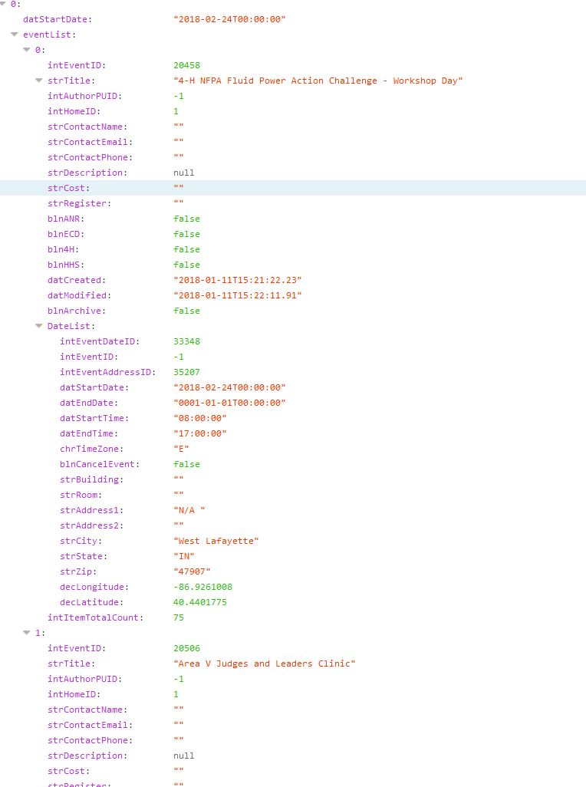

Retrieve Events based on Home and Date

A web service method is available at [https://ag.purdue.edu/api/DepotWS/event.ashx](https://ag.purdue.edu/api/DepotWS/event.ashx%20) that enables users to retrieve the list of events based on the filters selected. In order to retrieve these details, the user needs to submit a request to the web service with the following parameters

|  |  |  |  |
| --- | --- | --- | --- |
| Parameter | Data Type | Required | Description |
| i | Integer | Yes | Pass -1 for all county or CountyID to get specific county results |
| t | String | Yes | Always set it to “ep” |

The web service will attempt to find a Home object with the ID provided (“i”). If the Home object exists, all of its social media links will be returned to the user as a list of JSON objects with the following properties:

|  |  |  |
| --- | --- | --- |
| Property Name | Data Type | Description |
| intEventID | Integer | The Event ID |
| intHomeID | Integer | The Home ID of the Event |
| intEventDateID | Integer | The Event Date ID of the event |
| intHomeID | Integer | Home ID of the Event |
| datStartDate | Date | Start Date of the Event |
| datStartTime | Date | Start Time of the event |
| datEndTime | Date | End Time of the Event |
| chrTimeZone | Character | Time Zone of the Event |
| blnCancelEvent | Boolean | Specifies if the Event has been canceled |
| strTitle | String | Title of the Event |
| strCity | String | City where the Event is going to take place |
| intOrderID | Integer | The order ID |
| intEventDateCount | Integer | The number of the Events on a particular day |

If an object with the home ID provided does not exist, then an empty JSON object will be returned instead.

## Example Call

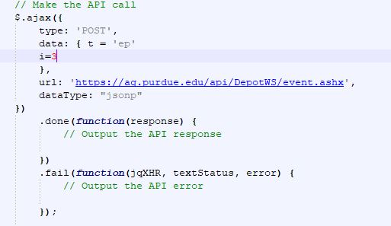

## JSON Returned

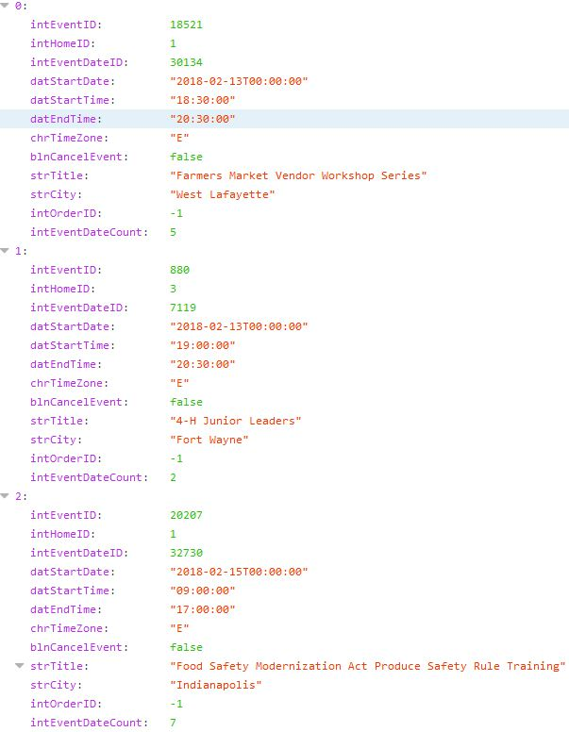

Retrieve List of Labels

A web service method is available at <https://ag.purdue.edu/api/DepotWS/label.ashx> that enables users to retrieve the list of labels. This web service call doesn’t require any parameters.

|  |  |  |  |
| --- | --- | --- | --- |
| Parameter | Data Type | Required | Description |
| t | String | Yes | Always set it to “l” |

The web service will attempt to find a Home object with the ID provided (“i”). If the Home object exists, all of its social media links will be returned to the user as a list of JSON objects with the following properties:

|  |  |  |
| --- | --- | --- |
| Property Name | Data Type | Description |
| intLabelID | Integer | The ID of the Label |
| strLabel | String | The Label name |

If an object with the home ID provided does not exist, then an empty JSON object will be returned instead.

## Example Call

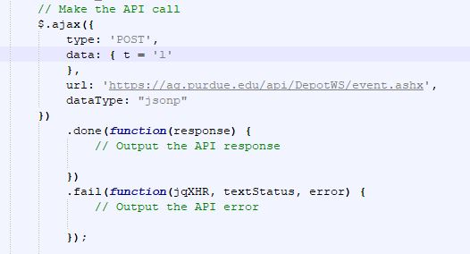

## JSON Returned

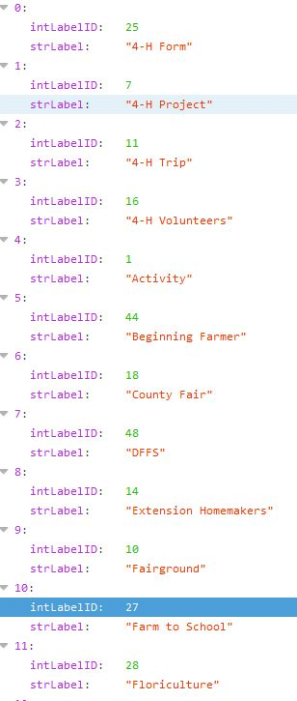

Retrieve list of ItemBlurbs

A web service method is available at <https://ag.purdue.edu/api/DepotWS/label.ashx> that enables users to retrieve the list of events based on the filters selected. In order to retrieve these details, the user needs to submit a request to the web service with the following parameters

|  |  |  |  |
| --- | --- | --- | --- |
| Parameter | Data Type | Required | Description |
| i | Integer | Yes | Pass -1 for all county or CountyID to get specific county results |
| t | String | Yes | Always set to “b” |

The web service will attempt to find a Home object with the ID provided (“i”). If the Home object exists, all of its social media links will be returned to the user as a list of JSON objects with the following properties:

|  |  |  |
| --- | --- | --- |
| Property Name | Data Type | Description |
| intItemID | Integer | The Item ID |
| strTitle | String | Title of the Item |
| strShortBody | String | Short Description |
| blnANR | Boolean | Flag indicating if the item in ANR |
| blnECD | Boolean | Flag indicating if the item is ECD |
| bln4H | Boolean | Flag indicating if the item in 4H |
| blnHHS | Boolean | Flag indicating if the item is HHS |
| blnHasVideos | Boolean | Flag indicating if the item has videos |
| blnHasFiles | Boolean | Flag indicating if the item has files |
| blnHasImages | Boolean | Flag indicating if the item has images |
| intCatID | Integer | Category ID of the item |
| strCatTitle | String | Sub category title of the item |
| intSubCatID | Integer | Sub category ID of the item |
| intPageCount | Integer | Page count |
| intItemTotalCount | Integer | Total number of items |
| datPublishedAfter | Date | Publish after date |

If an object with the home ID provided does not exist, then an empty JSON object will be returned instead.

## Example Call

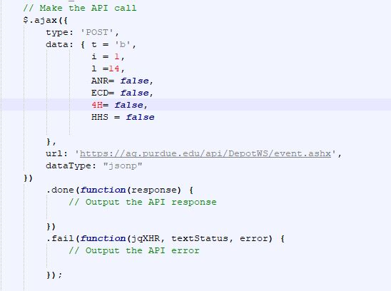

## JSON Returned

