Extension DCR Web Service

A web service has been made available to access read-only information for use on Extension web sites. The web service provides methods to access Files, Images, Item Details, Static Item Details, Expanded Item details, a Site Menu, and the Home ID for a given URL.

# Retrieve Item Details

A web service method is available at <https://site/Item.ashx> that enables users to retrieve details on an Item in the system. In order to retrieve these details, the user needs to submit a request to the web service with the following parameters:

|  |  |  |  |
| --- | --- | --- | --- |
| Parameter | Data Type | Required | Description |
| t | String | Yes | This should be set to “d”. |
| i | Integer | Yes | Item ID |
| callback | String | No | The callback JavaScript method for Cross-Domain AJAX requests, if overriding jQuery defaults |

The web service will attempt to find an Item with the ID provided (“i”) that is ready for display. If the Item is set to be published at the time of the request, it will be returned to the user as a JSON object with the following properties:

|  |  |  |
| --- | --- | --- |
| Property Name | Data Type | Description |
| strAuthorAlias | String | The username for the Author |
| strAuthorName | String | The Full Name of the Author |
| strTitle | String | The Title of the Item |
| datCreated | Date/Time | The date the Item was created |
| blnANR | Boolean |  |
| blnECD | Boolean |  |
| bln4H | Boolean | A flag indicating if the Item is a 4-H Item |
| blnHHS | Boolean |  |

If the Item with the ID provided in is not set to be published at the time of the request, or no such item exists, then an empty JSON object will be returned instead.

## JSON Returned

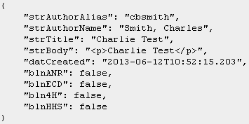

If JSONP is used to create a cross-domain AJAX request, then the JSON object will be surrounded with a JavaScript method with the name passed in the “callback” parameter. Normally, jQuery should handle stripping this extra information and returning just the JSON object.

## Example Call

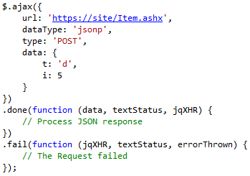

## MVC URL

**https://site/Item/GetItemDetails/5**

# Retrieve Expanded Item Details

A web service method is available at <https://site/Item.ashx> that enables users to retrieve the expanded details on an item in the system. In order to retrieve these expanded details, the user needs to submit a request to the web service with the following parameters:

|  |  |  |  |
| --- | --- | --- | --- |
| Parameter | Data Type | Required | Description |
| t | String | Yes | This should be set to “e”. |
| i | Integer | Yes | Item ID |
| callback | String | No | The callback JavaScript method for Cross-Domain AJAX requests, if overriding jQuery defaults |

The web service will attempt to find an Item with the ID provided (“i”) that is ready for display. If the Item is set to be published at the time of the request, it will be returned to the user as a JSON object with the following properties:

|  |  |  |
| --- | --- | --- |
| Property Name | Data Type | Description |
| Files | List<ItemFile> | List of Files |
| Videos | List<ItemVideo> | List of Videos |
| Images | List<ItemImage> | List of Images |
| Links | List<ItemRelatedLink> | List of Links |

Each ItemFile object will have the following structure:

|  |  |  |
| --- | --- | --- |
| Property Name | Data Type | Description |
| intItemID | Integer | The ID of the item |
| intFileID | Integer | The ID of the file |
| strLinkText | String | The text of the link |

Each ItemVideo object will have the following structure:

|  |  |  |
| --- | --- | --- |
| Property Name | Data Type | Description |
| intItemID | Integer | The ID of the item |
| intVideoID | Integer | The ID of the video |
| strLinkText | String | The text of the link |
| strVideoTitle | String | The title of the video |

Each ItemImage object will have the following structure:

|  |  |  |
| --- | --- | --- |
| Property Name | Data Type | Description |
| intItemID | Integer | The ID of the item |
| intImageID | Integer | The ID of the image |
| strCaption | String | The caption of the image |
| strAltText | String | The alternate text of the image |
| strPosition | String | The position of the image |

Each ItemRelatedLink object will have the following structure:

|  |  |  |
| --- | --- | --- |
| Property Name | Data Type | Description |
| intRelatedLinkID | Integer | The ID of the related link |
| intOrder | Integer | The order of the link |
| strLinkURL | String | The URL link |
| strLinkText | String | The text of the URL link |
| blnNewWindow | Boolean | True/False if the link should open up in a new window |
| intItemID | Integer | The ID of the item |

If the Item with the ID provided does not exist, then an empty JSON object will be returned instead.

## JSON Returned

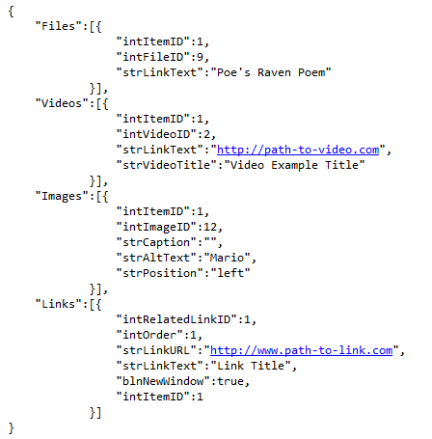

If JSONP is used to create a cross-domain AJAX request, then the JSON object will be surrounded with a JavaScript method with the name passed in the “callback” parameter. Normally, jQuery should handle stripping this extra information and returning just the JSON object.

## Example Call

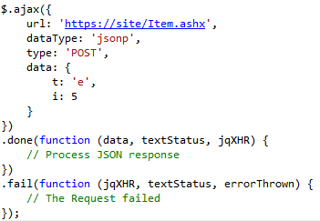

## MVC URL

**https://site/Item/GetExpandedItemDetails/5**

# Retrieve Static Item Details

A web service method is available at <https://site/Item.ashx> that enables users to retrieve details on Static Content in the system. In order to retrieve these details, the user needs to submit a request to the web service with the following parameters:

|  |  |  |  |
| --- | --- | --- | --- |
| Parameter | Data Type | Required | Description |
| t | String | Yes | This should be set to “s”. |
| i | Integer | Yes | Static Content ID |
| callback | String | No | The callback JavaScript method for Cross-Domain AJAX requests, if overriding jQuery defaults |

The web service will attempt to find Static Content with the ID provided (“i”). If the Static Content exists, it will be returned to the user as a JSON object with the following properties:

|  |  |  |
| --- | --- | --- |
| Property Name | Data Type | Description |
| strTitle | String | The Title of the Static Content |
| strBody | String | The Body text of the Static Content |

If Static Content with the ID provided does not exist, then an empty JSON object will be returned instead.

## JSON Returned

## 

If JSONP is used to create a cross-domain AJAX request, then the JSON object will be surrounded with a JavaScript method with the name passed in the “callback” parameter. Normally, jQuery should handle stripping this extra information and returning just the JSON object.

## Example Call

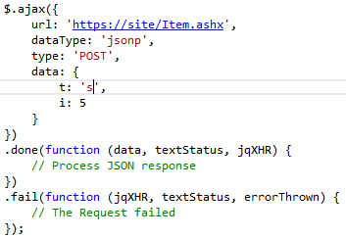

## MVC URL

**https://site/Item/GetStaticItemDetails/5**

# Retrieve Expanded Static Item Details

A web service method is available at <https://site/Item.ashx> that enables users to retrieve expanded details on Static Content in the system. In order to retrieve these details, the user needs to submit a request to the web service with the following parameters:

|  |  |  |  |
| --- | --- | --- | --- |
| Parameter | Data Type | Required | Description |
| t | String | Yes | This should be set to “c”. |
| i | Integer | Yes | Static Content ID |
| callback | String | No | The callback JavaScript method for Cross-Domain AJAX requests, if overriding jQuery defaults |

The web service will attempt to find Static Content with the ID provided (“i”). If the Static Content exists, it will be returned to the user as a JSON object with the following properties:

|  |  |  |
| --- | --- | --- |
| Property Name | Data Type | Description |
| Files | List<StaticFile> | List of Files |
| Videos | List<StaticVideo> | List of Videos |
| Images | List<StaticImage> | List of Images |

Each StaticFile object will have the following structure:

|  |  |  |
| --- | --- | --- |
| Property Name | Data Type | Description |
| intStaticContentID | Integer | The ID of the static content |
| intFileID | Integer | The ID of the file |
| strLinkText | String | The text of the link |

Each StaticVideo object will have the following structure:

|  |  |  |
| --- | --- | --- |
| Property Name | Data Type | Description |
| intStaticContentID | Integer | The ID of the static content |
| intVideoID | Integer | The ID of the video |
| strLinkText | String | The text of the link |
| strTitle | String | The title of the video |

Each StaticImage object will have the following structure:

|  |  |  |
| --- | --- | --- |
| Property Name | Data Type | Description |
| intStaticContentID | Integer | The ID of the static content |
| intImageID | Integer | The ID of the image |
| strCaption | String | The caption of the image |
| strAltText | String | The alternate text of the image |
| strPosition | String | The position of the image |

If the Item with the ID provided does not exist, then an empty JSON object will be returned instead.

## JSON Returned

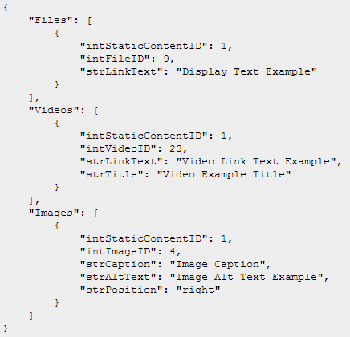

If JSONP is used to create a cross-domain AJAX request, then the JSON object will be surrounded with a JavaScript method with the name passed in the “callback” parameter. Normally, jQuery should handle stripping this extra information and returning just the JSON object.

## Example Call

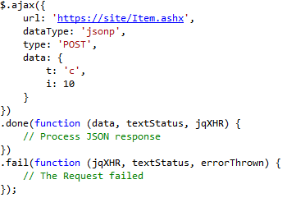

## MVC URL

**https://site/Item/GetExpandedStaticItemDetails/5**

# Retrieve Item Blurb List

A web service method is available at <https://site/Item.ashx> that enables users to retrieve the item blurb list by the current home. In order to retrieve these details, the user needs to submit a request to the web service with the following parameters:

|  |  |  |  |
| --- | --- | --- | --- |
| Parameter | Data Type | Required | Description |
| t | String | Yes | This should be set to “b”. |
| i | Integer | Yes | The ID of the Current Home |
| callback | String | No | The callback JavaScript method for Cross-Domain AJAX requests, if overriding jQuery defaults |

The web service will attempt to find an Item with the ID provided (“i”) that is ready for display. If the Item is set to be published at the time of the request, it will be returned to the user as a JSON array object with the following properties:

|  |  |  |
| --- | --- | --- |
| Property Name | Data Type | Description |
| intItemID | Integer | Item ID |
| strTitle | String | Title of Item |
| strShortBody | String | Short Body text of Item |

If the Item with the ID provided does not exist, then an empty JSON object will be returned instead.

## JSON Returned

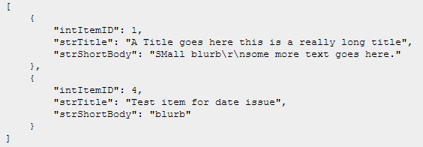

## Example Call

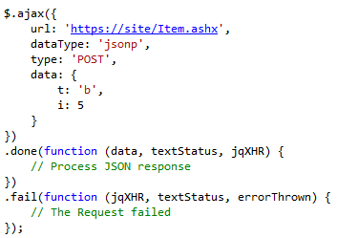

## MVC URL

**https://site/Item/GetItemBlurbList/5**

# Retrieve Item Blurb Expanded

A web service method is available at <https://site/Item.ashx> that enables users to retrieve the expanded item blurb details list for the current home and a category/subcategory. In order to retrieve these details, the user needs to submit a request to the web service with the following parameters:

|  |  |  |  |
| --- | --- | --- | --- |
| Parameter | Data Type | Required | Description |
| t | String | Yes | This should be set to “x”. |
| i | Integer | Yes | The ID of the current home |
| c | Integer | Yes | The ID of the category. -1 for subcategory |
| s | Integer | Yes | The ID of the subcategory. -1 for category |
| callback | String | No | The callback JavaScript method for Cross-Domain AJAX requests, if overriding jQuery defaults |

The web service will attempt to find a list of Items with the ID of the current home provided (“i”) that is ready for display. If the Items are set to be published at the time of the request, it will be returned to the user as a JSON array object with the following properties:

|  |  |  |
| --- | --- | --- |
| Property Name | Data Type | Description |
| intItemID | Integer | Item ID |
| blnANR | Boolean |  |
| blnECD | Boolean |  |
| bln4H | Boolean | A flag indicating if the Item is a 4-H Item |
| blnHHS | Boolean |  |
| blnHasVideos | Boolean | Boolean stating if Item has videos |
| blnHasFiles | Boolean | Boolean stating if Item has files |

If the Item with the ID provided does not exist, then an empty JSON object will be returned instead.

## JSON Returned

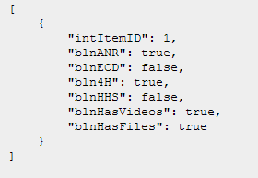

## Example Call

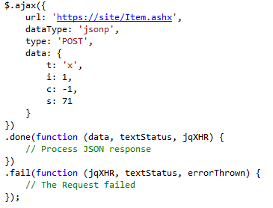

## MVC URL

**https://site/Item/GetItemBlurbExpanded/1?c=-1&s=71**

# Retrieve Home ID

A web service method is available at <https://site/Home.ashx> that enables users to retrieve details of a Home object with a given URL. In order to retrieve these details, the user needs to submit a request to the web service with the following parameters:

|  |  |  |  |
| --- | --- | --- | --- |
| Parameter | Data Type | Required | Description |
| t | String | Yes | This should be set to “h”. |
| u | String | Yes | Request URL |
| callback | String | No | The callback JavaScript method for Cross-Domain AJAX requests, if overriding jQuery defaults |

The web service will attempt to find a Home object with the URL provided (“u”). If the Home object exists, it will be returned to the user as a JSON object with the following properties:

|  |  |  |
| --- | --- | --- |
| Property Name | Data Type | Description |
| intHomeID | Int | The ID of the Home Object |
| strHomeName | String | The Name of the Home Object |
| strPublicURLRoot | String | The Public URL Root of the Home Object |
| strGoogleSearchID | String | The Google Search ID of the Home Object |
| strGoogleSearchResultsURL | String | The Google Search Results URL of the Home Object |

If a Home object with the URL provided does not exist, then an empty JSON object will be returned instead.

## JSON Returned

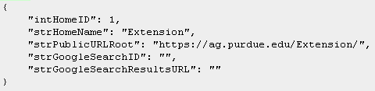

## Example Call

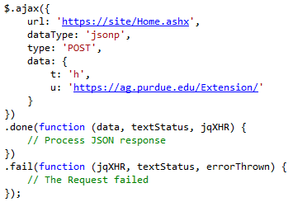

## MVC URL

**https://site/Home/GetHomeListJson?u=https://ag.purdue.edu/Extension/**

# Retrieve Social Media Links

A web service method is available at <https://site/Home.ashx> that enables users to retrieve the social media links for a home object. In order to retrieve these links, the user needs to submit a request to the web service with the following parameters:

|  |  |  |  |
| --- | --- | --- | --- |
| Parameter | Data Type | Required | Description |
| t | String | Yes | This should be set to “s”. |
| i | Integer | Yes | The ID of the Home object to search for |
| callback | String | No | The callback JavaScript method for Cross-Domain AJAX requests, if overriding jQuery defaults |

The web service will attempt to find a Home object with the ID provided (“i”). If the Home object exists, all of its social media links will be returned to the user as a list of JSON objects with the following properties:

|  |  |  |
| --- | --- | --- |
| Property Name | Data Type | Description |
| intSocialMediaID | Integer | The ID of the social media link |
| strSocialMediaName | String | The name of the social media link |
| strSocialMediaURL | String | The URL of the social media link |

If an object with the home ID provided does not exist, then an empty JSON object will be returned instead.

## JSON Returned

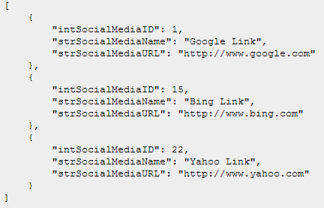

## Example Call

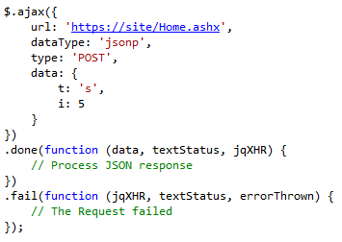

## MVC URL

**https://site/Home/GetSocialMediaLinks/5**

# Retrieve Relevant Links

A web service method is available at <https://site/Home.ashx> that enables users to retrieve the relevant links for a home object. In order to retrieve these links, the user needs to submit a request to the web service with the following parameters:

|  |  |  |  |
| --- | --- | --- | --- |
| Parameter | Data Type | Required | Description |
| t | String | Yes | This should be set to “r”. |
| i | Integer | Yes | The ID of the Home object to search for |
| c | Integer | Yes | The ID of the category. -1 for subcategory |
| s | Integer | Yes | The ID of the subcategory. -1 for category |
| callback | String | No | The callback JavaScript method for Cross-Domain AJAX requests, if overriding jQuery defaults |

The web service will attempt to find a list of relevant links with the ID of the current home provided (“i”) that is ready for display. If the Items are set to be published at the time of the request, it will be returned to the user as a JSON array object with the following properties:

|  |  |  |
| --- | --- | --- |
| Property Name | Data Type | Description |
| intLinkID | Integer | ID of the Link |
| strLinkURL | String | URL of the Link |
| strLinkText | String | Display text of the Link |
| blnNewWindow | Boolean | A flag indicating if the link opens in new window |
| intHomeID | Integer | ID of the related Home |

If an object with the home ID provided does not exist, then an empty JSON object will be returned instead.

## JSON Returned

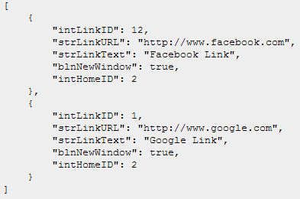

## Example Call

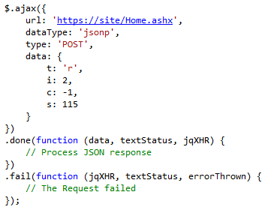

## MVC URL

**https://site/Home/GetRelevantLinks/2?c=-1&s=115**

# Retrieve Menu

A web service method is available at <https://site/Menu.ashx> that enables users to retrieve details of the Menu for a Home object. In order to retrieve these details, the user needs to submit a request to the web service with the following parameters:

|  |  |  |  |
| --- | --- | --- | --- |
| Parameter | Data Type | Required | Description |
| t | String | Yes | This should be set to “m”. |
| i | Integer | Yes | The ID of the Home object to search for |
| callback | String | No | The callback JavaScript method for Cross-Domain AJAX requests, if overriding jQuery defaults |

The web service will attempt to find a Home object with the ID provided (“i”). If the Home object exists, its menu will be returned to the user as a JSON object with the following properties:

|  |  |  |
| --- | --- | --- |
| Property Name | Data Type | Description |
| currentHome | Home | The Home object for the passed in ID |
| listMenuCategories | List<MenuCategory> | The list of Menu Categories |

Each Home object will have the following structure:

|  |  |  |
| --- | --- | --- |
| Property Name | Data Type | Description |
| intHomeID | Integer | The ID of the Home object |
| intHomeTypeID | Integer | The ID of the Home Type |
| strHomeName | String | The Name of the Home object |
| intOrgID | Integer | The Organization ID associated with the Home object |
| strPublicURLRoot | String | The Public URL Root associated with the Home object |
| strGoogleSearchID | String | The Google Search ID associated with the Home object |
| strGoogleSearchResultsURL | String | The Google Search Results URL associated with the Home object |

Each MenuCategory object will have the following structure:

|  |  |  |
| --- | --- | --- |
| Property Name | Data Type | Description |
| intCategoryID | Integer | The ID of the Category |
| strCategoryText | String | The descriptive text of the Category |
| strCategoryURL | String | The URL of the Category |
| listMenuLinks | MenuLinkList | The Links associated with the Category |
| listMenuSubCategories | MenuSubCategoryList | The Sub-Categories associated with the Category |

Each MenuLinkList object will have the following structure:

|  |  |  |
| --- | --- | --- |
| Property Name | Data Type | Description |
| intNodeID | Integer | The ID of the Link |
| strNodeText | String | The descriptive text of the Link |
| strNodeURL | String | The URL of the Link |
| blnNewWindow | Boolean | A flag indicating if the Link should be opened in a new browser window |

Each MenuSubCategoryList object will have the following structure:

|  |  |  |
| --- | --- | --- |
| Property Name | Data Type | Description |
| intSubCatID | Integer | The ID of the Sub-Category |
| strSubCatText | String | The descriptive text of the Sub-Category |
| strSubCatURL | String | The URL of the Sub-Category |
| listMenuLinks | MenuLinkList | The Links associated with the Sub-Category |

If a Home object with the URL provided does not exist, then an empty JSON object will be returned instead.

## JSON Returned

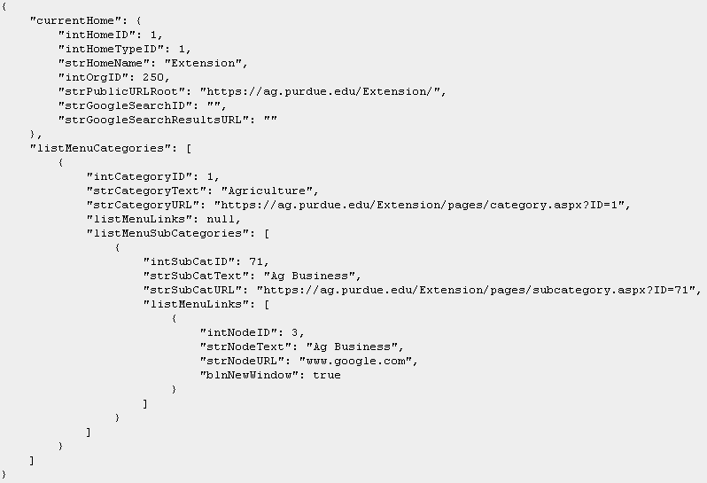

## Example Call

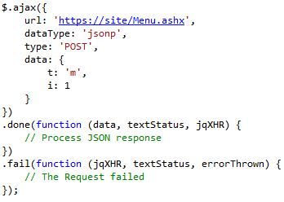

## MVC URL

**https://site/Menu/GetMenu/1**

# Retrieve Menu Expanded

A web service method is available at <https://site/Menu.ashx> that enables users to retrieve the expanded details of the Menu for a Home object. In order to retrieve these details, the user needs to submit a request to the web service with the following parameters:

|  |  |  |  |
| --- | --- | --- | --- |
| Parameter | Data Type | Required | Description |
| t | String | Yes | This should be set to “e”. |
| i | Integer | Yes | The ID of the Home object to search for |
| callback | String | No | The callback JavaScript method for Cross-Domain AJAX requests, if overriding jQuery defaults |

If a menu object with the home ID provided does not exist, then an empty JSON object will be returned instead.

## JSON Returned

## Example Call

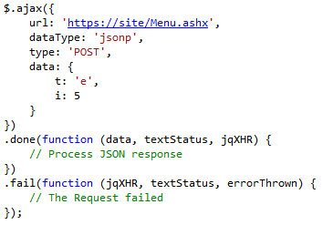

## MVC URL

**https://site/Menu/GetExpandedMenu/5**

# Download File

A web service method is available at <https://site/File.ashx> that enables users to download a file by the specified file ID. In order to download a file, the user needs to submit a request to the web service with the following parameters:

|  |  |  |  |
| --- | --- | --- | --- |
| Parameter | Data Type | Required | Description |
| t | String | Yes | This should be set to “f”. |
| i | Integer | Yes | File ID |

## Example Call



## MVC URL

**https://site/File/GetFile/10**

# Open Image

A web service method is available at <https://site/File.ashx> that enables users to open an image by the specified image ID. In order to open an image, the user needs to submit a request to the web service with the following parameters:

|  |  |  |  |
| --- | --- | --- | --- |
| Parameter | Data Type | Required | Description |
| t | String | Yes | This should be set to “i”. |
| i | Integer | Yes | Image ID |

## Example Call



## MVC Call

**https://site/File/GetImage/3**