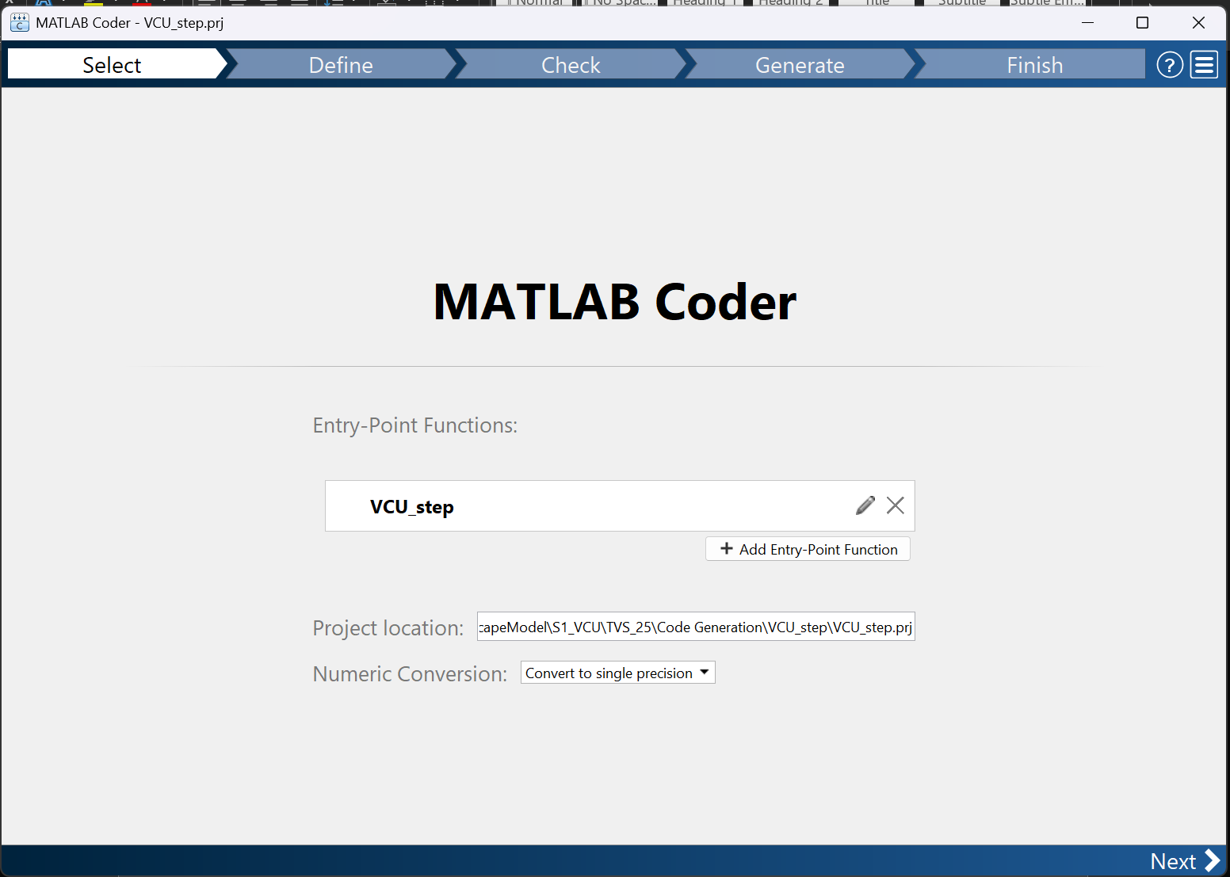

1. Type in function name
2. Choose folder for project and code generated files to reside
   1. Add folder to MATLAB PATH
3. Pick single precision calculations
4. Click next

1. Type in example of function usage
2. Click autodefine Input types
3. Define dummy inputs for all inputs (for example, in matlab terminal)
4. Pick the type name for each struct
5. Click next

1. Click the drop down on check for issues
2. Click check for issues
3. Click next

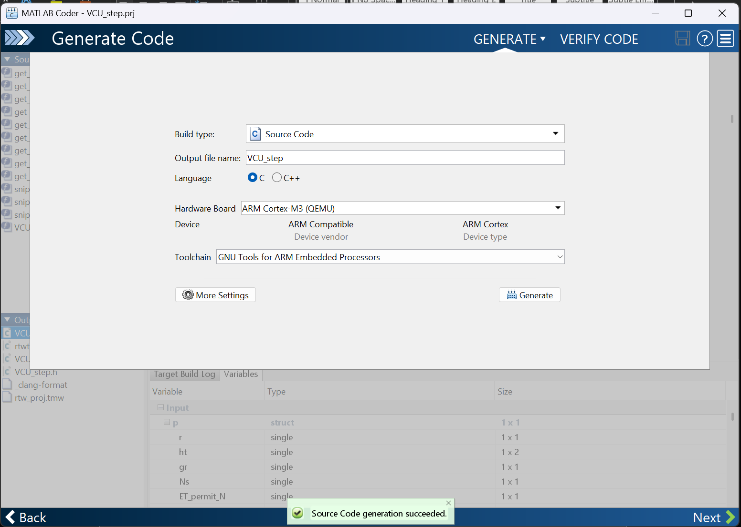

1. Click the drop down on check for issues
2. Configure big parameters:
   1. Build Type: Source Code
   2. Output file: name it the same as the function from before. Ie: VCU_step
   3. Hardware board:
   4. Toolchain: GNU Tools for ARM Embedded Processors
3. More Settings:
   1. Support nonfinite number: **NO**
   2. Enable variable sizing: **NO**
   3. Enable dynamic memory allocation: **NO**
   4. Include comments: **NO**
   5. Initialize function required: **NO**
   6. Terminate function required: **NO**
   7. Generate example main: **NO**
   8. Generate makefile: **NO**
   9. Preserve variable names: **ALL**
4. Click generate
5. Click next

1. You are done