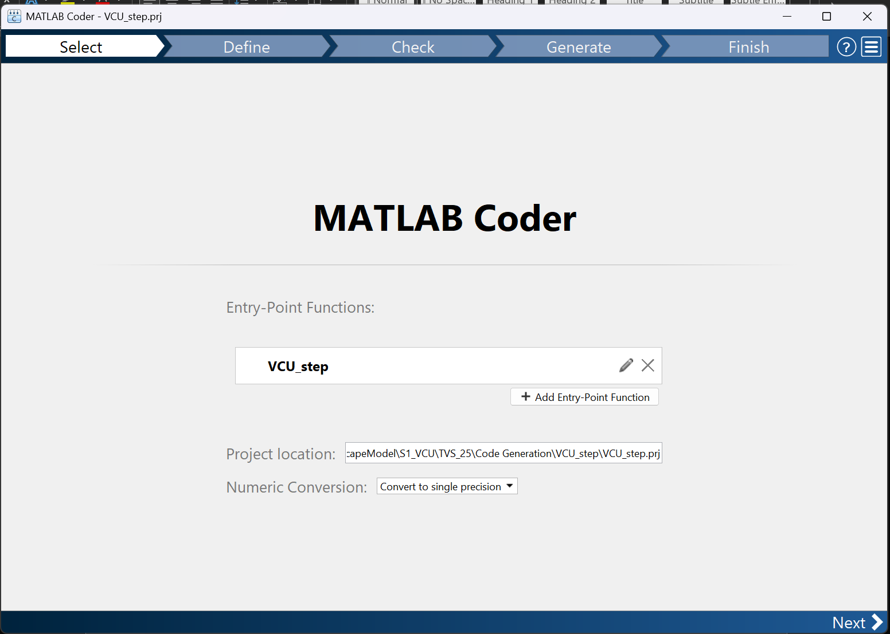

- Type in function name
- Choose folder for project and code generated files to reside
  - Add folder to MATLAB PATH
- Pick single precision calculations
- Click next
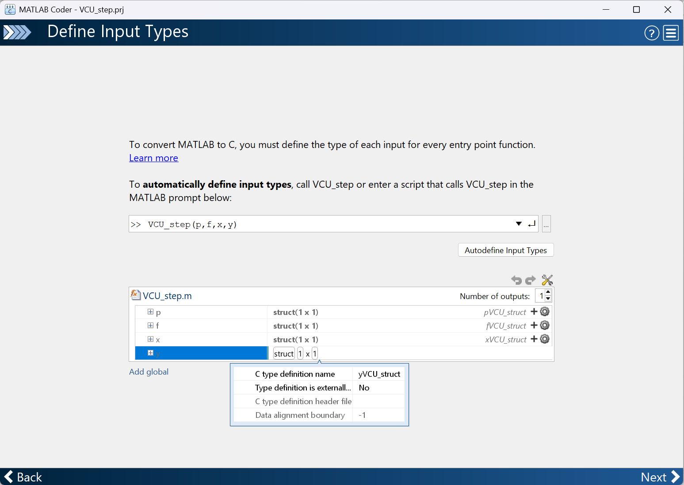
- Type in example of function usage
- Click autodefine Input types
- Define dummy inputs for all inputs (for example, in matlab terminal)
- Pick the type name for each struct
- Click next

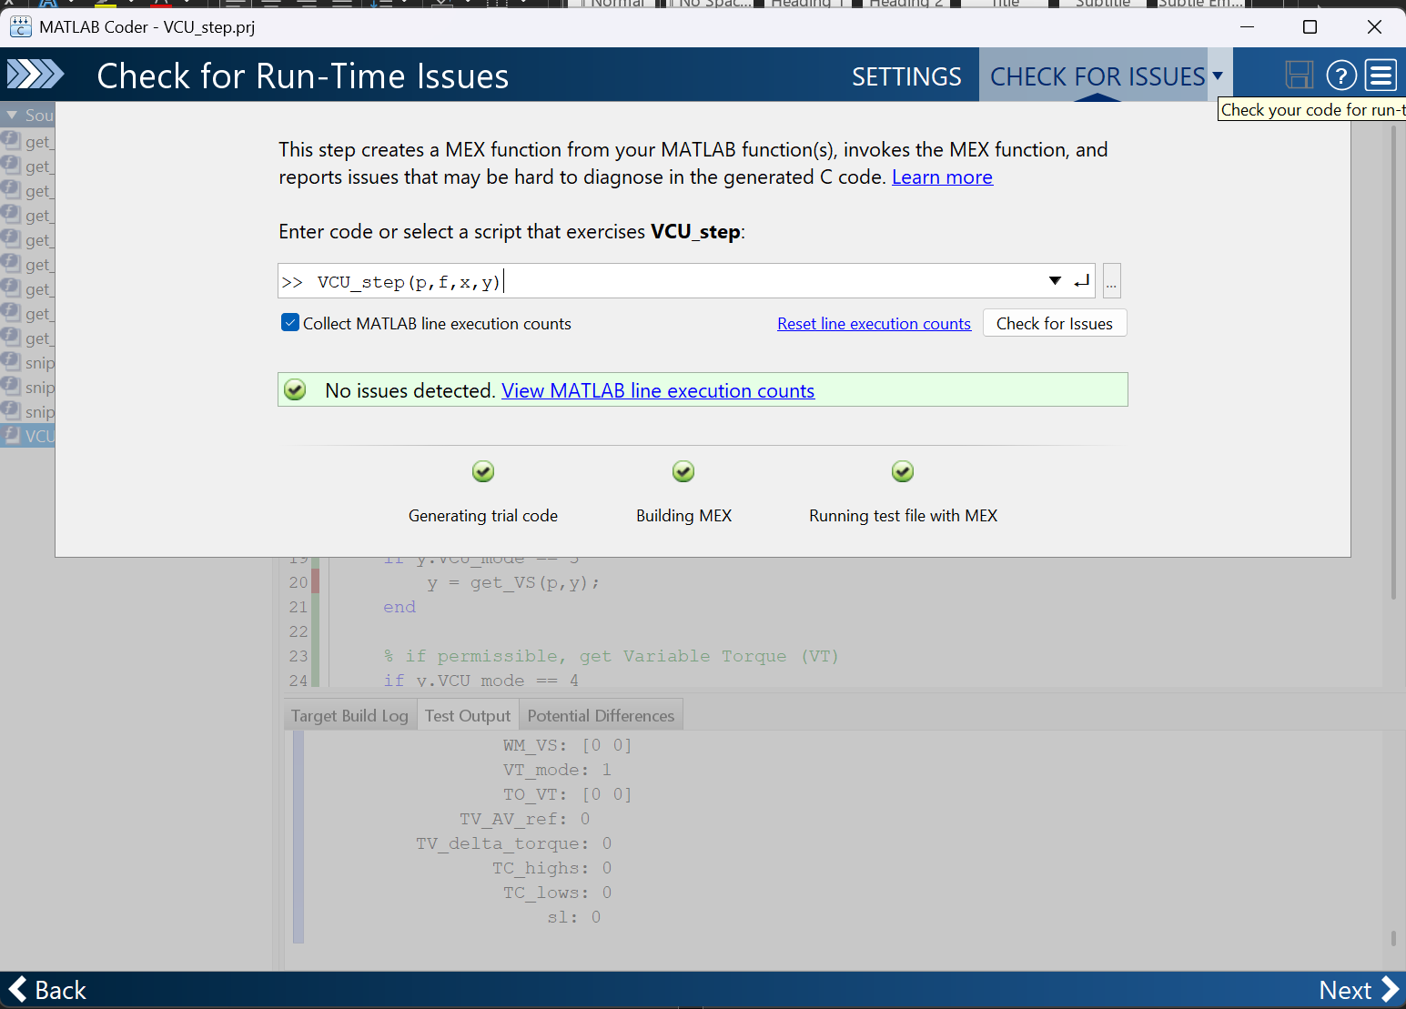
- Click the drop down on check for issues
- Click check for issues
- Click next

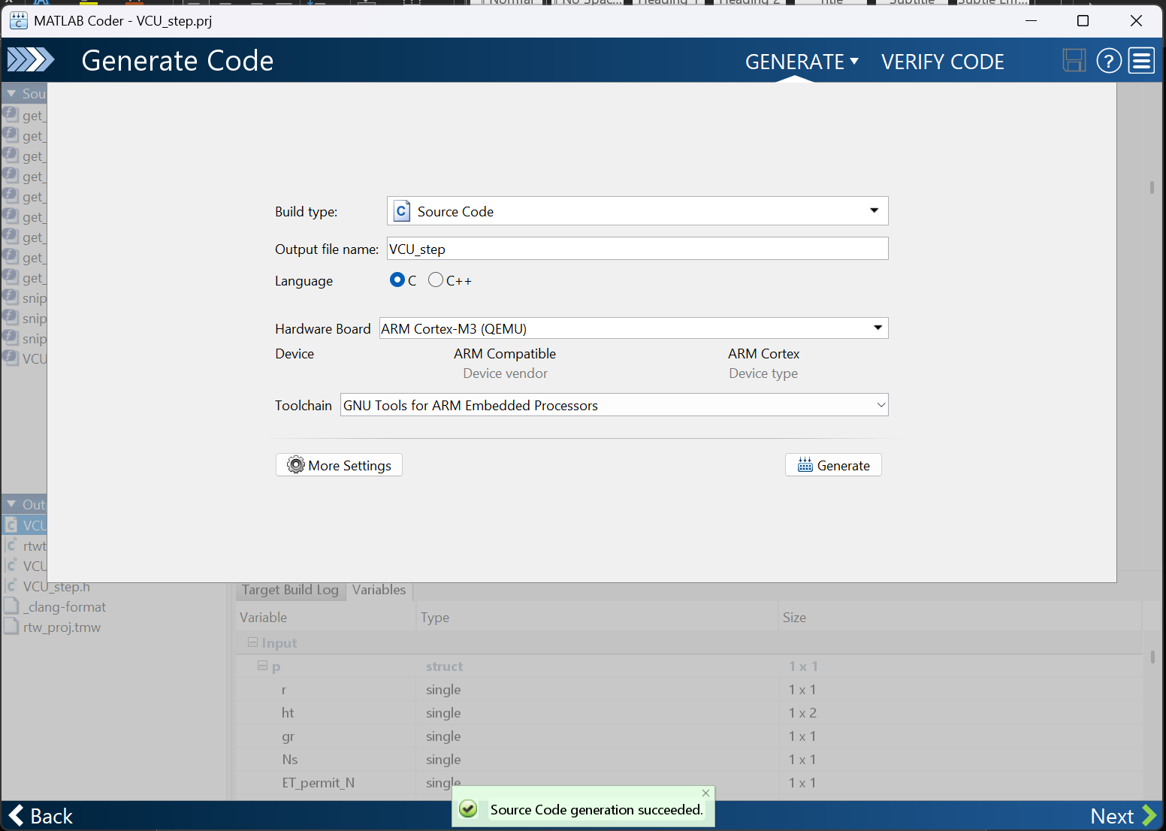
- Click the drop down on check for issues
- Configure big parameters:
  - Build Type: Source Code
  - Output file: name it the same as the function from before. Ie: VCU_step
  - Hardware board:
  - Toolchain: GNU Tools for ARM Embedded Processors
- More Settings:
  - Support nonfinite number: NO
  - Enable variable sizing: NO
  - Enable dynamic memory allocation: NO
  - Include comments: NO
  - Initialize function required: NO
  - Terminate function required: NO
  - Generate example main: NO
  - Generate makefile: NO
  - Preserve variable names: ALL
- Click generate
- Click next

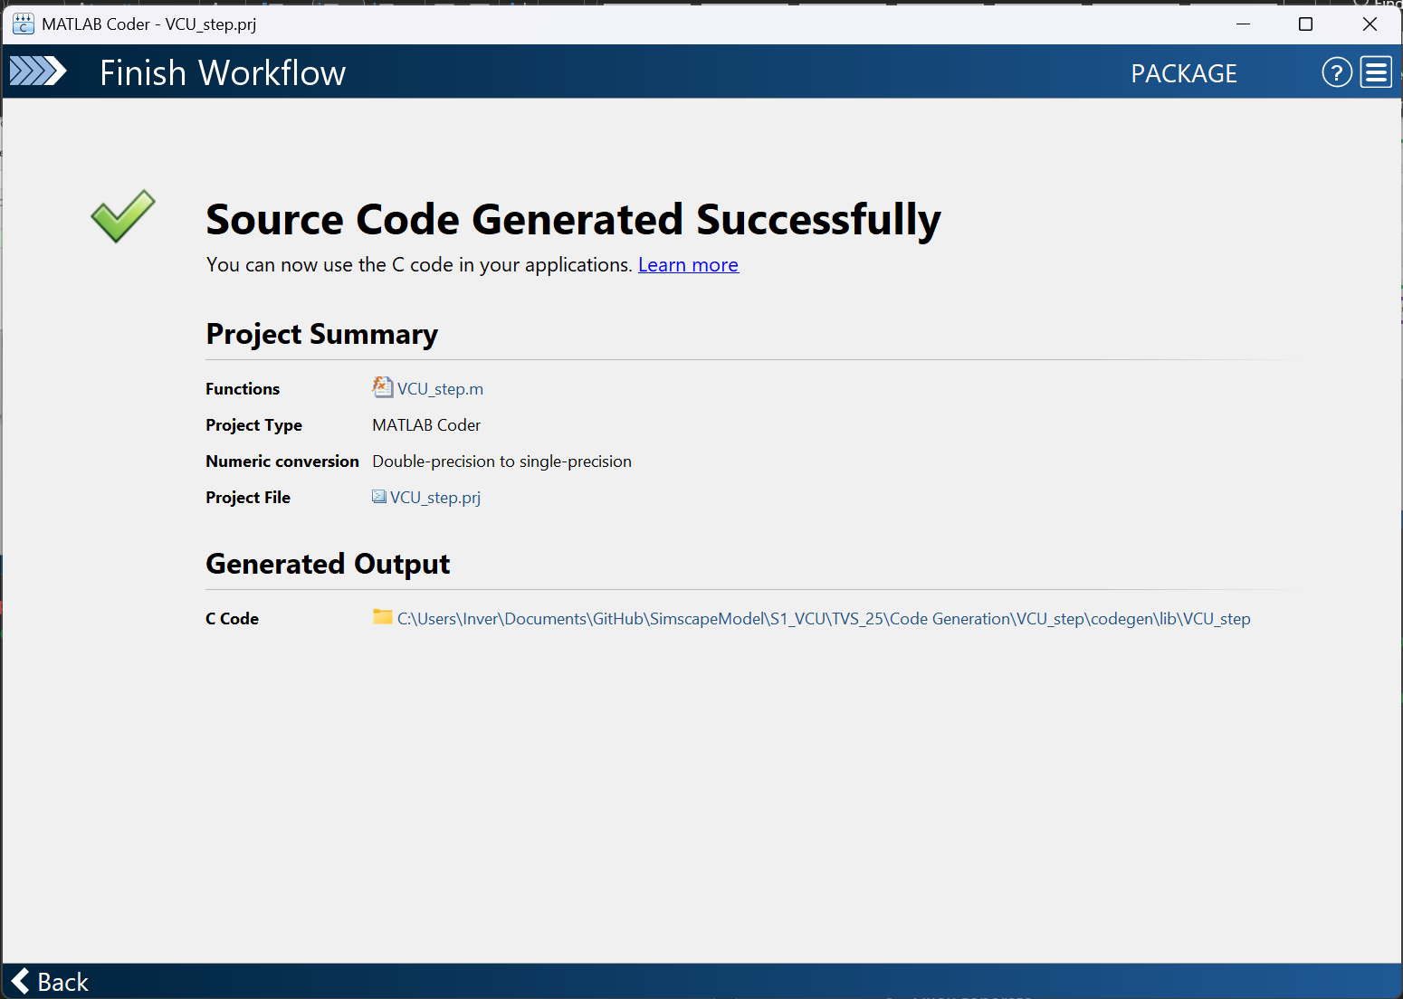
- You are done

