Wagon Wheel

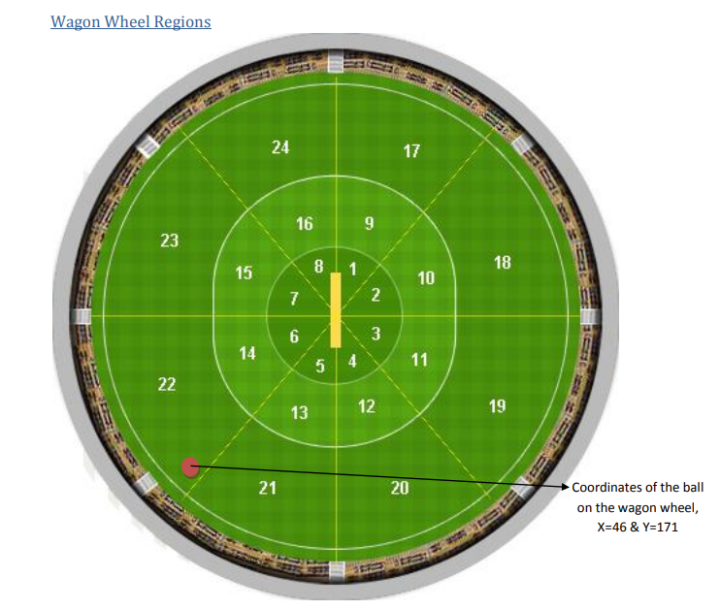

Pitch Map

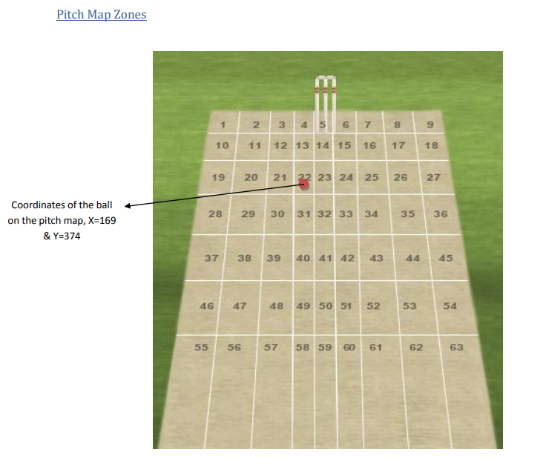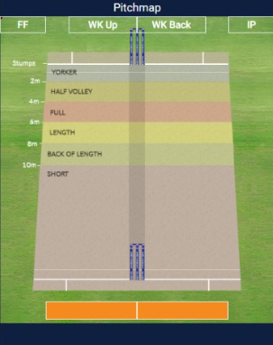

- There are 5 types of Pitch map length, each length name represents many zone values.

S.No | LENGTH | ZONES
1 | Yorker | 10,11,12,13,14,15,16,17,18
2 | Full-Length(2m*to4m) | 19,20,21,22,23,24,25,26,27
3 | Good-Length(4mto6m) | 28,29,30,31,32,33,34,35,36
4 | Back-Of-Length | 37,38,39,40,41,42,43,44,45
5 | Short | 46,47,48,49,50,51,52,53,54,55,56,57,58,59,60,61,62,63

- There are 9 types of Pitch map line, each line name represents many zone values.

S.No | LINE | ZONES
1 | Off-Stump | 4,13,22,31,40,49,58
2 | Outside-Off-Stump | 3,12,21,30,39,48,57
3 | Deep-Outside-Off-Stump | 2,11,20,29,38,47,56
4 | Deepest-Outside-Off-Stump | 1,10,19,28,37,46,55
5 | Middle-Stump | 5,14,23,32,41,50,59
6 | Leg-Stump | 6,15,24,33,42,51,60
7 | Outside-Leg-Stump | 7,16,25,34,43,52,61
8 | Deep-Outside-Leg-Stump | 8,17,26,35,44,53,62
9 | Deepest-Outside-Leg-Stump | 9,18,27,36,45,54,63

Shot Zone Coordinates (Height X and Height Y)

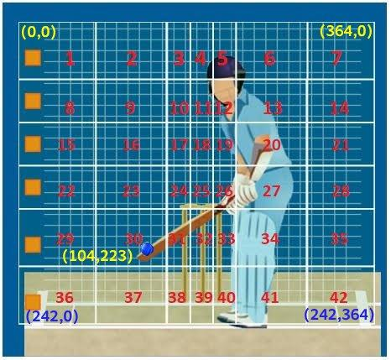

- This is the point where the batsman meets the ball.
- Height X gives the line in which he met the ball.
- Height Y gives the height at which he met the ball.
- Shot Zone is split into 42 different regions.

BALL BY BALL data field descriptions:

- match_id - Each match has a unique match_id

- innings - Innings ID (1 or 2, if test match, ID go up to 4)

- overs - It is a mandatory field and displays which ball of the over starting from 0.1

- innings_ball_num - Each delivery within the innings has a unique ball number and it starts from 1.

- over_num - over (EX - 1, 2…)

- over_ball_num – ball number within an over

- batting_team_id - batting team’s unique id

- batting_team – Name of the batting team

- bowling_team_id - bowling team’s unique id

- bowling_team – name of the bowling team

- striker_id - ID of the batsman who is currently on the strike

- striker_name - Name of the batsman who is currently on the strike

- non_striker_id - ID of the batsman who is currently on the non-strike

- non_striker_name - Name of the batsman who is currently on the non-strike

- bowler_id - ID of the bowler who is currently bowling

- bowler_name - Name of the bowler who is currently bowling

- batting_type - batting type of the striker whether RHB or LHB

- bowling_type - bowling type of the bowler For eg. Right-arm medium, Slow left-arm orthodox etc.

- batting_order - batting order of the striker.

- extras_type - Name of the Extras Type. For eg. legbyes, wide etc.

- extras_1 - extra runs given on the current ball. For eg. 1 run for overstepping.

- extras_2 – Additional/2nd type of extras runs on the current ball. For eg. legbyes on a no-ball.

- runs - runs scored by the batter on the current ball.

- is_wicket - Displays whether wicket fell in the current ball or not. (EX - 0 for no wicket, 1 for wicket)

- dismissal_type_id - dismissal type id of how the batsman wicket fell.

- dismissal_type - name of the dismissal type of the batsman wicket.

- catch_difficulty - In case the batter is out caught, it shows the level of difficulty of the catch taken. For eg. Easy, Medium etc.

- is_four - Displays whether the runs scored by batsman is four or not. (0 for no four, 1 for four runs)

- is_six - Displays whether the runs scored by batsman is six or not. (0 for no six, 1 for six runs)

- dismissed_player_id - player ID of the dismissed batsman.

- Dismissed_player_name - Name of the dismissed batsman.

- pace_or_spin - Ball bowled by the bowler is pace or spin. (2 possible values: Pace, Spin)

- bowl_speed - speed of the ball bowled by the bowler.

- stroke - NAME of the stroke of how the batsman tackled the ball. For eg. Push, Cover drive, Pull Shot etc.

- delivery_style - NAME of the delivery style of the ball. For eg. Seamed In, Leg Break, Yorker etc.

- batsman_crease_movement - NAME of the crease movement of the batsman while tackling the ball. For eg. Back Foot, Creating Room, Charging etc.

- batsman_facing_style - NAME of the Bat subject of how the batsman faced the ball. For eg. Beaten, Defensive, Attacking etc.

- batsman_shot_connection_type - Name of the shot connection of how the batsman connected the ball. For eg. Inside Edge, Good Contact, etc.

- wto_type - Type of the WTO (Wicket taking Opportunity) of how the fielder missed the opportunity of batsman’s wicket. For eg. Runout, Caught, Stumping etc.

- wto_difficulty - Classification of WTO based on difficulty. For eg. Easy, Medium, Difficult etc.

- wto_batsman_id- Player ID of the batsman whose wicket was missed by the fielder. Either striker or non-striker.

- wto_fielder_id - ID of the fielder who missed the opportunity of batsman’s wicket.

- over_or_around_name - whether the bowler is bowling over the wicket or around the wicket. (Possible values: Over, Around).

- fielding_event_position - NAME of the position a fielder is fielding at during an event like Catch taken or Catch Dropped

- on_or_off - NAME of the side of the field the ball is played at. (On-Side or Off-Side)

- bowling_end_name - Name of the end of where the bowler bowls from.

- Is_drs - Displays whether DRS review is taken by either of the teams against umpire’s appeal. (False = DRS not taken and True = DRS taken)

- over_throw_runs - run achieved by the batsman while on overthrow.

- delivery_ist_time - India Standard Time when the current delivery was bowled.

- pitchmap_zone - value of the zone according to the length of the ball bowled by a bowler. (Refer Pitch Map Figure)

- wagon_wheel_zone - zone value of the ball displaced. (Refer Wagon Wheel Figure)

- shot_zone - Shot Zone is broken up into 7 zones horizontally, 6 vertically, counting from left to right, from the top - this indicates which Zone the Ball was in. (Refer shot zone Figure)

- impact_in_player – name of the player who is brought into the game as an impact substitute.

- impact_out_player – name of the player who is taken out of the game as an impact substitute.

