Alexander Ticket
Note: This report has been sanitized for public sharing.
All internal IPs, hostnames, and CrowdStrike URLs have been redacted or replaced with simulated values.

Report was originally prepared for Jira; internal console links are not publicly accessible. Query references shown for context
*The Summary :*
The alert indicates a sequence of suspicious activities including defense evasion through process masquerading of a core Windows binary (RuntimeBroker.exe) executed from an anomalous user directory, detection of an untrusted payload via cloud-based machine learning, living-off-the-land proxy execution via regsvr32.exe beneath a browser process subtree, and local host reconnaissance using systeminfo.exe to gather infrastructure and OS vulnerabilities on host [redacted-host]. 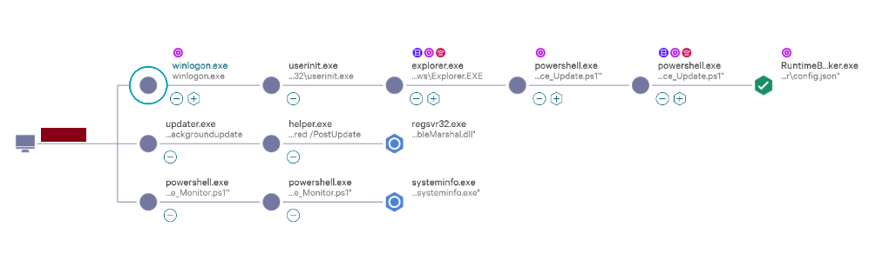
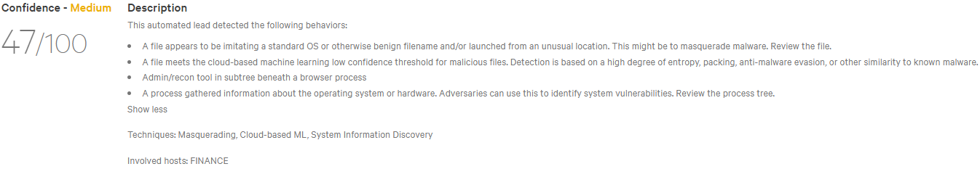

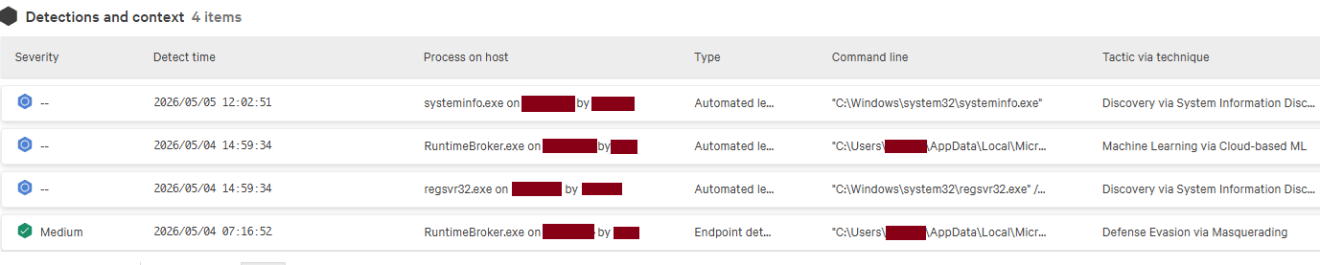

*CrowdStrike Link:*

- Incident(CrowdScore):
(internal link, redacted for confidentiality)

- 1. Endpoint Detection (Defense Evasion via Masquerading - RuntimeBroker.exe) :
(internal link, redacted for confidentiality)
- 2. Automated Lead Context (Machine Learning via Cloud-based ML) :
(internal link, redacted for confidentiality)

*Description*
A multi-stage intrusion was detected on host [redacted-host], characterized by an initial credential-based Remote Desktop (RDP) session hijacking followed by secondary payload execution via the local mail client. The adversary gained initial access at 06:27:19 by reconnecting to a long-standing, persistent REMOTE_INTERACTIVE session of the '[redacted]' user. Immediate defense evasion was conducted via runonce.exe to destroy installation artifacts, followed by the execution of an anomalous PowerShell stager disguised as firefox_dump.zip at 06:29 to harvest browser credentials.
At 07:13, operating within the hijacked desktop session, the adversary initiated an updated instance of Mozilla Thunderbird (thunderbird.exe) to force an encrypted IMAP synchronization at 07:14:06. This step was utilized to ingest a targeted spear-phishing mail containing a malicious shortcut file (Runtime_Service_Update.ps1.lnk) into the local profile database. At 07:15, this shortcut was executed, triggering a secondary script that performed binary masquerading by compile-writing a packed cryptomining implant (RuntimeBroker.exe) into an anomalous user path. Threat progression was terminated by CrowdStrike Falcon, which blocked the masqueraded process and quarantined the core execution file. Approximately 16 hours later, the adversary re-engaged the host via a separate script to perform automated host reconnaissance using systeminfo.exe.

🔹 Host Information:
Hostname: [redacted-host]
Operating System: Windows 10
External IP: [redacted]
Local IP Address: [redacted internal IP]
Host Type: Workstation
🔹 User Information:
1. Initial Compromised Account:
Username: [redacted]
Local Admin: Yes
Login Type: REMOTE_INTERACTIVE
Login Time: Feb. 2, 2026 09:57:05
Login Domain: [redacted-domain]
🔹 Tactic & Technique:
Technique: Defense Evasion via Masquerading, Discovery via System Information Discovery, Machine Learning via Cloud-based ML, Sensor-based ML
MITRE ATT&CK ID: T1036, T1218.010, T1059.001, T1082

*Investigation Findings and Analysis:*

Observed Command 1: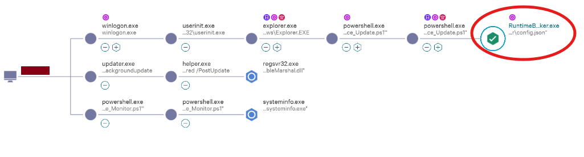

➀ Phase 1: Initial Access, Execution & Payload Deployment
Process: explorer.exe
Start time: May 4, 2026 06:27:19
Command line
C:\Windows\Explorer.EXE
File path
\Device\HarddiskVolume2\Windows\explorer.exe

Executable SHA256
988a56d897915315eef9ca679b3bc8adfcecf5e227aea99aaa1817620520e97e
[Resulthere|https://www.virustotal.com/gui/file/988a56d897915315eef9ca679b3bc8adfcecf5e227aea99aaa1817620520e97e]
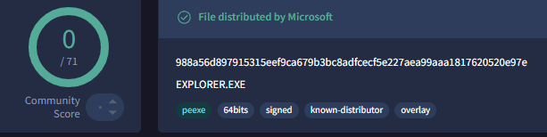
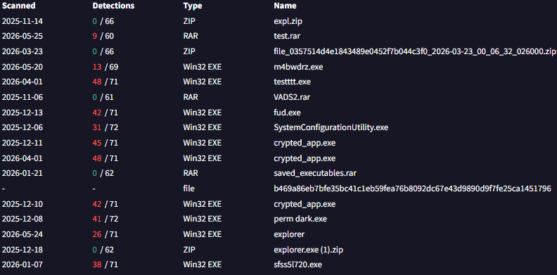
The lineage begins with the primary user shell. This confirms the activity originated from an interactive RDP session. Although the binary is legitimate (0/71 on VT), the 11/17 malicious execution parents suggest this session context is frequently targeted for hijacking. The adversary utilized the existing [redacted-host] session to bypass the need for a new authentication event.

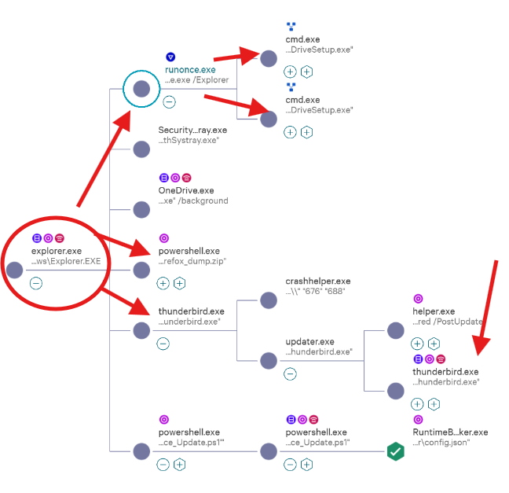

Subprocess: runonce.exe
Parent Process : explorer.exe
Start time: May 4, 2026 06:27:44 End time: May 4, 2026 06:27:51
Command line
"runonce.exe /Explorer"
File path
\Device\HarddiskVolume2\Windows\System32\runonce.exe

Executable SHA256
eb40639c488a46f8b787ab4ebc7a4f712286971432f1e8675e993dcc4c778554
[Resulthere|https://www.virustotal.com/gui/file/eb40639c488a46f8b787ab4ebc7a4f712286971432f1e8675e993dcc4c778554/detection]
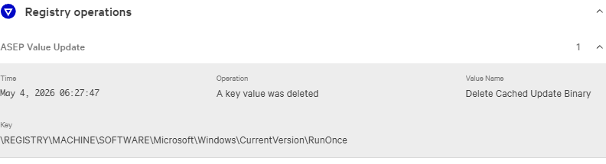
This process represents a critical pivot point leveraging Windows Auto-Start Execution Points (ASEP) for defense evasion. Triggered directly by the user shell (explorer.exe), runonce.exe executed an entry staged in the registry under the RunOnce key titled Delete Cached Update Binary. The binary itself is a legitimate Windows component (0/69 on VT), but its execution was subverted by the adversary to sequentially spawn two command shell instances designed to purge forensic artifacts before the system's runtime monitoring could flag the source installer.

Subprocess: cmd.exe (Multiple Instances)
Parent Process : runonce.exe
Start time: May 4, 2026 06:27:46 End time: May 4, 2026 06:27:50
Command line 1
"C:\Windows\System32\cmd.exe" /q /c del /q "C:\Program Files\Microsoft OneDrive\Update\OneDriveSetup.exe"
Command line 2
"C:\Windows\System32\cmd.exe" /q /c del /q "C:\Program Files\Microsoft OneDrive\StandaloneUpdater\OneDriveSetup.exe"
File path
\Device\HarddiskVolume2\Windows\System32\cmd.exe

Executable SHA256
badf4752413cb0cbdc03fb95820ca167f0cdc63b597ccdb5ef43111180e088b0

[Resulthere|https://www.virustotal.com/gui/file/badf4752413cb0cbdc03fb95820ca167f0cdc63b597ccdb5ef43111180e088b0/relations]

Spawned as direct sub-processes of runonce.exe, these instances utilize the native Microsoft Command Shell binary, which displays a clean signature and high prevalence globally (0/53 on VT). However, CrowdStrike Falcon generated Medium and Low severity "Anomalous Process Execution" alerts targeting this specific sequence. The EDR's behavioral AI flagged the execution context due to highly suspicious command-line parameters optimized for stealth history suppression and quiet file deletion (/q /c del). This correlates with known multi-stage LNK exploitation tactics where trusted system binaries are abused to execute automated indicator removal, successfully purging the initial delivery payloads from the OneDrive directories to impede forensic timeline reconstruction.
Subprocess: powershell.exe
Parent Process : explorer.exe
Start time: May 4, 2026 06:29:08 End time: May 4, 2026 06:29:14
Command line
"C:\Windows\System32\WindowsPowerShell\v1.0\powershell.exe" -w hidden -ep bypass -File "C:\Users\[redacted]\AppData\Local\Temp\firefox_dump.zip"
File path
\Device\HarddiskVolume2\Windows\System32\WindowsPowerShell\v1.0\powershell.exe

Executable SHA256
9785001b0dcf755eddb8af294a373c0b87b2498660f724e76c4d53f9c217c7a3
[Resulthere|https://www.virustotal.com/gui/file/9785001b0dcf755eddb8af294a373c0b87b2498660f724e76c4d53f9c217c7a3/detection]
Flagged by defensive systems due to highly evasive command-line arguments designed to conceal execution visibility from the user (-w hidden) and intentionally override corporate security configurations (-ep bypass). The adversary utilized a native, trusted Microsoft interpreter to execute code stored inside an obfuscated script masquerading as a compressed folder archive (firefox_dump.zip) within the local Temp directory. Community threat intelligence marks this execution context as highly suspicious, serving as the primary automated bridge to deploy the final masqueraded RuntimeBroker.exe implant.
Subprocess: thunderbird.exe (Updated Instance)
Parent Process : updater.exe
Start time: May 4, 2026 07:13:45 End time: May 4, 2026 07:15:57
Command line
"C:\Program Files\Mozilla Thunderbird\thunderbird.exe"
File path
\Device\HarddiskVolume2\Program Files\Mozilla Thunderbird\updated\thunderbird.exe

Executable SHA256
e414b612806f2b9b642e0979a75e4ee9de498b4ca8372b00c0deecc072e06f3f
[Resulthere|https://www.virustotal.com/gui/file/e414b612806f2b9b642e0979a75e4ee9de498b4ca8372b00c0deecc072e06f3f]
This specific process tracks an updated instance of the mail client running within the hijacked user session context. Timeline analysis confirms this process is not the initial network entry point, as malicious execution (firefox_dump.zip) occurred 44 minutes prior. Instead, this activity represents post-compromise deployment tradecraft. Network telemetry confirms that at 07:14:06, the adversary utilized the active session to force encrypted synchronization over port 993 (IMAP) with the internal mail server [redacted]. This maneuver allowed the attacker to extract a pre-staged email containing the malicious shortcut payload (Runtime_Service_Update.ps1.lnk) directly into the local profile database, effectively using the compromised mailbox as an internal data staging and execution vector.

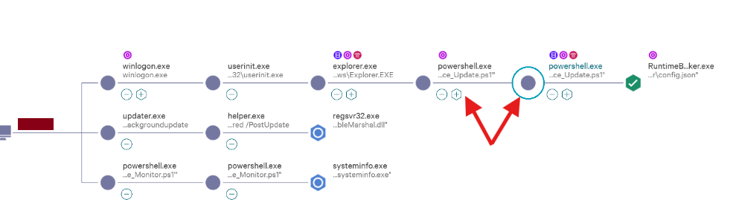

Process: powershell.exe (1)
Start time: May 4, 2026 07:15:38 End time: May 4, 2026 07:15:44
Command line
"C:\Windows\System32\WindowsPowerShell\v1.0\powershell.exe" "-Command" "if((Get-ExecutionPolicy ) -ne 'AllSigned') { Set-ExecutionPolicy -Scope Process Bypass }; & 'C:\Users\[redacted]\Downloads\Runtime_Service_Update.ps1'"
File path
\Device\HarddiskVolume2\Windows\System32\WindowsPowerShell\v1.0\powershell.exe

Executable SHA256
9785001b0dcf755eddb8af294a373c0b87b2498660f724e76c4d53f9c217c7a3
[Resulthere|https://www.virustotal.com/gui/file/9785001b0dcf755eddb8af294a373c0b87b2498660f724e76c4d53f9c217c7a3]
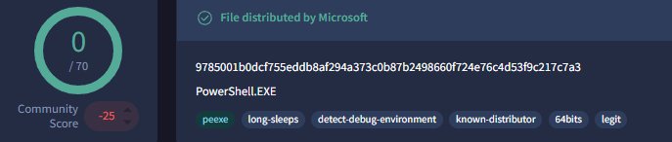

This process marks the initial automated triage phase of the script execution layout. Spawned directly from the user shell following the link file interaction, this instance evaluates the host's current script execution restrictions. By executing an inline command block, the script dynamically forces an execution policy override exclusively within its current process scope (-Scope Process Bypass), bypassing global administrative restrictions without altering permanent system registry values. This defense evasion maneuver was critical to immediately prime the system environment for running the un-signed Runtime_Service_Update.ps1 script located inside the user's Downloads directory.

Process: powershell.exe (2)
Start time: May 4, 2026 07:15:43 End time: May 4, 2026 07:15:51
Command line
"C:\Windows\System32\WindowsPowerShell\v1.0\powershell.exe" -NoProfile -ExecutionPolicy Bypass -File "C:\Users\[redacted]\Downloads\Runtime_Service_Update.ps1"

This process represents the core operational execution engine of the threat workflow, running with the highly evasive -NoProfile flag to block user-specific profile modifications from triggering security event logs. Network telemetry shows active automated external staging over port 443 (HTTPS) interacting directly with github.com and release-assets.githubusercontent.com (IPs: 140.82.121.4, 185.199.110.133) to stream dual-purpose payloads.
Disk and memory telemetry indicate a sophisticated multi-component drop:
- Resource Hijacking: The process extracted and dropped a cryptocurrency mining suite (xmrig.exe, solo_mine_example.cmd) along with a low-level hardware access kernel-mode driver (WinRing0x64.sys) into the local user Temp path.
- Persistence & Defense Evasion: Simultaneously, the script performed process masquerading by compile-writing an untrusted binary implant named RuntimeBroker.exe into an anomalous local application directory (\Device\HarddiskVolume2\Users\[redacted]\AppData\Local\Microsoft\WindowsApps\RuntimeBroker\RuntimeBroker.exe ), laying the groundwork for an evasive execution tree mimicking standard OS background operations.
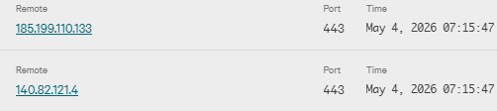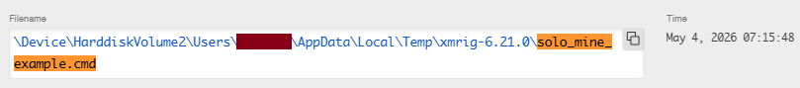
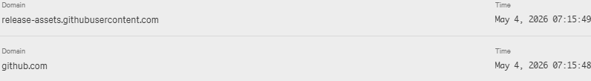
Ip 140.82.121.4
[Resulthere|https://www.virustotal.com/gui/ip-address/140.82.121.4]
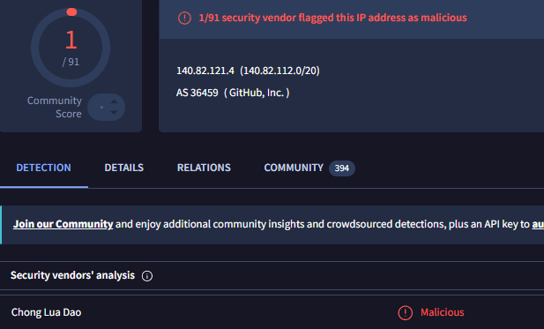
Ip 185.199.110.133
[Resulthere|https://www.virustotal.com/gui/ip-address/185.199.110.133]
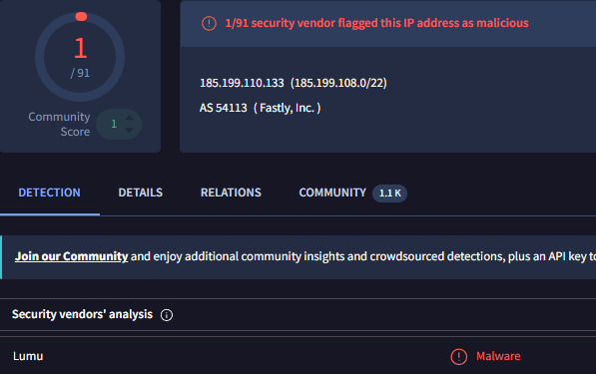

Process: RuntimeBroker.exe
Start time: May 4, 2026 07:15:50 End time: May 4, 2026 07:15:50
Executable SHA256
f07c7223fdb691acbf0ebc7d9cc2ae614c0cf705920420c0130248a0c0e861d4
[Resulthere|https://www.virustotal.com/gui/file/f07c7223fdb691acbf0ebc7d9cc2ae614c0cf705920420c0130248a0c0e861d4]
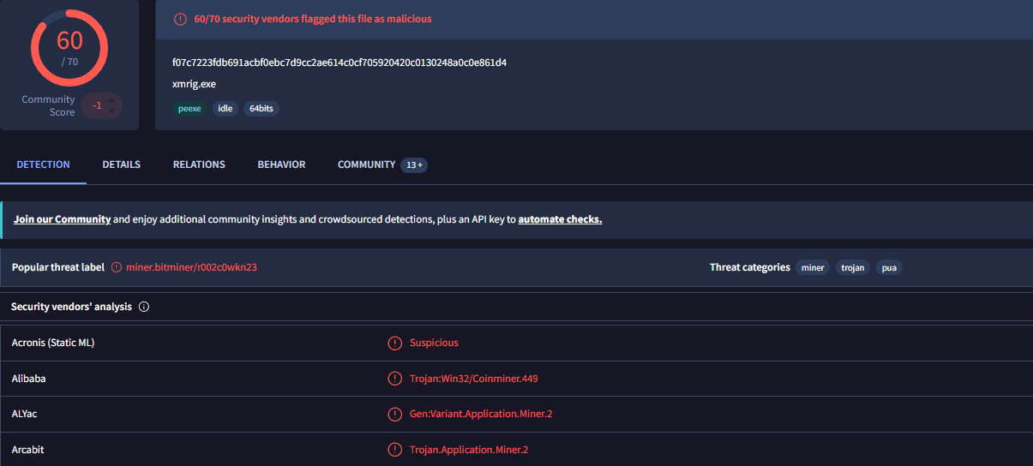
This process represents the final intended payload of the upper execution tree and was immediately terminated by security controls. The execution chain exhibits definitive indicators of T1036 (Defense Evasion via Masquerading). While RuntimeBroker.exe is a legitimate Windows core system binary, its execution out of an anomalous user profile subfolder (\Device\HarddiskVolume2\Users\[redacted]\AppData\Local\Microsoft\WindowsApps\RuntimeBroker\RuntimeBroker.exe) rather than the native trusted C:\Windows\System32\ directory confirms binary impersonation.

CrowdStrike flagged:
Detection: Machine Learning via Sensor-based ML
Detection Timestamp: May 4, 2026 07:16:52
Action taken: File quarantined + File blocked
Triggering indicator :
File path
\Device\HarddiskVolume2\Users\[redacted]\AppData\Local\Microsoft\WindowsApps\RuntimeBroker\RuntimeBroker.exe

The local on-sensor AI engine flagged the execution attempt due to real-time behavioral anomalies, triggering a pre-emptive termination based on localized heuristics.
CrowdStrike flagged:
Detection: Defense Evasion via Masquerading
Action taken: File quarantined + File blocked + Remediation performed
Associated MD5
118c2d536d52dd30116baaf06dfe5e63
The binary actively mimicked a core operating system component while operating from an unprivileged, non-standard path, establishing a clear structural signature of directory and binary masquerading.
Identified by CrowdStrike as an automated lead:
Detection: Machine Learning via Cloud-based ML
Detection Timestamp: May 4, 2026 14:59:34
Command line
"C:\Users\[redacted]\AppData\Local\Microsoft\WindowsApps\RuntimeBroker\RuntimeBroker.exe" -c "C:\Users\[redacted]\AppData\Local\Microsoft\WindowsApps\RuntimeBroker\config.json"
File path
\Device\HarddiskVolume2\Users\[redacted]\AppData\Local\Microsoft\WindowsApps\RuntimeBroker\RuntimeBroker.exe

Cloud-based intelligence confirmed advanced evasion indicators, noting high mathematical entropy and binary packing anomalies characteristic of custom crypted payloads.

🔹 Telemetry & SIEM Validation (Advanced Event Search):
Event Type: AssociateTreeIdWithRoot
Enforcement Timeline:
- 07:15:50.627 — Triggered PatternId: 10139 (Behavioral Masquerading Context Correlation).
- 07:15:51.096 — Triggered PatternId: 5700 (Sensor-Based ML Real-Time Execution Halt).

Observed Command 2:
Ruled Out Context (False Positive) 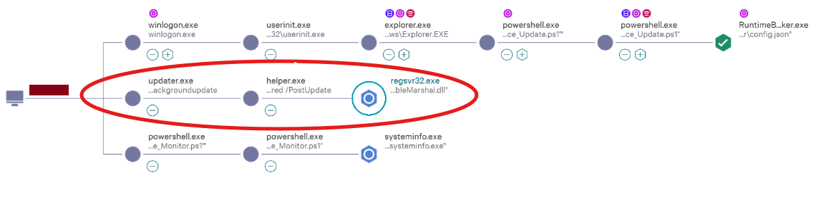

Processes: updater.exe ➔ helper.exe ➔ regsvr32.exe
Command Line: "C:\Windows\system32\regsvr32.exe" /s "C:\Users\[redacted]\AppData\Local\Mozilla Firefox\AccessibleMarshal.dll"
This alert is classified as a False Positive. The regsvr32.exe utility falls under the LOLBAS (Living off the Land Binaries and Scripts) classification and is heavily abused by threat actors to execute arbitrary code silently. Consequently, its invocation within a browser-related process subtree automatically triggers standard heuristic telemetry rules within CrowdStrike Falcon.
However, deep context verification validates its benign nature: the system registration binary was executed in silent mode (/s) exclusively to register the official, digitally signed library AccessibleMarshal.dll (a legitimate Mozilla component responsible for Accessibility features). The zero-enforcement state (Actions taken: None) and the complete absence of this event within the telemetry detection repository (#repo:detections) confirm that this process posed no security threat, had no correlation with the malicious XMRig deployment, and constitutes standard operating system background noise.

Observed Command 3:
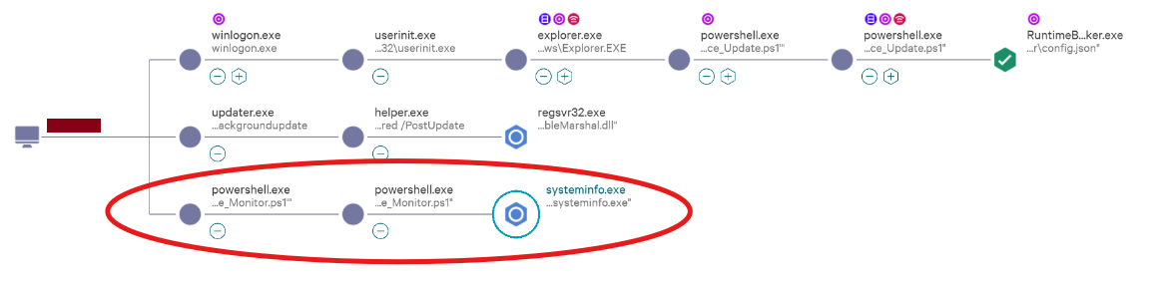

➁ Phase 2 : Host Reconnaissance & Discovery
Process: powershell.exe (1 - Discovery Policy Evasion)
Start time: May 5, 2026 12:01:29 End time: May 5, 2026 12:01:34
Command line
"C:\Windows\System32\WindowsPowerShell\v1.0\powershell.exe" "-Command" "if((Get-ExecutionPolicy ) -ne 'AllSigned') { Set-ExecutionPolicy -Scope Process Bypass }; & 'C:\Users\[redacted]\Downloads\System_Performance_Monitor.ps1'"
File path
\Device\HarddiskVolume2\Windows\System32\WindowsPowerShell\v1.0\powershell.exe
Executable SHA256
9785001b0dcf755eddb8af294a373c0b87b2498660f724e76c4d53f9c217c7a3

[Resulthere|https://www.virustotal.com/gui/file/9785001b0dcf755eddb8af294a373c0b87b2498660f724e76c4d53f9c217c7a3]
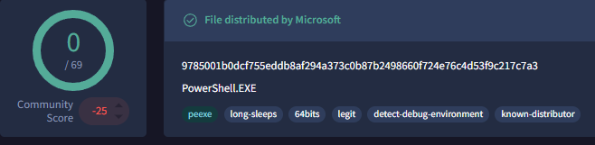

Mirroring the defense evasion techniques seen in Phase 1, this transient 5-second instance was spawned to systematically check and dismantle execution policy restrictions. By forcing an inline -Scope Process Bypass, the adversary primed the environment to execute the untrusted script System_Performance_Monitor.ps1 from the user's Downloads folder without changing permanent registry configurations.

Process: powershell.exe (2 - Reconnaissance Script Engine)
Start time: May 5, 2026 12:01:34 End time: May 5, 2026 12:02:25
Command line
"C:\Windows\System32\WindowsPowerShell\v1.0\powershell.exe" -NoProfile -ExecutionPolicy Bypass -File "C:\Users\[redacted]\Downloads\System_Performance_Monitor.ps1"
File path
\Device\HarddiskVolume2\Windows\System32\WindowsPowerShell\v1.0\powershell.exe

This process acted as the core execution vehicle for the second stage script. Running with -NoProfile to minimize logging footprints, the script remained active in memory for 51 seconds. The name System_Performance_Monitor.ps1 represents a deceptive masquerading attempt designed to mimic normal system administrative workflows. The primary objective of this script session was to systematically spawn discovery commands to audit the host machine configuration.

Process: systeminfo.exe
Start time: May 5, 2026 12:01:47 End time: May 5, 2026 12:01:53
Executable SHA256
6f87caa51bdea802045bb281fc2686a3c76364c26a3ffe6c2ccac4af5f9db37b
[Resulthere|https://www.virustotal.com/gui/file/6f87caa51bdea802045bb281fc2686a3c76364c26a3ffe6c2ccac4af5f9db37b]
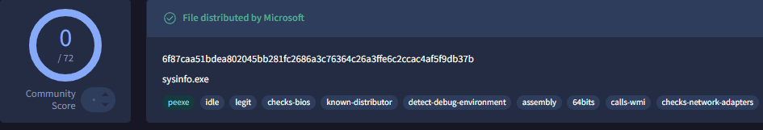
Identified by CrowdStrike as an automated lead:
Detection: Discovery via System Information Discovery
Detection Timestamp: May 5, 2026 12:02:51
Command line
"C:\Windows\system32\systeminfo.exe"
File path
\Device\HarddiskVolume2\Windows\System32\systeminfo.exe

This activity constitutes confirmed Host Reconnaissance. While systeminfo.exe is a legitimate, native Windows administrative binary (0/75 on VirusTotal), its execution from the context of an unvetted user download script confirms malicious intent. The adversary explicitly abused this tool to collect critical system parameters, including OS architecture, domain naming structures, hardware specifications, network interfaces, and installed hotfixes/patches.
Threat actors routinely leverage this precise information to identify missing security updates, customize subsequent privilege escalation exploits, or determine if the machine is a sandboxed analysis environment. Though CrowdStrike registered this as a non-enforced context lead (Actions taken: None), it confirms that the adversary successfully collected architectural layout data from the [redacted-host] endpoint before this specific tool session closed.

Analysis

A thorough analysis of associated processes (lsass, services, svchost) has been conducted. No anomalous activity indicating additional attack vectors or hidden backdoors within system processes was detected. All network and registry activity within these branches has been deemed legitimate system background activity (baseline).
Command Line Breakdown: Phase 1 (Initial Access & Payload Deployment)
"C:\Windows\System32\cmd.exe" /q /c del /q "C:\Program Files\Microsoft OneDrive\Update\OneDriveSetup.exe"
- Indicator Removal → The adversary subverted the native Windows RunOnce registry key via runonce.exe to quietly execute targeted file deletions. The use of silent flags (/q /c del) was optimized to purge the source installer artifacts and corrupt the forensic timeline.
"C:\Windows\System32\WindowsPowerShell\v1.0\powershell.exe" -w hidden -ep bypass -File "C:\Users\[redacted]\AppData\Local\Temp\firefox_dump.zip"
- -w hidden & -ep bypass → Standard adversary tradecraft to completely hide the desktop console window from the active user and force an execution policy override.
- Defense Evasion → The malicious loader script was masqueraded inside a fake compressed archive (firefox_dump.zip) and executed directly from the user's local Temp path to evade basic static string inspection.
"C:\Windows\System32\WindowsPowerShell\v1.0\powershell.exe" -NoProfile -ExecutionPolicy Bypass -File "C:\Users\[redacted]\Downloads\Runtime_Service_Update.ps1"
- Resource Hijacking → The core script engine established automated external connections to GitHub infrastructure to ingest a cryptocurrency mining suite (xmrig.exe) and drop a low-level hardware access kernel driver (WinRing0x64.sys) into user-space directories.
- Evasive Persistence → Simultaneously, the script initiated compilation sequences to compile-write an untrusted backdoor payload disguised as a core Windows component directly into an anomalous local application path.
"C:\Users\[redacted]\AppData\Local\Microsoft\WindowsApps\RuntimeBroker\RuntimeBroker.exe" -c "C:\Users\[redacted]\AppData\Local\Microsoft\WindowsApps\RuntimeBroker\config.json"
- Process Masquerading → The binary explicitly mimicked the name of a legitimate Microsoft core system component (RuntimeBroker.exe) to blend with benign background processes while loading a hidden configuration layer (-c config.json).
- Software Packing/Entropy → Cloud-based intelligence flagged high mathematical entropy and binary packing configurations, indicating a heavily obfuscated defense evasion attempt.
Command Line Breakdown: Phase 2 (Host Reconnaissance & Discovery)
"C:\Windows\System32\WindowsPowerShell\v1.0\powershell.exe" -NoProfile -ExecutionPolicy Bypass -File "C:\Users\[redacted]\Downloads\System_Performance_Monitor.ps1"
- Execution Pattern Continuity → The adversary reappeared approximately 16 hours later, utilizing an identical process-scope execution policy bypass rule. The script was intentionally renamed to System_Performance_Monitor.ps1 to masquerade as legitimate administrative workflows and lower the risk of detection during active runtime monitoring.
"C:\Windows\system32\systeminfo.exe"
- System Information Discovery → The script abused the native Microsoft configuration auditing tool to harvest detailed host parameters, including OS architecture, active domain trees, hardware specifications, and hotfix patch levels. This reconnaissance data is routinely gathered to map vulnerabilities for subsequent privilege escalation exploits.
The Verdict (SUCCESSFUL BLOCK) → Raw telemetry confirms a synchronized multi-layered enforcement action. Local hybrid engines successfully intercepted the execution within milliseconds (PatternId: 5700 and 10139). The masqueraded RuntimeBroker.exe binary was completely blocked and shifted into a quarantined state before it could establish persistent external C2 communications.

Potential Impact
- Unauthorised Resource Hijacking (Partial Success): The core PowerShell script successfully dropped a cryptocurrency mining suite (xmrig.exe, solo_mine_example.cmd) and a low-level hardware kernel driver (WinRing0x64.sys) into the local user Temp directory. While the primary backdoor was intercepted, these staging files remain on disk and pose an active risk to system performance and resource integrity until manually purged.

- Host Infrastructure Reconnaissance (Success): The execution of systeminfo.exe via the second-stage script (System_Performance_Monitor.ps1) was successfully completed with no enforcement action taken (Actions taken: None). The adversary successfully gathered the workstation's OS architecture, domain naming schema, and hotfix patch levels, effectively mapping out the system baseline to identify potential privilege escalation exploits.

- Forensic Artifact Tampering (Success): The adversary successfully subverted the Windows Auto-Start Execution Points (ASEP) by leveraging the RunOnce registry key to trigger runonce.exe and cmd.exe. This allowed them to quietly purge the source OneDriveSetup.exe installers from the program directories, intentionally eliminating early-stage indicators of compromise and disrupting forensic timeline reconstruction.

- Evasive Backdoor Persistence (Prevented): The compilation and attempted deployment of the packed RuntimeBroker.exe implant within the WindowsApps folder was completely countered. Falcon’s hybrid machine learning and behavioral masquerading engines intercepted the execution within milliseconds, preventing the attacker from establishing a persistent, hidden command-and-control (C2) channel via the config.json layer.

- Threat Containment Velocity (Near-Zero Payload Dwell Time): Due to automated EDR intervention at the critical execution threshold of the masqueraded payload, the adversary failed to transition from script execution to an interactive binary shell. The dwell time for the primary backdoor implant was effectively restricted to less than one second, preventing any actual damage to corporate data integrity.

Host Inspection:
During the manual investigation of host [redacted-host] , the following artifacts and evidence were identified, confirming the intrusion and execution chain.
- Filesystem Artifacts (Evidence of Staging) A manual search of the user's directory confirmed the presence of the malicious directory structure and persistent configuration payload identified in the CrowdStrike alerts.
Directory: C:\Users\[redacted]\AppData\Local\Microsoft\WindowsApps\RuntimeBroker
File Identified: config.json
SHA256: 37BE1EB4641F5A6061648623B289BFFCAD863BE47F5031F6980B542A09904EB1 VirusTotal Score: 0/75 (Unknown/Unseen). Classified as a newly generated, campaign-specific mining profile.
- Configuration Content Analysis (Static Analysis) Manual inspection of the configuration logic (via cat) revealed the adversary’s automated deployment process and mining pool destination parameters: Payload Intent: The parameters explicitly map out an unauthorized XMRig cryptocurrency mining operational environment. Resource Exploitation: The configuration was optimized to heavily hijack workstation performance via the "max-threads-hint": 80 key, forcing up to 80% CPU utilization. C2 Pool Reporting: Connections were mapped to an external stratum mining pool destination at portugalloindostan.top:443 using strict TLS encryption ("tls": true) to bypass network detection controls, funneling assets directly to a hardcoded attacker wallet address.

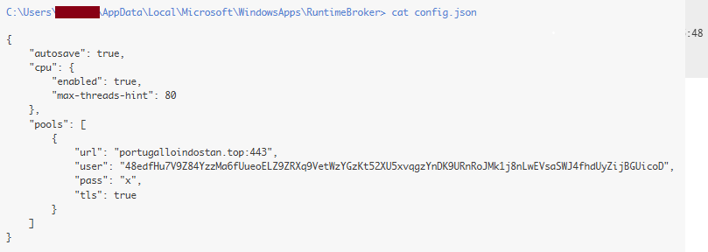
Execution Evidence (Command Line Telemetry) Forensic evidence from the host's memory and event logs provided the exact parameters used to initiate the mining impact: Mining Command: "C:\Users\[redacted]\AppData\Local\Microsoft\WindowsApps\RuntimeBroker\RuntimeBroker.exe" -c "C:\Users\[redacted]\AppData\Local\Microsoft\WindowsApps\RuntimeBroker\config.json"
Analysis: The binary deliberately targeted system binary impersonation to run out of an unprivileged user folder. The use of the -c switch to load the local configuration file confirms that the masqueraded process execution and the cryptomining configuration block were part of the same coordinated attack.
System Remediation State A check of the temporary directories and the EDR quarantine status confirmed: Quarantined Binaries: RuntimeBroker.exe (confirmed successfully extracted and isolated from the WindowsApps\RuntimeBroker\ path).
Neutralized Drivers: WinRing0x64.sys, xmrig.exe, and solo_mine_example.cmd (staged within the local user Temp path). Current State: No active malicious processes are currently running on the host. The primary backdoor execution tree was successfully defeated by the EDR sensor. Remaining passive folder structures and the config.json text artifact are queued for final manual purging.

[Resulthere|https://www.virustotal.com/gui/search?query=37BE1EB4641F5A6061648623B289BFFCAD863BE47F5031F6980B542A09904EB1]

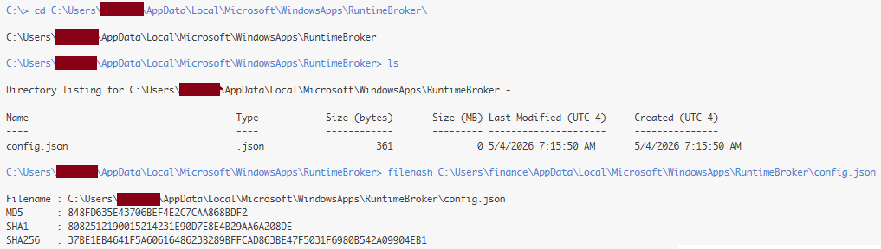

Response:
CrowdStrike Falcon detection page for the RuntimeBroker.exe event — Action taken: Process blocked + File quarantined (Purged). The primary masqueraded backdoor payload was neutralized (SHA256: f07c7223fdb691acbf0ebc7d9cc2ae614c0cf705920420c0130248a0c0e861d4). As documented in 1 screenshot and 2, the binary was delivered via an evasive PowerShell stager and triggered both the behavioral engine for File Impersonation (T1036) and the Machine Learning sensor (CST0007). 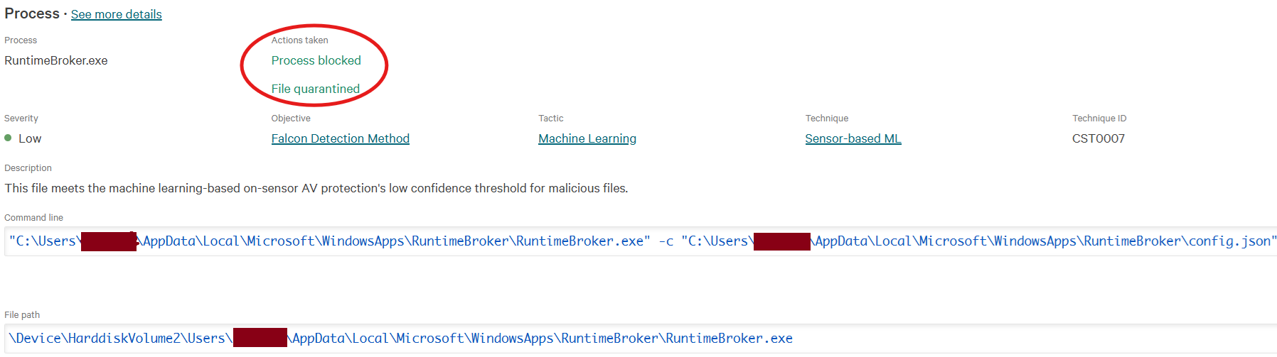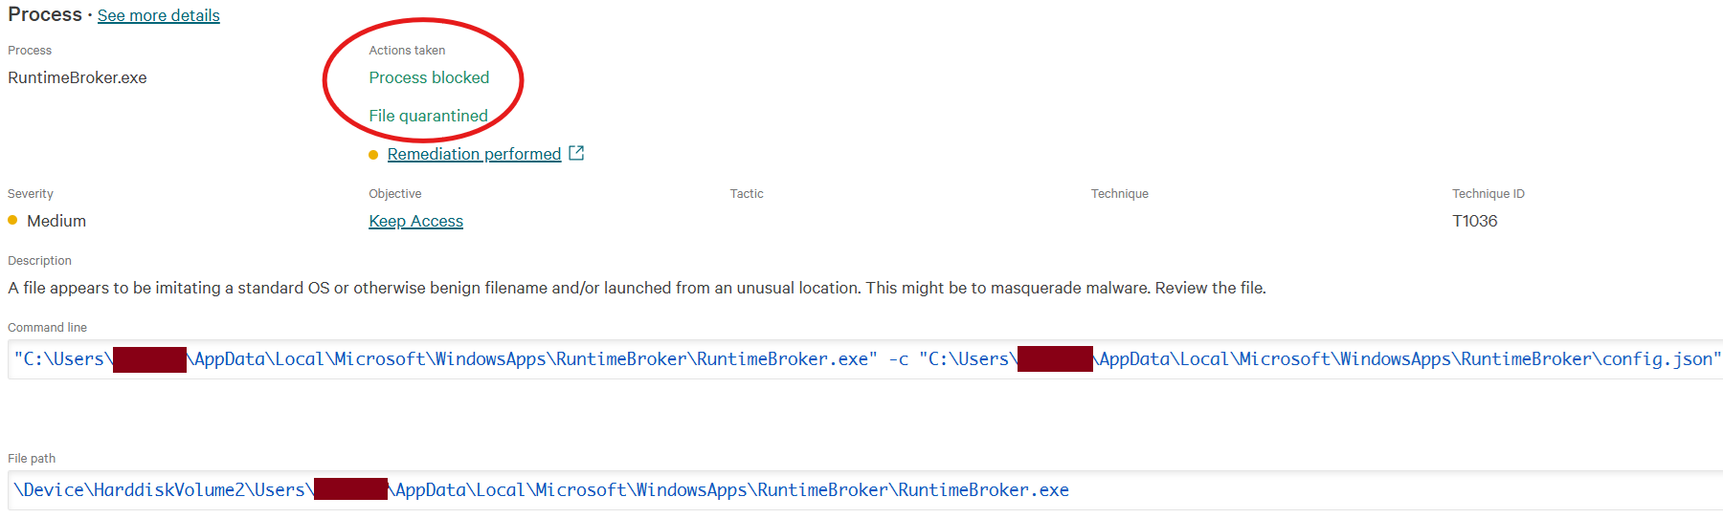Execution was terminated and the binary status was updated to Purged at 07:15:53, as confirmed by Screenshot 3. 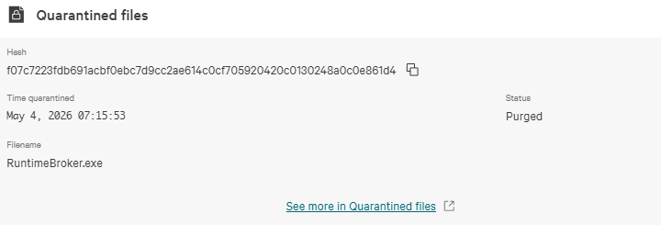Automated sandbox analysis detailed in Screenshot 4.
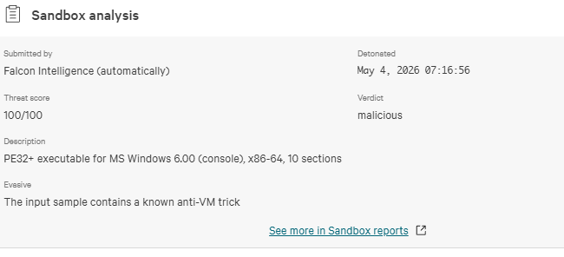Screenshot 5, and Screenshot 6 gave the file a Malicious Threat Score of 100/100, identifying embedded anti-VM tricks and explicitly classifying the payload with the "Miner" tag.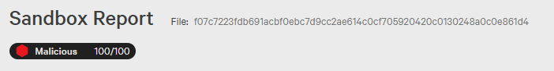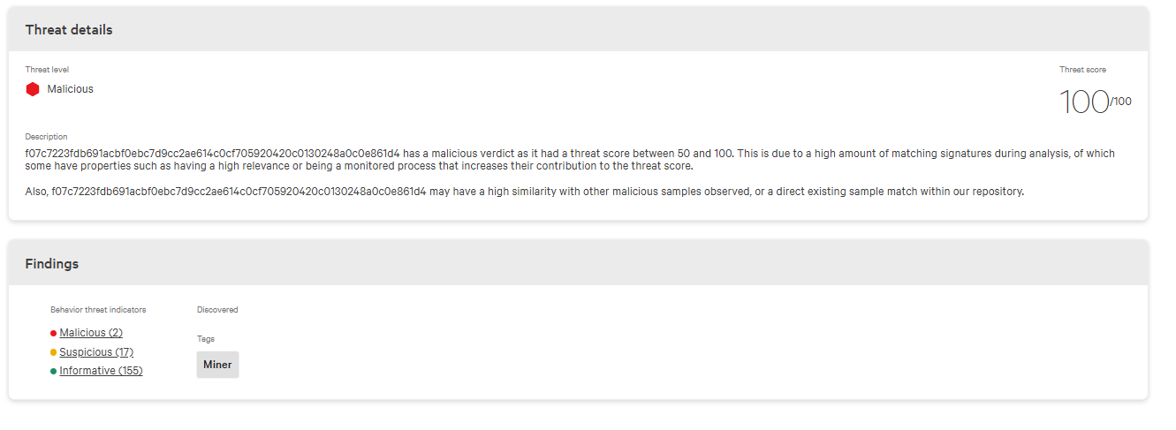
Unlike the compiled binary, the unprivileged configuration script config.json, the initial staging archive firefox_dump.zip in the local Temp path, and the second-stage reconnaissance script System_Performance_Monitor.ps1 in the user's Downloads directory were not automatically removed and remain on the host. Manual remediation is required to delete the residual unprivileged application directory C:\Users\[redacted]\AppData\Local\Microsoft\WindowsApps\RuntimeBroker, purge the dormant XMRig staging files (xmrig.exe, solo_mine_example.cmd, WinRing0x64.sys) from the Temp folder, and clean the user download paths to eliminate remaining indicators of compromise. Additionally, a network firewall block and outbound log audit for the stratum mining pool domain portugalloindostan.top over port 443 are recommended due to the hardcoded C2 infrastructure extracted from the surviving configuration block.
Overall Analyst Assessment
This incident is assessed as a True Positive (TP) involving a multi-stage, targeted resource hijacking and reconnaissance campaign targeting the [redacted-host] workstation. The adversary gained initial access via credential compromise and RDP session hijacking, reconnecting to a long-standing, persistent REMOTE_INTERACTIVE session belonging to the [redacted] user at 06:27:19. This allowed the attacker to completely bypass primary authentication gateways and EDR login triggers.
To ensure early defense evasion and disrupt forensic tracking, the attacker immediately subverted Windows Auto-Start Execution Points (ASEP) by hijacking the RunOnce registry key to spawn runonce.exe and cmd.exe instances, successfully purging the source OneDriveSetup.exe installer files before advanced baseline monitors could alert on the source. At 06:29, the adversary executed a hidden PowerShell stager disguised as a compressed archive (firefox_dump.zip) within the user Temp directory to harvest browser-stored credentials.
To facilitate secondary payload delivery within the hijacked desktop session, the adversary launched the local mail client (thunderbird.exe) at 07:13, forcing an encrypted IMAP synchronization to ingest a targeted malicious shortcut payload (Runtime_Service_Update.ps1.lnk) into the local profile database. The execution of this shortcut triggered an automated retrieval script from GitHub to stage the core XMRig mining suite (xmrig.exe, solo_mine_example.cmd, and the low-level WinRing0x64.sys driver) into the local user space.
Simultaneously, the script performed advanced directory and binary Masquerading (T1036) by compile-writing a packed backdoor implant disguised as a core system component (RuntimeBroker.exe) into an anomalous application folder. CrowdStrike Falcon successfully intercepted the execution via its behavioral masquerading engine (PatternId 10139) and localized machine learning (PatternId 5700), blocking the process in less than one second and completely purging the malicious binary (SHA256: f07c7223fdb691acbf0ebc7d9cc2ae614c0cf705920420c0130248a0c0e861d4). Automated sandbox testing validated a maximum malicious score of 100/100, identifying active anti-VM evasion mechanisms.
Advanced host and telemetry triage confirmed that approximately 16 hours following the initial block, the adversary re-engaged the host using an identical process-scope execution policy bypass pattern. Operating under a deceptive administrative file name (System_Performance_Monitor.ps1) from the user's Downloads folder, the attacker successfully executed systeminfo.exe (Actions taken: None) to map the system's architecture, domain layout, and hotfix patch baseline to identify privilege escalation paths.
While the interactive backdoor threat was completely neutralized, the incident is only partially contained. Passive files including the custom config.json layer—which contains a hardcoded, encrypted stratum mining pool destination (portugalloindostan.top:443) and the actor's verified Monero wallet address (48edfHu7V9Z84YzzMa6fUueoELZ9ZRXq9VetWzYGzKt52XU5xvqgzYnDK9URNroJMk1j8nLwEVsaSWJ4fhdUyZijBGUicoD)—remain on disk alongside the staging PowerShell files. Immediate network isolation and manual remediation are required to purge these residual filesystem artifacts and implement perimeter blocks against the extracted network infrastructure.

Mini Attack Visualization
[Phase 1: Initial Access & Payload Deployment]
↓
[Interactive Session Active: user '[redacted]' on host [redacted-host] ]
↓
[Defense Evasion: runonce.exe & cmd.exe execute to purge early OneDrive setup artifacts]
↓
[Execution: Hidden powershell.exe instance invokes stager disguised as firefox_dump.zip]
↓
[Post-Compromise Tradecraft: thunderbird.exe processes pre-staged payload via encrypted IMAP sync]
↓
[Staging: Runtime_Service_Update.ps1 bypasses execution policy & streams XMRig miner from GitHub]
↓
[Masquerading: Script drops a packed, custom backdoor implant named RuntimeBroker.exe into WindowsApps]
↓
[Execution Attempt: RuntimeBroker.exe launches with -c config.json to hijack 80% CPU resources]
↓
[EDR Enforcement: Falcon Behavioral (PatternId 10139) & ML (PatternId 5700) engines block process and quarantine file (Purged)]
↓
[Phase 2 (~16hrs Later): Adversary re-engages host via disguised System_Performance_Monitor.ps1 script]
↓
[Host Discovery (Success): systeminfo.exe runs with zero enforcement to harvest OS patch & architecture baselines]
↓
[Current State: Partially Contained (RuntimeBroker.exe neutralized; passive config.json and staging scripts remain)]

Recommended Actions:
1. Immediate Host Containment & Isolation (CrowdStrike Falcon)
- Network Isolation: Trigger the automated network containment feature via the CrowdStrike Falcon console for host [redacted-host] immediately. This blocks all inbound and outbound network traffic (preventing Lateral Movement and automated downloading of secondary payloads) while preserving the EDR telemetry channel for investigation.
- Registry & Persistence Freeze: Maintain containment until all subsequent credential revocations and volatile memory sweeps are completed.

2. Access & Credential Security
- Password Reset: Enforce an immediate, mandatory complex password change for the [redacted-domain] domain account. Since a hidden PowerShell stager named firefox_dump.zip was executed within the user profile context at 06:29, assume all browser-stored credentials and session cookies are compromised.
- Session Termination: Revoke and terminate all active interactive, RDP, and mail application sessions for the [redacted] user across the network to invalidate any exfiltrated session tokens and kick the adversary out of the REMOTE_INTERACTIVE session.
- RDP Hardening: Restrict RDP access to the [redacted-host] workstation using Network Level Authentication (NLA), limit access to specific authorized IP ranges (Admin Jump-host), and implement MFA.

3. Filesystem Remediation (Post-Isolation Cleanup)
- FileSystem Purging: Once the host is network-isolated, delete the residual unprivileged application directory C:\Users\[redacted]\AppData\Local\Microsoft\WindowsApps\RuntimeBroker\ along with the surviving config.json file.
- Staging Artifact Cleanup: Scour and delete the dormant cryptocurrency mining files (xmrig.exe, solo_mine_example.cmd, WinRing0x64.sys) from the local user Temp path C:\Users\[redacted]\AppData\Local\Temp\.
- Script Deletion: Locate and permanently remove the malicious script loader Runtime_Service_Update.ps1 and the discovery script System_Performance_Monitor.ps1 from the user's Downloads folder.
- Indicator Audit: Review the Windows Registry for unauthorized modifications within the Run and RunOnce keys (specifically inspecting entries triggered around 06:27 on May 4, 2026).

4. Network & IOC Controls
- Infrastructure Blocking: Blacklist the following malicious stratum mining pool destination and external ingestion endpoints at the perimeter firewall:
  - portugalloindostan.top (Malicious Cryptomining C2 Pool over Port 443)
  - 140.82.121.4 / 185.199.110.133 (External staging locations associated with payload distribution)
- Fleet Hunting: Perform an enterprise-wide endpoint sweep for the following high-fidelity Indicators of Compromise (IoCs):
  - SHA256: f07c7223fdb691acbf0ebc7d9cc2ae614c0cf705920420c0130248a0c0e861d4 (Masqueraded RuntimeBroker.exe)
  - SHA256: 37be1eb4641f5a6061648623b289bffcad863be47f5031f6980b542a09904eb1 (Malicious config.json profile)

5. System Hardening & GPO
- PowerShell Policy Restriction: Enforce a strict AllSigned script execution policy via Group Policy Objects (GPO) across the domain. Enable PowerShell Script Block Logging (Event ID 4104) to enhance deep-dive inspection visibility into obfuscated, process-scope execution bypass attempts.
- User Space Hardening: Implement explicit software restriction policies (such as AppLocker) to strictly block the execution of binary files or scripts launched directly from unprivileged locations (AppData\Local\ and Downloads).

6. Escalation & Deep Dive Analysis

RDP Access & Credential Root Cause Analysis (RCA): Conduct an immediate forensic audit of the Domain Controller security logs and the local workstation's Security.evtx log. Target Event ID 4624 (specifically Logon Type 10 - RemoteInteractive or Type 3 - Network) matching the timestamp 06:27:19 on May 4, 2026. Extract the source IP address, workstation name, and routing path to identify the attacker's true network origin and determine if the credentials were leaked via an external breach, info-stealer infection, or compromised via brute-force (Event ID 4625).

EDR Policy Review: Coordinate with the Security Engineering team to evaluate why the execution of systeminfo.exe during Phase 2 discovery did not trigger automated containment or alert generation on the sensor earlier in the triage timeline.

Threat Hunting Handoff: Provide the unique cryptocurrency wallet address extracted from the configuration block (48edfHu7V9Z84YzzMa6fUueoELZ9ZRXq9VetWzYGzKt52XU5xvqgzYnDK9URNroJMk1j8nLwEVsaSWJ4fhdUyZijBGUicoD) to the Cyber Threat Intelligence (CTI) team to monitor for broader campaigns targeting corporate resources.

