Customer Login and Booking

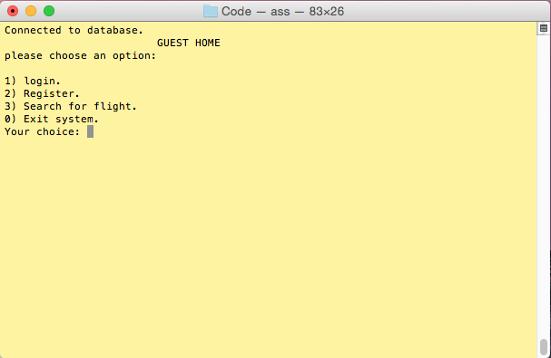

*Initial screen. User can select to log in if registered*

*Or register. Users can also search for flight without*

*needing to register.*

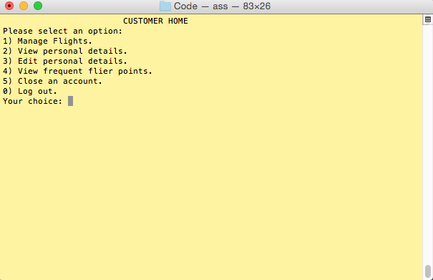

*Once a customer is logged in they are able manage their flights*

*View, edit personal details and frequent flier points.*

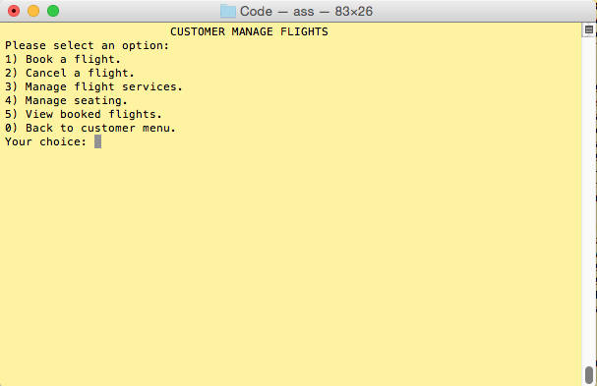

*This is the customer’s menu to manage flights they are able*

*To book, cancel flights, manage any flight services*

*Manage their seating and view booked flights.*

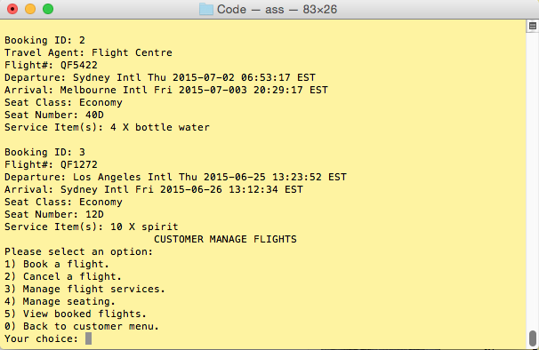

*The customer has selected option 5 and the system will show*

*All booked flights including the flight number, departure*

*Arrival, seat class and number and service items purchased.*

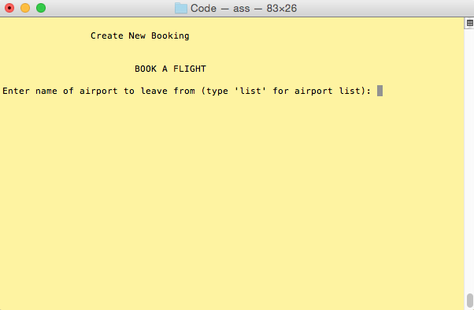

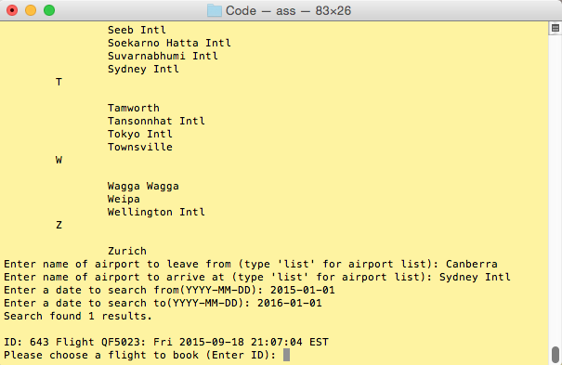*A customer has selected to create a new booking*

*Here the customer can see a list of airports and enters the departure and*

*Arrival airports along with a date range for they wish to fly.*

*The system will return all flights available for that route.*

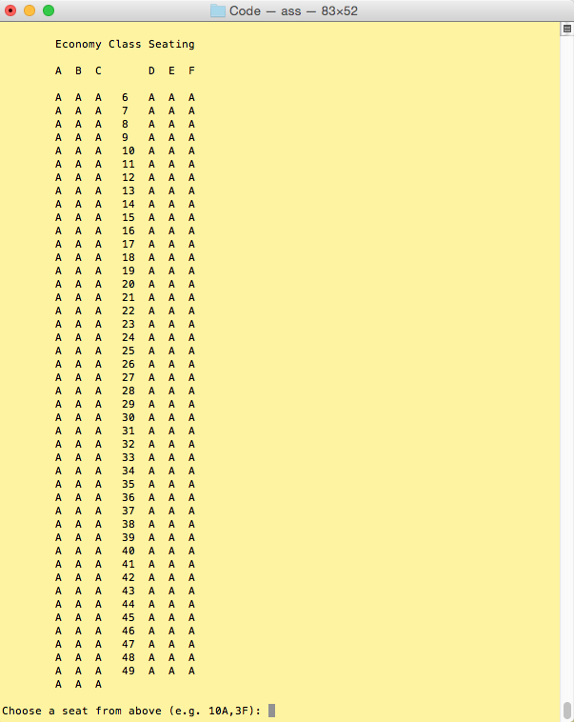

*This is where a customer can select a seat to sit at.*

*The “A” represents an available seat.*

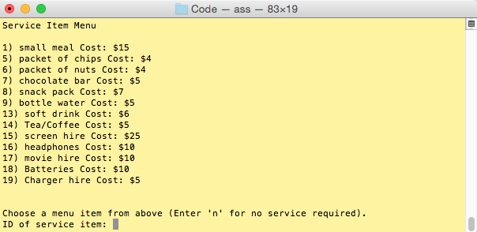

*A customer then selects any in flight services they want*

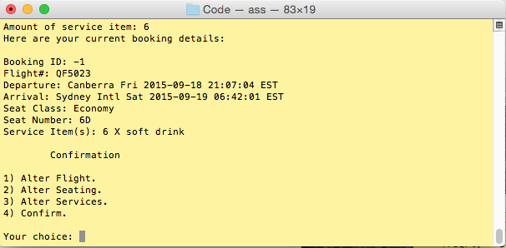

*Once completed a customer is given the details of the booking*

*And the option to alter the flight, seating or services or can confirm.*

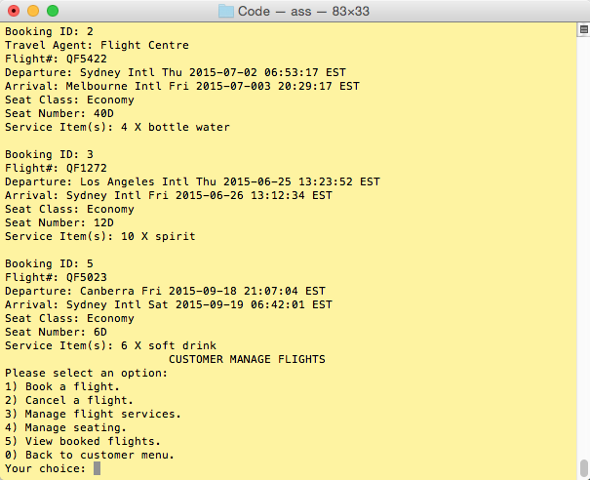

*Here a customer is viewing booked flights to confirm*

*That it has been created in their account.*

Travel Agent

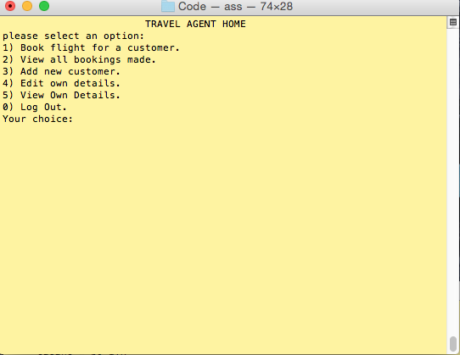

*This is the home page for the travel agent*

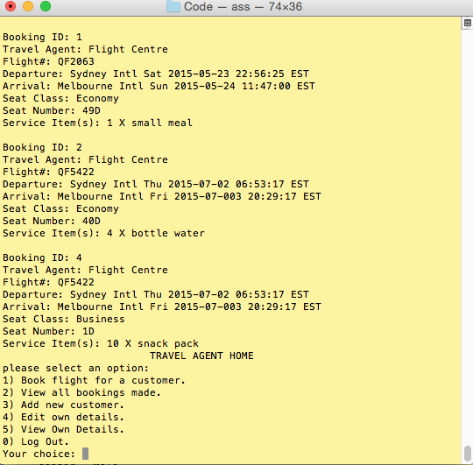

*The travel agent has selected option 2 and the system will*

*Return all bookings that this travel agent has created for customers.*

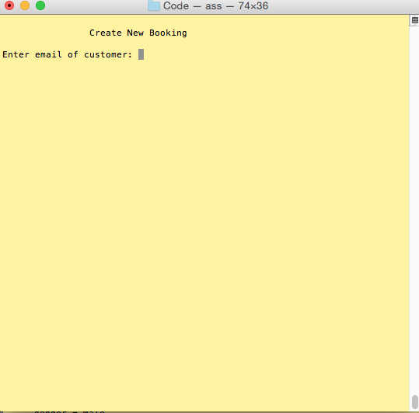

*The travel agent will enter the email of a customer to create a booking*

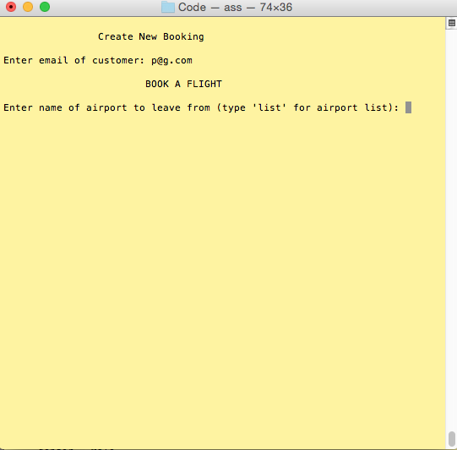

*The travel agent begins the same process as a customer to create a*

*Booking for a client.*