**Construction Phase**

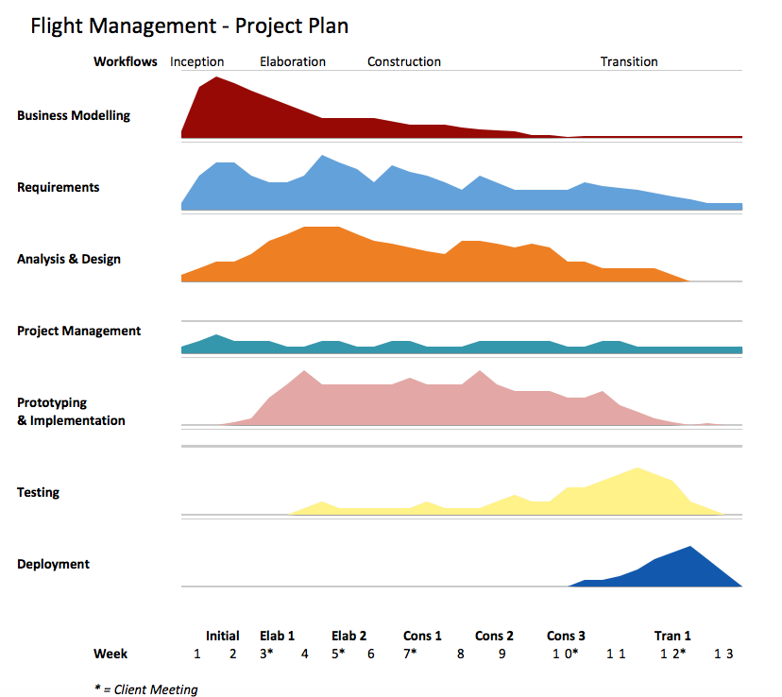

**Iteration 1 (Week 7)**

Our team’s first iteration of the construction phase involves expanding on the current skeleton system - creating functional menus, conditions, error checking, and placeholders for functions that would be implemented in the next iteration. Our use cases and class diagrams proved to be helpful here, as they guided us in building the menus systems and improved concurrency between our diagrams and actual system.

By the end of the first iteration, our system enabled the user to logon as different users (including all of the managers, admin, customer, or as a guest) and traverse through the menu system. The function at this point did nothing apart from output static data which may represent what the actual data may have looked like.

We chose an SQL database for our system, and a big part of this iteration was building the database, using our class diagrams as a guide.

**Iteration 2 (Week 8 and 9)**

Now that we had our menu systems and classes functioning correctly, it was time to actually build the functions, and interact classes with one another. Our team’s main objective here was to tick off the major core requirements such as allowing the booking of flights, searching of flights, generating reports, and editing personal details.

This involved another major component, which was to get sqlite3 functioning correctly in the system, especially in the search and report functions where we needed specific select statements. This phase also included getting the password masking functionality working across all systems (Mac, Windows, Linux).

As we were expanding our functionality of the system, we also had to modify and expand both our SQL database and our classes. This involved adding attributes and references to the SQL database, and adding in more functions to our classes which we previously didn’t foresee which are called by other functions, such as functions that traverse through certain SQL tables.

**Iteration 3 (Weeks 10 and 11)**

The third and final iteration involved finalising and refining the requirements, and expanding into any stretch goal given that we had finished the core requirements first.

We also began implementing a weather system API which sends notifications to flight managers, yet this proved to be tedious, and to get this working completely would mean that we would have to leave out some core requirements which we didn’t want to do. Upon discussing this with our client in Week 10, they confirmed that they would require the core requirements over stretch goals.

As our implementation came to an end in this block, we began more thorough testing, mostly black box testing but also white box testing as well to test the thoroughness of our system.