**11.2. Diary – Ali Sayed**

|  |  |
| --- | --- |
| Date | 16/3/2015 |
| Action | Group meeting after lecture. We all collaborated our gathered system requirements. |
| Time Expected | 30mins |
| Time Taken | 45mins |
| Problems | / |
| Solutions | / |

|  |  |
| --- | --- |
| Date | 25/3/2015 |
| Action | Group meeting before client meeting. We decided what questions we needed to ask the clients. I proposed we get the reporting function sorted, and that I would create a prototype to the client and see what their input was. |
| Time Expected | 1hr |
| Time Taken | 1hr |
| Problems | / |
| Solutions | / |

|  |  |
| --- | --- |
| Date | 25/3/2015 |
| Action | Created a reporting prototype (reporting.cpp) - quick program which generates static reports. Presented this to the clients. They said we need more ‘interesting facts’ in the report, not just things that they can find by looking at the database. |
| Time Expected | 20mins |
| Time Taken | 40mins |
| Problems | / |
| Solutions | / |

|  |  |
| --- | --- |
| Date | 1/4/2015 |
| Action | Group meeting. Kresimir assigned jobs to each member, mine was to get started on the project plan and create a gantt chart to illustrate the plan. |
| Time Expected | 1hr |
| Time Taken | 1hr |
| Problems | / |
| Solutions | / |

|  |  |
| --- | --- |
| Date | 9/4/2015 |
| Action | Evaluated different project planning schemes, created the gantt chart to display the project plan. |
| Time Expected | 1hr |
| Time Taken | 2hr |
| Problems | Experienced a few problems. Most of the trouble was how to illustrate each iteration in the project plan; I think this is pretty ineffective with a gantt chart. |
| Solutions | Tell the team that an RUP approach illustrated through area charts is going to be a better approach. |

|  |  |
| --- | --- |
| Date | 15/4/2015 |
| Action | Meeting with all group members. We evaluated what work was left remaining and assigned jobs suitably to each member. I was assigned to finish the use case diagrams and also publish the project plan. |
| Time Expected | 1hr |
| Time Taken | 1hr |
| Problems | / |
| Solutions | / |

|  |  |
| --- | --- |
| Date | 16/4/2015 |
| Action | Go back over lecture notes of Rational Unified Process (RUP) |
| Time Expected | 1hr |
| Time Taken | 45mins |
| Problems | / |
| Solutions | / |

|  |  |
| --- | --- |
| Date | 17/4/2015 |
| Action | Created the RUP project plan. |
| Time Expected | 2hr |
| Time Taken | 3hr |
| Problems | Had to use separate graphs for each phase |
| Solutions | Used Excel’s area graphing function |

|  |  |
| --- | --- |
| Date | 19/4/2015 |
| Action | Create use case diagrams. I already had some of these drafted from earlier, but a lot of them weren’t finished. |
| Time Expected | 3hr |
| Time Taken | 2hr 30mins |
| Problems | Struggled to find an effective way to do this on PowerPoint or Word. Used Creately but couldn’t save unless I created an account. |
| Solutions | Used Creately.com (web), and used screen capture function. |

|  |  |
| --- | --- |
| Date | 23/4/2015 |
| Action | Begin command line interface |
| Time Expected | 1hr |
| Time Taken | 1hr |
| Problems | / |
| Solutions | / |

|  |  |
| --- | --- |
| Date | 30/4/2015 |
| Action | More command line interfacing |
| Time Expected | 2hr |
| Time Taken | 1.5hr |
| Problems | Staying consistent with the use case diagrams, at some points I got a bit lost. |
| Solutions | Keep the use case diagrams open at all time and keep revising them and traversing through them. |

|  |  |
| --- | --- |
| Date | 7/5/2015 |
| Action |  |
| Time Expected | 2hr |
| Time Taken | 1.5hr |
| Problems | Staying consistent with the use case diagrams, at some points I got a bit lost. |
| Solutions | Keep the use case diagrams open at all time and keep revising them and traversing through them. |

|  |  |
| --- | --- |
| Date | 10/5/2015 |
| Action | Research password masking |
| Time Expected | 30mins |
| Time Taken | 45mins |
| Problems | We need a cross-platform solution here |
| Solutions | Use ncurses.h |

|  |  |
| --- | --- |
| Date | 13/5/2015 |
| Action | Begin password masking on test files |
| Time Expected | 1hr |
| Time Taken | 30mins |
| Problems | University computers don’t allow me to download the ncurses library which we need for this functionality. |
| Solutions | Try on home computer |

|  |  |
| --- | --- |
| Date | 14/5/2015 |
| Action | Being password masking on test files, take two. |
| Time Expected | 1hr |
| Time Taken | 2hr |
| Problems | Had a lot of trouble getting the ncurses library downloaded to the right directory |
| Solutions | Use terminal commands from reputable sources rather than .zip files. |

|  |  |
| --- | --- |
| Date | 15/5/2015 |
| Action | Implement password masking on test files |
| Time Expected | 1hr |
| Time Taken | 1hr |
| Problems | / |
| Solutions | Password masking working fine on test files. |

|  |  |
| --- | --- |
| Date | 22/5/2015 |
| Action | Implement password masking on program files |
| Time Expected | 1hr |
| Time Taken | 5hr |
| Problems | Can’t get the ncurses library linked properly in our program. I’ve tried linking several different ways in the makefile, but nothing has worked so far. |
| Solutions | Nothing yet.. |

|  |  |
| --- | --- |
| Date | 27/5/2015 |
| Action | Use #define statements to define system specific password masking |
| Time Expected | 2hr |
| Time Taken | 2hr |
| Problems | Finding the correct #ifdef statements |
| Solutions | Research. Correct #ifdef statements are __unix__, and _WIN32 |

|  |  |
| --- | --- |
| Date | 28/5/2015 |
| Action | Begin the reporting systems for booking manager and service manager |
| Time Expected | 2hr |
| Time Taken | 2hr |
| Problems | Implementing the reports sounded like an easy enough task, but I’m having a lot of trouble with the SQL integration in our system. |
| Solutions | Discuss with team members, get feedback, check other simlar implemented reports |

|  |  |
| --- | --- |
| Date | 29/5/2015 |
| Action | Work on the reporting systems for booking manager and service manager |
| Time Expected | 2hr |
| Time Taken | 4hr |
| Problems | Still having a lot of trouble with SQL. I understand the select statements, but the variable initializing and column traversing in c++ language doesn’t make sense to me. |
| Solutions | Discuss with team members again. |

|  |  |
| --- | --- |
| Date | 1/6/2015 |
| Action | Work on the notification system |
| Time Expected | 2hr |
| Time Taken | 2hr |
| Problems | Was getting an SQL error “SELECT FAILED”. |
| Solutions | This was because I modified some tables and attribute names directly from the database.sql file. Apparently I need to use an ALTER TABLE and COLUMN statement. |

**. Construction Phase**

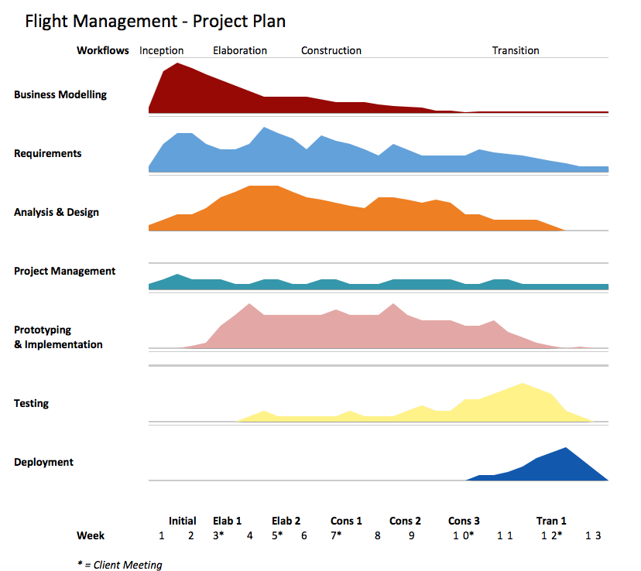

Iteration 1 (Weeks 7 and 8)

Our team’s first iteration of the construction phase involves expanding on the current skeleton system - creating functional menus, conditions, error checking, and placeholders for functions that would be implemented in the next iteration.

Iteration 2 (Week 9)

Iteration 3 (Weeks 10 and 11)

The third and final iteration involves finalising and refining the requirements, and expanding into any stretch goal given that we had finished the core requirements first. We began implementing a weather system API which sends notifications to flight managers, yet this proved to be tedious, and to get this working completely would mean that we would have to leave out some core requirements.