Contents

Business Plan Summary 2

The Business 2

The Market 2

The Future 2

The Business 3

Organisation chart 3

Key personnel 4

Operations 4

The Market 5

Market targets 5

Your customers 5

The Future 6

Vision statement 6

Mission statement 6

Goals/objectives 6

Action plan 6

## Business Plan Summary

### The Business

**Business name:** *ADKP*

**Business structure:** *Students*

**Business location:** *University of Wollongong*

**Date established:** *March 2nd 2015*

**Relevant owner experience:** *We are 2nd and 3rd year students all completing a Computer Science degree.*

**Products/services:** *Flight Booking System*

### The Market

**Target market:**

*The targeted market are stakeholders wishing to book flights either for holidays or business trips. Staff will also be a target market allowing them to perform various roles through the system.*

### The Future

**Goals/objectives:**

*The teams goal is to provide a stable and fully functional flight booking system that will meet our clients needs and its customers.*

## 

## The Business

### Organisation chart

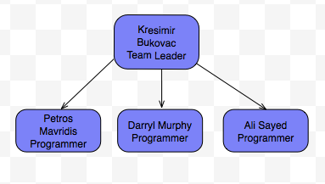

### 

### Key personnel

**Current staff**

| Job Title | Name | Skills or strengths |
| --- | --- | --- |
| *Team leader*  *Programmer*  *Tester* | *Kresimir Bukovac* | *Knowledge of C++ programming language and an understanding of leading team meetings.* |
| *Programmer*  *Tester* | *Petros Mavridis* | *Knowledge of the C++ programming language and some GUI programming.* |
| *Programmer*  *Tester* | *Darryl Murphy* |  |
| *Programmer*  *Tester* | *Ali Sayed* |  |

### 

### Operations

**Production process**

*The process used to develop the flight booking system will be a Rational Unified Process along with the Prototyping method of showing our clients a progress of the developed product for feedback.*

**Technology (Software)**:

*The technology we will be using will be C++ language with the initial prototyping being a command line package. Our stretch goal will be to implement a GUI using Qt.*

**Communication channels**:

*Our team has been communicating through face to face meetings and over Skype®. Our meeting with our client has been face to face during allocated times in tutorials.*

**Quality control**:

*Quality control will be measured through testing of our code, each function or portion of code will have corresponding test code to test its correctness.*

### 

## The Market

### Market targets

### Your customers

**Customer demographics**

**Key customers**

**Customer management**

## The Future

### Vision statement

### Mission statement

### Goals/objectives

### Action plan

| Milestone | Date of expected completion | Person responsible |
| --- | --- | --- |
|  |  |  |
|  |  |  |
|  |  |  |
|  |  |  |