**SE-Assignment-4**

1. **Introduction to GitHub:**

**What is GitHub, and what are its primary functions and features? Explain how it supports collaborative software development.**

GitHub is an online software development platform. It's used for storing, tracking, and collaborating on software projects. It makes it easy for developers to share code files and collaborate with fellow developers on open-source projects. GitHub also serves as a social networking site where developers can openly network, collaborate, and pitch their work.

It encourages users to build a personal profile and brand for themselves.

**Primary Functions and Features of GitHub:**

* *Code Hosting and Sharing:*

GitHub provides a platform to host your code repositories, which are essentially folders containing your project's files and Git history. These repositories can be public or private, allowing you to share code openly or keep it confidential.

* *Issue Tracking:*

GitHub allows you to create and manage issues, which are essentially tasks or bugs related to the project. This helps developers track progress, assign tasks, and keep communication organized.

* *Community and Open Source:*

GitHub is a vibrant hub for the developer community. You can explore open-source projects, contribute to existing ones, and connect with other developers. This fosters knowledge sharing and innovation.

* *Collaborative Development:*

GitHub fosters collaboration through features like:

**Forking:** Developers can create a copy (fork) of an existing repository, make changes on their fork, and then submit a pull request to merge their changes back into the original project.

**Pull Requests:** This functionality allows developers to propose changes they've made on their forks. The original project owner can then review and merge the pull request if the changes are deemed valuable. Code discussions and feedback can happen within pull requests, promoting teamwork.

**Branching:** Developers can create branches to work on specific features or bug fixes without affecting the main codebase. This allows parallel development and easier integration of changes.

* *Version Control with Git:*

Git tracks changes made to code over time, allowing developers to see the history of modifications, revert to previous versions if needed, and collaborate effectively.

**How GitHub supports collaborative software development.**

*Pull Requests:* Enable code reviews and discussions before integrating changes, improving code quality and team communication.

*Branching and Merging:* Developers can create branches for new features or fixes and merge them back into the main branch after peer reviews, ensuring a smooth workflow.

*Documentation:* The README files within repositories help maintain up-to-date project documentation, ensuring that all team members have access to necessary information.

*Distributed Version Control:* GitHub uses Git, allowing multiple developers to work on different parts of a project simultaneously without conflicts.

*Issue Tracking:* Helps teams manage tasks, bug reports, and feature requests, providing a clear overview of project progress and responsibilities.

1. **Repositories on GitHub:**

**What is a GitHub repository? Describe how to create a new repository and the essential elements that should be included in it.**

A repository (often shortened to "repo") serves as the foundation for your project. It's a place to keep your project's files, track changes to them, and collaborate with others. Each repository contains all the project’s files and the revision history, allowing multiple people to work on the project simultaneously.

**Creating a New Repository:**

Head to GitHub: Visit https://github.com/ and create an account if you don't have one already.

Create a New Repository:

* Click the + icon at the top right corner of the page.
* Select New repository from the dropdown menu.

Repository Details:

* Repository Name: Enter a descriptive name for your repository.
* Description (optional): Write a short description of your project.
* Public/Private: Choose whether the repository will be public (anyone can see it) or private (only you and selected collaborators can see it).

Repository Details:

* Repository Name: Enter a descriptive name for your repository.
* Description (optional): Write a short description of your project.
* Public/Private: Choose whether the repository will be public (anyone can see it) or private (only you and selected collaborators can see it).

Create Repository: Click the Create repository button.

**Essential Elements to Include in a GitHub Repository**

* *README File:* Provide a brief description of the project, steps to install and set up the project, how to use the project, including examples, and guidelines for contributing to the project.
* *.gitignore File:* This file tells Git which files it should ignore.
* *LICENSE File:* A license file specifies the terms under which others can use, modify, and distribute your project.
* *Source Code:* The actual code files that make up your project. Organize these files in a clear and logical structure.
* *Documentation:* Additional documentation files (e.g., docs/ directory) providing detailed information about the project’s architecture, features, API, etc.
* *Changelog:* A file (often named CHANGELOG.md) documenting all notable changes made to the project over time. This helps users and contributors keep track of updates and modifications*.*

1. **Version Control with Git:**

**Explain the concept of version control in the context of Git. How does GitHub enhance version control for developers?**

Version control is a system that tracks changes to a set of files over time, so you can recall specific versions later. It is essential for collaborative work, as it helps multiple people work on the same project simultaneously without overwriting each other's work.

Git is a distributed version control system, which means every developer has a complete copy of the project’s history on their local machine, allowing for offline access and more efficient handling of changes.

**How GitHub Enhances Version Control for Developers:**

*Centralized Hosting:* While Git allows local repositories, GitHub offers a central location to store your Git repositories. This makes collaboration and sharing easier.

*Forking:* GitHub allows "forking" a repository, essentially creating a copy that another developer can modify. This is a powerful tool for contributing to open-source projects or experimenting with changes without affecting the original code.

*Issue Tracking:* GitHub's issue tracking system allows developers to report bugs, request features, and track project tasks.

*Code Review and Quality:* GitHub supports inline comments on pull requests, which allows for detailed code reviews.

*Pull Requests:* Pull requests are a way to propose changes to a repository. They allow team members to review, discuss, and test the changes before merging them into the main codebase. This process ensures code quality and facilitates collaboration.

1. **Branching and Merging in GitHub:**

**What are branches in GitHub, and why are they important?** **Describe the process of creating a branch, making changes, and merging it back into the main branch.**

Branches in GitHub are separate lines of development within a repository. Each branch is a unique version of the project, allowing multiple versions to coexist and evolve independently. The default branch, typically called main or master, is often used for the production-ready version of the project.

**Importance of Branches:**

Parallel Development: Multiple developers can work on different branches simultaneously, accelerating development.

Modular Development: Branches can be used to break down large projects into smaller, more manageable pieces. This promotes better organization and easier integration of changes.

Isolation: Branches allow developers to work on features, bug fixes, or experiments in isolation from the main codebase.

Version Management: Branches enable easy management of different versions of a project, such as release branches, hotfix branches, and feature branches.

Collaboration: Multiple developers can work on different branches simultaneously without interfering with each other’s work.

Controlled Integration: Changes can be reviewed, tested, and approved before being merged into the main branch, ensuring that only stable and verified code is added.

**Process of creating a branch, making changes, and merging it back into the main branch.**

**Creating a Branch:**

Give your branch a descriptive name that reflects the changes you plan to make. Give your branch a descriptive name that reflects the changes you plan to make.

*git branch <branch name>*

**Making Changes:**

Once you’ve created a new branch, you can start making changes. Commit your changes regularly with clear commit messages describing what you modified.

Make Edits: Edit files in your working directory as needed.

Stage Changes: Add the changes to the staging area using:

*git add .*

Commit Changes: Commit the staged changes with a descriptive message:

*git commit -m "Descriptive commit message"*

**Pushing the Branch to GitHub:**

Push the branch to the remote repository.

*git push origin new-branch-name*

**Creating a Pull Request:**

To merge your changes into the main branch, you need to create a pull request:

Go to your repository on GitHub.

Click the "Pull requests" tab.

Click the "New pull request" button.

Select the base branch (usually main) and the compare branch (your new branch).

Review the changes, add a title and description for the pull request.

Click "Create pull request".

**Reviewing and Merging the Pull Request:**

Once the pull request is created, it goes through a review process:

Code Review, Testing, Address Feedback, and Approval.

**Merging the Pull Request**:’

Click the "Merge pull request" button on the pull request page.

Confirm the merge by clicking "Confirm merge".

Delete the branch if it’s no longer needed by clicking the "Delete branch" button.

1. **Pull Requests and Code Reviews:**

**What is a pull request in GitHub, and how does it facilitate code reviews and collaboration? Outline the steps to create and review a pull request.**

A pull request (PR) in GitHub is a feature that allows developers to notify team members about changes they've pushed to a branch in a repository. It is a mechanism for proposing changes to the codebase and initiating discussions around those changes before they are merged into the main branch.

**How Pull Requests Facilitate Code Reviews and Collaboration:**

Transparency and Visibility: Pull requests provide a clear record of all changes proposed and the discussions surrounding them.

Code Review: Pull requests allow other developers to review the proposed changes line by line.

Collaboration: Pull requests provide a platform for team members to review code, offer feedback, suggest improvements, and discuss changes before they are integrated into the main codebase.

Code Quality: Through peer reviews, pull requests help maintain high code quality by catching bugs, ensuring adherence to coding standards, and promoting best practices.

**Steps to Create and Review a Pull Request:**

* Make your changes: Work on your new feature or bug fix in a separate branch.
* Commit your changes: Regularly commit your work with clear and descriptive commit messages.
* Push your branch (optional): If collaborating with others, push your branch to the remote repository on GitHub.
* Navigate to your branch: On GitHub, go to your branch and click the "Pull request" button.
* Compare branches: GitHub will automatically compare your branch with the main branch, highlighting the proposed changes.
* Write a clear and concise title and description: Explain what your pull request aims to achieve.
* Request reviewers (optional): You can suggest specific developers to review your code.
* Submit the pull request.

Reviewing a Pull Request:

Review the code: Carefully examine the changes proposed in the pull request.

Leave comments: Provide feedback, or ask questions.

Approve or request changes: Once you're satisfied with the code, you can approve the pull request, signaling that it's ready to be merged.

1. **GitHub Actions:**

**Explain what GitHub Actions are and how they can be used to automate workflows. Provide an example of a simple CI/CD pipeline using GitHub Actions.**

GitHub Actions is a built-in automation engine that allows you to streamline your software development workflow directly within your GitHub repositories. GitHub Actions enables users to automate various GitHub events, such as cloning a repository, generating Docker images, and testing scripts. This means that users can build, test, and deploy code written in different languages and running on different platforms, all using the same automation tool.

**How GitHub Actions Can Automate Workflows:**

* CI/CD (Continuous Integration and Continuous Delivery): GitHub Actions excels at automating CI/CD pipelines. You can configure workflows to automatically build, test, and deploy your code upon code pushes or pull requests.
* Automation: Running scripts, managing issues, handling pull requests, and performing other repetitive tasks.
* Monitoring: Triggering notifications and alerts based on specific conditions or changes in the repository.
* Repetitive Tasks: Any repetitive task within your development process can be automated using GitHub Actions. This could include tasks like code formatting, linting (checking for stylistic or coding errors), running unit tests, or deploying documentation.
* Custom Workflows: The flexibility of GitHub Actions allows you to define workflows for almost any purpose. You can integrate with third-party services using pre-built actions or create custom actions to suit your specific needs.

**Example of a Simple CI/CD Pipeline Using GitHub Actions:**

**Workflow file (.github/workflows/ci.yml):**

*name: CI/CD Pipeline*

*on:*

*push:*

*branches:*

*- main*

*- develop*

*jobs:*

*build-and-test:*

*runs-on: ubuntu-latest*

*steps:*

*- name: Checkout repository*

*uses: actions/checkout@v2*

*- name: Set up Node.js*

*uses: actions/setup-node@v2*

*with:*

*node-version: '14'*

*- name: Install dependencies*

*run: npm install*

*- name: Run tests*

*run: npm test*

*deploy:*

*needs: build-and-test*

*runs-on: ubuntu-latest*

*if: success()*

*steps:*

*- name: Checkout repository*

*uses: actions/checkout@v2*

*- name: Deploy to staging*

*run: echo "Deploying to staging environment..."*

*# Here you would add commands to deploy your code, e.g., uploading files to a server*

* This workflow is triggered by code pushes to the main branch.
* It defines a single job named build-and-test that runs on an Ubuntu virtual machine.
* The workflow uses pre-built actions:
* actions/checkout@v3: Checks out the code from the repository.
* actions/setup-node@v3: Sets up a Node.js environment for running tests.
* The workflow then installs dependencies using npm install and executes the tests with npm test.

1. **Introduction to Visual Studio:**

**What is Visual Studio, and what are its key features? How does it differ from**

**Visual Studio Code?**

Microsoft introduced Visual Studio in 1997, establishing it as an integrated development environment (IDE) tailored for creating, modifying, and troubleshooting websites, web applications, mobile applications, and cloud services. It is designed for creating applications across a variety of platforms, including Windows, web, mobile, cloud, and more.

Visual Studio Code (VS Code) is a lightweight, open-source code editor developed by Microsoft. It is designed to be fast and responsive while providing powerful features typically found in full-fledged IDEs. VS Code is highly customizable and extensible, making it a popular choice among developers.

**key features of Visual Studio:**

* Comprehensive support for various programming languages (C++, C#, .NET, Python, Java, and more) with built-in compilers, debuggers, and code editors.
* Rich graphical user interface (GUI) with powerful tools for project management, code navigation, refactoring, and unit testing.
* Integration with various development lifecycle (SDLC) tools and version control systems (like Git).
* Designed for professional developers working on complex software projects.
* Version Control Integration: Git and GitHub: Seamless integration with Git version control and GitHub repositories.
* Multiple Platform Support: Cross-Platform Development: Tools for developing applications for Windows, macOS, Linux, Android, and iOS.

**Differences Between Visual Studio and Visual Studio Code**

* One limitation of Visual Studio is its lack of compatibility with Linux. This may pose a considerable disadvantage for developers who prefer or require a Linux development environment. While, VS Code is available on Windows, Mac, and Linux, offering a versatile solution for developers across different platforms. Its cross-platform availability is a significant advantage for teams with diverse operating system preferences.
* Visual Studio is particularly well-suited for developers working primarily with languages like C#, C, C++, or Python. Its robust tools and features make it a preferred choice for large-scale and complex projects. VS Code, on the other hand, is often the preferred choice for projects involving modern web technologies like React, Vue, or Angular. Its lightweight nature and flexibility make it ideal for front-end development and smaller projects.
* Visual Studio offers a range of extensions, but its marketplace is less extensive than that of VS Code. This can sometimes limit the customization and extensibility of the development environment. While, VS Code is highly customizable, thanks to its extensive range of professionally curated extensions. Developers can tailor their coding environment to their exact preferences and project requirements.
* Visual Studio(vs) focuses on Complex software development. Whereas, VS Code focuses on Lightweight coding and scripting.

1. **Integrating GitHub with Visual Studio:**

**Describe the steps to integrate a GitHub repository with Visual Studio. How does this integration enhance the development workflow?**

Step 1: Open Visual Studio.

Launch Visual Studio from your desktop or start menu.

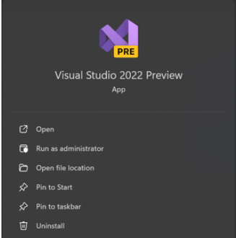

Step 2: Open the account settings.

Go to File > Account Settings.

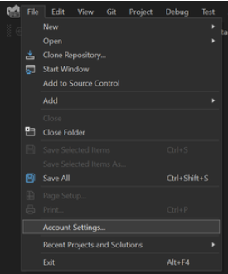

Step 3: Add an account and Select GitHub.

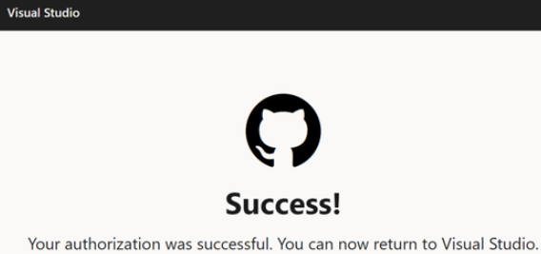

Step 4: Sign in with your GitHub credentials.

If your GitHub account is already open in the browser cache, the below interface will be opened. After authorization, GitHub asked for your account password.

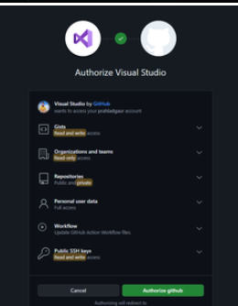

Step 5: After the password authorization, the below message will be visible.

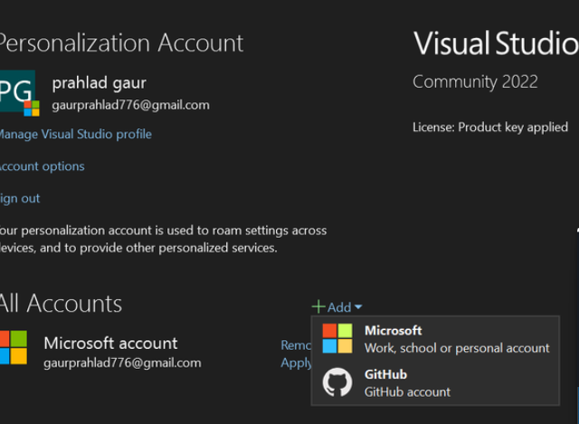

Step 6: Now, we can see the linked GitHub account in Visual Studio in account settings.

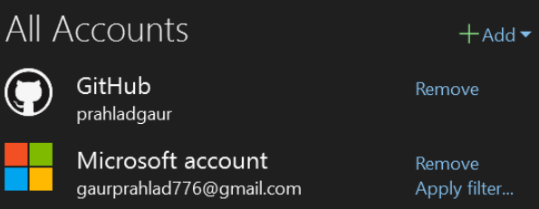

From here we can create, clone, and push to the repository in Git Hub. we can manage repositories, branches, commits and sync changes.

**Benefits of Integration:**

* Improved Workflow Efficiency: The integration eliminates the need to switch between tools for version control tasks.
* Simplified Version Control: You can directly commit your changes, view commit history, and manage branches within Visual Studio. No need to switch between the IDE and command line for Git operations.
* Enhanced Collaboration: Collaborate on code with your team through pull requests. You can review changes, leave comments, and merge branches directly from within Visual Studio.
* Unified Environment: Single Interface: Developers can code, manage version control, and collaborate all within the Visual Studio environment, reducing context switching.

1. **Debugging in Visual Studio:**

**Explain the debugging tools available in Visual Studio. How can developers use these tools to identify and fix issues in their code?**

Debugging means to run your code step by step in a debugging tool like Visual Studio, to find the exact point where you made a programming mistake. You then understand what corrections you need to make in your code and debugging tools often allow you to make temporary changes so you can continue running the program.

**Breakpoints**

Breakpoints allow developers to pause the execution of their code at specific lines, enabling them to inspect the state of the application at those points.

*Setting Breakpoints:* Click in the left margin next to the line of code where you want to set a breakpoint, or press F9. A red dot will appear, indicating the breakpoint is set.

*Conditional Breakpoints:* Right-click on a breakpoint and select "Conditions". Set conditions to break only when certain criteria are met.

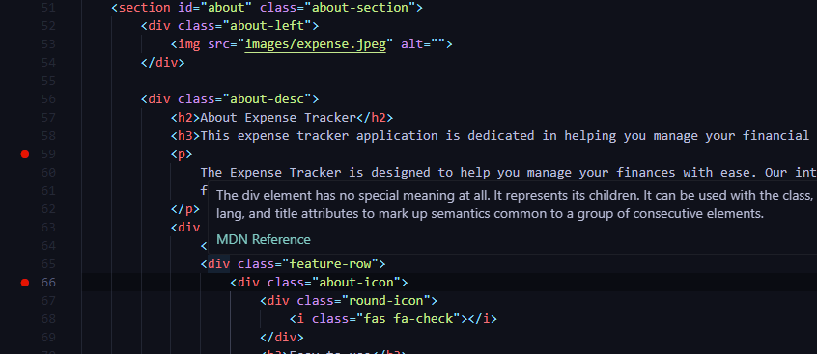

**How can developers use these tools to identify and fix issues in their code?**

* Set Breakpoints at strategic points where you suspect the issue might be originating.
* Step Through the Code: Use the Step Over, Step Into, and Step Out commands to navigate through the code line-by-line.
* Run the Debugger: Start debugging your code. Visual Studio will pause execution at the first breakpoint.
* Fix the Code: Once you identify the root cause of the issue, make necessary code modifications to address the error.
* Resume Debugging and Test: Resume debugging and step through the code again to verify if the fix resolves the problem.

1. **Collaborative Development using GitHub and Visual Studio:**

**Discuss how GitHub and Visual Studio can be used together to support collaborative development. Provide a real-world example of a project that benefits from this integration.**

GitHub and Visual Studio offer a powerful combination for collaborative software development.

By integrating GitHub's version control and collaboration features with Visual Studio's robust development environment, teams can efficiently manage code, track changes, and work together seamlessly on projects.

Centralized Repository on GitHub: GitHub serves as a central repository where developers can store, track, and manage all code changes for the project.

Local Repositories with Visual Studio: Each developer uses Visual Studio to work with a local copy (clone) of the repository, allowing them to work offline and commit changes locally.

Branching and Merging: Visual Studio integrates seamlessly with Git branching. Developers can create branches in Visual Studio to isolate changes, work on features or bug fixes independently, and then merge their branches back into the main codebase using pull requests on GitHub.

**Collaboration Features:**

* Pull Requests: Developers create pull requests on GitHub to propose changes from their branches. Within Visual Studio, you can review code changes, leave comments, and discuss modifications before merging. This fosters code review and ensures high-quality code integration.
* Issue Tracking: Both GitHub and Visual Studio allow creating and managing issues (tasks or bugs) related to the project. This keeps communication organized and tracks project progress.
* Conflict Resolution: Visual Studio can assist in identifying and resolving merge conflicts that might arise when working with branches. This simplifies collaboration and ensures a smooth integration process.

**Real-World Example: Open-Source Project with GitHub and Visual Studio:**

Imagine a team working on an open-source web application built with JavaScript and Python. Here's how GitHub and Visual Studio can support their development:

* *Centralized Codebase:* The project codebase is hosted on a public GitHub repository.
* *Individual Development:* Developers use Visual Studio with Git integration to work on their local copies of the code.
* *Feature Branches:* Developers create separate branches for new features or bug fixes.
* *Pull Requests and Code Reviews:* When a developer is happy with their changes on a branch, they create a pull request on GitHub. Team members can then review the code within Visual Studio, discuss changes, and suggest improvements.
* *Merging and Integration*: Once the pull request is approved, the changes can be merged back into the main codebase on GitHub.

This collaborative workflow ensures that everyone works on the latest codebase version, maintains a clear history of changes, and benefits from code review for improved quality. The integration of GitHub and Visual Studio streamlines communication, simplifies version control, and empowers the team to develop a robust open-source application efficiently.

**Benefits of this Integration:**

* *Improved Code Quality:* Collaborative code review with pull requests leads to fewer bugs and higher-quality code.
* *Streamlined Workflow:* Version control and branch management within Visual Studio simplify development.
* *Real-Time Collaboration:* Features like Live Share enable developers to collaborate in real-time, solving issues faster and improving knowledge sharing.
* *Enhanced Communication:* Issue tracking and pull request discussions promote clear communication and coordination within the development team.
* *Transparency and Openness:* (For open-source projects) Public repositories on GitHub foster transparency and allow contributions from the broader developer community.