Program Structure

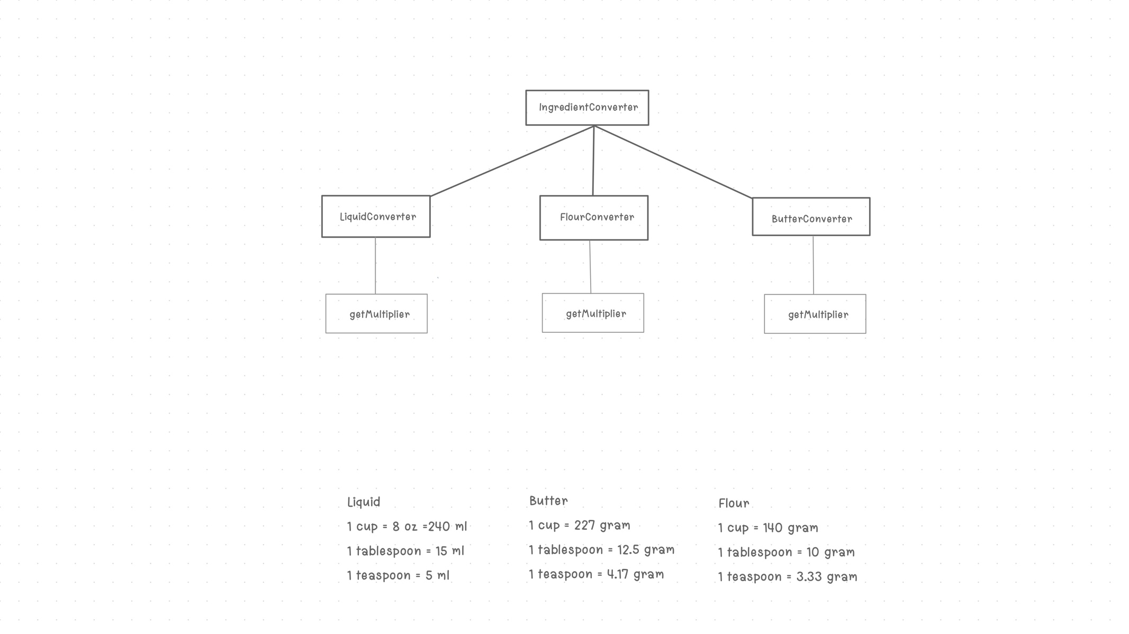

Top-down Integration

|  |  |  |  |  |
| --- | --- | --- | --- | --- |
| Unit under test | List of Stubs/Drivers | result | Stub’s return value | Expected results |
| Driver | StubLiquidMultiplier  StubFlourMultiplier  StubButterMultiplier  StubIngredient | 50.0 Pass | 50.0 | 50.0 |
| IngredientConverter(); | - | 75.0 Pass | - | 75.0 |
| IngredientConverter(); | - | 12.0 Fail | - | 13.32 |
| IngredientConverter(); | - | 10.0 Fail | - | 8.34 |
| LiquidConverter convert();  + getMultiplier(); | - | 1500.0 Fail | - | 1440.0 |
| FlourConverter convert();  + getMultiplier(); | - | 24.0 Fail | - | 30.0 |
| ButterConverter convert();  + getMultiplier(); | - | 2497.0 Pass | - | 2497.0 |
| LiquidConverter convert(); | StubLiquidMultiplier | 1440.0 Pass | 240.0 | 1440.0 |
| FlourConverter convert(); | StubFlourMultiplier | 30.0 Pass | 10.0 | 30.0 |
| ButterConverter convert(); | StubButterMultiplier | 2497.0 Pass | 227.0 | 2497.0 |

Bottom-up Integration

|  |  |  |  |  |
| --- | --- | --- | --- | --- |
| Unit under test | List of Stubs/Drivers | result | Stub’s return value | Expected results |
| LiquidConverter convert(); | StubLiquidMultiplier | 1200.0 Pass | 240.0 | 1200.0 |
| FlourConverter convert(); | StubFlourMultiplier | 70.0 Pass | 10.0 | 70.0 |
| ButterConverter convert(); | StubButterMultiplier | 681.0 Pass | 227.0 | 681.0 |
| LiquidConverter convert();  + getMultiplier(); | driver | 1250.0 Fail | - | 1200.0 |
| FlourConverter convert();  + getMultiplier(); | driver | 56.0 Fail | - | 70.0 |
| ButterConverter convert();  + getMultiplier(); | driver | 681.0 Pass | - | 681.0 |
| IngredientConverter(); | driver | 80.0 Pass | - | 80.0 |
| IngredientConverter(); | driver | 420.0 Pass | - | 420.0 |
| IngredientConverter(); | driver | 28.0 Fail | - | 25.0 |
| Driver | StubIngredient | 50.0 Pass | 50.0 | 50.0 |