

Thesis Proposal
Design and Implementation of an Intelligent sEMG-Based
Human-Machine Interface for Multi-DOF Robotic Arm Control

Course: CSE0400 - Project

Submitted By
Muhtasim Al Ahsan
UG02-61-22-042

1. Introduction

Background and Motivation
Surface electromyography (sEMG) provides a non-invasive method of capturing muscle activation signals from the human body and has been widely explored for prosthetic control, rehabilitation systems, and human-machine interaction. By translating muscle signals into control commands, sEMG-based interfaces offer an intuitive way for users to interact with robotic systems.
Despite significant research progress, most EMG-controlled prosthetic and robotic systems rely on expensive hardware, proprietary software, and limited adaptability, making them inaccessible in low-resource environments. Additionally, controlling multi-degree-of-freedom (DOF) robotic systems using a small number of EMG channels remains a challenging problem due to signal variability, noise, and limited information bandwidth.
This project aims to design and implement a low-cost, modular, and intelligent sEMG-based control system capable of driving a 6-degree-of-freedom robotic arm using machine learning techniques. The system emphasizes real-time performance, usability, and reproducibility while maintaining affordability and extensibility for future research.

2. Problem Statement
Although sEMG-based control has demonstrated promise, several limitations remain:
- High cost of commercial EMG acquisition systems
- Difficulty in mapping limited EMG channels to multi-DOF robotic control
- Sensitivity of EMG signals to noise, electrode placement, and user variability
- Lack of integrated training, visualization, and evaluation platforms
Most existing systems either focus on hardware design without intelligent control strategies or apply machine learning without considering real-time usability and robustness.

3. Research Objectives
The main goal of this thesis is to design and evaluate an intelligent sEMG-based control system for robotic arm manipulation.

Specific Objectives
- Design a low-cost sEMG signal acquisition setup using surface electrodes and microcontrollers
- Implement real-time EMG preprocessing, windowing, and feature extraction
- Train and evaluate machine learning models for classifying muscle activation patterns
- Develop a mode-based control strategy to map limited EMG channels to multiple robotic DOFs
- Design a graphical user interface (GUI) for training, visualization, and control
- Evaluate system performance in terms of accuracy, latency, and robustness

4. Literature Review

sEMG Based Human-Machine Interfaces
sEMG signals have been widely used for prosthetic hand control and rehabilitation robotics. Traditional systems rely on threshold-based or rule-based control, which often lack adaptability and robustness in real-world conditions.

Machine Learning for EMG Classification
Recent studies have applied machine learning techniques such as Support Vector Machines (SVM), Random Forests, and neural networks to classify EMG signals. Deep learning approaches, including 1D Convolutional Neural Networks (CNNs), have shown improved performance by learning features directly from raw or minimally processed EMG data.

Multi-DOF Control with Limited EMG Channels
Due to hardware and comfort constraints, many systems use only one or two EMG channels. Mode-based control strategies and sequential control schemes are commonly employed to extend control capability without increasing sensor count.

Research Gap
Most existing works either rely on expensive equipment or lack an integrated framework that combines low-cost acquisition, intelligent control, user training, and real-time visualization. This project addresses this gap by proposing a complete, affordable, and extensible system.

5. Methodology

5.1 Signal Acquisition
- Surface EMG electrodes placed on forearm muscles
- Analog amplification and conditioning
- Data sampled at ~200 Hz using an Arduino-based microcontroller
- Raw ADC values transmitted to a PC via serial communication

5.2 Signal Preprocessing
- DC offset removal
- Rectification
- Envelope extraction using smoothing filters
- Sliding window segmentation (e.g., 200 ms windows)

5.3 Feature Extraction
Time-domain features extracted from each window:
- Mean Absolute Value (MAV)
- Root Mean Square (RMS)
- Waveform Length (WL)
- Zero Crossing (ZC)
- Slope Sign Changes (SSC)
These features form the input to machine learning models.

5.4 Machine Learning Models

Baseline Models
- Random Forest
- Support Vector Machine (SVM)
Chosen for interpretability, fast training, and robustness with small datasets.

Advanced Model
- 1D Convolutional Neural Network (1D CNN)
- Operates directly on windowed EMG signals
A comparative evaluation between classical and deep learning models will be performed.

5.5 Training Protocol (Cue-Based)
- Visual cues (animations or icons) instruct users to perform specific muscle actions
- Structured acquisition protocol:
  - Rest period
  - Action period
  - Rest period
- Multiple repetitions per class
- Automatic labeling during data collection

5.6 Control Strategy
- Mode-based control to map EMG classes to multiple robotic DOFs
- Modes include:
  - Grip control
  - Wrist control
  - Arm movement
- Simultaneous activation of multiple channels triggers mode switching
- Cooldown mechanism prevents accidental repeated switching

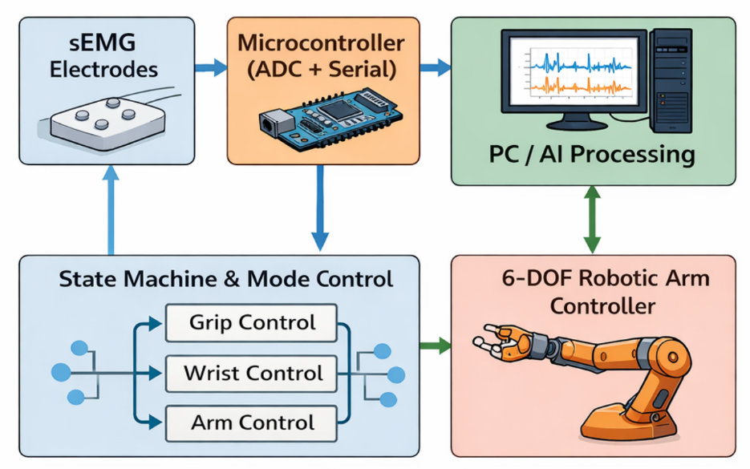
5.7 Graphical User Interface
The GUI will support:
- Live EMG waveform visualization
- Training mode with visual cues
- Real-time prediction display
- Mode and command monitoring
- Data recording and replay

6. Expected Contribution
- A complete low-cost sEMG-based robotic arm control framework
- Demonstration of real-time intelligent control using machine learning
- Comparative analysis of classical ML and deep learning models for EMG
- An extensible research platform for future prosthetic and rehabilitation studies

7. Timeline (Approximate: 8 Months)
Week | Activities
1-2 | Literature review, system design
3-4 | EMG acquisition hardware setup
5-6 | Signal preprocessing & dataset collection
7-8 | Classical ML model development
9-10 | CNN model development
11-12 | GUI implementation
13-14 | System integration & evaluation
15-16 | Thesis writing and submission

8. Conclusion
This project proposes a practical and intelligent approach to sEMG-based robotic arm control using low-cost hardware and machine learning. By integrating structured data acquisition, robust signal processing, intelligent classification, and user-centered design, the system aims to contribute both as a functional prototype and as a research framework suitable for academic publication.

9. References
- Phinyomark, A., et al. Feature extraction and selection for EMG signal classification.
- Englehart, K., Hudgins, B. A robust, real-time control scheme for multifunction myoelectric control.
- Atzori, M., Müller, H. Control capabilities of myoelectric robotic prostheses.
- Oskoei, M. A., Hu, H. Myoelectric control systems—A survey.
- Chen, X., et al. Deep learning for EMG-based hand gesture recognition.

