**Hotel Booking Insights Dashboard – a breakthrough for decoding hospitality data.**

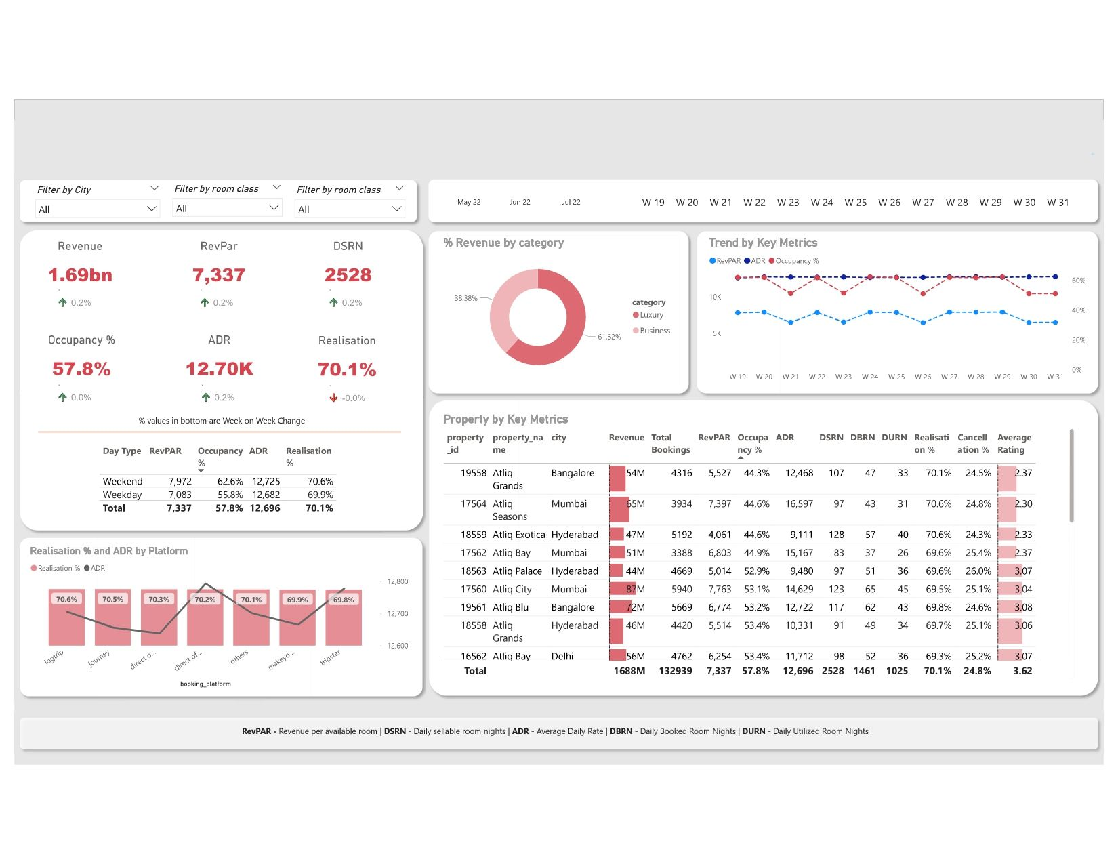

**Here are some of the insights:**

📈 **Revenue by Category, City, and Room Class**: Explore revenue distribution by room categories, filter by city, and drill down to room classes for smarter pricing decisions.

📊 **Weekly Trend Analysis**: Track RevPAR, DSRN, and more with weekly filters, empowering strategic marketing planning.

🏨 **Comparative Property Metrics**: Filter by room class to compare property performance, optimize resources, and boost profitability.

💰 **Platform-Specific Insights**: Focus on booking platforms with revealing Realization Percentage and ADR, guiding marketing choices.

🔍 **Decoding Acronyms**:

- **RevPAR**: Revenue per Available Room

- **DSRN**: Daily Sellable Room Nights

- **ADR**: Average Daily Rate

- **DBRN**: Daily Booked Room Nights

- **DURN**: Daily Utilized Room Nights

I recently had the opportunity to work with survey data specifically collected from data professional, and with the help of Power BI, I extracted some of the insights that provide valuable industry perspectives. 📈💡  
One of the findings were the Difficulty of Programming Languages among data professionals. Through careful analysis of the survey responses, I identified the programming languages that pose the greatest challenges in the field. This knowledge can aid aspiring data professionals in prioritizing their learning and assist organizations in allocating resources effectively. 🖥️📚  
Moreover, I delved into the survey data to uncover the countries where data professionals are most prevalent. The geographical distribution revealed interesting insights into the global landscape of data expertise. Understanding the concentration of data professionals in different regions can inform business decisions and market strategies. 🌍📊  
Work-life balance is a crucial aspect of job satisfaction, especially in the demanding field of data. By exploring the survey responses, I assessed the level of satisfaction data professionals experience with their work-life balance. The results shed light on the importance of maintaining a healthy equilibrium between work and personal life in the data industry. ⚖️😊  
In addition, I examined the satisfaction levels of data professionals with their current salary. This analysis provided valuable insights into how professionals perceive their compensation within the field. The findings can assist both individuals and organizations in making informed decisions about salary expectations and negotiations. 💰💼  
During the data cleaning process, I employed various techniques to ensure the accuracy and reliability of the insights. This involved removing irrelevant columns, optimizing data types for analysis, eliminating duplicate entries, and implementing other cleansing methods to enhance data quality. 🧹✨  
Overall, this experience reaffirmed the power of data analysis and visualization using Power BI for data