**A Comprehensive Review of Cluster Analysis:**

**Automation of Spotify Playlist Creation**

**Dr. Hariharan Rajadurai**

**Assistant Professor**

**VIT Bhopal**

**`**

**Abstract:**

This research paper presents an innovative approach to automate playlist creation on Spotify, leveraging high-dimensional data and the K-means clustering algorithm. The primary objective is to efficiently organize large playlists by breaking them down into smaller, more focused ones, ultimately enhancing the user experience. The methodology involves extracting audio features from the Spotify API, such as tempo, rhythm, and energy, to capture the musical essence of each song. Utilizing K-means clustering, songs are grouped based on their similarities, forming cohesive clusters within playlists. By harnessing this method, personalized playlists can be generated for users, tailored to their preferences and moods.

This approach aims to provide curated playlists that align closely with individual musical tastes, enriching the overall music streaming experience on Spotify. The proposed method not only benefits users by offering curated content, but also contributes to Spotify's success as a music platform, fostering user engagement, satisfaction, and retention. By effectively organizing large playlists, this methodology allows users to navigate through their music collections more efficiently, discovering new songs that resonate with their unique preferences. In conclusion, this research paper introduces an automated playlist creation method on Spotify, utilizing high-dimensional data and K-means clustering, to provide personalized playlists that enhance user satisfaction and improve music discovery.

**Introduction:**

With the advent of digital music streaming platforms, such as Spotify, users have access to an immense collection of songs. However, manually creating and curating personalized playlists from these vast libraries can be a daunting and time-consuming task. Personalized playlists play a pivotal role in enhancing the music listening experience by tailoring the content to individual preferences, moods, and musical tastes. To address this challenge, there is a growing need for automated methods that can efficiently organize large music libraries and generate playlists tailored to users' unique preferences.

**K-means clustering:**

The K-means clustering algorithm works by iteratively assigning data points to clusters and updating cluster centroids to minimize the within-cluster variance. It aims to group data points that are closer to each other in terms of their features. In the context of playlist creation, we can utilize audio features such as popularity, liveness, loudness, speechiness, tempo, and valence to measure the similarity between songs.

By applying the K-means clustering algorithm to high-dimensional audio feature data extracted from the Spotify API, we can effectively group songs with similar characteristics into clusters. Each cluster represents a subset of songs that share common attributes, enabling us to create targeted playlists. This automated approach eliminates the need for users to manually sift through a large number of songs and allows for the creation of personalized playlists effortlessly.

In the following sections, we will delve into the methodology, where we will discuss the data extraction process, feature selection, and the application of the K-means clustering algorithm. We will also present the results and findings of our research, followed by a discussion of the advantages, limitations, and future directions. Ultimately, this research aims to provide Spotify users with an enhanced music listening experience through automated playlist creation.

**Objective:**

The primary goal of this project is to leverage clustering algorithms to efficiently divide larger playlists into smaller, more precise ones. By utilizing the K-means clustering algorithm, we seek to group songs based on their audio features, including popularity, liveness, loudness, speechiness, tempo, and valence. These audio features encompass different aspects of a song's characteristics, allowing us to capture a comprehensive view of each track. Through the application of clustering techniques, our objective is to identify meaningful patterns and similarities among songs, enabling the creation of curated playlists that closely align with users' musical preferences and moods. By breaking down larger playlists into more focused ones, we aim to enhance the overall music listening experience, providing users with tailored and enjoyable musical journeys. This project aims to demonstrate the effectiveness and potential of clustering algorithms in playlist organization, contributing to advancements in music recommendation systems and personalized playlist creation.

**Methodology:**

1. **Data collection:** The initial step involves extracting audio feature data from the Spotify API for songs within a specific playlist, accessing attributes such as tempo, rhythm, pitch, and energy. This data forms the foundation for subsequent analysis and automated playlist creation.
2. **Feature selection:** In the feature selection phase, relevant audio features such as popularity, liveness, loudness, speechiness, tempo, and valence are identified, considering their significance in capturing different aspects of the songs' characteristics and emotional content. These selected features serve as key indicators for creating personalized playlists aligned with users' preferences and moods.
3. **Pre-processing**: Prior to analysis, the feature data undergoes pre-processing steps, including normalization and scaling, to ensure comparability and remove potential biases caused by varying data ranges. This pre-processing enhances the accuracy and effectiveness of subsequent clustering algorithms in grouping songs based on their similarities.
4. **K-means clustering**: By applying the K-means algorithm, songs are grouped into clusters based on their feature similarities, enabling the creation of cohesive clusters within playlists. This clustering process facilitates the organization of songs, allowing for the efficient creation of personalized playlists that align closely with users' musical preferences and moods.
5. **Playlist generation**: After the K-means clustering process, songs are assigned to their respective clusters, and smaller playlists are created within each cluster. This step ensures that songs with similar audio features and musical characteristics are grouped together, resulting in cohesive and focused playlists that cater to users' preferences and moods.

**Results:**

* The visualization gives a clear overview of the relative abundance of tracks in each genre, allowing us to identify the genres with the highest and lowest number of tracks. This information provides valuable insights into the diversity and popularity of different music genres within the dataset.

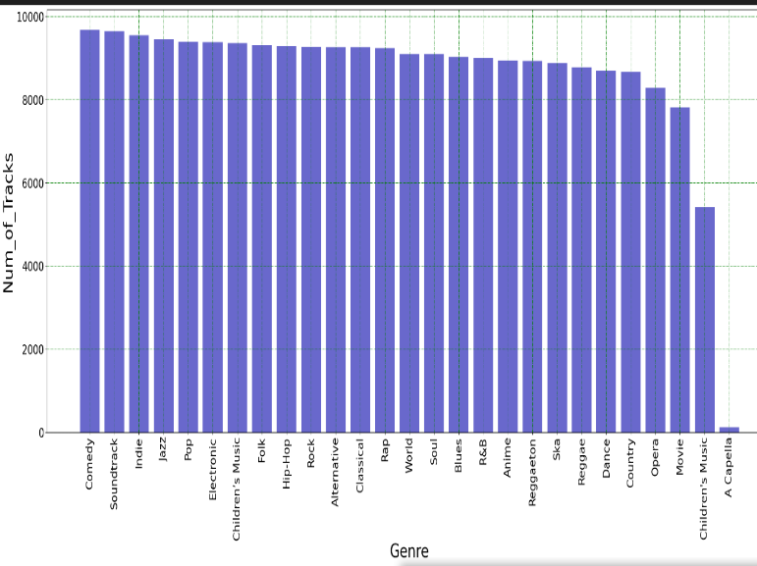

* The below heatmap represents the popularity of different genres within the dataset. By analyzing the heatmap, we can quickly identify the genres that are most popular and those that are less popular among the dataset. This visualization helps in understanding the relative popularity of different music genres and can provide valuable insights.

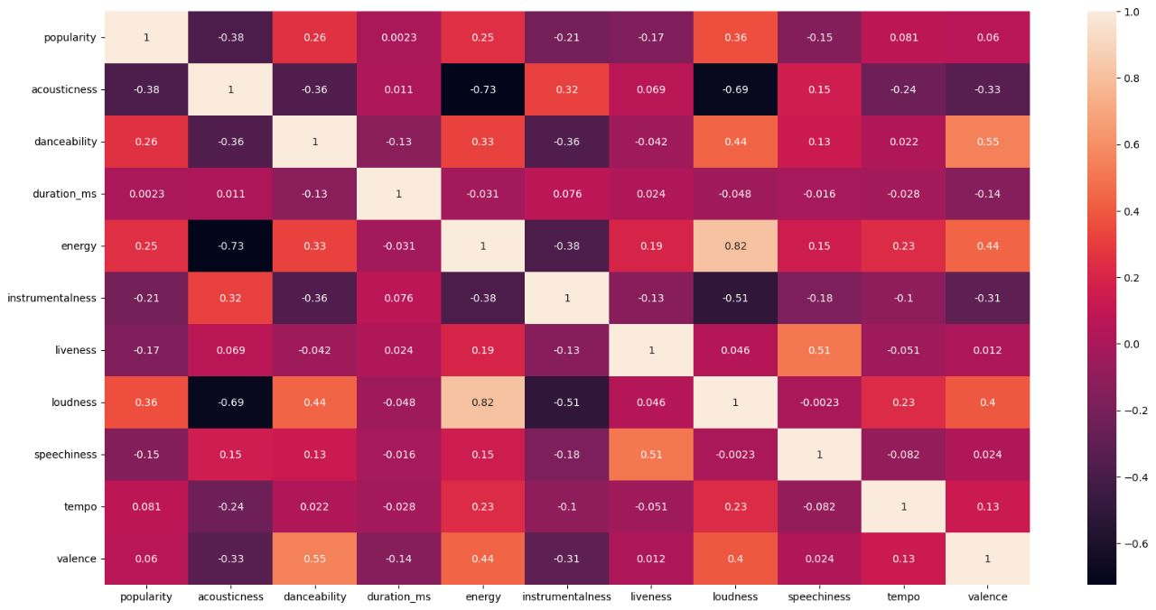

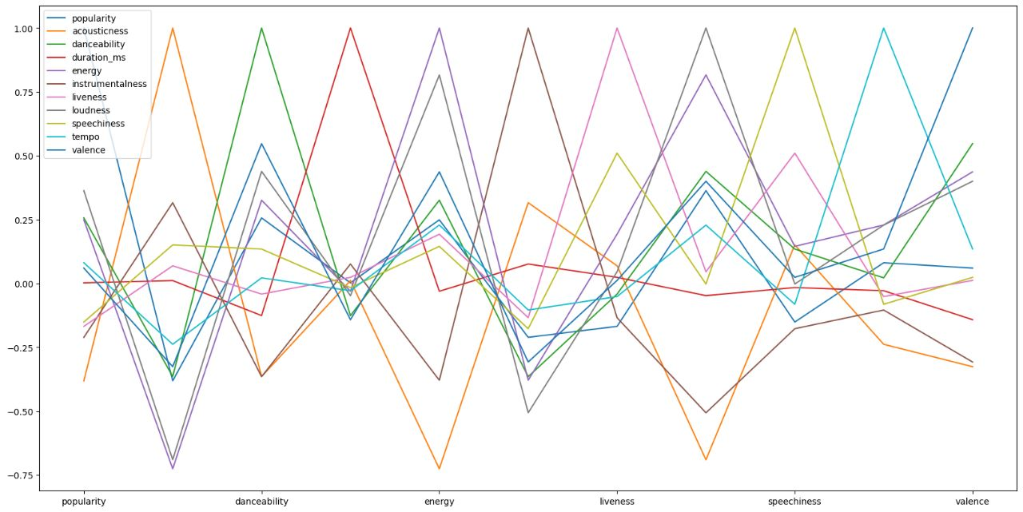

* The following scatterplots allows us to observe any patterns or correlations between the features and popularity. These scatterplots provide a concise visual summary of the relationships between popularity and various features, enabling us to understand the impact of each feature on a song's overall popularity.
* Such visualizations are valuable tools for music analysis, industry professionals, and researchers studying the dynamics of popular music

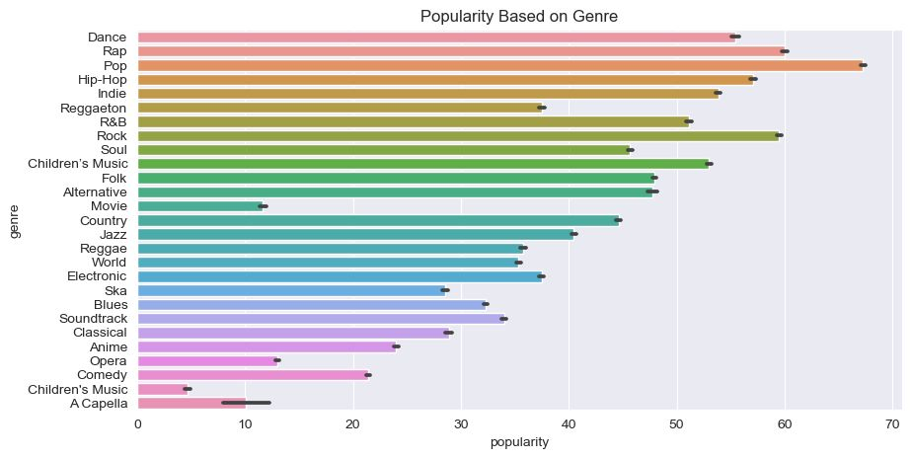

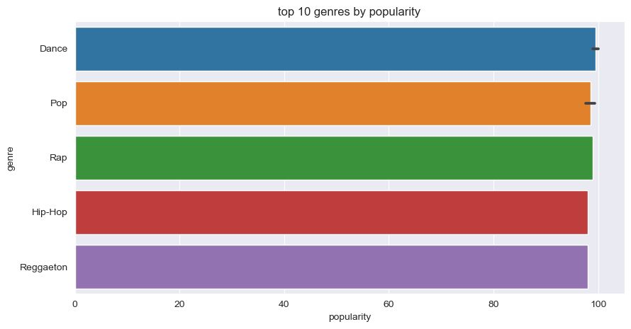

* The graphs depict **the frequency distribution of various features** such as tempo, valence, energy, loudness, and liveliness. Each graph shows the distribution of values on the x-axis and the frequency of occurrence on the y-axis.

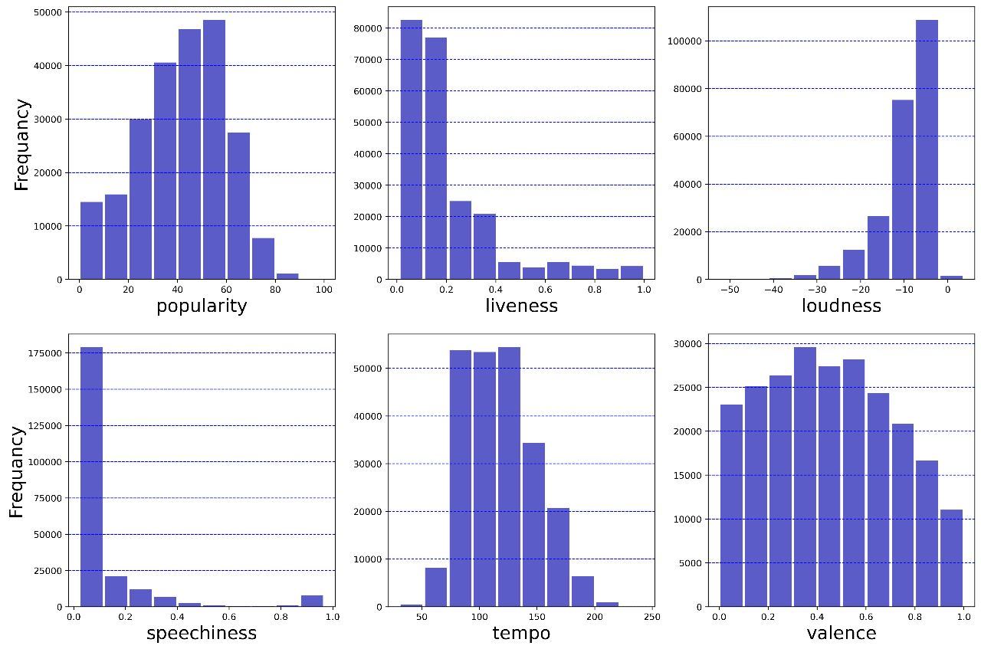

**Conclusion:**

* The research paper presents an innovative and automated methodology for playlist creation on Spotify, utilizing high-dimensional data and the K-means clustering algorithm.
* The proposed model generates personalized playlists tailored to users' unique preferences and moods, enhancing the overall music listening experience.
* Automation in playlist curation offers significant benefits, saving users valuable time and effort while providing them with highly engaging and immersive music discovery.
* The findings highlight the transformative potential of data-driven techniques in delivering individualized recommendations and pave the way for future advancements in music recommendation systems.
* The integration of technology and user preferences in playlist creation methods fosters an enriched musical journey for listeners worldwide.

**Reference:**

1. “A Novel Effective Distance Measure and a Relevant Algorithm for Optimizing the Initial Cluster Centroids of K-means” by Yang Liu, Shuaifeng Ma, and Xinxin Du published in IEEE Access Early Access Digital Object Identifier: 10.1109/ACCESS.2020.3044069.
2. Patient Clustering for Vital Organ Failure Using ICD Code with Graph Attention Zhangdaihong Liu, Ying Hu, Xuan Wu, Gert Mertes, Yang Yang, David A. Clifton, DOI 10.1109/TBME.2023.3243311.
3. Semi-supervised EEG Clustering with Multiple Constraints Chenglong Dai, Jia Wu, Senior Member, IEEE, Jessica J.M. Monaghan, Guanghui Li, Hao Peng, Stefanie I. Becker, David McAlpine, DOI 10.1109/TKDE.2022.3206330.
4. Correction to: A Fresh Look at Socio-Demographics in Work-Family Conflict: a Cluster Analysis Approach Kyle J. Pagel • Jacqueline K. Deulingl • Joseph J. Mazzola I • Kathleen M. Rospenda2 Published mlirp: 12 March 2019.
5. Experimental analysis of clustering based models and proposal of a novel evaluation metric for static video summarization Deeksha Gupta • Akashdeep Sharma • Pavit Kaur • Ritika Gupta.
6. Automatic Clustering for Improved Radio Environment Maps in Distributed Applications Haithem Ben Chikha 1, and Alaa Alaerjan 2.
7. Cluster Analysis and Discriminant Analysis for Determining Post-Earthquake Road Recovery Patterns Jieling Wu 1 , Mitsugu Saito 2, and Noriaki Endo 3.
8. RESEARCH PAPER ON CLUSTER TECHNIQUES OF DATA VARIATIONS Er. Arpit Gupta 1 ,Er.Ankit Gupta 2,Er. Amit Mishra.
9. ANALYSIS OF STUDENT ACADEMIC PERFORMANCE USING CLUSTERING TECHNIQUES K. Govindasamy1 , T.Velmurugan2.

Cluster Analysis of Educational Data: an Example of Quantitative Study on the answers to an Open-Ended Questionnaire Onofrio Rosario Battaglia , Benedetto Di Paola and Claudio Fazio