**1). Customers with the Highest Number of Orders**

**This query finds the customers who have placed the most orders and filters out those who have placed fewer than 3 orders.**

**Using sub-Query**



**Using join**



**2). Cities with the Highest Average Customer Age**

**This query finds the cities with the highest average customer age.**

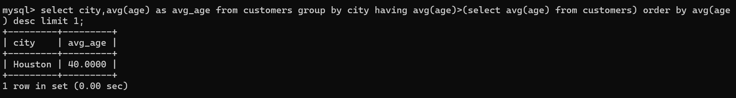

**3). Total Number of Orders Placed on Each Date**

**This query counts the number of orders placed on each order date.**

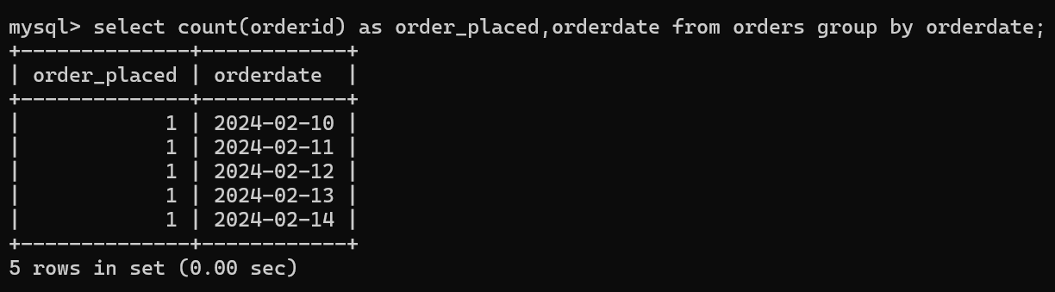

**4). Maximum Order Quantity for Each Product**

**This query finds the maximum quantity ordered for each product.**

**Using sub-Query**

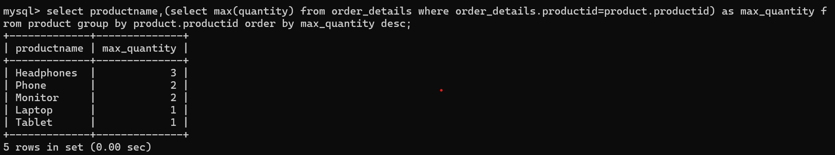

**Using Join**

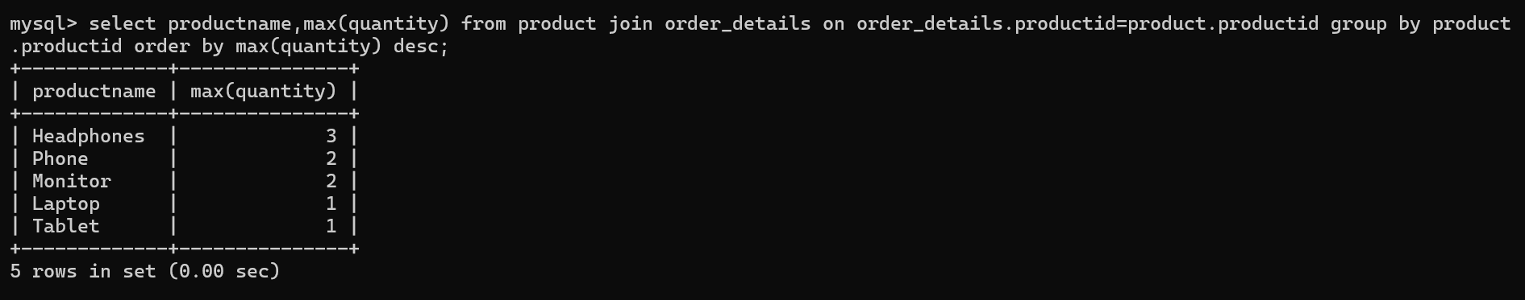

**5). Cities with More Than 2 Customers**

**This query lists cities that have more than two customers.**

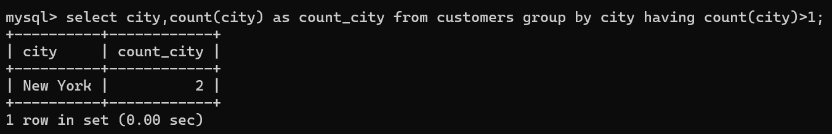

**6). Average Age of Customers by City**

**This query calculates the average age of customers in each city.**

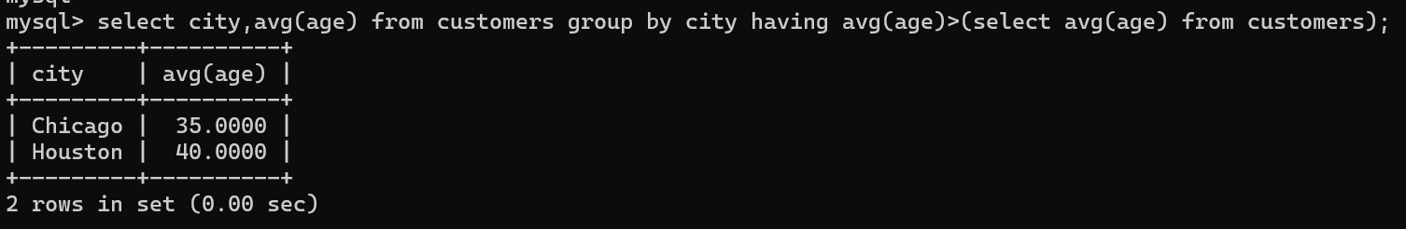

**7). Number of Orders Per Customer**

**This query finds out how many orders each customer has placed.**

**Using sub-Query**

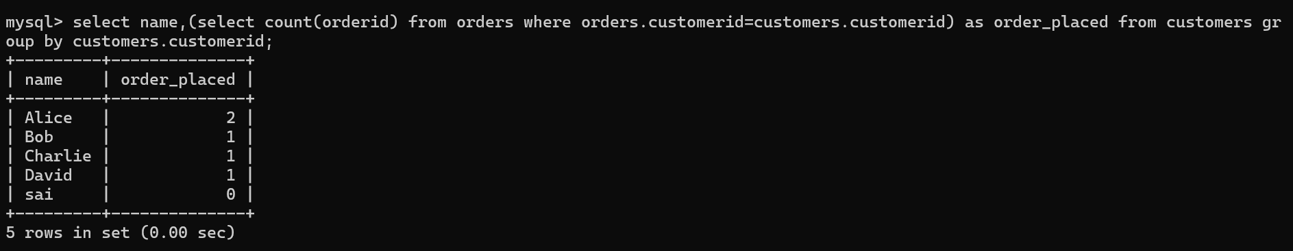

**Using Join**

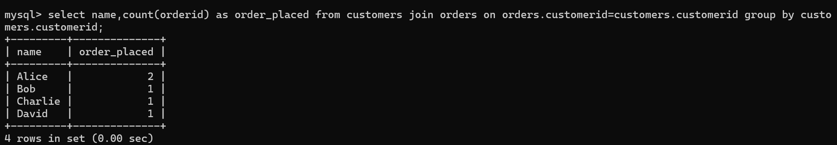

**8). Group Customers by City and Count Them**

**This query counts how many customers are in each city.**

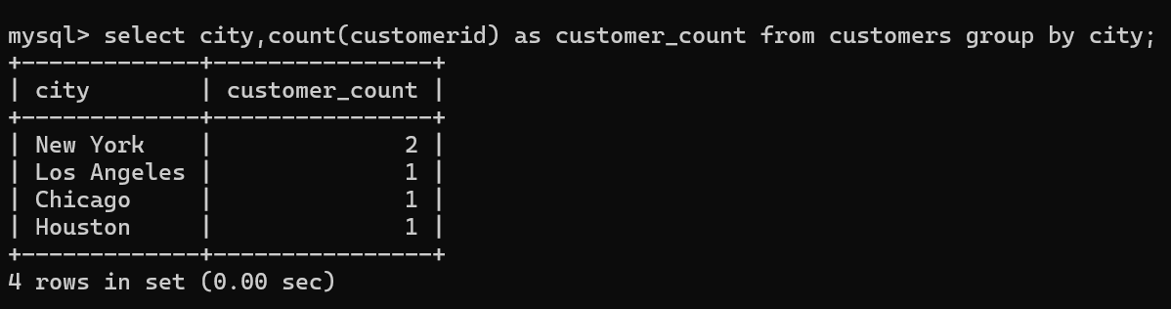

**9) Total Expenditure by Each Customer**

**This query calculates the total expenditure for each customer by summing the product of price and quantity in the order details table using subqueries.**

**Using sub query**

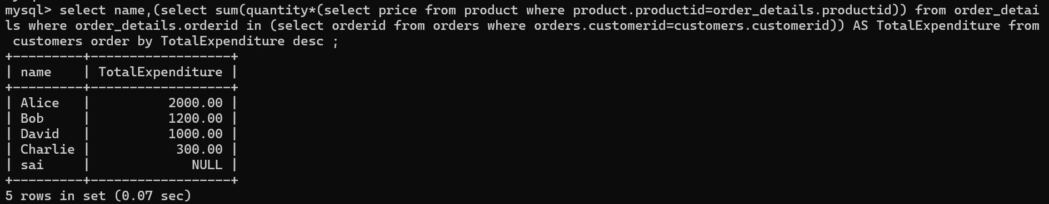

**Using Joins**

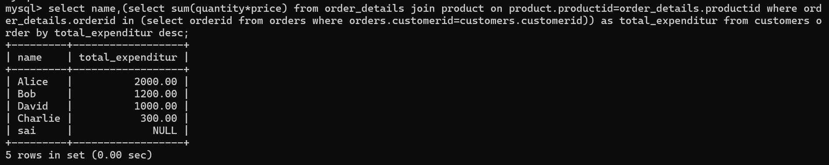

**10). Customers with Expenditure Above a Certain Amount**

**This query filters the customers whose total expenditure exceeds a certain threshold, e.g., 1000.**

**Using subquery**

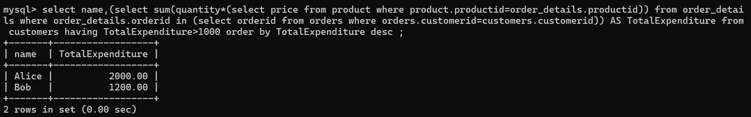

**Using Joins**

