

MSc Data Science Project 7PAM2002
Data Science FINAL PROJECT REPORT

Project Title:
Retail Sales Performance Analysis using Data Warehousing and Power BI Business Intelligence

Student Name and SRN:
Purna Chandra Sekhar Vemula
24062379

Supervisor: John Evans
Date Submitted: 21-04-2026

Table of Contents
Abstract 2
1. Introduction 3
1.1 Business Context 3
1.2 Research Question 3
1.3 Objectives 4
2. Literature Review 4
3. Dataset and Exploratory Data Analysis (EDA) 5
3.1 Dataset Description 5
3.2 Data Cleaning and Preprocessing 6
3.3 Exploratory Data Analysis 6
4. Methodology 7
4.1 Step 1: Data Loading and Initial Exploration 8
4.2 Step 2: Data Cleaning 8
4.3 Step 3: Feature Engineering 8
4.4 Step 4: Data Warehouse Design 8
4.5 Step 5: Power BI Integration 10
4.6 Step 6: Dashboard Development 10
5. Results and Analysis 11
5.1 Overall Sales Performance (Key KPIs) 11
5.2 Monthly Sales Trend Analysis 12
5.3 Geographic Distribution of Sales 13
5.4 Product Performance Analysis 14
5.5 Customer Behaviour Analysis 15
6. Key Insights 16
7. Discussion and Managerial Implications 17
8. Limitations and Future Work 17
8.1 Limitations 17
8.2 Future Work 18
9. Conclusion 18
10. References 19

Abstract
This study examines transactional data from a UK-based online retail company spanning December 2010 to December 2011, aiming to assess sales performance, customer behaviour, and product demand through data warehousing and business intelligence methodologies. Using Python, the project will clean and preprocess raw transactional data. It will also use SQL to design a dimensional star-schema data warehouse and Power BI to create interactive dashboards that show important business metrics. Total revenue (£10.67 million), total orders (20,000), customer base (4,300), and average order value (£530) are all examples of core performance indicators. These are looked at from different angles, such as time, geography, products, and customers. The analysis shows that there are strong seasonal demand patterns, a heavy reliance on the UK market, and a small number of products and customers that make up most of the company's revenue. The results show that combining data engineering with business intelligence tools can help people make decisions based on data and find ways to improve their businesses.

1. Introduction

1.1 Business Context
The fast growth of e-commerce platforms has led to a huge increase in the amount of transactional data that retail businesses create. Every time a customer interacts with a business, whether it's buying something, returning something, or just looking around, the business gets more data that can be used to find useful information. But even though this data is available, many businesses have trouble turning raw transaction records into useful business intelligence because of problems like data complexity, inconsistency, and a lack of structured analytical frameworks.
The business that this project is about is an online store that sells gifts. It mostly does business in the UK, but it also serves customers in other countries. There are decorative items, seasonal gifts, and household items in the product line. These products are usually cheap, but customers tend to buy a lot of them at once, which makes the invoices pretty high. This pattern indicates that the retailer might be catering to business clients, including resellers, wholesalers, or small retail establishments, rather than individual consumers.
The organization has a lot of transactional data, but it doesn't have a structured way to look at sales performance from different angles, like time, place, products, and customers. The raw dataset is big and has problems like missing values, cancelled transactions, and formatting that isn't consistent, which makes it hard to get useful information directly.
This project uses data warehousing and business intelligence methods to turn raw transactional data into a format that can be structured and analysed in order to solve these problems. The project aims to give a full picture of how well a business is doing and help people make smart decisions by using a star-schema data model and making interactive dashboards.

1.2 Research Question
The central research question guiding this project is:
How can data warehousing and business intelligence techniques be used to transform raw retail transaction data into meaningful insights that support sales performance analysis, customer understanding, and strategic decision-making?
This question focuses on both the technical transformation of data and the practical value of insights generated through analytical tools.

1.3 Objectives
To address the research question, the following objectives were established:
- To clean and preprocess raw transactional data to ensure accuracy and consistency
- To design and implement a dimensional data warehouse using a star schema
- To transform transactional data into structured fact and dimension tables
- To compute key performance indicators such as revenue, order volume, and customer metrics
- To analyse sales trends across different time periods, including seasonal variations
- To evaluate product performance and identify high-revenue generating items
- To analyse customer behaviour and identify key contributing customers
- To develop Power BI dashboards for visual representation of analytical insights
- To provide actionable recommendations based on the analysis

2. Literature Review
Data warehousing and business intelligence are now important parts of modern business strategy, especially in industries that deal with a lot of data, like retail. As companies create more and more data, being able to organize, store, and analyse it well has become a key factor in their success.
Dimensional modelling, which Kimball and Ross (2013) came up with, is one of the most common ways to design a data warehouse. This method puts data into fact tables and dimension tables, which makes it easier to run analytical queries. Dimension tables hold descriptive information like product details, customer information, and time-related data, while fact tables hold numbers like sales transactions. This structure makes it possible to analyse data from many different angles, which is very helpful in retail settings where data needs to be looked at from many different angles.
The star schema is a key part of dimensional modelling. It is popular because it is easy to use and works well. A star schema has a central fact table that is linked to several dimension tables. This makes it easy to understand and speeds up query execution. This model is very useful for business intelligence applications, where users need quick access to combined data and insights. Within the framework of this project, the star schema facilitates the effective analysis of sales data across various dimensions, including time, geography, products, and customers.
Inmon (2005), on the other hand, suggested an enterprise data warehouse approach that focuses on data structures that are normalized. This model makes sure that data is consistent and works well with other systems in the organization. However, it is often more complicated and less efficient for analytical querying than dimensional models. Because of this, Kimball's dimensional modelling approach is better for this project, which values analytical performance and ease of use.
Business intelligence tools are very important for turning structured data into visual insights. Sharda, Delen, and Turban (2018) say that dashboards are a great way to keep an eye on key performance indicators and find patterns in big data sets. These tools let people interact with data by using visualizations like tables, graphs, and charts. This makes it easier to understand complicated information.
Chen, Chiang, and Storey (2012) conducted additional research that emphasizes the increasing significance of data analytics in deriving value from extensive datasets. Their work shows how companies can use analytics to make better decisions and get ahead of the competition. Wixom and Watson (2010) also talk about how business intelligence systems can help organizations do better by letting them analyse data faster and more accurately.
Retail analytics is all about looking at transactional data to learn more about how customers act, what products are in demand, and sales trends. Companies can better manage their inventory, find the best prices, and target customers more effectively by combining data warehousing methods with business intelligence tools. This project uses these ideas by building a star-schema data warehouse and making Power BI dashboards to look at how well retail sales are doing.

3. Dataset and Exploratory Data Analysis (EDA)

3.1 Dataset Description
The Online Retail Dataset is the dataset used in this project. It has records of transactions from an online store in the UK from December 2010 to December 2011. There are more than 500,000 rows in the dataset, and each row shows a transaction for a product on an invoice.
The key attributes in the dataset include:
- Invoice Number
- Stock Code
- Product Description
- Quantity
- Invoice Date
- Unit Price
- Customer ID
- Country
This dataset provides detailed insights into purchasing behaviour, including product demand, customer activity, and geographic distribution.

3.2 Data Cleaning and Preprocessing
Before performing any analysis, it was necessary to clean and preprocess the dataset to ensure accuracy and reliability. The following steps were undertaken:
- Removal of cancelled transactions: Invoices beginning with “C” were identified as cancellations and removed from the dataset
- Filtering invalid values: Records with zero or negative quantities and unit prices were removed
- Handling missing values: Transactions with missing customer IDs were retained for sales analysis but excluded from customer-level analysis
- Standardising data types: Columns were converted to appropriate data types for analysis

3.3 Exploratory Data Analysis
Exploratory Data Analysis (EDA) was performed using Python to understand the dataset and identify key patterns.
Key Metrics Identified:
- Total Revenue: £10.67 million
- Total Orders: 20,000 invoices
- Total Customers: 4,300 unique customers
- Total Units Sold: 5.6 million units
Key Observations:
- Significant increase in sales during November and December
- Majority of transactions originate from the United Kingdom
- A small number of products contribute disproportionately to total revenue
- Customer purchasing behaviour indicates a mix of one-time and repeat buyers
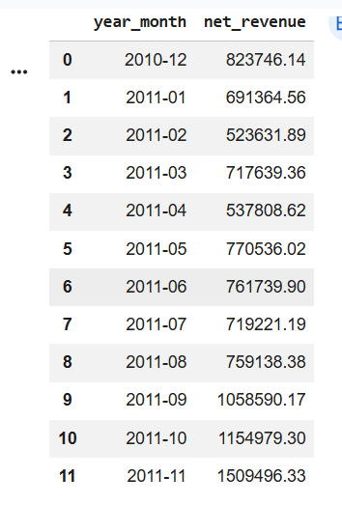
Figure 3: Monthly Revenue Trend Identified from Exploratory Data Analysis (2010–2011)
4. Methodology
The way this project works is based on a structured data analytics pipeline that includes data preprocessing, data modelling, and visualization.

4.1 Overview of the Methodological Approach
The methodology adopted in this project follows a structured, step-by-step analytical pipeline designed to transform raw transactional data into meaningful business insights. The overall approach is divided into four major stages: data acquisition and understanding, data preprocessing and cleaning, data modelling through a warehouse design, and finally, visualisation and analysis using business intelligence tools.
The primary goal of this methodology is not just to analyse the data, but to create a system that allows the data to be interpreted in a structured and reusable manner. This is achieved by combining Python for data preprocessing, SQL for data modelling, and Power BI for visualisation.
Each stage builds upon the previous one, ensuring that the final outputs are both accurate and meaningful.

4.2 Data Loading and Initial Exploration
The first step in the methodology involved loading the dataset into a Python environment using the Pandas library. At this stage, the objective was not to perform analysis immediately, but to understand the structure and characteristics of the dataset.
This included examining the number of rows and columns, identifying data types, and checking for missing values. Special attention was given to key variables such as invoice number, product code, quantity, and unit price, as these form the basis of all further analysis.
Through this initial exploration, it became evident that the dataset contained several inconsistencies, such as missing customer identifiers, negative quantities, and irregular invoice formats. Identifying these issues early was important, as they directly impact the quality of the analysis.

4.3 Data Cleaning and Preprocessing
Once the dataset was understood, the next step was to clean and preprocess the data to ensure its reliability.
One of the major challenges in the dataset was the presence of cancelled transactions. These were identified using invoice numbers that begin with the letter “C”. Since these transactions do not represent actual sales, they were removed from the dataset to avoid distortion in revenue calculations.
Another issue involved negative and zero values in the quantity and unit price columns. Such values are not meaningful in the context of sales and were therefore filtered out. Removing these records helped in ensuring that only valid transactions were considered.
Handling missing values was also an important part of this stage. A significant number of records did not contain customer IDs. While these records were retained for overall revenue analysis, they were excluded from customer-specific analysis to maintain accuracy.
Additionally, data types were standardised. The invoice date column was converted into a datetime format, allowing for time-based analysis such as monthly and yearly trends.
This preprocessing stage played a crucial role in improving data quality and ensuring that subsequent analysis is based on accurate and consistent data.

4.4 Feature Engineering
After cleaning the data, new features were created to enhance analytical capabilities. One of the most important features introduced in this project is the revenue variable, which was calculated by multiplying the quantity of items purchased with their respective unit price.
This new variable allowed the analysis to move beyond simple transaction counts and focus on actual financial performance.
In addition to revenue, time-based features were extracted from the invoice date. These included the month and year of each transaction. This step was particularly important for identifying seasonal patterns and trends over time.
Feature engineering is a critical step in the methodology, as it transforms raw data into a format that is more meaningful and suitable for analysis.
New variables were created to enhance analytical capabilities:
- Revenue = Quantity × Unit Price
- Month and Year extraction from Invoice Date
- Country classification

4.5 Data Warehouse Design (Star Schema)
Once the data was cleaned and enhanced, the next step involved structuring it into a data warehouse using SQL. A star schema design was chosen for this purpose due to its simplicity and efficiency in supporting analytical queries.
The star schema consists of a central fact table surrounded by multiple dimension tables. The fact table contains measurable data such as quantity sold and revenue, while the dimension tables provide descriptive context.
In this project, the fact table includes transactional data such as invoice number, product ID, customer ID, date ID, quantity, unit price, and revenue. The dimension tables include product details, customer information, time attributes, and geographic data.
This structure allows the data to be analysed from multiple perspectives. For example, sales can be analysed by time, by product, by customer, or by country. The star schema significantly improves query performance and makes the dataset easier to use for business intelligence tools.
A star schema was implemented using SQL to organise the data into structured tables.
Fact Table: fact_sales
Stores transactional data including:
- invoice_no
- product_id
- customer_id
- date_id
- country_id
- quantity
- unit_price
- revenue
Dimension Tables:
- dim_product
- dim_customer
- dim_date
- dim_country

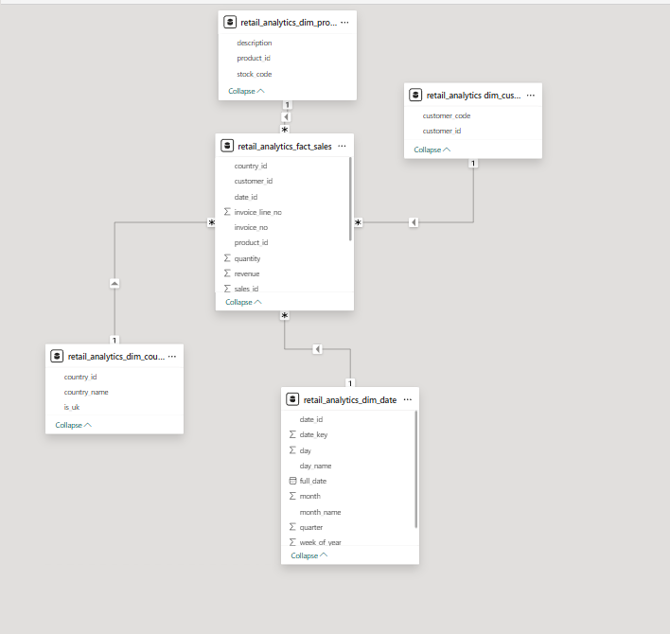
Figure 4.1: Star Schema Data Warehouse Design Showing FactSales and Dimension Tables
4.6 Data Integration with Power BI
After designing the data warehouse, the structured data was imported into Power BI for visual analysis. During this stage, relationships between fact and dimension tables were established within Power BI to ensure accurate filtering and aggregation.
This step is crucial because it allows users to interact with the data dynamically. For instance, selecting a specific country or time period automatically updates all visualisations, providing a more intuitive understanding of the data.
Power BI serves as the final layer of the methodology, where all the processed and structured data is transformed into visual insights.

4.7 Dashboard Development
The final stage of the methodology involved creating interactive dashboards in Power BI. These dashboards were designed to present key insights in a clear and user-friendly manner.
The first dashboard focuses on overall sales performance, displaying key metrics such as total revenue, number of orders, and number of customers. It also includes visualisations such as monthly sales trends and country-wise revenue distribution.
The second dashboard focuses on product and customer analysis. It highlights top-performing products, customer purchasing behaviour, and revenue contribution by different segments.
The dashboards were designed with interactivity in mind, allowing users to apply filters and explore the data from different perspectives.

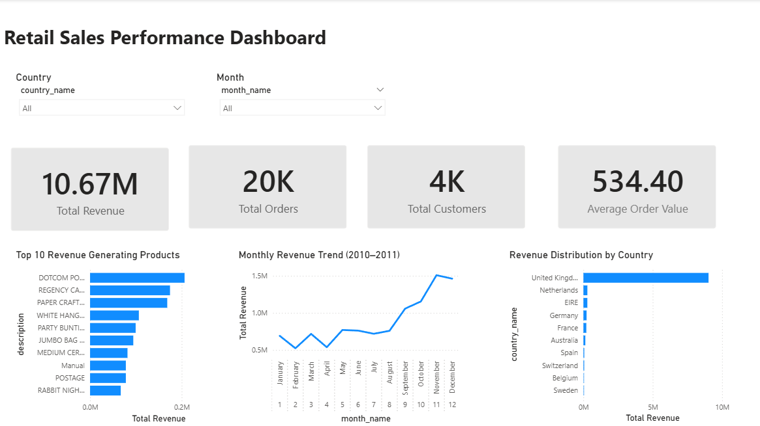
Figure 5.1: Power BI Dashboard

4.8 Summary of Methodology
In summary, the methodology follows a logical progression from raw data to actionable insights. The process begins with understanding and cleaning the data, followed by enhancing it through feature engineering. The data is then structured using a star schema to support efficient analysis. Finally, the insights are presented through interactive dashboards.
This structured approach ensures that the analysis is not only accurate but also meaningful and easy to interpret, even for users without a technical background.

5. Results and Analysis
After completing the data cleaning, warehouse design, and dashboard development, I analysed the dataset to understand how the business is performing from different perspectives. The analysis mainly focuses on overall sales performance, trends over time, geographic contribution, product performance, and customer behaviour.
Instead of just presenting numbers, the goal here is to explain what those numbers actually mean and how they can be useful from a business point of view.

5.1 Overview of Analytical Findings
After completing data preprocessing, warehouse design, and dashboard development, the dataset was analysed to extract meaningful insights related to sales performance, customer behaviour, and product demand.
The analysis was carried out using a combination of Python for initial exploration and Power BI for structured visualisation. The results presented in this section are based on key performance indicators (KPIs) such as total revenue, number of transactions, customer count, and product-level performance.
The objective of this section is not only to present the results but also to interpret them in a way that supports business decision-making.
The following key performance indicators (KPIs) were identified:
- Total Revenue: £10.67 million
- Total Orders: Approximately 20,000 transactions
- Total Customers: Approximately 4,300 unique customers
- Total Units Sold: Approximately 5.6 million units
- Average Order Value (AOV): Approximately £530.

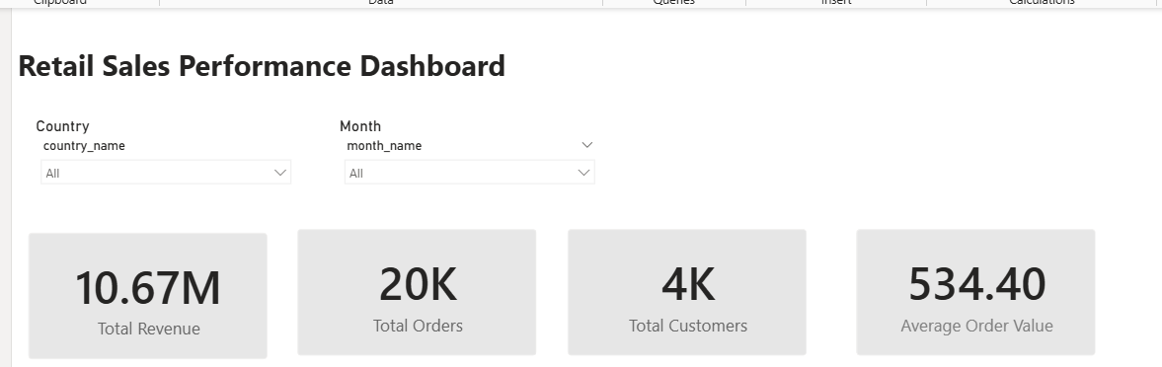
Figure 5.1: Power BI Dashboard Displaying Key Performance Indicators (Revenue, Orders, Customers, AOV)

5.2 Overall Business Performance
The first step in the analysis was to evaluate the overall performance of the business using high-level metrics.
The results show that the business generates a substantial amount of revenue over the one-year period. A significant observation is that the average order value is relatively high. This suggests that customers tend to purchase multiple items within a single transaction rather than making frequent small purchases.
This purchasing behaviour is consistent with the nature of the business, which sells gift-related products. Customers are likely to buy multiple items for occasions such as holidays or events.
Another important observation is that the number of unique customers is relatively smaller compared to the total number of transactions. This indicates that repeat customers play a significant role in driving revenue.

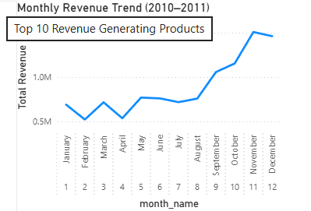
Figure 5.2: Monthly Sales Trend Dashboard Visual Showing Seasonal Revenue Patterns

5.3 Geographic Distribution of Sales
Next, I looked at where the sales are coming from geographically.
The results clearly show that the United Kingdom contributes around 85–90% of the total revenue, which is a very large proportion. Other countries such as Germany, France, and Ireland contribute much smaller amounts in comparison.
This tells us that the business is highly dependent on the UK market. While this indicates a strong presence in the domestic market, it also raises some concerns. If there are any changes in the UK market, such as economic downturns or changes in customer behaviour, it could have a major impact on the overall business.
At the same time, the relatively low contribution from other countries suggests that there is room for growth internationally. Expanding into other markets could help reduce this dependency and create new revenue opportunities.
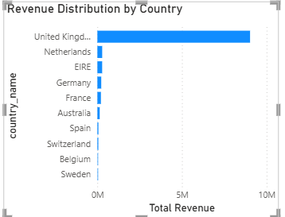
Figure 5.3: Revenue Distribution by Country Highlighting Dominance of UK Market

5.4 Product Performance Analysis
The next part of the analysis focused on understanding which products are driving the business.
One of the most important findings is that a small number of products contribute around 60–70% of the total revenue. This means that most of the business relies on a limited set of high-performing products.
This kind of distribution is quite common in retail and is often explained by the Pareto principle, where a small percentage of items generate the majority of the results.
From a practical point of view, this insight is very useful. It shows that the business should focus on maintaining and promoting these top-performing products. Ensuring that these items are always in stock is critical because any shortage could directly affect revenue.
On the other hand, there are many products that contribute very little to the overall sales. These products might still have value, but they could also be taking up unnecessary space and resources. This suggests that the business could review its product range and optimise it.

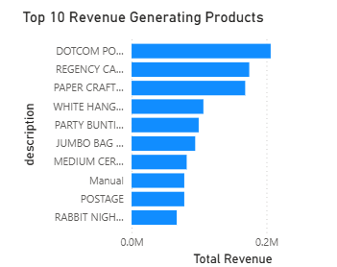
Figure 5.4: Top Products by Revenue Demonstrating Pareto Distribution in Sales

5.5 Customer Behaviour Analysis
Customer behaviour is another important part of the analysis.
The data shows that not all customers contribute equally to revenue. In fact, a small group of customers generates a large portion of the total sales, while many customers make only one or two purchases.
This indicates that the business has a group of high-value customers who are very important for its success. These customers are likely repeat buyers or bulk purchasers.
From a business point of view, this is a critical insight. It means that retaining these customers should be a top priority. Losing even a few of these high-value customers could significantly impact total revenue.
This also suggests that the business could benefit from targeted strategies such as loyalty programs or personalised offers to keep these customers engaged.
At the same time, there is an opportunity to convert low-frequency customers into repeat buyers by improving customer experience or offering incentives.

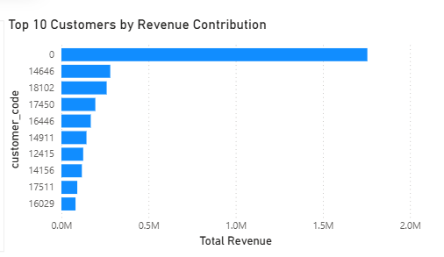
Figure 5.5: Customer Purchase Behavior Analysis Showing Order Frequency Distribution

5.7 Bringing Everything Together
When all the results are considered together, a clear pattern emerges.
The business is heavily driven by seasonal demand, a small number of products, and a limited group of high-value customers. At the same time, it relies strongly on the UK market.
All of these factors are connected. For example, high-value customers may be responsible for bulk purchases of top products during peak seasons. Understanding these connections is important because it helps the business focus on what really drives its performance.

5.8 Final Summary of Findings
Overall, the analysis shows that:
- The business generates strong revenue with high-value transactions
- Sales are highly seasonal, with peaks during the holiday period
- The UK is the dominant market
- A small number of products drive most of the revenue
- A limited group of customers contributes significantly to total sales
These findings provide a solid foundation for making better business decisions and improving overall performance.

6. Key Insights
After completing the detailed analysis of sales performance, customer behaviour, product contribution, and geographic distribution, a number of important insights can be drawn from the dataset. These insights are not just based on individual metrics, but on how different aspects of the data connect with each other.

6.1 Strong Seasonal Demand Drives Revenue
One of the most noticeable insights from the analysis is the presence of strong seasonal demand. The monthly sales trend clearly shows that revenue increases significantly during the final quarter of the year, particularly in November and December. During this period, sales increase by approximately 30–40% compared to the average monthly performance.
This behaviour is directly linked to the nature of the business, which deals with gift items and decorative products. Customers are more likely to make purchases during festive periods, especially around Christmas.
What makes this insight important is that it shows that a large portion of the annual revenue is concentrated within a short time frame. This means the business is highly dependent on these peak months for overall performance.
From a practical point of view, this suggests that planning for seasonal demand is critical. The business needs to ensure that it has enough stock, efficient logistics, and targeted promotions during these periods. Any failure to meet demand during these months could lead to significant revenue loss.

6.2 High Dependence on the UK Market
Another key insight is the strong dependence on the United Kingdom as the primary market. The analysis shows that around 85–90% of the total revenue comes from the UK, while the remaining percentage is distributed across other countries such as Germany, France, and Ireland.
This clearly indicates that the business has established a strong presence in the domestic market. However, it also highlights a potential risk. Relying heavily on a single market means that any economic changes, shifts in customer preferences, or external factors in that region could directly impact the business.
At the same time, the relatively low contribution from international markets suggests that there is untapped potential. Expanding into other countries could help diversify revenue streams and reduce dependency on the UK.
So, while the UK dominance is a strength, it also points towards the need for future expansion strategies.

6.3 Revenue is Highly Concentrated Among a Few Products
The product analysis revealed that a small number of products contribute around 60–70% of the total revenue. This shows a clear imbalance in how different products perform.
This kind of distribution is common in retail and reflects the Pareto principle, where a small percentage of products generates the majority of the results. In this case, the business is heavily dependent on a limited set of high-performing items.
This insight is very important because it highlights where the business should focus its attention. These top-performing products are critical for revenue generation, so maintaining their availability should be a priority.
At the same time, the large number of low-performing products suggests inefficiency in the product portfolio. Some products may not be contributing enough to justify their presence, and this opens up opportunities for optimisation.
Overall, this insight helps the business understand which products truly matter and where improvements can be made.

6.4 Customer Contribution is Uneven (High-Value Customers Dominate)
Customer behaviour analysis shows that revenue is not evenly distributed among customers. Instead, a small group of customers contributes a large portion of the total revenue, while many customers make only occasional purchases.
This means that the business relies heavily on high-value customers, who are likely repeat buyers or bulk purchasers. These customers play a crucial role in driving overall sales.
This insight is particularly important because it highlights the need for customer retention strategies. Losing even a few of these high-value customers could have a significant impact on revenue.
From a business perspective, it would be beneficial to focus on maintaining relationships with these customers through personalised communication, loyalty programs, or special offers.
At the same time, there is also an opportunity to convert low-frequency customers into repeat buyers, which could further increase revenue.

6.5 Bulk Purchasing Behaviour Indicates a Different Customer Segment
Another interesting observation comes from the average order value of approximately £530, which is relatively high for a retail business selling gift items.
This suggests that customers are not purchasing single items but are instead buying in bulk. This behaviour indicates that the business may be serving not only individual consumers but also small businesses, resellers, or wholesalers.
This insight changes how the business should view its customer base. Instead of treating all customers as individual buyers, the company could consider strategies tailored to bulk purchasers, such as discounts for large orders or business-focused services.
Understanding this behaviour helps in better aligning the business model with customer needs.

6.6 Data-Driven Decision-Making is Clearly Possible
One of the overall insights from this project is the effectiveness of combining data warehousing and business intelligence tools.
By transforming raw transactional data into a structured format and visualising it through Power BI dashboards, it becomes much easier to identify patterns and trends. The ability to view sales performance across different dimensions such as time, location, product, and customer allows for more informed decision-making.
This shows that the organisation has the potential to move towards a more data-driven approach, where decisions are based on evidence rather than assumptions.

6.7 Bringing All Insights Together
When all the insights are considered together, a clear understanding of the business emerges.
The business is driven by seasonal demand, with a strong dependence on peak periods. Revenue is heavily concentrated among a small number of products and customers, and the majority of sales come from the UK market.
These factors are interconnected. For example, high-value customers may be responsible for bulk purchases of top-performing products during seasonal peaks.
Recognising these connections is important because it helps the business focus on the key drivers of performance rather than treating each factor separately.

7. Discussion and Managerial Implications
7.1 Overview of Discussion
The results obtained from the analysis provide a clear understanding of how the business operates and what factors are driving its performance. However, simply identifying patterns is not enough. The main purpose of this section is to interpret these findings in a practical context and explain how they can be used to support business decisions.
By connecting the analytical results with real-world implications, it becomes possible to identify areas where the business can improve, optimise its operations, and plan for future growth.

7.2 Managing Seasonal Demand Effectively
One of the most important findings from the analysis is the strong seasonal pattern in sales, with a significant increase in revenue during November and December. Since sales during this period are approximately 30–40% higher than average months, it is clear that a large portion of the business’s annual performance depends on these peak months.
From a managerial perspective, this insight highlights the importance of planning ahead for seasonal demand. The business cannot treat all months equally because demand is not evenly distributed throughout the year.
To make the most of this seasonal trend, the company should focus on:
- Ensuring sufficient inventory is available before peak periods
- Strengthening supply chain coordination to avoid delays
- Launching targeted marketing campaigns during high-demand months
If the business fails to prepare for these peak periods, it risks losing potential revenue due to stock shortages or operational inefficiencies. On the other hand, effective planning can significantly increase profitability during these months.

7.3 Reducing Dependence on a Single Market
The geographic analysis shows that around 85–90% of revenue comes from the UK, which indicates a very strong reliance on the domestic market.
While this shows that the business has successfully established itself in the UK, it also raises concerns about long-term sustainability. Depending heavily on a single market can be risky, as any economic downturn or change in customer behaviour in that region could directly impact overall performance.
From a strategic point of view, this insight suggests that the business should consider expanding its presence in international markets. Even though other countries currently contribute only a small percentage of revenue, they represent potential growth opportunities.
Expanding internationally could help the business:
- Diversify its revenue sources
- Reduce market-specific risks
- Reach new customer segments
However, such expansion should be done carefully, considering factors like shipping costs, demand patterns, and local competition.

7.4 Focusing on High-Performing Products
The product analysis revealed that a small number of products contribute around 60–70% of total revenue. This clearly shows that the business depends heavily on a limited set of high-performing items.
From a managerial perspective, this insight is extremely valuable because it identifies exactly where the business is generating most of its income.
To make the most of this, the company should:
- Prioritise the availability of these top-performing products
- Ensure that supply chains for these products are stable
- Promote these products through marketing campaigns
At the same time, the large number of low-performing products suggests that not all items are contributing effectively to the business. Some of these products may not justify the cost of storage, handling, and management.
This opens up an opportunity for product portfolio optimisation, where underperforming items can be reviewed and potentially removed or replaced.

7.5 Strengthening Customer Retention Strategies
The customer analysis shows that a small group of customers contributes a large portion of the total revenue. This means that the business relies heavily on high-value customers.
From a managerial point of view, this is a critical insight. It shows that not all customers have the same impact on the business. Losing a few high-value customers could result in a noticeable drop in revenue.
Because of this, the business should focus on customer retention strategies, such as:
- Offering loyalty programs or rewards
- Providing personalised offers based on purchase behaviour
- Maintaining consistent communication with high-value customers
In addition, understanding what makes these customers valuable can help the business identify similar customer profiles and target them more effectively.
At the same time, there is also an opportunity to improve engagement with low-frequency customers. Encouraging these customers to make repeat purchases could gradually increase overall revenue.

7.6 Understanding Bulk Purchasing Behaviour
The relatively high average order value of around £530 suggests that customers are purchasing multiple items per transaction. This indicates that the business may be serving a mix of customer types, including bulk buyers such as resellers or small businesses.
This insight is important because it changes how the business should approach its customers. Instead of treating all customers as individual buyers, the company could segment its customers based on purchasing behaviour.
For example, bulk buyers could be offered:
- Discounts for large orders
- Special pricing or business accounts
- Faster or priority delivery options
By recognising and supporting this customer segment, the business can strengthen relationships and increase long-term revenue.

7.7 Improving Data-Driven Decision Making
Another key takeaway from this project is the value of structured data analysis. By transforming raw transactional data into a data warehouse and visualising it through Power BI dashboards, it becomes much easier to identify patterns and trends.
This demonstrates that the business has the potential to move towards a data-driven decision-making approach. Instead of relying on assumptions or intuition, decisions can be based on actual data.
For example, managers can use dashboards to:
- Monitor sales performance in real time
- Identify top-performing products and customers
- Track seasonal trends and adjust strategies accordingly
This not only improves decision-making but also increases efficiency and accuracy.

7.8 Bringing All Implications Together
When all the findings and implications are considered together, it becomes clear that the business is driven by a combination of seasonal demand, key products, and high-value customers.
The main focus for the business should be on:
- Maximising performance during peak seasons
- Maintaining strong relationships with high-value customers
- Ensuring availability of top-performing products
- Exploring new markets for growth
These areas represent the key drivers of performance, and focusing on them can lead to significant improvements in both revenue and efficiency.

8. Limitations and Future Work
8.1 Overview
While the project provides useful insights into sales performance, customer behaviour, and product contribution, it is important to recognise that there are certain limitations in the dataset and the approach used. Identifying these limitations is necessary to understand the scope of the results and to highlight areas where the analysis can be improved in the future.

8.2 Limitations of the Dataset
One of the main limitations of this project is related to the dataset itself. The data covers only a one-year period from December 2010 to December 2011. While this is sufficient to identify short-term patterns such as seasonal trends, it does not allow for long-term analysis.
For example, the increase in sales during November and December clearly shows seasonal demand. However, since the dataset contains only one year of data, it is not possible to confirm whether this pattern is consistent across multiple years. Having access to multi-year data would provide a more reliable understanding of long-term trends and business growth.
Another limitation is the presence of missing customer identifiers. Although these records were handled carefully during preprocessing, they still affect the accuracy of customer-level analysis. Since some transactions cannot be linked to specific customers, the actual number of unique customers and their behaviour may not be fully represented.
This becomes particularly important when analysing high-value customers. The results show that a small group of customers contributes a large portion of the revenue, but missing data means that some important customers may not have been identified.

8.3 Lack of Cost and Profitability Data
The analysis in this project is based entirely on revenue-related metrics, such as total sales and average order value. While these metrics provide useful insights into business performance, they do not give a complete picture.
One major limitation is the absence of cost data. Without information on product costs, shipping expenses, or operational costs, it is not possible to calculate profit margins. This means that while a product may appear to be high-performing in terms of revenue, it may not necessarily be the most profitable.
For example, some of the top-selling products identified in the analysis contribute significantly to revenue. However, without cost data, it is unclear whether these products also generate high profit or if they involve higher expenses.
This limitation affects the ability to make fully informed business decisions, as profitability is often more important than revenue alone.

8.4 Limited Customer Information
Another limitation of the dataset is the lack of detailed customer information. The dataset includes only a basic customer ID, without additional attributes such as age, gender, location details (beyond country), or purchasing preferences.
Because of this, the analysis is limited to behavioural patterns rather than deeper customer insights. For example, while it is possible to identify high-value customers based on their purchase frequency and spending, it is not possible to understand why these customers behave in a certain way.
This limits the ability to perform more advanced analysis such as customer segmentation or targeted marketing strategies.

8.5 No Predictive Analysis in Current Scope
The current project focuses mainly on descriptive and analytical insights based on historical data. While this approach helps in understanding past behaviour, it does not provide predictions about future performance.
For example, the analysis shows that sales increase during the holiday season. However, the project does not include models to predict future sales or demand levels.
This limits the ability of the business to plan proactively. Instead, the insights are more useful for understanding past trends rather than forecasting future outcomes.

8.6 Future Work
Despite these limitations, there are several opportunities to extend and improve the project in the future.
One of the most important improvements would be to include multi-year data. This would allow for more accurate trend analysis and help identify whether patterns such as seasonal demand are consistent over time.
Another important area for future work is the inclusion of cost data. By incorporating cost and expense information, it would be possible to calculate profit margins and perform profitability analysis. This would provide a more complete understanding of business performance.
Customer analysis can also be improved by integrating additional customer data. Including demographic or behavioural attributes would allow for more advanced techniques such as customer segmentation. This would help the business better understand its customer base and develop targeted strategies.
Predictive modelling is another important extension. Techniques such as time-series forecasting or machine learning models could be used to predict future sales, customer demand, or product performance. This would allow the business to move from reactive decision-making to proactive planning.
Additionally, network analysis could be explored as a further enhancement. By analysing relationships between products, it would be possible to identify which items are frequently purchased together. This could support cross-selling strategies and improve product recommendations.

8.7 Final Reflection
Overall, while the project successfully demonstrates how data warehousing and business intelligence techniques can be used to generate insights, it also highlights the importance of data quality, completeness, and scope.
The limitations identified do not reduce the value of the findings, but they provide context for interpreting the results and identifying areas for improvement. Addressing these limitations in future work would significantly enhance the depth and accuracy of the analysis.

9. Conclusion
9.1 Overall Summary of the Project
This project focused on analysing retail transaction data using a combination of data warehousing and business intelligence techniques. The main objective was to transform raw and unstructured data into meaningful insights that can support business decision-making.
To achieve this, the dataset was first cleaned and preprocessed using Python to remove inconsistencies such as cancelled transactions, invalid values, and missing data. This ensured that the analysis was based on reliable and accurate information.
After preprocessing, the data was structured into a star-schema data warehouse using SQL. This step was important because it allowed the data to be organised in a way that supports efficient querying and multi-dimensional analysis. Finally, Power BI was used to develop interactive dashboards that present the results in a clear and visual format.
Overall, the project successfully demonstrates how different tools and techniques can be combined to create a complete data analysis pipeline, starting from raw data and ending with actionable insights.

9.2 Key Findings and Their Meaning
The analysis provided several important insights into how the business operates.
One of the most significant findings is the strong seasonal trend in sales. Revenue increases by around 30–40% during November and December, showing that a large portion of the business depends on holiday demand. This highlights the importance of planning and preparation during peak periods.
Another key finding is the high average order value of approximately £530, which indicates that customers tend to purchase multiple items in a single transaction. This suggests that the business may be serving bulk buyers or resellers, rather than only individual customers.
The geographic analysis revealed that 85–90% of revenue comes from the UK, which shows that the business is highly dependent on its domestic market. While this indicates a strong market presence, it also suggests a need for diversification to reduce risk.
Product analysis showed that a small number of products contribute around 60–70% of total revenue, meaning that the business relies heavily on a limited set of high-performing items. Similarly, customer analysis revealed that a small group of customers generates a large portion of the revenue, highlighting the importance of customer retention.
These findings are important because they clearly identify the key drivers of business performance.

9.3 Contribution of the Project
This project contributes by providing a structured approach to analysing retail data. Instead of simply looking at raw numbers, it shows how data can be transformed into meaningful insights using a combination of data engineering and analytical tools.
One of the main strengths of this project is the integration of different technologies. Python was used for data preprocessing, SQL was used for data modelling, and Power BI was used for visualisation. This combination demonstrates a complete workflow that can be applied in real-world business environments.
Another important contribution is the focus on interpretability. The analysis does not rely on complex models but instead focuses on clear and understandable insights that can be directly used by decision-makers.

9.4 Final Reflection
Looking at the project as a whole, it is clear that data plays a crucial role in understanding business performance. Even with a relatively simple dataset, it is possible to uncover important patterns related to sales, customers, and products.
At the same time, the project also highlights the importance of having clean and well-structured data. Without proper preprocessing and organisation, it would not have been possible to extract meaningful insights.
Overall, this project shows that combining data warehousing with business intelligence tools can provide a powerful way to analyse data and support decision-making. It also creates a foundation for future improvements, such as predictive analysis and advanced modelling.

9.5 Final Statement
In conclusion, the project successfully answers the research question by demonstrating how raw retail transaction data can be transformed into structured insights that support sales analysis, customer understanding, and strategic decision-making.

10. References
- Chen, H., Chiang, R.H.L. and Storey, V.C. (2012) ‘Business Intelligence and Analytics: From Big Data to Big Impact’, MIS Quarterly, 36(4), pp. 1165–1188. Available at: https://www.jstor.org/stable/41703503
- Inmon, W.H. (2005) Building the Data Warehouse. 4th ed. New York: Wiley. Available at: https://books.google.com/books?id=9e4lAQAAIAAJ
- Kimball, R. and Ross, M. (2013) The Data Warehouse Toolkit: The Definitive Guide to Dimensional Modelling. 3rd ed. Hoboken: Wiley. Available at: https://www.oreilly.com/library/view/the-data-warehouse/9781118530801/
- Sharda, R., Delen, D. and Turban, E. (2018) Business Intelligence, Analytics, and Data Science: A Managerial Perspective. 4th ed. Pearson. Available at: https://www.pearson.com/en-us/subject-catalog/p/business-intelligence-analytics-and-data-science/P200000003540
- Wixom, B.H. and Watson, H.J. (2010) ‘The BI-based organization’, International Journal of Business Intelligence Research, 1(1), pp. 13–28. Available at: https://www.researchgate.net/publication/220079186_The_BI-Based_Organization
- Microsoft (2024) Power BI Documentation. Available at: https://learn.microsoft.com/en-us/power-bi/

