MongoDB-Assignments

Assignment-1:

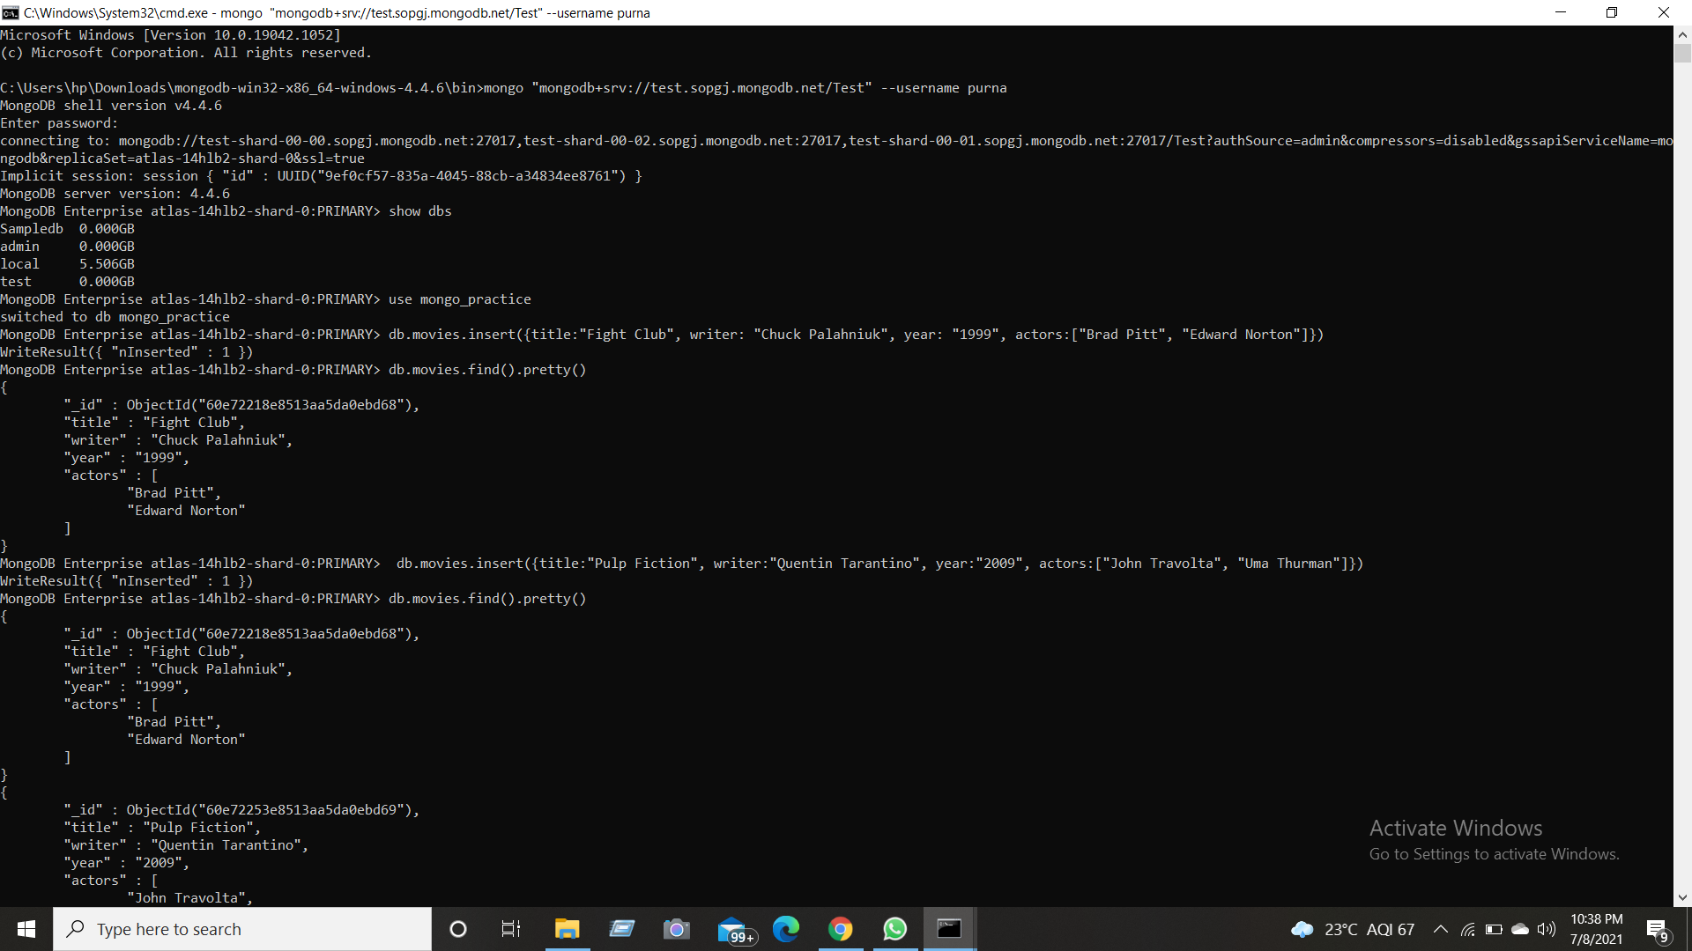

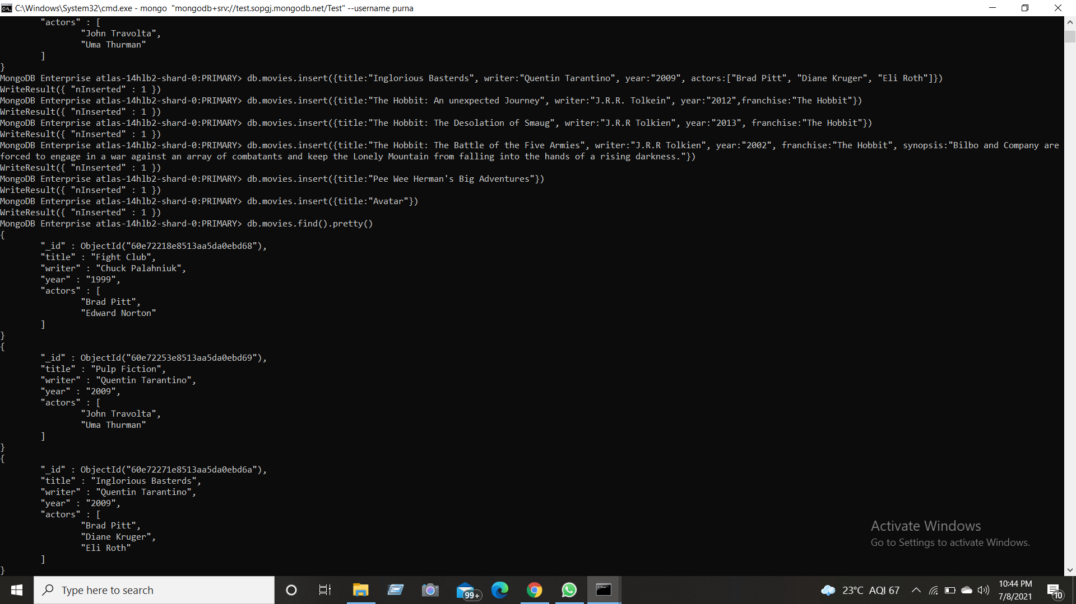

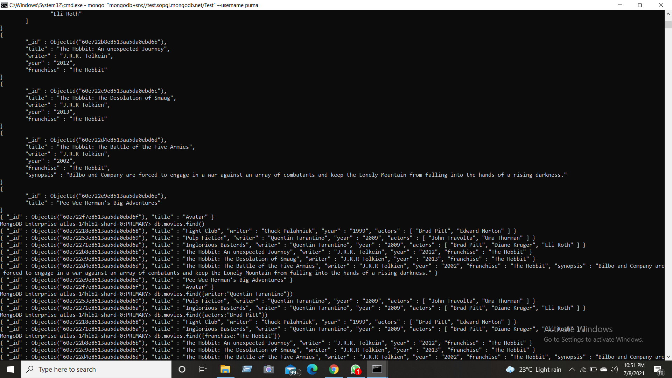

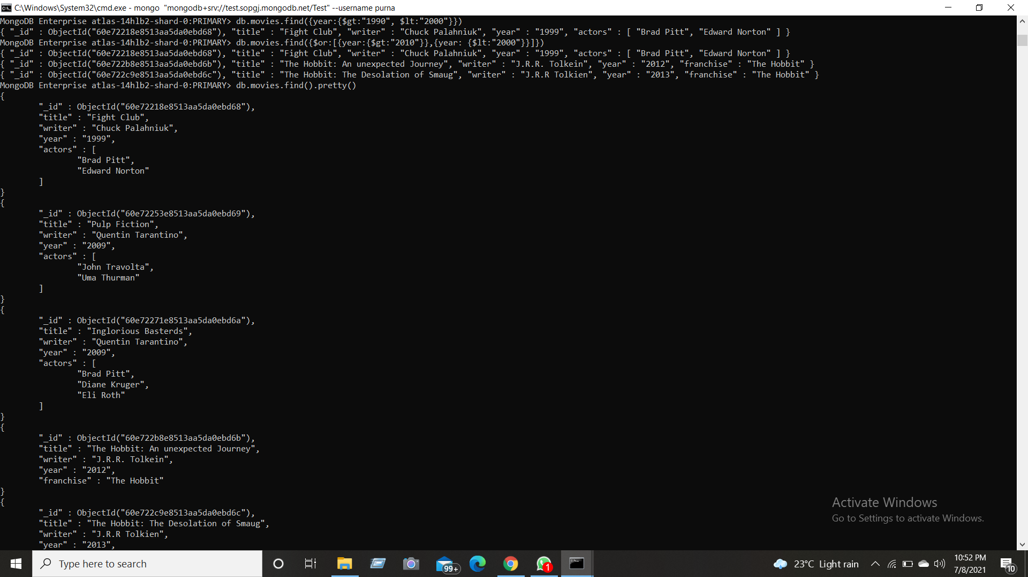

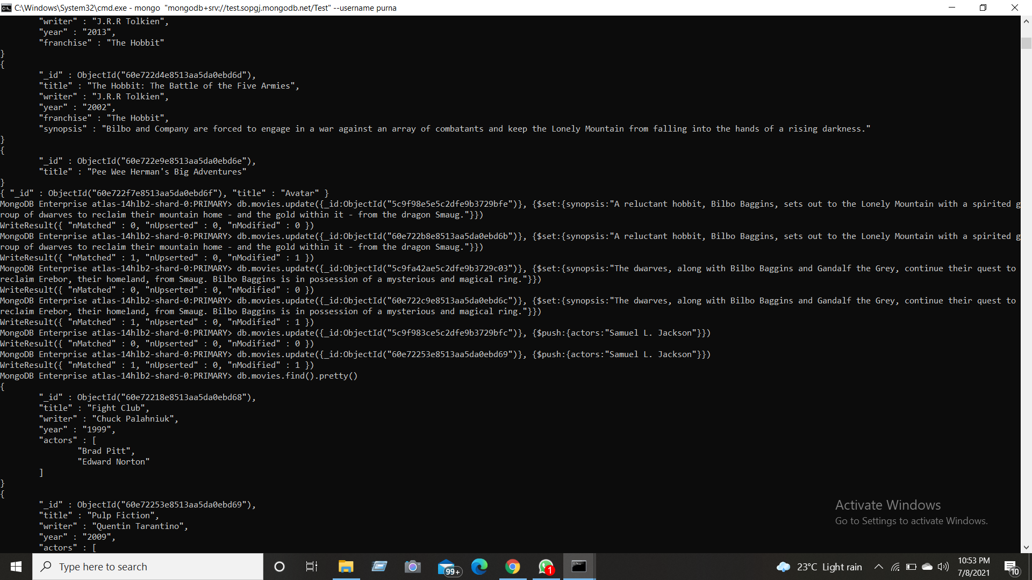

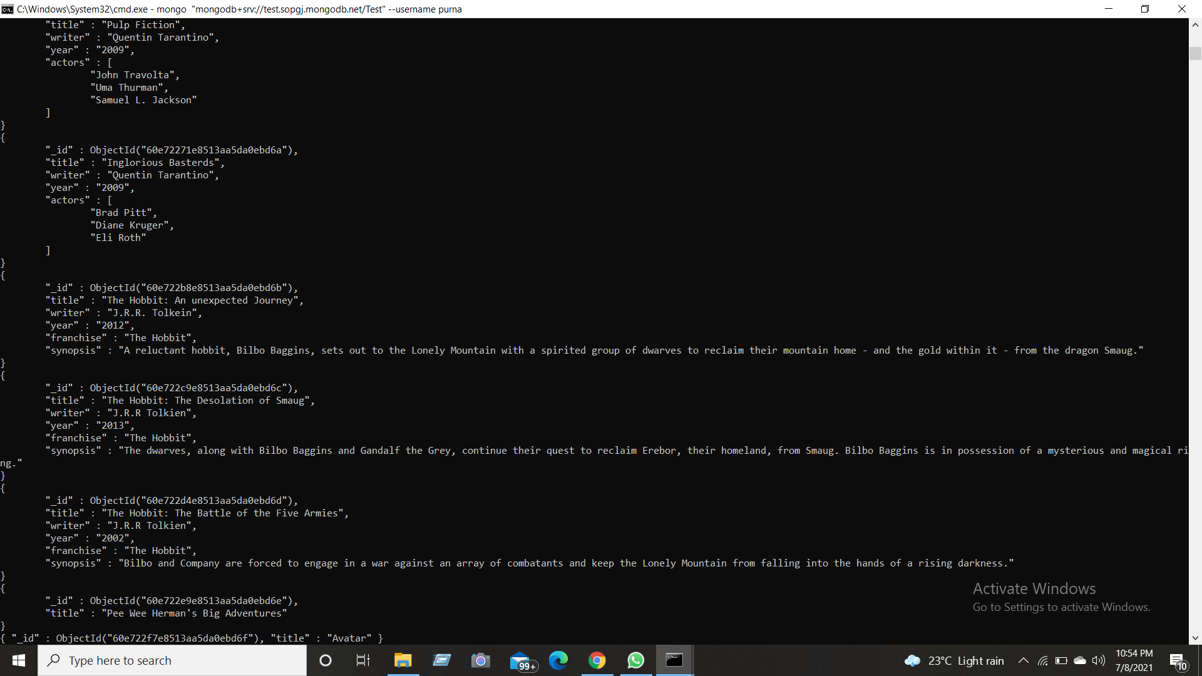

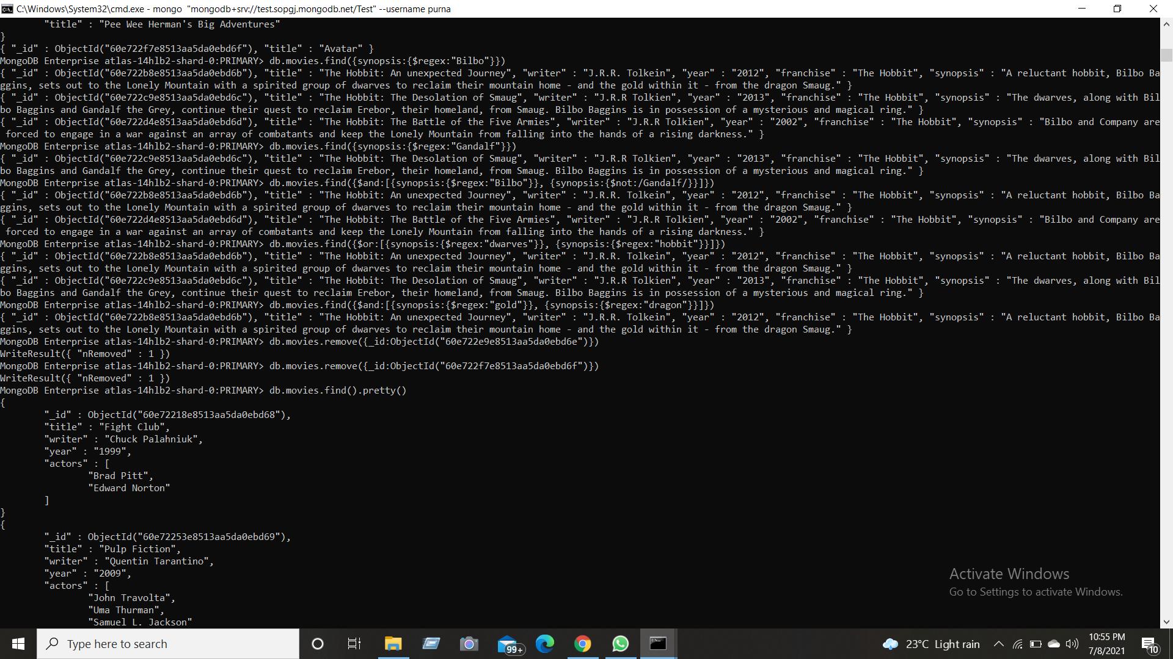

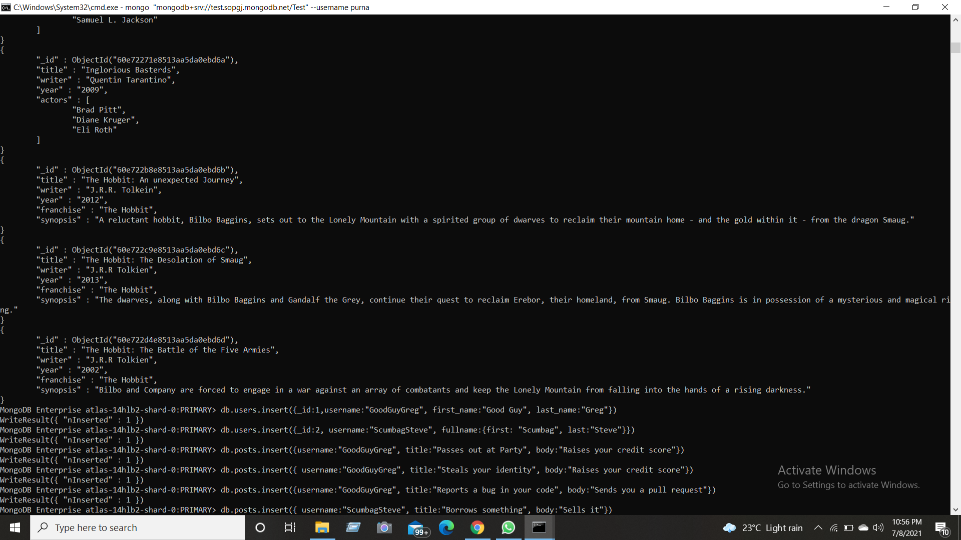

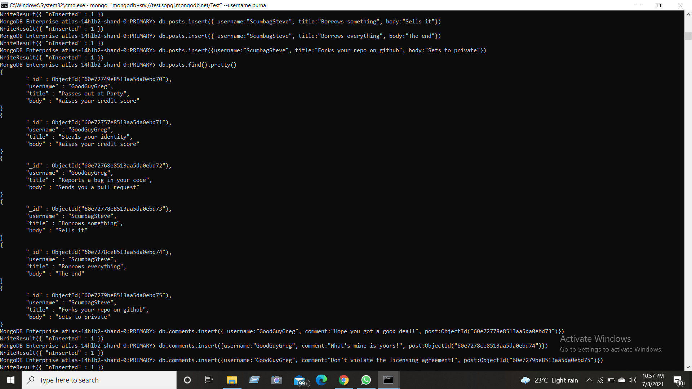

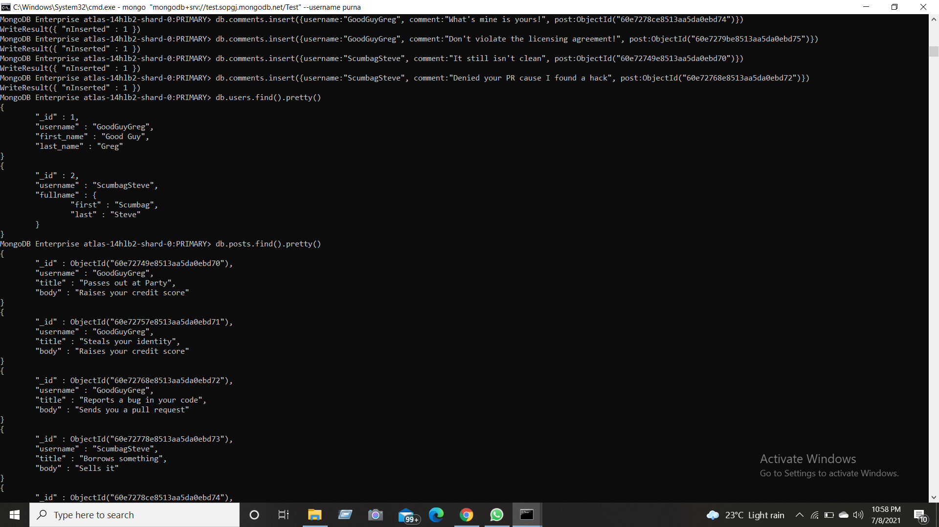

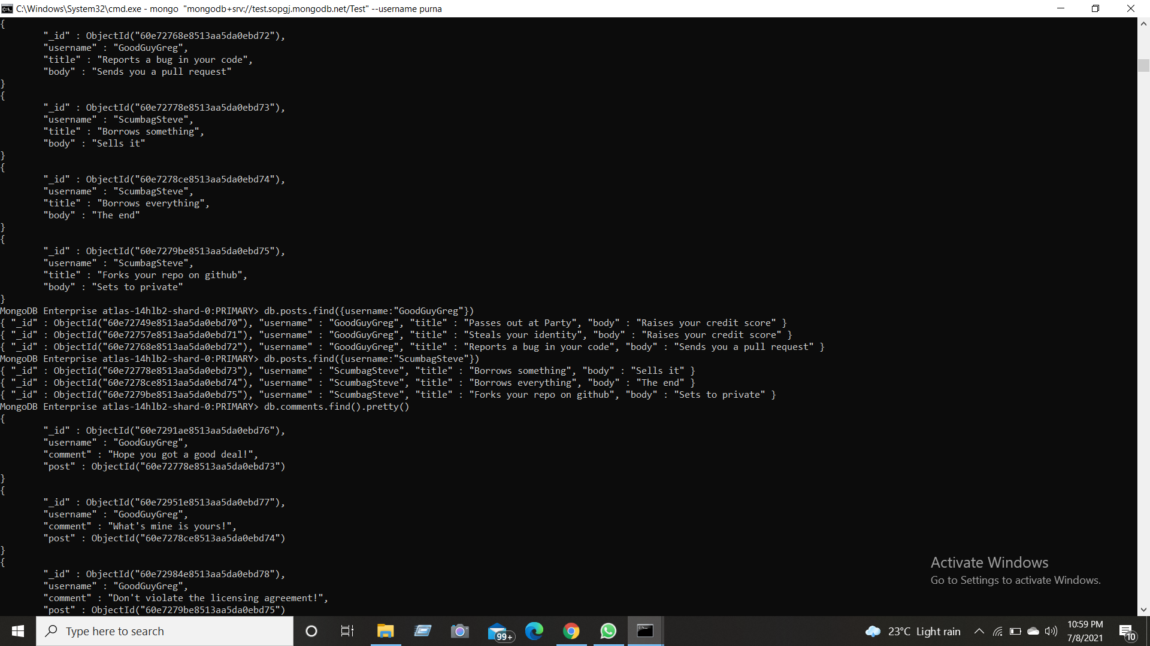

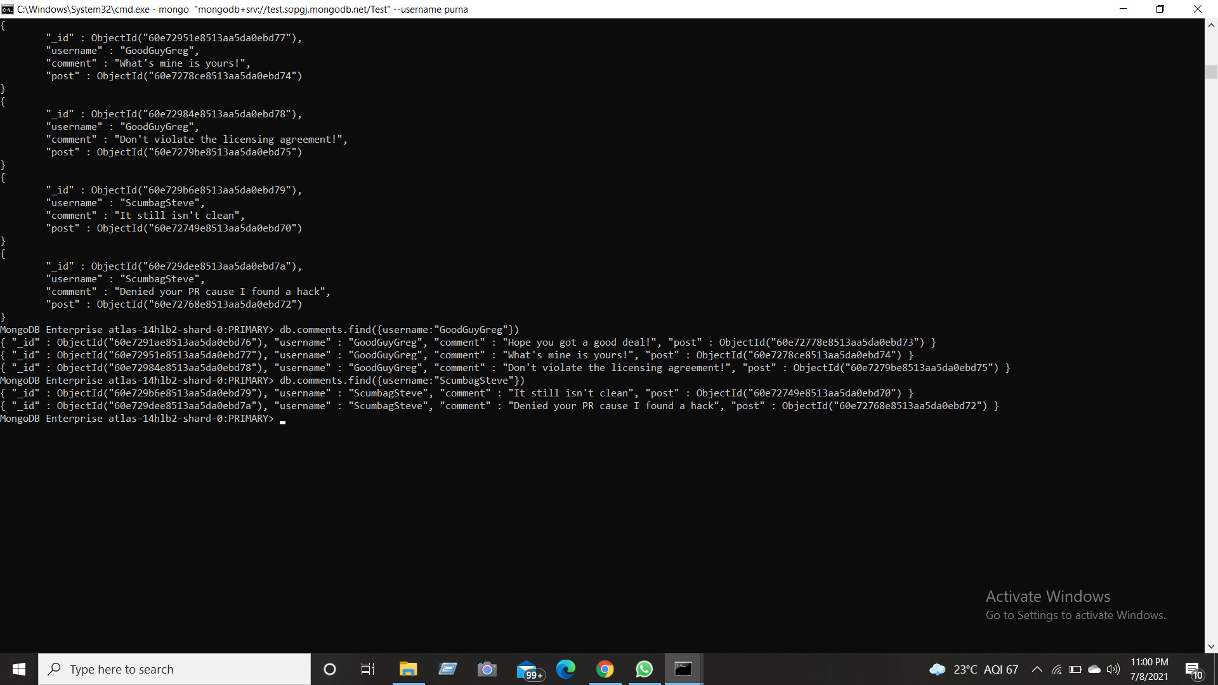

Assignment-2:

ATLANTA Population

1. db.zipcodes.find({city:"ATLANTA",state:"GA"})

2. db.zipcodes.aggregate([{$match: {city:"ATLANTA",state:"GA"}}])

3.db.zipcodes.aggregate([{$match:{city:"ATLANTA"}},{$group:{_id:"$city",zip_count:{$sum:1}}}])

4.db.zipcodes.aggregate([{$match:{city:"ATLANTA"}},{$group:{_id:"$city",total_count:{$sum:"$pop"}}}])

Populations By State:

1. db.zipcodes.aggregate([{$group:{_id:"$state",count:{$sum:"$pop"}}}])
2. db.zipcodes.aggregate([{$sort:{pop:-1}}])
3. db.zipcodes.aggregate([{$sort:{pop:-1}},{$limit:3}])

Population By City:

1. db.zipcodes.aggregate([{$group:{_id:{city:"$city",state:"$state",total_pop:{$sum:"$pop"}}}}])
2. db.zipcodes.aggregate([{$sort:{pop:-1}}])
3. db.zipcodes.aggregate([{$group:{_id:"$city"}},{$sort:{"pop":-1}},{$limit:3}])
4. db.zipcodes.aggregate([{$group:{_id:{state:"Texas",city:"$city"}}},{$sort:{"pop":-1}},{$limit:3}])

Bonus:

1. db.zipcodes.aggregate([{$group:{_id:{state:"$state"},avg:{$avg:"$pop"}}}])
2. db.zipcodes.aggregate([{$group:{_id:{state:"$state"},avg:{$avg:"$pop"}}},{$sort:{pop:-1}},{$limit:3}])

Assignment-3:

Exercise Questions:

1. db.addresses.find().pretty()
2. db.addresses.aggregate([{$project:{"restaurant_id":1,"name":1,"borough":1,"cuisine":1}}])
3. db.addresses.aggregate([{$project:{"restaurant_id":1,"name":1,"borough":1,"cuisine":1,"_id":0}}])
4. db.addresses.aggregate([{$project:{"restaurant_id":1,"name":1,"borough":1,"address.zipcode":1,"_id":0}}])
5. db.addresses.aggregate([{$match:{borough:"Bronx"}},{$limit:5}]).pretty()
6. db.addresses.aggregate([{$match:{borough:"Bronx"}}]).pretty()
7. db.addresses.aggregate([{$match:{borough:"Bronx"}},{$skip:5},{$limit:5}]).pretty()
8. db.addresses.find({"grades.score":{$gt:90}}).pretty()
9. db.addresses.find({$and:[{"grades.score":{$gt:80}},{"grades.score":{$lt:100}}]}).pretty()
10. db.addresses.find({"address.coord.0":{$lt:-95.754168}}).pretty()
11. db.addresses.find({$and:[{"grades.score":{$gt:70}},{"address.coord.0":{$lt:-65.754168}},{cuisine:{$not:{$regex:"American"}}}]}).pretty()
12. db.addresses.find({$and:[{"grades.score":{$gt:70}},{"address.coord":{$lt:-65.754168}},{cuisine:{$not:{$regex:"American"}}}]}).pretty()
13. db.addresses.find({$and:[{cuisine:{$not:{$regex:"American"}}},{"grades.grade":"A"},{borough:{$not:{$regex:"Brooklyn"}}}]}).sort({cuisine:-1}).pretty()
14. db.addresses.find({name:/^Wil/},{restaurant_id:1,name:1,borough:1,cuisine:1})
15. db.addresses.find({name:/ces$/},{restaurant_id:1,name:1,borough:1,cuisine:1})
16. db.addresses.find({name:/Reg/},{restaurant_id:1,name:1,borough:1,cuisine:1})
17. db.addresses.find({borough:"Bronx",$or:[{cuisine:"American"},{cuisine:"Chinese"}]}).pretty()
18. db.addresses.find({$or:[{borough:"Staten Island"},{borough:"Queens"},{borough:"Bronxor"},{borough:"Brooklyn"}]},{restaurant_id:1,name:1,borough:1,cuisine:1})
19. db.addresses.find({$and:[{borough:{$not:/Staten Island/}},{borough:{$not:/Queens/}},{borough:{$not:/Bronx/}},{borough:{$not:/Brooklyn/}}]},{restaurant_id:1,name:1,borough:1,cuisine:1})
20. db.addresses.find({"grades.score":{$lt:10}},{restaurant_id:1,name:1,borough:1,cuisine:1})
21. db.addresses.find({$or:[{name:/^Wil/},{$and:[{cuisine:{$not:{$regex:"American"}}},{cuisine:{$not:{$regex:"Chinese"}}}]}]},{restaurant_id:1,name:1,borough:1,cuisine:1})
22. db.addresses.find({$and:[{"grades.grade":"A"},{"grades.score":11},{"grades.date":ISODate("2014-08-11T00:00:00Z")}]},{restaurant_id:1,name:1,grades:1}).pretty()
23. db.addresses.find({$and:[{"grades.grade":"A"},{"grades.score":9},{"grades.date":ISODate("2014-08-11T00:00:00Z")}]},{restaurant_id:1,name:1,grades:1}).pretty()
24. db.addresses.find({"address.coord.1":{$gt:42,$lte:52}},{restaurant_id:1,name:1,address:1}).pretty()
25. db.addresses.find().sort({name:1}).pretty()
26. db.addresses.find().sort({name:-1}).pretty()
27. db.addresses.find().sort({cuisine:1,borough:-1}).pretty()
28. db.addresses.find({"address.street":{$exists:true}}).pretty()
29. db.addresses.find({"address.coord":{$type:"double"}}).pretty()
30. db.addresses.find({"grades.score":{$mod:[7,0]}},{restaurant_id:1,name:1,grades:1}).pretty()
31. db.addresses.find({name:/mon/},{name:1,borough:1,cuisine:1,"address.coord":1})
32. db.addresses.find({name:/^Mad/},{name:1,borough:1,cuisine:1,"address.coord":1})