**ARRAYS**

|  |  |  |
| --- | --- | --- |
| **S.NO** | **PROGRAMS** | **TEACHER’S SIGNATURE** |
| 1. | Write a C++ program to search for an element in an array using linear search. |  |
| 2. | Write a C++ program to search an element in an array using binary search. |  |
| 3. | Write a C++ program to sort an array using insertion sort. |  |
| 4. | Write a C++ program to sort an array using selection sort. |  |
| 5. | Write a C++ program to merge and sort two arrays into a third array. |  |
| 6. | Write a C++ program to find the sum of elements on both the diagonals in a square matrix. |  |
| 7. | Write a C++ program to multiply two matrices. |  |
| 8. | Write a C++ program for transpose of a matrix. |  |

**ARRAYS**

1. Write a C++ program to search for an element in an array using linear search.

## INPUT:

#include<iostream.h>

#include<conio.h>

#include<math.h>

void main()

{

clrscr();

int a[10];

int ser=0;

int min;

cout<<"Enter 10 values"<<endl;

for(int i = 0;i<=9;i++)

{

cin>>a[i];

}

cout<<" Enter the value you want to search for "<<endl;

cin>>ser;

for(int j = 0;j<=9;j++)

{

if(ser==a[j])

{

min = j;

break;

}

}

if(ser == 0)

{

cout<<" The value you have entered is not present in the array"<<endl;

}

else

{

cout<<" Position is "<<min+1;

}

getch();

}

## OUTPUT:

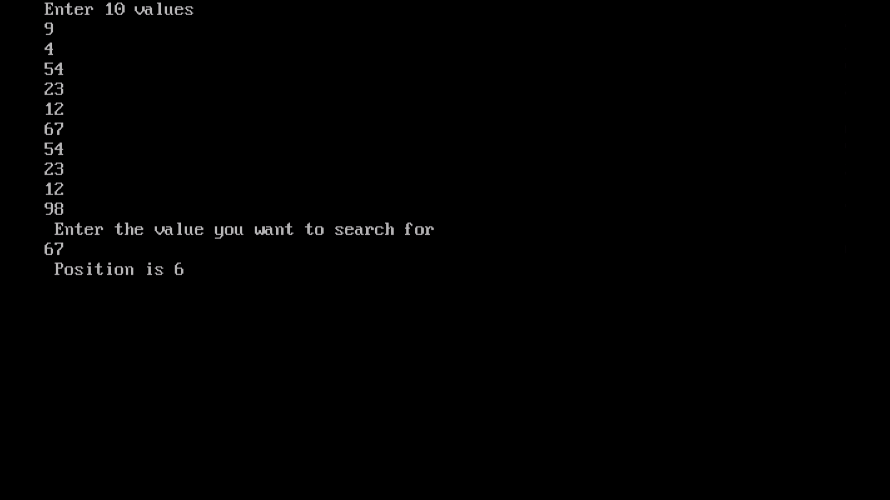

1. Write a C++ program to search an element in an array using binary search.

## INPUT:

#include<iostream.h>

#include<conio.h>

void search(int a[10],int size,int item );

void main()

{

clrscr();

int i,j,a[10],size,item;

cout<<"Enter the size of array ";

cin>>size;

cout<<"Enter the elements of array "<<endl;

for(i=0;i<size;i++)

cin>>a[i];

cout<<"Array \n";

for(i=0;i<size;i++)

cout<<a[i]<<" ";

cout<<endl;

cout<<"item to be searched";

cin>>item;

search(a,size,item);

getche();

}

void search(int a[10],int size,int item)

{

int ino,l=0,u=size-1,m,j,temp,i;

int pos=-1;

for(i=0;i<size-1;i++)

{

for(j=0;j<size-i-1;j++)

{

if(a[j]>a[j+1])

{

temp=a[j+1];

a[j+1]=a[j];

a[j]=temp;

}

}

}

cout<<"\n Sorted Array : \n";

for(i=0;i<size;i++)cout<<a[i]<<" ";

do

{

m=(l+u)/2;

if(a[m]==item)

{

pos=m;

break;

}

else if(a[m]>item)

u=m-1;

else

l=m+1;

}while(l<=u);

if(pos==-1)

cout<<endl<<"No such item exist";

else

cout<<endl<<"Element found in position: "<<pos+1;

}

## OUTPUT:

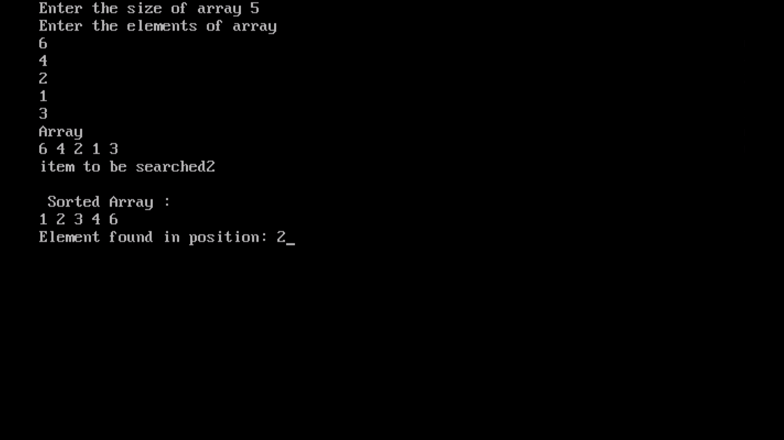

1. Write a C++ program to sort an array using insertion sort

## INPUT:

#include<iostream.h>

#include<conio.h>

void isort(int a[10],int size );

void main()

{

clrscr();

int i,j,a[10],size;

cout<<"Enter the size of array A ";

cin>>size;

cout<<"Enter the elements of array A"<<endl;

for(i=0;i<size;i++)

cin>>a[i];

cout<<"Array A \n";

for(i=0;i<size;i++)

cout<<a[i]<<" ";

cout<<endl;

isort(a,size);

getche();

}

void isort(int a[10],int size)

{

int i,j,k,temp;

for(i=1;i<size;i++)

{

temp=a[i];

j=i-1;

while((temp<a[j])&&(j>=0))

{

a[j+1]=a[j];

j--;

}

a[j+1]=temp;

cout<<"After PASS "<<i+1<<endl;

for(j=0;j<size;j++)

cout<<a[j]<<" ";

cout<<endl;

}

}

## OUTPUT:

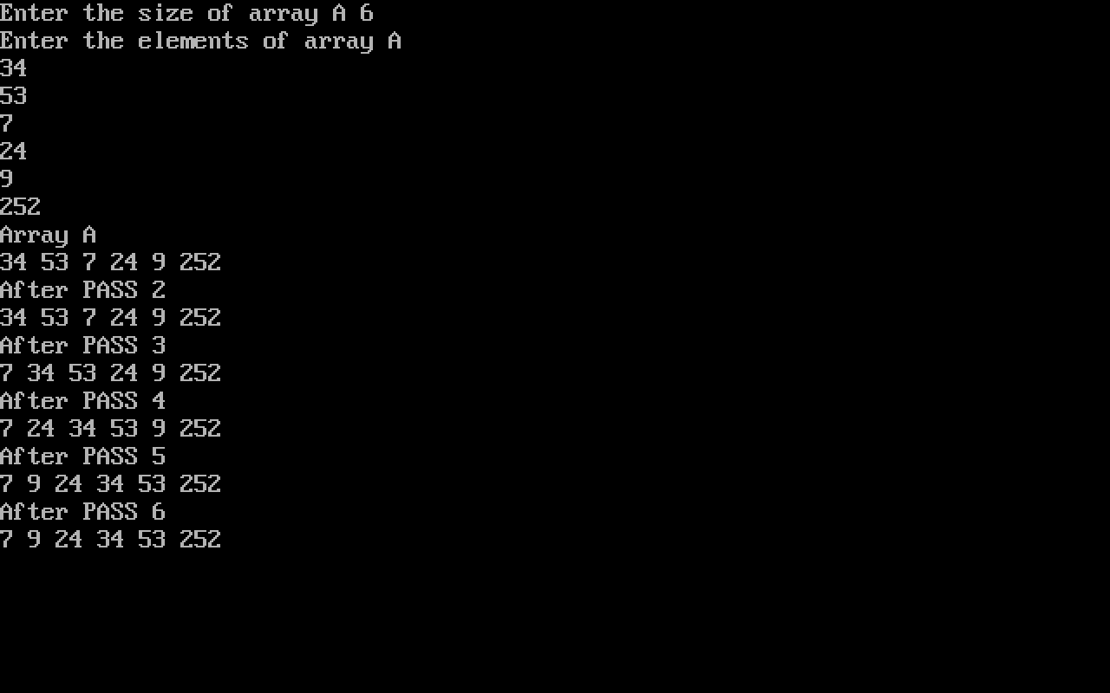

1. Write a C++ program to sort an array using selection sort

## INPUT:

#include<iostream.h>

#include<conio.h>

void selsort(int a[10],int size );

void main()

{

clrscr();

int i,j,a[10],size;

cout<<"Enter the size of array ";

cin>>size;

cout<<"Enter the elements of array "<<endl;

for(i=0;i<size;i++)

cin>>a[i];

cout<<"Array \n";

for(i=0;i<size;i++)

cout<<a[i]<<" ";

cout<<endl;

selsort(a,size);

getche();

}

void selsort(int a[10],int size)

{

int i,j,small,temp,pos;

for(i=0;i<size;i++)

{

small=a[i];

pos=i;

for(j=i+1;j<size;j++)

{

if(a[j]<small)

{

small=a[j];

pos=j;

}

}

temp=a[i];

a[i]=small;

a[pos]=temp;

cout<<"After PASS "<<i+1<<endl;

for(j=0;j<size;j++)

cout<<a[j]<<" ";

cout<<endl;

}

}

## OUTPUT:

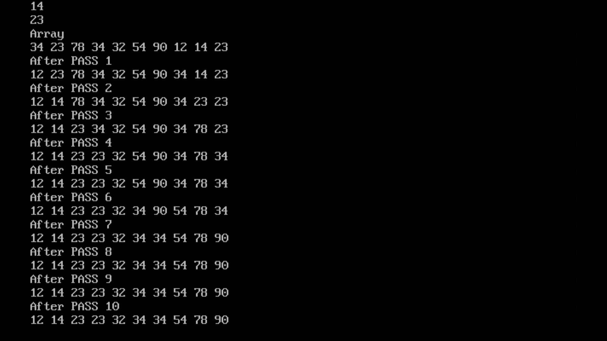

1. Write a C++ program to merge and sort two arrays into a third array.

## INPUT:

#include<iostream.h>

#include<conio.h>

void mergesort(int a[10],int b[10],int m,int n );

void main()

{

clrscr();

int i,j,a[10],m,n,b[10];

cout<<"Enter the size of array A ";

cin>>m;

cout<<"Enter the elements of array A"<<endl;

for(i=0;i<m;i++)

cin>>a[i];

cout<<"Array A \n";

for(i=0;i<m;i++)

cout<<a[i]<<" ";

cout<<endl;

cout<<endl<<"Enter the size of array B ";

cin>>n;

cout<<"Enter the elements of the array B";

for(i=0;i<n;i++)

cin>>b[i];

cout<<"Array B \n";

for(i=0;i<n;i++)

cout<<b[i]<<" ";

cout<<endl;

cout<<endl;

mergesort(a,b,m,n);

getche();

}

void mergesort(int a[10],int b[10],int m,int n)

{

int i=0,j=n-1,c[30],k=0;

while(i<n && j>=0)

{

if(a[i]<b[j])

c[k++]=a[i++];

else

c[k++]=b[j--];}

while(i<n)

c[k++]=a[i++];

while(j>=0)

c[k++]=b[j--];

cout<<"\n Sorted Array C: \n";

for(i=0;i<size;i++)

cout<<c[i]<<" ";

}

## OUTPUT:

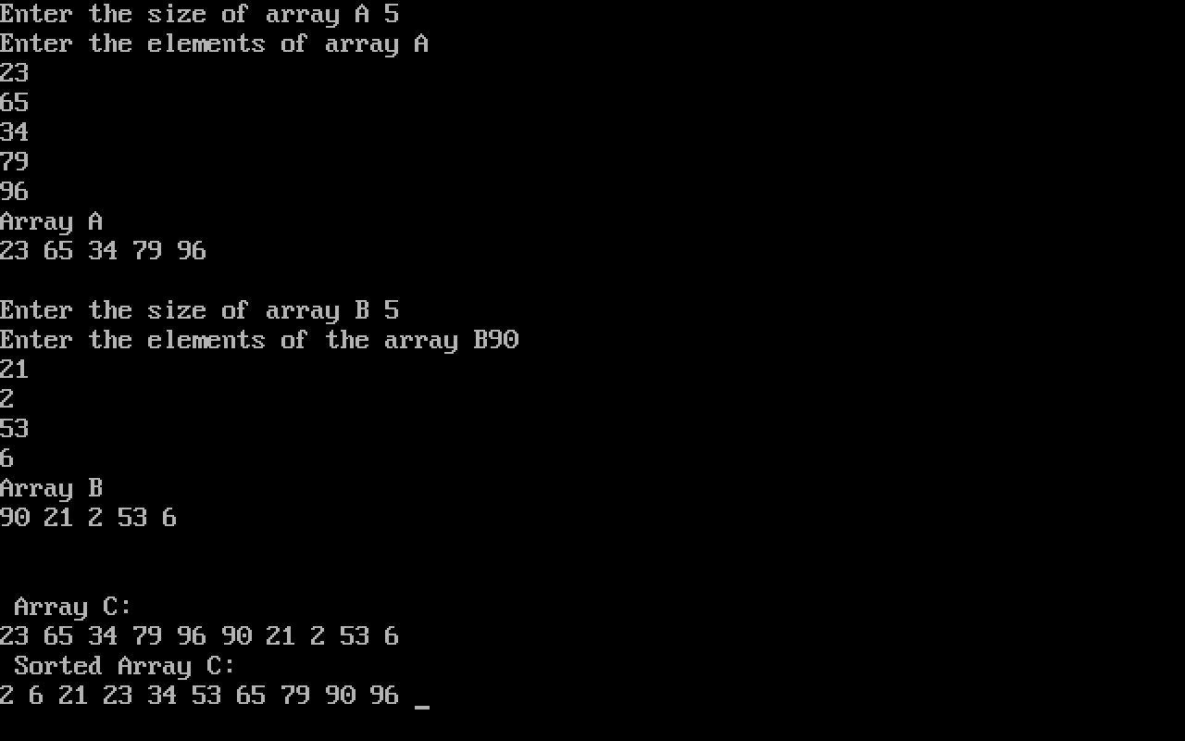

1. Write a C++ program to find the sum of elements on both the diagonals in a square matrix.

## INPUT:

#include<iostream.h>

#include<conio.h>

void diagsum(int[50][50],int m,int n);

void main()

{

clrscr();

int i,j,a[50][50],m,n;

cout<<"Enter the rows and columns for the matrix "<<endl;

cin>>m>>n;

cout<<"Enter the elements of the array"<<endl;

for(i=0;i<m;i++)

{

for(j=0;j<n;j++)

{

cin>>a[i][j];

}

}

cout<<"Matrix \n";

for(i=0;i<m;i++)

{

for(j=0;j<n;j++)

cout<<a[i][j]<<" ";

cout<<endl;

}

diagsum(a,m,n);

getche();

}

void diagsum(int a[50][50],int m,int n)

{

int i,j,sum=0;

for(i=0;i<m;i++)

{

for(j=0;j<n;j++)

{

if(i==j || i+j==(m-1))

sum+=a[i][j];

else

a[i][j]=0;

}

}

cout<<"\n Diagonals: \n";

for(i=0;i<m;i++)

{

for(j=0;j<n;j++)

cout<<a[i][j]<<" ";

cout<<endl;

}

cout<<endl<<"SUM OF THE DIAGONALS:- "<<sum;

}

## OUTPUT:

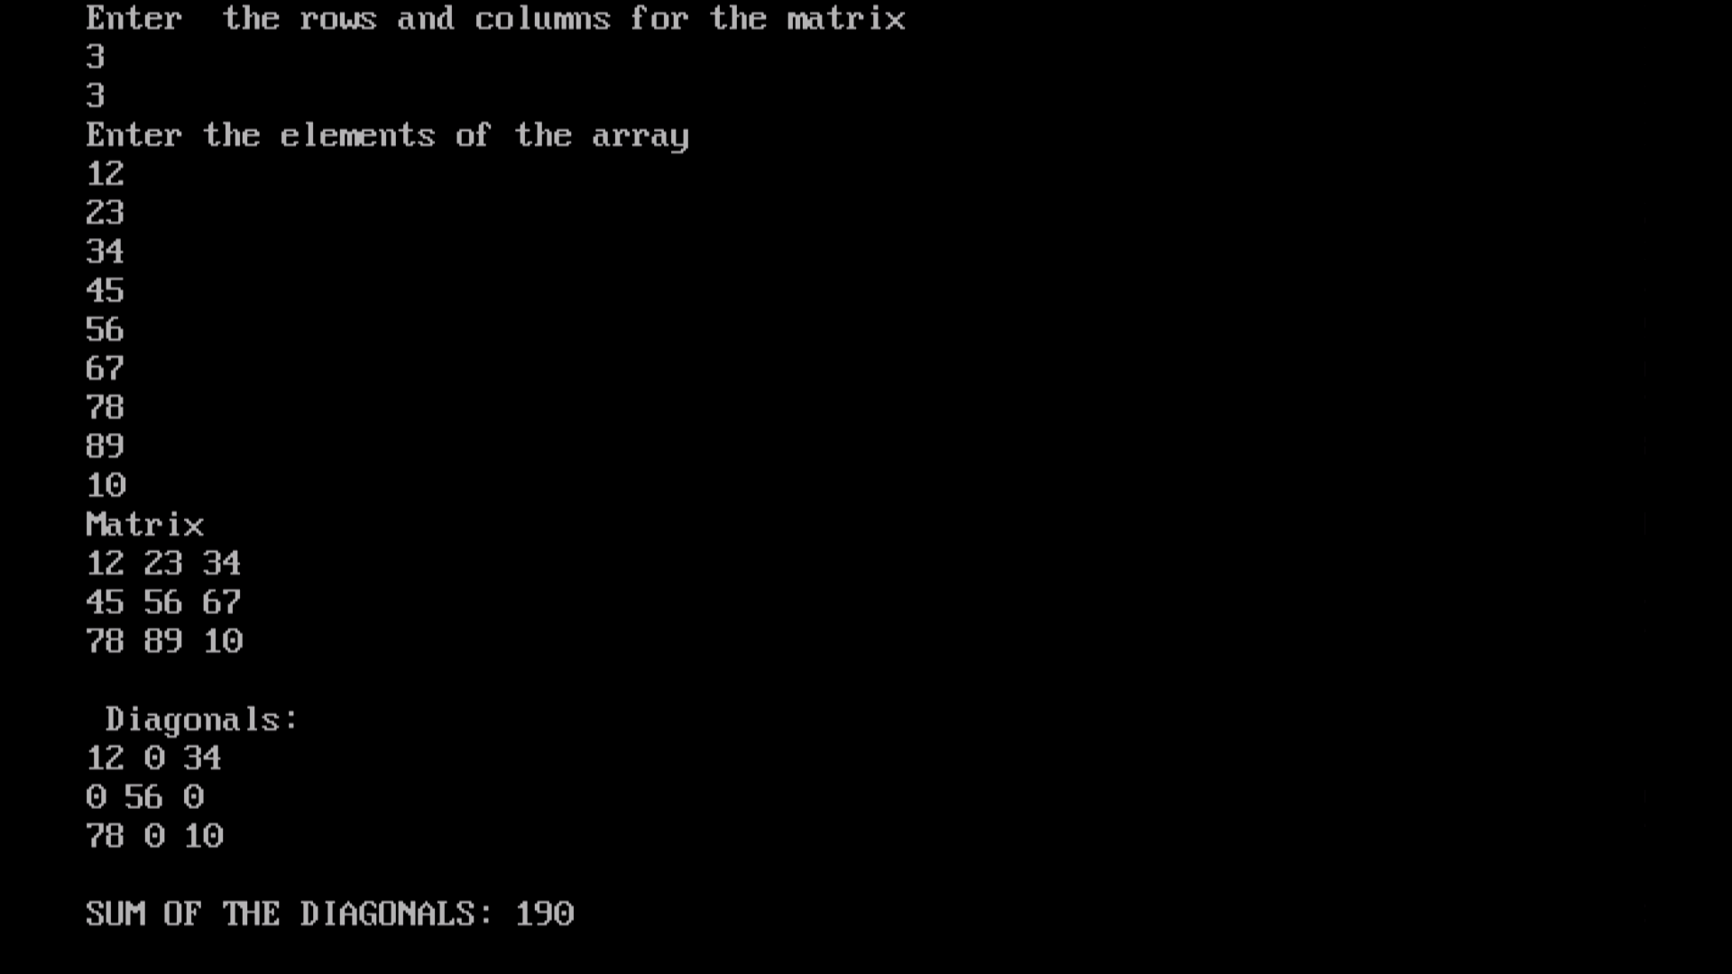

1. Write a C++ program to multiply two matrices.

**INPUT:**

#include<iostream.h>

#include<conio.h>

void multiply (int a[10][10],int b[10][10],int m, int n, int x );

void main()

{

clrscr();

int i,j,a[10][10],m,n,b[10][10],x,y;

cout<<"Enter the rows and columns for the matrix A ";

cin>>m>>n;

cout<<"Enter the elements of the array A"<<endl;

for(i=0;i<m;i++)

{

for(j=0;j<n;j++)

{

cin>>a[i][j];

}

}

cout<<"Matrix A \n";

for(i=0;i<m;i++)

{

for(j=0;j<n;j++)

cout<<a[i][j]<<" ";

cout<<endl;

}

cout<<endl<<"Enter the rows and columns for the matrix B ";

cin>>x>>y;

cout<<"Enter the elements of the array B";

for(i=0;i<x;i++)

{

for(j=0;j<y;j++)

{

cin>>b[i][j];

}

}

cout<<"Matrix B \n";

for(i=0;i<x;i++)

{

for(j=0;j<y;j++)

cout<<b[i][j]<<" ";

cout<<endl;

}

cout<<endl;

multiply(a,b,m,n,x);

getche();

}

void multiply(int a[10][10],int b[10][10],int m,int n, int x)

{

int i,j,k,c[10][10];

if(n==x)

{

for(i=0;i<m;i++)

{

for(j=0;j<n;j++)

{

c[i][j]=0;

for(k=0;k<x;k++)

{

c[i][j]+=(a[i][k]*b[k][j]);

}

}

}

}

else

{

cout<<"Product cannot be found";

goto end;

}

cout<<"\nProduct matrix C: \n";

for(i=0;i<m;i++)

{

for(j=0;j<n;j++)

cout<<c[i][j]<<" ";

cout<<endl;

}

end:

}

## OUTPUT:

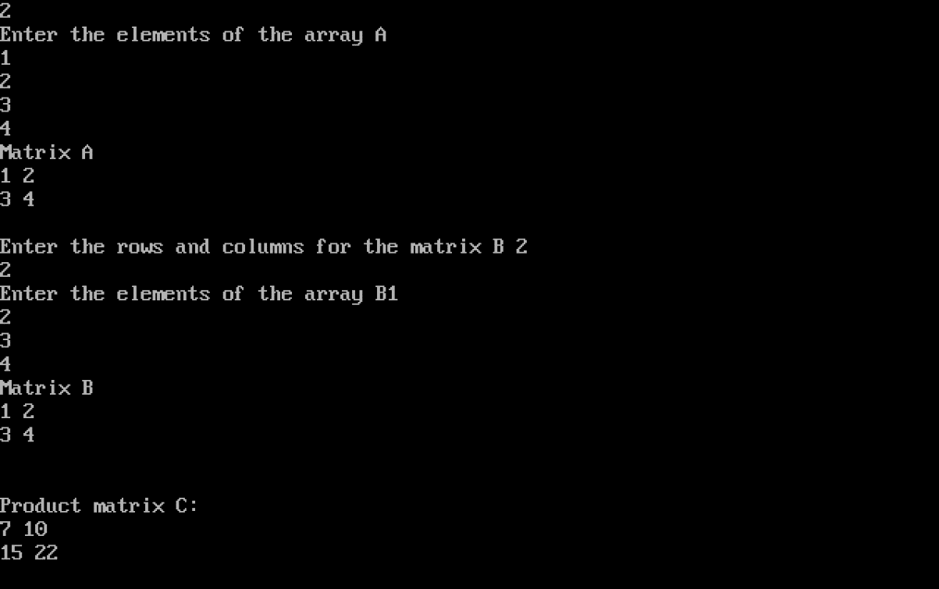

1. Write a C++ program for transpose of a matrix.

**INPUT:**

#include<iostream.h>

#include<conio.h>

void transpose(int[50][50],int m,int n);

void main()

{

clrscr();

int i,j,a[50][50],m,n;

cout<<"Enter the number of rows and columns for the matrix ";

cin>>m>>n;

cout<<"Enter the elements of the array";

for(i=0;i<m;i++)

{

for(j=0;j<n;j++)

{

cin>>a[i][j];

}

cout<<endl;

}

cout<<"Matrix \n";

for(i=0;i<m;i++)

{

for(j=0;j<n;j++)

cout<<a[i][j]<<" ";

cout<<endl;

}

transpose(a,m,n);

getche();

}

void transpose(int a[50][50],int m,int n)

{

int i,j,temp=0;

for(i=0;i<m;i++){

for(j=i;j<n;j++){

temp=a[i][j];

a[i][j]=a[j][i];

a[j][i]=temp;

}

}

cout<<"\nTransposed matrix: \n";

for(i=0;i<m;i++)

{

for(j=0;j<n;j++)

cout<<a[i][j]<<" ";

cout<<endl;

}

}

## OUTPUT:

