**POINTERS**

1. Write a program to print each string in reverse order in array of char pointers.

**INPUT:**

#include<iostream.h>

#include<conio.h>

#include<string.h>

#include<stdio.h>

void main()

{

clrscr();

char str[45][20];

char *ptr[20];

int no,i,j;

int len[20];

cout<<"Enter no of strings to entered"<<endl;

cin>>no;

for(i=0;i<no;i++)

{

cout<<"Enter the string "<<i+1<<" to be reversed "<<endl;

gets(str[i]);

}

for(i=0;i<no;i++)

len[i]=strlen(str[i]);

for(i=0;i<no;i++)

{

ptr[i]=str[i]+len[i];

}

for(j=0;j<no;j++)

{

cout<<"Reversed string "<<j+1<<endl;

for(i=0;i<len[j]+1;i++)

{

cout<<*ptr[j];

ptr[j]--;

}

cout<<endl;

}

getche();

}

## OUTPUT:

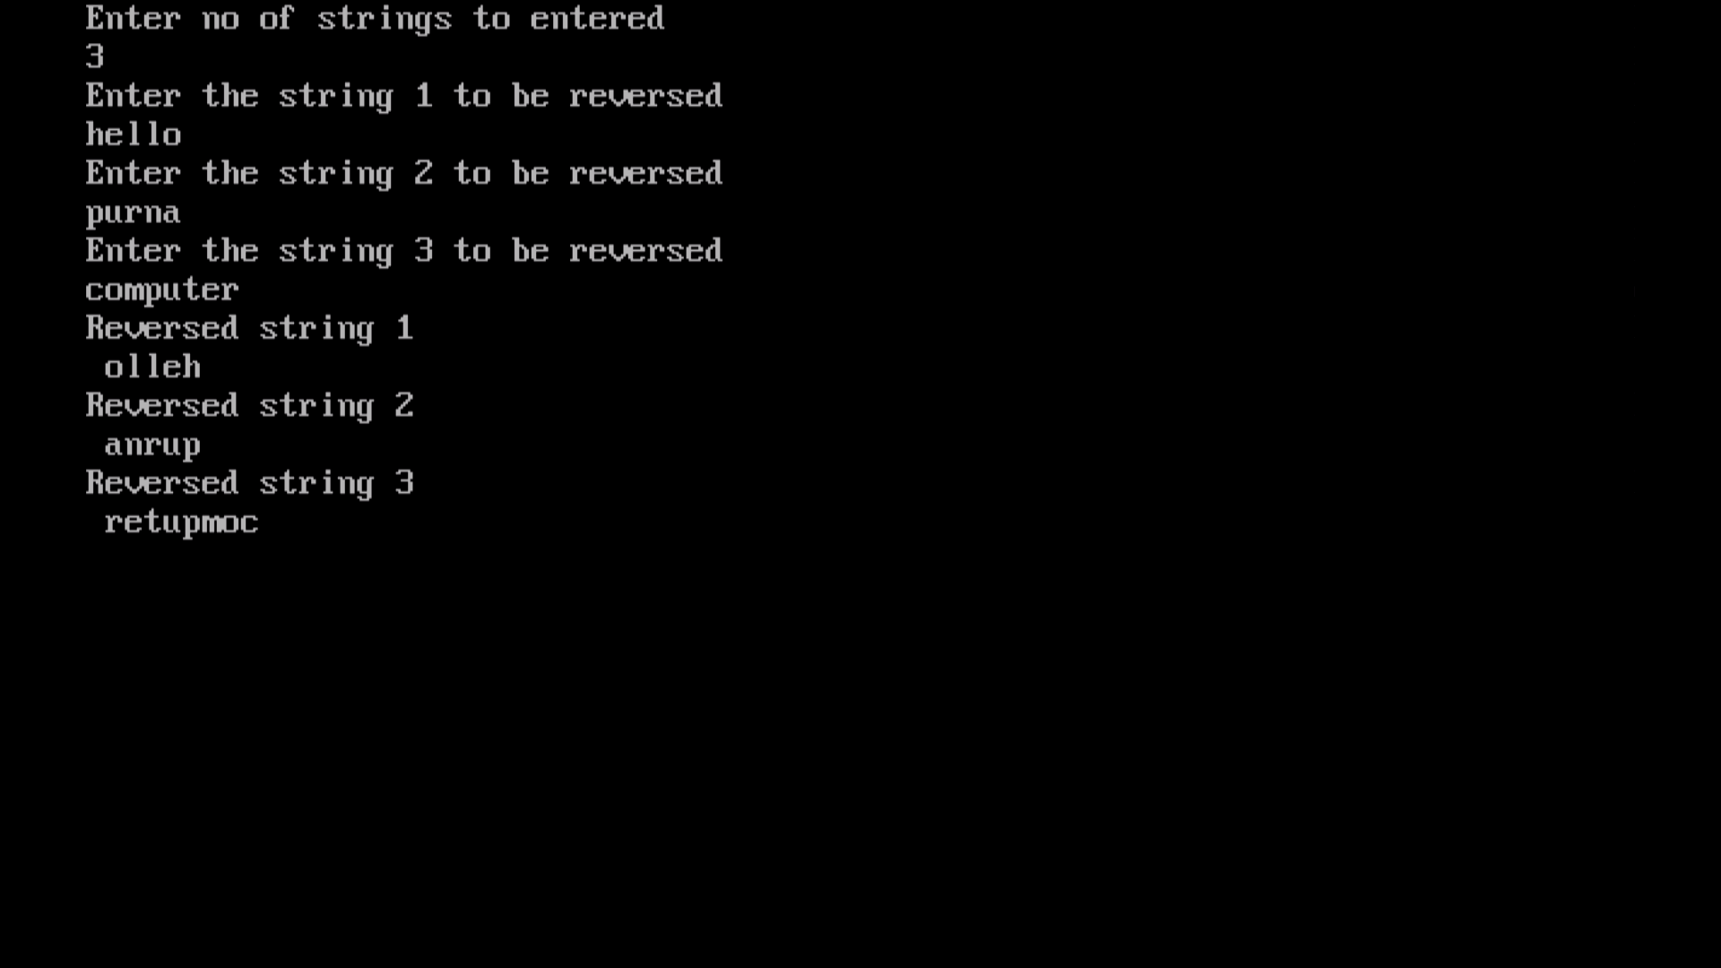

1. Write a program having function to swap values of two variables using pass by reference method.

**INPUT:**

#include<iostream.h>

#include<conio.h>

#include<string.h>

#include<stdio.h>

void swap(int &x,int &y)

{

int temp=0;

temp=x;

x=y;

y=temp;

}

void main()

{

clrscr();

int x,y;

cout<<"Enter the values of x and y"<<endl;

cin>>x>>y;

int *ptr1,*ptr2;

ptr1=&x;

ptr2=&y;

swap(x,y);

cout<<"Swapped values of x and y are:"<<endl;

cout<<*ptr1<<" "<<*ptr2;

getche();

}

## OUTPUT:

## 

1. Write a program having function to swap values of two variables by passing pointers

## INPUT:

#include<iostream.h>

#include<conio.h>

#include<string.h>

#include<stdio.h>

void swap(int *ptr1,int *ptr2)

{

int temp=0;

temp=*ptr1;

*ptr1=*ptr2;

*ptr2=temp;

}

void main()

{

clrscr();

int x,y;

cout<<"Enter the values of x and y"<<endl;

cin>>x>>y;

int *ptr1,*ptr2;

ptr1=&x;

ptr2=&y;

swap(ptr1,ptr2);

cout<<"Swapped values of x and y are:"<<endl;

cout<<*ptr1<<" "<<*ptr2;

getche();

}

## OUTPUT:

## 

1. Write a program to find a substring in a string using pointer

**INPUT:**

#include<iostream.h>

#include<conio.h>

#include<string.h>

#include<stdio.h>

void main()

{

clrscr();

char *ptr;

char str[45];

int no,i,count=0;

int len;

cout<<"Enter the string to find substring "<<endl;

gets(str);

len=strlen(str);

ptr=str;

cout<<endl<<"Substrings of a string are: "<<endl;

for(i=0;i<len+1;i++){

if(*ptr!=' ')

cout<<*ptr;

else{

cout<<endl;

count++;}

ptr++;}

cout<<"No of substrings = "<<count+1;

getche();

}

## OUTPUT:

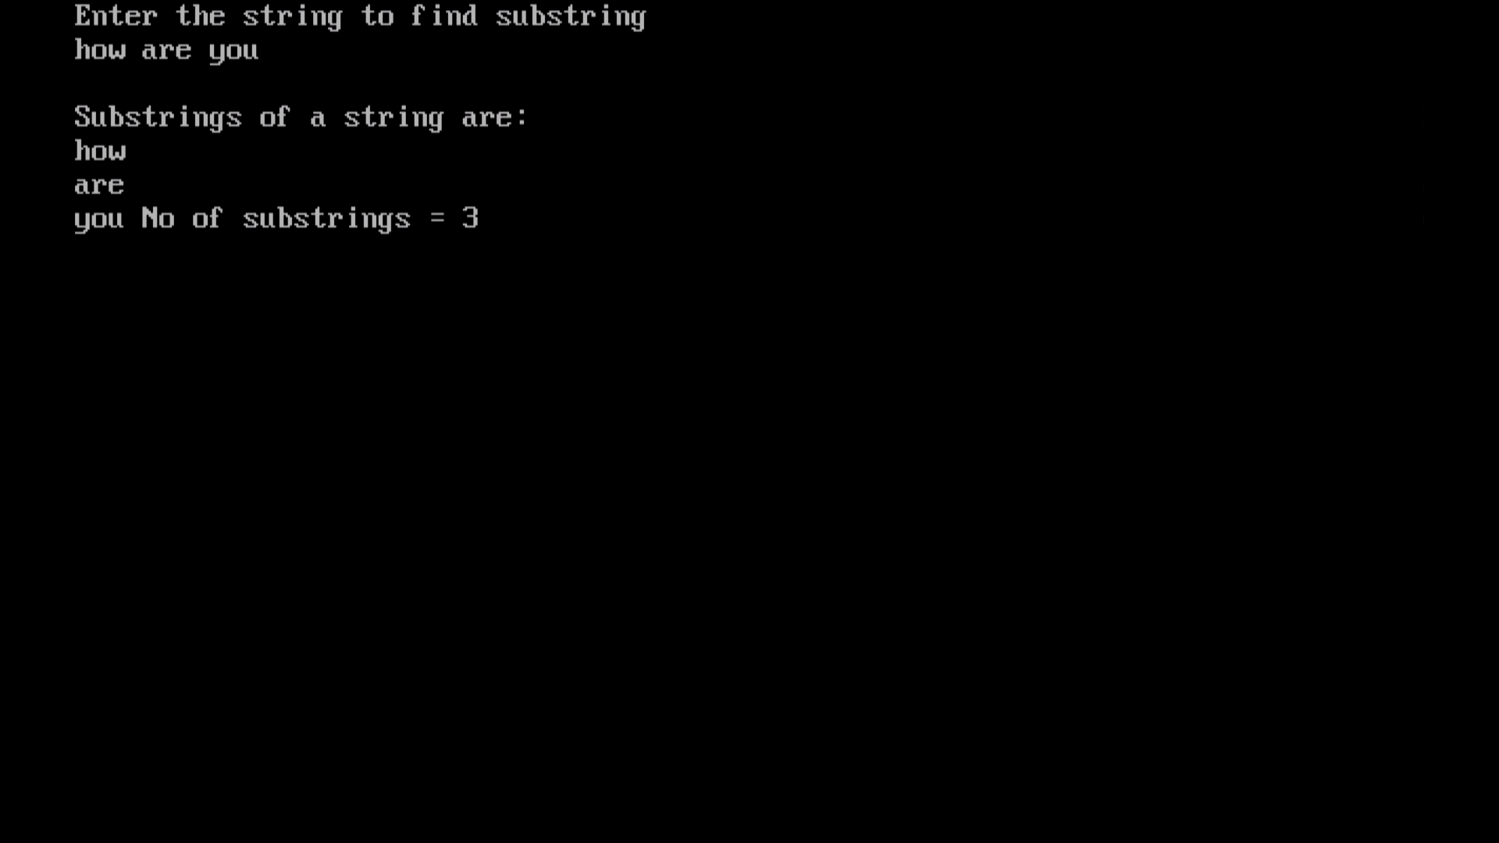

1. Write a program to exchange positions of strings at even position with odd position stored in array using array of pointers.

## INPUT:

#include<iostream.h>

#include<conio.h>

#include<string.h>

#include<stdio.h>

void main()

{

clrscr();

char *ptr[20];

char str[45][20];

int no,i,j;

int len[20];

cout<<"Enter no of strings to be entered"<<endl;

cin>>no;

for(i=0;i<no;i++)

{

cout<<"Enter the string "<<i+1<<endl;

gets(str[i]);

}

cout<<endl;

for(i=0;i<no;i++)

cout<<str[i]<<" ";

cout<<endl;

for(i=0;i<no;i++)

{

if(i%2==0)

{

if(i!=(no-1))

len[i+1]=strlen(str[i]);

else

len[i]=strlen(str[i]);

}

else

len[i-1]=strlen(str[i]);

}

for(i=0;i<no;i++)

{

if(i%2==0)

{

if(i!=(no-1))

ptr[i+1]=str[i];

else

ptr[i]=str[i];

}

else

ptr[i-1]=str[i];

}

cout<<endl<<"Positions of strings exchanged"<<endl;

for(j=0;j<no;j++)

{

for(i=0;i<len[j]+1;i++)

{

cout<<*ptr[j];

ptr[j]++;

}

cout<<" ";

}

getche();

}

## OUTPUT:

