Step 1: Go to URL shohoz.com .After change the language from English to bangle the phone number doesn’t change in bangle.

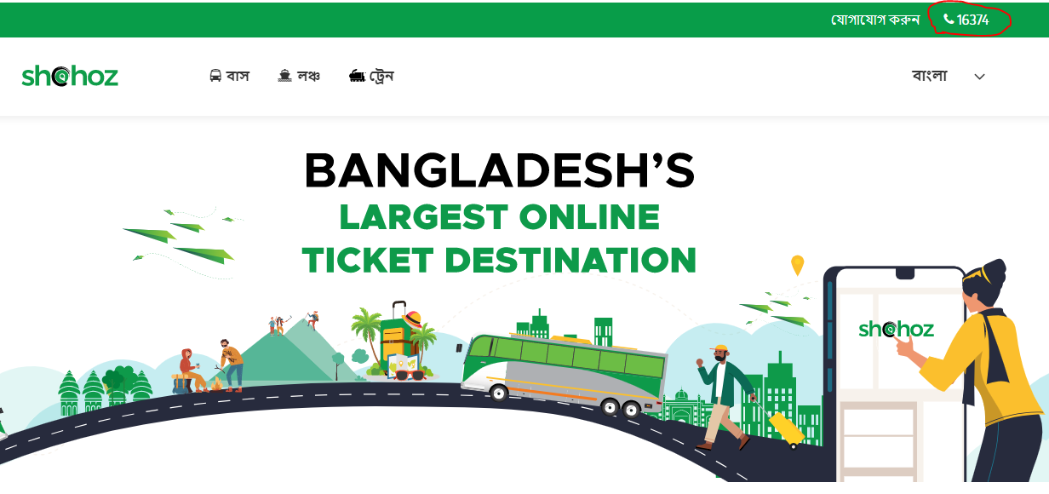

2. Assign the developer

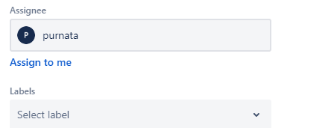

3. Developer got this invitation to join the team

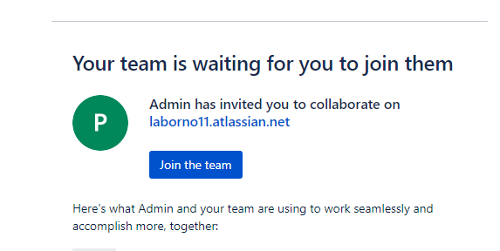

4. After developer work in progress

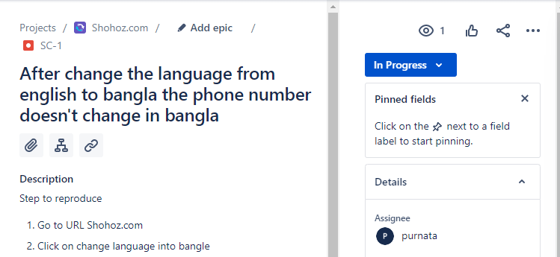

5. Then developer done this process and reduce the bug

